**Agricultural Analysis Using R**

Ashutosh Kumar Kaushik

**Table of Contents**

|  |  |  |  |  |  |
| --- | --- | --- | --- | --- | --- |
| **1** | **Introduction** | | | |  |
|  | 1.1 | | Data | . . . . . . . . . . . . . . . . . . . . . . . . . . . . . . . . . . . . . . . . . . . . . . . . . . . . . |  |
| **2** | **Methodology** | | | |  |
|  | 2.1 | | Exploratory Data Analysis . . . . . . . . . . . . . . . . . . . . . . . . . . . . . . . . . . . .. . . | |  |
|  |  | | 2.1.1 | Outlier Analysis . . . . . . . . . . . . . . . . . . . . . . . . . . . . . . . . . . . . . . . |  |
|  |  | | 2.1.2 | Analysis. . . . . . . . . . . . . . . . . . . . . . . . . . . . . . . . . . . . . . . . . . . . . . |  |
|  |  | | 2.1.3 | Trends and Seasonality . . . . . . . . . . . . . . . . . . . . . . . . . ... . . . . . . |  |
|  |  |

**1. Introduction**

**1.1 Data**

Cleaning of data is done in excel. There is an issue with the cases of commodities.

**Data (Monthly_data_CMO Dataset)**

**There is total** 62429 observations and 11 variables.

There is total 349 APMCs and 204 commodities.

**2. Methodology**

**2.1 Exploratory Data Analysis**

**2.1. Outlier Analysis**

Since, we have 205 commodities. So, we need to calculate outliers for each commodities.

commodity <- split(data, data$Commodity) #to split the data for each commodity

**##### Filtering Outliers ####**

for(j in 2:205){

for(i in 5:8){

bp <- boxplot(commodity[[j]][,i], plot = FALSE)

commodity[[j]][which(commodity[[j]][,i] %in% bp$out),i] <- NA # to remove the outliers

}

}

**#number of outliers in each commodity AND removing them**

for(i in 2:205){

print(names(commodity[i]))

print(sum(is.na(commodity[[i]])))

n <- sum(is.na(commodity[[i]]))

if(n!=0)

commodity[[i]] <- na.omit(commodity[[i]])

}

**1. amba koy**

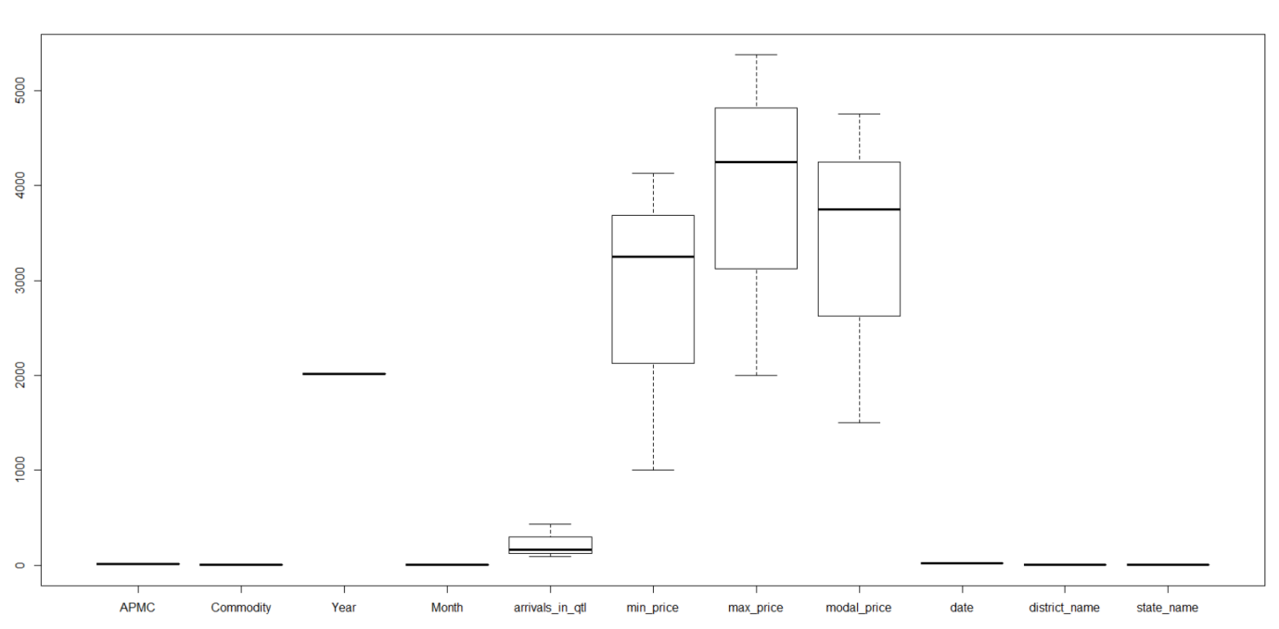

**2. Maize**

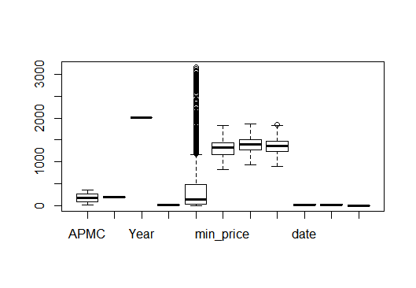

**3. cotton**

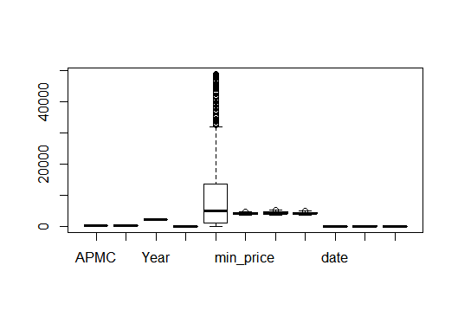

**4. apple**

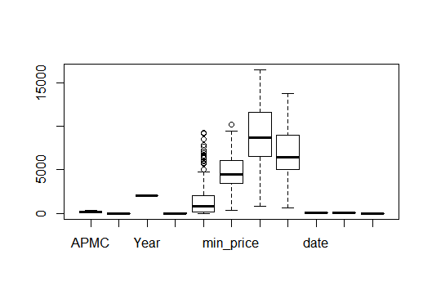

**5. Baru seed**

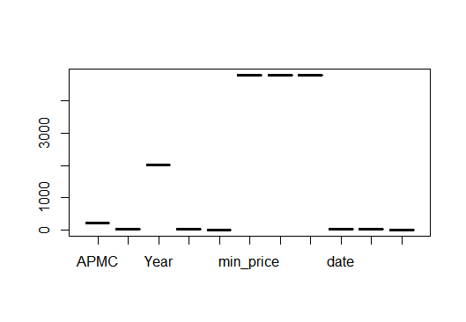

**6. Sun Flower**

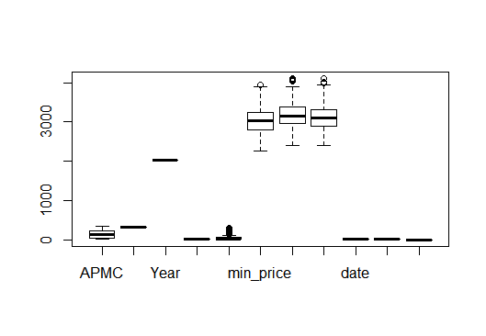

**7. Sugarcane**

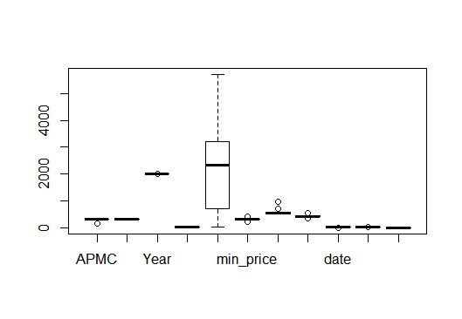

**8. bajri**

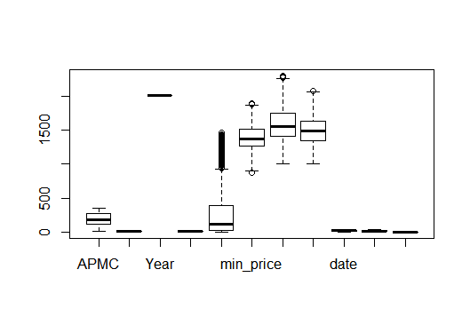

**9. banana**

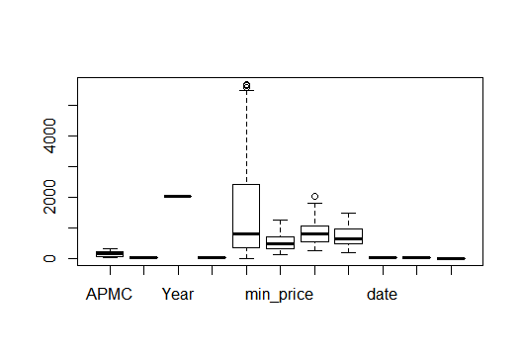

**10. Wheat Husked**

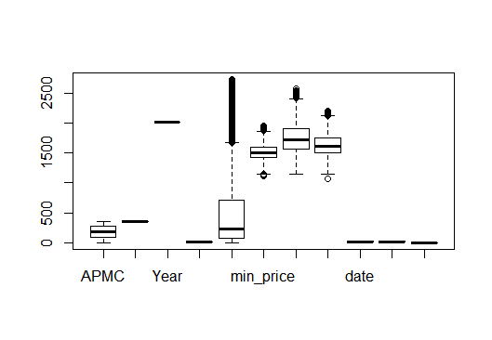

**2.1.3 Seasonal effect for each commodity**

There is additive seasonality in most of the commodities

**1. Amba Koy**

**Additive Seasonality**

Amba Koy production clearly follows quarterly seasonality. As it is recorded monthly, there are 12 data points recorded per year, and we use a moving average window of 12.

There is constant trend over years in this case. Price is almost constant trend from year 2014 to 2016. There is quarterly seasonality in this case.

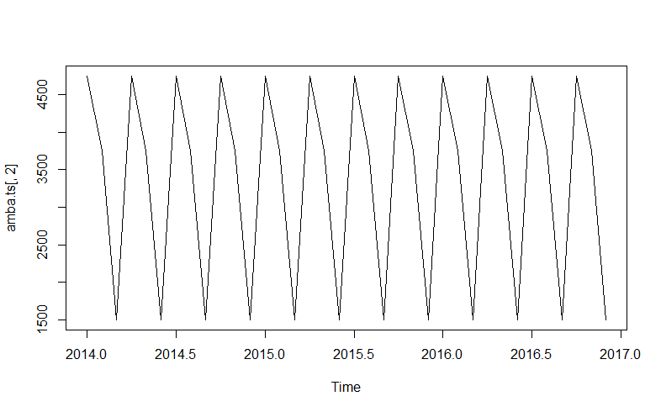

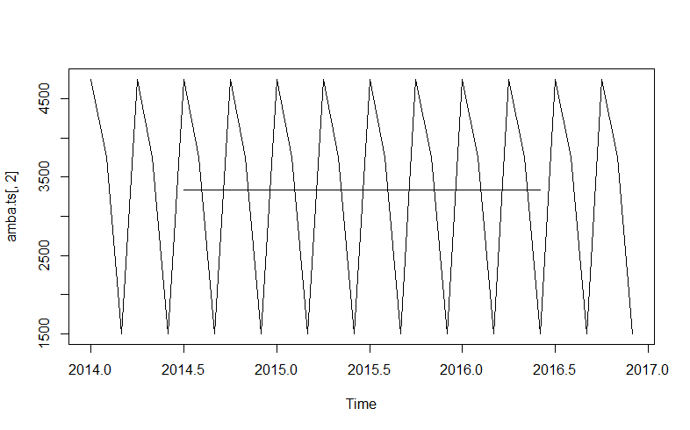

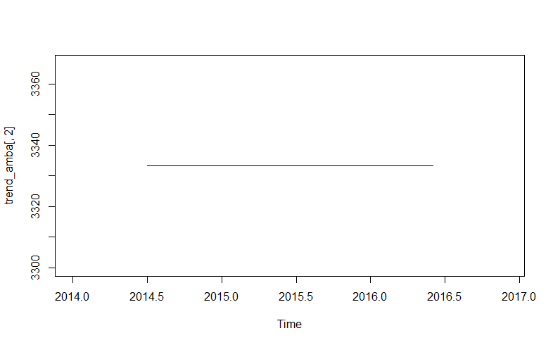

**2. maize**

**Additive Seasonality**

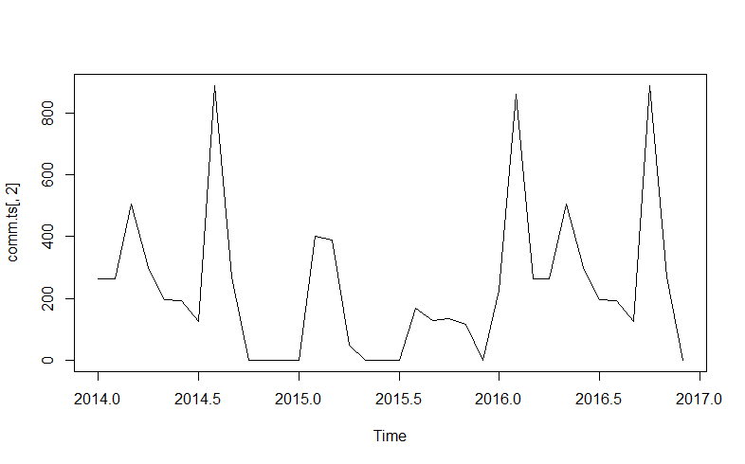

Seasonality with trend line

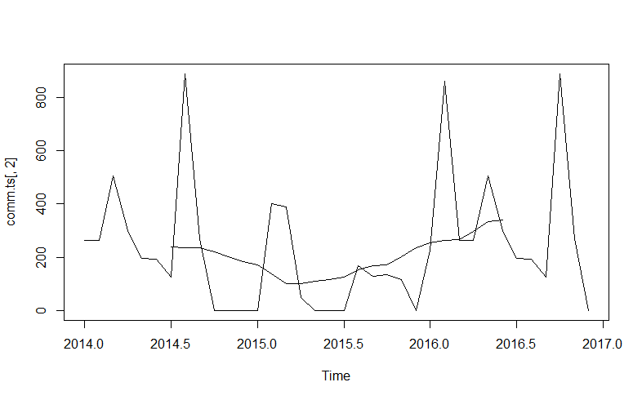

Trend line

(There is decrease in price in the beginning of the year 2015 and then price has increased after that.)

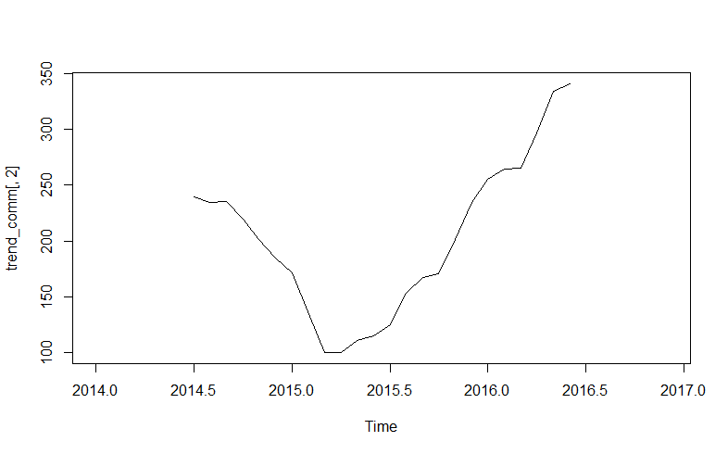

**Before De-Seasonlise**

Jan Feb Mar Apr May Jun Jul Aug Sep Oct Nov Dec

2014 264 263 506 300 196 193 125 888 270 0 0 0

2015 0 400 388 50 0 0 0 167 129 136 115 0

2016 225 859 264 263 506 300 196 193 125 888 270 0

**After De-seasonalise**

Jan Feb Mar Apr May Jun Jul

1 1.222842e+136 1.057361e-18 8.422319e+129 2.769957e+125 2.127652e+117 8.368437e+93 2.802184e+86

2 2.714109e+21 3.330945e+41 4.771806e+78 7.393541e+16 1.607615e+32 1.270016e+10 1.447726e+32

3 1.412166e+119 7.306925e+240 6.701423e+24 2.363617e+109 9.103112e+251 2.466913e+140 1.916041e+117

Aug Sep Oct Nov Dec

1 Inf 4.494084e+118 5.865635e+36 4.727818e+20 9.554116e+74

2 4.734225e+69 2.612879e+57 6.797741e+95 4.154571e+70 9.554116e+74

3 9.266280e+80 4.785654e+55 Inf 8.593516e+137 9.554116e+74

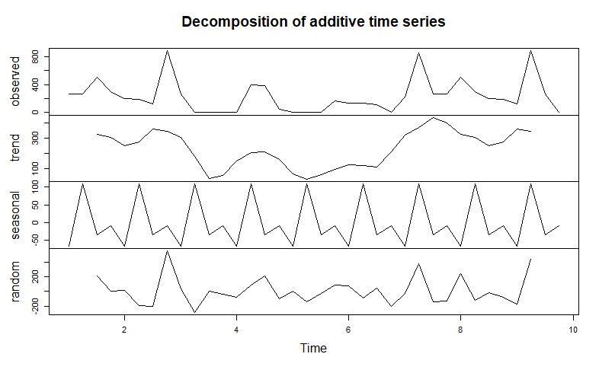**3. Cotton**

**Seasonality**

**Annual Seasonality is followed in this case.**

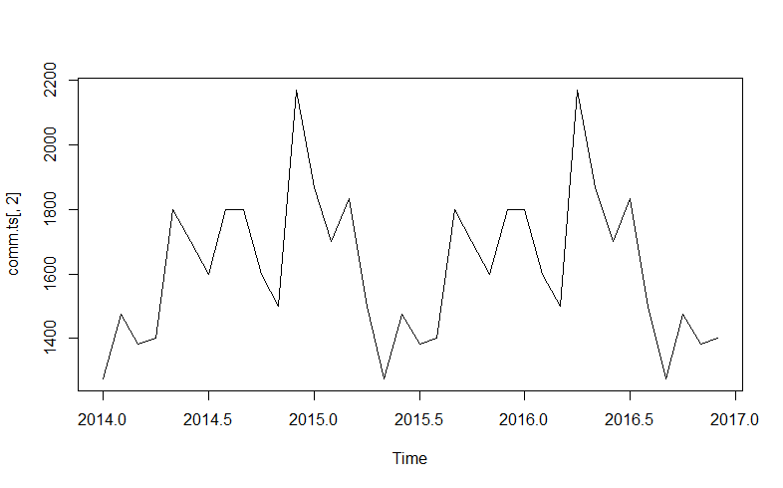

**Seasonality with Trend Line**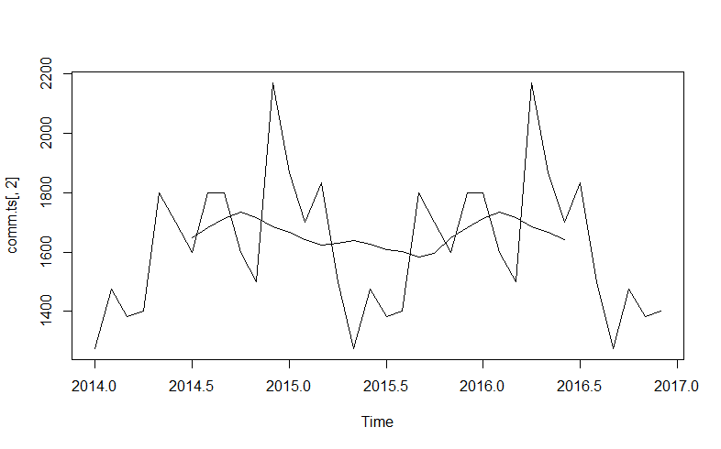

**Trend Line**

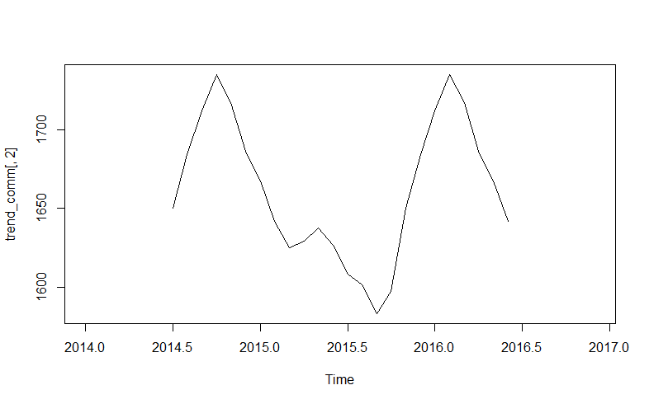

**After and Before de-seasonalise (Red denotes before and green denotes after)**

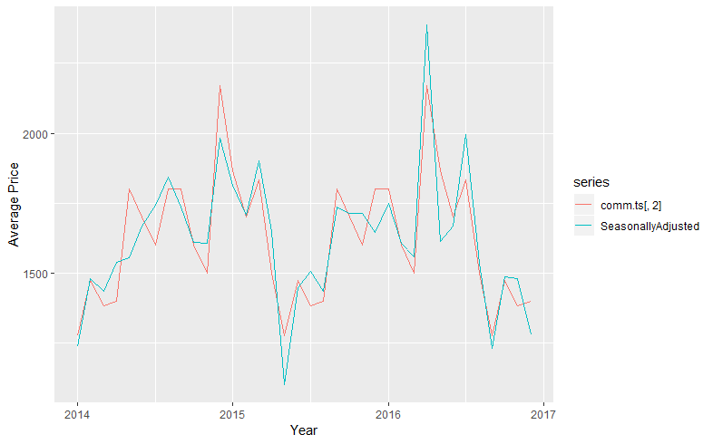

**4. Apple**

**Seasonality**

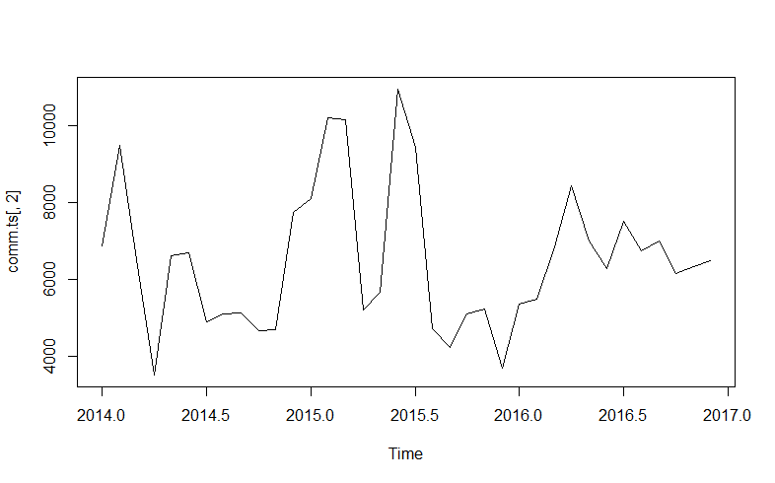

**Seasonality with Trend Line**

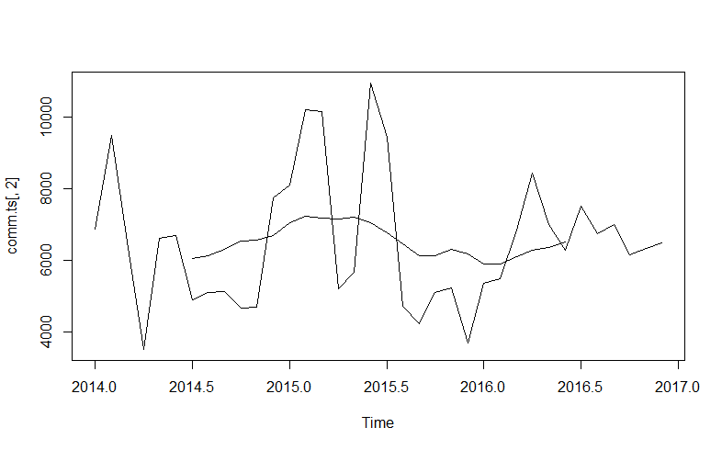

**Trend Line**

**There was an increase in price in the beginning of year 2015 then after few months price decreased.**

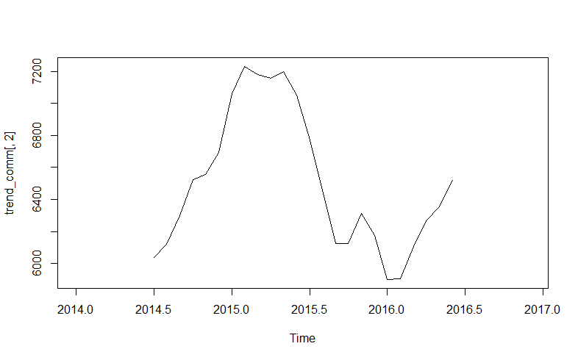

**5. Baru Seed**

**Seasonality**

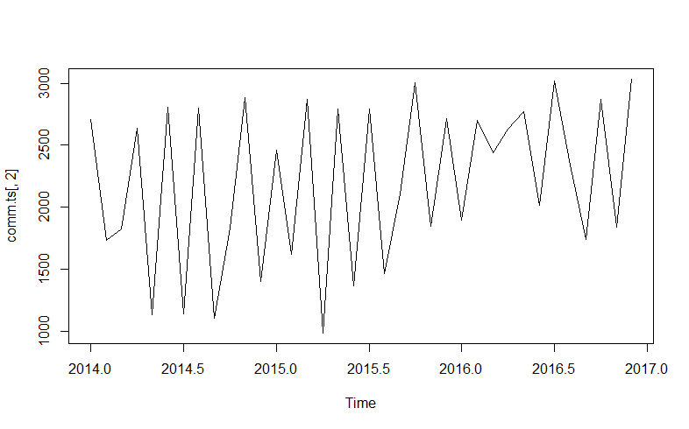

**Seasonality with trend line**

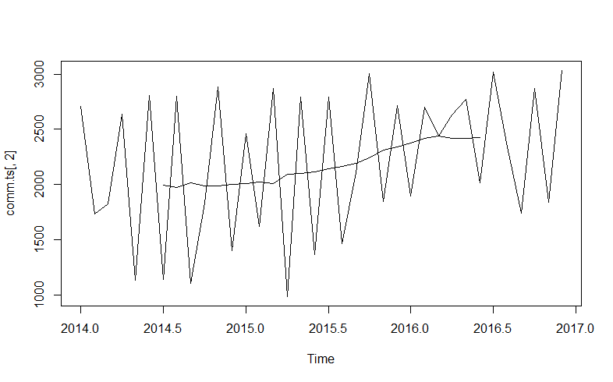

**Trend Line**

**There is an increase over years in price of arvi**

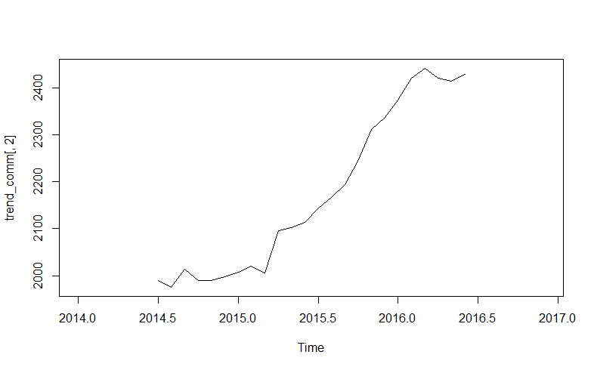

**After and Before de-seasonalise (Red denotes before and green denotes after)**

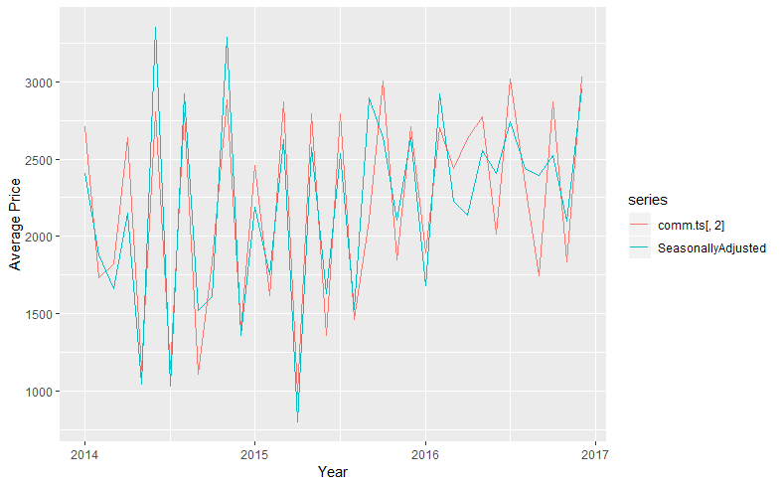

**6. Sunflower**

**Seasonality**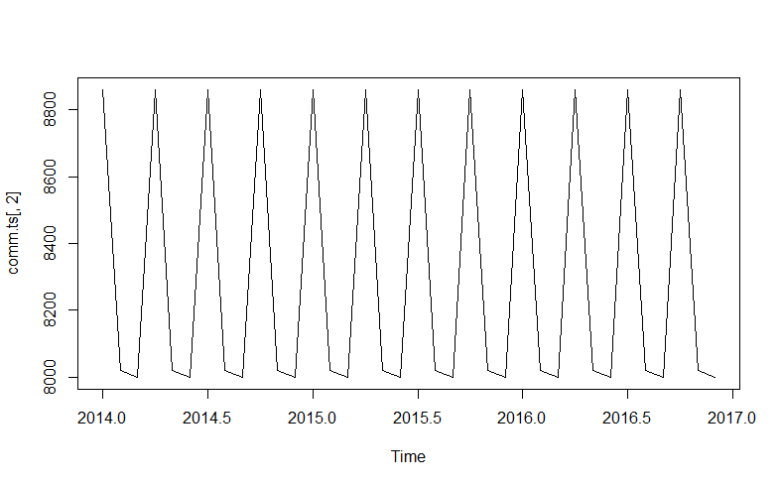

**Seasonality with Trend Line**

**No change in Price over years**

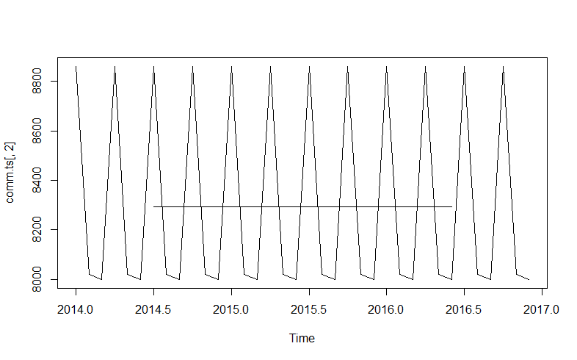

**After and Before de-seasonalise (Red denotes before and green denotes after)**

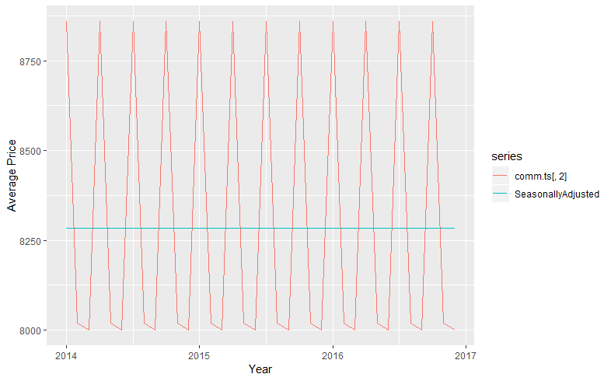 **7. Sugar Cane**

**Seasonality**

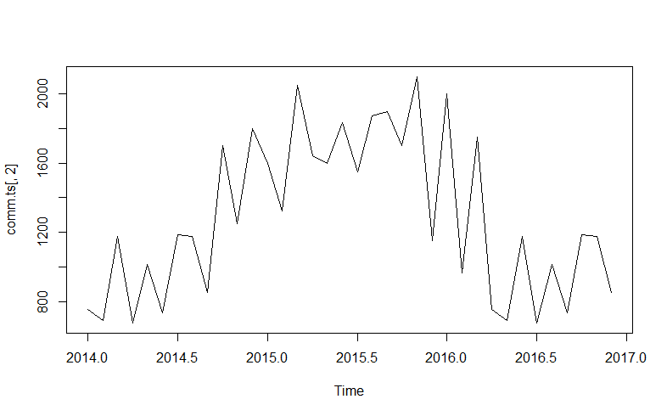

**Seasonality with Trend Line**

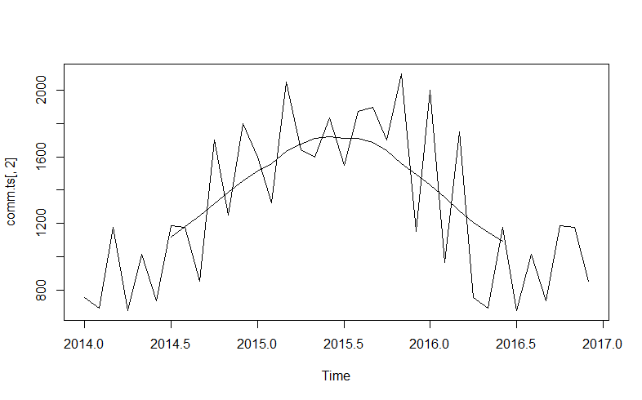

**After and Before de-seasonalise (Red denotes before and green denotes after)**

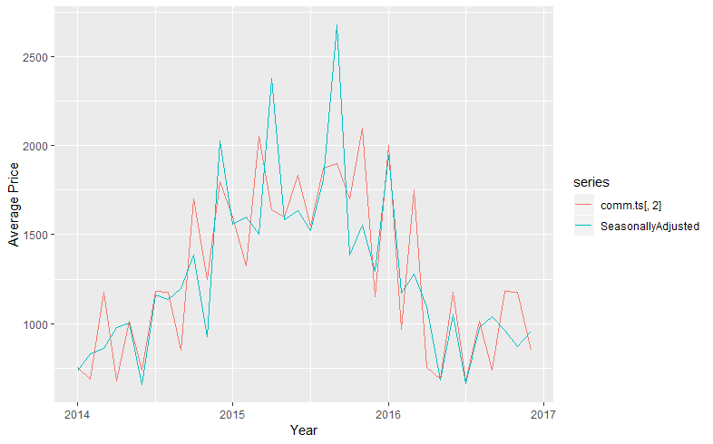

**8. Bajri**

**Seasonality**

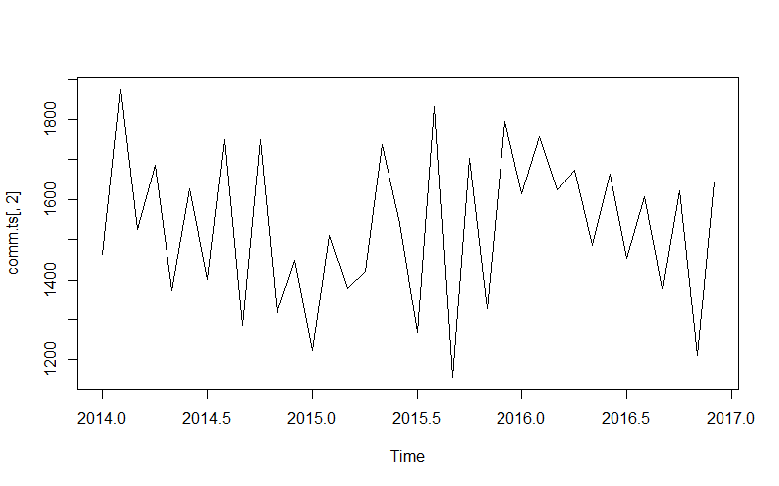

**Seasonality with trend line**

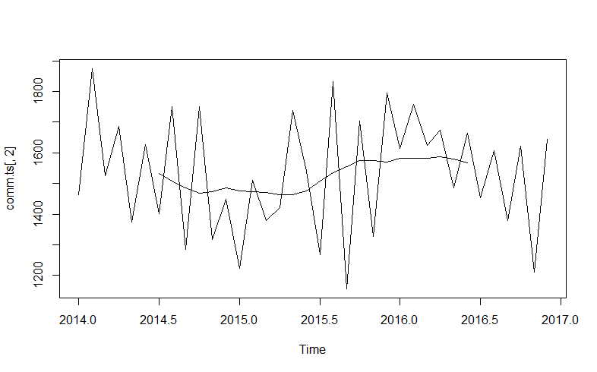

**After and Before de-seasonalise (Red denotes before and green denotes after)**

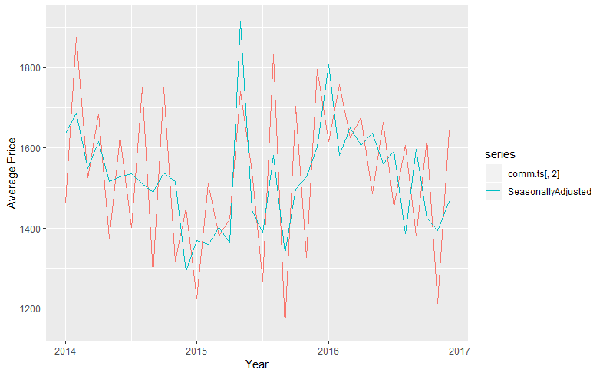

**9. Banana**

**Seasonality**

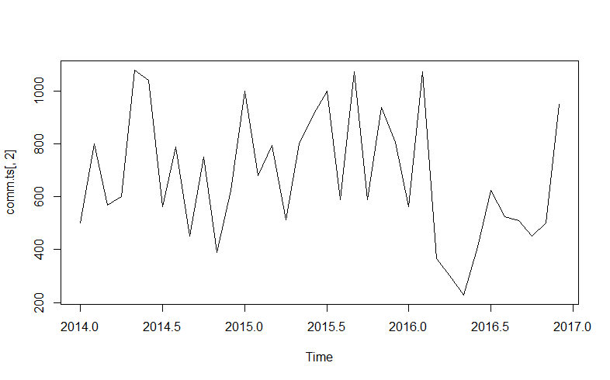

**Seasonality with Trend Line**

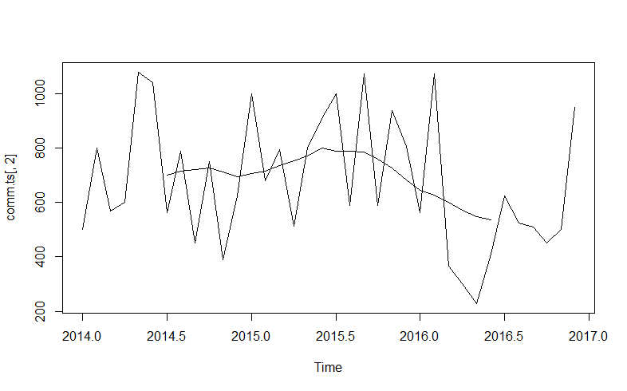

**After and Before de-seasonalise (Red denotes before and green denotes after)**

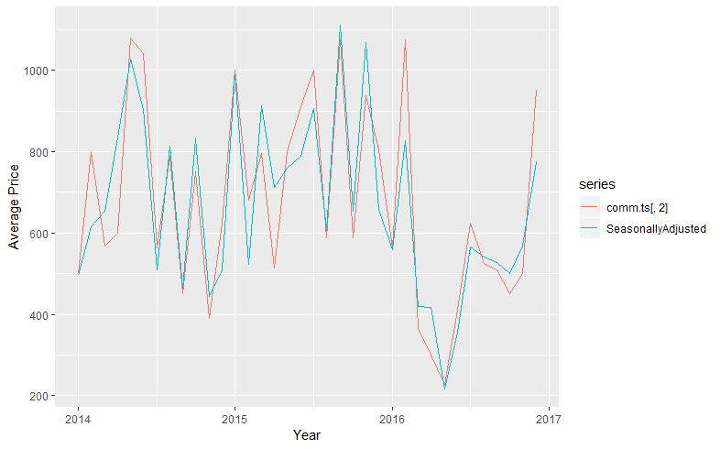

**10. Wheat Husked**

**Seasonality**

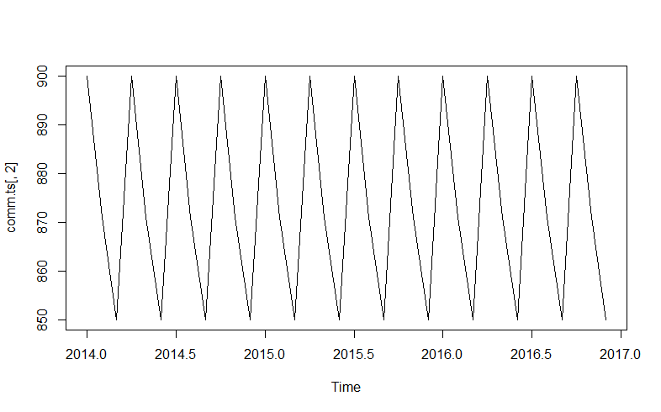

**Seasonality with trend line (constant Trend)**

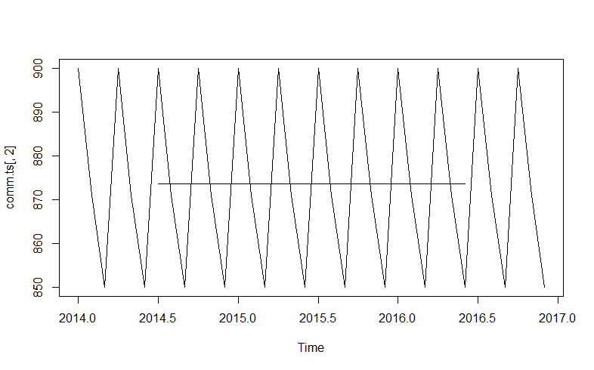

**In the same, we will find seasonality of all the other remaining commodities and de-seasonalize them.**