**Goldman Sachs Hacker Rank Questions**

1. Write an efficient program to find the second smallest element in an array.

It should cover all the edge cases including null and duplicate elements.

If it has fewer than 2 elements than return 0.

Expected complexity: O(n)

Input 1: 2 3 9 2 4 10 9 4 1 7 6

Output : 2

Input 2: {12, 13, 1, 10, 34, 1}

Output: 10

Input 3: 0

Output: 0

Input 4: 0,1

Output 4: 1

Input 5: -1, 0, 0, 1, -1

Output 5: 0

**Rating: Low**

1. Given an apache log file, return IP addresses which accesses the file most often.

Our log is in the format(Current Log format). One entry per line and it starts with the IP Address which accessed the site followed by a whitespace:

“10.0.0.1 -frank [10/DEC/2000:12:34:46 -0500] \”GET /a.gif HTTP/1.0\” 200 234” ,

“10.0.0.1 -frank [10/DEC/2000:12:34:57 -0500] \”GET /b.gif HTTP/1.0\” 200 234” ,

“10.0.0.2 -nancy [10/DEC/2000:12:34:58 -0500] \”GET /c.gif HTTP/1.0\” 200 234”

All log file entries are passed as an array.

Expected complexity: O(n)

Input1: “10.0.0.1 -frank [10/DEC/2000:12:34:46 -0500] \”GET /a.gif HTTP/1.0\” 200 234” ,

“10.0.0.1 -frank [10/DEC/2000:12:34:57 -0500] \”GET /b.gif HTTP/1.0\” 200 234” ,

“10.0.0.2 -nancy [10/DEC/2000:12:34:58 -0500] \”GET /c.gif HTTP/1.0\” 200 234”

Output1: 10.0.0.1

Input2:

“10.0.0.1 -frank [10/DEC/2000:12:34:46 -0500] \”GET /a.gif HTTP/1.0\” 200 234” ,

“10.0.0.1 -frank [10/DEC/2000:12:34:57 -0500] \”GET /b.gif HTTP/1.0\” 200 234” ,

“10.0.0.2 -nancy [10/DEC/2000:12:34:58 -0500] \”GET /c.gif HTTP/1.0\” 200 234” ,

“10.0.0.2 - frank [10/DEC/2000:12:34:45 -0500] \”GET /a.gif HTTP/1.0\” 200 234”,

“10.0.0.2 - frank [10/DEC/2000:12:34:43 -0500] \”GET /b.gif HTTP/1.0\” 200 234”,

“10.0.0.1 - nancy [10/DEC/2000:12:34:41 -0500] \”GET /c.gif HTTP/1.0\” 200 234”

Output2: 10.0.0.2, 10.0.0.1

**Rating: Low**

1. Panagram Detector:

The sentence “The quick brown fox jumps over the lay dog” contains every single letter in the alphabet. Such sentences are called pangrams.

Write a function that takes an input string and returns Boolean value “True” if all the characters of the alphabet are included in the input string.

Input 1: abcdefghijklmnopqrstuvwxy

Output: False

Input2: The quick brown fox jumps over the lay dog

Output: True

**Rating: Medium**

1. Given a list of student test scores, write a program to find the best average grade.

Each student may have more than one test score in the list. Complete the best average grade in the function below. It has one parameter scores which is an array of student test scores. Each element in the array is a two element array of the form [student name, test score]

Eg: [“Bobby”, “87”]

Test scores may be positive or negative numbers. If you end up with an average grade that is not an integer, you should use a floor function to return the largest integer less than or equal to the average.

Return 0 for empty input.

Input: [ [ “Bobby”, “87”],

[“Charles”, “100”],

[“Eric”, ”64”],

[“Charles”, “22”] ]

Expected output: 87

Explanation: The average scores are 87, 61 and 64 for Bobby, Charles and Eric respectively, of which 87 is the highest.

**Rating: Medium**

1. Find the Square root of a number:

This is not a math problem. You are required to code up a simple mathematical technique to find the square root of a number.

The Newton Raphson method can be used to find the square root of a number N as follows:

Make an initial guess

Update the initial guess using the below formula

New Estimate = Current Estimate – (F(Current Estimate)/F’(Current Estimate)) where

F(Current Estimate) = Current Estimate * Current Estimate -N

F’(Current Estimate) = 2* Current Estimate

Input : {2,4,100,0}

Output: {1.41421, 2, 10}

**Rating: Low**

1. Given an input number X, return true is X is a power of 10 otherwise return false

Expected Complexity: O(n)

Input 1: 10

Output 1: True

Input 2: 3

Output 2: False

Input 3: 1000

Output 3: True

**Rating: Low**

1. Addition of Fractions:

Given two fractions passed in as an int array. Return the fraction which is the addition of two input fractions.

A fraction is represented as a two-element array – [numerator, denominator].

The returned fraction has to be in its simplest form.

Input 1: arr1=[1,500] arr2 = [2, 1500]

Output1 : [1,300]

Input 2: arr1=[2,3] arr2 = [1, 2]

Output 2 : [7,6]

**Rating: Medium**

1. Given a string, find its first non-repeating character.

Expected Complexity: O(n)

Input 1: GeeksforGeeks

Output1: f

Input 2: GeeksQuiz

Output2: G

**Rating: Low**

1. Circle and Lattice Points:

Given a circle of radius **r** in 2-D with origin or (0, 0) as center. The task is to find the total lattice points on circumference. Lattice Points are points with coordinates as integers in 2-D space.

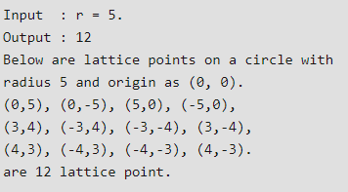

**Rating: Medium**

1. Given a set of numbers as an array, arrange the numbers in such a way that it forms the biggest number.

Expected Complexity: O(n)

Input 1: {54, 546, 548, 60}

Output1: 6054854654

Input 2: {1, 34, 3, 98, 9, 76, 45, 4}

Output 2: 998764543431

**Rating: Medium**

1. Given an expression string exp , write a program to examine whether the pairs and the orders of “{“,”}”,”(“,”)”,”[“,”]” are correct in exp.

Expected Complexity: O(n)

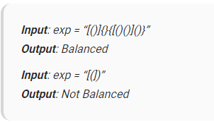

**Rating: Medium**

1. Given an array of integers, replace every element with the next greatest element (greatest element on the right side) in the array. Since there is no element next to the last element, replace it with -1.

Expected Complexity: O(n)

Input 1: {16, 17, 4, 3, 5, 2}

Output 2: {17, 5, 5, 5, 2, -1}

**Rating: Medium**

1. Find the minimum element in a sorted and rotated array.

Given an input array which is rotated at some unknown point, find the minimum element in it.

Expected Complexity: O(n)

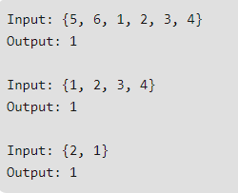

**Rating: Medium**

1. Median of two sorted arrays of same size:

There are 2 sorted arrays A and B of size n each. Write an algorithm to find the median of the array obtained after merging the above 2 arrays(i.e. array of length 2n). The complexity should be O(log(n)).

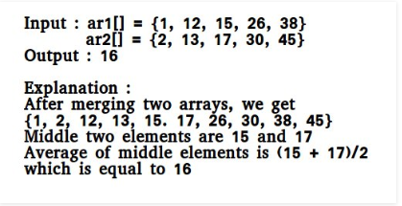

**Rating: Low**

1. Given an array of n elements which contains elements from 0 to n-1, with any of these numbers appearing any number of times. Find these repeating numbers in O(n) and using only constant memory space.

For example, let n be 7 and array be {1, 2, 3, 1, 3, 6, 6}, the answer should be 1, 3 and 6.

**Rating: Low**

1. Sliding Window Maximum

Give an array **arr[]** of **N** integers and another integer **k ≤ N**. The task is to find the maximum element of every sub-array of size **k**.

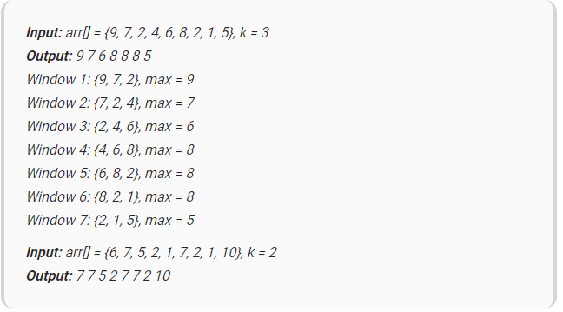

**Rating: Medium**