Terraform Beginners

LAB Works

Table of Contents

Environment Setup 2

Visual Studio Code 2

Terraform Download 2

Set the Environment Variable 2

Test the Installation 2

Exercise 1 – Create GitHub Repo using Terraform 3

Screenshot of Final Result 3

Exercise 2 – Create Docker Container Using Terraform 4

Download and Install Docker Desktop 4

Screenshot of Final Result 4

Common Errors / Troubleshoots: 4

Exercise 3 – Create Azure Resources From Terraform 5

Screenshot of Final Result : 5

Common Errors / Troubleshoots: 5

Exercise 4 – Create a Python Container 6

Screenshot of Final Result 6

Common Errors / Troubleshoots: 6

## Environment Setup

### Visual Studio Code

Download and install Visual Studio Code: <https://code.visualstudio.com/>

Install the following extension in VS Code:

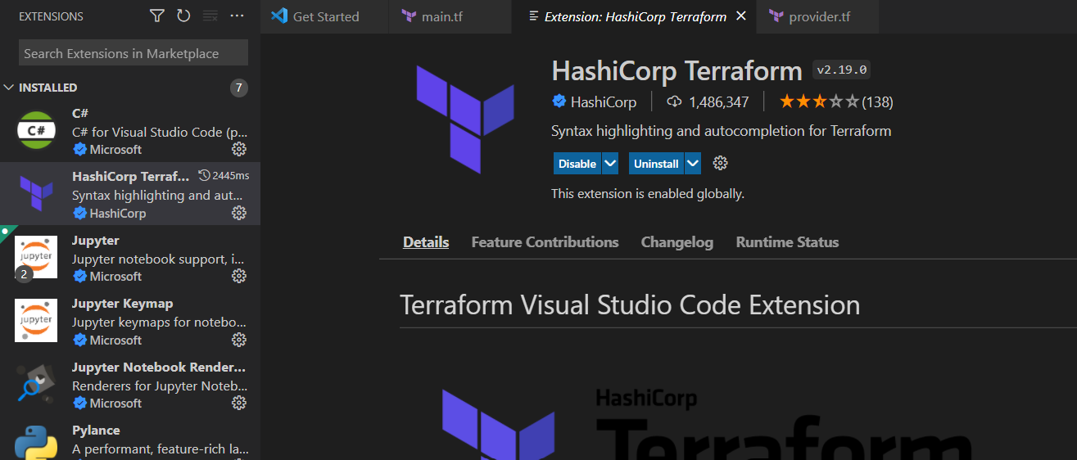

### Terraform Download

Download Terraform for Windows from this location:

Click on the amd64 link for 64 bit OS

<https://www.terraform.io/downloads>

Unzip the downloaded file. Keep the EXE in any location of your choice

Eg: C:\Terraform

### Set the Environment Variable

Go to Control Panel, click on System 🡪 Advanced System Setting 🡪 Environment Variable 🡪 Path

Add a new path with the location of the EXE

### Test the Installation

Run 🡪 cmd

Type in the following command and see it it returns the version installed

terraform --version

## Exercise 1 – Create GitHub Repo using Terraform

Lab Tutorial URL: <https://www.youtube.com/watch?v=aHve0Ji13IY>

Provider URL: <https://registry.terraform.io/providers/integrations/github/latest/docs/resources/repository>

Source Code URL: <https://github.com/kaushikganguli/Terraform_Beginner/tree/main/git_tf_integration>

### Screenshot of Final Result

## Exercise 2 – Create Docker Container Using Terraform

### Download and Install Docker Desktop

<https://docs.docker.com/desktop/windows/install/>

Lab Tutorial URL : <https://www.youtube.com/watch?v=z5XW17BRh7k>

Provider URL : <https://registry.terraform.io/providers/kreuzwerker/docker/latest/docs>

Source Code URL : <https://github.com/kaushikganguli/Terraform_Beginner/tree/main/docker_tf>

### Screenshot of Final Result

### Common Errors / Troubleshoots:

Docker Desktop Failed to Load Error

If the Docker Desktop fails to load, go to Settings 🡪 Resources and set the appropriate values.

If you get the following error on running terraform plan, change the provider details

Did a minor changed to the provider to enable version compatibility

provider "docker" {

  version = "~> 2.7"

  host    = "npipe:////.//pipe//docker_engine"

}

## Exercise 3 – Create Azure Resources From Terraform

Lab Tutorial URL: <https://www.youtube.com/watch?v=vExArBRJDxU>

Provider URL: <https://github.com/hashicorp/terraform-provider-azurerm>

Source Code URL : <https://github.com/kaushikganguli/Terraform_Beginner/tree/main/az_resourcegroup>

### Screenshot of Final Result :

### Common Errors / Troubleshoots:

If you get this error, you might need to login first using Azure CLI

## Exercise 4 – Create a Python Container

Lab Tutorial URL : <https://www.youtube.com/watch?v=CMyTMfSwb_c>

Provider URL : <https://registry.terraform.io/providers/kreuzwerker/docker/latest/docs>

Source Code URL : <https://github.com/kaushikganguli/Terraform_Beginner/tree/main/py_container>

### Screenshot of Final Result

### Common Errors / Troubleshoots:

Docker Desktop Failed to Load Error

If the Docker Desktop fails to load, go to Settings 🡪 Resources and set the appropriate values.

If you get the following error on running terraform plan, change the provider details

Did a minor changed to the provider to enable version compatibility

provider "docker" {

  version = "~> 2.7"

  host    = "npipe:////.//pipe//docker_engine"

}