WT Assignment 1
Kaushik Ghorai 2402031000022
Steps to create github repository
Step 1: open in github.com write email address and click signin.

Step 2: Write down password and username.
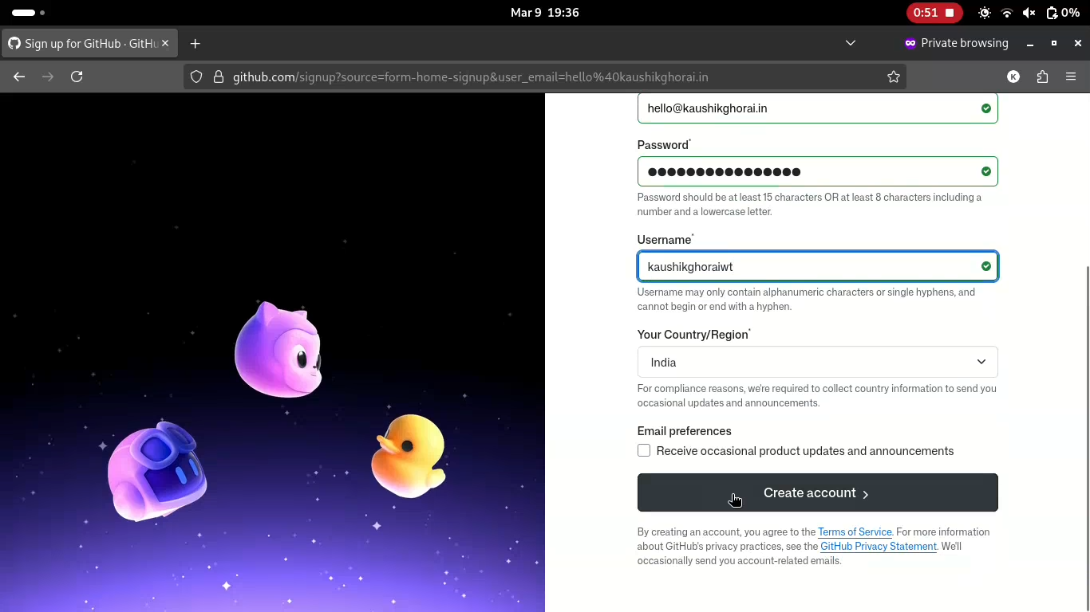
Step 3: Click on Create repository.
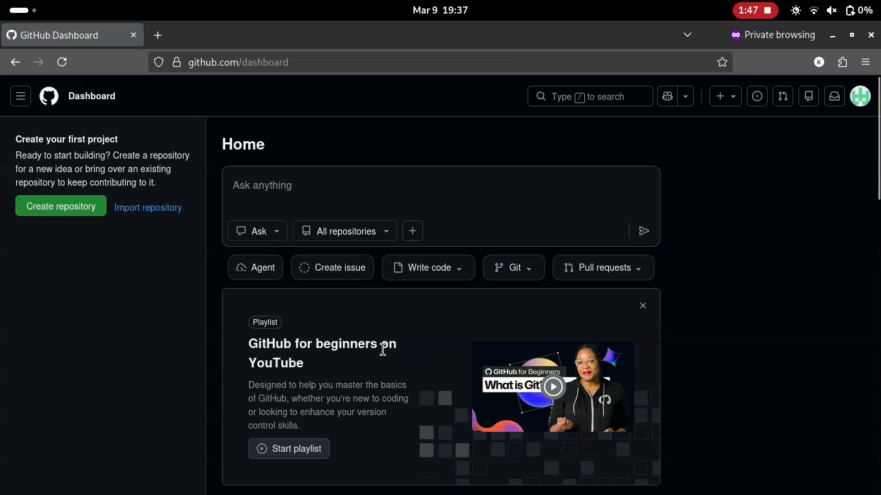

Step 4: write enrollment number as a repository name and scroll down then click on create repository.
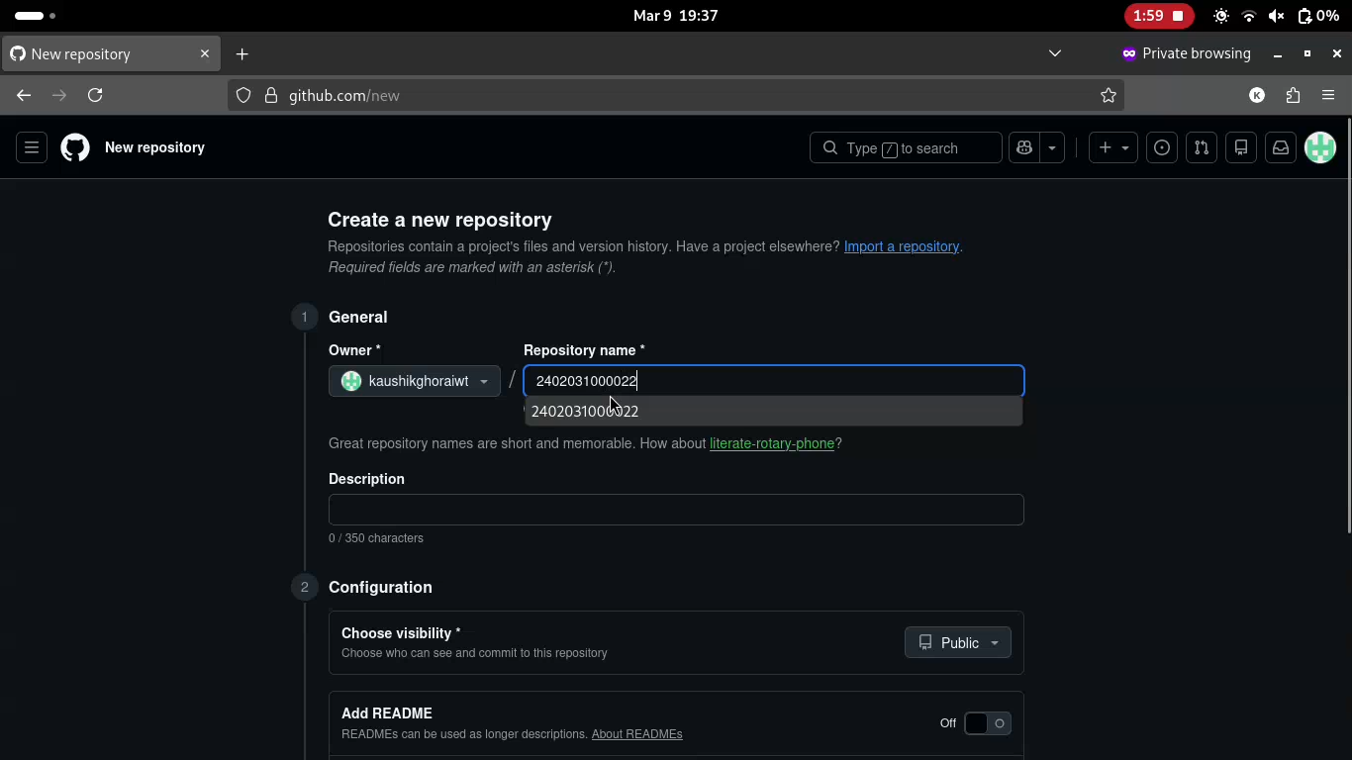

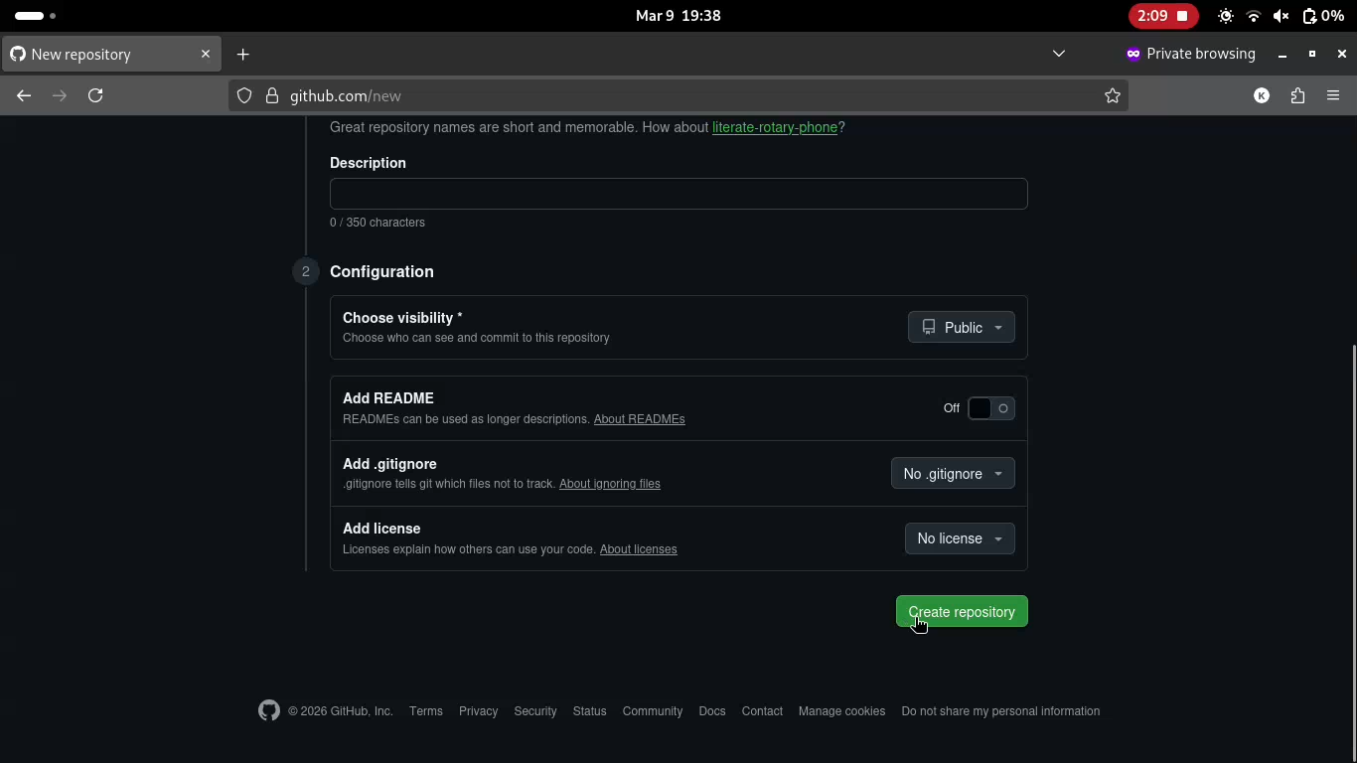

Step 5: Click on create a new file.
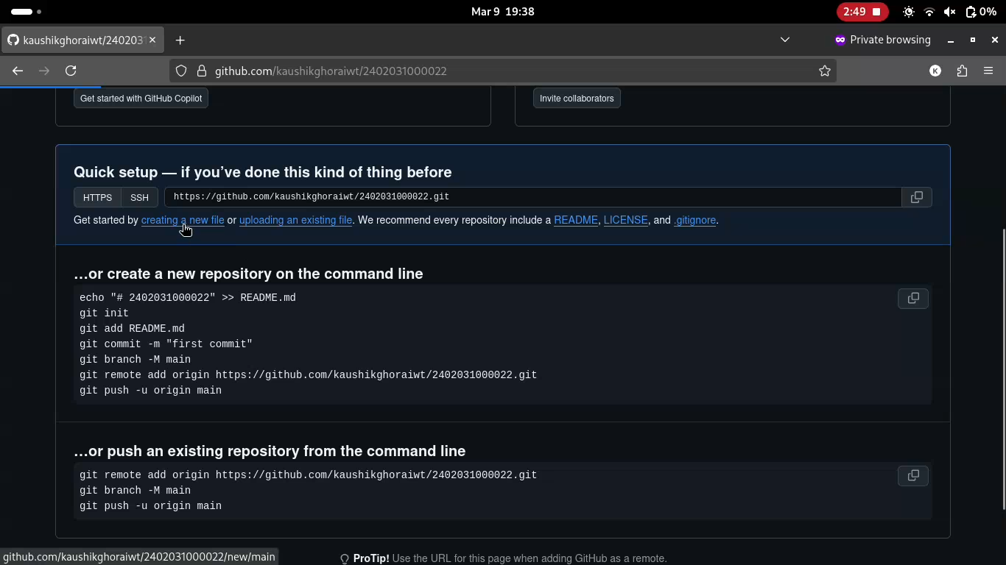

Step 6: In name your file input box write “Assignment_1/” and again “1”. (“/” is important to make folder.
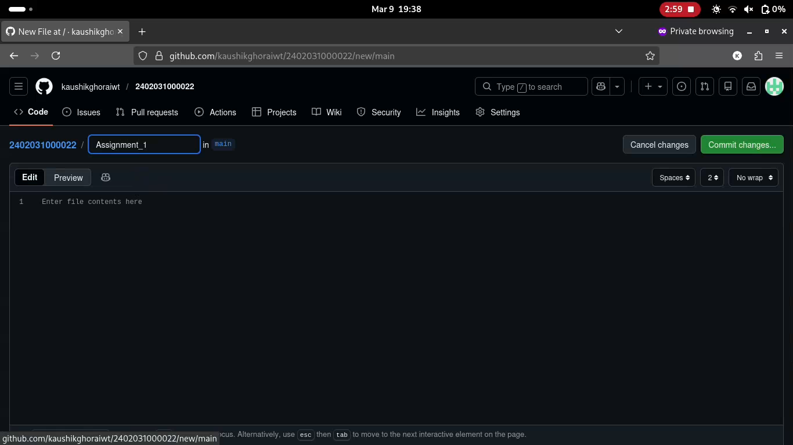

Step 7: Click on Add file > upload files > choose files.
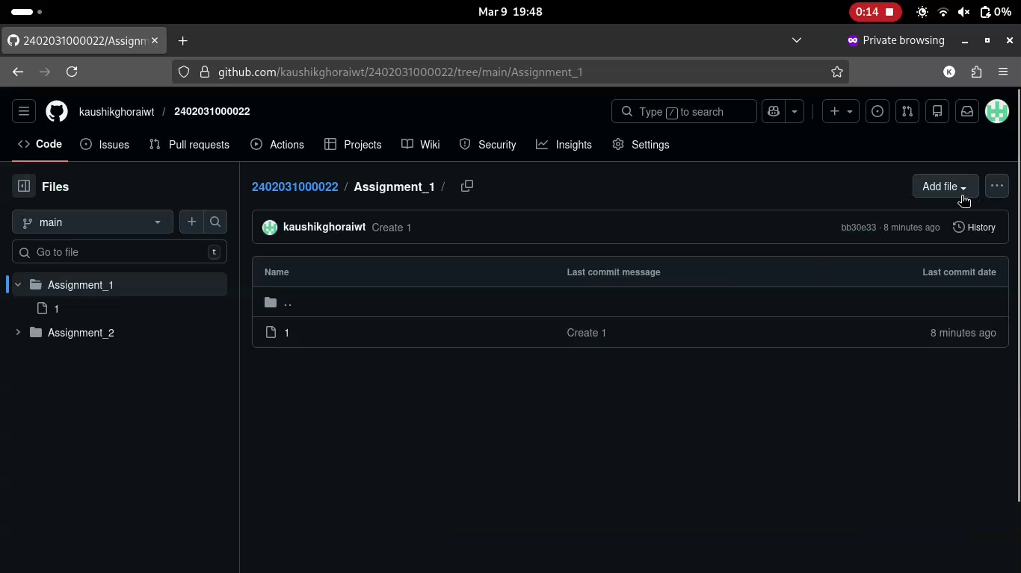

Step 9: Select the necessary files for assignment 1. Wait for the files to upload and then click commit changes at the bottom of the page.
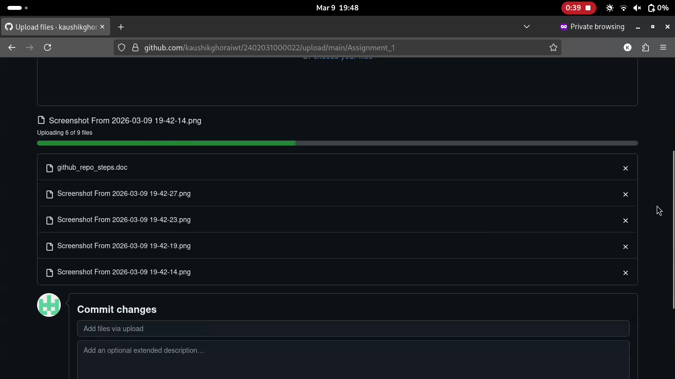
Step 10: Same for the Assignment 2.


