Program Structures and Algorithms

Spring 2023(SEC –3)

**NAME**: Kaushik Gnanasekar

**NUID**: 002766012

**Task:**

Implement Insertion sort and benchmark using *Benchmark_Timer* class.

**Relationship Conclusion:**

Ordered array: This is the best case, the average outcome takes O(n) operations.

Partially ordered array: Since its partially ordered, the performance is close to O(n2).

Randomly ordered array: On an average randomly ordered input takes O(n2).

Reversed array: This is the worst case for this algorithm, which is O(n2)

**Evidence to support that conclusion:**

|  |  |  |  |  |
| --- | --- | --- | --- | --- |
| N | Ordered (ms) | Partial Order (ms) | Random Order (ms) | Reverse Order (ms) |
| 1000 | 0.00339663 | 0.16246413 | 0.63613797 | 1.24266037 |
| 2000 | 0.00539498 | 0.64429335 | 2.5310554 | 5.03385787 |
| 4000 | 0.01064373 | 2.5427101 | 10.10178627 | 20.17509794 |
| 8000 | 0.01621123 | 10.06152422 | 39.57033243 | 78.56655208 |
| 16000 | 0.0393167 | 40.9895279 | 172.596395 | 324.4013821 |

**Graphical Representation:**

**Unit Test Screenshots:**

Benchmark Test

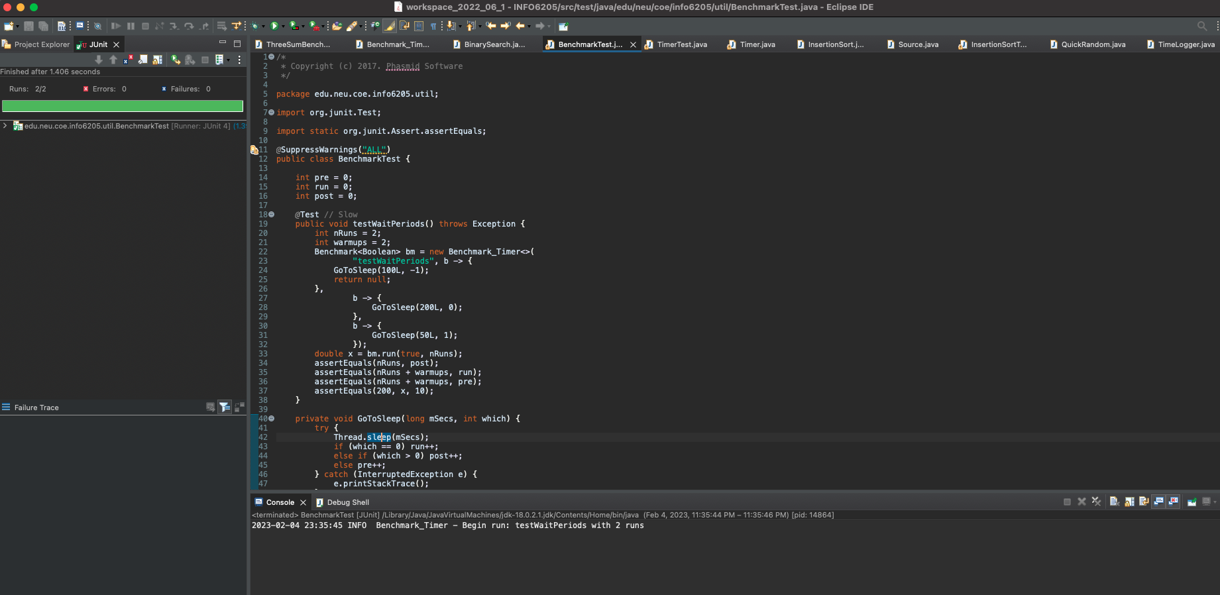

Timer Test

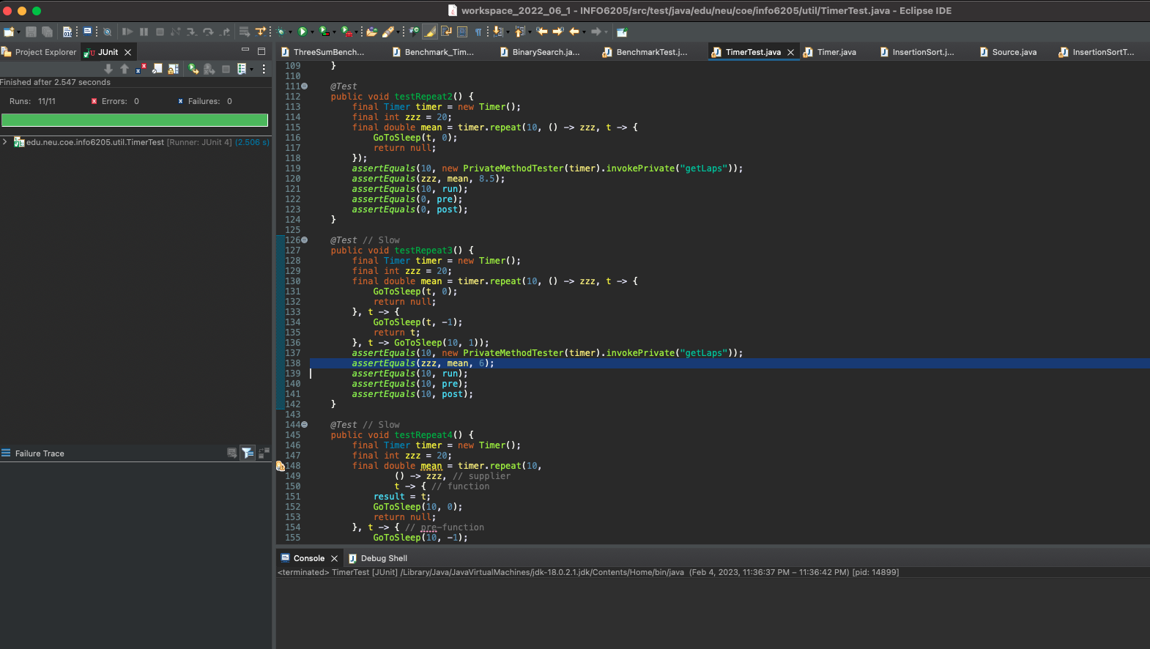

Insertion Sort Test

