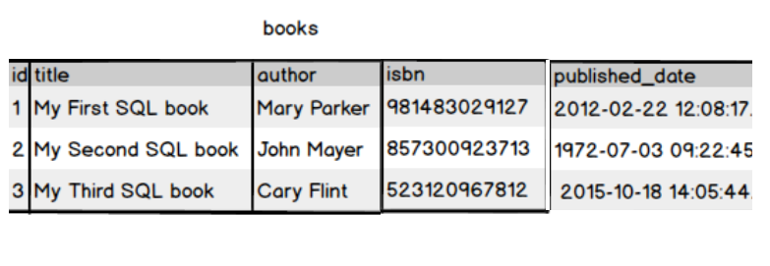

Create a book table with id as primary key and provide the appropriate data type to other attributes .isbn no should be unique for each book

Write a query to fetch the details of the books written by author whose name ends with er.



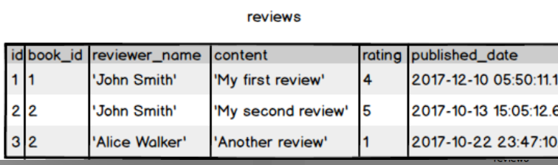

Display the Title ,Author and ReviewerName for all the books from the above table





Display the reviewer name who reviewed more than one book.

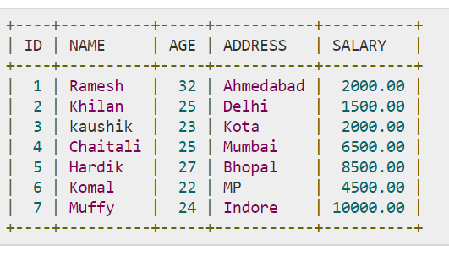

Display the Name for the customer from above customer table who live in same address which has character o anywhere in address

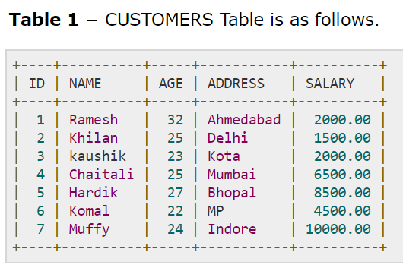 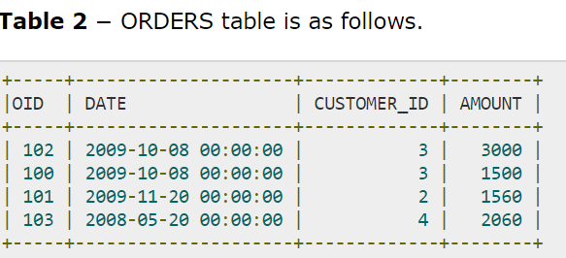

Write a query to display the Date,Total no of customer placed order on same Date

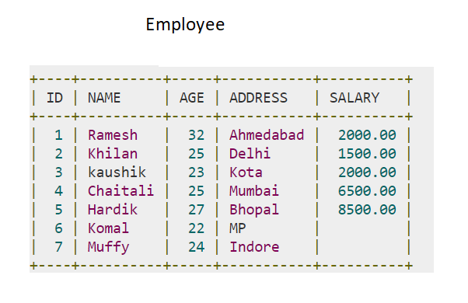

Display the Names of the Employee in lower case, whose salary is null

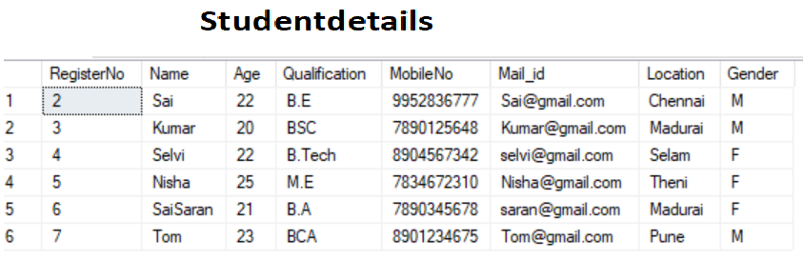

Write a sql server query to display the Gender,Total no of male and female from the above

relation .

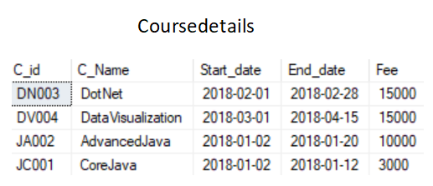 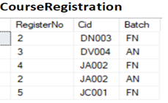

Retrieve the CourseName and the number of student registered for each course between 2018-01-02 and 2018-02-28 and arrange the result by courseid in descending order

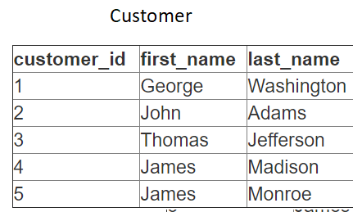

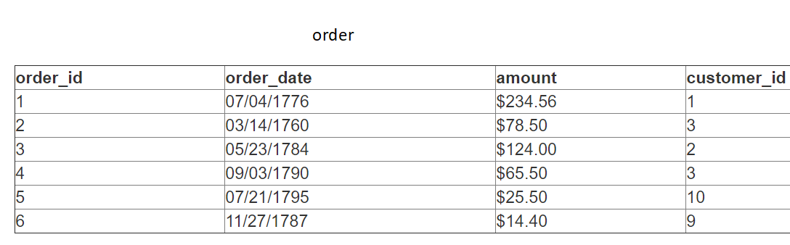

Display the Firstname and LastName of the customer who have placed exactly 2 orders.



Display all the student name in reverse order and Capitalize all the character in location

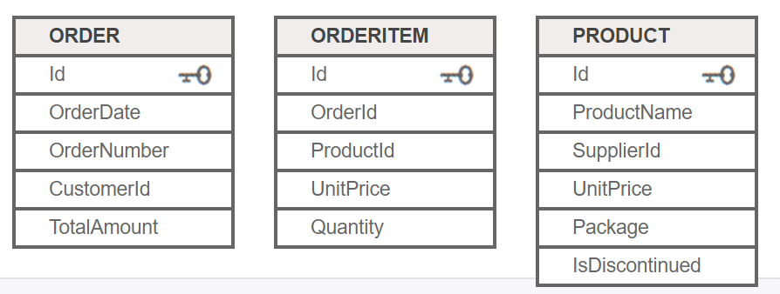

Create a view table to display the ProductName,ordered Quantity and OrderNumber from the above relations



 

Display the Course Name registered by student Nisha