**Initialising an empty Git Repository on Github Website.**

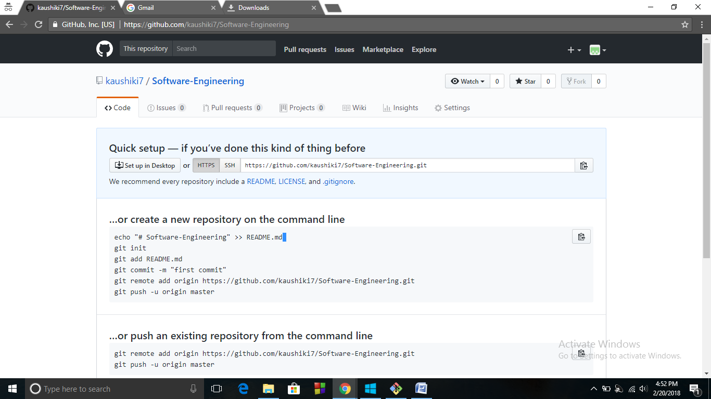

**Creating a new repository on the command line using set of Commands**

git init

git add filename

git commit -m "first commit"

git remote add origin https://github.com/kaushiki7/Software-Engineering.git

git push -u origin master

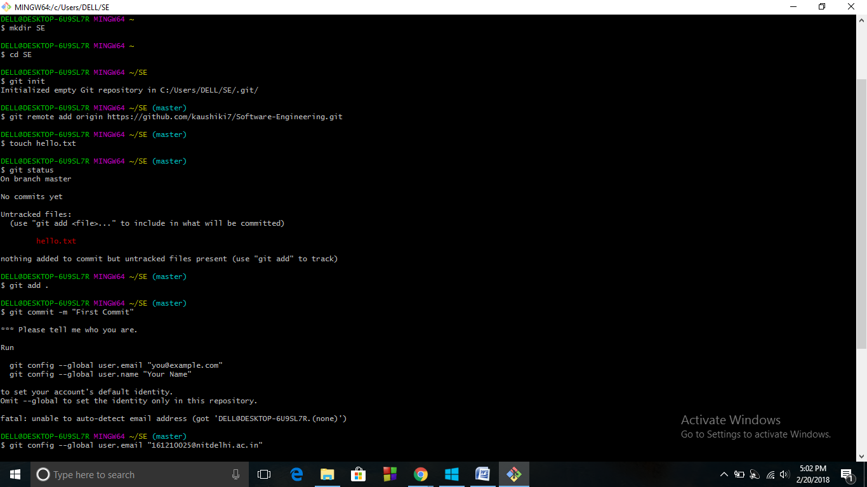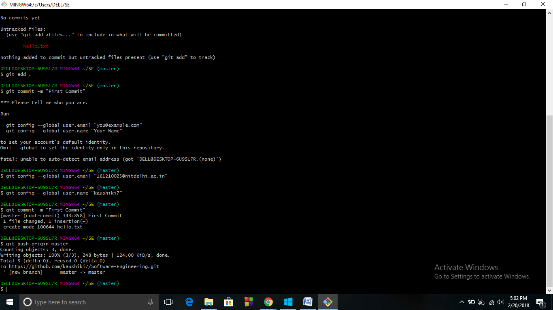

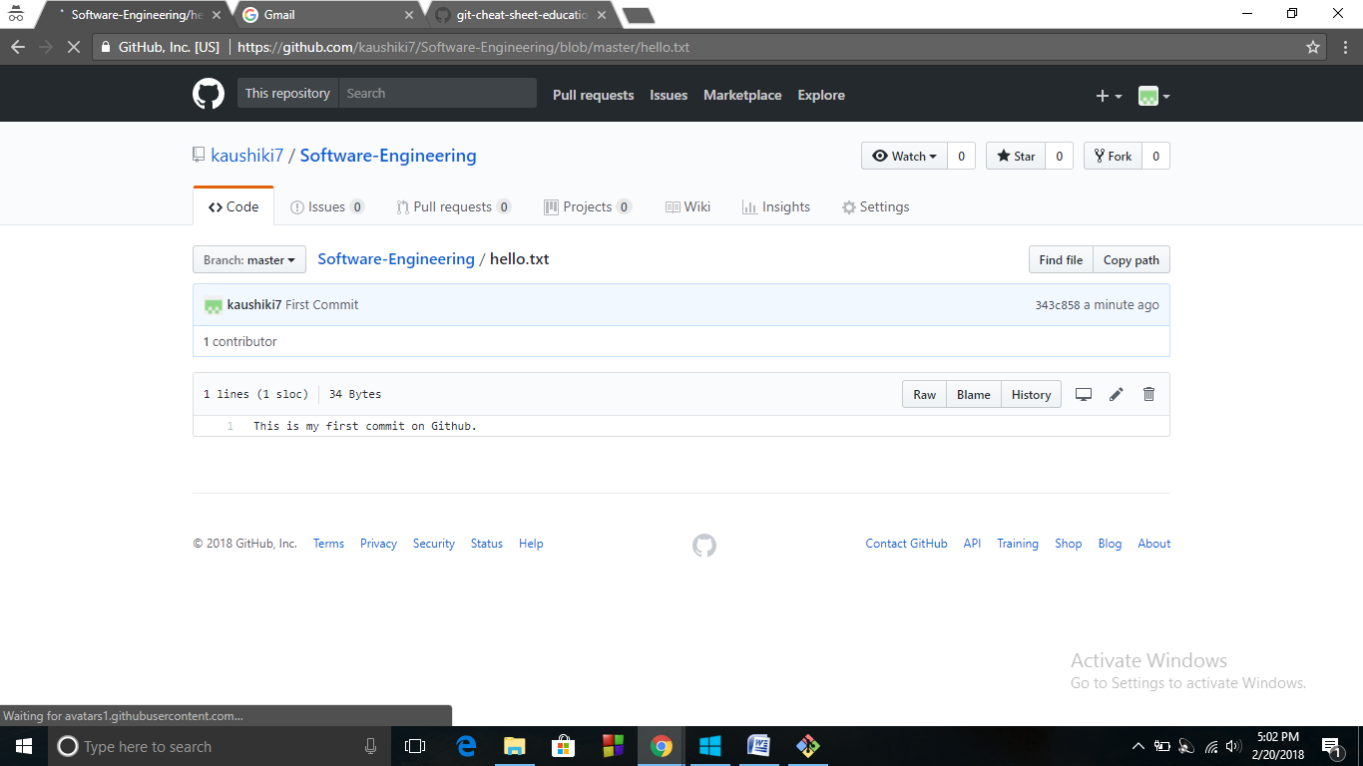

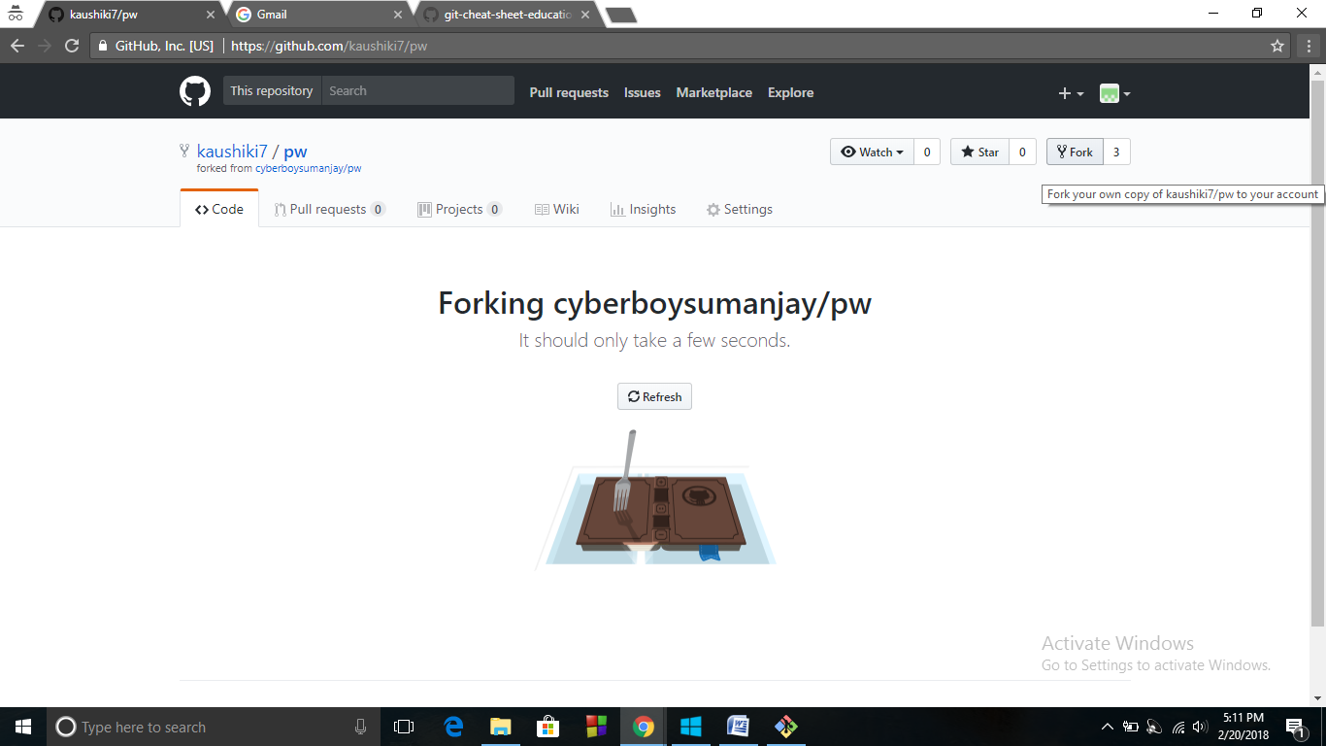

**Forking a Repository**

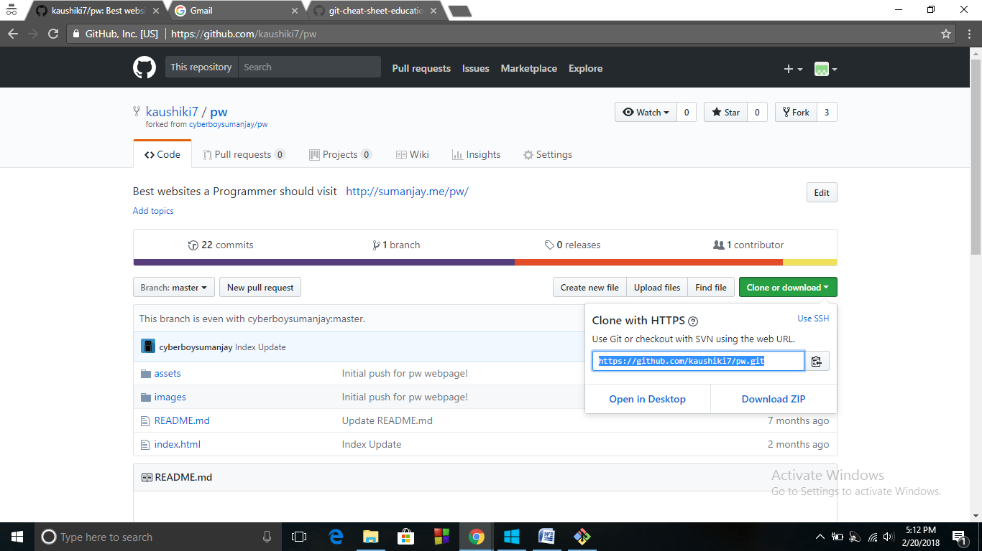

**Cloning a Repository**

git clone <https://github.com/kaushiki7/pw.git>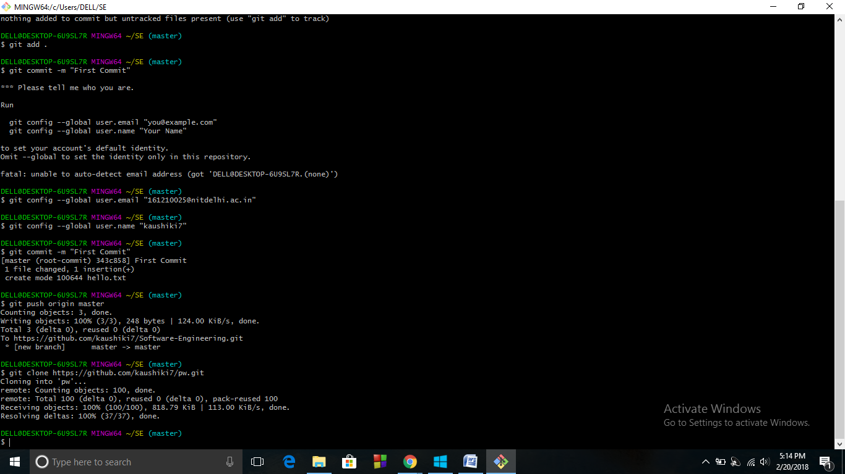

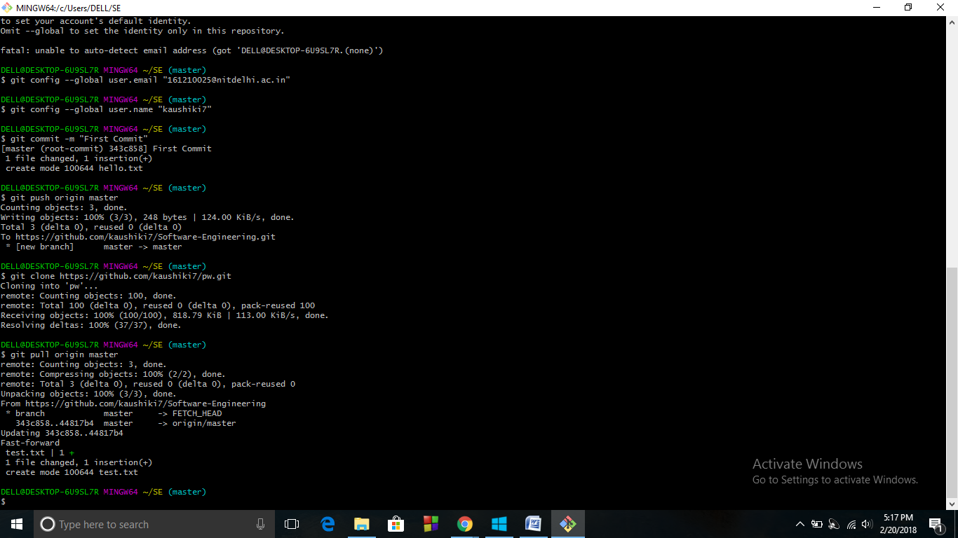

**Pulling files from Repository**

git pull origin master

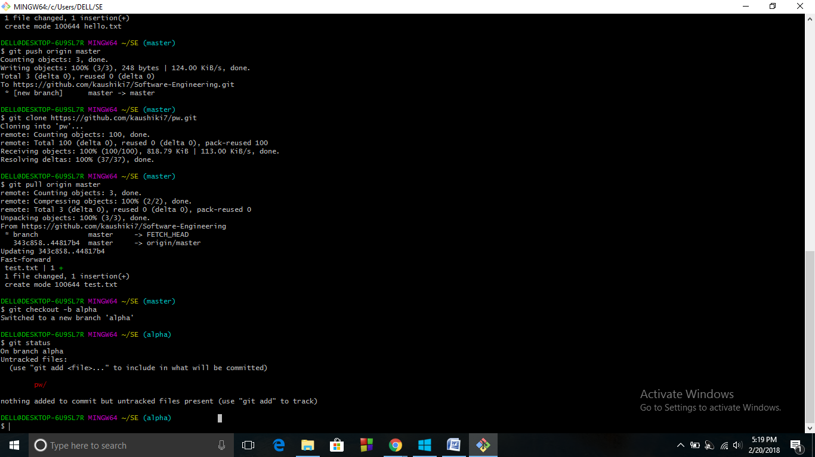

**Switching to a new branch**

git checkout –b branch_name