Scenarios to cover:
- New non-RTL param added to an IP's .prm — all existing SoC/SS instances of that IP need values
- New SoC or SoC·SS starts using an existing IP — all non-RTL params for that IP need values for the new context
- Existing param value changes for a specific SoC/SS instance (e.g. revision bump, feature flag flip)
- IP is removed from a SoC/SS — stale entries need pruning
- New IP added to the ecosystem — no non-RTL params exist yet; DB needs bootstrapping
- Param removed from a .prm — DB has orphaned entries
- Bulk SoC variants — a new chip tier (e.g. IMX95 Lite) that's mostly identical to an existing one
The core tension: authors own .prm files and know the values, but they won't touch the DB directly. So the workflow needs to pull information from authors through a lightweight, familiar interface and push it into the DB automatically.
Good. Now let me write the response and build the diagram:
The scenarios you described fall into four distinct trigger types, and the key design insight is: the .prm file already contains the ground truth of what needs to exist in the DB — you can diff it against the DB at any time to know exactly what's missing, stale, or orphaned. That makes the workflow computable, not manual.
Here's the full proposal:

Core principle: .prm-driven validation as the source of truth
The non-RTL DB should never be updated blindly. Every update starts with a gap analysis — compare the .prm file(s) for the target IP(s) against what the DB already contains, and generate a structured contribution request that authors fill in. The DB only accepts values through a validated merge, never through direct hand-editing.
The four scenarios and their workflows:
Scenario 1 — New non-RTL param added to an IP's .prm A CI hook on the .prm file detects the new parameter (type non-rtl). It runs the gap analyzer, finds all existing SoC/SS instances of that IP in the DB, and generates a YAML contribution file with one empty slot per instance. That file is committed to a db-contributions/ branch and a pull request is opened — assigned automatically to the IP's author group. Authors fill in values directly in the PR (YAML is readable, diff-friendly). A validation schema checks types, range limits, and enumerated accepted values against the .prm definition before merge. On merge, a DB merge script ingests the YAML into the JSON hierarchy.
Scenario 2 — New SoC or SoC·SS starts using an existing IP When the top spec memory map XLSX gains a new row (detected by CI), the gap analyzer is run for that SoC/SS prefix. It finds all non-RTL params for the referenced IP that don't yet have entries for the new SoC·instance combination, and generates a contribution YAML scoped to just those new slots. Same PR workflow — authored by the new SoC's documentation team lead, reviewed by the IP owner.
Scenario 3 — Param value change for a specific instance Standard PR to the contribution YAML for that SoC/SS. The validation step checks that the new value is within the declared range or accepted value set in the .prm before allowing merge.
Scenario 4 — IP removed from a SoC/SS Memory map XLSX diff detects the removal. CI opens a "cleanup PR" flagging all DB entries for that SoC·IP combination as candidates for deletion. A human approves the cleanup merge — no auto-delete.
Scenario 5 — New IP added to ecosystem (bootstrapping) No DB entries exist yet. The gap analyzer produces a full contribution template covering all SoC/SS instances that reference this IP in any memory map XLSX across the repo. Bootstrapping contribution assigned to the IP spec author.
Scenario 6 — Param removed from .prm .prm diff shows a non-rtl param removed. CI opens an "orphan cleanup" PR flagging DB entries for that param across all instances. Author of the .prm change reviews and approves deletion.
Scenario 7 — New chip tier (variant of existing SoC) Contribution template is pre-populated with values from the parent SoC (e.g. IMX95 → IMX95-Lite). Authors only need to override the entries that differ. A copy-from directive in the contribution YAML allows inheriting all values from a named chip prefix with explicit per-instance overrides on top.
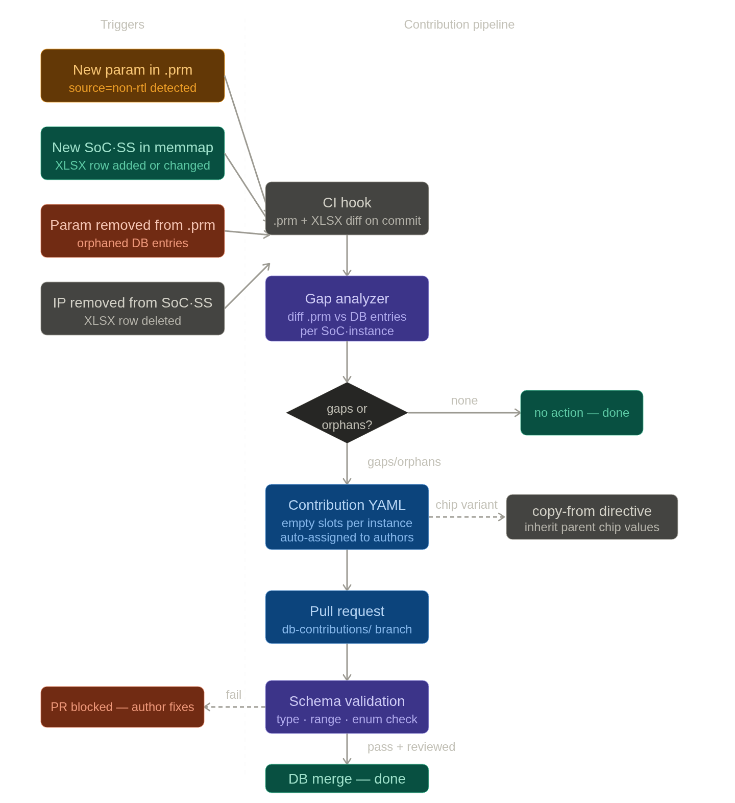

The contribution YAML format (what authors actually fill in):
yaml
# Auto-generated by gap-analyzer — do not edit structure
# IP: FlexCAN | triggered-by: FEATURE_FDCAN added to ip.prm
# Assign: @flexcan-doc-team
schema_version: "2.1"
ip: FlexCAN
param: FEATURE_FDCAN
type: boolean # from .prm — validates your entries
accepted-values: [true, false]

instances:
IMX95:
FLEXCAN_0: __FILL__
FLEXCAN_1: __FILL__
IMX93:
FLEXCAN_0: __FILL__
FLEXCAN_1: __FILL__

# Chip variant shortcut — uncomment to inherit and override
# copy-from: IMX95
# overrides:
# FLEXCAN_0: false
Tooling you'd need to build (all small Python scripts):
Tool | Trigger | What it does
gap-analyzer.py | CI on .prm or XLSX commit | Diffs .prm non-rtl params vs DB; diffs XLSX rows vs DB instances; outputs structured gap report
contribution-gen.py | Output of gap-analyzer | Generates pre-filled YAML contribution files with __FILL__ slots; opens draft PR
schema-validator.py | PR CI check | Validates YAML values against .prm type/range/enum before merge is permitted
db-merge.py | On PR merge | Ingests validated YAML into the JSON DB hierarchy; handles copy-from inheritance
orphan-report.py | On param/IP removal | Generates cleanup PR flagging stale DB entries for human approval
Key guardrails:
- The DB JSON is never edited directly — only through the merge tool
- __FILL__ slots that remain unfilled block the PR merge (schema validator rejects them)
- The copy-from directive is the escape hatch for chip variants — authors declare inheritance explicitly and only override what differs, rather than re-entering everything
- Cleanup (orphan removal) always requires human approval — never auto-deleted



