Production-Ready AI Brokerage Assistant
Complete Delivery Roadmap
Multilingual (English · Hindi · Tamil) brokerage assistant
Ollama Cloud (Gemma + embeddinggemma) · Qdrant (dense + native sparse) · FastAPI · Sarvam AI · Next.js · Railway Pro
NALCO Pilot

Contents
Contents 2
Project Goal 3
Phase 0 — Research & Competitive Analysis 3
Phase 1 — UX Design 4
Phase 2 — System Architecture 4
Production System Architecture (Railway) 7
Phase 3 — Backend Foundation 8
Phase 4 — Data Ingestion Layer 11
Phase 5 — Embedding Pipeline 16
Phase 6 — RAG System 20
Phase 7 — Multilingual Layer 25
Phase 8 — NALCO Pilot 26
Phase 9 — Website Navigation Agent 26
Phase 10 — Production Frontend 26
Phase 10A — Admin Dashboard 27
Phase 11 — Scalability & Reliability 27
Phase 12 — Algo Trading Knowledge Layer 28
Phase 13 — Differentiators 29
Phase 14 — Production Launch 29
Phase 15 — Production Data Source Registry 30

Project Goal
Build a state-of-the-art multilingual brokerage AI assistant that:
- Supports English, Hindi and Tamil
- Can be embedded into any brokerage website
- Provides stock information
- Explains company disclosures and filings
- Helps users navigate the website
- Explains brokerage services
- Provides NALCO-focused disclosure intelligence
- Supports future algo-trading education and workflows
- Scales to 100+ concurrent users
- Runs on Railway Pro
- Uses Ollama Cloud — Gemma for generation and embeddinggemma (multilingual) for embeddings
- Uses Qdrant as the vector database (dense + native sparse vectors)
- Uses FastAPI as the backend
- Uses a modern React / Next.js frontend

Phase 0 — Research & Competitive Analysis
Before writing code, analyze:

Competitors
Brokerage Chatbots
- Zerodha
- Angel One
- Groww
- Upstox
- ICICI Direct
AI Chat Platforms
- Botpress
- ManyChat
- Intercom AI
- Drift AI
- Freshchat AI

Analyse
For each competitor:
User Experience
- Homepage experience
- Chat experience
- Mobile experience
AI Features
- Language support
- Search capability
- Document retrieval
- Stock information
Lead Generation
- Account opening assistance
- Human handoff
- Call booking

Identify Gaps
Questions:
- What are they missing?
- What frustrates users?
- Where can we differentiate?

Phase 1 — UX Design
Design before coding.

Deliverables
Website Wireframes — Pages:
- Home
- Stock Research
- NALCO Intelligence
- Algo Education
- Pricing
- Contact
Chatbot Widget — Features:
- Floating chatbot
- Full-screen chatbot
- Mobile responsive
Multilingual UI — Languages:
- English
- Hindi
- Tamil

Phase 2 — System Architecture

Deployment Platform
Railway Pro

Architecture
Users
↓
Website
↓
Next.js Frontend
↓
FastAPI Backend
↓
Intent Router
↓
Market-data branch: FastAPI Market Service → Redis → Response
↓
Knowledge branch: Qdrant dense + native sparse retrieval → Hosted Re-Ranker → Ollama Cloud

The end-to-end deployment topology is shown in Figure 1 (next page): application services run on Railway Pro, while LLM generation, embeddings, and cross-encoder re-ranking are served by external hosted endpoints.
Design note: Phase 2 now surfaces the intent-routing fork at the architecture level: market-data requests go to the FastAPI Market Service + Redis, and knowledge requests go through Qdrant hybrid (dense + native sparse) retrieval and the hosted re-ranker to Ollama Cloud — mirroring the corrected Phase 6 pipeline.

External Services

LLM Layer
- Ollama Cloud (Gemma)

Embedding Layer
- Ollama Cloud (embeddinggemma)

Language Layer
- Sarvam AI API

Re-Ranking Layer
- Hosted Cloud Cross-Encoder Re-Ranker Endpoint

Market Data Provider Layer

Architecture Principle
The application must not be tightly coupled to any single market data vendor. All market data providers must implement a common interface.
Example — MarketDataProvider
interface MarketDataProvider:
Methods:
- get_ltp()
- get_market_depth()
- get_ohlc()
- get_option_chain()
- subscribe_ticks()

Implementations:
- TrueDataProvider
- TickerDataProvider
- FutureProvider

Provider Topology

Primary Provider
- TrueData API + WebSocket

Alternative Providers
- TickerData API
- Exchange Approved Data Feeds
- Future Data Vendors

Broker Integration
- Kite Connect API + WebSocket

Corporate Filings
- NSE India
- BSE India

Investor Relations Sources
- NALCO Investor Relations Website

Knowledge Sources
- Brokerage Website
- Google Drive Knowledge Repository

Vector Database
- Qdrant (dense + native sparse)

Caching
- Redis

Persistence
- PostgreSQL

Architecture Principle
No LLM generation model, embedding model, or cross-encoder re-ranking model weights run inside the FastAPI process or any Railway application service. LLM generation and dense embeddings are served by Ollama Cloud. Cross-encoder re-ranking is served by a hosted / cloud inference endpoint.

Production System Architecture (Railway)
Phase 2 system architecture. Application services run on Railway Pro; all model inference (LLM generation, embeddings, re-ranking) runs on hosted cloud endpoints — no model weights run inside the Railway application.
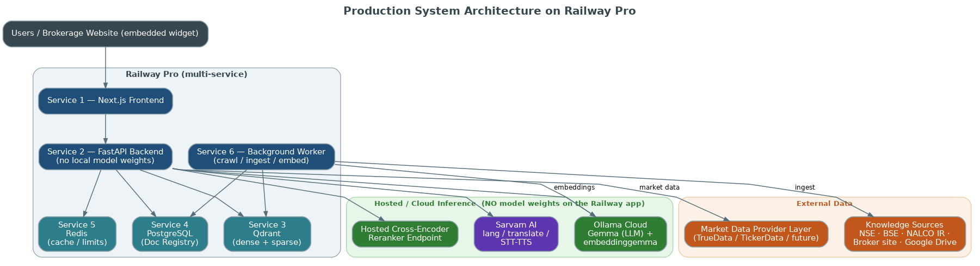
Figure 1 — Production system architecture on Railway Pro, with hosted Ollama Cloud, hosted re-ranker endpoint, and Sarvam AI off-process.

Phase 3 — Backend Foundation
Build:

FastAPI
Modules:
- Authentication & Access Control
  - Widget Origin Authentication (per-brokerage API key + domain allowlist)
  - Anonymous Session Identity (signed session token, no login required)
  - Admin Authentication (login for dashboard / internal users)
  - Abuse & Cost Control (rate limits, quotas, bot defense)
- Chat
- Search
- Filings
- Stock Information

PostgreSQL
Stores:
- Users
- Sessions
- Feedback
- Analytics
- API Keys (per-brokerage widget keys + allowed domains)
- Usage Quotas (per-tenant request/cost counters)

Document Registry
Purpose:
Central metadata repository for all documents indexed into Qdrant.
Stores:
- Source Metadata
- Document Versions
- Citation Information
- Duplicate Detection Data
- Re-indexing Information
- Audit History

Additional PostgreSQL Table — documents
Fields:
id
source
url
company
filing_type
filing_date
document_version
checksum
created_at
updated_at

Field Definitions
Field | Definition
id | Unique document identifier.
source | Document origin. Examples: NSE, BSE, NALCO IR, Brokerage Website, Google Drive.
url | Original document URL.
company | Associated company. Example: NALCO.
filing_type | Document category. Examples: Annual Report, Quarterly Results, Shareholding Pattern, Board Meeting.
filing_date | Official publication date.
document_version | Version number of the document.
checksum | Hash used for duplicate detection.
created_at | First ingestion timestamp.
updated_at | Latest processing timestamp.

Document Registry Workflow
Document Discovered
↓
Metadata Extraction
↓
Document Registry Check
↓
Duplicate Detection
↓
Version Validation
↓
Document Registration
↓
Embedding Generation (Ollama Cloud · embeddinggemma)
↓
Qdrant Indexing (dense + sparse)

Citation Workflow
User Query
↓
Qdrant Retrieval
↓
Document IDs + Chunk IDs Retrieved (foreign keys)
↓
Document Registry Lookup (PostgreSQL)
↓
Source Metadata Retrieval
↓
Citation Generation
↓
Response Returned

Duplicate Detection Rules
Before indexing:
- Calculate checksum.
- Search documents table.
- If checksum exists: skip indexing.
- If checksum differs: create new document version.
- Update registry.

Redis
Stores:
- Session Cache
- Rate Limits (per-session, per-IP, and per-API-key)
- Chat Context

Qdrant
Stores:
- Website embeddings (dense + native sparse)
- NSE embeddings (dense + native sparse)
- BSE embeddings (dense + native sparse)
- NALCO embeddings (dense + native sparse)

Architecture Principle
Qdrant stores vectors. PostgreSQL stores document metadata. Source citations must never be generated directly from vector storage. All citation information must be retrieved from the Document Registry. The Qdrant payload holds only foreign keys (Document ID, Chunk ID) plus retrieval-filter fields; every citation field is resolved from PostgreSQL.

Widget Security & Abuse Control
Purpose:
Protect the public, unauthenticated chat widget from abuse and runaway cost.
Widget Authentication:
- Each brokerage gets a public widget key (tenant ID).
- Backend validates the request Origin / Referer against a per-key domain allowlist.
- Reject requests from non-allowlisted domains.
Anonymous Session Identity:
- On first load, backend issues a short-lived signed session token (e.g. JWT).
- All chat calls carry this token; no personal login required.
- Token ties a visitor to rate limits and analytics.
Abuse & Cost Control:
- Per-session rate limit (messages per minute).
- Per-IP rate limit (sessions per hour).
- Per-tenant daily quota (caps Ollama Cloud + Sarvam spend).
- CAPTCHA / challenge on threshold breach.
- Block on quota exhaustion; return a friendly limit message.
Architecture Principle:
The chat widget is a public endpoint. Every request must be attributable to a tenant and a session. LLM and translation calls must never run before rate-limit and quota checks pass.

Backend Foundation Architecture Summary
FastAPI
↓
PostgreSQL
↓
Document Registry
↓
Documents Table
↓
Field Definitions
↓
Registry Workflow
↓
Citation Workflow
↓
Duplicate Detection Rules
↓
Architecture Principle
↓
Redis
↓
Qdrant

Phase 4 — Data Ingestion Layer
Build data ingestion before AI.

Source 1 — Broker Website
Example:
https://yourbroker.com
Connection Method:
Sitemap Discovery + Website Crawling
Pages to Crawl:
- Home
- About Us
- FAQ
- Pricing
- Products
- KYC
- Open Account
- Algo Trading
- Research
- Contact
Recommended Tools:
- Crawl4AI
- Firecrawl
- Playwright
Flow:
Website
↓
Crawler
↓
HTML Extraction
↓
Content Cleaning
↓
Chunking
↓
Dense Embedding (Ollama Cloud) + Sparse Vector
↓
Qdrant (dense + sparse)

Refresh:
Daily at 2 AM

Source 2A — Market Data Provider Layer
Primary Provider:
TrueData API
Alternative Providers:
- TickerData API
- Exchange Approved Data Feeds
- Future Data Vendors
Connection Method:
- REST API
- WebSocket
Purpose:
- LTP
- OHLC
- Market Depth
- Volume
- Option Chain
Architecture:
Market Data Provider
↓
REST API / WebSocket
↓
FastAPI Market Service
↓
Redis Cache
↓
AI Bot

Refresh:
Real-Time
Architecture Principle:
Market Data must always come from APIs or WebSockets. Market Data must never be obtained through website crawling. Market Data must never be served from Qdrant. All providers must implement the MarketDataProvider interface.

Source 2B — NSE Corporate Filings
Website:
https://www.nseindia.com
Connection Method:
Official APIs where available
Fallback:
Structured Crawling
Data Collected:
- Quarterly Results
- Corporate Announcements
- Shareholding Patterns
- Board Meetings
- Corporate Actions
Recommended Tools:
- Requests
- Playwright
- BeautifulSoup
Flow:
NSE
↓
Ingestion Service
↓
Document Parsing
↓
Metadata Extraction
↓
Document Registry
↓
Chunking
↓
Dense Embedding (Ollama Cloud) + Sparse Vector
↓
Qdrant (dense + sparse)

Refresh:
Hourly
Design note: NSE refresh cadence (Hourly) added here to match the Phase 15 Production Data Source Registry, which lists NSE = Hourly.
Architecture Principle:
Corporate Filings are knowledge documents. Corporate Filings must be indexed into Qdrant. Corporate Filings are not market data. All filings must be stored in the Document Registry before indexing.

Source 3 — BSE India
Website:
https://www.bseindia.com
Connection Method:
Structured Crawling
Collect:
- Results
- Filings
- Corporate Actions
- Disclosures
Recommended Tools:
- Playwright
- BeautifulSoup
Refresh:
Hourly
Flow:
BSE
↓
Ingestion Service
↓
Document Parsing
↓
Metadata Extraction
↓
Document Registry
↓
Chunking
↓
Dense Embedding (Ollama Cloud) + Sparse Vector
↓
Qdrant (dense + sparse)

Architecture Principle:
Corporate Filings are knowledge documents. Corporate Filings must be indexed into Qdrant. Corporate Filings are not market data. All filings must be stored in the Document Registry before indexing.

Source 4 — NALCO Investor Relations
Website:
https://nalcoindia.com
Connection Method:
Website Crawling
Collect:
- Annual Reports
- Presentations
- Financial Results
- Press Releases
Recommended Tools:
- Crawl4AI
- Playwright
Refresh:
Daily

Source 5 — Google Drive Knowledge Repository
Connection Method:
Google Drive API
Supported Files:
- PDF
- DOCX
- PPTX
- XLSX
Purpose:
- Brokerage FAQs
- Product Documents
- Brokerage Policies
- Compliance Manuals
- Research Reports
- Internal Knowledge Documents
- Training Material
- Circulars
Flow:
Google Drive Folder
↓
Google Drive API
↓
Document Sync Service
↓
Document Parser
↓
Chunking
↓
Dense Embedding (Ollama Cloud) + Sparse Vector
↓
Qdrant (dense + sparse)

Refresh:
Every 15 Minutes

Phase 5 — Embedding Pipeline

Embedding Model
Recommended:
embeddinggemma — multilingual embedding model served by Ollama Cloud.
Design note: The embedding model is now embeddinggemma (multilingual), replacing the earlier English-centric recommendations (nomic-embed-text / bge-small-en-v1.5). A single multilingual embedding space covers English, Hindi and Tamil, which the product must support. No embedding model weights are loaded locally — all embeddings are generated by Ollama Cloud.
Requirements:
- Vector dimension must match the selected embedding model.
- Qdrant collection dimension must be generated dynamically.
- The system must never hardcode embedding dimensions.
- Fast retrieval.
- Compatible with Qdrant.
- Optimized for RAG.
- Multilingual coverage (English, Hindi, Tamil) from a single embedding space.
Collection:
brokerage_kb — a dual-vector collection holding BOTH a named dense vector and a native sparse vector.

Collection Initialization Rules
- Connect to the Ollama Cloud embedding model (embeddinggemma) and detect the dense vector dimension from a probe embedding.
- Detect vector dimension automatically.
- Create the Qdrant collection with BOTH a dense vector (using the detected dimension) AND a native sparse vector (BM25 / IDF).
- Validate dimensions before vector insertion.
- Reject mismatched vectors.
Design note: The collection is created with a dense AND a native sparse (BM25/IDF) vector so the Phase 6 hybrid retrieval (Dense + Sparse → RRF) is actually supported at the storage layer. Qdrant native sparse vectors are used — no separate Elasticsearch service.
Example:
embedding_dimension = ollama_cloud.embeddings("embeddinggemma").dimension # detected dynamically

if collection_not_exists:
create_collection(
name="brokerage_kb",
vectors_config={
"dense": VectorParams(
size=embedding_dimension, # never hardcoded
distance=Distance.COSINE,
)
},
sparse_vectors_config={
# Qdrant NATIVE sparse vector (BM25/IDF) — no Elasticsearch
"sparse": SparseVectorParams(modifier=Modifier.IDF)
},
)
else:
validate_collection_dimension(
collection_name="brokerage_kb",
expected_dimension=embedding_dimension,
)
The application must not assume a fixed vector size.

Startup Initialization Requirements
During application startup:
- Configure the Ollama Cloud embedding model (embeddinggemma).
- Detect embedding dimension automatically.
- Connect to Qdrant.
- Check whether collection "brokerage_kb" exists.
- If collection does not exist: create it with a dense vector (detected dimension) and a native sparse vector (BM25/IDF).
- If collection exists: validate the dense dimension matches the embedding model and the sparse vector is configured.
- Stop startup if dimensions or vector configuration do not match.
- Mark embedding service as ready.
Process
Application Startup
↓
Configure Ollama Cloud Embedding Model (embeddinggemma)
↓
Detect Embedding Dimension
↓
Initialize Qdrant Client
↓
Check if Collection Exists
↓
Create Dual-Vector Collection (dense + native sparse) if absent
↓
Validate Collection Configuration
↓
System Ready

Document Processing Flow
Document
↓
Chunking
↓
Dense Embedding (Ollama Cloud · embeddinggemma) + Sparse Vector (BM25/IDF)
↓
Vector & Metadata Validation
↓
Qdrant Storage (dual-vector: dense + sparse)

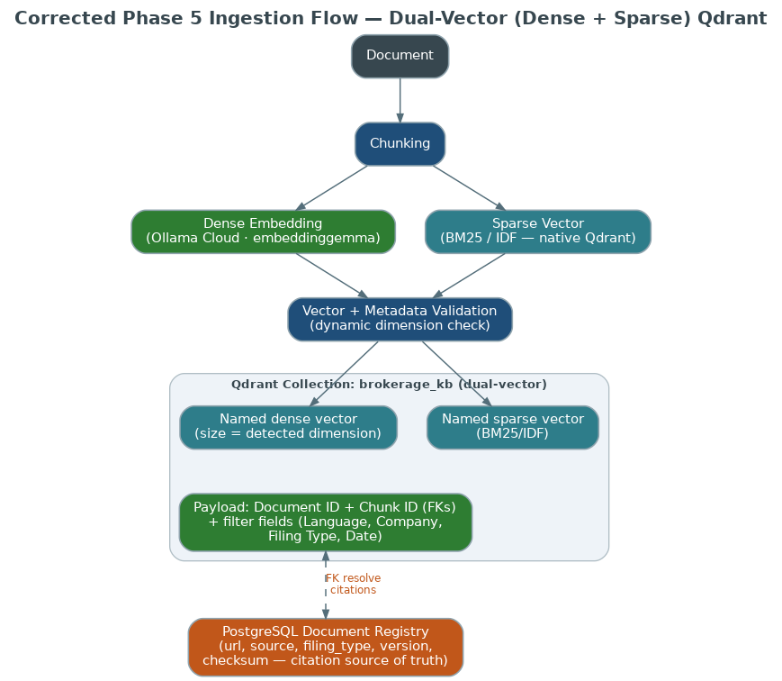
Figure 2 — Phase 5 ingestion: dense + sparse vectors written into the dual-vector brokerage_kb collection; citation fields stay in PostgreSQL.

Qdrant Payload & Metadata
The Qdrant payload stores only foreign keys plus the fields needed as retrieval filters. All citation fields are resolved from the PostgreSQL Document Registry.
Stored in the Qdrant payload (foreign keys + retrieval filters):
- Document ID — foreign key to the PostgreSQL documents table
- Chunk ID — foreign key identifying the chunk
- Language — retrieval filter (English / Hindi / Tamil)
- Company — retrieval filter (e.g. NALCO)
- Filing Type — retrieval filter
- Date — retrieval filter
Resolved from PostgreSQL at citation time (never stored in Qdrant):
- Source
- URL
- Document Version
- Checksum
- Any other citation metadata
Design note: Per the citation principle ("citations must never come from vector storage"), url / source / filing details / version / checksum are no longer written into the Qdrant payload. The payload keeps only Document ID + Chunk ID as foreign keys, plus the fields used as retrieval filters. Every citation is resolved from the Document Registry in PostgreSQL.
Embedding Validation — At Startup:
- Verify the Ollama Cloud embedding model is reachable.
- Verify detected embedding dimension.
- Verify Qdrant collection exists with dense + sparse vectors.
- Verify collection dense dimension matches the model.
Before Indexing:
- Verify vector compatibility (dense and sparse).
- Verify metadata integrity.
- Verify collection availability.
If mismatch detected:
- Log error.
- Stop ingestion process.
- Notify administrator.
Reason:
Prevent corrupted vector storage and retrieval failures.

Architecture Principle
Qdrant collection creation is a startup responsibility. Document ingestion must never create collections dynamically. All collections must be validated before the first document is processed. No model weights run on the FastAPI / Railway application: embeddings are produced by Ollama Cloud (embeddinggemma), and the cross-encoder reranker runs on a hosted cloud inference endpoint.
Design note: Ollama-Cloud-only constraint made explicit: the FastAPI/Railway process loads no embedding or reranker weights. Generation and embeddings are served by Ollama Cloud (Gemma + embeddinggemma); reranking is served by a hosted cloud endpoint.

Phase 6 — RAG System
The canonical query pipeline routes market-data intents to live APIs and knowledge intents through hybrid retrieval. Query translation happens before retrieval, metadata filters are applied at retrieval time on both branches, and a single retrieve-then-rerank path feeds Ollama Cloud.
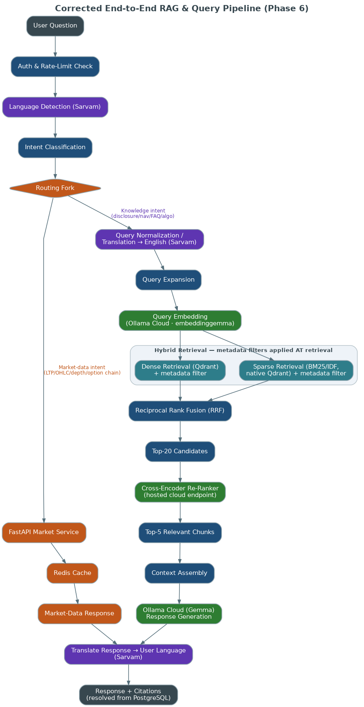
Figure 3 — Corrected end-to-end pipeline: market-data fork, query translation, and Dense+Sparse → RRF → filter → rerank → Ollama Cloud.

Canonical Query Pipeline
User Question
↓
Auth & Rate-Limit Check
↓
Language Detection (Sarvam)
↓
Intent Classification
↓
ROUTING FORK

Branch A — Market-Data Intents (LTP / OHLC / Market Depth / Option Chain):
FastAPI Market Service
↓
Redis Cache
↓
Market-Data Response
↓
Translate to User Language (Sarvam, if needed)
↓
Response

Branch B — Knowledge Intents (Disclosure / Navigation / FAQ / Algo) → RAG:
Query Normalization / Translation → English (Sarvam)
↓
Query Expansion
↓
Query Embedding (Ollama Cloud · embeddinggemma)
↓
Hybrid Retrieval — metadata filters applied AT retrieval on BOTH branches: Dense Retrieval (Qdrant) + filter · Sparse Retrieval (BM25/IDF native Qdrant) + filter
↓
Reciprocal Rank Fusion (RRF)
↓
Top-20 Candidate Retrieval
↓
Cross-Encoder Re-Ranker (hosted cloud endpoint)
↓
Top-5 Relevant Chunks
↓
Context Assembly
↓
Ollama Cloud (Gemma) — Response Generation
↓
Translate Response → User Language (Sarvam)
↓
Response + Citations (resolved from PostgreSQL)

Intent Types & Routing
Intent | Route
Stock Query | Market-data route → FastAPI Market Service → Redis (live APIs). Never served from Qdrant.
Disclosure Query | Knowledge route → RAG (hybrid retrieval).
Navigation Query | Knowledge route → RAG (hybrid retrieval).
FAQ Query | Knowledge route → RAG (hybrid retrieval).
Algo Query | Knowledge route → RAG (hybrid retrieval).

Design note: An explicit routing fork now follows Intent Classification. Stock / market-data intents (LTP / OHLC / depth / option chain) go to the FastAPI Market Service backed by Redis — honoring the principle that market data comes from the MarketDataProvider APIs, never from Qdrant. Only knowledge intents enter the RAG pipeline.

Market Data Routing
Market-data requests (LTP, OHLC, market depth, option chain) are answered by the FastAPI Market Service reading from the MarketDataProvider APIs / WebSockets, cached in Redis. These requests never touch Qdrant and never enter the RAG pipeline.

Hybrid Retrieval
Purpose:
Improve retrieval quality by combining semantic search and keyword search.
Components:
- Dense Retrieval: Qdrant vector search over the embeddinggemma dense vector, with metadata filters applied at retrieval.
- Sparse Retrieval: Qdrant native sparse vector (BM25 / IDF) keyword search, with metadata filters applied at retrieval.
Query Preparation:
Before retrieval, the query is normalized and, when not already English, translated to English via Sarvam so it matches the multilingual embedding space and sparse index consistently.
Fusion Strategy:
Reciprocal Rank Fusion (RRF) over the filtered dense and sparse candidate lists.
Benefits:
- Better retrieval of stock symbols
- Better retrieval of company names
- Better retrieval of financial terms
- Better filing search accuracy
Design note: Metadata filters are applied AT retrieval time as Qdrant query filters on both the dense and sparse branches, so candidates are filtered before fusion — not after RRF. A query normalization / translation step (Sarvam) runs before retrieval so Hindi and Tamil queries retrieve correctly.

Re-Ranking Layer
Purpose:
Improve retrieval precision before sending context to Ollama Cloud.
Problem:
Vector search retrieves semantically similar documents but may not retrieve the most relevant answer.
Solution:
Use a Cross-Encoder Re-Ranker, served by a hosted cloud inference endpoint, to score retrieved chunks against the user's query.
Workflow:
User Query
↓
Query Normalization / Translation → English (Sarvam)
↓
Hybrid Retrieval (Dense + Sparse) with metadata filters at retrieval
↓
Reciprocal Rank Fusion (RRF)
↓
Top-20 Candidates
↓
Cross-Encoder Re-Ranker (hosted cloud endpoint) scores all 20
↓
Select Top-5 chunks
↓
Send Top-5 chunks to Ollama Cloud (Gemma)

Design note: There is now ONE canonical retrieval pipeline everywhere. The earlier dense-only "Qdrant Top 20 → rerank → Top 5" description is replaced by Dense+Sparse → RRF → metadata filter (at retrieval) → Top-20 → cross-encoder rerank → Top-5 → Ollama Cloud, matching the Phase 6 pipeline above.
Benefits:
- Better answer accuracy
- Better citation quality
- Better handling of financial disclosures
- Reduced hallucinations
- Improved relevance ranking

Recommended Re-Ranker
Production:
- BAAI/bge-reranker-base
- or BAAI/bge-reranker-large
Requirements:
- Query-document pair scoring
- Cross-Encoder architecture
- Compatible with financial document retrieval
Deployment:
Hosted cross-encoder inference endpoint — a separate cloud service. The reranker is NOT loaded into the FastAPI process; no reranker weights run on the Railway app.
Design note: The reranker deployment changed from "Integrated into FastAPI Backend" to a hosted cloud inference endpoint, consistent with the Ollama-Cloud-only constraint that no model weights run inside the FastAPI / Railway application.
Selection Strategy:
Hybrid Retrieval (Dense + Sparse) with metadata filter at retrieval
↓
Reciprocal Rank Fusion (RRF) → Top-20
↓
Cross-Encoder Re-Rank (hosted endpoint)
↓
Keep Top-5
↓
Send to Ollama Cloud

Claude Code Requirements
- Normalize / translate the query to English via Sarvam when it is not already English.
- Generate the query embedding via Ollama Cloud (embeddinggemma).
- Retrieve candidates from Qdrant with metadata filters applied AT retrieval on BOTH the dense and sparse branches.
- Fuse the dense and sparse candidate lists with Reciprocal Rank Fusion (RRF).
- Take the Top-20 fused candidate chunks.
- Pass the Top-20 candidates to the hosted Cross-Encoder Re-Ranker.
- Score all candidate chunks.
- Sort chunks by relevance score.
- Select the Top-5 chunks.
- Build the context window.
- Send context to Ollama Cloud (Gemma) and generate the response.
- Translate the response to the user's language via Sarvam.
- Return the answer with source citations resolved from PostgreSQL.

Implementation Rules
- Always retrieve before reranking.
- Never rerank the entire collection.
- Only rerank the Top-20 retrieved candidates.
- Apply metadata filters at retrieval time (on dense and sparse branches), not after fusion.
- Always pass the Top-5 reranked chunks to Ollama Cloud.
- Preserve foreign-key references (Document ID, Chunk ID) throughout the pipeline.
- Attach citations to every generated answer, resolved from PostgreSQL.
- No model weights run inside FastAPI: embeddings (Ollama Cloud) and reranking (hosted endpoint) are remote calls.

Architecture Principle
Vector search optimizes for recall. Cross-Encoder Re-Ranking optimizes for precision. The system must retrieve broadly using Qdrant hybrid search (dense + native sparse, fused with RRF) and then rerank candidates before generating responses.
This retrieve-then-rerank architecture should be used for:
- NSE Filings
- BSE Filings
- Annual Reports
- Corporate Disclosures
- Investor Presentations
- NALCO Knowledge Base

Phase 7 — Multilingual Layer
Provider:
Sarvam AI
Features:
- Language Detection
- Translation
- Transliteration
- Speech-to-Text (STT) and Text-to-Speech (TTS) for optional voice
Supported:
- English
- Hindi
- Tamil
Multilingual support spans the whole pipeline: the query is translated to English BEFORE retrieval (Phase 6), and the generated answer is translated back to the user's language. Query-side translation — not only response translation — is what makes Hindi and Tamil retrieval work against the multilingual embeddinggemma space.
Workflow:
User Language
↓
Detect Language (Sarvam)
↓
Normalize / Translate Query → English (before retrieval)
↓
Retrieve Knowledge (hybrid: Dense + Sparse → RRF)
↓
Generate Response (Ollama Cloud · Gemma)
↓
Translate Response → User Language
↓
Return Response

Design note: The multilingual layer now translates the QUERY before retrieval (in addition to translating the response), and the embedding model is multilingual (embeddinggemma). This fixes retrieval for Hindi and Tamil, which previously failed because only the response was translated and the embedding model was English-only.

Phase 8 — NALCO Pilot
Build the first complete company intelligence layer.
Sources:
- NSE Corporate Filings
- BSE Corporate Filings
- NALCO Investor Relations Website
- Annual Reports
- Investor Presentations
- Press Releases
- Financial Results
- Corporate Announcements
- Shareholding Patterns
- Board Meeting Outcomes
Questions Supported:
- Latest Results
- Dividend History
- Board Meetings
- Shareholding Pattern
- Corporate Announcements

Phase 9 — Website Navigation Agent
Purpose:
Guide users through the brokerage website.
Example:
User: “How do I open a Demat account?”
Bot:
- Explains process
- Provides direct link
- Offers assistance
Data Source:
Website Sitemap + Website Content

Phase 10 — Production Frontend
Technology:
Next.js
Features:
- Floating Chat Widget
- Full Screen Assistant
- Citation Display
- Related Documents
- Suggested Questions
- Voice Ready Architecture
Voice Ready Architecture: voice input and output are served via Sarvam STT (speech-to-text) and TTS (text-to-speech) when enabled — kept future / optional.
Design note: "Voice Ready Architecture" now names a concrete speech path: Sarvam STT/TTS, enabled optionally in the future.
Must Support:
- Desktop
- Mobile
- Tablet

Phase 10A — Admin Dashboard
- Rate-Limit Events
- Quota Usage (per tenant)
- Blocked Requests
- Crawler Status
- NSE Sync
- BSE Sync
- Google Drive Sync
- Indexed Documents
- Embedding Count
- Failed Jobs
- User Feedback

Phase 11 — Scalability & Reliability
Target:
100 Concurrent Users
Requirements:
Stateless Services — never store chat history in memory. Use Redis.
Background Jobs — use workers for:
- Crawling
- Embeddings
- File Processing

Railway Deployment
Railway Services:
- Service 1: Next.js Frontend
- Service 2: FastAPI Backend (no local model weights)
- Service 3: Qdrant (dense + native sparse vectors)
- Service 4: PostgreSQL (Document Registry)
- Service 5: Redis (session cache / rate limits)
- Service 6: Background Worker
Hosted inference endpoints (off-process — not Railway application processes):
- Ollama Cloud — Gemma (LLM generation) + embeddinggemma (embeddings)
- Hosted Cross-Encoder Reranker endpoint
- Sarvam AI — language detection, translation, transliteration, optional STT/TTS
Design note: The Railway services list now reflects the Ollama-Cloud-only constraint: LLM generation, embeddings, and the cross-encoder reranker all run on hosted endpoints, not inside the FastAPI / Railway app. A hosted reranker endpoint is called out explicitly.

Re-Ranking Service
Purpose:
Re-rank retrieved chunks before LLM generation.
Deployment:
Hosted cross-encoder inference endpoint (separate cloud service). NOT integrated into the FastAPI process; no reranker weights run on the Railway app.
Optimization:
Only rerank the Top-20 retrieved candidates (Dense + Sparse → RRF).
Expected Output:
Top-5 chunks passed to Ollama Cloud.
Background Worker Responsibilities:
- Website Crawling
- NSE Ingestion
- BSE Ingestion
- NALCO Crawling
- Google Drive Sync
- Embedding Generation (via Ollama Cloud · embeddinggemma)

Monitoring
Implement:
- Error Tracking
- Health Checks
- Logging
- Performance Metrics
- Sentry
- OpenTelemetry

Phase 12 — Algo Trading Knowledge Layer
Research Sources:
- Kite Connect Documentation — https://kite.trade/docs/connect/v3/
- NSE Retail Algo Framework
- NSE Circulars
- White Box Algorithms
- Black Box Algorithms
- Vendor Ecosystem
- Broker APIs
- Order Routing Workflows
- Risk Management Systems
- Exchange Compliance Requirements
Store:
- Documentation
- Circulars
- Compliance Rules
Purpose:
Educational AI assistant. Not direct trade execution initially.

Phase 13 — Differentiators
Most competitors provide: FAQs and generic support.
Provide:
Disclosure Intelligence
Explain filings in plain English.
NALCO Deep Research
Company-specific intelligence.
Multilingual Support
Hindi, Tamil, English.
Source Citations
Every answer linked to source documents (resolved from the PostgreSQL Document Registry).
Explain Like I'm New
Convert complex filings into simple explanations.
Investor Education Mode
Explain:
- Results
- Corporate Actions
- Shareholding Changes
- Board Decisions

Phase 14 — Production Launch

Final Production Architecture
Broker Website
↓
Market Data Provider Layer (TrueData / TickerData / Future Providers)
↓
NSE Corporate Filings
↓
BSE Corporate Filings
↓
NALCO Investor Relations
↓
Google Drive Knowledge Repository (Google Drive API)
↓
NSE Algo Circulars (Weekly Crawling)

Continuous Learning Pipeline
Broker Website Updates
↓
Automatic Crawl
↓
Qdrant Update (dense + sparse)

NSE / BSE New Filings
↓
Automatic Detection
↓
Qdrant Update (dense + sparse)

Google Drive Document Changes
↓
Automatic Sync
↓
Qdrant Update (dense + sparse)

NALCO IR Updates
↓
Automatic Crawl
↓
Qdrant Update (dense + sparse)

The AI continuously learns from brokerage website updates, regulatory disclosures, investor-relations content, and Google Drive documents without requiring any manual uploads, retraining, or developer intervention.

Phase 15 — Production Data Source Registry
API Sources
- TrueData API
- TickerData API
- Kite Connect API
Market Data Sources
- TrueData
- TickerData
- Exchange Approved Feeds
Structured Filing Sources
- NSE Corporate Filings
- BSE Corporate Filings

Refresh Schedule
Source | Refresh Cadence
Market Data | Real-Time
NSE | Hourly
BSE | Hourly
Broker Website | Daily
NALCO | Daily
Google Drive | 15 Minutes
NSE Circulars | Weekly

