Software Requirements Specification (SRS)
SRNs: PES1UG24CS223, PES1UG24CS226, PES1UG24CS237
Project Name: Online Quiz System (Group 14)
1. Introduction
This Software Requirements Specification (SRS) document details the functional and non-functional requirements for the Online Quiz System. The system is designed to facilitate the creation, management, execution, and evaluation of digital quizzes for educational environments.
2. User Roles
The system supports three primary user roles with specific access levels and permissions:
- Admin: Responsible for high-level system organization, including managing subject categories and reviewing broad class analytics and reports.
- Teacher: Authorized to manage the quiz lifecycle, including creating quizzes, managing the question bank, setting quiz schedules, and generating performance reports.
- Student: End-users who access scheduled quizzes, submit attempts within time limits, view their attempt history, access leaderboards, and provide feedback.
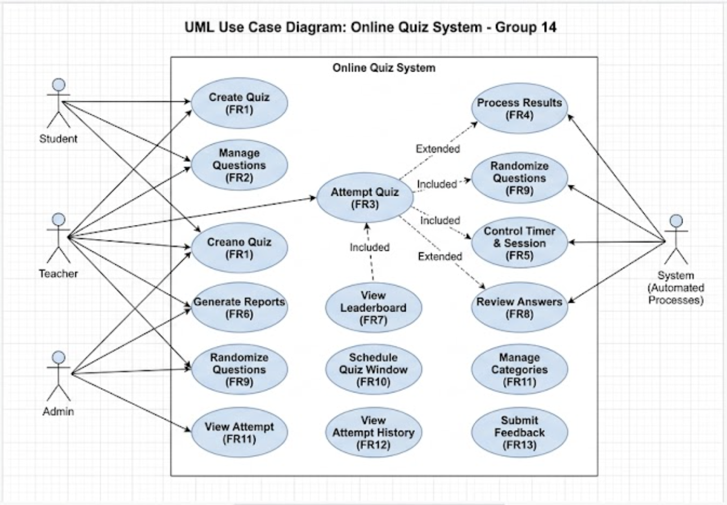
3. Functional Requirements (FR)
FR1: Quiz Creation and Configuration Module
- The system shall allow authorized Teachers to create a new quiz by specifying a title, subject, time limit, and passing percentage.
- The system shall validate quiz configuration inputs and reject invalid data (e.g., negative time limits or passing marks over 100%).
- The system shall allow Teachers to update existing quiz details or delete a quiz entirely.
- The system shall support importing questions from an existing question bank into a new or existing quiz.
FR2: Question Management Module
- The system shall allow Teachers to create, edit, and delete various question types, including Multiple Choice Questions (MCQs), True/False, and Fill-in-the-Blanks.
- The system shall require the Teacher to specify the correct answer for each question created.
- The system shall prevent the saving of incomplete questions (e.g., MCQs with missing options).
FR3: Quiz Attempt and Submission Module
- The system shall allow Students to select options or input text to answer questions during an active quiz attempt.
- The system shall allow Students to manually submit a completed quiz.
- The system shall enforce strict access control, preventing Students from opening or submitting a quiz outside of its configured availability window.
- The system shall automatically submit the quiz attempt if the allocated time limit expires, retaining all answered questions.
FR4: Automated Result Processing Module
- The system shall automatically evaluate submitted answers against the predefined answer key.
- The system shall calculate the total score and determine the pass/fail status based on the quiz's configured passing threshold.
- The system shall generate and display the final score and result immediately to the Student upon submission.
FR5: Timer and Session Control Module
- The system shall display a real-time countdown timer for quizzes configured with a time limit.
- The system shall track attempt counts and restrict Students from initiating a second attempt if the quiz is configured for a single attempt.
- The system shall terminate the active session and block further responses the moment the countdown reaches zero.
FR6: Performance Reporting and Analytics Module
- The system shall generate individual performance reports for specific Students upon request by a Teacher.
- The system shall aggregate data to generate class-wide performance reports for specific quizzes.
- The system shall allow Admins and Teachers to view these analytics, accurately reflecting stored scores.
FR7: Leaderboard and Ranking Module
- The system shall generate a leaderboard that ranks Students in descending order based on their achieved scores.
- The system shall consistently handle and display equal scores for tied Students.
- The system shall allow the leaderboard to be filtered by specific quizzes.
FR8: Answer Review and Feedback Module
- The system shall allow Students to review their submitted attempt after completion, displaying their selected answers alongside the correct answers.
- The system shall display predefined explanations for incorrect answers during the review phase.
- The system shall block Students from accessing the review screen before their quiz attempt has been submitted.
FR9: Question Randomization Module
- The system shall support shuffling the order of questions for different attempts to prevent cheating.
- The system shall support randomizing the order of answer options (A, B, C, D) within MCQs.
- The system shall ensure that the automated evaluation correctly identifies the right answer regardless of how the options were shuffled.
FR10: Quiz Scheduling Module
- The system shall allow Teachers to define a specific start date/time and end date/time window for a quiz.
- The system shall restrict early access, preventing Students from starting a scheduled quiz before the start time.
- The system shall render the quiz unavailable once the scheduled end time has passed.
FR11: Category and Subject Management Module
- The system shall allow Admins to create, update, and manage subject categories (e.g., DBMS, Operating Systems).
- The system shall allow quizzes and questions to be assigned to, and filtered by, these specific categories.
FR12: Attempt History and Log Module
- The system shall maintain a historical log of all quiz attempts for each Student.
- The system shall record and display the date of the attempt, the final score, and the total time taken to complete the quiz.
- The system shall protect the privacy of this data, ensuring Students cannot view the attempt histories of other Students.
FR13: Feedback and Rating Module
- The system shall allow Students to submit a quantitative rating (e.g., 1 to 5) and an optional text comment after completing a quiz.
- The system shall calculate the average rating for each quiz based on submitted feedback.
- The system shall restrict feedback submission to Students who have successfully completed the respective quiz.
4. Non-Functional Requirements (NFR)
- Security & Authentication: The system must securely authenticate users (Admin, Teacher, Student) and ensure strict role-based access control to prevent unauthorized actions (e.g., Students modifying quiz schedules).
- Performance & Concurrency: The system must handle multiple concurrent Student sessions simultaneously without degrading performance, ensuring timers and auto-submissions fire precisely.
- Reliability & Data Integrity: In the event of a network failure during an active attempt, the system must handle invalid submissions safely without corrupting result data.
- Usability: The user interface should clearly differentiate states for users, such as displaying empty-state messages for leaderboards with no attempts or clearly indicating when a quiz window is closed.

