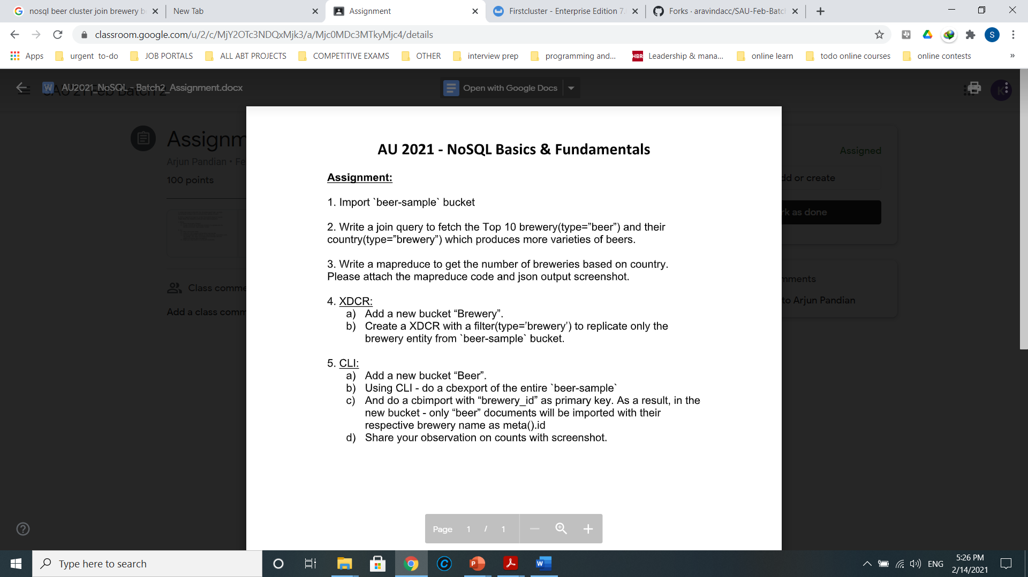

Step-1: Make sure `beer-sample` bucket is installed.

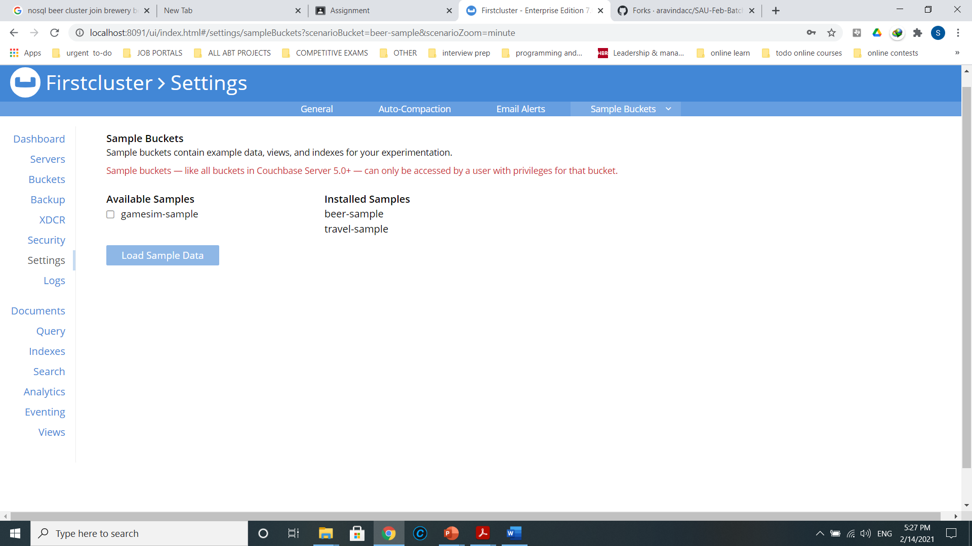

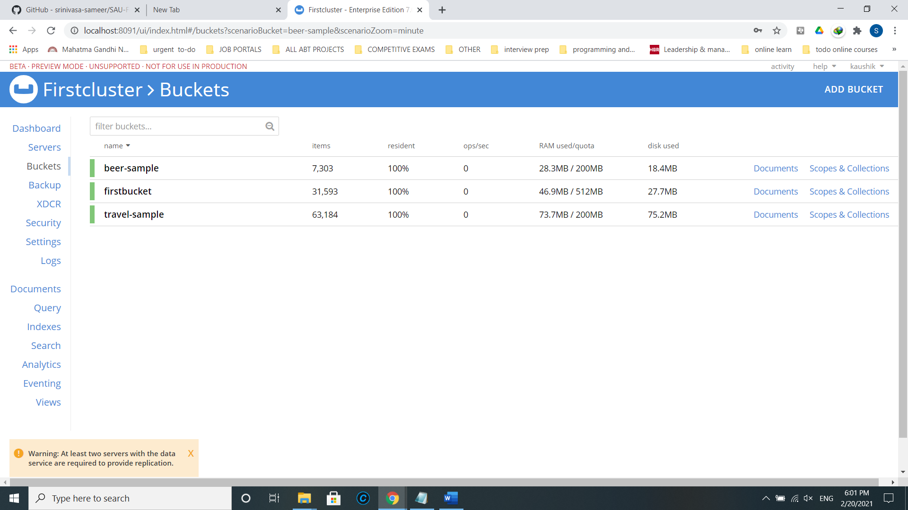

Step-2: Go to Query Tab and run N1QL query

SELECT breweries.name AS BreweryName,

breweries.country AS Country

FROM `beer-sample` beers

INNER JOIN `beer-sample` breweries ON KEYS beers.brewery_id

WHERE beers.type = "beer"

AND breweries.type = "brewery"

LIMIT 10;

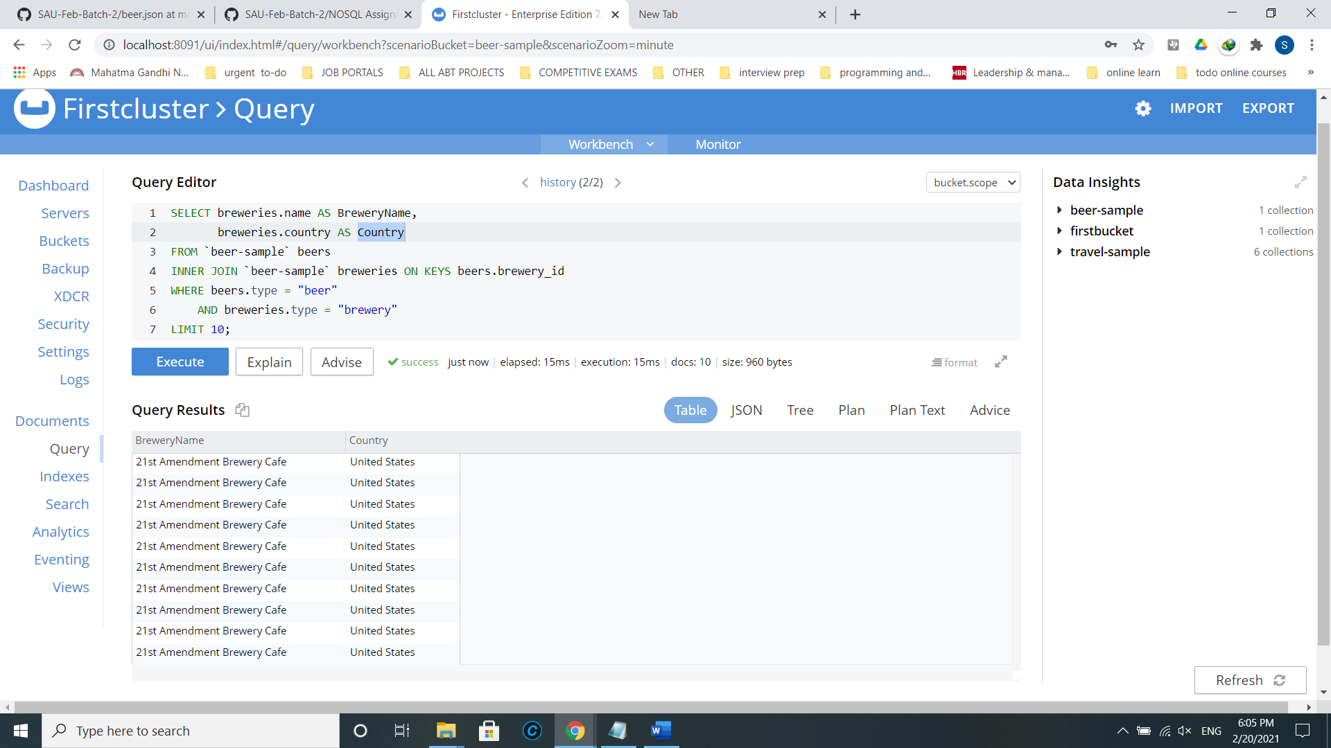

Step-3: Go to Views Tab and create a new development view and edit the view by adding map and reduce functions

function(doc,meta) {

if(doc.type=="brewery")

emit(doc.country,null);

}

_count

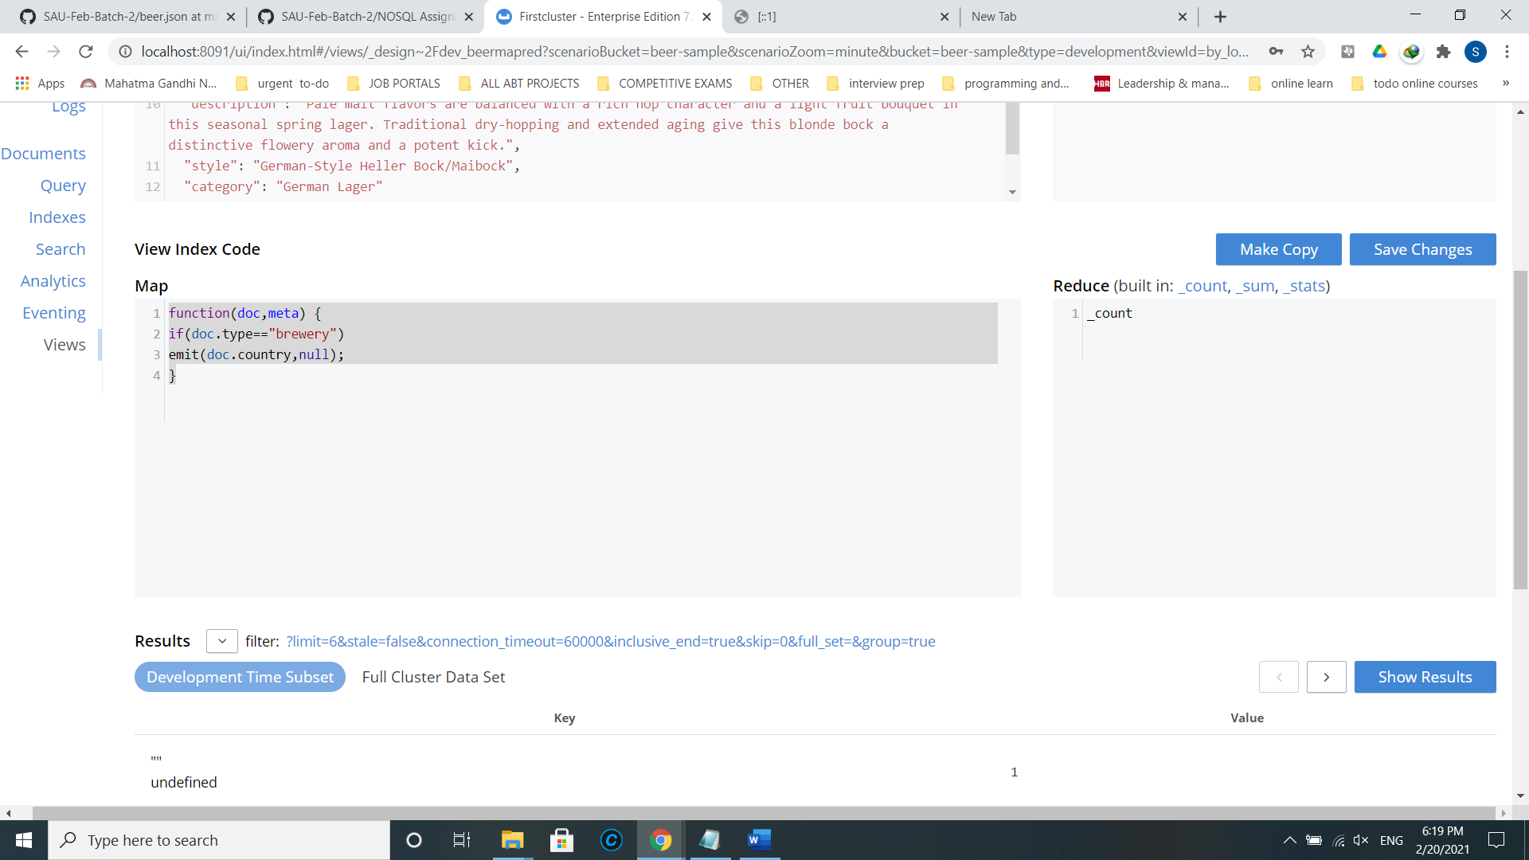

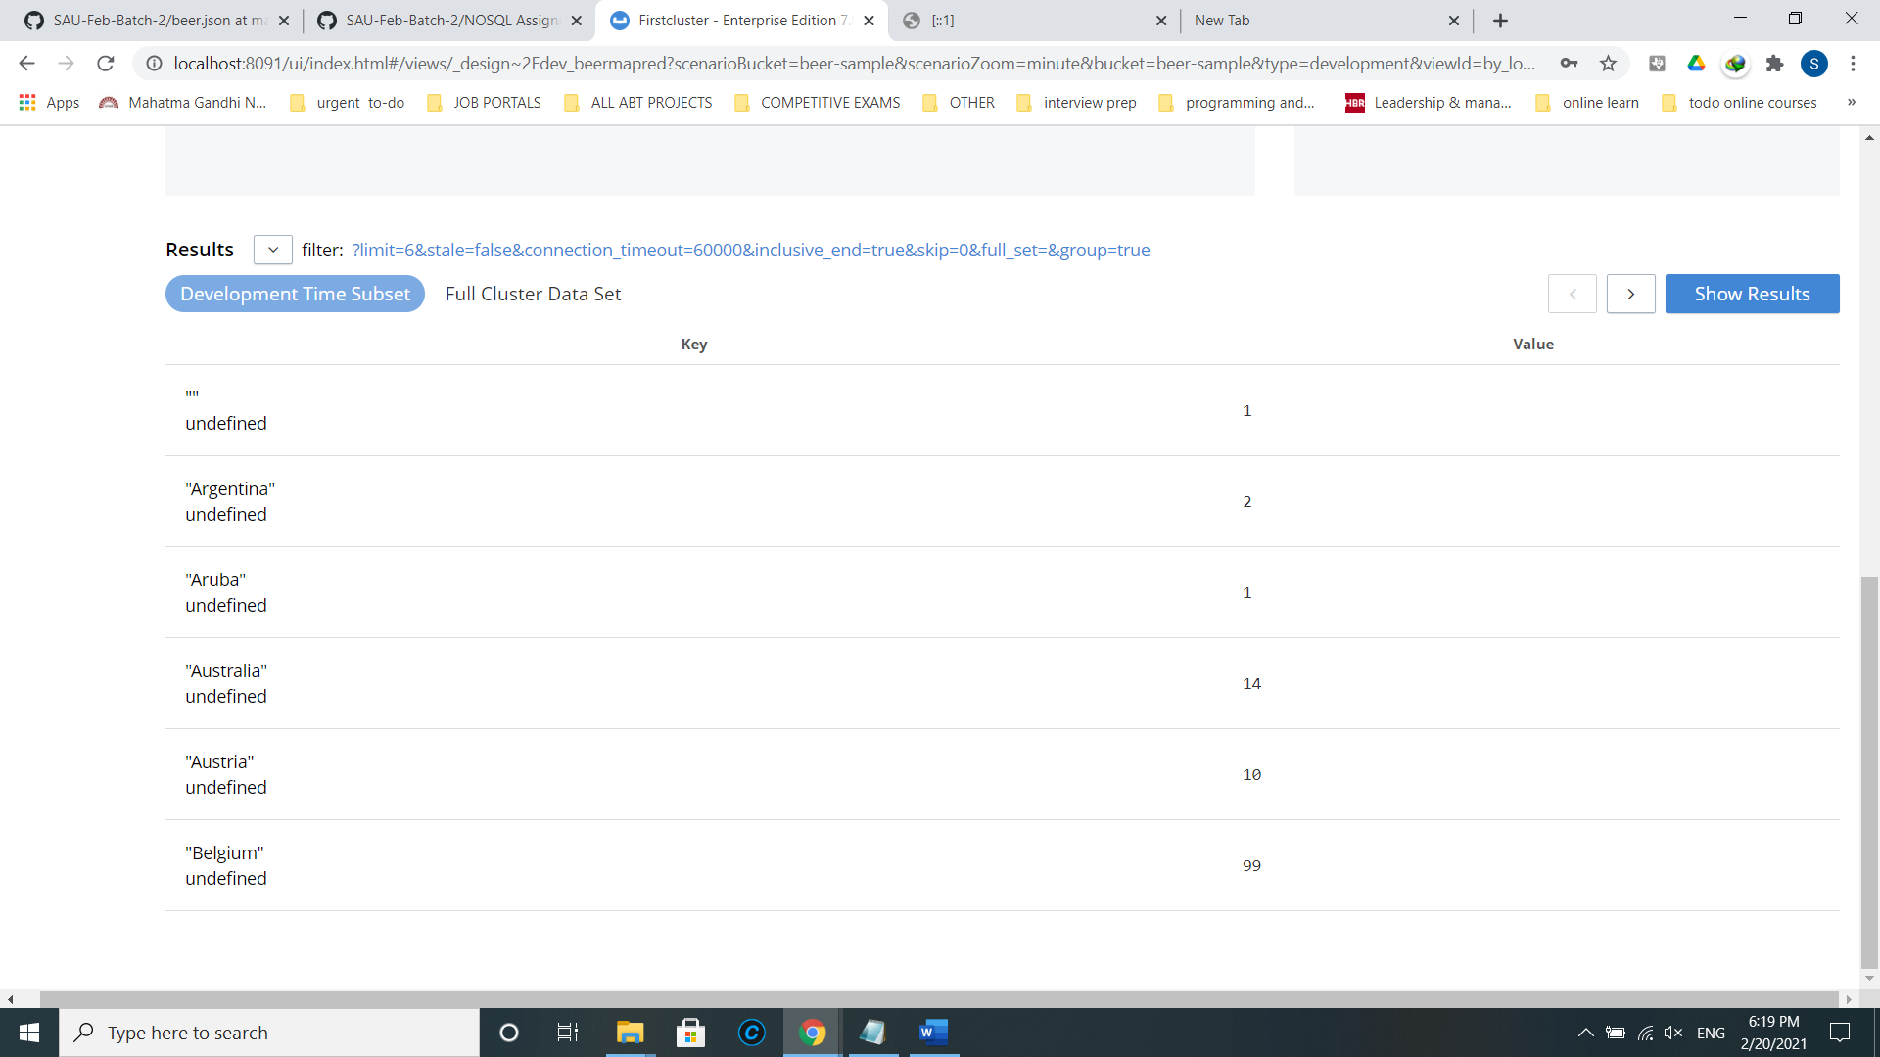

Step 4: Create a new bucket “beerbucket” and add it as remote, then create a XDCR with type=’brewery’ and replicate brewery entity to the beerbucket

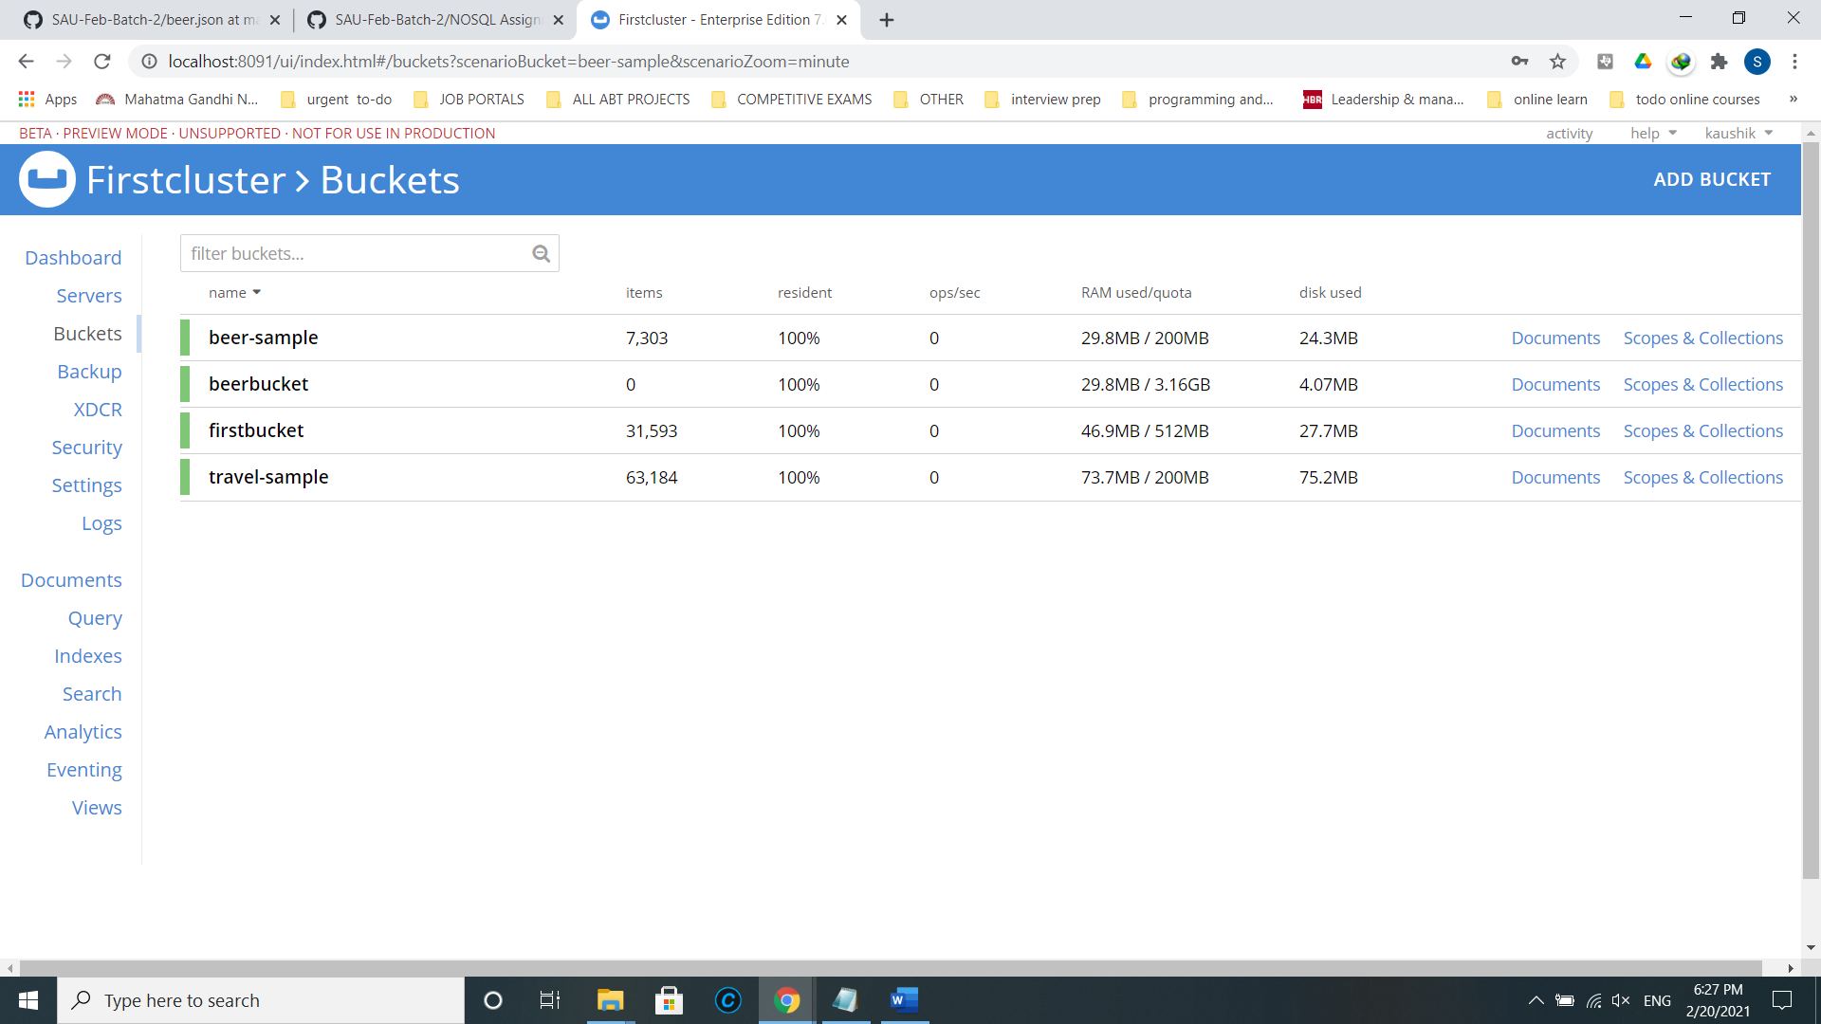

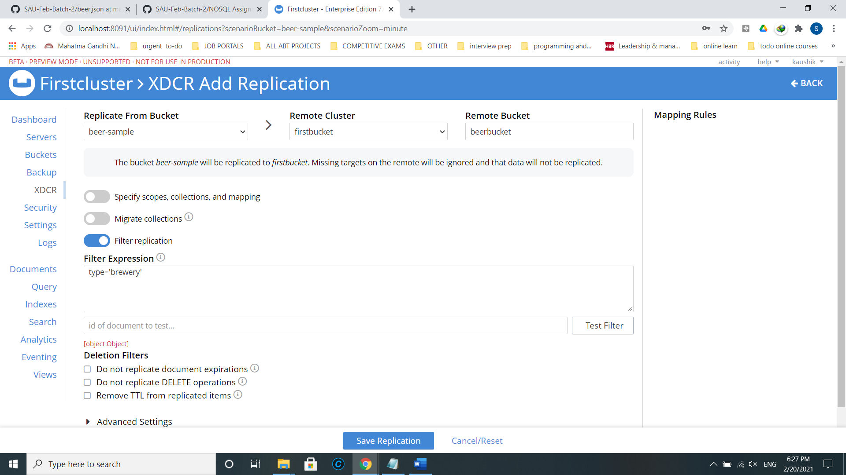

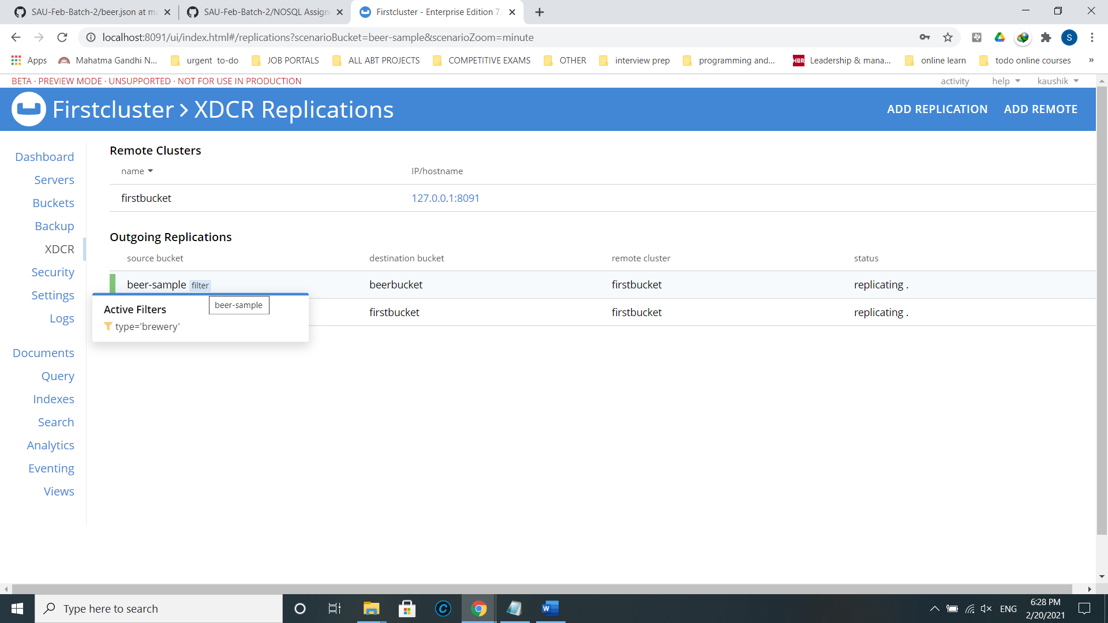

Step 5:

* 1. Add a new bucket “Beer”.
  2. Using CLI - do a cbexport of the entire `beer-sample`
  3. And do a cbimport with “brewery_id” as primary key. As a result, in the new bucket - only “beer” documents will be imported with their respective brewery name as meta().id
  4. Share your observation on counts with screenshot.

In cmd,

cd C:\Program Files\Couchbase\Server\bin

cbexport json -c couchbase://127.0.0.1 -u kaushik -p Klss1234@ -b beer-sample -o C:\Users\jayas\Desktop\beer.json -f lines -t 4

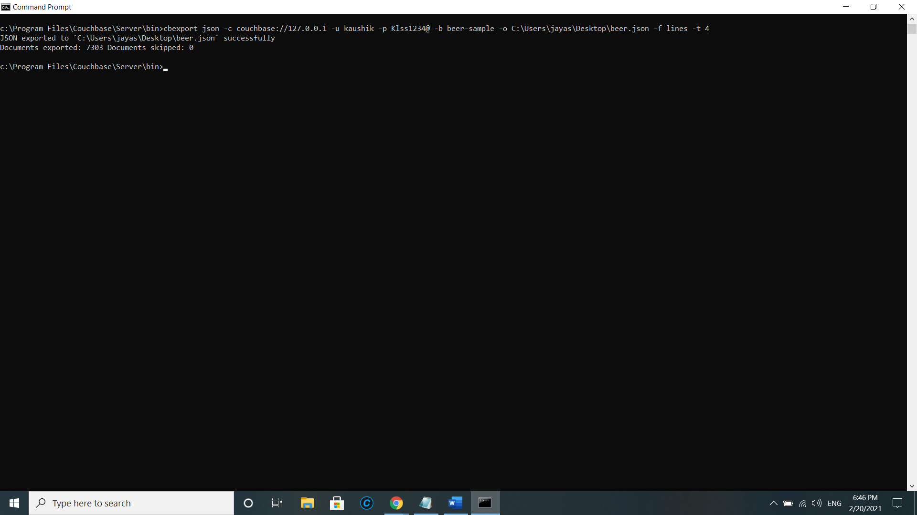

Editing a document,

BEFORE:

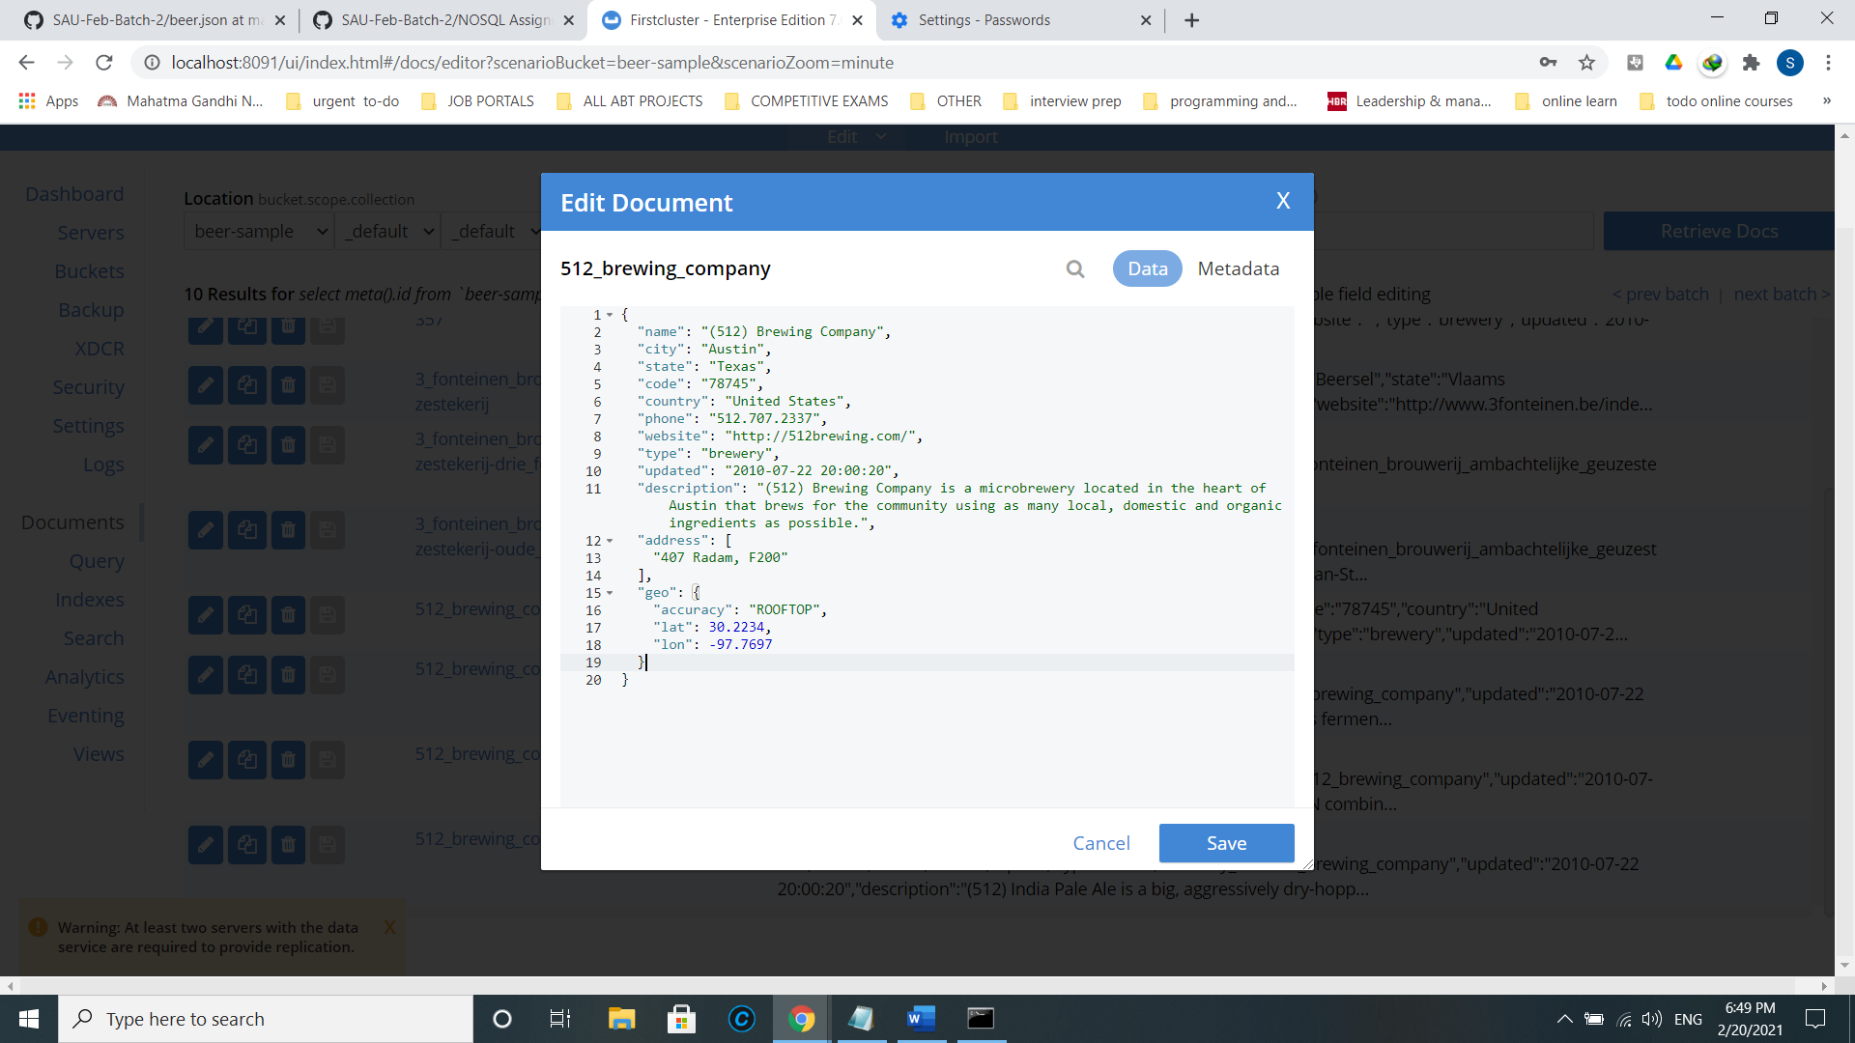

AFTER:

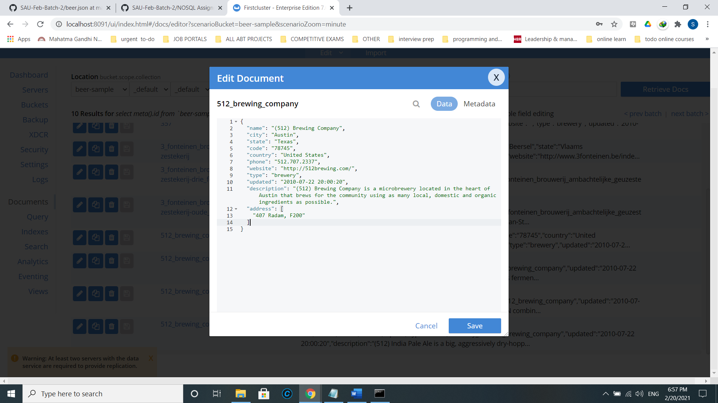

cbimport json -c couchbase://127.0.0.1 -u kaushik -p Klss1234@ -b beer-sample -f lines -d file://C:/Users/jayas/Desktop/beer.json -t 4 -g %brewery_id%

