GoorGrow
Project guide
An AI career tool for students: upload your resume, match it to real jobs, and get an honest verdict for each role – GO (apply now) or GROW (build these skills first).
Team: Team 404
Code: github.com/kaushikkarthikayan/GrowOrGo

1. What GoOrGrow is
Students and recent graduates face the same question every time they see a job ad: “Should I apply now, or do I need to get better first?” Most people guess. Some apply to hundreds of jobs and hear nothing back; others never apply to roles they could have won.
GoOrGrow answers that question job by job, using the candidate’s own resume as evidence. It reads the resume, finds 5–10 matching jobs, shows which skills are on track and which are missing, and then lets the candidate choose:
- GO – prepare a tailored, truthful application for the jobs they pick.
- GROW – follow a learning plan for the missing skills, then check again.

Who it is for
User | Their situation | What GoOrGrow gives them
College student (final or pre-final year) | Planning internships and campus hiring | Which roles to target now, and which skills to build before graduating
Recent graduate | Applying widely, often rejected | A short list of jobs that really fit, with reasons
Early-career job seeker (0–3 years) | Wants a better role or salary | A salary reality check and the skills that close the gap
Career switcher | Moving into a new field | Transferable skills versus real gaps

2. How the website works – the four pages
The website is one continuous flow. A progress bar at the top shows the four steps: Your documents → What you want → Your matches → Go or grow. Moving to a new step plays a short transition so the user always knows where they are.

Page 1 – Your documents
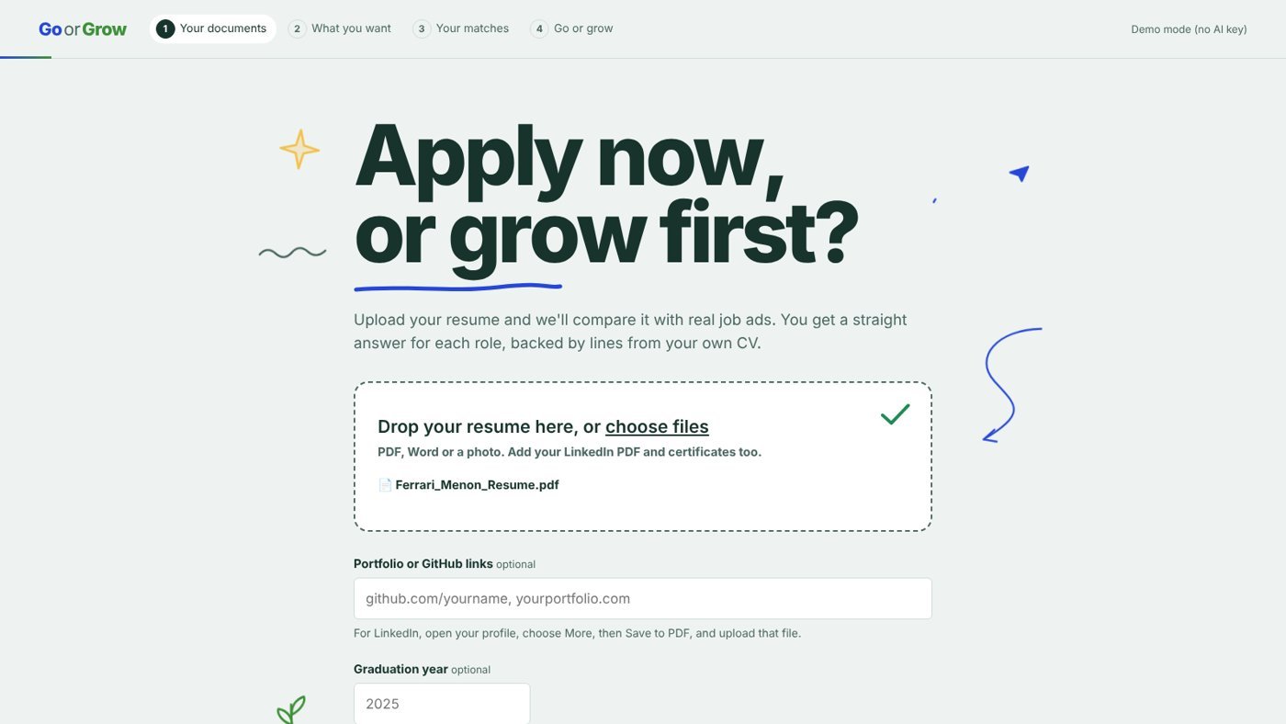
The first page, after a resume has been added

What the user sees
- The headline “Apply now, or grow first?”, which builds in letter by letter, with hand-drawn doodles around it.
- An upload box for the resume, LinkedIn PDF and certificates (PDF, Word, photos or text files).
- Optional boxes for GitHub or portfolio links, and the graduation year.

What happens behind the scenes
- The text is extracted from each file. Scanned pages and photos are read with OCR (Tesseract).
- GitHub links are read through GitHub’s public API (projects and languages). LinkedIn cannot be read automatically, so users upload LinkedIn’s own “Save to PDF” file instead.
- The text is split into sections (education, experience, projects, skills), and each skill is rated by its proof: used at work, used in a project, or only listed.
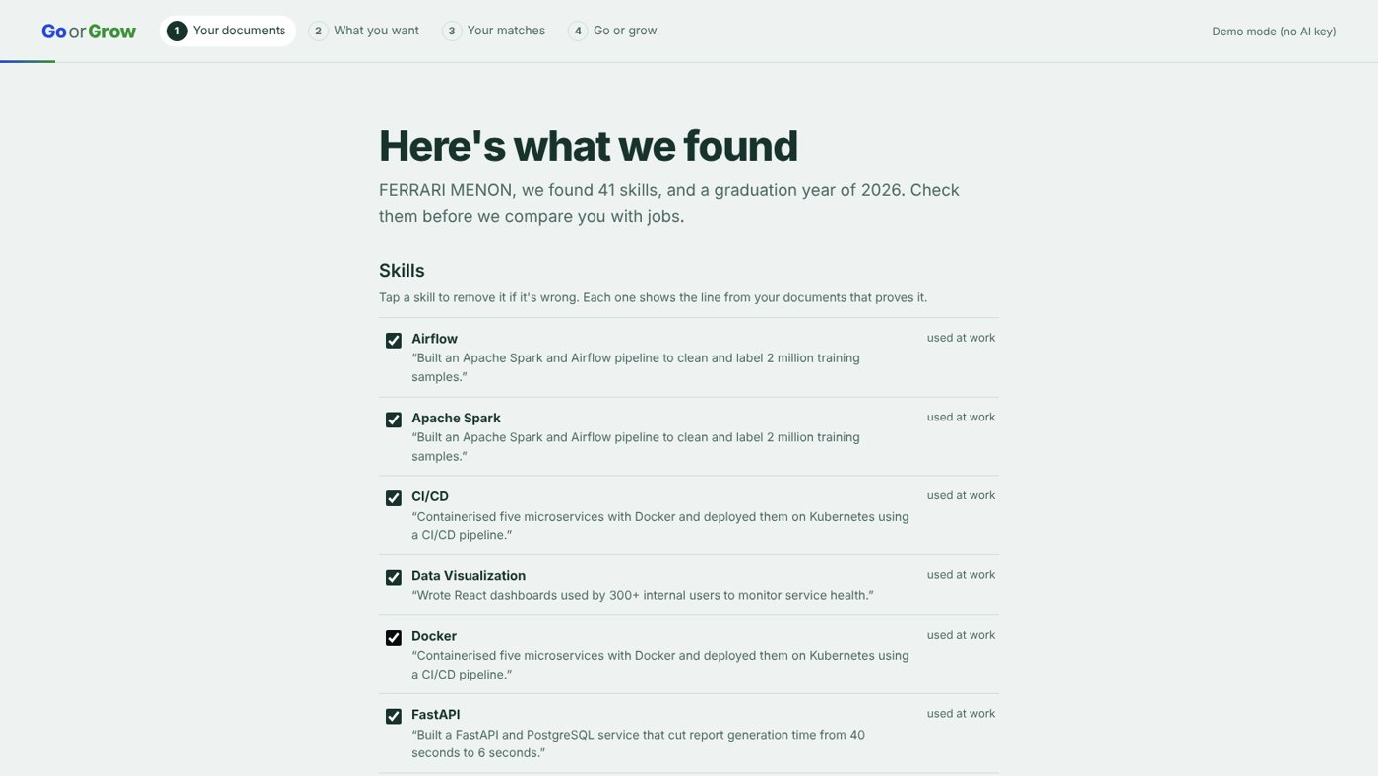
“Here’s what we found” – every skill shows the resume line that proves it
Checkpoint 1: the user reviews every skill, unticks anything wrong and adds anything missed. Nothing continues until they confirm.

Page 2 – What you want
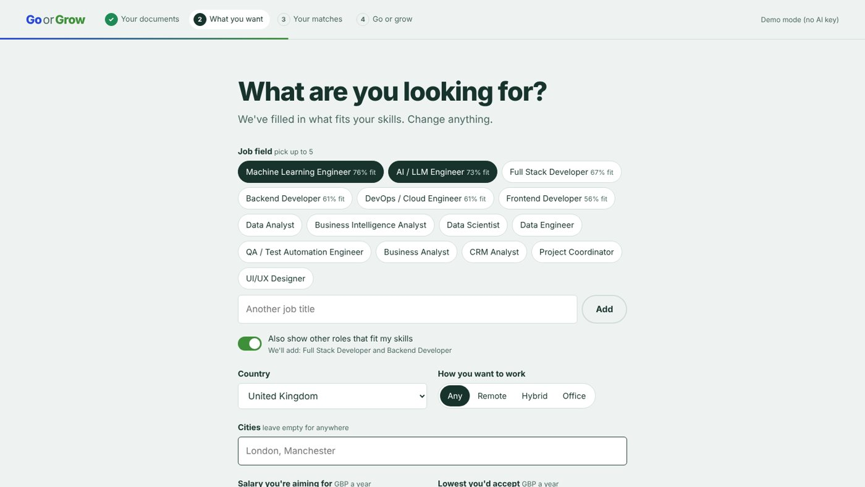
Preferences, with job fields suggested from the user’s skills
- Suggested job fields appear as chips with a fit percentage, worked out from the confirmed skills. The user picks up to five.
- Place and work style: country, cities, and remote, hybrid or office.
- Salary: the target salary and the lowest the user would accept. The currency follows the country.
- Companies: ones the user likes, and ones to skip.
- “Also show other roles that fit my skills” (on by default) adds the two best-fitting roles the user did not choose, so they see options they did not know to look for.

Page 3 – Your matches
While the search runs, the screen shows the real analysis steps one by one: reading the profile, collecting listings, reading what each job asks for, filtering, comparing skills and ranking.
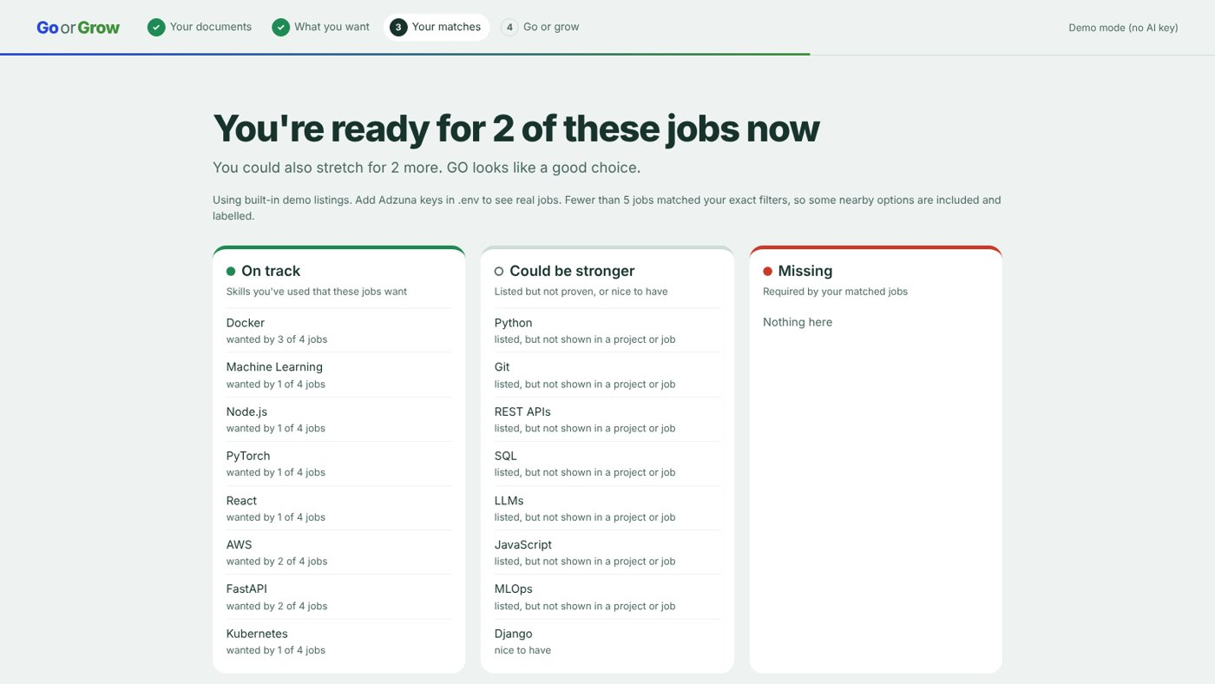
The results page: a plain answer, then the readiness flags

Readiness flags
Flag | Meaning
Green – On track | The user has really used this skill (at work or in a project) and the matched jobs want it
White – Could be stronger | The skill is listed but not proven, or the jobs only list it as nice to have
Red – Missing | The matched jobs require this skill and the user does not have it yet

Below the flags is a salary reality check, which uses only salary figures listed in real job ads – never guesses.
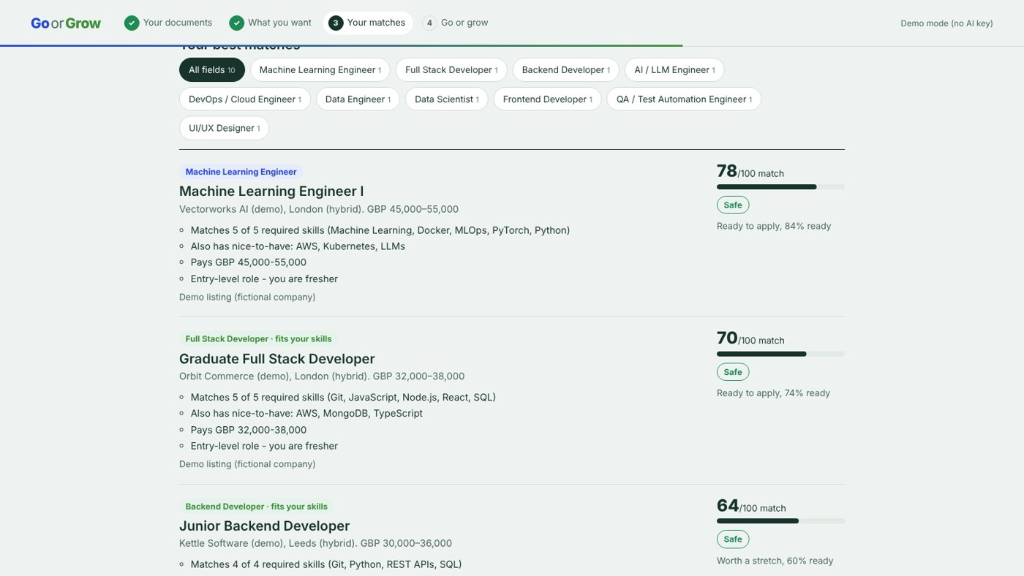
Matched jobs, each with a score, a field label and plain-language reasons

How each job is scored (out of 100)
Part | Weight | What it measures
Skill match | 50% | Required skills count double; skills used at work count more than skills only listed
Meaning match | 25% | How similar the resume and the job ad are in meaning
Salary fit | 15% | The job’s pay compared with the user’s target
Level fit | 10% | Entry, mid or senior, compared with the user’s experience level

Each job is also labelled safe (has 70%+ of the required skills), stretch (40–70%) or reach (under 40%). Tabs let the user view one job field at a time, and the top list mixes fields so one field cannot take every spot.

Page 4 – Go or grow
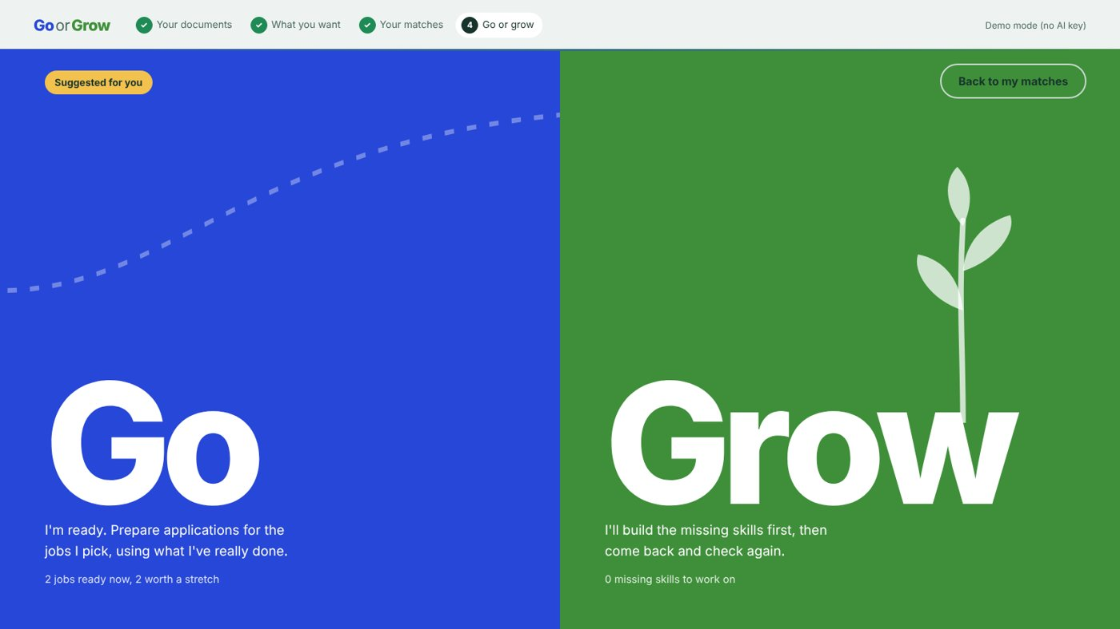
The choice screen: the suggested side is marked, but the user decides
The screen splits in two. GoOrGrow marks the side it suggests – GO needs at least one job the user is ready for now and half the matches within reach – but the choice is always the user’s.

GO – tailored applications
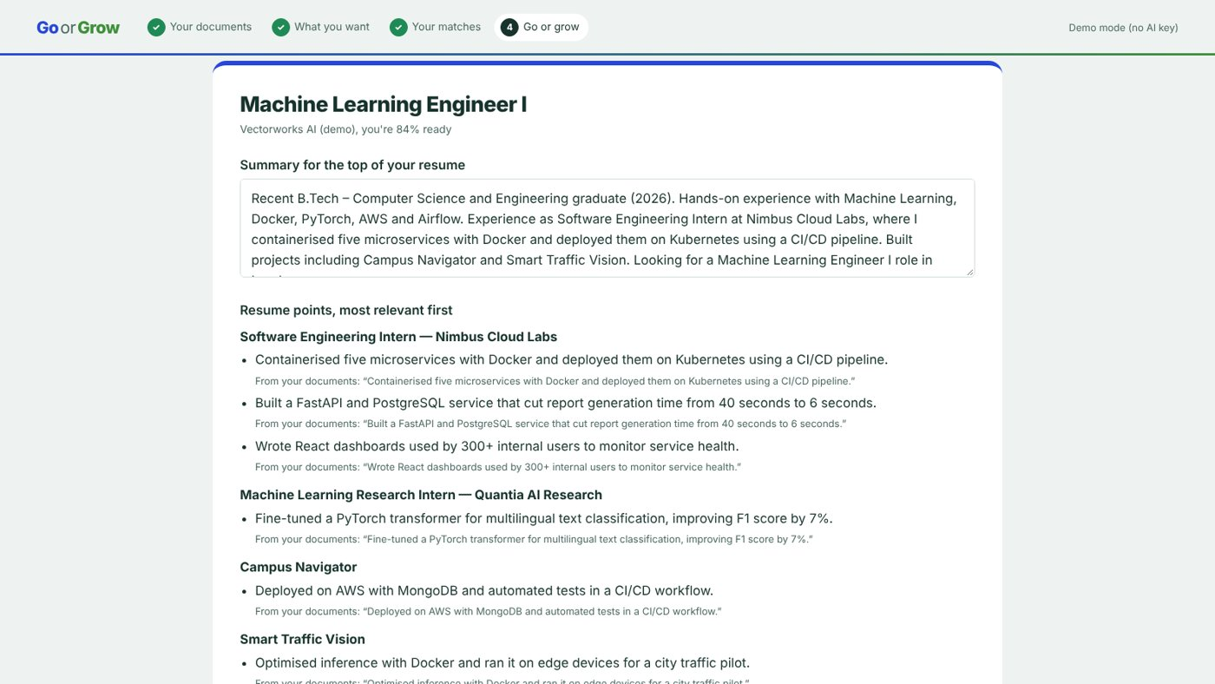
A tailored application, with the source line under every resume point
- The user picks one or more jobs, and GoOrGrow prepares for each: a summary for the top of the resume, the most relevant resume points first, a cover letter, which projects to show first, words from the ad they can honestly use, and skills they must not claim.
- Honesty guard: every line must point to evidence in the user’s documents. A line that mentions a skill they do not have, or a number not in their resume, is removed and shown with the reason.
- Checkpoint 2: the user edits and approves the application, then saves it as a PDF and applies themselves. GoOrGrow never submits anything.

GROW – learning plan
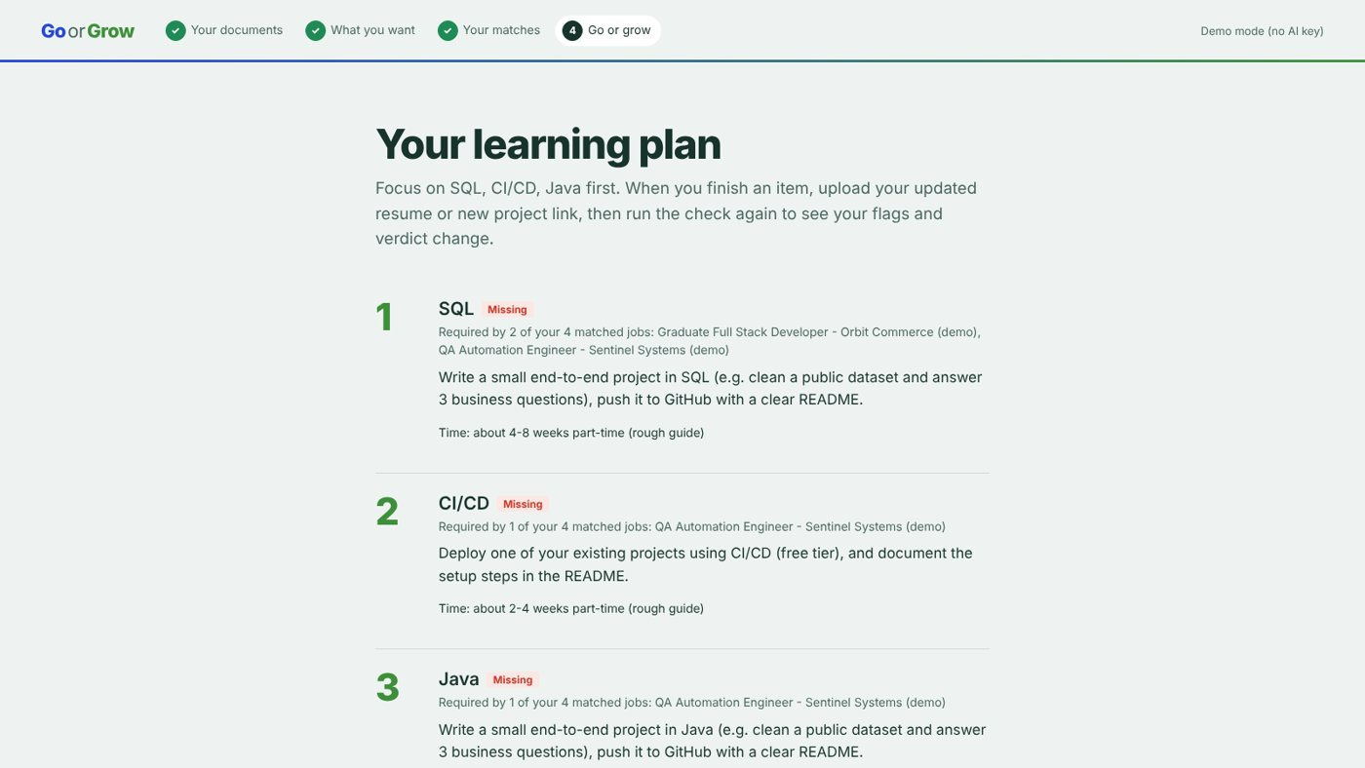
The learning plan, most-needed skills first
- Missing skills come first, ordered by how many matched jobs need them; then skills to prove; then nice-to-haves.
- Each item has a project idea to prove the skill and a rough time estimate. Course links can be added later.
- Check again: after learning, the user uploads a new resume or project link and re-runs the check to see which flags turned green and whether the advice changed.

3. How the AI works
GoOrGrow does not train its own model. It combines three parts, and none of them learns from users’ resumes.
Part | What it does | Status
Rules written by the team | Finds resume sections and skills (from a list of about 90 skills and their other spellings), rates skill strength, scores jobs, sets the flags and suggests GO or GROW | Always on
Pre-trained similarity model (all-MiniLM-L6-v2) | Measures how close the resume and each job ad are in meaning, for the 25% meaning match | On by default; downloaded once (about 90 MB)
Large language model (Gemini, Claude or OpenAI) | Reads messy resumes more accurately and writes smoother application text | Only when an API key is added

The rules always make the decisions. The language model only reads and writes, and everything it writes is checked against the user’s own documents before it is shown.

4. Built to be honest
- No made-up content: every skill and every application line points to a real line in the user’s documents.
- The user stays in control: they confirm their profile, choose GO or GROW, and approve and submit every application themselves.
- Every number is explained: each job shows why it scored what it did.
- Fair scoring: name, gender, age, photo and college name are never used in scoring.
- Privacy: uploaded files stay on the server running GoOrGrow, and one action deletes everything about a user.
- Real figures only: missing salaries are shown as unknown, never guessed.

5. Technology
Layer | What we used
Website | HTML, CSS and JavaScript, animated with GSAP (bundled, so it works offline)
Server | Python 3.12 with FastAPI
Reading files | pdfplumber and PyMuPDF for PDFs, python-docx for Word, Tesseract for OCR
Matching | Skills list with aliases, rapidfuzz, sentence-transformers
Job listings | Adzuna API (labelled “Jobs by Adzuna”), or 32 built-in demo listings from fictional companies
Storage | One file per user session; can move to a database such as Supabase later

6. How to run it

First-time setup (Windows)
You need Python 3.12 (3.15 is too new for some libraries).
- Download the code:
git clone https://github.com/kaushikkarthikayan/GrowOrGo.git
cd GrowOrGo
- Create and switch on a separate Python environment:
py -3.12 -m venv .venv
.venv\Scripts\Activate.ps1
If PowerShell blocks this, run Set-ExecutionPolicy -Scope CurrentUser RemoteSigned once, then try again.
- Install the libraries:
python -m pip install --upgrade pip
pip install -r requirements.txt
- Create your settings file (optional – the app works without keys):
Copy-Item .env.example .env
- Start the server:
uvicorn main:app --reload
- Open the website at http://127.0.0.1:8000

Optional keys (in the .env file)
Key | What it unlocks | Without it
GEMINI_API_KEY (or a Claude or OpenAI key) | Smarter resume reading and better-written applications | Rule-based reading and template drafts
ADZUNA_APP_ID and ADZUNA_APP_KEY | Real job listings | 32 demo listings from fictional companies
GITHUB_TOKEN | More GitHub lookups per hour | 60 lookups per hour

Never upload the .env file to GitHub – it holds your private keys. It is already excluded by the project’s .gitignore.

Quick check
Run the end-to-end test. It uses the sample resume and demo jobs, so it costs no API calls, and it should end with “ALL STEPS PASSED”:
python test_flow.py

7. What’s next
- Course links for each skill in the learning plan.
- Interview practice based on each job’s missing skills.
- Using real application outcomes to tune the GO and GROW thresholds.
- Accounts and a proper database for many users.
- An anonymous dashboard for college placement teams.

Credits
Job listings by Adzuna. Animation by GSAP. Meaning matching with the pre-trained all-MiniLM-L6-v2 model. Sample resumes and demo job listings are fictional.

