RAG MCP 101
Exposing a RAG System as an MCP Tool
A complete step-by-step guide — from project setup to a working MCP server

1. Project Overview
This document captures everything done to build RAG MCP 101 — a system that exposes an existing RAG pipeline as an MCP (Model Context Protocol) tool. The project builds on top of RAG Project 101 and adds a standardised interface that any MCP-compatible AI agent can call.

The goal was to take a working local RAG system (PDF ingestion, vector search, Ollama LLM) and wrap it in an MCP server so that an AI agent can discover and invoke it as a tool — without the agent needing to know anything about the underlying implementation.

1.1 What is MCP?
MCP stands for Model Context Protocol. It is an open standard created by Anthropic that defines how AI agents communicate with external tools and data sources. Instead of building custom integrations for every tool, MCP provides a single standardised interface — an agent that speaks MCP can use any MCP-compatible tool.

An MCP server exposes one or more tools. Each tool has a name, a description (which the agent reads to decide when to use it), and typed input/output parameters. The agent calls the tool by sending a JSON message; the server executes the tool and returns the result.

1.2 Architecture Overview

Layer | Component | Description
Source document | business_modeler_ide.pdf | The knowledge base ingested into ChromaDB
RAG core library | rag_core/ | Reusable modules for chunking, embedding, retrieval
Ingestion pipeline | ingest.py | One-time script — chunks, embeds, saves to disk
Vector database | chromadb_store/ | Persisted ChromaDB — survives server restarts
MCP server | mcp_server.py | Exposes query_documents tool over SSE transport
LLM | Ollama (Llama 3) | Runs locally, generates grounded answers
Inspector | MCP Inspector | Browser UI to test and debug MCP tools

1.3 Architecture Diagram

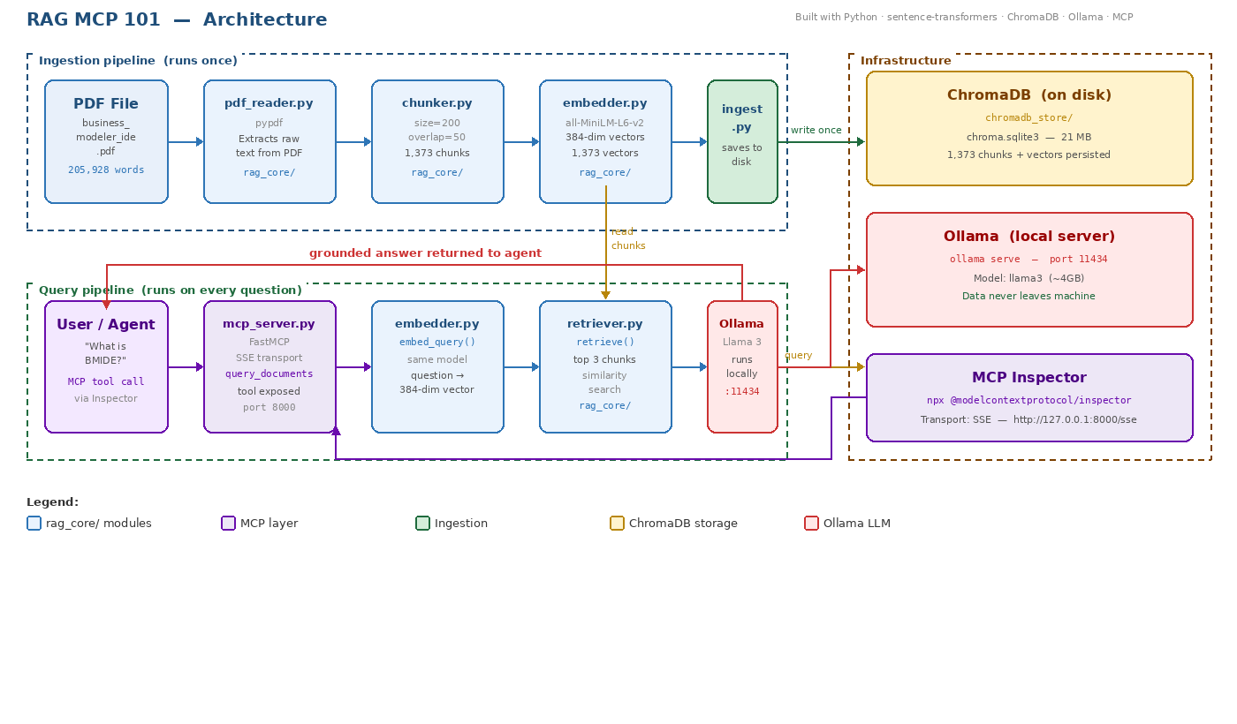
Figure 1 — RAG MCP 101 full system architecture

1.4 Why a Separate Project?
RAG MCP 101 was built as a separate project from RAG Project 101 rather than modifying the original. This follows the same learning philosophy — understand each layer in isolation before combining them. Keeping them separate means:

- If something breaks, you know immediately whether the fault is in the RAG layer or the MCP layer
- The original project remains intact as a working reference
- The rag_core/ library can be imported cleanly without circular dependencies

2. Project Structure
All files live inside the rag_mcp_101 folder. The project is split into two clear layers: the rag_core/ library (reusable RAG logic) and the top-level scripts that use it.

File / Folder | Purpose | Status
rag_core/__init__.py | Makes rag_core a Python package | New
rag_core/pdf_reader.py | Extracts raw text from PDF files using pypdf | New
rag_core/chunker.py | Splits text into overlapping word-based chunks | Refactored from 01_chunk.py
rag_core/embedder.py | Converts text to vectors using sentence-transformers | Refactored from 02_embed.py
rag_core/retriever.py | Stores/retrieves vectors in ChromaDB, calls Ollama | Refactored from 03_store.py + 04_rag.py
ingest.py | One-time ingestion pipeline — reads PDF, chunks, embeds, stores | New
mcp_server.py | MCP server exposing query_documents tool over SSE | New
chromadb_store/ | Persisted ChromaDB database — created by ingest.py | Generated
business_modeler_ide.pdf | Source document — the knowledge base | User-provided
venv/ | Virtual environment with all dependencies | Local only

2.1 Key Design Decision — rag_core/ as a Library
In RAG Project 101, each script (01_chunk.py through 04_rag.py) was standalone and self-contained. For RAG MCP 101, all that logic was refactored into rag_core/ as importable modules. This means:

- ingest.py imports from rag_core/ instead of duplicating logic
- mcp_server.py imports ask() from rag_core/retriever.py — it is just a thin wrapper
- Any future script can use the same RAG logic without copy-pasting code

3. Environment Setup

3.1 Prerequisites
RAG MCP 101 requires everything from RAG Project 101 plus two additional components:

Tool | Version / Purpose
Python | 3.13.5 — same as RAG Project 101
Ollama | 0.18.2 — runs Llama 3 locally
Node.js | v22.18 — required for MCP Inspector (npx)
VS Code | Code editor with Python extension

3.2 Cloning from RAG Project 101
Rather than starting from scratch, the project was cloned from the existing RAG Project 101 folder and given a fresh virtual environment:

# Windows
xcopy rag_project_101 rag_mcp_101 /E /I
cd rag_mcp_101
rmdir /s /q venv
python -m venv venv
venv\Scripts\activate

3.3 Python Libraries
All libraries from RAG Project 101 carry over. One new library is added for the MCP server:

pip install sentence-transformers chromadb pypdf ollama mcp fastmcp

Library | What it does
sentence-transformers | Embedding model — converts text to 384-dimensional vectors
chromadb | Vector database — stores and searches vectors by similarity
pypdf | PDF reader — extracts raw text from PDF files
ollama | Python client connecting to local Ollama app running Llama 3
mcp | Anthropic’s official MCP Python SDK
fastmcp | FastMCP framework — reduces MCP server boilerplate

4. The Code Files

4.1 — rag_core/pdf_reader.py
Reads a PDF file and returns all text as a single string. Used by ingest.py as the first step in the ingestion pipeline.

from pypdf import PdfReader

def read_pdf(filepath: str) -> str:
reader = PdfReader(filepath)
text = ""
for page in reader.pages:
text += page.extract_text() + "\n"
return text

Key concepts:
- PdfReader iterates through every page and concatenates the extracted text
- Returns a single string — downstream chunker splits it into pieces
- Replaces the old document.txt approach — real PDFs can now be used as the knowledge base

4.2 — rag_core/chunker.py
Splits the extracted text into overlapping word-based chunks. Identical logic to 01_chunk.py from RAG Project 101, refactored as an importable function.

- chunk_size=200 — each chunk contains 200 words
- overlap=50 — the last 50 words of each chunk repeat at the start of the next
- load_and_chunk() — convenience function for loading a .txt file directly (kept for compatibility)

4.3 — rag_core/embedder.py
Converts text chunks into 384-dimensional vectors using the all-MiniLM-L6-v2 model. Uses a singleton pattern to avoid reloading the model on every call.

- get_model() — lazy-loads the model on first call, then reuses it
- embed_chunks(chunks) — encodes a list of chunks, returns list of vectors
- embed_query(query) — encodes a single query string, returns one vector
- The singleton pattern is important for MCP — the model stays loaded in memory across multiple tool calls

4.4 — rag_core/retriever.py
The core RAG module. Handles storing vectors in ChromaDB, querying for similar chunks, and calling Ollama to generate a grounded answer.

Key functions:
- get_collection(persist_path) — connects to or creates a persistent ChromaDB collection
- store_chunks(chunks, embeddings, persist_path) — stores all chunks and vectors to disk
- retrieve(query_embedding, n_results, persist_path) — finds top N similar chunks
- ask(query, n_results, persist_path) — the full pipeline: embed → retrieve → Ollama → answer

The ask() function constructs a three-part prompt for Ollama:

Prompt Part | Content
System | Answer using only the context below. Say ‘I don’t have enough information’ if not found.
Context | Top 3 retrieved chunks joined into one block
User | The original question

4.5 — ingest.py
The one-time ingestion pipeline. Reads the PDF, chunks it, embeds all chunks, and saves them to ChromaDB on disk. Run this once before starting the MCP server. Re-run only if the source document changes.

python ingest.py

What it does step by step:
- Calls read_pdf() from rag_core/pdf_reader.py to extract all text
- Calls chunk_text() from rag_core/chunker.py to split into 200-word overlapping chunks
- Calls embed_chunks() from rag_core/embedder.py to convert chunks to vectors
- Calls store_chunks() from rag_core/retriever.py to save everything to chromadb_store/

Result from first run against business_modeler_ide.pdf:
- 205,928 words extracted
- 1,373 chunks created and stored
- 21MB ChromaDB database written to disk

Important: ChromaDB uses get_or_create_collection — re-running ingest.py appends to the existing collection rather than replacing it. Delete the chromadb_store/ folder first if you want a clean rebuild.

4.6 — mcp_server.py
The MCP server. Imports ask() from rag_core/retriever.py and exposes it as a single tool called query_documents. Uses SSE (Server-Sent Events) transport to handle long-running Ollama responses without timing out.

from mcp.server.fastmcp import FastMCP
from rag_core.retriever import ask

mcp = FastMCP("RAG MCP 101", host="127.0.0.1", port=8000)

@mcp.tool()
def query_documents(question: str) -> str:
"""
Search the knowledge base and return a grounded answer.
Use this tool to answer questions about the ingested PDF document.
"""
return ask(question, persist_path=PERSIST_PATH)

if __name__ == "__main__":
mcp.run(transport="sse")

Key concepts:
- @mcp.tool() decorator registers query_documents as a discoverable MCP tool
- The docstring is what the AI agent reads to decide when to call this tool — keep it descriptive
- transport="sse" — SSE keeps a persistent HTTP connection, avoiding timeout issues with slow local LLMs
- mcp_server.py is a thin wrapper — all RAG logic lives in rag_core/

5. Running the System

5.1 Step 1 — Run ingest.py (once only)
cd D:\Kaushik\Projects\rag_mcp_101
venv\Scripts\activate
python ingest.py

Expected output:
[1/3] Reading PDF: business_modeler_ide.pdf
Done — 205928 words extracted
[2/3] Chunking text (size=200, overlap=50)
Done — 1373 chunks created
[3/3] Embedding and storing in ChromaDB at './chromadb_store'
Stored 1373 chunks to ./chromadb_store
Done. ChromaDB is saved to disk and ready for mcp_server.py

5.2 Step 2 — Start the MCP Server
python mcp_server.py

Expected output:
Starting RAG MCP 101 server on http://127.0.0.1:8000
INFO: Started server process [67192]
INFO: Uvicorn running on http://127.0.0.1:8000 (Press CTRL+C to quit)

Leave this terminal running. The server stays alive and waits for tool calls.

5.3 Step 3 — Open MCP Inspector
In a second terminal:
npx @modelcontextprotocol/inspector

When the browser opens, set:
- Transport Type → SSE
- URL → http://127.0.0.1:8000/sse
- Click Connect — you should see a green Connected dot and the query_documents tool listed

5.4 Step 4 — Ask a Question
Click query_documents in the Tools panel, type a question about your PDF, and click Run Tool. The full pipeline executes — embedding, retrieval, Ollama generation — and the answer appears under Tool Result: Success.

6. Issues Encountered & Fixes

Issue | Root Cause | Fix
MCP Inspector showed Connection Error on first run | mcp_server.py was inside rag_core/ instead of project root | Moved mcp_server.py to rag_mcp_101/ root level
Tool call silently hung — no output, no error | MCP Inspector STDIO transport has an internal timeout shorter than Ollama’s response time (20-30s) | Switched transport from STDIO to SSE — run server directly with mcp.run(transport="sse")
MCP error -32001: Request timed out | Maximum Total Timeout in Inspector was 60 seconds | Confirmed by switching to SSE which has no timeout issue
embeddings.position_ids UNEXPECTED warning | Harmless model loading warning from sentence-transformers | Safe to ignore — does not affect embedding quality
HF_TOKEN unauthenticated warning | Hugging Face suggests registering for higher rate limits | Safe to ignore — model is public, downloads without token
store_chunks appends on re-run | get_or_create_collection does not reset existing data | Delete chromadb_store/ folder before re-running ingest.py for a clean rebuild

7. Key Learnings

What we did | What we learned
Refactored 4 scripts into rag_core/ | Separating logic into importable modules makes the codebase reusable and debuggable — mcp_server.py is only 20 lines because all the work is in rag_core/
Switched from in-memory to persistent ChromaDB | MCP servers are long-running processes — in-memory databases reset on every restart. PersistentClient saves to disk so the server loads existing vectors on startup
Used SSE instead of STDIO transport | STDIO has hidden timeouts that break with slow local LLMs like Ollama. SSE keeps a persistent connection and handles long-running responses correctly
Tested RAG pipeline in isolation first | Running python -c "from rag_core.retriever import ask; print(ask(...))" confirmed the RAG pipeline worked before debugging MCP. Always isolate layers when debugging
Used MCP Inspector for testing | The Inspector provides a browser UI to call tools manually. It shows the full input/output schema, structured results, and server notifications without needing any agent code
Identified correct FastMCP import source | Running inspect.getfile(FastMCP) confirmed exactly which package was being used. Always verify the source of imports when two packages share similar APIs

8. Suggested Next Steps

Experiments to try:
- Ask questions at the boundary of what the PDF covers — verify the 'I don’t have enough information' response works correctly
- Change n_results from 3 to 5 in ask() — test if more context chunks improve answer quality
- Change chunk_size to 100 in ingest.py, re-ingest, and compare retrieval precision
- Ingest multiple PDFs — run ingest.py with different files to expand the knowledge base

Improvements to build:
- Python agent script — use the Anthropic API to build an agent that calls query_documents automatically when relevant
- Source citations — return which chunk each answer came from alongside the answer
- Multiple tools — add a second MCP tool such as list_topics that returns a summary of what the knowledge base covers
- Streamlit UI — build a simple chat interface that connects to the MCP server
- Persistent conversation history — pass previous Q&A pairs as additional context to Ollama

9. Final Project Structure
rag_mcp_101/
├── rag_core/
│ ├── __init__.py
│ ├── chunker.py
│ ├── embedder.py
│ ├── pdf_reader.py
│ └── retriever.py
├── chromadb_store/ ← generated by ingest.py
├── ingest.py
├── mcp_server.py
├── business_modeler_ide.pdf
├── .gitignore
└── venv/

RAG MCP 101 · Built with Python, sentence-transformers, ChromaDB, Ollama (Llama 3) and MCP

