**T12-HOL001_TestCase [Unit Testing of Angular Routing]**

In this hands on, we will perform Unit Testing of Angular Routing using Jasmine and Karma.

Tasks:

1. Create two components: HomeComponent and AboutUsComponent.
2. In app.module.ts file add the following:

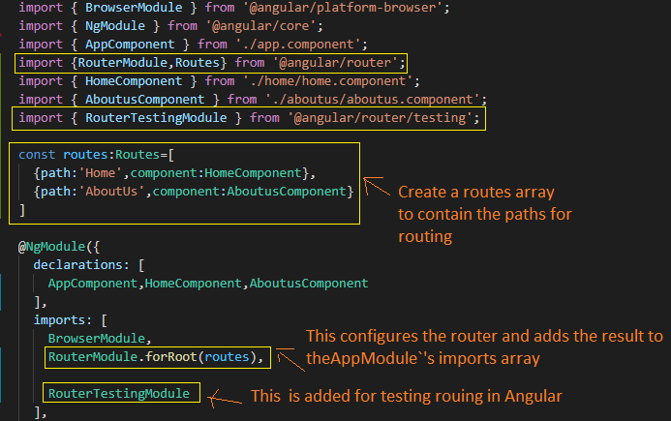

1. In app.component.html add the anchor tags for routing and router-outlet to display routed view.

**Sample code of app.component.ts and app.component.html is given for your reference:**

import { Component } from '@angular/core';

@Component({

  selector: 'app-root',

  templateUrl: './app.component.html',

  styleUrls: ['./app.component.css']

})

export class AppComponent {

}

<a routerLink="/Home">Home</a>

<br/><br/>

<a id="link2" routerLink="/AboutUs">About Us</a>

<br/><br/>

<router-outlet></router-outlet>

**Sample Output:**

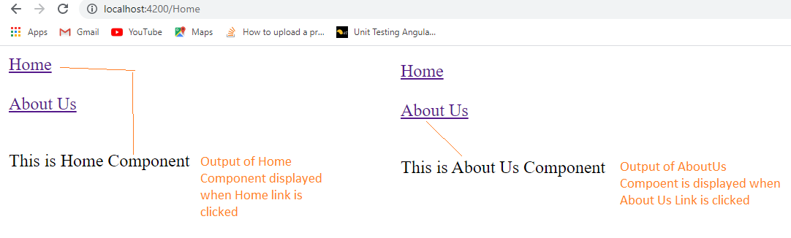

1. Under app.component.spec.ts check if the describe () block for AppComponent is present.
2. Check whether a beforeEach() block that instantiates a new instance of AppComponent for each spec is present. Also under TestBed add the RoutingTestingModule and add the routing paths for Home and AboutUs component for testing the routing.
3. Check if there is a test case to check whether the AppComponent is created is present.
4. Create a test case to check if the routing is happening when link is clicked for HomeComponent.
5. Create a test case to check if the routing is happening when link is clicked for AboutUsComponent.

**Sample Testing Code is given for your reference:**

import { TestBed, async, inject } from '@angular/core/testing';

import { By } from '@angular/platform-browser';

import { RouterTestingModule } from '@angular/router/testing';

import { AboutusComponent } from './aboutus/aboutus.component';

import { AppComponent } from './app.component';

import { HomeComponent } from './home/home.component';

describe('AppComponent', () => {

  beforeEach(async(() => {

    TestBed.configureTestingModule({

      imports: [

        RouterTestingModule.withRoutes([

          { path: 'Home', component: HomeComponent },

          {path:'AboutUs',component:AboutusComponent}

         ])

      ],

      declarations: [

        AppComponent,HomeComponent,AboutusComponent

      ],

    }).compileComponents();

  }));

  it('should create the app', () => {

    const fixture = TestBed.createComponent(AppComponent);

    const app = fixture.debugElement.componentInstance;

    expect(app).toBeTruthy();

  });

  it('Should Route To Home Component',

  async() => {

  let fixture = TestBed.createComponent(AppComponent);

  fixture.detectChanges();

  let href=fixture.debugElement.query(By.css('a')).nativeElement

  .getAttribute('href');

  fixture.whenStable().then(() => {

    expect(href).toEqual('/Home');

    console.log('after expect');

  });

  });

  it('Should Route To About Us Component',

  async() => {

  let fixture = TestBed.createComponent(AppComponent);

  fixture.detectChanges();

  let href=fixture.debugElement.query(By.css('#link2')).nativeElement

  .getAttribute('href');

  fixture.whenStable().then(() => {

    expect(href).toEqual('/AboutUs');

    console.log('after expect');

  });

  });

});

1. Run the command ng test in cli window to execute your test.
2. Use the url generated after running the ng test command to open Karma window in the browser and click Debug button to get Jasmine Test Result.

**Sample output is given below for your reference:**



