**Angular-T02-HOL_001_TestCase [Testing Built-In-Pipes]**

In this hands on we will understand how to perform unit testing of Angular applications using Jasmine and Karma on built-in-pipes.

Tasks

1. Create a component called Employee. Add the following data under this component:

title="employee information"

  name="sam";

  salary=90000;

  joiningDate=new Date("2021/05'20");

1. Under employee.component.html file, add pipes to get the following display:
2. The title should be in title case and present under h1 tag
3. The name should be in upper case and present in a h2 tag with id=”name”
4. The salary should be displayed in INR as ₹90,000.00 (use currency pipe) under a h2 tag with id=”salary”
5. The joining date should be displayed as fullDate (use date pipe) under a h2 tag with id=”joiningDate”.

**Sample output is given for your reference:**

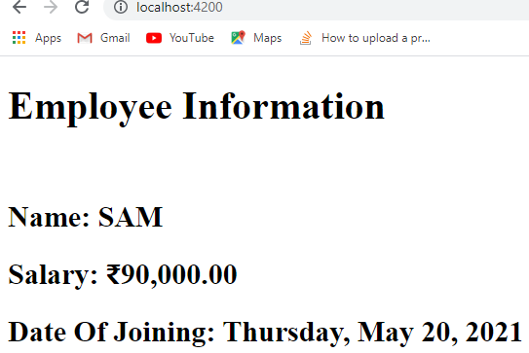

1. Use xdescribe() for app.component.spec.ts
2. Check whether the file employee.component.spec.ts is present in src/app/employee.
3. Check if the describe () block for EmployeeComponent is present.
4. Check whether a beforeEach() block that instantiates a new instance of EmployeeComponent for each spec is present
5. Check if there is a test case to check whether the EmployeeComponent is created is present.
6. Create a test case to check whether there is a title called “employee information” is present.
7. Create a test case to check whether there is a name called “sam” is present.
8. Create a test case to check whether there is salary called with value 9000 is present.
9. Create a test case to check whether there the joining date with value 2021/05/20 is present.
10. Create a test case to check if the title is present in h1 tag as “Employee Information”
11. Create a test case to check if the name is present in h2 tag with id=”name” as “Name: SAM”
12. Create a test case to check if the salary is present in h2 tag with id=”salary” as “Salary: ₹90,000.00”
13. Create a test case to check if the joining date is present in h2 tag with id=”joiningDate” as “Date Of Joining: Thursday, May 20, 2021”.

Run the command ng test in cli and click the debug button of Karma window in browser to see the jasmine test results.

**Sample output is given for your reference:**

