**Angular-T03-HOL_001_TestCase**

In this hands on we will understand how to perform unit testing of Angular applications using Jasmine and Karma. Jasmine is a behavior-driven development framework for testing JavaScript code. Here we will write the test suite and test cases using Jasmine. Karma is the test runner for Angular.

**Tasks:**

1. Under hallo.component.ts take three variables: a=10, b=20 and result=0. Create a method called Addition(). Perform the addition of a and b and store the value under result. Return the result.
2. Under hallo.component.html call the Addition() method and display the addition result using interpolation under h2 tag.
3. Add the selector of HalloComponent under app.component.html for display. Sample output is given below:

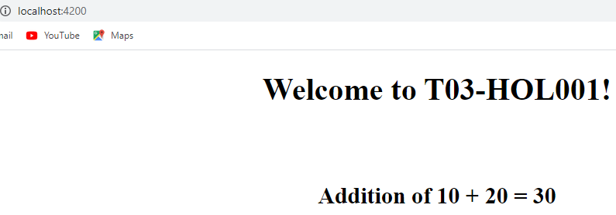

1. Use xdescribe() block under app.component.spec.ts to stop this test suite from executing.
2. Check whether the file hallo.component.spec.ts is present in src/app.
3. Check if the describe () block for HalloComponent is present.
4. Check whether a beforeEach() block that instantiates a new instance of HalloComponent for each spec is present
5. Check if there is a test case to check whether the HalloComponent is created or not is present.
6. Create a test case to check whether the addition result matches with the expected result [where the expected result is 30].
7. Create a test case to check whether the addition result is present in h2 tag for display.
8. Run ng test to check your output.

Sample Test Output:

