**Angular-T04-HOL_001_TestCase**

In this hands on we will understand how to perform unit testing of Angular applications using Jasmine and Karma on Interface, Component Classes and Methods.

**Tasks:**

1. Create an interface called IEmployee with the below properties:

id, name, salary, permanent with data types number, string, number and boolean types respectively.

1. Create a component class called EmployeeComponent and implement the IEmployee interface.
2. Create 4 methods in the component class:
3. DisplayId(): It will return the employee id.
4. DisplayName(): It will return the employee name
5. DisplaySalary(): It will return the employee salary
6. DisplayPermanentOrNot(): It will return the permanent status.
7. Also add a variable under component class called title with a value “Employee Information”.
8. Display the title in an h1 tag and the above 4 method values in h2 tag under employee.component.html file. Sample output is given for your reference.

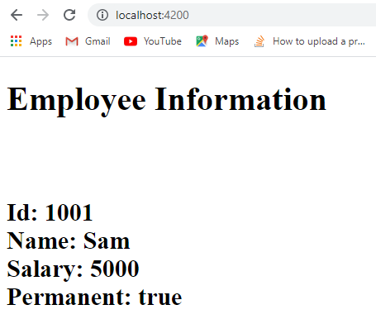

1. Use xdescribe() for app.component.spec.ts
2. Check whether the file employee.component.spec.ts is present in src/app/employee.
3. Check if the describe () block for EmployeeComponent is present.
4. Check whether a beforeEach() block that instantiates a new instance of EmployeeComponent for each spec is present
5. Check if there is a test case to check whether the EmployeeComponent is created is present.
6. Create a test case to check whether there is a title called “Employee Information” is present.
7. Create a test case to check whether the title is present in h1 tag for display.
8. Create a test case to check if the DisplayId() is defined.
9. Create a test case to check if the DisplayName() is defined
10. Create a test case to check if the DisplaySalary() is defined
11. Create a test case to check if the DisplayPermanentOrNot () is defined
12. Create a test case to check if the employee id >=1000
13. Create a test case to check if the employee name returned is not blank
14. Create a test case to check if the salary returned is >=3000
15. Create a test case to check if the id is present in h2 tag
16. Create a test case to check if the name is present in h2 tag
17. Create a test case to check if the salary is present in h2 tag
18. Create a test case to check if the permanent is present in h2 tag

Use ng test to run the test. Open the browser and press debug button of karma window to debug the tests and check output. Sample reference is given below:

