**Angular-T06-HOL_001_TestCase [Testing Custom Directive]**

In this hands on we will understand how to perform unit testing of Angular applications using Jasmine and Karma on Custom Directive.

**Tasks:**

1. Create a custom directive called HoverFocus [use the command ***ng g directive –skipTests=true HoverFocus***].
2. Under the HoverFocus directive add the below code to change the background color of a textbox on mouse over and mouse out:

import { Directive,HostListener,HostBinding } from '@angular/core';

@Directive({

  selector: '[hoverfocus]'

})

export class HoverFocusDirective {

constructor() { }

@HostBinding("style.background-color") backgroundColor: string;

@HostListener('mouseover') onHover() {

  this.backgroundColor = 'blue';

}

@HostListener('mouseout') onLeave() {

 this.backgroundColor = 'yellow';

 }

}

1. Create a component called TestHoverFocus. **The code is given below for component class:**

import { Component, OnInit } from '@angular/core';

import { HoverFocusDirective } from './../hover-focus.directive';

@Component({

selector: 'app-test-hover-focus',

templateUrl: './test-hover-focus.component.html',

styleUrls: ['./test-hover-focus.component.css']

})

export class TestHoverFocusComponent implements OnInit {

constructor() { }

ngOnInit() {

}

}

1. Add the below code under test-hover-focus.component.html
2. <input type="text" hoverfocus>
3. Add the selector of TestHoverFocusComponent class under app.component.html for display. **Sample Output is given below:**

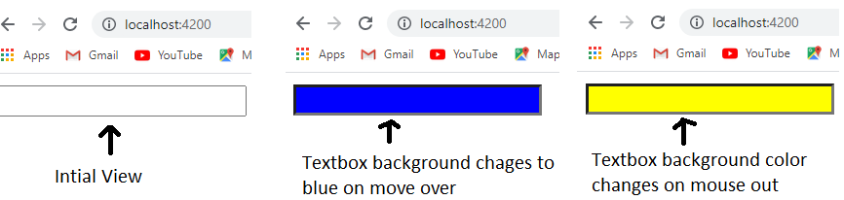

1. Check whether the file test-hover-focus.component.spec.ts is present in src/app/test-hover-focus.
2. Check if the describe () block for TestHoverFocusComponent
3. is present.
4. Check whether a beforeEach() block that instantiates a new instance of TestHoverFocusComponent for each spec is present
5. Check if there is a test case to check whether the TestHoverFocusComponent is created is present.
6. Create a test case to check if the background color of input field changes to blue on mouse over.
7. Create a test case to check if the background color of input field changes to yellow on mouse out.
8. Use xdescribe() block for app.component.spec.ts to stop it from executing.

**Sample code for TestHoverFocus test is given below:**

import { async, ComponentFixture, TestBed } from '@angular/core/testing';

import { Component, DebugElement } from "@angular/core";

import { By } from "@angular/platform-browser";

import { HoverFocusDirective } from './../hover-focus.directive';

import { TestHoverFocusComponent } from './test-hover-focus.component';

describe('TestHoverFocusComponent', () => {

  let component: TestHoverFocusComponent;

  let fixture: ComponentFixture<TestHoverFocusComponent>;

  let inputEl: DebugElement;

  beforeEach(async(() => {

    TestBed.configureTestingModule({

      declarations: [ TestHoverFocusComponent,HoverFocusDirective ]

    })

    .compileComponents();

  }));

  beforeEach(() => {

    fixture = TestBed.createComponent(TestHoverFocusComponent);

    component = fixture.componentInstance;

    inputEl = fixture.debugElement.query(By.css('input'));

    //fixture.detectChanges();

  });

  it('should create TestHoverFocusComponent Component', () => {

    expect(component).toBeTruthy();

  });

  it('hovering over input', () => {

    inputEl.triggerEventHandler('mouseover', null);

    fixture.detectChanges();

    expect(inputEl.nativeElement.style.backgroundColor).toBe('blue');

    inputEl.triggerEventHandler('mouseout', null);

    fixture.detectChanges();

    expect(inputEl.nativeElement.style.backgroundColor).toBe('yellow');

});

});

1. Run the command ng test to execute your test.
2. Open the Karma window and click the debug button to get your jasmine test results. Sample output is given for your reference.

