**Angular-T01-HOL_001_TestCase**

In this hands on we will understand how to perform unit testing of Angular applications using Jasmine and Karma. Jasmine is a behavior-driven development framework for testing JavaScript code. Here we will write the test suite and test cases using Jasmine. Karma is the test runner for Angular.

**Tasks**

1. In AppComponent class add a variable called title with a value “Unit Testing In Angular”. Add the title under h1 tag in app.component.html for display. Sample output is given below:

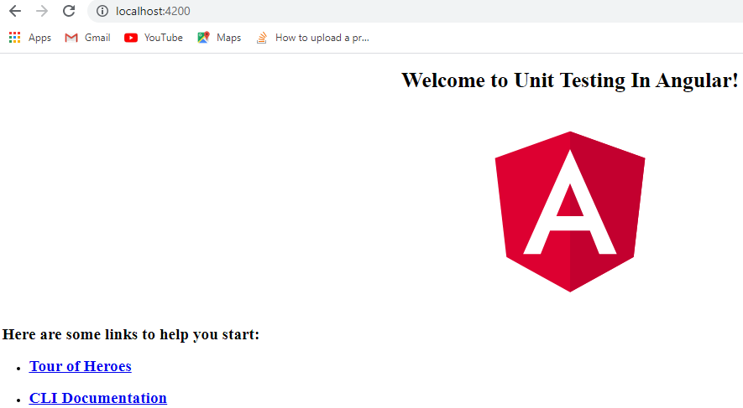

1. Check whether the file app.component.spec.ts is present in src/app.
2. Check if the describe () block for AppComponent is present.
3. Check whether a beforeEach() block that instantiates a new instance of AppComponent for each spec is present
4. Check if there is a test case to check whether the AppComponent is created is present.
5. Check if there is a test case to check whether the title with value “Unit Testing In Angular” is present.
6. Check if there is a test case to check whether the title is present in h1 tag is present.
7. Run the command ng test in cli window to execute your test.
8. Use the url generated after running the ng test command to open Karma window in the browser. Sample reference is given below:



1. Click the Debug button to execute the test cases and display the Jasmine test outputs in browser. Sample reference is given below:

