There will be multiple ways which will help to create product configurator.

1. **We can use third party extensions**

We need to change that extension or generate custom options from backend according to the requirement.

<https://www.havipropel.com/magento-product-configurator>

1. **We can create our custom extension and implement it by using following ways.**

I will check if product type will be custom helment then out custom product detail page will open or magento’s default page will be open.

I will have to use depended custom options for color type and color selection.

Also, depended option will be use for check fontstyle, helmet size and visor.

Need to use toggle selection effect for Matte and Glossy option types.

We can choose different option type and it will show result option according to option type.

Need to use tooltip for visor selection and it will reflect according to our selection.

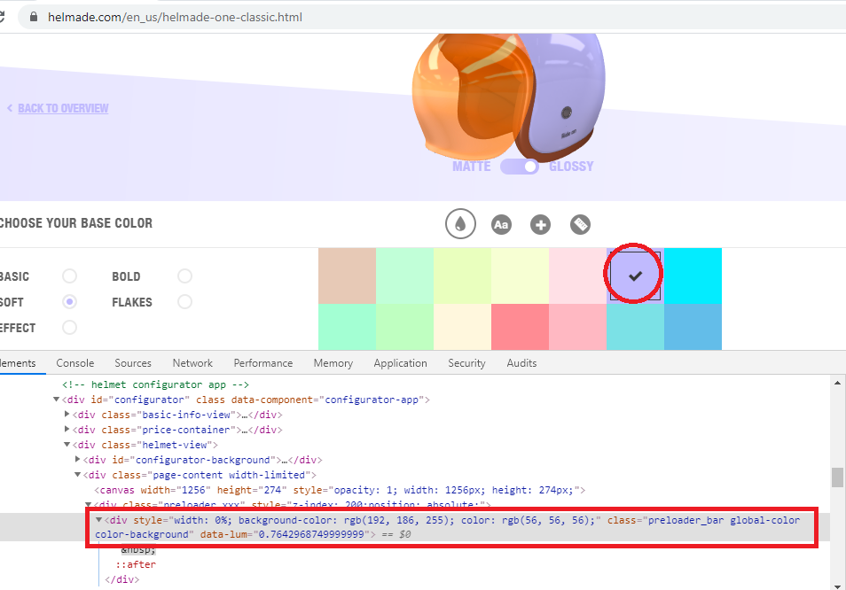

There will be onclick jQuery events on every selection I need to use for selecting different color and according to that selection, div layer style will be change (highlighted in the screenshot)

Once add to cart will be clicked by user, the new image will be generated according to our selection and it will be showing in the cart page by using cart session object in Magento 2.

<https://www.helmade.com/media//customImages/8bf38a33b49e820206ef40362fa6e9b024a43eaf.png>

For entire procedure, we need to use jQuery onclick event for different options and it will be reflected into the canvas by using jQuery and HTML5 standards.

1. **we can also use readymade third party jquery plugin and customize in Magento. Please check following URL for your reference.**

<https://codyhouse.co/gem/product-builder>

1. **if do you have code for Magento 1 standard, then the procedure will be very easy because we need to only migrate that code from Magento 1 to Magento 2.**