Manual Procedure For Ingesting Error Record

- Check for which package, we had an issue with pdf using MailPieceId notified by Print Vendor. You will find MailPieceId from provided pdf file name{MailPieceId_ActualPdfFileName.pdf) and PrintTrailBatchId which is nothing but submitted BatchId
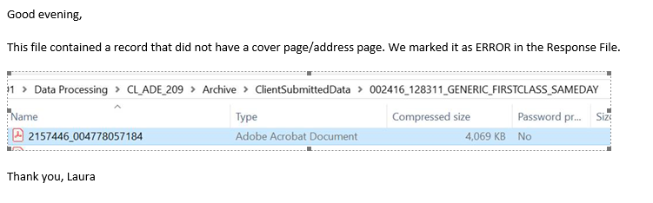
- Take MailPieceId, PrintTrailBatchId and Error Description(Provided in response file) and replace with existing variable in below script and execute.

- Validate records after update and then execute COMMIT TRAN in above script. If you find any issue with data update then execute ROLLBACK TRAN in above script.

