Operating Systems

EOPSY

Lab 4

Kaushikram Krishnamoorthy

302335

Introduction:

Memory management is the functionality of an operating system which handles or manages primary memory and moves processes back and forth between main memory and disk during execution. Memory management keeps track of each and every memory location, regardless of either it is allocated to some process or it is free. It checks how much memory is to be allocated to processes. It decides which process will get memory at what time. It tracks whenever some memory gets freed or unallocated and correspondingly it updates the status.

A computer can address more memory than the amount physically installed on the system. This extra memory is actually called virtual memory.

Paging is a memory management scheme that eliminates the need for contiguous allocation of physical memory. This scheme permits the physical address space of a process to be non – contiguous.

In paging, each process in secondary memory is divided in the form of pages and the physical memory is also divided into frames. Each page is stored in each frame. It can be stored in different locations, but the preferred way is storing them in a contiguous way. The size of each frame must be equal. Since we map the pages to frames the page size should be the same of frame size.

A page fault occurs when a program attempts to access a block of memory that is not stored in the physical memory, or RAM. The fault notifies the operating system that it must locate the data in virtual memory, then transfer it from the storage device, such as an HDD or SSD, to the system RAM.

Since actual physical memory is much smaller than virtual memory, page faults is quite common. In case of page fault, Operating System might have to replace one of the existing pages with the newly needed page. Different page replacement algorithms suggest different ways to decide which page to replace. The target for all algorithms is to reduce the number of page faults.

**First In First Out (FIFO) –**  
This is the simplest page replacement algorithm. In this algorithm, the operating system keeps track of all pages in the memory in a queue, the oldest page is in the front of the queue. When a page needs to be replaced page in the front of the queue is selected for removal.

**Optimal Page replacement –**  
In this algorithm, pages are replaced which would not be used for the longest duration of time in the future.

**Least Recently Used –**  
In this algorithm page will be replaced which is least recently used.

Results:

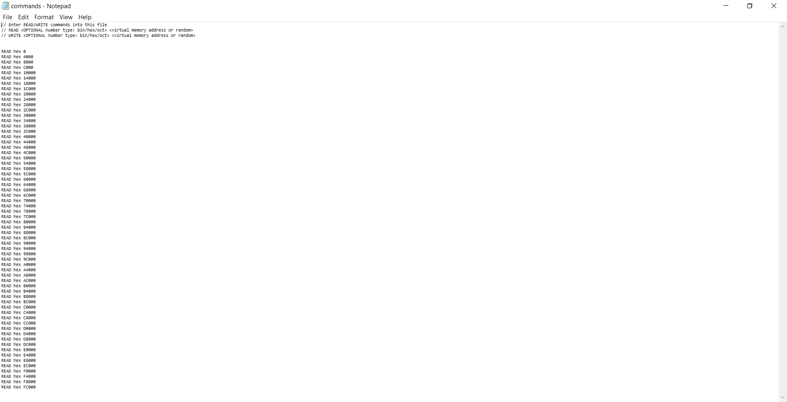

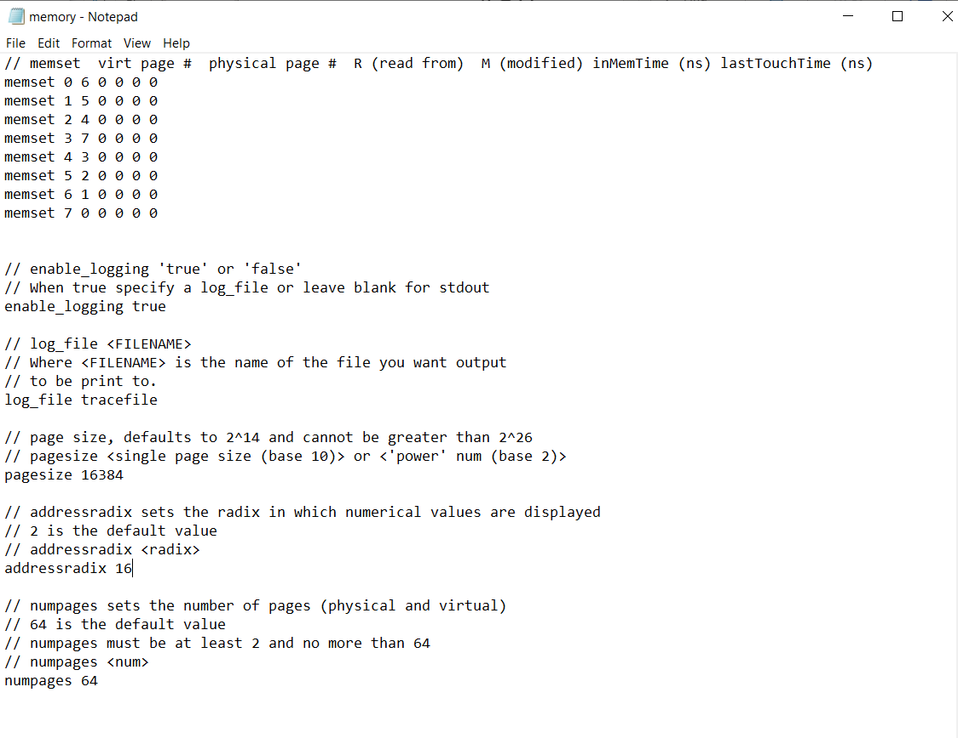

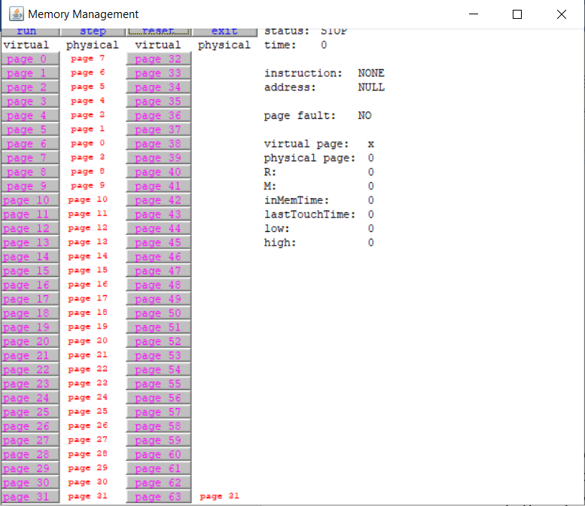

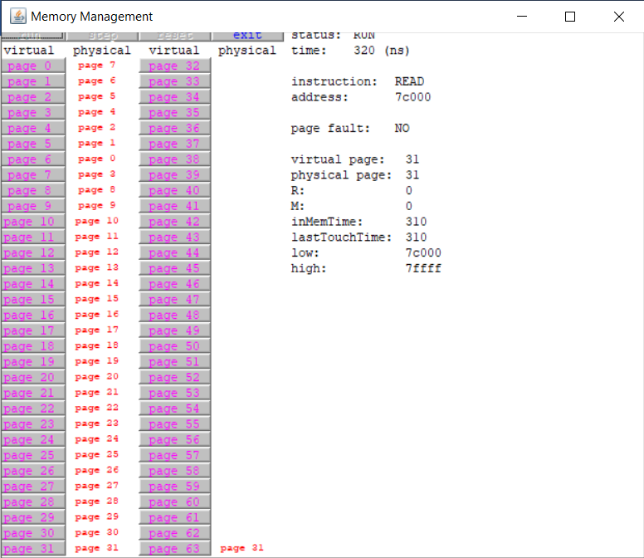

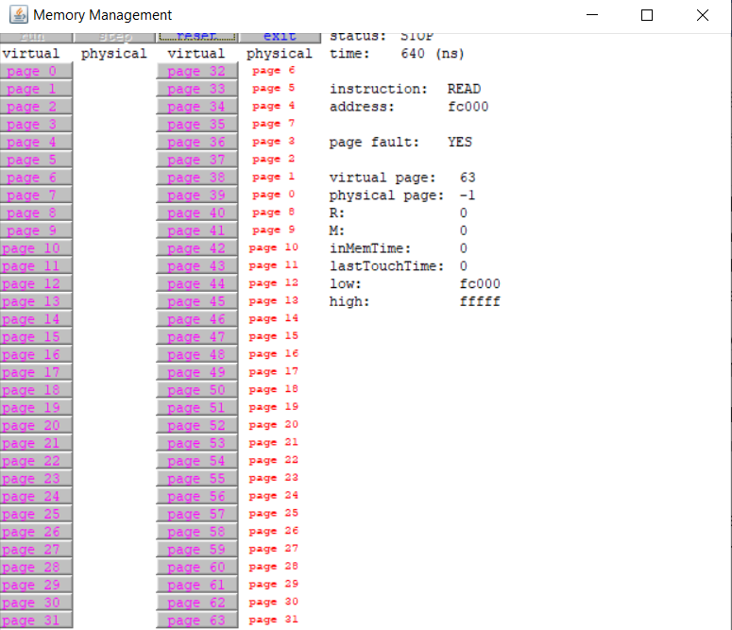

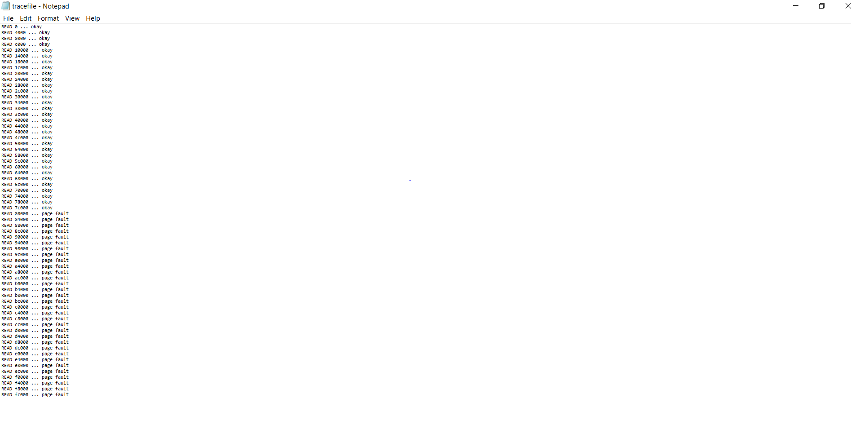

Observations:

Our task was to map any 8 pages of physical memory to the first 8 pages of virtual memory, reads from one virtual memory address on each of the 64 virtual pages, and predict which virtual memory addresses cause page faults and What page replacement algorithm is being used.

The first thing to observe is that it was impossible to map only 8 pages of physical memory to the first 8 pages of virtual memory and read 64 pages because as we can observe that the maximum number of pages is always equal to the sum of physical and virtual pages mapped.

For example if we set the maximum number of pages to 16 then the simulator always maps the first 8 pages of physical memory to the first 8 pages of virtual memory.

That is why if we have the maximum number of pages set to 64 then the simulator will map the first 32 pages of physical memory to the 32 pages of virtual memory.

So when we have the maximum number of pages set to 64 then 32 are physical and 32 are virtual.

Then we observed that after reading the first 31 pages there were page faults for every page till page 63 because in this case only the first 32 pages of the physical memory were mapped to the first 32 pages of the virtual memory.

Afterwards for the next 32 pages there were page faults because the program attempts to access a block of memory that is not stored in the physical memory.

Because only the first 32 pages of the virtual memory were mapped to the physical memory that is why it will show a page fault for the rest of the 32 pages as they

were not mapped to the physical memory.

For page replacement FIFO (First in First out) replacement algorithm was used. It uses for replacement the frame whose page has been in memory the longest.

The page that came in the first will be replaced the first as well.

The page frames are kept in a queue and the frame that was used lately is moved to the tail and in the next replacement the next page from the queue is used or we can say that they are replaced sequentially.