Day70 - April 15th 2024

1. Started my day as usual
2. Solved LRU cache problem on leetcode

Find my approach and explanatio : <https://docs.google.com/document/d/16DmBNCZCrJi8kNAwBLec2bbh0mWhCDWvHi15_wcjnI8/edit?usp=sharing>

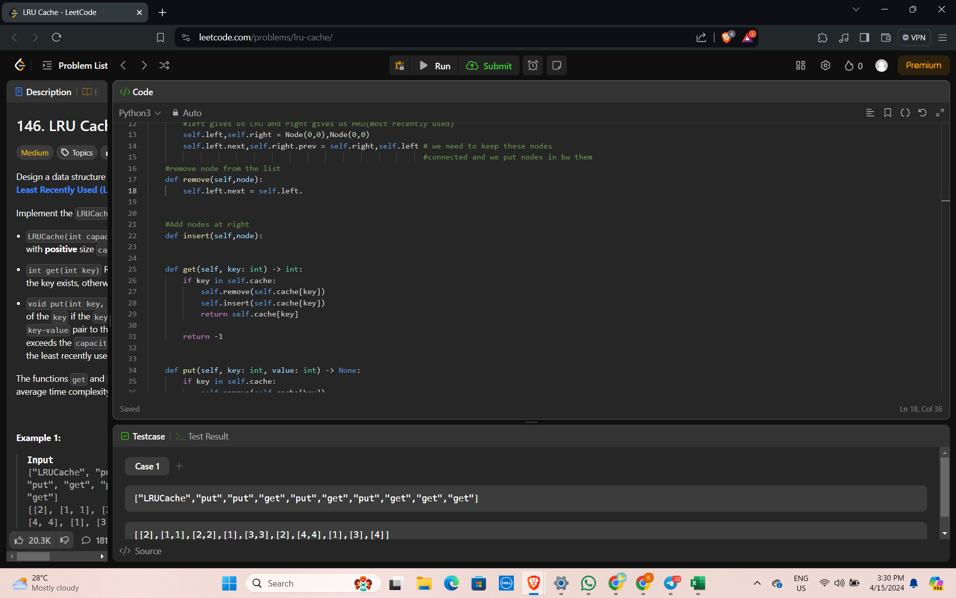

1. Ended my day by solving sql queries on hackerrank