Database

Ques 1. Create Database

Ans 1. 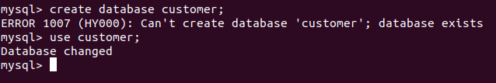

Ques 2. Design Schema

Ans 2. 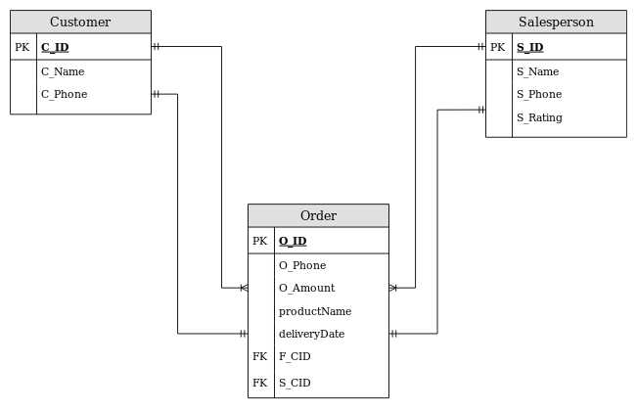

Ques 3.Create tables

Ans 3

Customers table

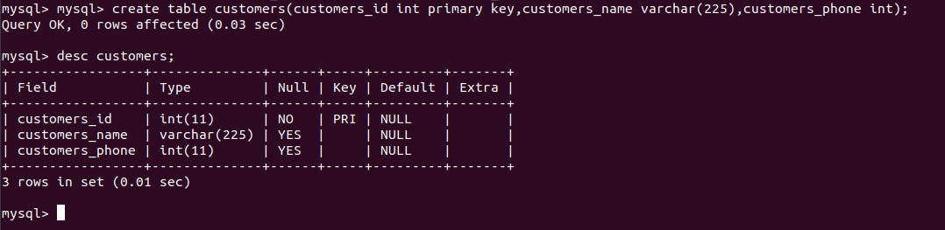

Salesperson table

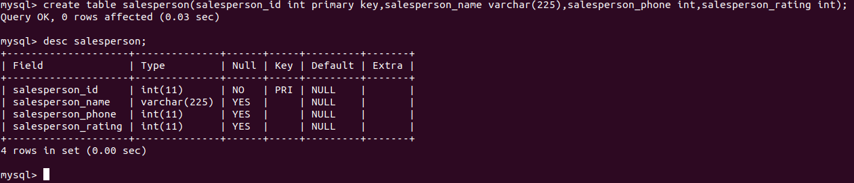

Order_detail table

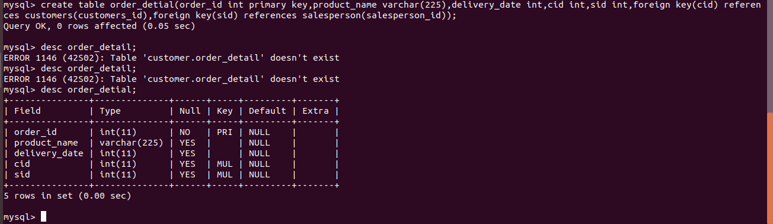

Ques 4.Insert sample data

Ans 4.

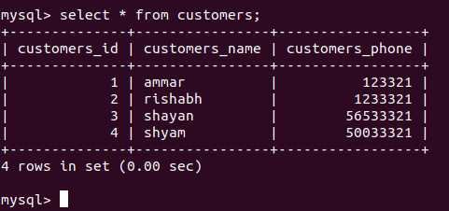

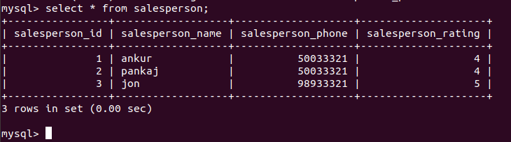

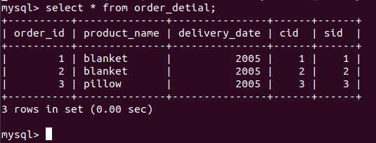

Ques 5. Find the sales person have multiple orders.

Ans 5.

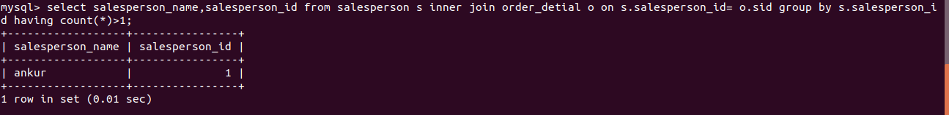

Ques 6. Find the all sales person details along with order details

Ans 6.

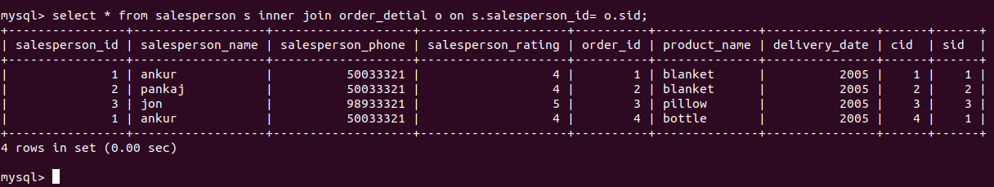

Ques 7. Create index

Ans 7.

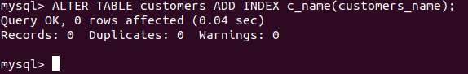

Ques 8. How to show index on a table

Ans 8.

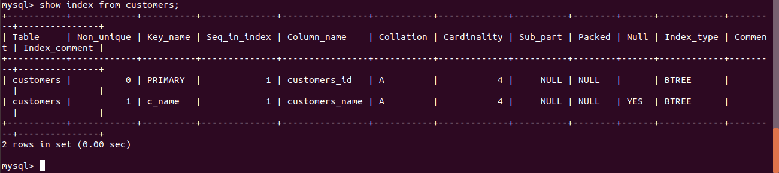

Ques 9. Find the order number, salesperson name, along with the customer to whom that order belongs to

Ans 9.

