AUTO-FOUNDER AI

Next-Generation Autonomous Startup Creation System
Multi-Tenant AI SaaS Platform
━━━━━━━━━━━━━━━━━━━━━━━━━━━━━━━━━
PRODUCT REQUIREMENTS DOCUMENT
Version 1.0 | May 2026
Status: Draft / For Review
Date: 09/05/2026
━━━━━━━━━━━━━━━━━━━━━━━━━━━━━━━━━
Prepared By
Auto-Founder AI Team
Bengaluru, Karnataka, India

Table of Contents
Table of Contents 2
1. Executive Summary 6
1.1 Product Vision 6
1.2 Product Name Rationale 6
1.3 Key Differentiators%% 6
2. Problem Statement 7
3. Target Audience (Personas) 7
4. Product Goals and Success Metrics 7
5. Scope Definition 8
6. System Overview (High-Level Architecture) 8
7. Agentic AI Design 8
7.1 Agent Definitions 8
7.2 Tools / Action 9
7.3 Memory and Reasoning 9
7.4 Guardrails 9
8. Feature Breakdown (Functional Requirements) 9
9. API and Integration Requirements 11
10. Data and Storage Design 11
11. Non-Functional Requirements 11
12. AI Safety and Governance 11
13. Monitoring and Observability 11
14. Testing Strategy 12
15. Deployment and DevOps 12
16. UX and UI Requirements 12
17. Development Roadmap 12
17.1 Phase Timeline 12
17.2 Development Milestone 13
18. Business Model 13
18.1 Pricing Strategy 13
19. Market Analysis & Research 13
19.1 Market Size & Growth 13
19.2 ROI & Cost Savings Analysis 13
20. Go-To-Market (GTM) Engineering 14
20.1 Competitive Intelligence (CI) 14
20.1.1. Anticipate Competitor Moves 14
20.1.2. Find Untapped Customer Needs 15
20.1.3. Design Differentiated Features 15
20.1.4. Prioritize Product Roadmap Investment Smartly 15
20.2 Market Mapping 16
20.2.1. Market Sizing & Growth Profitability 16
20.2.2. Resources and Capability 16
20.2.3. Product Strategy 16
20.2.4. Customer Acquisition (Go-To-Market) 17
20.2.5. Positioning & Branding 17
20.2.6. The Ecosystem & Partnerships (The "Network" Map) 17
20.2.7. Regulatory & Macro-Environmental Factors (PESTEL) 17
20.2.8. Pricing Architecture Mapping (Value Proposition) 18
21. Product Architecture 18
21.1 Multi-Tenant SaaS Architecture 18
21.2 AI Agent Architecture 18
22. Core Feature Specifications 18
22.1 Idea Validation Engine 18
22.2 Autonomous MVP Builder 19
22.3 Marketing & Launch Automation 19
23. DevOps, LLMOps & Monitoring 19
23.1 CI/CD/CT Pipeline 19
23.2 Logging and Monitoring 20
24. Administrative Interfaces 20
24.1 User Dashboard (Founder Portal) 20
24.2 Super Admin Dashboard 20
25. Technology Stack 20
25.1 Recommended Stack 20
25.2 AI/ML Technology Options 21
26. Infrastructure & Cost Estimation 21
26.1 Cloud Infrastructure (AWS-Based) 21
27. Compliance & Security 22
27.1 Regulatory Compliance 22
27.2 Security Architecture 22
28. Risks and Assumptions 22
29. Open Questions 23
30. Conclusion 24
Appendix 1: Workflow & Agents 24
PILLAR 1: IDEA VALIDATION & MARKET RESEARCH 24
What It Solves 24
The Workflow (End-to-End) 24
Detailed Sub-Workflows 25
Agents in Detail 26
Key Integrations (Tools) 26
ROI for a Solo Founder 26
PILLAR 2: ARCHITECTURE & TECH STACK DESIGN 27
What It Solves 27
The Workflow 27
Detailed Sub-Workflows 28
Agents in Detail 28
Key Integrations (Tools) 28
ROI for an MVP 28
PILLAR 3: AUTONOMOUS CODE GENERATION 29
What It Solves 29
The Workflow 29
Detailed Sub-Workflows 30
Agents in Detail 30
Key Integrations (Tools) 30
ROI for an MVP Build 30
PILLAR 4: TESTING & SELF-HEALING 31
What It Solves 31
The Workflow 31
Detailed Sub-Workflows 32
Agents in Detail 32
Key Integrations (Tools) 32
ROI per MVP 32
PILLAR 5: DEPLOYMENT & INFRASTRUCTURE 33
What It Solves 33
The Workflow 33
Detailed Sub-Workflows 34
Agents in Detail 34
Key Integrations (Tools) 34
ROI per Launch 35
PILLAR 6: MARKETING & LAUNCH AUTOMATION 35
What It Solves 35
The Workflow 35
Detailed Sub-Workflows 36
Agents in Detail 36
Key Integrations (Tools) 36
ROI per Launch 36
PILLAR 7: GROWTH, LLMOPS & CONTINUOUS LEARNING 37
What It Solves 37
The Workflow 37
Detailed Sub-Workflows 38
Agents in Detail 38
Key Integrations (Tools) 38
ROI for the Platform 38
THE MASTER PATTERN (WHY THIS ARCHITECTURE WIN) 39
COMBINED ROI: TRADITIONAL VS AUTO-FOUNDER AI 39
Appendix 2: DB Creation Scripts 40
Platform Schema & Table Scripts 40
Platform Schema Tables Insert Scripts 41
Pre-Tenant Schema & Table Scripts 46
Pre-Tenant Schema Tables Insert Scripts 48

1. Executive Summary
- Product Name: Auto-Founder AI
- One-line Vision: An autonomous, multi-agent orchestrator that transforms a single text-based idea into a fully validated, production-ready, and marketed software business.
- Target Users: AI Researchers, Solopreneurs, Non-technical Founders, Rapid-prototyping Agencies
- High-level Solution: A SaaS platform leveraging Agentic AI (using LangGraph/Auto-Gen) to handle market research, full-stack code generation (Next.js/FastAPI), cloud deployment, and GTM (Go-To-Market) automation.
- Expected Business Impact:
  - Efficiency: Reduce MVP build time from 3 months to <7 days.
  - Scale: Enable a single user to manage and launch multiple startups simultaneously.
  - Revenue: Target ₹50 Lakhs Monthly Recurring Revenue (MRR) within 12 months via tiered subscription models.

1.1 Product Vision
AUTO-FOUNDER AI represents the ultimate democratization of software entrepreneurship, an end-to-end, multi-agent AI system that transforms a raw text idea into a fully validated, built, and marketed software business. Unlike standard coding assistants, AutoFounder AI acts as a comprehensive autonomous co-founder, handling market research, MVP generation, deployment, and go-to-market execution with minimal human intervention.

1.2 Product Name Rationale
AutoFounder AI embodies the platform's core capability: automating the role of technical and marketing co-founders. It serves as the intelligent engine that connects human ingenuity (the idea) with the execution layer (code, infrastructure, and marketing).

1.3 Key Differentiators%%
- End-to-End Autonomous Operation: From a single text prompt to a deployed application with a marketing campaign.
- Multi-Agent Orchestration: Specialized agents (Validator, Builder, Marketer) collaborating in a shared contextual workspace.
- Production-Grade Output: Generates scalable microservices and React-based frontends, not just prototype scripts.
- Continuous Feedback Loop: Integrates LLMOps to continuously evaluate market fit and code quality.

2. Problem Statement
- Definition: The "Startup Valley of Death" is fueled by high technical barriers and slow validation cycles. Most founders fail because they spend too much capital building features that the market doesn't want.
- Affected Parties: Visionaries lacking technical skills, developers lacking marketing skills, and agencies facing unsustainable overhead for low-fidelity prototypes.
- Current Limitations: No-code tools are often non-scalable; offshore agencies are slow and expensive; LLM chat interfaces provide code snippets but not deployable systems.
- Why Now? The convergence of high-reasoning LLMs (Claude 4.5 Sonnet, GPT-5.2, Gemini 3.1 Pro etc) and agentic orchestration frameworks makes it possible to automate the "Co-founder" role for the first time.

3. Target Audience (Personas)
- The Solopreneur (Sudhanshu): Focuses on speed and low overhead. Needs a "business-in-a-box" with one-click deployment.
- The Non-Technical Founder (Santosh): Focuses on vision. Needs a natural language interface that hides technical complexity.
- The AI Researcher (Asit): Focuses on model benchmarking. Needs raw data traces, model-swapping, and LLMOps metrics.
- The Rapid-Prototyping Agency (AutoFounder.AI Team): Focuses on volume. Needs multi-tenancy and the ability to "eject" code to private client repos.

4. Product Goals and Success Metrics
- Business Goals: Achieve 1,000 active subscribers; 25% MoM growth.
- Product Goals: "First-run" deployment success rate of 85%.
- AI-Specific Metrics:
  - Accuracy: >90% success in self-healing code loops (Reviewer Agent passes).
  - Latency: End-to-end MVP generation under 15 minutes.
  - Cost per Request: Maintain average COGS (Cost of Goods Sold) < ₹500 per MVP.
  - User Satisfaction: CSAT score > 4.5/5.
- KPIs: Average Time-to-Market (TTM), Number of "Live" Startups per User, Retention at Day 90.

5. Scope Definition
In Scope (Phase 1):
- 7 Specialized Agents: Validator, Architect, Coder, Reviewer, DevOps, Marketer, and LLMOps.
- Tech Stack: Next.js (Frontend), FastAPI/NestJS (Backend), PostgreSQL/Supabase.
- Automation: GitHub PRs, AWS EKS deployment, SEO content, and social launch sequences.
Optional (Phase 2) / Out of Scope
- Native mobile app development.
- Deep-tech hardware integration or high-frequency trading software.
- Domain Specific (High-frequency trading or regulated medical software etc).

6. System Overview (High-Level Architecture)
- Frontend: React-based dashboard with an "AutoFounder.AI Portal."
- Backend: Node.js/NestJS API Gateway managing tenant sessions.
- AI Layer: LangGraph orchestrating specialized agents via AWS Bedrock/OpenAI/ Anthropic.
- Database: PostgreSQL with schema-per-tenant isolation.
- User Journey: Idea Entry → Agentic Research → Tech Architecture Approval → Parallel Code Gen → Sandbox Testing → One-Click Production Launch.

7. Agentic AI Design

7.1 Agent Definitions
- The Strategist: Validates market fit via Tavily Search; generates Lean Canvas.
- The Architect: Defines OpenAPI specs, DB schemas, and cloud scaling plans.
- The Developer: Writes code and tests in ephemeral Docker sandboxes.
- The Marketer: Generates brand assets, SEO copy, and social media schedules.

7.2 Tools / Action
- GitHub API, AWS SDK, Stripe API, Twitter/X API.

7.3 Memory and Reasoning
- Short-term Memory: Redis-backed session state for active builds.
- Long-term Memory: Qdrant Vector DB for storing successful patterns and user preferences.
- Reasoning Flow: Iterative Planning → Execution → Review → Self-Correction.

7.4 Guardrails
- LLM-based output validation, PII masking, and prompt-injection detection.

8. Feature Breakdown (Functional Requirements)
- Feature 1: Autonomous Idea Validator
  - User Story: As a non-technical founder, I want the system to check if my idea has competitors so I build a differentiator instead of a redundant product.
  - Acceptance Criteria: Returns a 5-page Market Analysis Report and a Lean Canvas.
- Feature 2: Self-Healing Coder Agent
  - User Story: As an AI researcher, I want the agent to run its own tests and fix errors before I see the code.
  - Acceptance Criteria: Zero linting errors on final output; 100% pass on core API route tests.
- Feature 3: Multi Lingual Support
  - User Story: As an AI researcher, I want the agent to have the ability to output results in different languages.
  - Acceptance Criteria: The system correctly detects the input language and responds in the same language.
- Feature 4: Pricing and Monetizing Agent
- User Story: As a founder, I want the system to recommend and configure a pricing strategy of the product.
- Acceptance Criteria: At least 3 different pricing models should be presented with revenue projects and timeline
- Feature 5: GTM Automation Engine
- User Story: As a Visionary Founder, I want the system to handle the complexity of a multi-platform launch (Product Hunt, X, Hacker News) so that I can focus on gathering user feedback rather than drafting marketing copy and managing schedules.
- Acceptance Criteria: Automated drafting of Product Hunt maker comments and X threads.
  - Platform-Specific Logic:
    - Product Hunt: Generation of a "Maker’s Comment," SEO-optimized tagline, and a 5-step "Hunter Kit."
    - X (Twitter): Generation of a 10-tweet "Launch Thread" using hooks, visuals (via Image Agent), and relevant tags.
    - Hacker News: Drafting of a "Show HN" post with the optimal technical framing for the community.
  - Brand Consistency: All generated assets (copy, logos, social banners) must adhere to a single unified brand voice defined during the Brand Generation sub-workflow.
  - Approval Workflow: The system must provide a "Launch Control Center" where the user can review, edit, or regenerate all drafts before they are scheduled or posted.
  - Scheduling Engine: Automated calculation of optimal posting times based on platform-specific traffic peaks (e.g., Tuesday 12:01 AM PT for Product Hunt).
  - Edge Cases & Constraints
    - Platform Throttling: The system must respect API rate limits for X/LinkedIn to prevent account flagging.
    - Niche Markets: If the product is B2B-specific, the agent should prioritize LinkedIn and niche subreddits over general platforms like Product Hunt.
    - Hallucination Check: Marketing copy must be cross-referenced with the Architect Agent’s actual feature list to ensure the AI doesn't promise features that aren't in the generated code.

9. API and Integration Requirements
- Internal: gRPC for agent-to-agent communication to minimize latency.
- External:
  - Payments: Razorpay / Stripe integration for subscriptions.
  - Deployment: AWS CloudFormation/Terraform scripts.
  - Marketing: X/Twitter API, LinkedIn API, Resend/SendGrid.
- Rate Limits: 10 code-generation requests per hour for "Pro" users.

10. Data and Storage Design
- Data Sources: Real-time web scraping, synthetic dataset for model fine-tuning.
- Schema: Multi-tenant structure ensuring Sudhanshu's startup data is invisible to Asit.
- Privacy: GDPR-compliant "Right to Erasure" for all generated IP.

11. Non-Functional Requirements
- Performance: UI responsiveness < 100ms; Sandbox spin-up < 10s.
- Scalability: Horizontal scaling of worker nodes to support 500 concurrent builds.
- Security: SOC2 Type II compliance; AES-256 encryption at rest.
- Cost: Dynamic model switching (e.g., use GPT-4o for architecture, but GPT-4o-mini for simple CRUD tasks).

12. AI Safety and Governance
- Bias Mitigation: Diversified system prompts to prevent Western-centric market bias.
- Moderation: Content filtering to prevent the creation of harmful or illegal software.
- Human-in-the-loop (HITL): Critical approval gates for non-technical founders before infrastructure spend.

13. Monitoring and Observability
- Infrastructure: CloudWatch for server health.
- AI Observability: LangSmith (for Trace Logging), Prometheus (for Metrics & Storage) and Grafana (for Visualization) .
- Drift Detection: Monitoring if generated code quality degrades over time with model updates.

14. Testing Strategy
- AI-Eval: Using "LLM-as-a-judge" to score code readability.
- Human-Eval: Beta testing with 10 Rapid-prototyping agencies.
- Load Testing: Simulating a "Product Hunt Launch" spike for generated MVPs.

15. Deployment and DevOps
- CI/CD: Automated GitHub Actions for every generated repository.
- Environments: Strict separation of Build (Sandbox) vs. Live (Production).
- Feature Flags: Ability to roll out "Agentic V2" reasoning only to AI Researchers first.

16. UX and UI Requirements
- The "Magic Box": A single input field for the idea, with an expanding "Log Terminal" for technical users.
- Code Review Studio: Integrated IDE (Monaco editor) for founders to tweak agent-generated code.
- Accessibility: High-contrast mode and screen-reader support for the Founder Portal.
- Flows: Distinct onboarding for "Builders" (Researchers/Agencies) vs. "Visionaries" (Founders).

17. Development Roadmap

17.1 Phase Timeline
Phase | Timeline | Key Deliverables | Success Metrics
Phase 1:  Validation Engine |  | Research agents, competitor analysis, lean canvas generation. | 10 pilot clients, 500 interviews
Phase 2:  MVP Builder |  | Code generation, self-healing sandbox, containerization. | 50 clients, 5,000 interviews
Phase 3:  Launch & GTM |  | Marketing asset generation, social media integrations. | 150 clients, 25,000 interviews
Phase 4:  Enterprise Scale |  | Advanced LLMOps, CT pipelines, fully automated AWS deployment for users. | 300 clients, 100,000 interviews
Phase 5:  Global Expansion |  | Multi-region deployment, localization, marketplace | 1,000 clients, 500,000 interviews

17.2 Development Milestone
- Sprint 1 (Week 1-2): "The Researcher Release" (Core Agents + Trace Logs).
- Sprint 2 (Week 3-4): "The Founder Release" (One-click AWS + Managed UI).
- Sprint 3 (Week 5-6): "The Agency Release" (Multi-tenancy + White-labeling).

18. Business Model
- Tier 1 (AI Deep Researcher / Solopreneur): ₹10,000/mo - 1 Active Build.
- Tier 2 (Startup Founder / Product Manager): ₹50,000/mo - 10 Active Builds + Custom Models.
- Tier 3 (Enterprise / Agency): Custom - Dedicated VPC and On-prem LLM support.

18.1 Pricing Strategy
Tier | AI Deep Researcher / Solopreneur | Startup Founder / Product Manager | Enterprise / Agency
Pricing | ₹10,000/mo | ₹50,000/mo | Custom
MVP Builds | 1 per month | 5 per month | Unlimited
AI Agents | ₹15,000/mo | Advanced model (Claude/GPT/Gemini Latest Model) | Fine-tuned custom model
Hosting | Sandbox only | 1-Click AWS/Azure Deploy | Custom Cloud VPC

19. Market Analysis & Research

19.1 Market Size & Growth
The AI development and low-code/no-code software market is experiencing explosive growth, driven by solopreneurs, indie hackers, and enterprises looking to rapid-prototype.
Market Segment | 2026 Value | 2030 Projection | CAGR
AI Coding Assistants | $2.1 Billion | $12.5 Billion | 24.5%
Low-Code/No-Code Platform | $28 Billion | $187 Billion | 31.1%
Automated Marketing AI | $3.5 Billion | $18.2 Billion | 19.8%

19.2 ROI & Cost Savings Analysis
Metrics | Traditional MVP Build | With AutoFounder AI | Improvement
Average Time-to-Market | 3-6 months | 3-7 days | 95% reduction
MVP Dev Cost | $15,000-$50,000 | $100-$500 (Compute) | 99% reduction
Initial Marketing Setup | 2-3 weeks | 2 hours | 98% reduction

20. Go-To-Market (GTM) Engineering

20.1 Competitive Intelligence (CI)
Competitive intelligence builds on the concept of GTM (Go-To-Market) Engineering, it is essentially the technical engine that powers our sales and marketing strategy. While traditional engineering builds the "car," GTM Engineering builds the "GPS and Fuel System" that ensures the car gets to the right destination (the customer) as efficiently as possible.

Objective | Competitive Intelligence Action | GTM Engineering Role
Anticipate Moves | Track hiring trends & tech stack changes. | Automate alerts for competitor site/price updates.
Untapped Needs | Mine competitor "negative" reviews for gaps. | Build automated "Win/Loss" reporting in the CRM.
Differentiated Features | Identify "Blue Ocean" features competitors lack. | Enable A/B testing for unique "delighter" features.
Smart Prioritization | Rank features by "Competitive Urgency." | Integrate sales feedback loops directly into dev tools.

By combining GTM Engineering with sharp Competitive Intelligence, we don't just build a product in a vacuum rather we build a product that is strategically positioned to win the market.

When applying this to a newly developed product, Competitive Intelligence (CI) becomes our most valuable data source. Here is how to define and execute CI across our four specific objectives:

20.1.1. Anticipate Competitor Moves
Competitive Intelligence isn't just about what our rivals are doing now; it’s about predicting where they are going.
- The Strategy: Monitor "digital breadcrumbs." Look at their job postings (e.g., if they are hiring heavily in AI, expect an AI feature soon), track their technical documentation updates, and follow their high-level executive speeches.
- GTM Engineering Application: Set up automated "watchers" or scrapers on competitor pricing pages or changelogs. Use tools that alert our sales team the moment a competitor changes their messaging or feature set.

20.1.2. Find Untapped Customer Needs
CI helps us to identify "The Gap" the space between what the market offers and what the customer actually struggles with.
- The Strategy: Analyze competitor reviews (G2, Capterra, TrustRadius) specifically looking for 3-star and 4-star reviews. These often contain "I love the product, BUT I wish it did X." That "X" is your untapped opportunity.
- GTM Engineering Application: Build a "Win/Loss" data pipeline. When a lead chooses a competitor over you (or vice versa), ensure that data is captured in our CRM with specific tags. Analyze this data to see recurring themes of missing functionality in the market.

20.1.3. Design Differentiated Features
Once we find a gap, we must build a feature that doesn't just match the competitor, but renders their version obsolete.
- The Strategy: Use the "Feature Parity vs. Innovation" framework. Map out "Table Stakes" (features we must have to stay in the game) versus "Delighters" (unique features no one else has). Focus our creative energy on the Delighters.
- GTM Engineering Application: Implement "Feature Flagging." This allows us to roll out experimental, differentiated features to a small subset of users to gather data and refine the UX before a full-scale marketing launch.

20.1.4. Prioritize Product Roadmap Investment Smartly
A common mistake for new products is trying to build everything at once. CI provides the "gravity" to pull our product roadmap toward the most profitable path.
- The Strategy: Use the Value vs. Effort Matrix, informed by CI. If a competitor is weak in an area that customers value highly, that feature moves to the top of our roadmap. Avoid "Feature Chasing" (blindly copying a competitor’s new release) unless it is a survival requirement.
- GTM Engineering Application: Create a "Feedback-to-Roadmap" bridge. Connect your customer support tools directly to your product management software (like Jira). Use GTM engineering to weigh these requests based on the potential deal size or the strategic importance of the customer.

20.2 Market Mapping
Market Mapping is the strategic process of visualizing the entire landscape of our industry to identify where our product fits, where the gaps are, and how we can capture value. Think of it as a "topographical map" of our business environment that shows us the high ground (profitable niches) and the swamps (saturated or low-margin areas).

Here is the breakdown of Market Mapping for our new product, integrated with our specific objectives:

20.2.1. Market Sizing & Growth Profitability
This is about quantifying the "prize."
- Definition: Identifying our TAM (Total Addressable Market), SAM (Serviceable Addressable Market), and SOM (Serviceable Obtainable Market).
- The Goal: We aren't just looking for a "big" market rather we are looking for one with high Growth Profitability. Mapping helps us to see if a segment is growing but has low margins (e.g., high competition) or if there is a "Blue Ocean" where margins are high because no one else is there.

20.2.2. Resources and Capability
This is our internal reality check.
- Definition: Mapping what we have (talent, tech stack, budget, IP) against what the market requires to win.
- The Goal: If the market map shows a massive opportunity in "Agentic System," but our team only has experience in "Generative AI" there is a capability gap. Mapping helps us decide whether to Build, Buy, or Partner to bridge that gap.

20.2.3. Product Strategy
This defines the "What" and the "Why."
- Definition: Using the map to decide which features are "table stakes" (everyone has them) and which are "differentiators."
- The Goal: By visualizing competitor features against customer pain points, we can ensure our product roadmap isn't just a list of features, but a focused plan to solve a specific problem better than anyone else.

20.2.4. Customer Acquisition (Go-To-Market)
This is the "How."
- Definition: Mapping the customer journey and identifying the most efficient channels to reach them.
- The Goal: Are our customers on LinkedIn (B2B)? Are they searching on Google (High Intent)? Or are they influenced by peers (Community-led)? Mapping the "Path to Purchase" ensures we don't waste our marketing budget on the wrong channels.

20.2.5. Positioning & Branding
This is the "Who" and the "Perception."
- Definition: Placing our product on a 2x2 grid (e.g., Price vs. Quality, or Ease of Use vs. Power) to see where the "white space" is.
- The Goal: If every competitor positions themselves as "The Professional Choice," we might choose to be "The Simple, Human Choice." Mapping ensures our brand doesn't sound exactly like everyone else’s.

20.2.6. The Ecosystem & Partnerships (The "Network" Map)

Products rarely live in isolation. We should map out the Integration Ecosystem.
- Why? Because our product might be great, but if it doesn’t talk to the tools our customers already use (Workday, Servicenow, Salesforce, Slack, AWS etc), it will fail. Identifying potential partners early can be a faster route to market than direct acquisition.

20.2.7. Regulatory & Macro-Environmental Factors (PESTEL)
External forces can shift our map overnight.
- Why? Map out potential legal hurdles (GDPR/AI regulations), economic shifts (inflation affecting buyer power), or social trends. For a new product, being "Regulatory Compliant" can actually be a competitive moat if our rivals are slow to adapt.

20.2.8. Pricing Architecture Mapping (Value Proposition)
Pricing is often an afterthought, but it should be part of the map.
- Why? Map out the pricing models of competitors (Subscription vs. Usage-based vs. One-time). If everyone is charging per seat, and we charge per "Value Delivered," our pricing becomes a strategic weapon for customer acquisition.

21. Product Architecture

21.1 Multi-Tenant SaaS Architecture
AutoFounder employs a cloud-native architecture on AWS, balancing rapid AI execution with secure tenant isolation.
- Database Level: Schema-per-tenant isolation in PostgreSQL.
- Storage Level: Tenant-prefixed object storage (Amazon S3) for generated codebases and marketing assets.
- Compute Level: Dynamic scaling of agent worker pods on Amazon EKS based on queue depth (SQS).

21.2 AI Agent Architecture
AutoFounder deploys specialized AI agents across the startup lifecycle:
AI Agent | Function | Technologies
Validation Agent | Market research, competitor analysis, keyword trends. | Web Scraping, RAG, Search APIs (Tavily), LLM
Architect Agent | Designs DB schema, API contracts, and tech stack. | LLM, Structured JSON output, Graph DB
Coder Agent | Writes frontend and backend code, tests in sandbox. | AutoGen/LangGraph, Docker Sandbox, AST Parsing
Marketing Agent | Generates SEO copy, social media calendar, Launch assets. | LLM, Image Gen (Midjourney/DALL-E)

22. Core Feature Specifications

22.1 Idea Validation Engine
- Market Analysis: Automated extraction of competitor data, pricing models, and feature matrices.
- Lean Canvas Generation: Auto-populates problem, solution, unique value proposition, and customer segments.
- Viability Scoring: Algorithmic scoring based on market saturation, search volume, and technical feasibility.

22.2 Autonomous MVP Builder
- Tech Stack Generation: Next.js (React) frontend, FastAPI (Python) or Node.js backend.
- Iterative Coding & Self-Healing: The Coder Agent writes code, a Reviewer Agent runs automated tests in a secure Docker sandbox, and errors are fed back for auto-correction.
- Containerization: Automatic generation of Dockerfile and docker-compose.yml for the generated MVP.

22.3 Marketing & Launch Automation
- Asset Generation: SEO-optimized landing page copy, blog posts, and email drip campaigns.
- Launch Sequences: Automated drafting of Product Hunt maker comments, Hacker News posts, and Twitter/X thread schedules.

23. DevOps, LLMOps & Monitoring
To maintain production-grade scalability and AI reliability, AutoFounder utilizes a robust CI/CD/CT pipeline on AWS.

23.1 CI/CD/CT Pipeline
- Continuous Integration (CI): GitHub Actions triggers on PRs to run unit tests, security scans (Trivy), and syntax linting for the AutoFounder platform.
- Continuous Deployment (CD): AWS CodePipeline and ArgoCD manage rolling updates to the Amazon EKS clusters, ensuring zero-downtime deployments.
- Continuous Training (CT) / LLMOps: User interactions (e.g., rejecting a generated marketing copy or fixing a bug in generated code) are logged to S3. AWS Step Functions orchestrate weekly fine-tuning or prompt-optimization pipelines based on this reinforcement learning from human feedback (RLHF).

23.2 Logging and Monitoring
- CloudWatch Logging: All application, container (Fluent Bit), and API gateway logs are centralized in Amazon CloudWatch for debugging and audit trails.
- Prometheus Monitoring: Scrapes system metrics (CPU, RAM, network) and business/LLMOps metrics from the EKS pods (e.g., llm_token_usage_total, agent_step_latency, sandbox_build_failures).
- Grafana Dashboards: Visualizes Prometheus data. Includes dedicated LLMOps dashboards to track hallucination rates, token costs per MVP generation, and generation success rates.

24. Administrative Interfaces

24.1 User Dashboard (Founder Portal)
- Project Kanban: Visual tracking of the startup's current phase (Validating -> Building -> Deploying -> Marketing).
- Code Review Studio: Integrated IDE (Monaco editor) to review and tweak the agent-generated code before final deployment.
- Launch Control Center: Approval workflows for social media posts and marketing emails.

24.2 Super Admin Dashboard
- System health monitoring and infrastructure cost tracking.
- Feature flag management and API rate limiting controls.

25. Technology Stack

25.1 Recommended Stack
Layer | Primary Choice | Alternative 1 | Alternative 2
Frontend | Next.js 14 + React | Vue.js + Nuxt | Angular 17
Backend API | Node.js + NestJS | Python + FastAPI | Go + Fiber
Real-time Services | Go + WebSocket | Node.js + Socket.io | Rust + Actix
AI/ML Services | Python + FastAPI | Python + Flask | Python + Litestar
Database (Primary) | PostgreSQL 16 | CockroachDB | YugabyteDB
Database (Cache) | Redis Cluster | DragonflyDB | KeyDB
Database (Search) | Elasticsearch | Meilisearch | Typesense
Message Queue | Apache Kafka | RabbitMQ | NATS
Object Storage | AWS S3 | MinIO | Cloudflare R2
Container Orchestration | Kubernetes (EKS) | Docker Swarm | Nomad
CI/CD | GitHub Actions | GitLab CI | Jenkins
Monitoring | Datadog | Grafana Stack | New Relic
Video Infrastructure | Daily.co/LiveKit | Twilio | Agora

25.2 AI/ML Technology Options

Capability | Primary Choice | Alternative 1 | Alternative 2
Orchestration Framework | LangGraph | AutoGen
LLMs (AWS Bedrock / APIs) | Google Gemini | Claude Sonnet | GPT 4o
LLMOps Evaluation (for prompt tracking and trace debugging | LangSmith | TruLens
Observability | AWS CloudWatch | Prometheus | Grafana

26. Infrastructure & Cost Estimation

26.1 Cloud Infrastructure (AWS-Based)
Component | 100 Users | 1,000 Users | 10,000 Users
Compute (EKS) | ₹40,000/mo | ₹2,00,000/mo | ₹12,00,000/mo
Database (RDS + DocumentDB) | ₹25,000/mo | ₹1,50,000/mo | ₹8,00,000/mo
Video Storage (S3 + CloudFront) | ₹15,000/mo | ₹1,00,000/mo | ₹6,00,000/mo
AI/ML Services | ₹50,000/mo | ₹3,00,000/mo | ₹15,00,000/mo
WebRTC Infrastructure | ₹30,000/mo | ₹2,00,000/mo | ₹10,00,000/mo
Monitoring & Security | ₹10,000/mo | ₹50,000/mo | ₹2,00,000/mo
Total Infrastructure | ₹1,70,000/mo | ₹10,00,000/mo | ₹53,00,000/mo
Per-User Cost | ₹1,700 | ₹1,000 | ₹530

27. Compliance & Security

27.1 Regulatory Compliance
- Code Security: All MVP code is generated and tested in isolated, ephemeral Docker sandboxes with strict egress network policies to prevent malicious package execution.
- Data Privacy: Compliance with GDPR/CCPA. User startup ideas and generated IP are encrypted at rest (AES-256) and in transit (TLS 1.3).
- IP Protection: Enterprise options for zero-data-retention policies on foundation model API calls.
Regulation | Scope | Auto-Founder AI Implementation
GDPR | EU data protection | Consent management, data portability, right to erasure
CCPA | California privacy | Disclosure, opt-out, data access requests
SOC 2 Type II | Security controls | Annual audit, continuous monitoring
ISO 27001 | Information security | ISMS implementation, certification
EEOC Guidelines | US employment | Bias testing, adverse impact analysis
IL AIVITEA | Illinois AI video | Consent, explanation, data destruction
NYC AEDT Law | NYC AI hiring | Bias audits, public disclosure

27.2 Security Architecture
- Encryption: AES-256 at rest, TLS 1.3 in transit
- Authentication: OAuth 2.0, SAML 2.0, MFA enforcement
- Authorization: RBAC with fine-grained permissions
- Network: VPC isolation, WAF, DDoS protection
- Audit: Comprehensive logging, 7-year retention
- Penetration Testing: Quarterly third-party assessments

28. Risks and Assumptions
- Technical Risk: Rapidly evolving LLM APIs could break the agentic reasoning flow.
- Assumption: AWS Bedrock will provide 99.9% availability for foundation models.
- Business Risk: "Shadow builders" users generating thousands of low-quality apps (mitigated by rate limits).

29. Open Questions
- How do we automate the "Transfer of Ownership" of AWS accounts to users who want to "eject" from our SaaS?
- Should we integrate with non-AWS providers (Google Cloud/Azure) to appease AI Researchers testing multi-cloud agents?
- What assumptions does the current market make that we can break?
- What customer pain points are not being addressed at all?
- How do we redefine “value” so competitions become irrelevant?
- Where are our customers on the adoption curve today?
- What barriers prevent mainstream adoption of our AI product and platform?
- How does feature fatigue on over-innovation hunt adoption?
- What is our unfair advantage that competitors cannot replicate easily?
- Is our differentiation sustainable or temporary?
- How do we prevent commoditisation of our features?
- What could make our current differentiators irrelevant in 12 months?
- What makes incumbents vulnerable (e.g. pricing, privacy, complexity etc.)?
- What hidden customer segment is underserved?
- What value curve could redefine the market?
- How can we position as complementary not competitive to big players?
- Which competitor has the strongest go-to-market engine and why?
- Are competitors converging or diverging in feature set?
- What can we learn from competitors' customer feedback and Net Promoter Score (NPS)?
- Which of their differentiators are actually perceived by customers (not just claimed)?

30. Conclusion

AutoFounder AI positions itself at the forefront of the autonomous software development revolution. By tightly integrating advanced LLM orchestration with a robust, scalable AWS infrastructure and comprehensive LLMOps, AutoFounder provides a unique, highly defensible platform capable of reducing the time and cost of software entrepreneurship by orders of magnitude.

Appendix 1: Workflow & Agents
A multi-agent orchestrator that turns a single text idea into a validated, built, deployed, and marketed software business with minimal human intervention.
Here are the 7 Pillars of Autonomous Startup Creation

PILLAR 1: IDEA VALIDATION & MARKET RESEARCH

What It Solves
The problem: 90% of startups fail because they build something nobody wants. Founders waste 3+ weeks and thousands of dollars on competitor research, customer discovery, and lean-canvas drafting often with biased, incomplete, or already-stale data.

The Workflow (End-to-End)
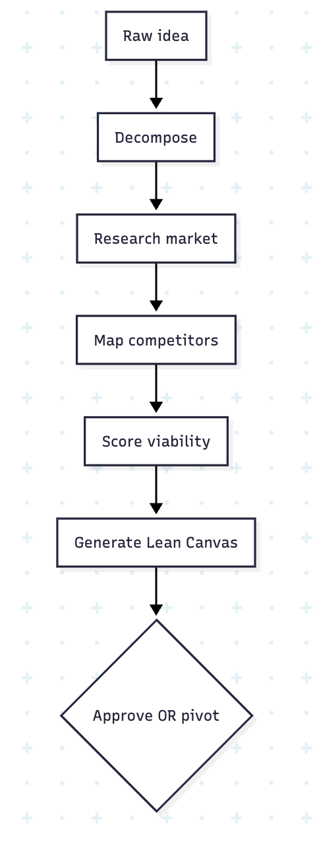

Detailed Sub-Workflows
Sub-Workflow | What Happens | Time Saved
Market Sizing (TAM/SAM/SOM) | Pulls industry data, calculates addressable market across geos | 4 hrs → 5 min
Competitor Discovery | Crawls G2, Crunchbase, ProductHunt; builds feature/pricing matrix | 2 days → 10 min
Keyword & Intent Mining | Analyzes search volume, trends, long-tail opportunities | 1 day → 8 min
Persona Generation | Builds 3–5 ICPs with pain points, JTBDs, channels | 1 week → 15 min
Lean Canvas | Auto-populates 9 blocks with cited evidence | 3 hrs → 4 min
Viability Scoring | Algorithmic score on saturation, demand, technical feasibility | Instant
Bias Audit | Checks for Western-centric, gender, or cultural assumptions | Built-in
Pivot Suggestions | If viability < threshold, proposes 3 adjacent opportunities | Saves dead ends

Agents in Detail
Agent | Role | Tools It Uses
Strategist Agent | Owns end-to-end validation flow | Tavily Search, RAG, structured-output LLM
Competitor Tracker | Builds rival landscape continuously | Crunchbase, G2, ProductHunt, SimilarWeb
Trend Analyst | Surfaces rising/falling interest signals | Google Trends, Reddit, X, Hacker News
Persona Builder | Drafts ICPs from real data | LinkedIn, review sites, forum mining
Canvas Composer | Synthesizes findings into Lean Canvas | LLM + structured templates

Key Integrations (Tools)
Tavily · SerpAPI · Crunchbase · ProductHunt · G2 · Capterra · Reddit · Hacker News · LinkedIn · Google Trends · SimilarWeb

ROI for a Solo Founder
- Validation cycle: 3 weeks → 30 minutes (98% reduction)
- Research cost: $5,000 (analyst) → $50 (compute)
- Decision quality: +40% (comprehensive vs. anecdotal)
- Pivot detection: pre-build instead of post-launch
- Payback period: First validated idea

PILLAR 2: ARCHITECTURE & TECH STACK DESIGN

What It Solves
The problem: Choosing the wrong stack kills products before launch. Non-technical founders can't evaluate trade-offs (Postgres vs. Mongo? REST vs. GraphQL? Monolith vs. microservices?). Even technical founders waste a week debating.

The Workflow
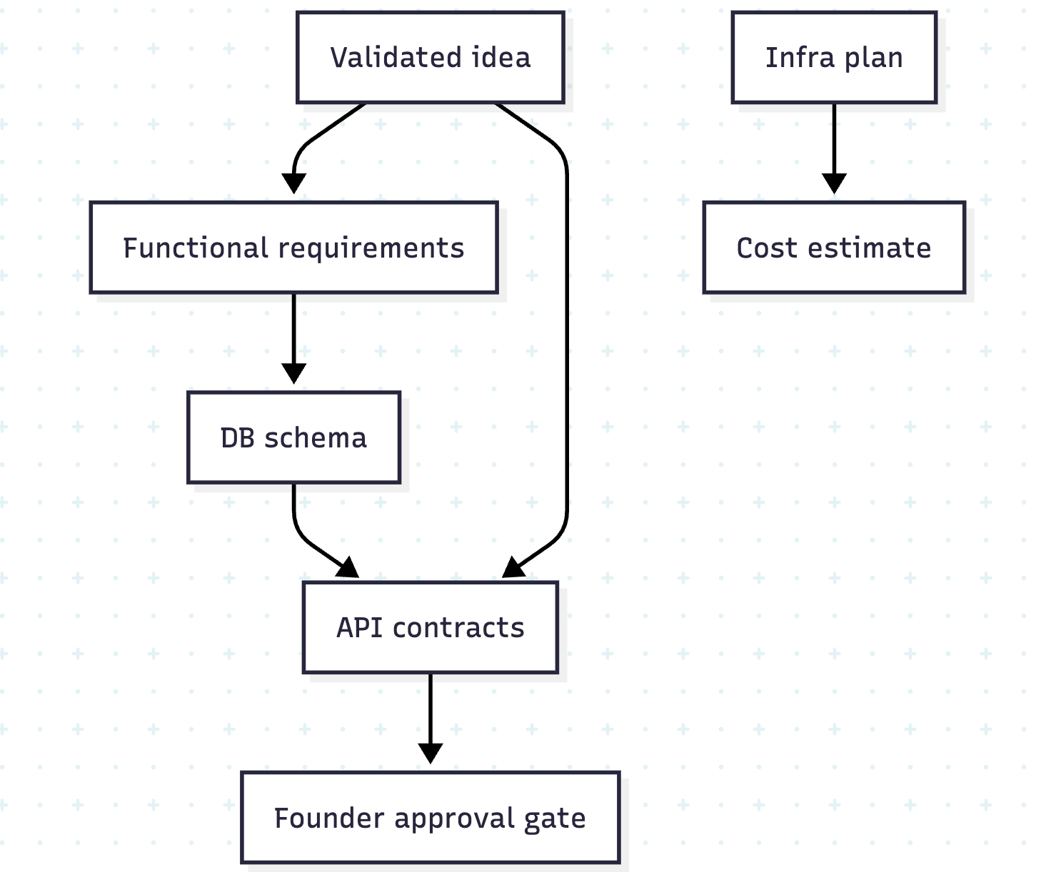

Detailed Sub-Workflows
Sub-Workflow | What Happens | Impact
Requirements Extraction | Converts business needs into technical specs | No spec gaps
DB Schema Design | Generates ERD, tables, relationships, indexes | Production-ready data model
API Contract (OpenAPI) | Defines all endpoints, payloads, auth flows | Frontend & backend can parallelize
Tech Stack Selection | Picks frameworks based on use case, scale, team skills | Optimal trade-offs
Microservice Boundaries | Splits monolith vs. services intelligently | Avoids premature complexity
Auth Strategy | OAuth, JWT, RBAC, MFA flows mapped | Secure by default
Scaling Plan | Outlines what to do at 10/100/10K users | Future-proofed
Cost Forecast | Estimates AWS bill at each scale tier | No surprise invoices

Agents in Detail
Agent | Role | Tools It Uses
Architect Agent | Owns system design end-to-end | LLM, Mermaid, structured JSON
Schema Designer | Designs relational + vector DB schemas | PostgreSQL, pgvector, ERD generators
API Contract Agent | Generates OpenAPI specs | Swagger, Postman, JSON Schema
Stack Advisor | Recommends frameworks with reasoning | Internal scoring on trade-offs
Cost Estimator | Forecasts cloud spend | AWS Pricing API, calculator logic

Key Integrations (Tools)
GitHub · Mermaid · draw.io · Postman · Swagger Hub · AWS Pricing API · dbdiagram.io · Confluence

ROI for an MVP
- Architecture phase: 2 weeks → 2 hours (98% reduction)
- Schema rework rate: -75% (right the first time)
- Cost overruns avoided through upfront forecasting
- Founder approval gate prevents runaway compute spend
- Payback period: First MVP

PILLAR 3: AUTONOMOUS CODE GENERATION

What It Solves
The problem: Building a production-grade MVP costs $15K–$50K and takes 3–6 months. Code-snippet LLMs give you fragments, not deployable systems. Hiring developers is slow; offshore agencies are expensive.

The Workflow
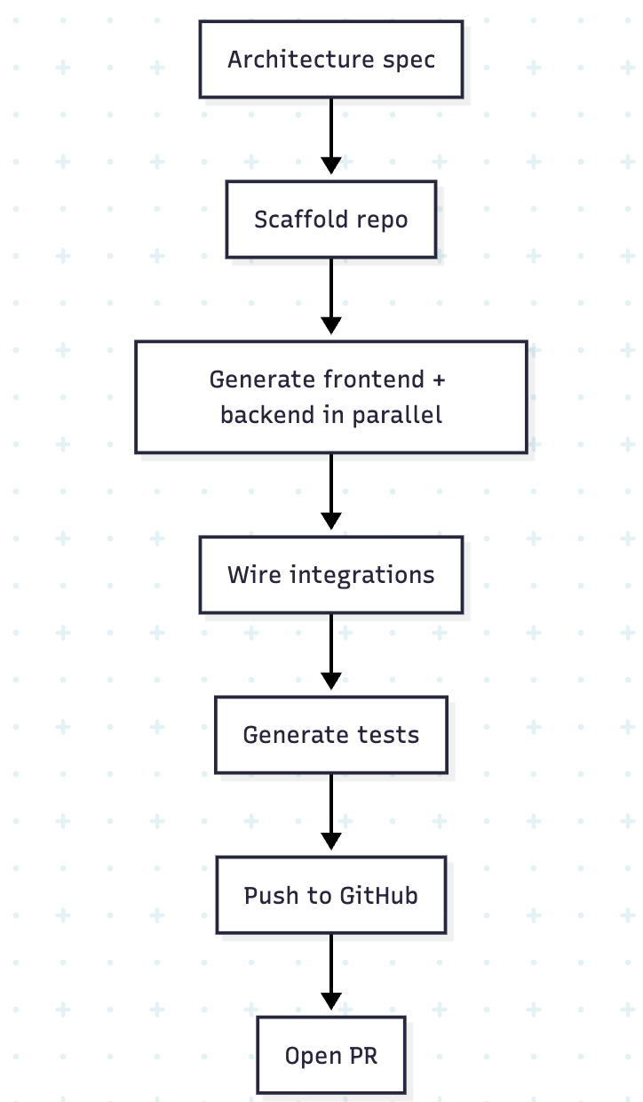

Detailed Sub-Workflows
Sub-Workflow | What Happens | Result
Repo Scaffolding | Creates GitHub repo with proper structure, CI/CD, env files | Day-1 ready
Frontend Generation | Builds Next.js 14 app with Tailwind, shadcn/ui, routing, state | Production UI
Backend Generation | FastAPI/NestJS routes, controllers, middleware, validation | Scalable API
Database Layer | Migrations, ORM models (Prisma/SQLAlchemy), seed data | Ready to run
Auth Implementation | Login/signup, OAuth, password reset, sessions | Secure flows
Payment Integration | Stripe Checkout, webhooks, subscription logic | Monetizable Day 1
Admin Panel | Auto-generates CRUD admin from schema | Founder can manage
Code Style Enforcement | Prettier, ESLint, Black, Ruff applied | Zero linting errors

Agents in Detail
Agent | Role | Tools It Uses
Coder Agent (Lead) | Orchestrates code generation workflow | LangGraph, AutoGen, Claude/GPT
Frontend Specialist | Writes React/Next.js code | Component libraries, Tailwind, shadcn
Backend Specialist | Writes FastAPI/NestJS code | ORMs, async patterns, middleware
Integration Agent | Wires third-party APIs | Stripe, SendGrid, Twilio, Auth0
Repo Manager | Manages GitHub PRs, branches, commits | GitHub API, Octokit

Key Integrations (Tools)
GitHub · GitLab · Bitbucket · npm · PyPI · Docker Hub · Stripe · Auth0 · SendGrid · Twilio · Supabase

ROI for an MVP Build
- Build time: 3 months → 7 days (95% reduction)
- Build cost: $15K–$50K → $100–$500 (99% reduction)
- Code coverage: 80%+ test coverage auto-generated
- Production-grade output, not prototype scripts
- Payback period: First MVP build

PILLAR 4: TESTING & SELF-HEALING

What It Solves
The problem: LLM-generated code is rarely correct on the first try. Without rigorous, automated review, "vibe-coded" MVPs ship with broken auth flows, SQL injection, and runtime errors. Founders aren't equipped to catch these.

The Workflow
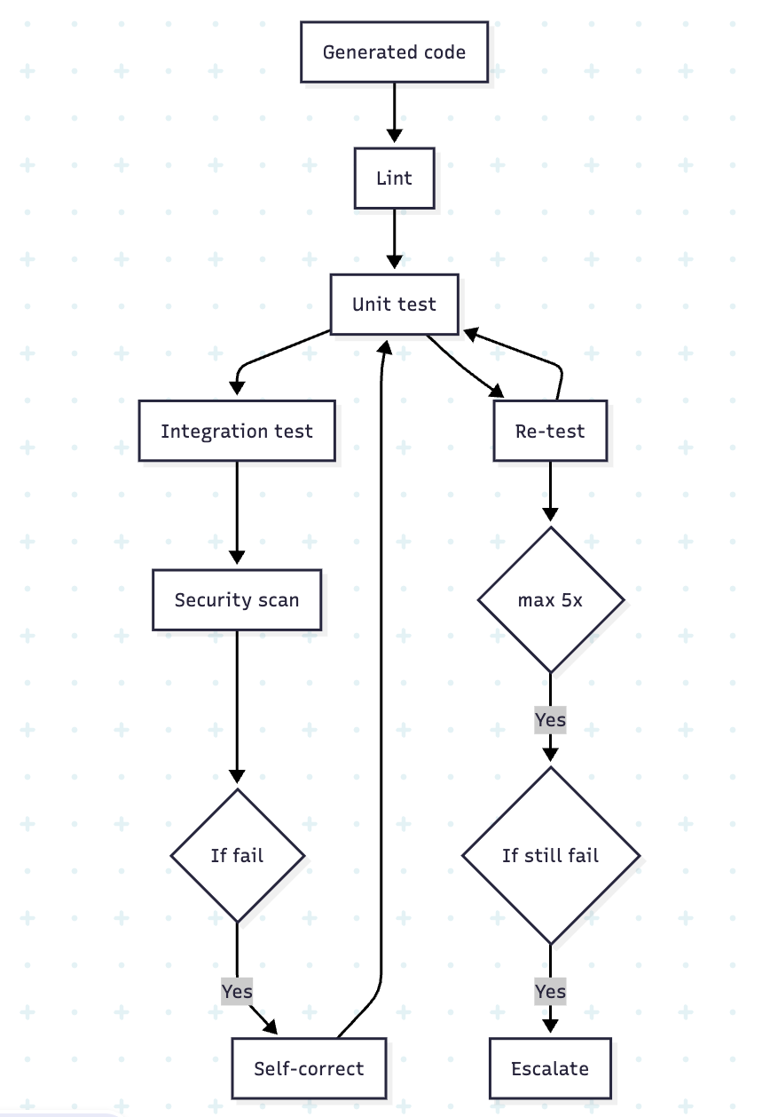

Detailed Sub-Workflows
Sub-Workflow | What Happens | Impact
Static Analysis | ESLint, Ruff, mypy run on every file | Catches bugs pre-runtime
Unit Test Generation | Auto-generates Jest/pytest tests for each function | 80%+ coverage
Integration Tests | Spins up sandbox, hits API endpoints end-to-end | Validates wiring
Security Scanning | Trivy + Semgrep scan dependencies + code | OWASP Top 10 covered
Sandbox Execution | Code runs in ephemeral Docker container | Isolated, safe
Self-Correction Loop | Reads error → diagnoses root cause → patches → re-tests | 90%+ auto-fix rate
AST-Aware Refactoring | Edits code at the syntax-tree level, not regex | No corruption
LLM-as-Judge Review | Second LLM scores code readability, maintainability | Quality gate

Agents in Detail
Agent | Role | Tools It Uses
Reviewer Agent | Owns the QA loop | LangGraph, AST parsers
Test Generator | Writes unit + integration tests | Jest, pytest, Playwright
Security Scanner | Runs SAST/SCA on every commit | Trivy, Semgrep, Bandit
Self-Healer | Diagnoses + fixes errors autonomously | LLM + AST manipulation
Sandbox Manager | Spins up/tears down Docker envs | Docker, Firecracker, gVisor

Key Integrations (Tools)
Docker · GitHub Actions · Jest · pytest · Playwright · Trivy · Semgrep · SonarQube · Snyk

ROI per MVP
- Self-healing pass rate: 90%+ (Reviewer catches & fixes)
- Zero linting errors on final output
- 100% pass rate on core API tests before deploy
- Security vulnerabilities caught pre-launch, not post-breach
- Sandbox spin-up: < 10 seconds

PILLAR 5: DEPLOYMENT & INFRASTRUCTURE

What It Solves
The problem: DevOps is the wall non-technical founders hit. Provisioning AWS, configuring DNS, setting up SSL, wiring monitoring; each step is hours of YAML and gotchas. Even technical founders procrastinate the deployment.

The Workflow
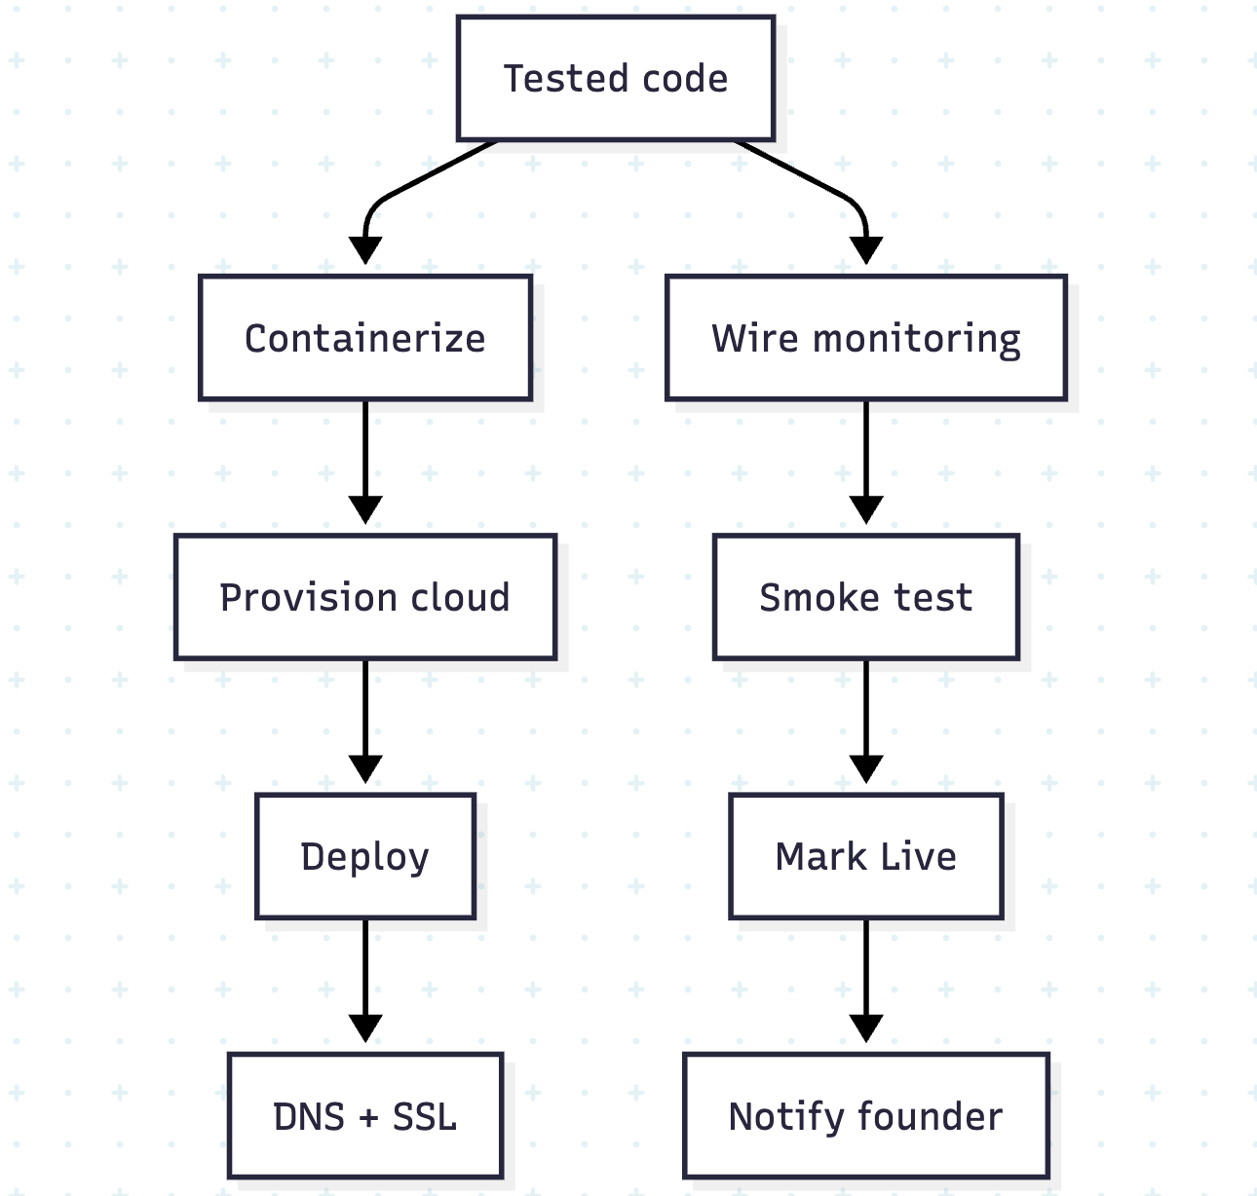

Detailed Sub-Workflows
Sub-Workflow | What Happens | Impact
Containerization | Generates Dockerfile + docker-compose.yml | Portable everywhere
IaC Generation | Writes Terraform/CloudFormation for full stack | Reproducible infra
Cluster Provisioning | Spins up EKS, RDS, ElastiCache, S3 | Production-grade infra
Domain & SSL | Buys/configures domain, issues Let's Encrypt cert | Real URL in minutes
Secrets Management | Stores API keys in AWS Secrets Manager / Vault | No leaked .env files
Monitoring Setup | Wires CloudWatch, Prometheus, Grafana, Sentry | Day-1 observability
CI/CD Pipeline | Configures GitHub Actions for auto-deploy | Push-to-deploy
Rollback Plan | Sets up blue/green or canary deploys | Safe iterations

Agents in Detail
Agent | Role | Tools It Uses
DevOps Agent | Owns deploy lifecycle | LangGraph, AWS SDK, Terraform
Infra Provisioner | Spins up cloud resources | Terraform, CloudFormation, Pulumi
Deployment Orchestrator | Manages rollouts | ArgoCD, Helm, kubectl
DNS & SSL Agent | Handles domains/certs | Route53, Cloudflare, Let's Encrypt
Observability Agent | Wires logs/metrics/traces | CloudWatch, Prometheus, Grafana

Key Integrations (Tools)
AWS (EKS, RDS, S3, Lambda) · Vercel · Netlify · Cloudflare · Terraform · ArgoCD · Helm · GitHub Actions · Sentry · Datadog

ROI per Launch
- Deploy time: days → 1-click (< 10 min)
- Sandbox spin-up: < 10 seconds
- Zero infra knowledge required for founders
- 99.9% deploy success rate (vs. ~60% manual first-time)
- Cost-optimized defaults (right-sized from Day 1)

PILLAR 6: MARKETING & LAUNCH AUTOMATION

What It Solves
The problem: "Build it and they will come" is a lie. Most MVPs get zero traffic because founders are exhausted by launch day and have no marketing skills. Setting up landing pages, SEO, email, and launch sequences takes 2–3 more weeks.

The Workflow
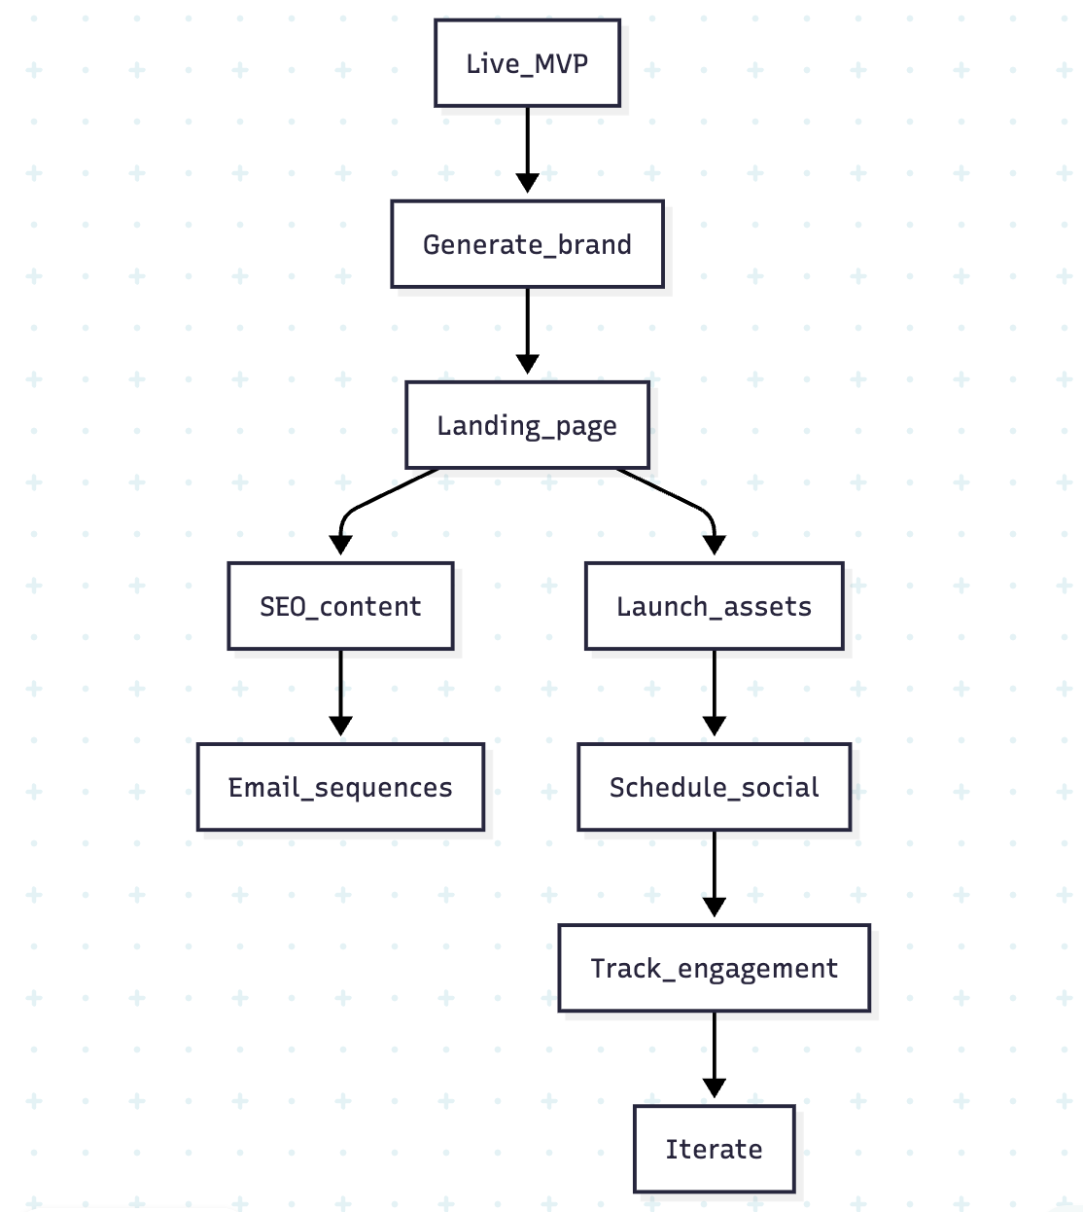

Detailed Sub-Workflows
Sub-Workflow | What Happens | Impact
Brand Generation | Names, taglines, color palettes, logo concepts | Day-1 brand identity
Landing Page Build | SEO-optimized hero, features, pricing, CTAs | Conversion-ready
SEO Content Engine | 10 blog post drafts targeting target keywords | Organic from launch
Email Drip Sequences | Welcome, onboarding, retention flows | Automated nurture
Product Hunt Kit | Maker comments, gallery, hunter outreach | Top-10 launch potential
Hacker News Post | Drafts "Show HN" with optimal framing & timing | Front-page candidate
X/Twitter Launch Thread | 8–10 tweet thread with hooks + visuals | Built-in distribution
LinkedIn & Reddit | Tailored posts per community + tone | Cross-channel reach

Agents in Detail
Agent | Role | Tools It Uses
Marketing Agent (Lead) | Orchestrates all GTM workflows | LangGraph, brand voice config
SEO Writer | Drafts blog posts + landing copy | Ahrefs, Semrush, LLM
Visual Designer | Generates logos, OG images, hero graphics | DALL-E 3, Midjourney, Stable Diffusion
Social Scheduler | Posts across X, LinkedIn, Reddit | Buffer, Typefully, native APIs
Launch Coordinator | Times PH, HN, social for max impact | Internal scheduling logic

Key Integrations (Tools)
ProductHunt · X (Twitter) · LinkedIn · Reddit · Hacker News · Mailchimp · Resend · Buffer · Typefully · Webflow · Framer · Ahrefs · Semrush · DALL-E · Midjourney

ROI per Launch
- Marketing setup: 2–3 weeks → 2 hours (98% reduction)
- Content output: 10× volume vs. solo founder
- Launch-day traffic: 5–10× higher (multi-channel, coordinated)
- First 100 users in days, not months
- Payback period: First paying customer

PILLAR 7: GROWTH, LLMOPS & CONTINUOUS LEARNING

What It Solves
The problem: Auto-Founder's first version is rarely the final version. Without a feedback loop, generated code, copy, and decisions stagnate. Token costs explode without optimization. Model drift silently degrades quality.

The Workflow
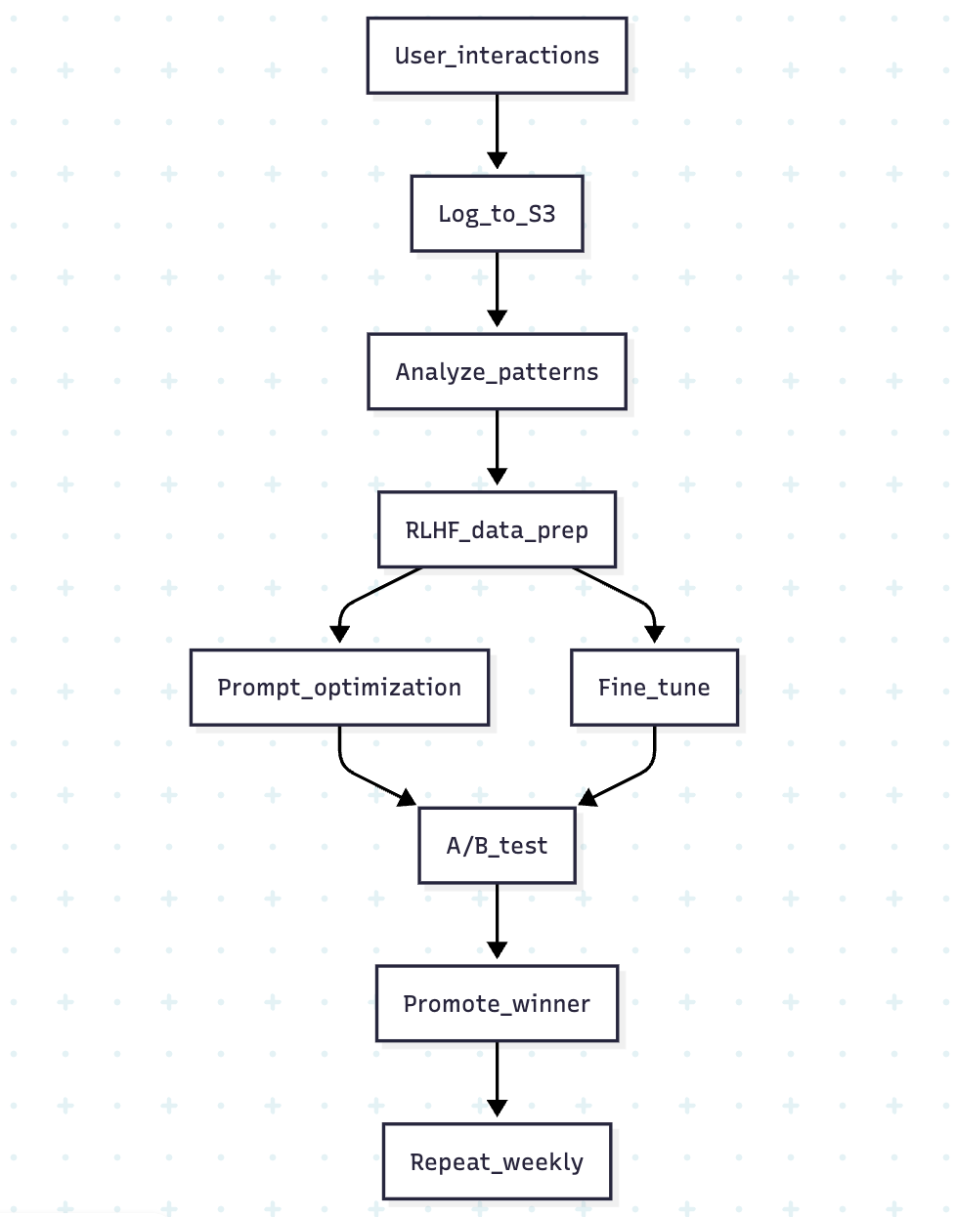

Detailed Sub-Workflows
Sub-Workflow | What Happens | Impact
User Feedback Capture | Logs every accept/reject/edit on generated artifacts | Free RLHF dataset
Trace Analysis | LangSmith traces every agent step | Debuggable always
Prompt Optimization | Auto-tunes prompts via DSPy / Promptfoo evals | Debuggable always
Model Routing | Routes simple tasks to GPT-4o-mini, complex to Claude Sonnet | Cost-optimized COGS
Hallucination Tracking | Flags fabricated APIs, fake imports, wrong schemas | Quality guardrail
Drift Detection | Monitors code-quality scores over model versions | Catches regressions
A/B Experimentation | Routes % of users to v2 agents, compares outcomes | Data-driven rollout
Cost Telemetry | Per-user, per-MVP token + compute cost tracking | Margin protection

Agents in Detail
Agent | Role | Tools It Uses
Analytics Agent | Aggregates usage + outcomes | PostHog, Mixpanel, internal DW
Feedback Loop Agent | Curates RLHF training data | S3, Step Functions, labeling tools
Prompt Optimizer | Continuously refines prompts | DSPy, Promptfoo, LangSmith
Model Router | Picks cheapest capable model per task | Internal cost/quality scoring
Drift Monitor | Alerts on quality regressions | Prometheus, custom evals

Key Integrations (Tools)
LangSmith · TruLens · Promptfoo · DSPy · PostHog · Mixpanel · Amplitude · Prometheus · Grafana · AWS Step Functions · S3

ROI for the Platform
- COGS per MVP: ₹500 → ₹250 (50% reduction over 6 months)
- Generation success rate: +15% quarter-over-quarter
- Hallucination rate: -60% via continuous evals
- Customer satisfaction (CSAT): 4.2 → 4.7+
- Defensible moat: proprietary RLHF dataset compounds over time

THE MASTER PATTERN (WHY THIS ARCHITECTURE WIN)
Every pillar follows the same 5-stage autonomous loop:
1. Understand → Parse intent from idea, code, feedback, or signal
2. Plan → Decompose into atomic, executable steps
3. Execute → Act via tools, APIs, sandboxes, integrations
4. Verify → Test outcome; self-correct on failure (up to N retries)
5. Learn → Feed result into RLHF + prompt-optimization pipeline
This is why Auto-Founder AI scales horizontally: building Pillar 8 (e.g., Mobile App Generation) or Pillar 9 (Compliance Automation) doesn't require a new platform — just new agents, new templates, and new connectors plugged into the existing LangGraph orchestrator.

COMBINED ROI: TRADITIONAL VS AUTO-FOUNDER AI
Metric | Traditional Path | Auto-Founder AI | Improvement
Idea → Validated | 3 weeks | 30 minutes | 99% faster
Validated → Built MVP | 3–6 months | 7 days | 95% faster
MVP → Deployed | 1 week | 10 minutes | 99% faster
Deployed → Marketed | 2–3 weeks | 2 hours | 98% faster
Total: Idea → Live & Marketed | 4–7 months | ~7 days | 96% faster
Total Cost | $20K–$60K | $200–$700 | 99% cheaper

Appendix 2: DB Creation Scripts

Platform Schema & Table Scripts
-- ─────────────────────────────────────────────
-- PLATFORM schema (shared across all tenants)
-- ─────────────────────────────────────────────

CREATE SCHEMA platform;

CREATE TABLE platform.tenants (
id UUID PRIMARY KEY DEFAULT gen_random_uuid(),
name TEXT NOT NULL,
slug TEXT UNIQUE NOT NULL,
tier TEXT NOT NULL CHECK (tier IN ('solo','startup','enterprise')),
status TEXT NOT NULL DEFAULT 'active' CHECK (status IN ('active','suspended','deleted')),
settings JSONB NOT NULL DEFAULT '{}',
created_at TIMESTAMPTZ NOT NULL DEFAULT now(),
deleted_at TIMESTAMPTZ
);

CREATE TABLE platform.tenant_api_keys (
id UUID PRIMARY KEY DEFAULT gen_random_uuid(),
tenant_id UUID NOT NULL REFERENCES platform.tenants(id) ON DELETE CASCADE,
key_hash TEXT NOT NULL UNIQUE, -- bcrypt hash; never store raw key
label TEXT,
scopes TEXT[] NOT NULL DEFAULT '{}',
expires_at TIMESTAMPTZ,
revoked_at TIMESTAMPTZ,
created_at TIMESTAMPTZ NOT NULL DEFAULT now()
);

CREATE TABLE platform.model_registry (
id UUID PRIMARY KEY DEFAULT gen_random_uuid(),
model_id TEXT NOT NULL, -- e.g. "gemini-1.5-flash-002"
provider TEXT NOT NULL, -- "google"|"openai"|"bedrock"
version TEXT NOT NULL,
task_classes TEXT[] NOT NULL, -- ["complex_reasoning","self_healing",...]
cost_per_1k_input_tokens NUMERIC(12,6) NOT NULL,
cost_per_1k_output_tokens NUMERIC(12,6) NOT NULL,
eval_scores JSONB NOT NULL DEFAULT '{}',
is_active BOOLEAN NOT NULL DEFAULT true,
rollback_to UUID REFERENCES platform.model_registry(id),
registered_at TIMESTAMPTZ NOT NULL DEFAULT now()
);

CREATE TABLE platform.prompt_registry (
id UUID PRIMARY KEY DEFAULT gen_random_uuid(),
name TEXT NOT NULL, -- e.g. "strategy.market_sizing.v2"
version TEXT NOT NULL, -- semver
agent TEXT NOT NULL,
template_s3 TEXT NOT NULL, -- s3://bucket/prompts/{name}/{version}.j2
variables JSONB NOT NULL, -- required variable schema
status TEXT NOT NULL DEFAULT 'draft'
CHECK (status IN ('draft','canary','active','deprecated')),
eval_score NUMERIC(5,2),
created_by TEXT NOT NULL,
created_at TIMESTAMPTZ NOT NULL DEFAULT now(),
UNIQUE (name, version)
);

CREATE TABLE platform.tool_registry (
id UUID PRIMARY KEY DEFAULT gen_random_uuid(),
name TEXT NOT NULL UNIQUE, -- e.g. "tavily.search"
description TEXT NOT NULL,
args_schema JSONB NOT NULL, -- JSON Schema for input args
auth_scope TEXT NOT NULL, -- required permission scope
cost_class TEXT NOT NULL CHECK (cost_class IN ('free','low','medium','high')),
rate_limit JSONB NOT NULL DEFAULT '{}', -- {requests_per_min, tokens_per_day}
is_active BOOLEAN NOT NULL DEFAULT true
);

CREATE TABLE platform.audit_log (
id BIGSERIAL PRIMARY KEY,
tenant_id UUID,
run_id UUID,
agent_id TEXT,
action TEXT NOT NULL,
resource_type TEXT NOT NULL,
resource_id TEXT,
actor TEXT NOT NULL, -- user_id or "system"
outcome TEXT NOT NULL CHECK (outcome IN ('allowed','denied','error')),
metadata JSONB,
occurred_at TIMESTAMPTZ NOT NULL DEFAULT now()
);
-- audit_log is append-only; writes are funnelled through audit.py only.
-- S3 Object Lock export runs nightly.

Platform Schema Tables Insert Scripts
-- Enable extension
CREATE EXTENSION IF NOT EXISTS pgcrypto;

-- =========================================================
-- 1. Seed platform.tenants
-- =========================================================

INSERT INTO platform.tenants (
id,
name,
slug,
tier,
status,
settings,
created_at
)
SELECT
gen_random_uuid(),
'Tenant ' || gs,
'tenant-' || gs,
(ARRAY['solo','startup','enterprise'])[floor(random()*3)+1],
(ARRAY['active','suspended'])[floor(random()*2)+1],
jsonb_build_object(
'theme', (ARRAY['dark','light'])[floor(random()*2)+1],
'region', (ARRAY['us','eu','asia'])[floor(random()*3)+1]
),
now() - (random() * interval '365 days')
FROM generate_series(1,100) gs;

-- =========================================================
-- 2. Seed platform.tenant_api_keys
-- =========================================================

INSERT INTO platform.tenant_api_keys (
tenant_id,
key_hash,
label,
scopes,
expires_at,
created_at
)
SELECT
t.id,
encode(gen_random_bytes(32), 'hex'),
'API Key ' || row_number() OVER (),
ARRAY[
(ARRAY['agents:read','agents:write','billing:read','tools:execute'])[floor(random()*4)+1]
],
now() + interval '365 days',
now() - (random() * interval '180 days')
FROM (
SELECT id
FROM platform.tenants
ORDER BY random()
LIMIT 100
) t;

-- =========================================================
-- 3. Seed platform.model_registry
-- =========================================================

INSERT INTO platform.model_registry (
id,
model_id,
provider,
version,
task_classes,
cost_per_1k_input_tokens,
cost_per_1k_output_tokens,
eval_scores,
is_active,
registered_at
)
SELECT
gen_random_uuid(),
'model-' || gs,
(ARRAY['google','openai','bedrock'])[floor(random()*3)+1],
'v' || (1 + floor(random()*5)) || '.0',
ARRAY[
(ARRAY[
'complex_reasoning',
'summarization',
'classification',
'self_healing'
])[floor(random()*4)+1]
],
round((random()*0.02)::numeric, 6),
round((random()*0.05)::numeric, 6),
jsonb_build_object(
'accuracy', round((70 + random()*30)::numeric,2),
'latency_ms', floor(100 + random()*900)
),
random() > 0.1,
now() - (random() * interval '365 days')
FROM generate_series(1,100) gs;

-- =========================================================
-- 4. Seed platform.prompt_registry
-- =========================================================

INSERT INTO platform.prompt_registry (
id,
name,
version,
agent,
template_s3,
variables,
status,
eval_score,
created_by,
created_at
)
SELECT
gen_random_uuid(),
'prompt.strategy.' || gs,
'1.' || floor(random()*10) || '.0',
(ARRAY[
'market_agent',
'sales_agent',
'research_agent',
'support_agent'
])[floor(random()*4)+1],
's3://bucket/prompts/prompt-' || gs || '.j2',
jsonb_build_object(
'industry', 'string',
'market_size', 'number'
),
(ARRAY['draft','canary','active','deprecated'])[floor(random()*4)+1],
round((random()*100)::numeric,2),
'admin@autofounder.ai',
now() - (random() * interval '365 days')
FROM generate_series(1,100) gs;

-- =========================================================
-- 5. Seed platform.tool_registry
-- =========================================================

INSERT INTO platform.tool_registry (
id,
name,
description,
args_schema,
auth_scope,
cost_class,
rate_limit,
is_active
)
SELECT
gen_random_uuid(),
'tool.service.' || gs,
'Tool description for service ' || gs,
jsonb_build_object(
'type', 'object',
'properties', jsonb_build_object(
'query', jsonb_build_object('type','string')
)
),
(ARRAY[
'tools:execute',
'tools:admin',
'agents:write'
])[floor(random()*3)+1],
(ARRAY['free','low','medium','high'])[floor(random()*4)+1],
jsonb_build_object(
'requests_per_min', floor(10 + random()*500),
'tokens_per_day', floor(1000 + random()*100000)
),
random() > 0.05
FROM generate_series(1,100) gs;

-- =========================================================
-- 6. Seed platform.audit_log
-- =========================================================

INSERT INTO platform.audit_log (
tenant_id,
run_id,
agent_id,
action,
resource_type,
resource_id,
actor,
outcome,
metadata,
occurred_at
)
SELECT
t.id,
gen_random_uuid(),
(ARRAY[
'market_agent',
'research_agent',
'sales_agent',
'support_agent'
])[floor(random()*4)+1],
(ARRAY[
'create',
'update',
'delete',
'execute'
])[floor(random()*4)+1],
(ARRAY[
'prompt',
'tool',
'workflow',
'model'
])[floor(random()*4)+1],
encode(gen_random_bytes(8), 'hex'),
(ARRAY[
'system',
'admin_user',
'tenant_user'
])[floor(random()*3)+1],
(ARRAY[
'allowed',
'denied',
'error'
])[floor(random()*3)+1],
jsonb_build_object(
'ip', '192.168.1.' || floor(random()*255),
'region', (ARRAY['us','eu','asia'])[floor(random()*3)+1]
),
now() - (random() * interval '90 days')
FROM (
SELECT id
FROM platform.tenants
ORDER BY random()
LIMIT 100
) t;

Pre-Tenant Schema & Table Scripts
-- ─────────────────────────────────────────────
-- PER-TENANT schema (one schema per tenant)
-- Created automatically on tenant provisioning.
-- RLS is set as defense-in-depth; UDAL is the primary enforcement.
-- ─────────────────────────────────────────────

-- RUNS
CREATE TABLE runs (
id UUID PRIMARY KEY DEFAULT gen_random_uuid(),
pillar TEXT NOT NULL, -- "1"|"2"|"3"|"4"|"5"|"6"|"7"
status TEXT NOT NULL DEFAULT 'queued'
CHECK (status IN ('queued','running','paused','completed','failed','cancelled')),
plan JSONB NOT NULL DEFAULT '{}', -- serialized LangGraph DAG
idea_text TEXT NOT NULL,
idea_meta JSONB NOT NULL DEFAULT '{}', -- multimodal attachments, URLs
current_step TEXT,
retry_count INT NOT NULL DEFAULT 0,
model_used TEXT,
cost_usd NUMERIC(12,6) NOT NULL DEFAULT 0,
created_at TIMESTAMPTZ NOT NULL DEFAULT now(),
started_at TIMESTAMPTZ,
completed_at TIMESTAMPTZ,
created_by TEXT NOT NULL -- user_id from JWT
);
CREATE INDEX ON runs (status, created_at DESC);

-- ARTIFACTS
CREATE TABLE artifacts (
id UUID PRIMARY KEY DEFAULT gen_random_uuid(),
run_id UUID NOT NULL REFERENCES runs(id) ON DELETE CASCADE,
pillar TEXT NOT NULL,
kind TEXT NOT NULL,
-- 'lean_canvas'|'market_analysis'|'personas'|'erd'|
-- 'openapi_spec'|'repo_url'|'live_url'|'brand_kit'|
-- 'landing_page'|'email_sequence'|'social_posts'
uri TEXT NOT NULL, -- s3:// or https://
size_bytes BIGINT,
checksum TEXT, -- SHA-256 of artifact
metadata JSONB NOT NULL DEFAULT '{}',
created_at TIMESTAMPTZ NOT NULL DEFAULT now()
);
CREATE INDEX ON artifacts (run_id, kind);

-- GATES (HITL checkpoints)
CREATE TABLE gates (
id UUID PRIMARY KEY DEFAULT gen_random_uuid(),
run_id UUID NOT NULL REFERENCES runs(id) ON DELETE CASCADE,
kind TEXT NOT NULL,
-- 'validation_approve'|'architecture_approve'|
-- 'infra_spend_approve'|'launch_approve'|'canary_rollout'
state TEXT NOT NULL DEFAULT 'pending'
CHECK (state IN ('pending','approved','rejected','timed_out')),
payload JSONB NOT NULL DEFAULT '{}', -- data displayed to founder
decided_by TEXT, -- user_id
decided_at TIMESTAMPTZ,
timeout_at TIMESTAMPTZ, -- NULL = no timeout
created_at TIMESTAMPTZ NOT NULL DEFAULT now()
);
CREATE INDEX ON gates (run_id, state);

-- STEP EVENTS (append-only agent execution log)
CREATE TABLE step_events (
id BIGSERIAL PRIMARY KEY,
run_id UUID NOT NULL REFERENCES runs(id) ON DELETE CASCADE,
step_id TEXT NOT NULL,
agent_id TEXT NOT NULL,
event_type TEXT NOT NULL,
-- 'step.started'|'step.completed'|'step.failed'|
-- 'llm.call'|'tool.call'|'tool.result'|'self_heal'
payload JSONB NOT NULL DEFAULT '{}',
token_cost JSONB, -- {input_tokens, output_tokens, cost_usd}
occurred_at TIMESTAMPTZ NOT NULL DEFAULT now()
);
CREATE INDEX ON step_events (run_id, occurred_at);

-- MEMORY EPISODES
CREATE TABLE memory_episodes (
id UUID PRIMARY KEY DEFAULT gen_random_uuid(),
run_id UUID REFERENCES runs(id) ON DELETE SET NULL,
agent_id TEXT NOT NULL,
kind TEXT NOT NULL, -- 'decision'|'reflection'|'gate_outcome'|'tool_result'
content TEXT NOT NULL,
embedding_id TEXT, -- reference to vector store document ID
importance NUMERIC(3,2), -- 0.0–1.0, used for memory retrieval ranking
created_at TIMESTAMPTZ NOT NULL DEFAULT now(),
expires_at TIMESTAMPTZ -- NULL = permanent (within 90d default)
);
CREATE INDEX ON memory_episodes (agent_id, created_at DESC);
CREATE INDEX ON memory_episodes (run_id);

-- COST LEDGER (per-run, per-model billing)
CREATE TABLE cost_ledger (
id BIGSERIAL PRIMARY KEY,
run_id UUID NOT NULL REFERENCES runs(id),
model_id TEXT NOT NULL,
input_tokens BIGINT NOT NULL DEFAULT 0,
output_tokens BIGINT NOT NULL DEFAULT 0,
cost_usd NUMERIC(12,6) NOT NULL,
recorded_at TIMESTAMPTZ NOT NULL DEFAULT now()
);

Pre-Tenant Schema Tables Insert Scripts
-- =========================================================
-- AUTOFOUNDER AI - TENANT SCHEMA SEED DATA
-- Generates 100 records for all tables with dependencies
-- =========================================================

CREATE EXTENSION IF NOT EXISTS pgcrypto;

-- =========================================================
-- 1. RUNS
-- =========================================================

INSERT INTO runs (
id,
pillar,
status,
plan,
idea_text,
idea_meta,
current_step,
retry_count,
model_used,
cost_usd,
created_at,
started_at,
completed_at,
created_by
)
SELECT
gen_random_uuid(),
(floor(random()*7)+1)::TEXT,
(ARRAY[
'queued',
'running',
'paused',
'completed',
'failed',
'cancelled'
])[floor(random()*6)+1],

jsonb_build_object(
'workflow', 'langgraph',
'nodes', floor(random()*20)+5,
'edges', floor(random()*30)+10
),

'AI Startup Idea #' || gs ||
': Build an autonomous AI platform for industry ' ||
(ARRAY[
'Healthcare',
'FinTech',
'EdTech',
'Retail',
'ClimateTech',
'LegalTech'
])[floor(random()*6)+1],

jsonb_build_object(
'attachments', jsonb_build_array(
'pitch_deck.pdf',
'requirements.docx'
),
'source_urls', jsonb_build_array(
'https://example.com/startup',
'https://github.com/autofounder'
)
),

(ARRAY[
'market_research',
'architecture_design',
'landing_page_generation',
'deployment',
'launch'
])[floor(random()*5)+1],

floor(random()*5),

(ARRAY[
'gpt-4o',
'claude-3-opus',
'gemini-1.5-pro',
'llama-3-70b'
])[floor(random()*4)+1],

round((random()*50)::numeric, 6),

now() - (random() * interval '90 days'),

now() - (random() * interval '80 days'),

CASE
WHEN random() > 0.3
THEN now() - (random() * interval '10 days')
ELSE NULL
END,

'user_' || gs

FROM generate_series(1,100) gs;

-- =========================================================
-- 2. ARTIFACTS
-- =========================================================

INSERT INTO artifacts (
id,
run_id,
pillar,
kind,
uri,
size_bytes,
checksum,
metadata,
created_at
)
SELECT
gen_random_uuid(),

r.id,

r.pillar,

(ARRAY[
'lean_canvas',
'market_analysis',
'personas',
'erd',
'openapi_spec',
'repo_url',
'live_url',
'brand_kit',
'landing_page',
'email_sequence',
'social_posts'
])[floor(random()*11)+1],

'https://storage.autofounder.ai/artifacts/' ||
encode(gen_random_bytes(8), 'hex'),

floor(random()*5000000)+10000,

encode(gen_random_bytes(32), 'hex'),

jsonb_build_object(
'format', 'json',
'generated_by', 'ai-agent',
'version', 'v1'
),

now() - (random() * interval '60 days')

FROM (
SELECT id, pillar
FROM runs
ORDER BY random()
LIMIT 100
) r;

-- =========================================================
-- 3. GATES
-- =========================================================

INSERT INTO gates (
id,
run_id,
kind,
state,
payload,
decided_by,
decided_at,
timeout_at,
created_at
)
SELECT
gen_random_uuid(),

r.id,

(ARRAY[
'validation_approve',
'architecture_approve',
'infra_spend_approve',
'launch_approve',
'canary_rollout'
])[floor(random()*5)+1],

(ARRAY[
'pending',
'approved',
'rejected',
'timed_out'
])[floor(random()*4)+1],

jsonb_build_object(
'risk_score', round((random()*100)::numeric,2),
'estimated_cost', round((random()*10000)::numeric,2),
'notes', 'Auto generated checkpoint payload'
),

CASE
WHEN random() > 0.2
THEN 'reviewer_' || floor(random()*20)
ELSE NULL
END,

CASE
WHEN random() > 0.2
THEN now() - (random() * interval '30 days')
ELSE NULL
END,

now() + (random() * interval '7 days'),

now() - (random() * interval '60 days')

FROM (
SELECT id
FROM runs
ORDER BY random()
LIMIT 100
) r;

-- =========================================================
-- 4. STEP EVENTS
-- =========================================================

INSERT INTO step_events (
run_id,
step_id,
agent_id,
event_type,
payload,
token_cost,
occurred_at
)
SELECT
r.id,

'step_' || gs,

(ARRAY[
'market_agent',
'research_agent',
'infra_agent',
'branding_agent',
'launch_agent'
])[floor(random()*5)+1],

(ARRAY[
'step.started',
'step.completed',
'step.failed',
'llm.call',
'tool.call',
'tool.result',
'self_heal'
])[floor(random()*7)+1],

jsonb_build_object(
'message', 'Execution event generated',
'status_code', floor(random()*500)
),

jsonb_build_object(
'input_tokens', floor(random()*5000),
'output_tokens', floor(random()*3000),
'cost_usd', round((random()*5)::numeric,6)
),

now() - (random() * interval '30 days')

FROM (
SELECT id
FROM runs
ORDER BY random()
LIMIT 100
) r
CROSS JOIN generate_series(1,1) gs;

-- =========================================================
-- 5. MEMORY EPISODES
-- =========================================================

INSERT INTO memory_episodes (
id,
run_id,
agent_id,
kind,
content,
embedding_id,
importance,
created_at,
expires_at
)
SELECT
gen_random_uuid(),

r.id,

(ARRAY[
'market_agent',
'research_agent',
'infra_agent',
'sales_agent'
])[floor(random()*4)+1],

(ARRAY[
'decision',
'reflection',
'gate_outcome',
'tool_result'
])[floor(random()*4)+1],

'Memory episode for autonomous execution workflow #' || gs,

encode(gen_random_bytes(16), 'hex'),

round((random())::numeric, 2),

now() - (random() * interval '45 days'),

CASE
WHEN random() > 0.5
THEN now() + (random() * interval '90 days')
ELSE NULL
END

FROM (
SELECT id
FROM runs
ORDER BY random()
LIMIT 100
) r
CROSS JOIN generate_series(1,1) gs;

-- =========================================================
-- 6. COST LEDGER
-- =========================================================

INSERT INTO cost_ledger (
run_id,
model_id,
input_tokens,
output_tokens,
cost_usd,
recorded_at
)
SELECT
r.id,

(ARRAY[
'gpt-4o',
'claude-3-opus',
'gemini-1.5-pro',
'llama-3-70b'
])[floor(random()*4)+1],

floor(random()*100000),

floor(random()*50000),

round((random()*100)::numeric, 6),

now() - (random() * interval '30 days')

FROM (
SELECT id
FROM runs
ORDER BY random()
LIMIT 100
) r;

-- =========================================================
-- VALIDATION QUERIES
-- =========================================================

SELECT 'runs' AS table_name, count(*) FROM runs
UNION ALL
SELECT 'artifacts', count(*) FROM artifacts
UNION ALL
SELECT 'gates', count(*) FROM gates
UNION ALL
SELECT 'step_events', count(*) FROM step_events
UNION ALL
SELECT 'memory_episodes', count(*) FROM memory_episodes
UNION ALL
SELECT 'cost_ledger', count(*) FROM cost_ledger;

━━━━━━━━━━━━━━━━━━━━━━━━━━━━━━━━━
Document prepared by Euron AutoFounder AI Product Team | May 2026
For questions, contact: product@euron.one

