1. Create a function named “addNumbers” that accepts two numbers and finds their sum

#include<stdio.h>

// user defined function to add two numbers
int addNumbers(int n1, int n2)
{
int sum;
sum = n1 + n2;
return sum;
}
int main()
{
int a, b, add; //variable declaration
printf("Enter two numbers (a,b): "); //Accepts two numbers
scanf("%d,%d", &a, &b);

//Assigns the value of function to variable add
add = addNumbers(a,b);
printf("The sum of %d + %d is: %d\n", a, b, add); //prints result
return 0;
}
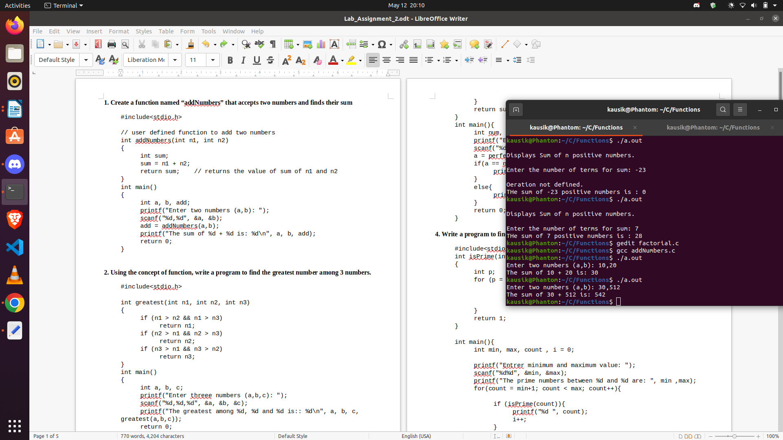

This is a program that returns the sum of two integer numbers with the use of user defined function addNumbes(). This function accepts two user input values and returns integer as the sum of two input numbers.

2. Using the concept of function, write a program to find the greatest number among 3 numbers.

#include<stdio.h>

//function declaration with three arguments (n1, n2, n3)
int greatest(int n1, int n2, int n3)
{
if (n1 > n2 && n1 > n3)
return n1;
if (n2 > n1 && n2 > n3)
return n2;
if (n3 > n1 && n3 > n2)
return n3;
}
int main()
{
int a, b, c, great; //variable declaration
printf("Enter threee numbers (a,b,c): "); // Accepts input
scanf("%d %d %d", &a, &b, &c);
printf(“Your input: %d, %d, %d\n”, a, b, c);

//Assigns the value of function to variable great
great = greatest(a,b,c);
printf("The greatest among is:: %d\n", great);
return 0;
}
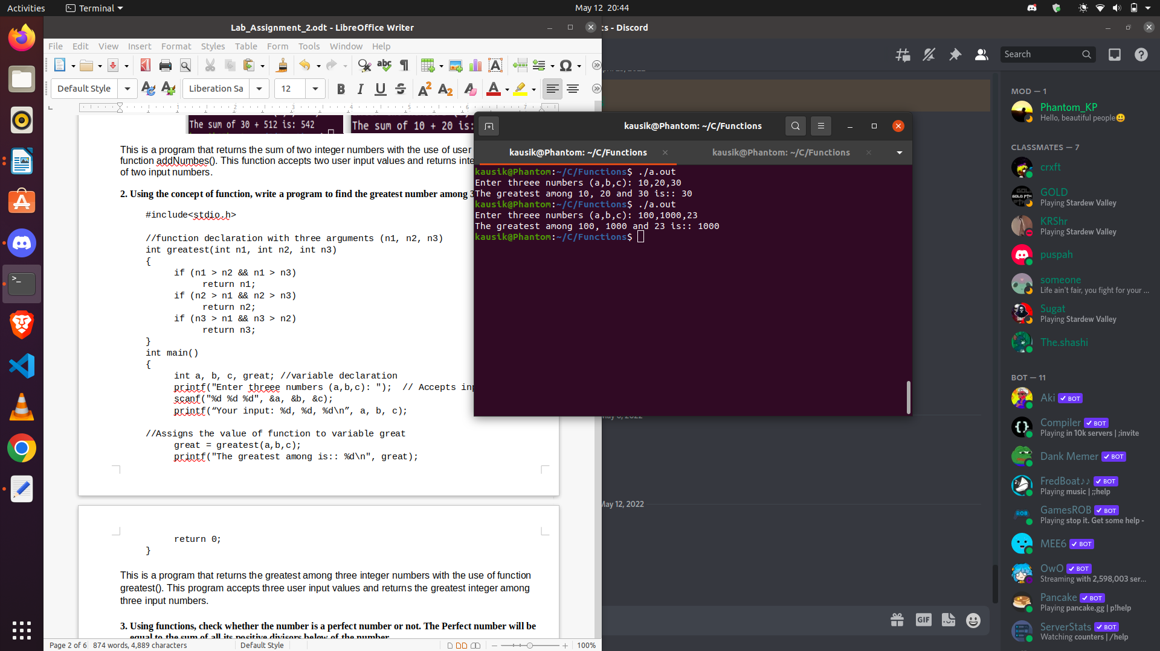

This is a program that returns the greatest among three integer numbers with the use of function greatest(). This program accepts three user input values and returns the greatest integer among three input numbers.

3. Using functions, check whether the number is a perfect number or not. The Perfect number will be
equal to the sum of all its positive divisors below of the number.

#include<stdio.h>

//function declaration with one integer arguement
int perfectNum(int n1){
int i, sum = 0 ; //variable declaration
for(i = 1; i < n1; i++){
if (n1 % i == 0){
sum+=i;
}
}
return sum; //returns the value of sum
}
int main(){
int num, a; //variable declaration
printf("Enter a number(num): "); //accepts input
scanf("%d", &num);

//Assigns value of function perfectNum() to variable a
a = perfectNum(num);
if(a == num){ //checks if value of a equals num
printf("\n%d is a perfect number\n", num);
}
else{
printf("\n%d is not a perfect number\n", num);
}
return 0;
}
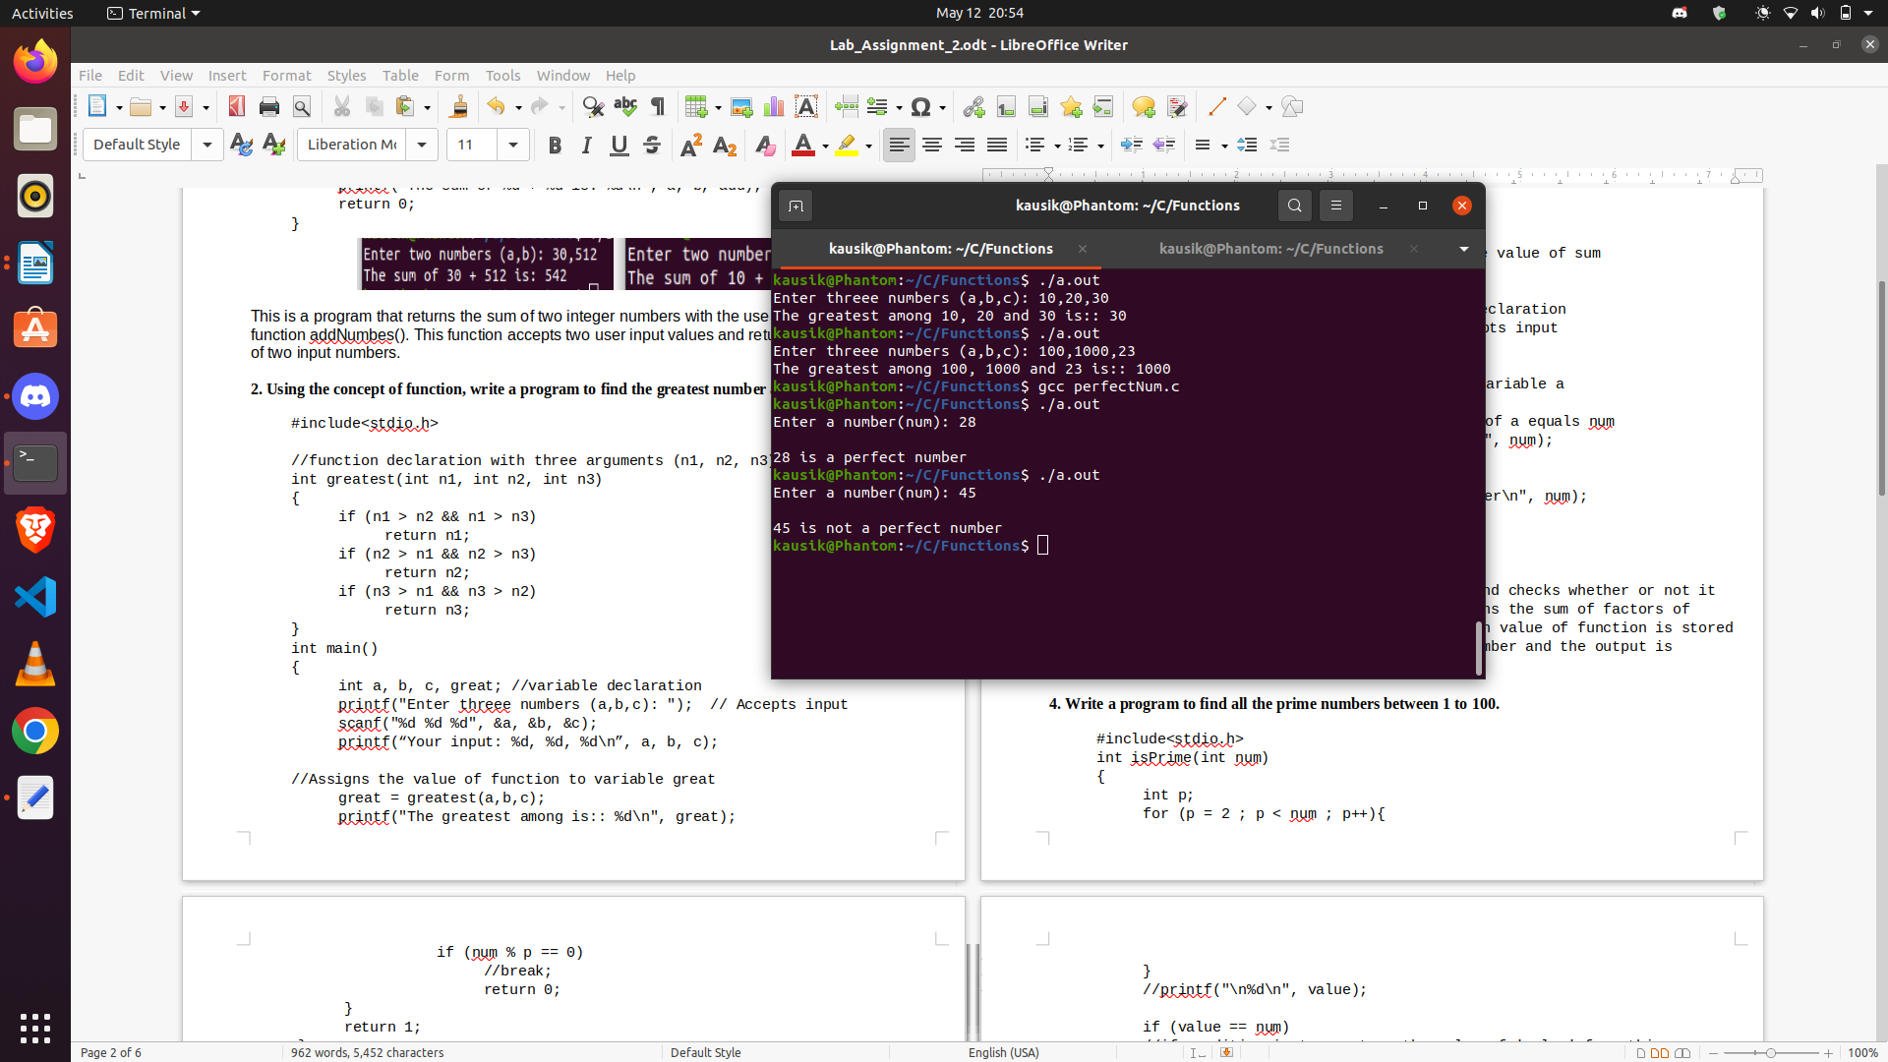

This is a program that accepts a input from user and checks whether or not it is perfect number. The function perfectNum() returns the sum of factors of input number excluding the input number. The return value of function is stored in variable ‘a’ which is compared with original number and the output is displayed accordingly

4. Write a program to find all the prime numbers between 1 to 100.

#include<stdio.h>

//function declaration with one integer argument
int isPrime(int num)
{
int p; //variable declaration
for (p = 2 ; p < num ; p++){
if (num % p == 0) //p is not prime
return 0;
}
//p is prime, so it is returned
return 1;
}

int main(){
int min, max, count , i = 0; //variable declaration

//Accepting minimum and maximum values
printf("Entrer minimum and maximum value: ");
scanf("%d%d", &min, &max);
printf("The prime numbers between %d and %d are: ", min ,max);
for(count = min+1; count < max; count++){

//if returned value is true (i.e. 1), then it is printed.
if (isPrime(count)){
printf("%d ", count);
i++; //count of prime is increased by 1.
}
}
printf("\n");

//displays the total number of prime between two input values
printf("Total prime numbers between %d and %d is: %d\n", min, max, i);
return 0;
}
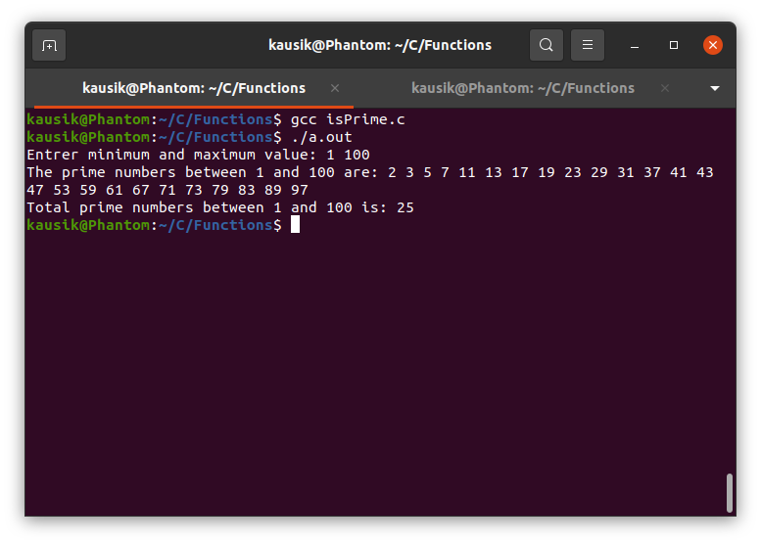

This is a program that asks user to input a minimum and a maximum value and displays the prime numbers between them. Finally, the total count of prime numbers between the range is displayed.
The function isPrime() takes in argument ‘num’ which iterates from (min + 1) to (max – 1). ‘p’ is the variable to be checked for prime. If it satisfies the condition of prime number, its value is returned by the function and is displayed as output.

5. Write a program to check whether a number is strong or not.

#include<stdio.h>
//factorial of num
int factorial(int num){
if (num == 1 || num == 0)
return 1;
if (num > 1)
return num*factorial(num-1);

}
//function to check if the number is strong or not
int strongNum(int num){
int store, rem, value = 0; //variable declaration

//store stores the value of num so that it doesn't change after looping
store = num;
while(num > 0 && store != 0)
{
rem = store % 10;
value += (factorial(rem));
store /= 10;

}
//checking if value is equal to num
if (value == num)
//if condition is true return the value of 'true = 1' from this function
return 1;
else
return 0;
}
int main(){

int n, a; //variable declaration
printf("Enter a num: "); //asking user input
scanf("%d", &n);

//a has the value of function strongNum
a = strongNum(n);

//if returned value is true (i.e. 1) then number is strong
if (a)
printf("%d is a strong num.\n", n);
else
printf("%d is not a strong num.\n", n);

return 0;
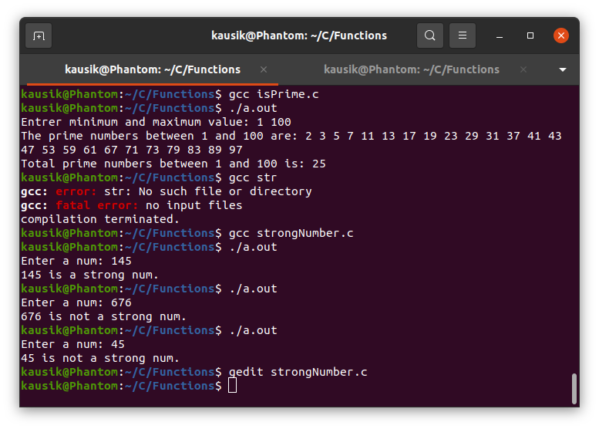
}
This is a program that asks a input number from user and checks whether it is a strong number or not using function and displays the output. A strong number is such a number whose sum of factorials of individual digit is equal to the number itself.
For eg: 145 is a strong number because 1! + 4! + 5! = 145
In this program, a separate factorial(int num) function is created to compute the factorial of individual digits of input number recursively.
As the factorial of individual digit is required, it is a lengthy process to perform a repititive task. Thus a function is created and is called when needed in the program.

In the function strongNum(), the input number is broken down into individual digit and sum of factorial of individual digit is performed. If the input number and the value obtained after performing the operation is equal then the value(=true i.e. 1) is returned from the function and output is displayed accordingly.

6. Write a program to evaluate the GCD of two numbers using functions or recursively find the GCD
of two input numbers.

#include<stdio.h>

int gcd(int n1, int n2){

if (n1 == 0)
return n2;
if (n2 == 0)
return n1;
if (n1 > n2)
return gcd(n1 % n2, n2);
if (n2 > n1)
return gcd(n1, n2 % n1);

}

int main(){
int a, b, g; //variable declaration
printf("Enter two numbers: "); //accepts user input
scanf("%d %d", &a, &b);

//Assigns the value of function to variable g
g = gcd(a,b);
printf("The GCD of %d and %d is: %d\n", a, b, g); //displays result
return 0;
}
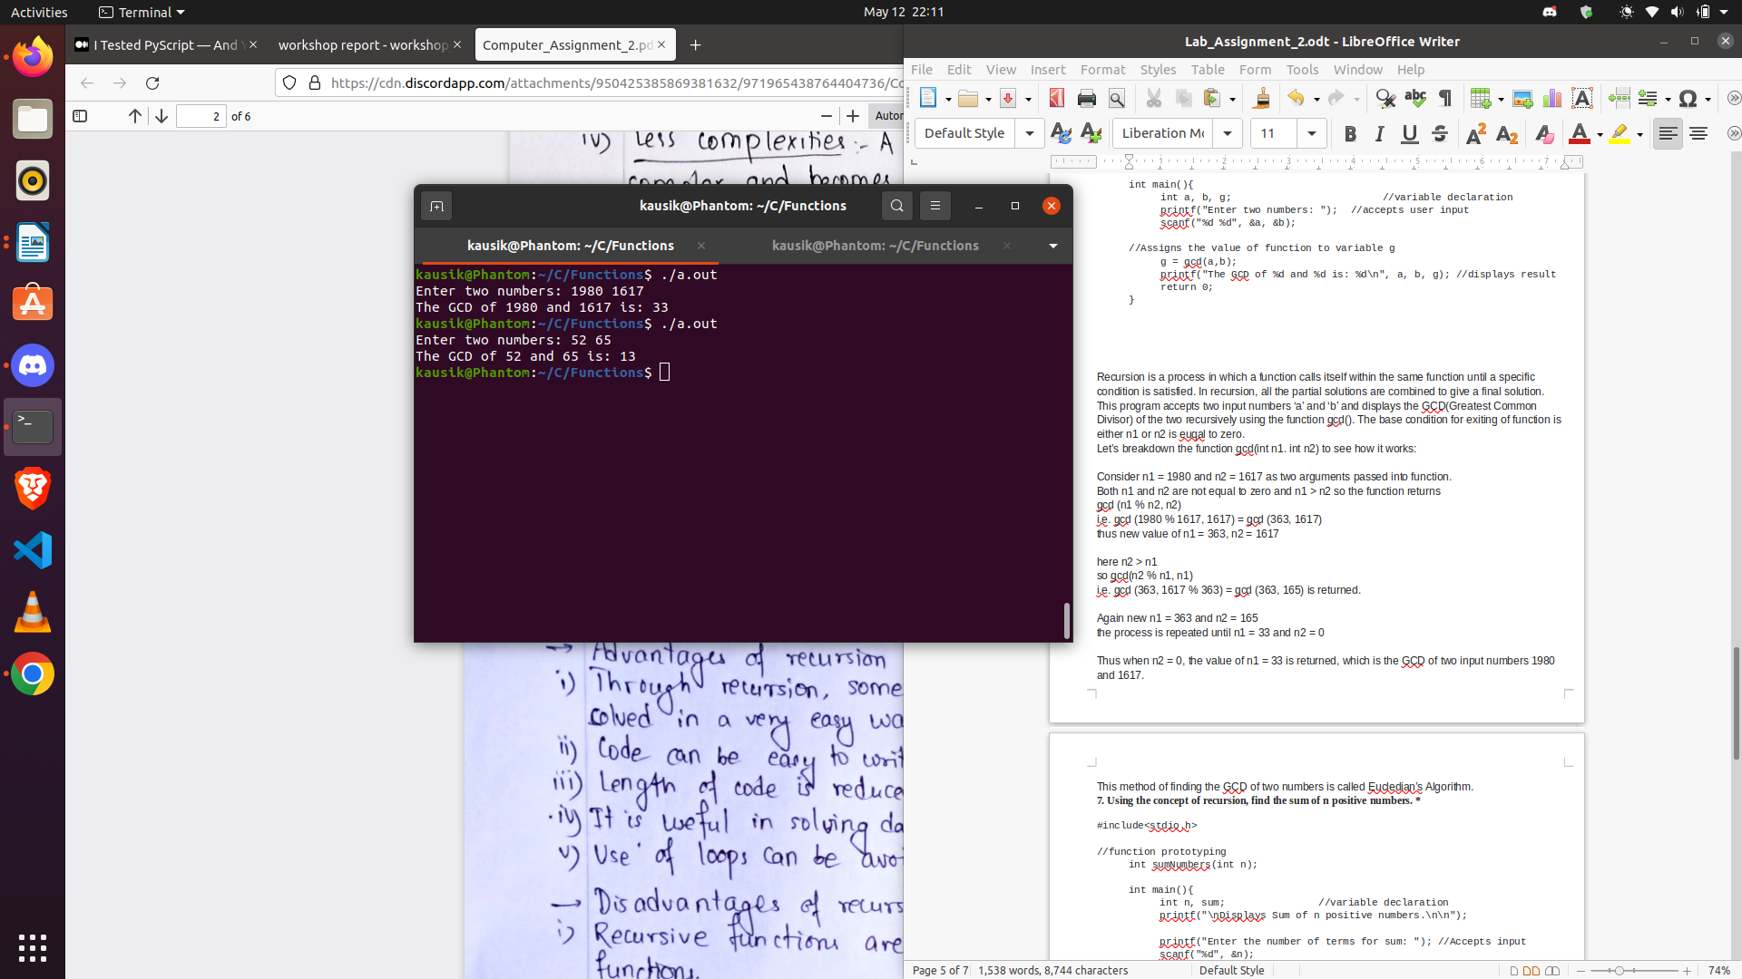
Recursion is a process in which a function calls itself within the same function until a specific condition is satisfied. In recursion, all the partial solutions are combined to give a final solution.
This program accepts two input numbers ‘a’ and ‘b’ and displays the GCD(Greatest Common Divisor) of the two recursively using the function gcd(). The base condition for exiting of function is either n1 or n2 is euqal to zero.
Let’s breakdown the function gcd(int n1. int n2) to see how it works:

Consider n1 = 1980 and n2 = 1617 as two arguments passed into function.
Both n1 and n2 are not equal to zero and n1 > n2 so the function returns
gcd (n1 % n2, n2)
i.e. gcd (1980 % 1617, 1617) = gcd (363, 1617)
thus new value of n1 = 363, n2 = 1617
here n2 > n1
so gcd(n2 % n1, n1)
i.e. gcd (363, 1617 % 363) = gcd (363, 165) is returned.
Again new n1 = 363 and n2 = 165
the process is repeated until n1 = 33 and n2 = 0
Thus when n2 = 0, the value of n1 = 33 is returned, which is the GCD of two input numbers 1980 and 1617.
This method of finding the GCD of two numbers is called Eucledian’s Algorithm.

7. Using the concept of recursion, find the sum of n positive numbers. *

#include<stdio.h>

//function prototyping
int sumNumbers(int n);

int main(){
int n, sum; //variable declaration
printf("\nDisplays Sum of n positive numbers.\n\n");

printf("Enter the number of terms for sum: "); //Accepts input
scanf("%d", &n);

//Assigns the value of function to variable sum
sum = sumNumbers(n);
printf("THe sum of %d positive numbers is : %d\n", n, sum);
return 0;
}

int sumNumbers(int n){
if (n >= 0)
return n+sumNumbers(n-1);
if (n < 0)
return 0;
}

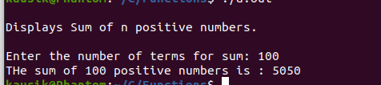

This is a program that accepts a user input positive integer and displays the continuous sum of numbers from 1 to itself recursively using function sumNumbers(). The function sumNumbers() accepts user input ‘n’ and computes sum until n equals to 0. If n equals 0, then the function returns the value of sum of numbers upto ‘n’ and displays the output.

The function sumNumbers(int n) is defined before main() function so that the compiler is made aware about the use of function later in the program. This technique of declaration of function before the main() function is called function prototyping.

8. Recursively, find the factorial of an input number n.

#include<stdio.h>

//function prototyping
int factorial(int n);

int main(){
int n, fact; //variable declaration
printf("Enter a number for factorial: "); //Accepts input
scanf("%d", &n);

//assigns value of function to variable fact
fact = factorial(n);
printf("The factorial of %d is: %d\n", n, fact); //Displays result
return 0;

}

int factorial(int n)
{
if (n == 0 || n == 1)
return 1;
if (n > 1)
return n*factorial(n-1);
if (n < 0)
return 0;

}
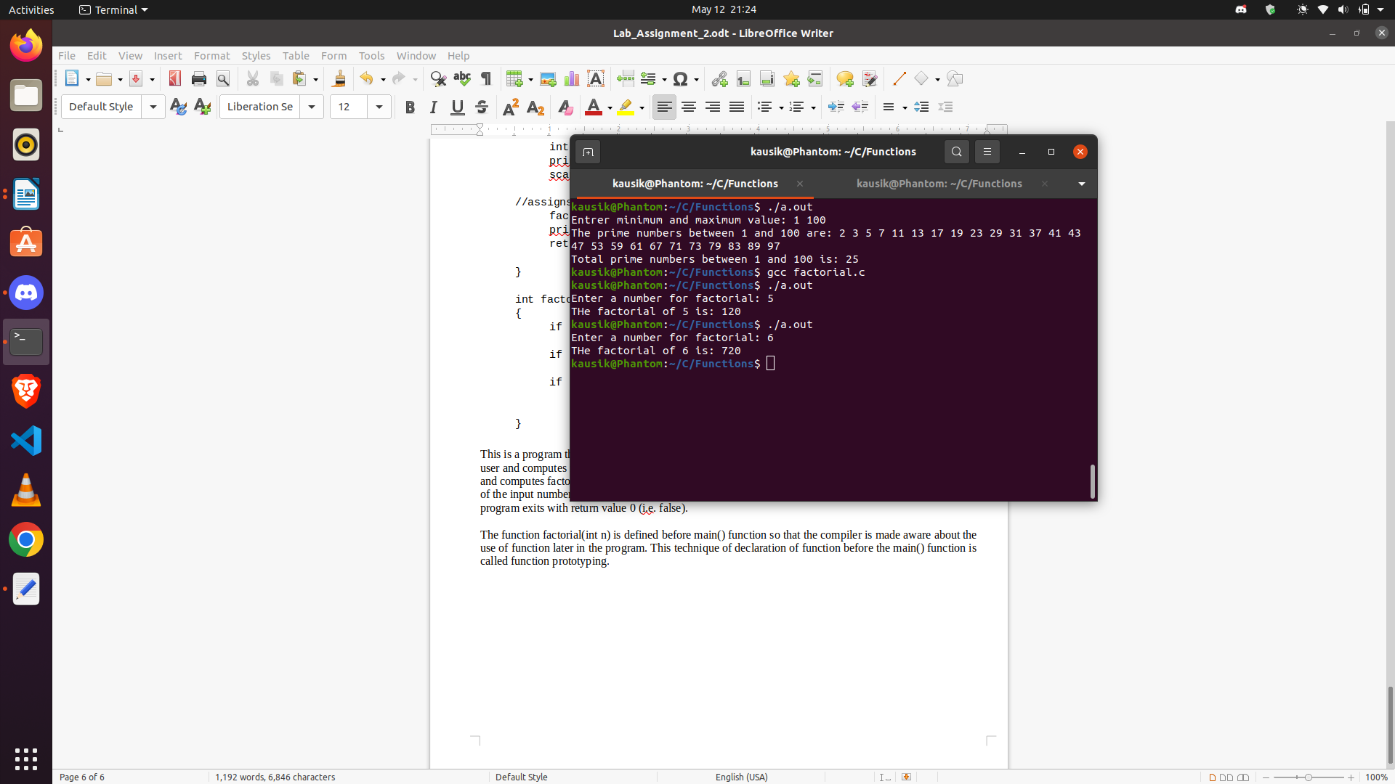

This is a program that displays the factorial of a given number recursively. It accepts a integer input from user and computes factorial using the function factorial(). The function factorial() takes in the user input (n) and computes factorial until ‘n’ equals to zero. If n equals 0 then the program exits by returning the factorial of the input number. If the input is 0 or 1, the return value is 1(i.e. true). If the input is less than 0, the program exits with return value 0 (i.e. false).

The function factorial(int n) is defined before main() function so that the compiler is made aware about the use of function later in the program. This technique of declaration of function before the main() function is called function prototyping.

