OTE: Every program in this section has been compiled with gcc 9.4.0 compiler.
1. WAP to find the equivalent grade for the marks obtained in KU system. (Use if statement
and if and else if statement both).

#include<stdio.h> //inclusion of standard library in the program
int main() //main function declaration
{
int marks; //variable declaration
printf("Enter yours marks: "); //Asking input from user
scanf("%d", &marks); //storing the value of variable marks
//Use of if ..else if statement
{
if(marks >= 80) //checks if marks is greater than 80
printf("The equivalent gradde is: A\n");
else if(marks >=75 && marks <80) //Chekcs if marks is less than 80 and greater than or equal 75
printf("The equivalent grade is: A-\n");
else if(marks >=70 && marks < 75)
printf("The grade point is: B+\n");
else if(marks >= 65 && marks < 70)
printf("The grade point is: B\n");
else if(marks >= 60 && marks < 65)
printf("The grade point is: B-\n");
else if(marks >= 55 && marks < 60)
printf("The grade point is: C+\n");
else if(marks >= 50 && marks < 55)
printf("The grade point is: C\n");
else if(marks >= 45 && marks < 50)
printf("The grade point is: C-\n");
else if(marks >= 40 && marks < 45)
printf("The grade point is: D\n");
else if(marks < 40)
printf("The grade point is: F\n");
}
return0;
}

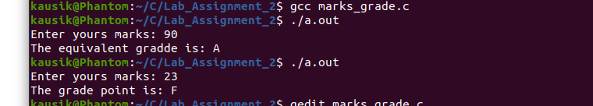

This is a program that asks user to input a marks and displays the equivalent Grade (A – F) in context of KU system. IF...Else is the looping structure used in this particular case. Also logical and (&&) operator is used . The condition is checked and the relevant output is dispalyed. The program works just fine if we use if only instead of else if statement.

2. Write a program to find the largest number among three numbers.

#include<stdio.h>
int main()
{
int a, b, c; //variable declaration
/**Asking three input from user and storing their values**/
printf("Enter first number A: ");
scanf("%d", &a);
printf("Enter second number B: ");
scanf("%d", &b);
printf("Enter third number C: ");
scanf("%d", &c);

if(a > b && a > c){ //checking whether a is greater than b and c simultaneously
printf("\nThe greatest number is: %d\n", a);
}
else if(b > a && b > c){ //checking if b is greater than c and a simultaneously
printf("\nThe greatest number is: %d\n", b);
}
else{ //if a and b is not the greatest number, c is automatically the greatest.
printf("\nThe greatest number is: %d\n", c);
}
return 0;
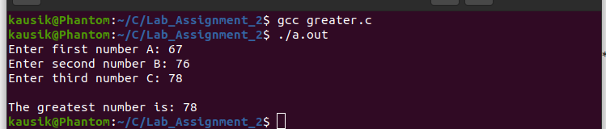
}

This is a program that asks three input numbers from user and checks which one of them is the greatest and displays the output. If...Else looping structure is used in this case also.

3. Write a program to carry out the arithmetic operations addition, subtraction, multiplication,
and division between two variables. Use switch statement for the choice.

#include<stdio.h>
int main()
{
int a, b, add, subtract, product, division; //variable declaration
int choice;
/**Asking two input from user**/
printf("Enter the first number A: ");
scanf("%d", &a);
printf("Enter the second number B: ");
scanf("%d", &b);
/**Asking user what operation do they want to perfotm**/
printf("\nWhat do you want to do? \n");
printf("\n1. Addition\n2. Subtraction\n3. Multiplication\n4. Division\n");
printf("\nPlese type the number (1/2/3/4): ");
scanf("%d", &choice); // storing user’s choice (1/2/3/4)
printf("\n");
add = a + b;
subtract = a - b;
product = a * b;
division = a / b;
/**Use of switch...case**/
switch(choice){
case 1: // if user inputs 1, this case (addition) is performed and the loop is exited.
printf("The sum is: %d\n", add);
break;
case 2: //If user inputs 2, subtraction is performed and loop is exited.
printf("The difference is: %d\n", subtract);
break;
case 3: //if user inputs 3, multiplication is performed and the loop is exited.
printf("The product is: %d\n", product);
break;
case 4: //if user inputs 4, division is performed and the loop is exited.
printf("The division is: %d\n", division);
break;
default: // If user inputs any other choice (e.g: 7), this case (default) is executed.
printf("Enter the correct choice. No operation is defined for %dth choice.\n", choice);
}
return 0;
}
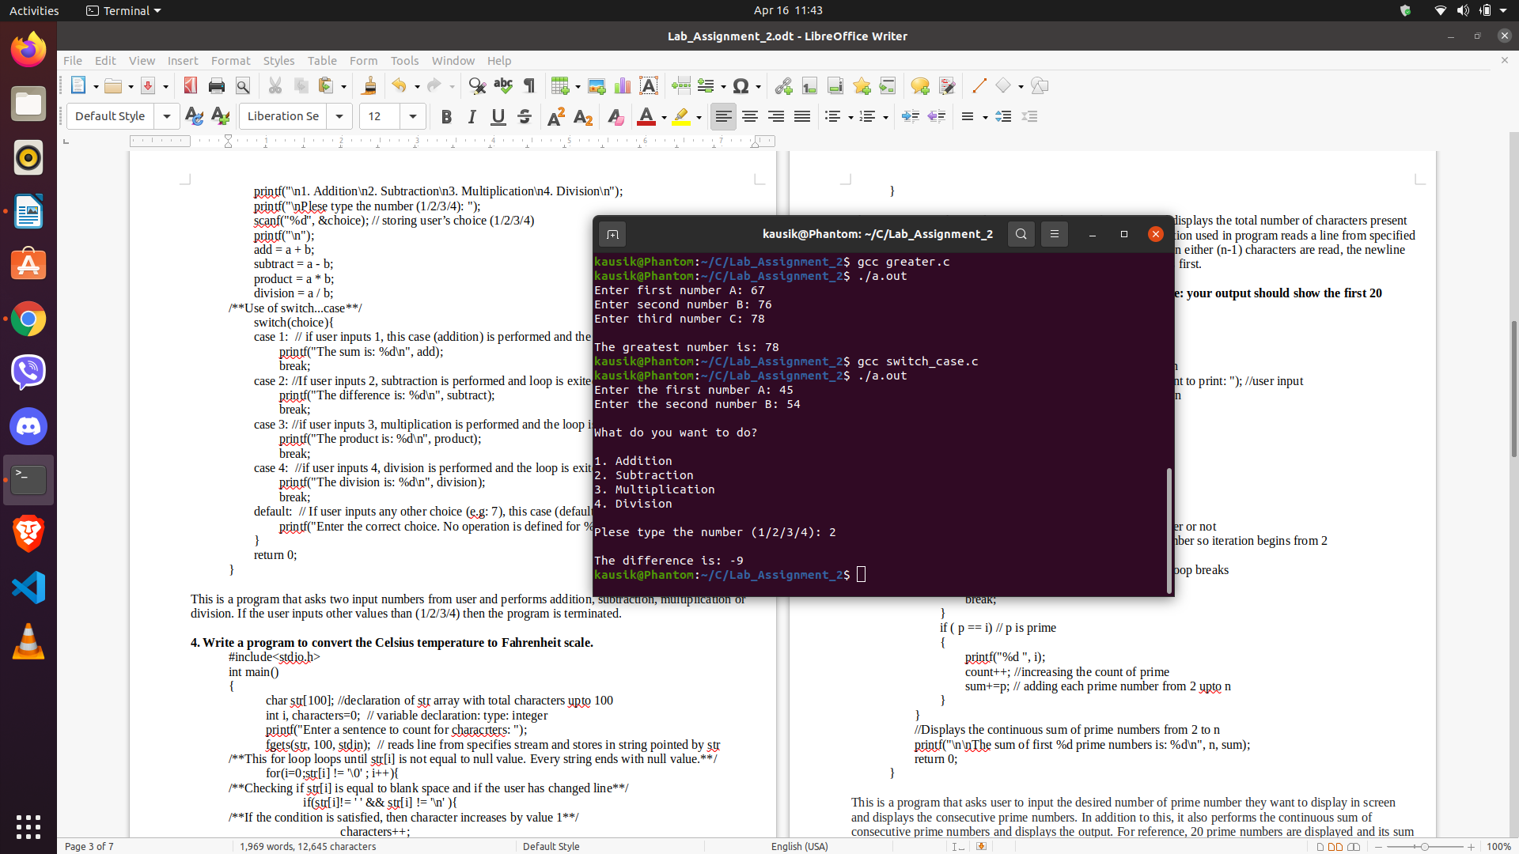

This is a program that asks two input numbers from user and performs addition, subtraction, multiplication or division. If the user inputs other values than (1/2/3/4) then the program is terminated.

4. Write a program to read a sentence and counts the total number of character (excluding space) using while loop.
#include<stdio.h>
int main()
{
char str[100]; //declaration of str array with total characters upto 100
int i, characters=0; // variable declaration: type: integer
printf("Enter a sentence to count for characrters: ");
fgets(str, 100, stdin); // reads line from specifies stream and stores in string pointed by str
/**This while loop loops until str[i] is not equal to null value. Every string ends with null value.**/
while(str[i] != '\0' ){
/**Checking if str[i] is equal to blank space and if the user has changed line**/
if(str[i]!= ' ' && str[i] != '\n' ){
/**If the condition is satisfied, then character increases by value 1**/
characters++;
}
i++; // increment of I by 1
}
printf("\nTotal characters: %d\n", characters); //Displays total number of character
return 0;
}
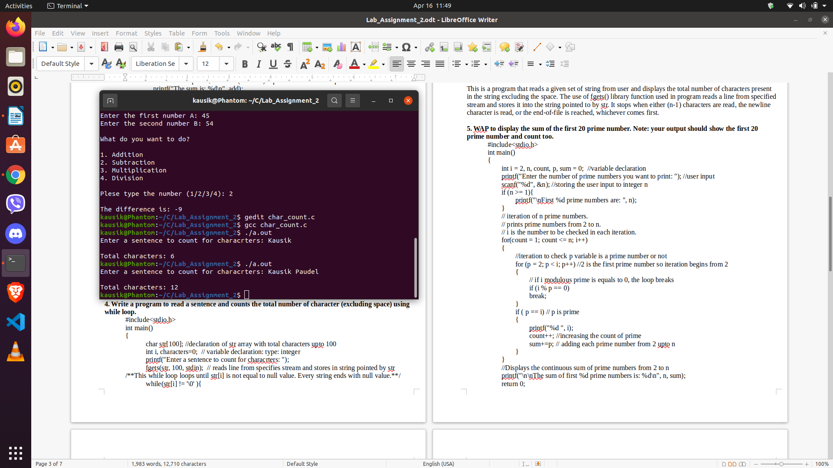

This is a program that reads a given set of string from user and displays the total number of characters present in the string excluding the space. The use of fgets() library function used in program reads a line from specified stream and stores it into the string pointed to by str. It stops when either (n-1) characters are read, the newline character is read, or the end-of-file is reached, whichever comes first.

5. WAP to display the sum of the first 20 prime number. Note: your output should show the first 20 prime number and count too.
#include<stdio.h>
int main()
{
int i = 2, n, count, p, sum = 0; //variable declaration
printf("Enter the number of prime numbers you want to print: "); //user input
scanf("%d", &n); //storing the user input to integer n
if (n >= 1){
printf("\nFirst %d prime numbers are: ", n);
}
// iteration of n prime numbers.
// prints prime numbers from 2 to n.
// i is the number to be checked in each iteration.
for(count = 1; count <= n; i++)
{
//iteration to check p variable is a prime number or not
for (p = 2; p < i; p++) //2 is the first prime number so iteration begins from 2
{
// if i modulous prime is equals to 0, the loop breaks
if (i % p == 0)
break;
}
if ( p == i) // p is prime
{
printf("%d ", i);
count++; //increasing the count of prime
sum+=p; // adding each prime number from 2 upto n
}
}
//Displays the continuous sum of prime numbers from 2 to n
printf("\n\nThe sum of first %d prime numbers is: %d\n", n, sum);
return 0;
}
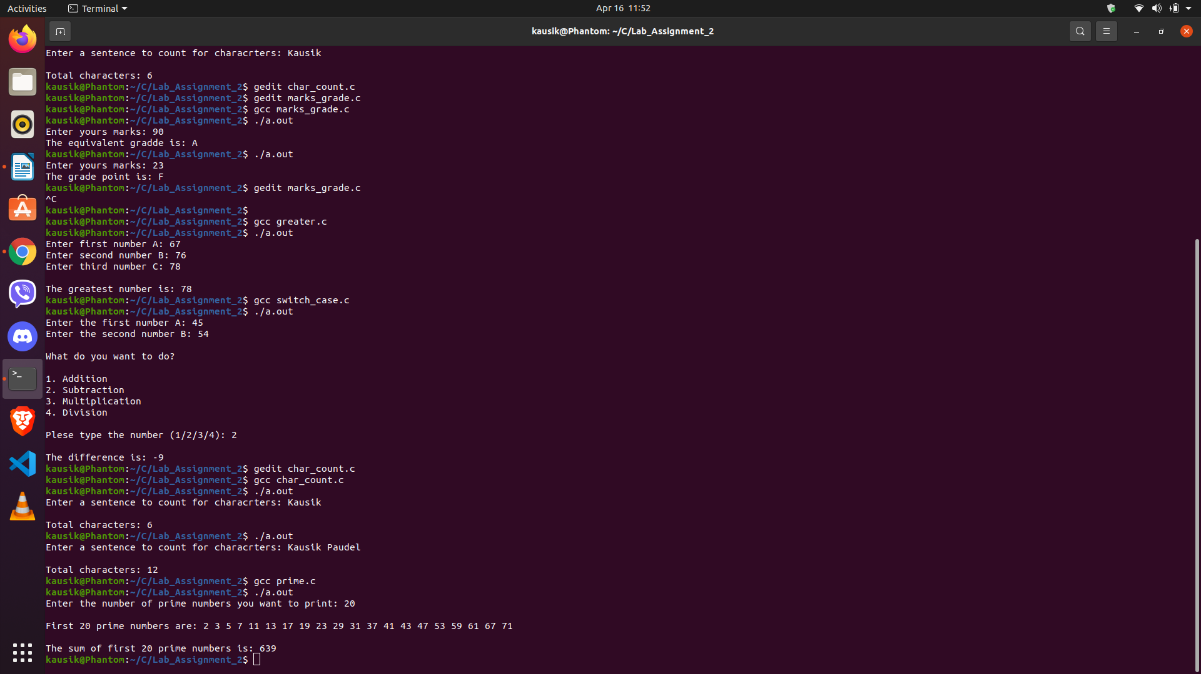

This is a program that asks user to input the desired number of prime number they want to display in screen and displays the consecutive prime numbers. In addition to this, it also performs the continuous sum of consecutive prime numbers and displays the output. For reference, 20 prime numbers are displayed and its sum is displayed.

6. Write a program to generate Fibonacci sequence using do while loop.
#include<stdio.h>
int main()
{
int n, a = 0, b = 1, c = 0, count = 3; //variable declaration
printf("How many fibonacci do you want to generate?: "); //asking input from user
scanf("%d", &n);
printf("%d ", a);
b+=a;
printf("%d ", b);
// a(0) and b(1) is printed before the loop and thus the loop below is executed for n-2 times
do{
c=a+b;
printf("%d ", c);
a = b; // value of a is assigned to b i.e. new b = 1
b = c; // value of b is assigned to c i.e. new c = 2
++count;// increment of count by 1
}
while(count <= n);
//loop is executed until count is less than or equal to n.
printf("\n");
return 0;
}
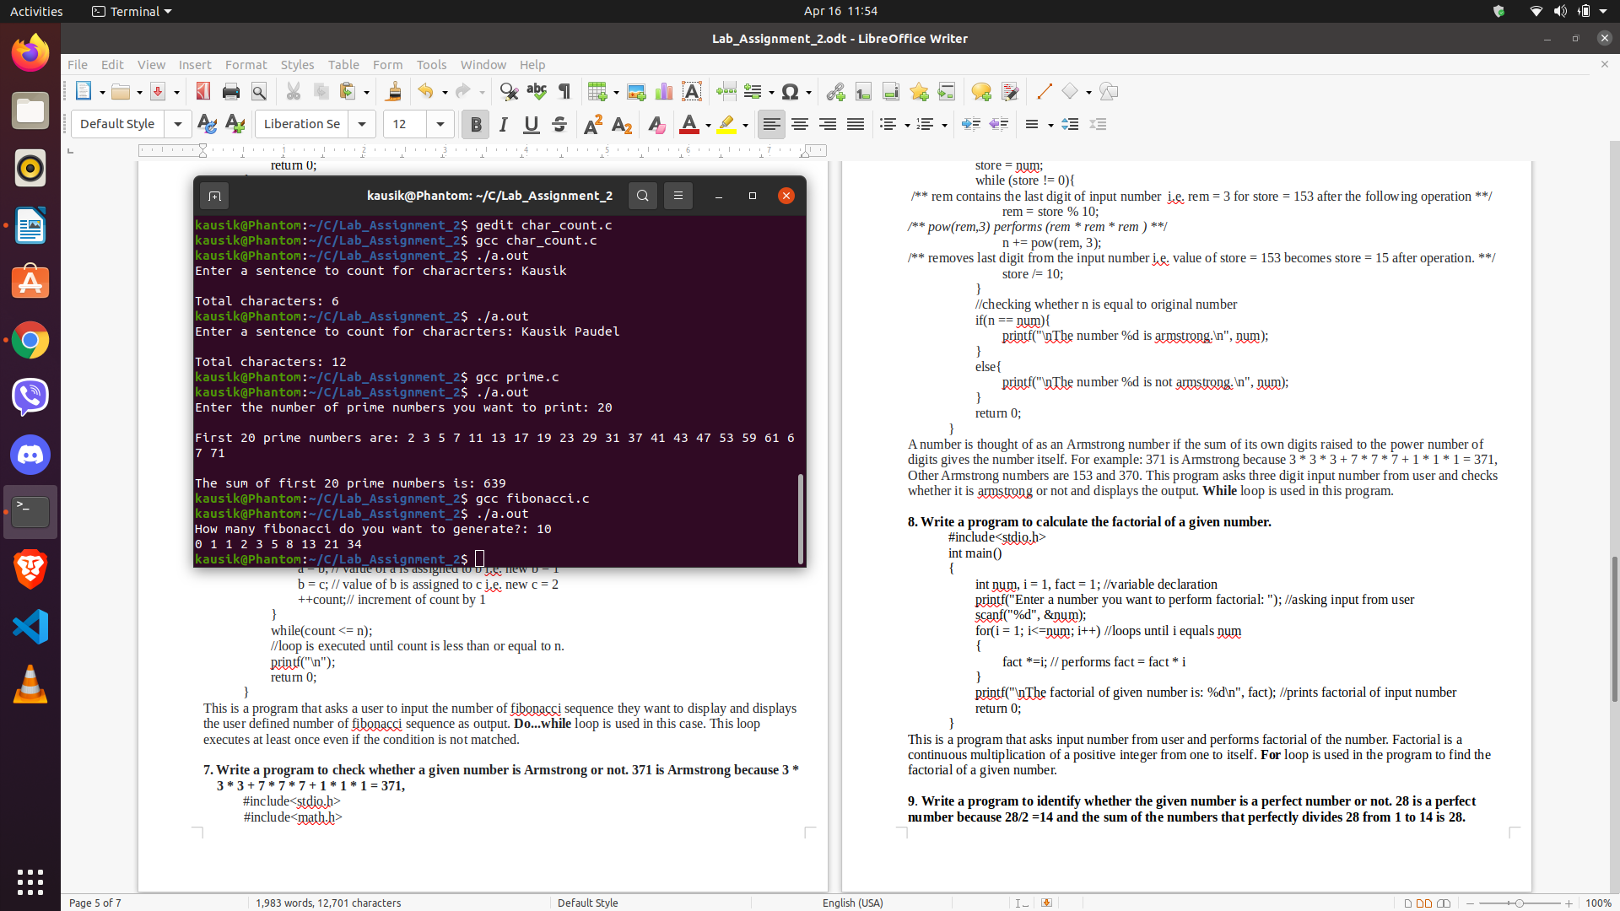

This is a program that asks a user to input the number of fibonacci sequence they want to display and displays the user defined number of fibonacci sequence as output. Do...while loop is used in this case. This loop executes at least once even if the condition is not matched.

7. Write a program to check whether a given number is Armstrong or not. 371 is Armstrong because 3 *
3 * 3 + 7 * 7 * 7 + 1 * 1 * 1 = 371,
#include<stdio.h>
#include<math.h>
int main()
{
int num, store, n = 0, rem; //variable declaration
printf("Enter three digit number to check for armstrong: ");
scanf("%d", &num);
//assigning the original number's value to store variable so that the original value is unchanged after looping
store = num;
while (store != 0){
/** rem contains the last digit of input number i.e. rem = 3 for store = 153 after the following operation **/
rem = store % 10;
/** pow(rem,3) performs (rem * rem * rem ) **/
n += pow(rem, 3);
/** removes last digit from the input number i.e. value of store = 153 becomes store = 15 after operation. **/
store /= 10;
}
//checking whether n is equal to original number
if(n == num){
printf("\nThe number %d is armstrong.\n", num);
}
else{
printf("\nThe number %d is not armstrong.\n", num);
}
return 0;
}
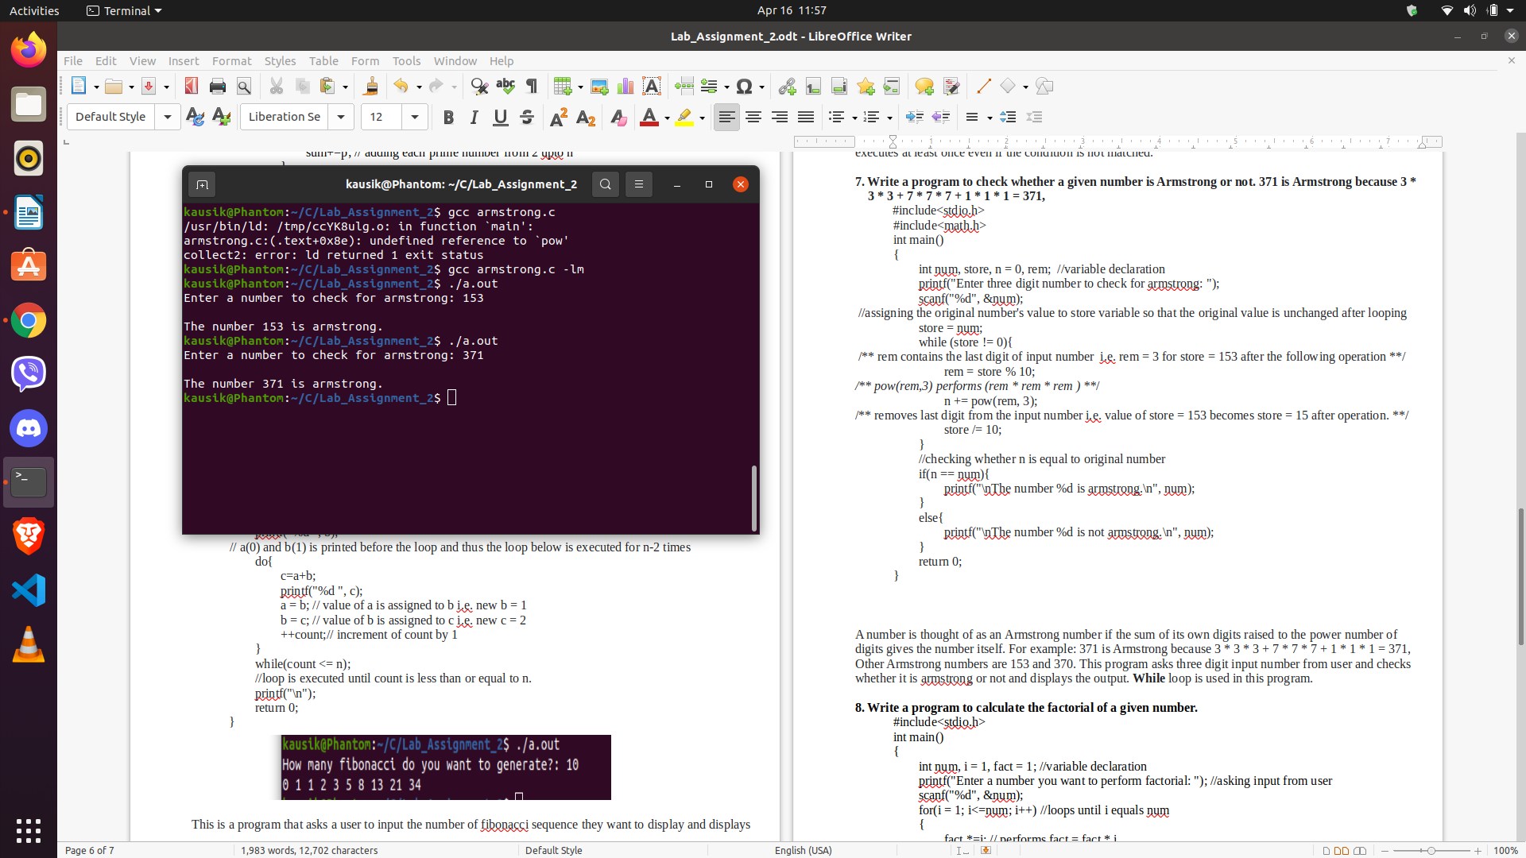

A number is called an Armstrong number if the sum of its own digits raised to the power number of digits gives the number itself. For example: 371 is Armstrong because 3 * 3 * 3 + 7 * 7 * 7 + 1 * 1 * 1 = 371, Other Armstrong numbers are 153 and 370. This program asks three digit input number from user and checks whether it is armstrong or not and displays the output. While loop is used in this program.

8. Write a program to calculate the factorial of a given number.
#include<stdio.h>
int main()
{
int num, i = 1, fact = 1; //variable declaration
printf("Enter a number you want to perform factorial: "); //asking input from user
scanf("%d", &num);
for(i = 1; i<=num; i++) //loops until i equals num
{
fact *=i; // performs fact = fact * i
}
printf("\nThe factorial of given number is: %d\n", fact); //prints factorial of input number
return 0;
}
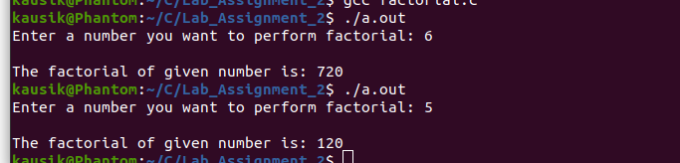

This is a program that asks input number from user and performs factorial of the number. Factorial is a continuous multiplication of a positive integer from one to itself. For loop is used in the program to find the factorial of a given number.

9. Write a program to identify whether the given number is a perfect number or not. 28 is a perfect number because 28/2 =14 and the sum of the numbers that perfectly divides 28 from 1 to 14 is 28.

#include<stdio.h>
int main()
{
int num, a = 0, b, i, var; // variable declarartion
printf("Enter a number: "); // asking input from user
scanf("%d", &num);
printf("\nThe factors of %d are: ", num); // displays factor of input number

for(i = 1; i <= num; i++){
b = num % i;
if (b == 0){
a+=i; // if i is the factor of num, it adds it
}
}
var = a - num; // num is factor of num so it is subtracted from a
/**Checks whether the input number is perfect of not **/
if(var == num){
printf("\n%d is a perfect number\n", num);
}
else{
printf("\n%d is not a perfect number\n", num);
}
return 0;
}

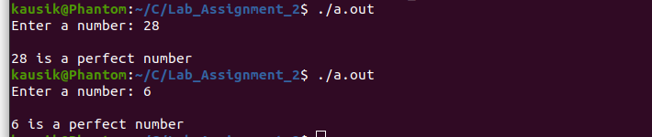

This is a program that asks input from user and calculates whether the number is perfect or not. For loop is used to calculate the factor of input number and add the factors where as if..else is used to display whether the input number is a perfect number or not

