**E-learning Platform Documentation**

**Team Name: PHEONIX DEBUGS**

**Date: 05-04-25**

**Project Overview**

The E-learning Platform is a web-based application designed to facilitate online learning with interactive features for both students and instructors. Developed during our hackathon, this platform provides course management, user authentication, and learning material distribution capabilities.

**Technical Specifications**

**System Architecture**

Frontend: React.js

Backend: Node.js with Express

Database: MongoDB

**Project Structure**

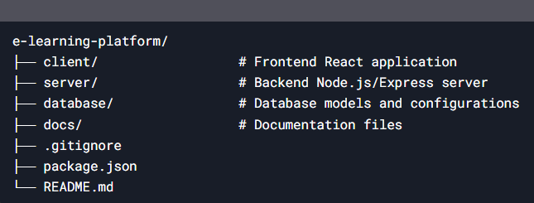

**Installation Guide**

Prerequisites

- Node.js (v14 or later)

- MongoDB Atlas account or local MongoDB installation

**Setup Instructions**

**Clone the repository:**

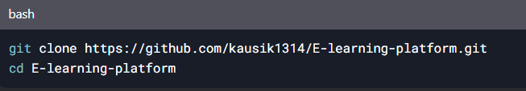

**Install dependencies:**

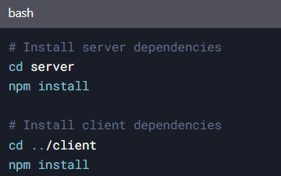

**Configure environment variables. (Create `.env` in `/server`):**

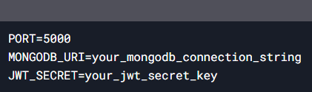

**Run the application:**

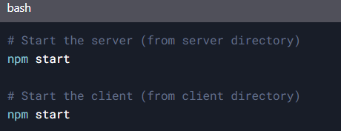

**Features**

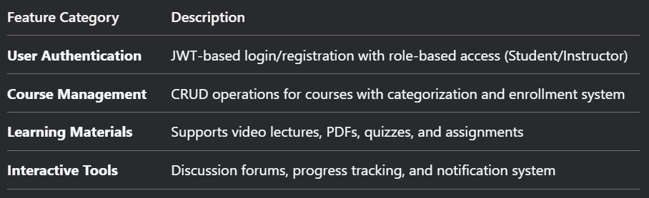

**API Reference**

**1 Authentication Endpoints**

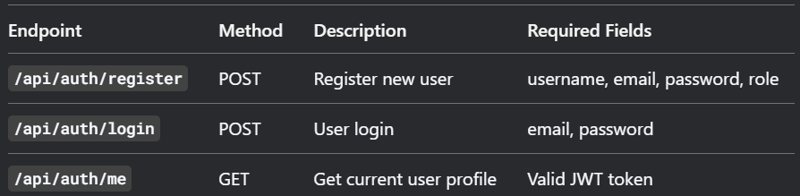

**2 Course Endpoints**

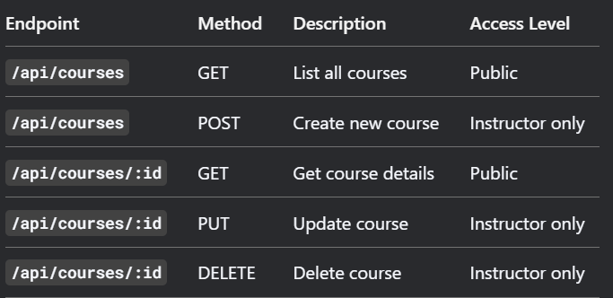

**Database Schema**

**1 User Model**

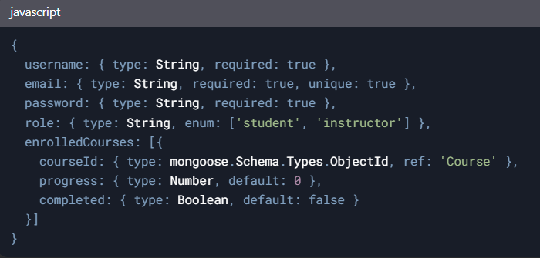

**2 Course Model**

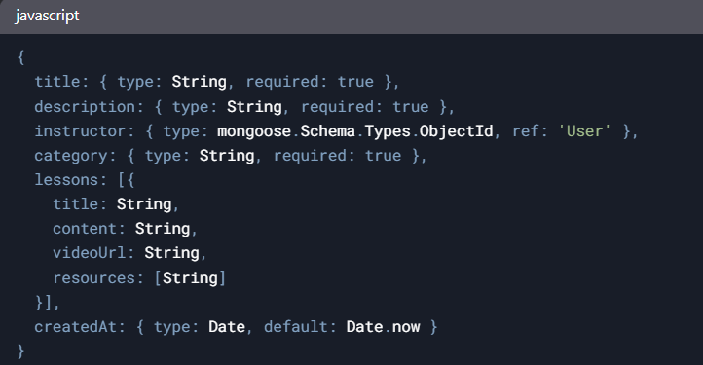

**Screenshots (Placeholder)**

1. Login Page

2. Course Dashboard

3. Instructor View

**Future Roadmap**

Phase 1: Payment gateway integration

Phase 2: Live class functionality using WebRTC

Phase 3: Mobile app development (React Native)

Phase 4:AI-powered course recommendations

