REGALIS WORKSPACE
Day Pass — Complete Feature Specification
Single-feature build document for the development team — single-location edition
Module: Day Pass (Customer Portal + Admin Portal)
Project Manager: Kausika
Document Version: 1.0 — September 2026

How To Use This Document
This document is self-contained — it describes ONE feature (Day Pass) end to end: what it does, what it looks like, every option it needs, and the exact flows a developer should build. It can be handed to Claude on its own to generate the Day Pass feature, without needing the full platform specification.
- Section 1 explains the feature in plain terms — what a Day Pass is and how it behaves.
- Section 2 is the pricing/options table — the exact numbers to hardcode or configure.
- Section 3 shows every screen with a real design reference image, described field by field.
- Section 4 has the 3 flow charts — purchase, redemption, and pack lifecycle.
- Section 5 lists the data model and business rules a developer needs to build this correctly.
- Section 6 lists open questions — assumptions made here that should be confirmed with the Project Manager before/while building.

1. What Is a Day Pass? (Overview)
A Day Pass gives a customer walk-in access to the Regalis WorkSpace office for a single day, without any monthly commitment. Instead of booking a specific desk, a Day Pass grants general shared seating access for that day.
NOTE: Regalis currently operates from a SINGLE office. There is no location picker, location list, or "which branch" step anywhere in this feature — every screen below assumes one office. If a second location opens in future, location selection can be added back in as a separate phase; do not build it now.
Customers can buy passes two ways:
- Single Day — pay once, use once, on a specific date.
- Multi-Day Packs (5 / 10 / 20 days) — pay once upfront, receive a bank of "day credits" that can be used on any days the customer likes, not necessarily consecutive days, within a validity window.
This is the core idea a developer needs to get right: a multi-day pack is NOT a booking for 5/10/20 specific consecutive days. It is a wallet of reusable single-day credits, similar to a punch-card. Each time the customer visits, one credit is consumed.
NOTE: This "credit wallet" model is the most important design decision in this document — if it's built as a fixed date-range booking instead, the feature will not match what was priced and sold. Flag this to the developer explicitly.

2. Pricing & Options (What This Feature Must Offer)
These are the exact options the Day Pass feature must present to the customer. Treat this table as the master list of configurable options — every row below must exist as a real, selectable option in the UI, not just as text.
Option | Price | Per-Day Rate | Notes
Single Day | ₹800 | ₹800 | One credit, must be used same day as purchase or a chosen future date
5-Day Pack | ₹3,600 | ₹720 | 5 credits, 10% cheaper per day than Single Day
10-Day Pack | ₹6,800 | ₹680 | 10 credits, 15% cheaper per day than Single Day
20-Day Pack | ₹12,800 | ₹640 | 20 credits, 20% cheaper per day than Single Day

Other configurable options a Day Pass purchase must offer:
- Visit date — optional at time of purchase; the customer should also be able to schedule/redeem visits later from their wallet, not only at checkout.
- Base amenities included with every pass: Wi-Fi, complimentary tea/coffee, printing/scanning limited quota — reuse the same "All Members" base benefits defined in the Membership Pricing document, since Day Pass is the entry-level tier.
NOTE: Day Pass holders do NOT get free Meeting Room credit — that is a Membership-only benefit. If the customer wants a meeting room, they pay the standard per-hour rate.

3. Screens — What It Should Look Like
Theme: warm cream background, gold/amber accent, white cards with soft rounded corners, Fraunces serif for headings, Manrope sans-serif for body text — consistent with the rest of the Regalis WorkSpace app. Colors: background #FBF6EC, card #FFFFFF, border #EEE4D2, gold accent #CC9A3D, gold-deep #B8842B, ink/text #241F19, muted grey #8C8272.

3.1 Day Pass — Buy a Pass (Customer)
Entry point from the bottom navigation bar or hamburger menu. Since there is only one office, the customer goes straight into pack selection — no browsing or choosing between locations.
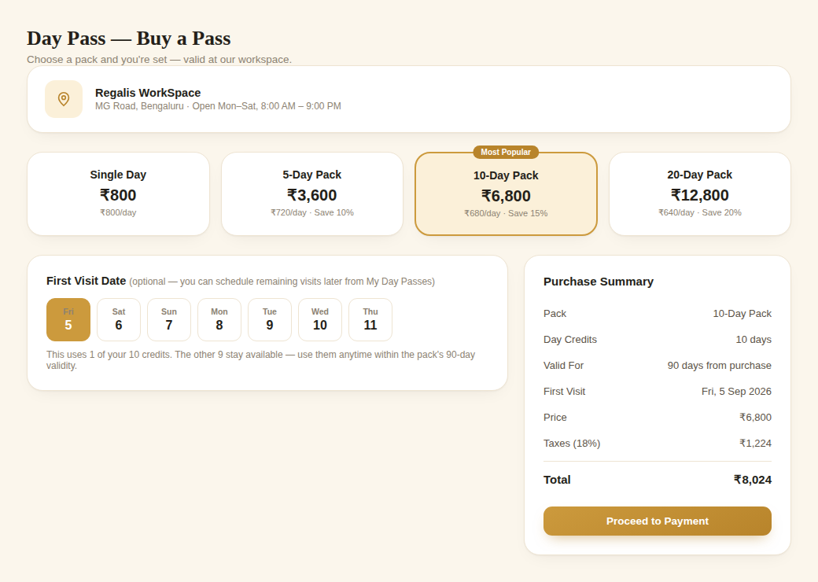
Reference: Office info banner + pack selection + first visit date + live purchase summary
- Small office-info banner at the top confirms which office the pass is for (name, address, opening hours) — informational only, not a selector.
- Pack tabs: Single Day, 5-Day Pack, 10-Day Pack (highlighted as "Most Popular"), 20-Day Pack — each shows total price and per-day rate so the discount is obvious.
- First Visit Date: optional date strip. Explicitly tell the customer how many credits remain unscheduled after this.
- Right-hand Purchase Summary panel: pack, day credits, validity period, first visit date, price, tax, total — sticky on scroll, matches the pattern used on the main Book a Space screen.

3.2 My Day Passes — Wallet (Customer)
New screen — the customer's view of everything they've purchased and how many credits remain. This is the most important screen in the whole feature, since it's where repeat usage happens.
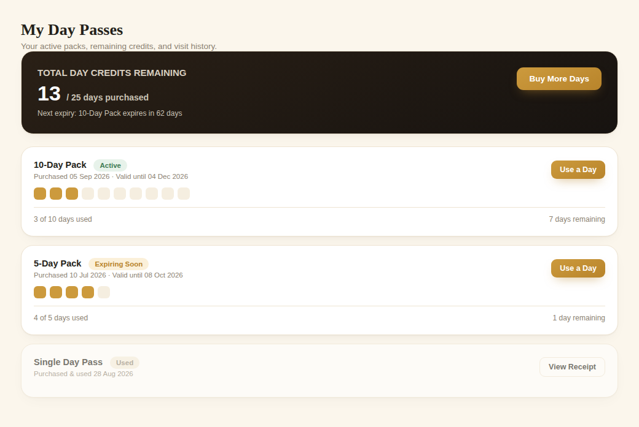
Reference: Day Pass wallet — total credits remaining, per-pack progress, and redemption action
- Hero summary bar (dark, gold accent): total day credits remaining across all active packs, and a note on the next pack to expire — plus a "Buy More Days" button.
- One card per pack owned: pack name, status pill (Active / Expiring Soon / Used / Expired), purchase date, validity end date.
- A row of small squares ("dots") visualizing used vs. remaining credits at a glance — filled gold = used, empty = remaining.
- "Use a Day" button on each active pack — starts the redemption flow (Section 4.2).
- Used-up or expired passes stay listed (greyed out) with a "View Receipt" action instead, for the customer's records.

3.3 Admin — Day Pass Settings (Admin Portal)
Replaces the earlier multi-location table concept. Since there is one office, this is a settings panel, not a list — one row per configurable item, not one row per location.
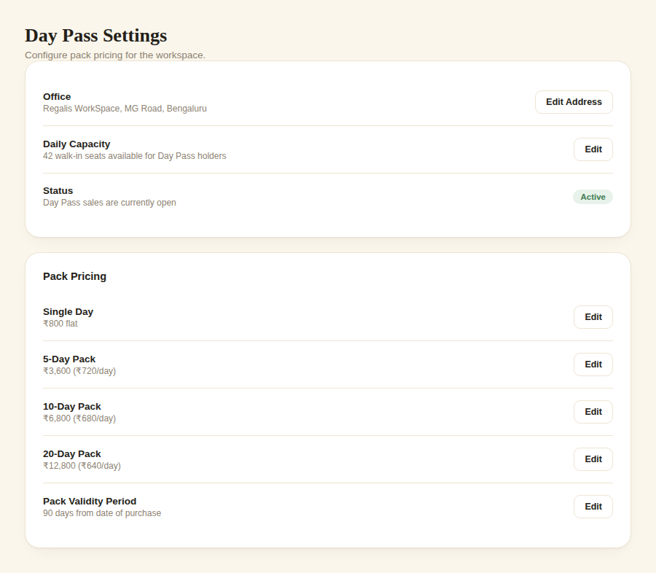
Reference: Day Pass Settings — office info, capacity, status, and pack pricing, all editable
- Office card: office name/address (editable), daily walk-in capacity, and an Active/Inactive toggle for whether Day Pass sales are currently open.
- Pack Pricing card: one editable row per pack (Single Day, 5-Day, 10-Day, 20-Day) plus the pack validity period — this is what feeds the pricing shown in Section 2.

3.4 Admin — Day Pass Sales & Redemptions (new table)
A separate table on the same Admin page, listing every pack sold and its usage:
Column | Example
Customer | Priya Sharma
Pack | 10-Day Pack
Purchased On | 05 Sep 2026
Valid Until | 04 Dec 2026
Credits Used / Total | 3 / 10
Status | Active / Expiring Soon / Fully Used / Expired
Action | View redemption history

4. Complete Flow Charts

4.1 Purchase Flow
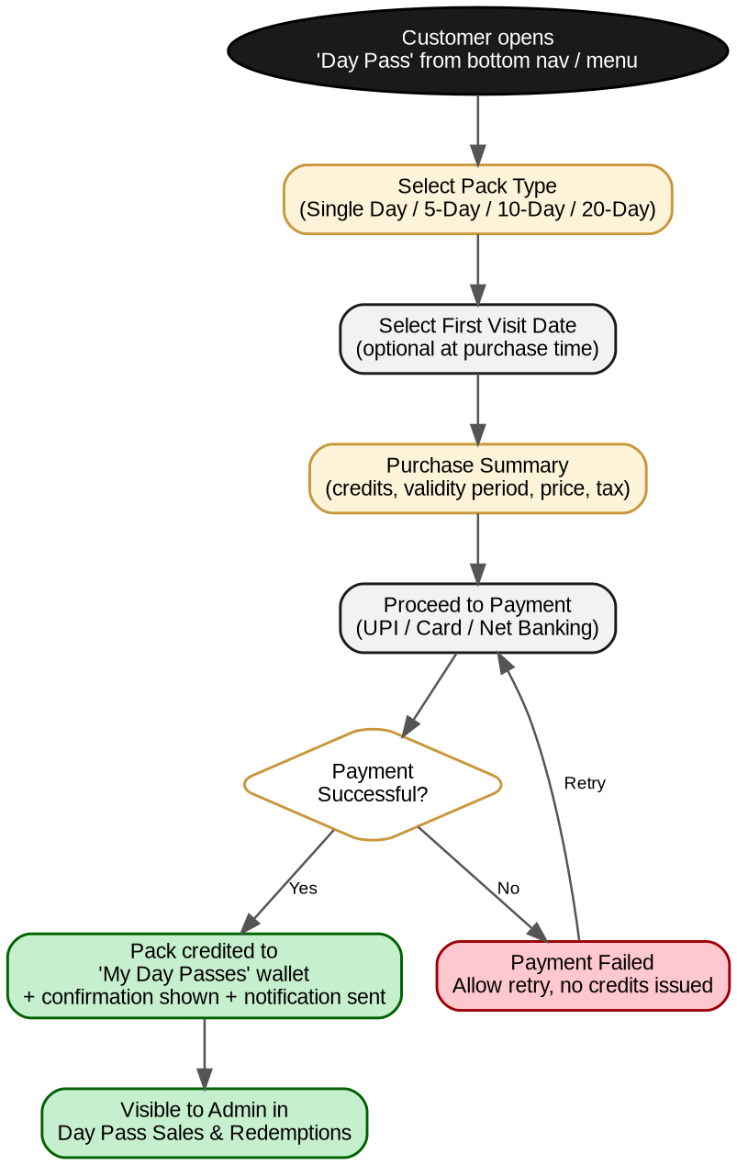
Figure 1 — Day Pass purchase flow, single day or pack (no location step)

4.2 Redemption / Check-in Flow
This is how a customer actually uses one credit from a pack they already own.
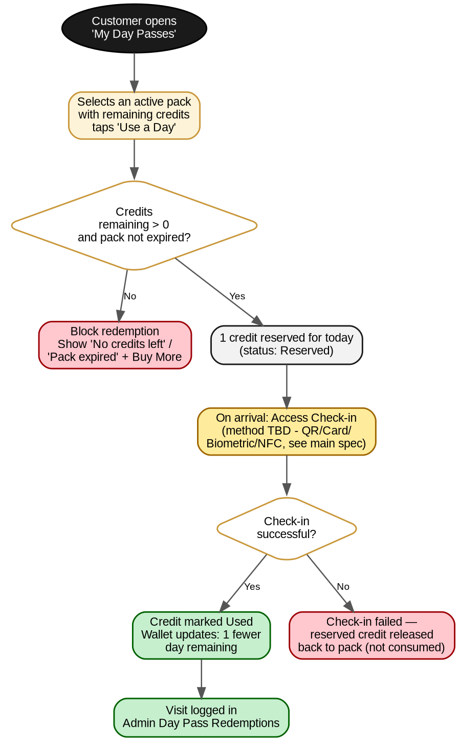
Figure 2 — Redeeming one day-credit from an owned pack (no location confirmation needed)
NOTE: The access check-in method (QR / Card / Biometric / NFC) is still pending confirmation across the whole platform — this flow assumes whichever method is eventually chosen plugs in at that one step. Do not build the check-in mechanism itself until that decision is confirmed; everything before it can be built now.

4.3 Pack Credit Lifecycle
How a pack's status changes over time — this drives which status pill shows in the customer wallet and the admin sales table.
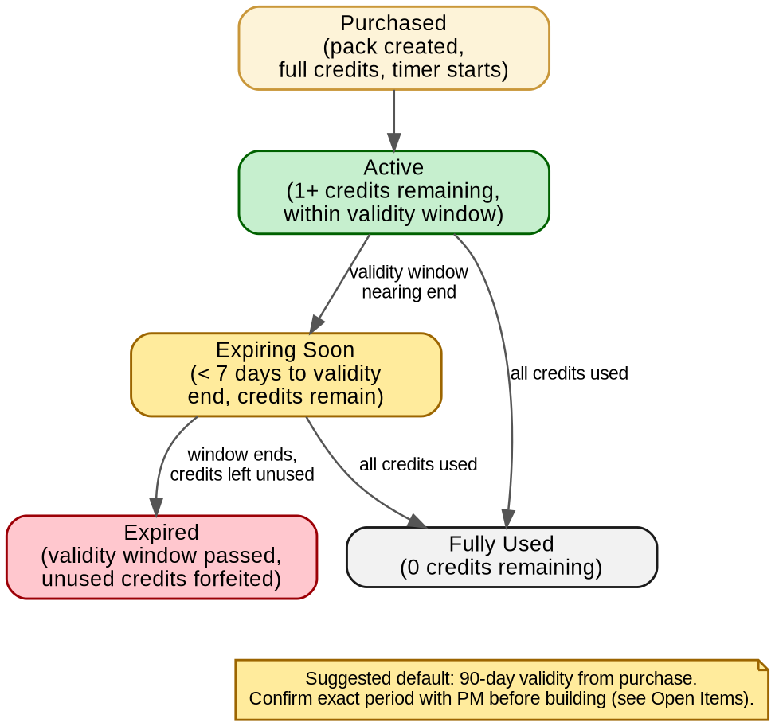
Figure 3 — Status states a Day Pass pack moves through

5. Data Model & Business Rules

5.1 Suggested Data Model
No DayPassLocation entity is needed — the office is a fixed, singleton setting (Section 3.3), not a list of records.
Entity | Key Fields
DayPassSettings (singleton) | office_name, office_address, daily_capacity, sales_status (active/inactive)
DayPassPackType | id, name (Single/5-Day/10-Day/20-Day), credit_count, price, validity_days
DayPassPurchase | id, customer_id, pack_type_id, purchase_date, expiry_date, amount_paid, payment_status
DayPassCredit | id, purchase_id, status (available/reserved/used), used_date

5.2 Business Rules
- 1 credit = 1 day of access at the office. Credits are deducted only on successful check-in, not at time of scheduling (see redemption flow).
- Credits within a pack do not need to be used on consecutive days.
- Unused credits are forfeited once the pack's validity window ends — no partial refund (confirm with PM, see Open Items).
- A pack cannot be redeemed if 0 credits remain or the validity window has passed — block with a clear message and a "Buy More Days" call to action.
- Admin can see every pack sold and its redemption history per customer, for support and reporting purposes.
- Day Pass purchases feed into the same Invoices / Payments records as every other purchase in the app — no separate billing system.

6. Open Items — Confirm Before / While Building
This document makes reasonable assumptions to stay buildable immediately. Flag these to the Project Manager rather than guessing silently if they matter to the build.
# | Assumption Made Here | Needs Confirmation
1 | Pack validity window = 90 days from purchase | Exact number of days — the source pricing document didn't specify one
2 | Unused credits are forfeited at expiry, no refund | Whether any refund/extension policy should exist
3 | Access check-in method is out of scope until confirmed (QR/Card/Biometric/NFC) | Tracked in the main platform specification — do not build check-in logic until resolved
4 | Day Pass base amenities mirror the Membership "All Members" tier | Confirm this is correct, or if Day Pass should have a reduced amenity set

7. Summary For The Developer
If you only read one paragraph of this document, read this one:
NOTE: Build Day Pass as a wallet-of-credits system for a SINGLE office — not a date-range booking, and not a multi-location picker. A customer buys a pack (Single/5/10/20 days), it appears in their 'My Day Passes' wallet with a credit count, and each visit consumes exactly one credit via the 'Use a Day' action — regardless of whether visits are consecutive or spread out over weeks. Everything else in this document (screens, admin tables, flow charts) exists to support that one model correctly.

