REGALIS WORKSPACE
Membership — Complete Feature Specification
Single-feature build document for the development team — single-location edition
Module: Membership (Customer Portal + Admin Portal)
Project Manager: Kausika
Document Version: 1.0 — September 2026

How To Use This Document
This document is self-contained — it describes ONE feature (Membership) end to end: what it does, what it looks like, every option it needs, and the exact flows a developer should build. It can be handed to Claude on its own to generate the Membership feature, without needing the full platform specification.
- Section 1 explains the feature in plain terms — what a Membership is and how it behaves.
- Section 2 is the pricing/options table — the exact numbers to hardcode or configure, across space type AND duration.
- Section 3 shows every screen with a real design reference image, described field by field.
- Section 4 has the 3 flow charts — purchase/signup, renewal, and meeting-room credit lifecycle.
- Section 5 lists the data model and business rules a developer needs to build this correctly.
- Section 6 lists open questions — assumptions made here that should be confirmed with the Project Manager before/while building.

1. What Is Membership? (Overview)
A Membership is a recurring commitment plan that gives a customer ongoing access to a specific space type at Regalis WorkSpace — Open/Hot Desk, Dedicated Desk, 4-Seater Cabin, 8-Seater Cabin, or Virtual Office — for a chosen duration, at a discounted monthly rate compared to paying month to month.
NOTE: Regalis currently operates from a SINGLE office. There is no location picker anywhere in this feature — every screen below assumes one office. This is consistent with the Day Pass feature specification.
Membership has two independent choices the customer makes:
- Space Type — which kind of space the membership covers (5 options).
- Duration — Monthly, 3-Month, 6-Month, or 12-Month commitment. Longer commitments unlock a lower effective monthly rate AND more free Meeting Room hours per month.
This is the core idea a developer needs to get right: pricing is a GRID (5 space types × 4 durations = 20 price points), not a flat list of plans. And membership tiers grant recurring monthly benefits (meeting room hours, guest passes) that reset every billing month — they are not one-time perks.
NOTE: Do not confuse this with the Day Pass feature. Day Pass is a wallet of one-time-use day-credits with no ongoing commitment. Membership is a recurring monthly/quarterly/annual commitment with monthly-refreshing benefits. They are separate features with separate data models, even though both appear in the same hamburger menu.

2. Pricing & Options (What This Feature Must Offer)
Discount rule is uniform across every space type: 5% off at 3 months, 10% off at 6 months, 15% off at 12 months. Every cell in the grid below must be a real, selectable combination in the UI.
Space Type | Monthly | 3-Month /mo | 6-Month /mo | 12-Month /mo
Open / Hot Desk | ₹7,000 | ₹6,650 | ₹6,300 | ₹5,950
Dedicated Desk | ₹9,000 | ₹8,550 | ₹8,100 | ₹7,650
4-Seater Cabin | ₹40,000 | ₹38,000 | ₹36,000 | ₹34,000
8-Seater Cabin | ₹80,000 | ₹76,000 | ₹72,000 | ₹68,000
Virtual Office | ₹2,500 | ₹2,375 | ₹2,250 | ₹2,125

Free Meeting Room Credit by Duration Tier
This is the second pricing dimension — it applies on top of whichever space type is chosen, based on duration only:
Duration | Free Hours/Month | Rooms Covered | Rate After Credit
Monthly (no commitment) | 0 hours | — | Standard rate
3-Month | 2 hours | 4-Seater only | Standard rate
6-Month | 4 hours | Any room type | 10% off standard
12-Month | 8 hours | Any room, incl. Board Room | 15% off standard
NOTE: Free hours do NOT roll over month to month. This must be enforced by a monthly reset job, not just displayed — see Section 4.3 and Section 5.2.

Other benefits every membership must present (see full detail in Section 3)
- Base benefits for all members: Wi-Fi, power backup, complimentary tea/coffee, community lounge access, limited free printing/scanning, GST invoicing.
- 3-Month adds: 1 complimentary guest day pass, free locker access.
- 6-Month adds: free business address usage, priority booking, 10% off extra meeting room bookings.
- 12-Month adds: dedicated support manager, 1 free space upgrade during the term, 1 free guest pass per month, 15% off extra bookings, doubled print quota, community event invites, up to 15 days pause per year.
- Cabin-only add-ons (4-Seater & 8-Seater, any duration): nameplate/branding, mail handling, free phone booth access.

3. Screens — What It Should Look Like
Theme: warm cream background, gold/amber accent, white cards with soft rounded corners, Fraunces serif for headings, Manrope sans-serif for body text — consistent with the rest of the Regalis WorkSpace app. Colors: background #FBF6EC, card #FFFFFF, border #EEE4D2, gold accent #CC9A3D, gold-deep #B8842B, ink/text #241F19, muted grey #8C8272.

3.1 Membership — Choose Your Plan (Customer)
Entry point from the hamburger menu. Two-step selector (space type, then duration) since pricing is a grid, followed by a benefits summary and purchase panel.
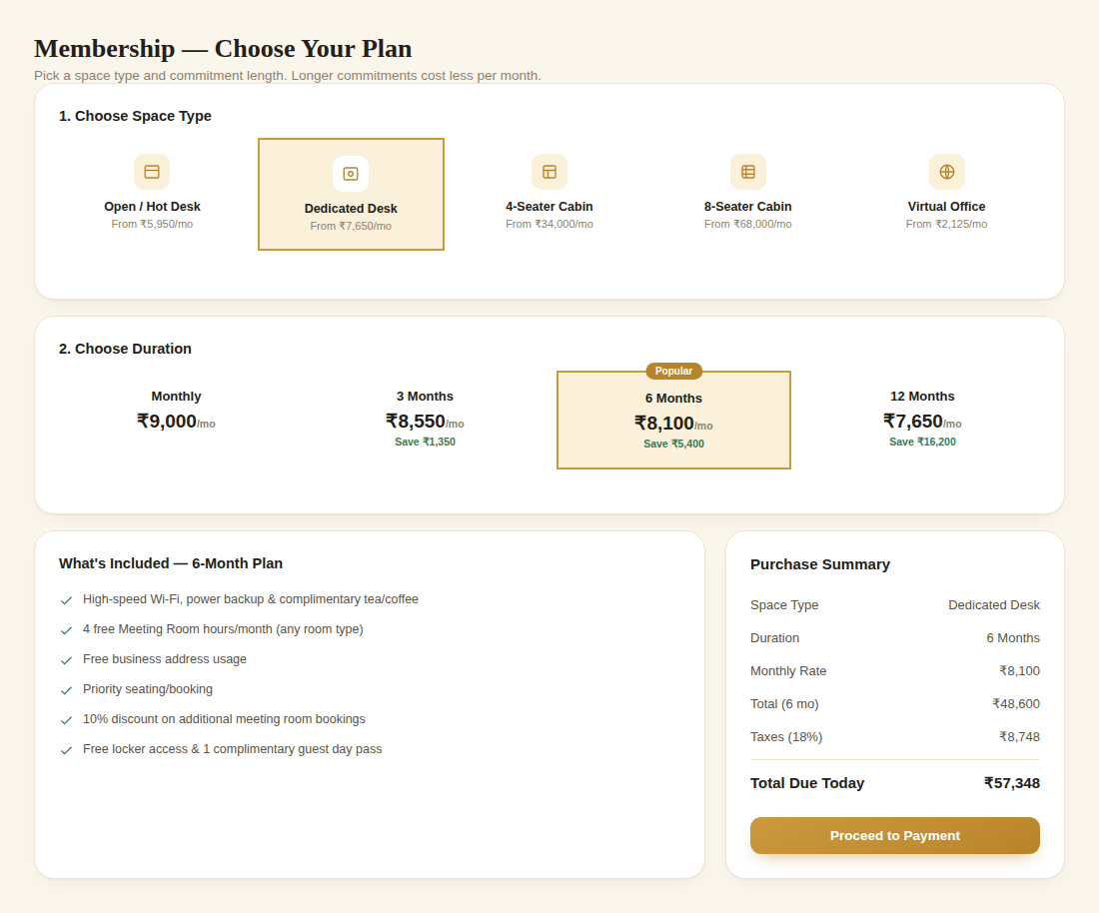
Reference: Space type cards, duration tabs with live pricing, included benefits, and purchase summary
- Step 1 — Space Type: 5 cards (Open/Hot Desk, Dedicated Desk, 4-Seater Cabin, 8-Seater Cabin, Virtual Office), each showing its cheapest available rate ("From ₹X/mo", i.e. the 12-month rate) to anchor value.
- Step 2 — Duration: 4 tabs (Monthly, 3, 6, 12 Months). Each tab shows the effective monthly rate for the CURRENTLY selected space type and the rupee amount saved vs. paying monthly. Recompute immediately when space type changes.
- "What's Included" panel: dynamically lists the benefits unlocked by the selected duration tier (pulls from the benefit rules in Section 2).
- Purchase Summary: space type, duration, monthly rate, full-term total, tax, total due today — sticky on scroll, same pattern as Book a Space and Day Pass.

3.2 My Membership — Dashboard (Customer)
New screen — shows the customer's active plan and, critically, how much of their monthly meeting-room credit they've used. This is the screen customers will check most often.
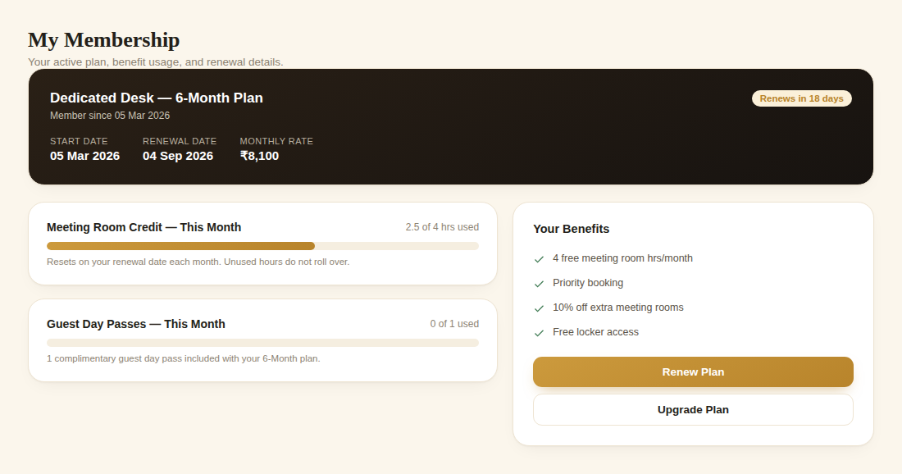
Reference: Active plan hero, meeting-room credit progress bar, guest pass usage, and benefits list
- Hero card (dark, gold accent): plan name (space type + duration), member-since date, renewal date, monthly rate, and a status pill ("Renews in N days" once within the renewal window).
- Meeting Room Credit progress bar: hours used vs. total free hours this month, with a note that unused hours don't roll over.
- Guest Day Pass usage (for 3-month+ plans): same progress-bar pattern.
- Benefits list for their current tier, plus "Renew Plan" and "Upgrade Plan" buttons.

3.3 Admin — Membership Settings
Three stacked tables: the pricing grid, the duration-tier benefit rules, and the list of currently active members.
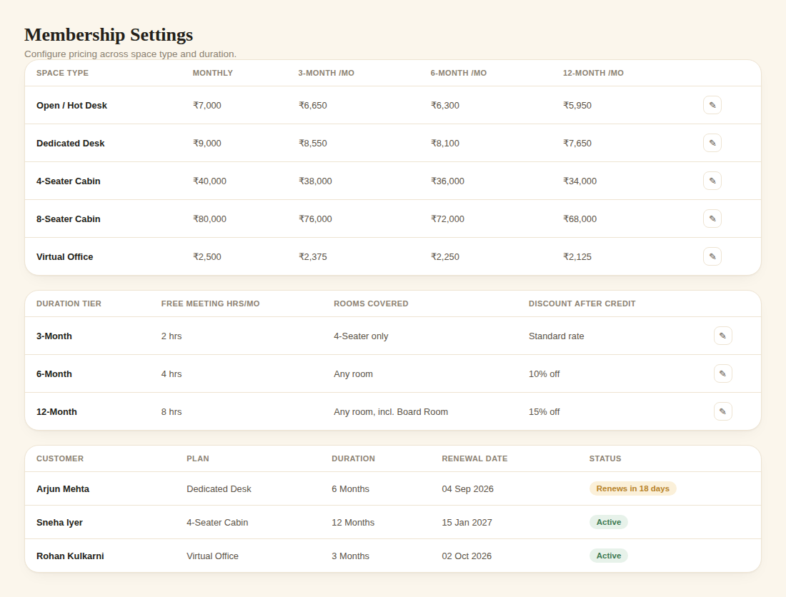
Reference: Space-type × duration pricing grid, benefit rules by tier, and active members list
- Pricing Grid table: 5 space-type rows × 4 duration columns, each cell editable — this is what feeds Section 2's pricing table and the customer-facing duration tabs.
- Duration Tier Benefits table: free hours/month, rooms covered, and post-credit discount per tier — editable.
- Active Members table: customer, plan, duration, renewal date, status — for support and renewal follow-up.

4. Complete Flow Charts

4.1 Purchase / Signup Flow
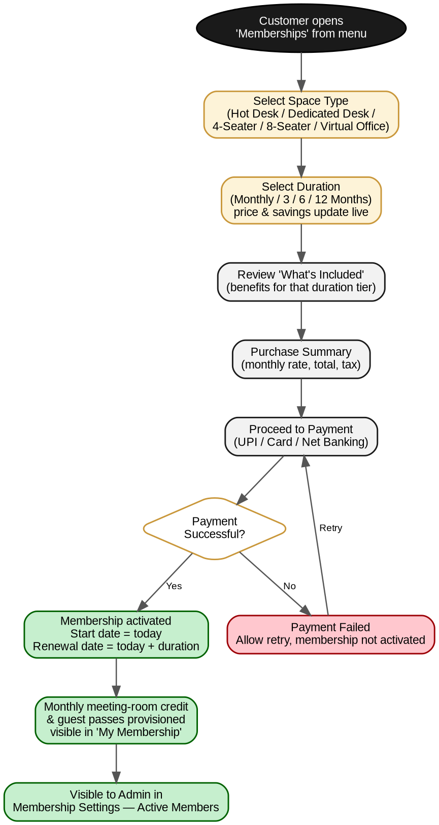
Figure 1 — Membership signup: space type, duration, payment, activation

4.2 Renewal Flow
Runs automatically for every active membership as its renewal date approaches.
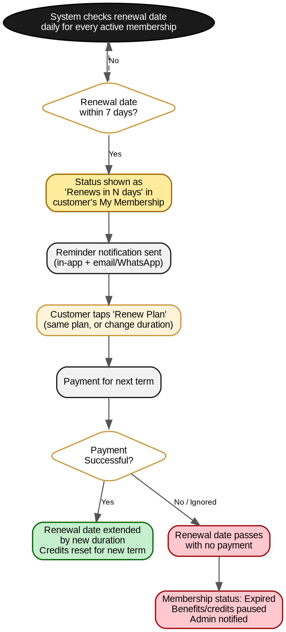
Figure 2 — Renewal reminder, payment, extension or expiry

4.3 Meeting Room Credit — Monthly Lifecycle
How free meeting-room hours move through states within each billing month. This is the mechanism Section 2's "do not roll over" rule depends on.
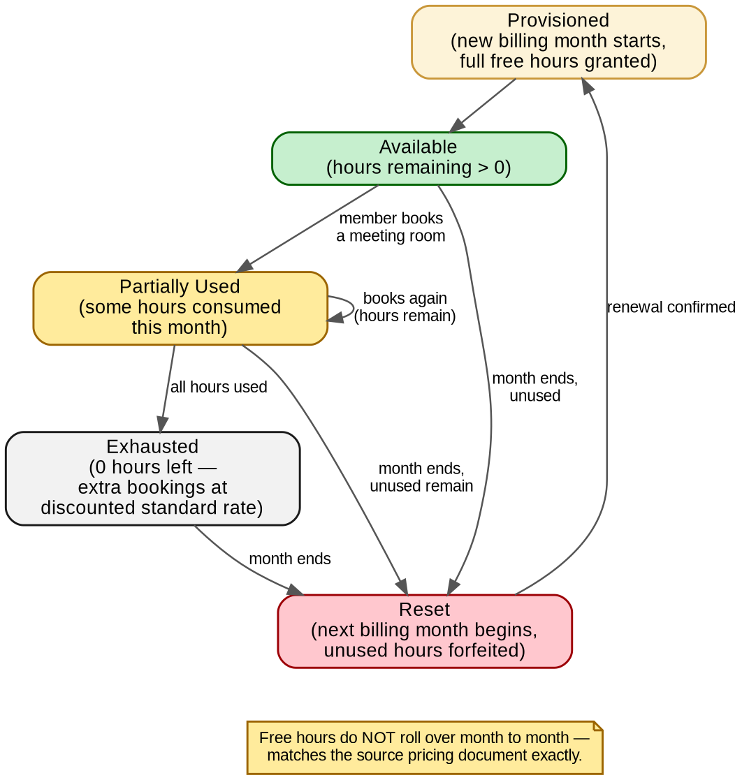
Figure 3 — Free meeting-room hours: provisioned, used, and reset each billing month

5. Data Model & Business Rules

5.1 Suggested Data Model
Entity | Key Fields
MembershipPlanPricing | space_type, duration (monthly/3/6/12), monthly_rate
MembershipDurationBenefit | duration, free_meeting_hours, rooms_covered, post_credit_discount_pct
MembershipSubscription | id, customer_id, space_type, duration, start_date, renewal_date, monthly_rate, status (active/expiring/expired/paused)
MeetingRoomCreditLedger | id, subscription_id, billing_month, hours_granted, hours_used, reset_date
GuestPassLedger | id, subscription_id, billing_month, passes_granted, passes_used

5.2 Business Rules
- Pricing is looked up from the 5×4 grid by (space_type, duration) — never store a flat per-plan price separately from this grid, or the two will drift out of sync.
- On successful payment, renewal_date = start_date + duration. On renewal, renewal_date extends by the new duration chosen (may differ from the original).
- Meeting-room credit and guest passes are granted fresh each billing month and expire at month end — implement as a scheduled job that resets the ledger on each subscription's monthly anniversary, not just on renewal.
- When a member books a meeting room, check MeetingRoomCreditLedger first; if hours remain, deduct from there at no charge; once exhausted, charge the standard rate minus the tier's post-credit discount.
- A membership with a lapsed renewal_date and no successful payment moves to status = expired; benefits and credit ledger stop provisioning until renewed.
- Membership purchases and renewals feed into the same Invoices / Payments records as every other purchase in the app.
- This is a separate feature and data model from Day Pass — do not merge the two, even though both are entry points from the same menu.

6. Open Items — Confirm Before / While Building
This document makes reasonable assumptions to stay buildable immediately. Flag these to the Project Manager rather than guessing silently if they matter to the build.
# | Assumption Made Here | Needs Confirmation
1 | Renewal reminder window = 7 days before renewal date | Exact number of days — not specified in the source pricing document
2 | A lapsed membership immediately loses benefits (no grace period) | Whether a short grace period should exist before status flips to expired
3 | Dedicated Desk / Cabin memberships grant a specific assigned desk/cabin vs. general access to that space type | Whether membership ties to one physical desk/cabin, or is flexible access like Hot Desk — affects the data model and whether it links into the Workspace Management module
4 | Upgrade Plan (mid-term space-type or duration change) recalculates pricing pro-rata | Exact proration rule for upgrades/downgrades mid-term — not specified in the source document
5 | Custom Plan / "Build Your Own" builder (from the pricing document, Section 9) is treated as a Phase 2 feature | Whether it should be included in this build or handled manually by sales for now

7. Summary For The Developer
If you only read one paragraph of this document, read this one:
NOTE: Build Membership as a recurring subscription with a two-dimensional price grid (5 space types × 4 durations) for a SINGLE office. Every duration tier unlocks monthly-refreshing benefits — most importantly free Meeting Room hours — that must reset on each billing anniversary and never roll over. This is a separate system from Day Pass: Day Pass is one-time-use credits with no recurring commitment; Membership is an ongoing subscription with monthly benefit resets. Keep the two data models and screens distinct even though they sit side by side in the menu.

