REGALIS WORKSPACE
Assets — Complete Feature Specification
Items, Incoming Goods, Outgoing Goods and Current Stock — with a QR code on every asset
Module: Assets (Admin Portal)
Menu: Assets → Items · Incoming Goods · Outgoing Goods · Current Stock
Covers: the asset register, consumable stock, movements and QR labels
Document Version: 1.0 — October 2026

How To Use This Document
This document is self-contained. It describes ONE part of the admin portal — Assets — end to end: what it is for, what every screen looks like, what every field means, how a number is calculated, and how the QR codes are made and printed. It can be handed to Claude on its own, together with the existing Regalis codebase.
- Section 1 is the most important. It explains the one decision the whole module rests on: that an item is either an asset or a consumable, and that this decides everything else.
- Section 2 lists the four pages and the routes they live on.
- Section 3 is the master list of fields, taken directly from the asset list the Regalis team has already filled in.
- Sections 4 to 8 show every screen with a design reference image, block by block, with the exact text and behaviour of each control.
- Section 9 is the QR code and label specification.
- Section 10 has the five flow charts: receiving, issuing, how a stock figure is calculated, the life of an asset, and the QR code from creation to scan.
- Section 11 gives the data model, the rules and the API. Section 12 explains how the 43 rows the team has today become individual tagged assets.
- Sections 13 to 16 cover permissions, empty and error states, open items and a one-paragraph summary.
NOTE: Build this inside the existing app. Reuse the current admin layout, sidebar, table component, drawer, form inputs, buttons and colour variables. Do not create a new design system and do not add a new menu group — the four pages already exist in the sidebar under Assets.
NOTE: The live UI design for every screen is on the Regalis Assets design canvas. The images in this document are taken from it; open the canvas to check exact spacing, colours and wording.

1. The One Thing To Get Right
Regalis owns two completely different kinds of thing, and today they share one screen without being told apart. Everything in this document follows from separating them.
 | An ASSET | A CONSUMABLE
Examples | Air conditioner, cupboard, switch board, workstation table, false ceiling, Wi-Fi router | Coffee, sugar, tea powder, coke, A4 paper, hand wash
How it is counted | One by one. Each physical unit is its own record | By amount. One record, and a quantity that rises and falls
Its code | Its own, unique: R-2W-E-EAC-001, -002, -003 | One code for the item: COFFEE-07
QR sticker | Yes, one per unit | No. There is no single thing to stick it on
What it has | A location, a condition, a status, a repair history, a book value | A unit, a reorder level, a quantity on hand
When it leaves | It is moved, repaired, scrapped or lost — it still exists | It is used up and gone
In the four pages | Created by Incoming Goods, tracked on Items, moved by Outgoing Goods, counted by location on Current Stock | Topped up by Incoming Goods, drawn down by Outgoing Goods, its balance shown on Current Stock

1.1 Why This Matters More Than It Sounds
The asset list the Regalis team has filled in has 43 rows, but those rows describe 114 physical things: one row says "Switch Board, quantity 8, MD Cabin". It also reuses the same code on many rows — R-2W-E-ESB appears on 12 different rows in 12 different rooms.
NOTE: A QR code is only useful if it identifies ONE thing. If twelve switch boards all carry the code R-2W-E-ESB, scanning the faulty one tells you nothing: not which board it is, not where it is, not when it was bought. So the 43 rows must become 114 asset records, each with its own code and its own sticker. This is the single most important change in this document, and Section 12 explains exactly how to do it.
Consumables are the opposite. There is no point giving each kilogram of coffee a code. One record, a quantity, and a reorder level is all that is needed — which is what the current Inventory Items page already does well.

1.2 The Codes Stay As Regalis Writes Them
- The prefix stays exactly as it is today: R-2W-E-EAC, R-2W-E-ESB, R-2W-E-FT. Nothing already written on a wall or in a file becomes wrong.
- The app adds a running number: R-2W-E-EAC-001 to -004, R-2W-E-ESB-001 to -012.
- The number is three digits, issued one at a time per prefix, and never reused — if an asset is scrapped, its number is retired with it.
- Consumable codes are unchanged: COFFEE-07, S-01, COKE-07, TEAPOWDER.

2. The Four Pages
The four pages already in the sidebar stay exactly where they are. This document says what each one does.
Page | Route | What it is for | What it must never do
Items | /admin/assets/items | The master list of everything Regalis owns, asset or consumable. Where details are read and edited | Never show a stock number that can be typed in
Incoming Goods | /admin/assets/incoming | Everything that arrives. The only way stock goes up and the only way a new asset record is created | Never create an asset without giving it a code and a QR code
Outgoing Goods | /admin/assets/outgoing | Everything used up, moved, repaired, returned, scrapped or lost. The only way stock goes down | Never let stock go below zero
Current Stock | /admin/assets/stock | What is held right now, worked out from the movements | Never hold a number of its own
NOTE: Notice the shape: Items is what things ARE, Incoming and Outgoing are what HAPPENS to them, and Current Stock is the answer that falls out of the two. No page holds a figure that another page could contradict.

2.1 The Screens At A Glance
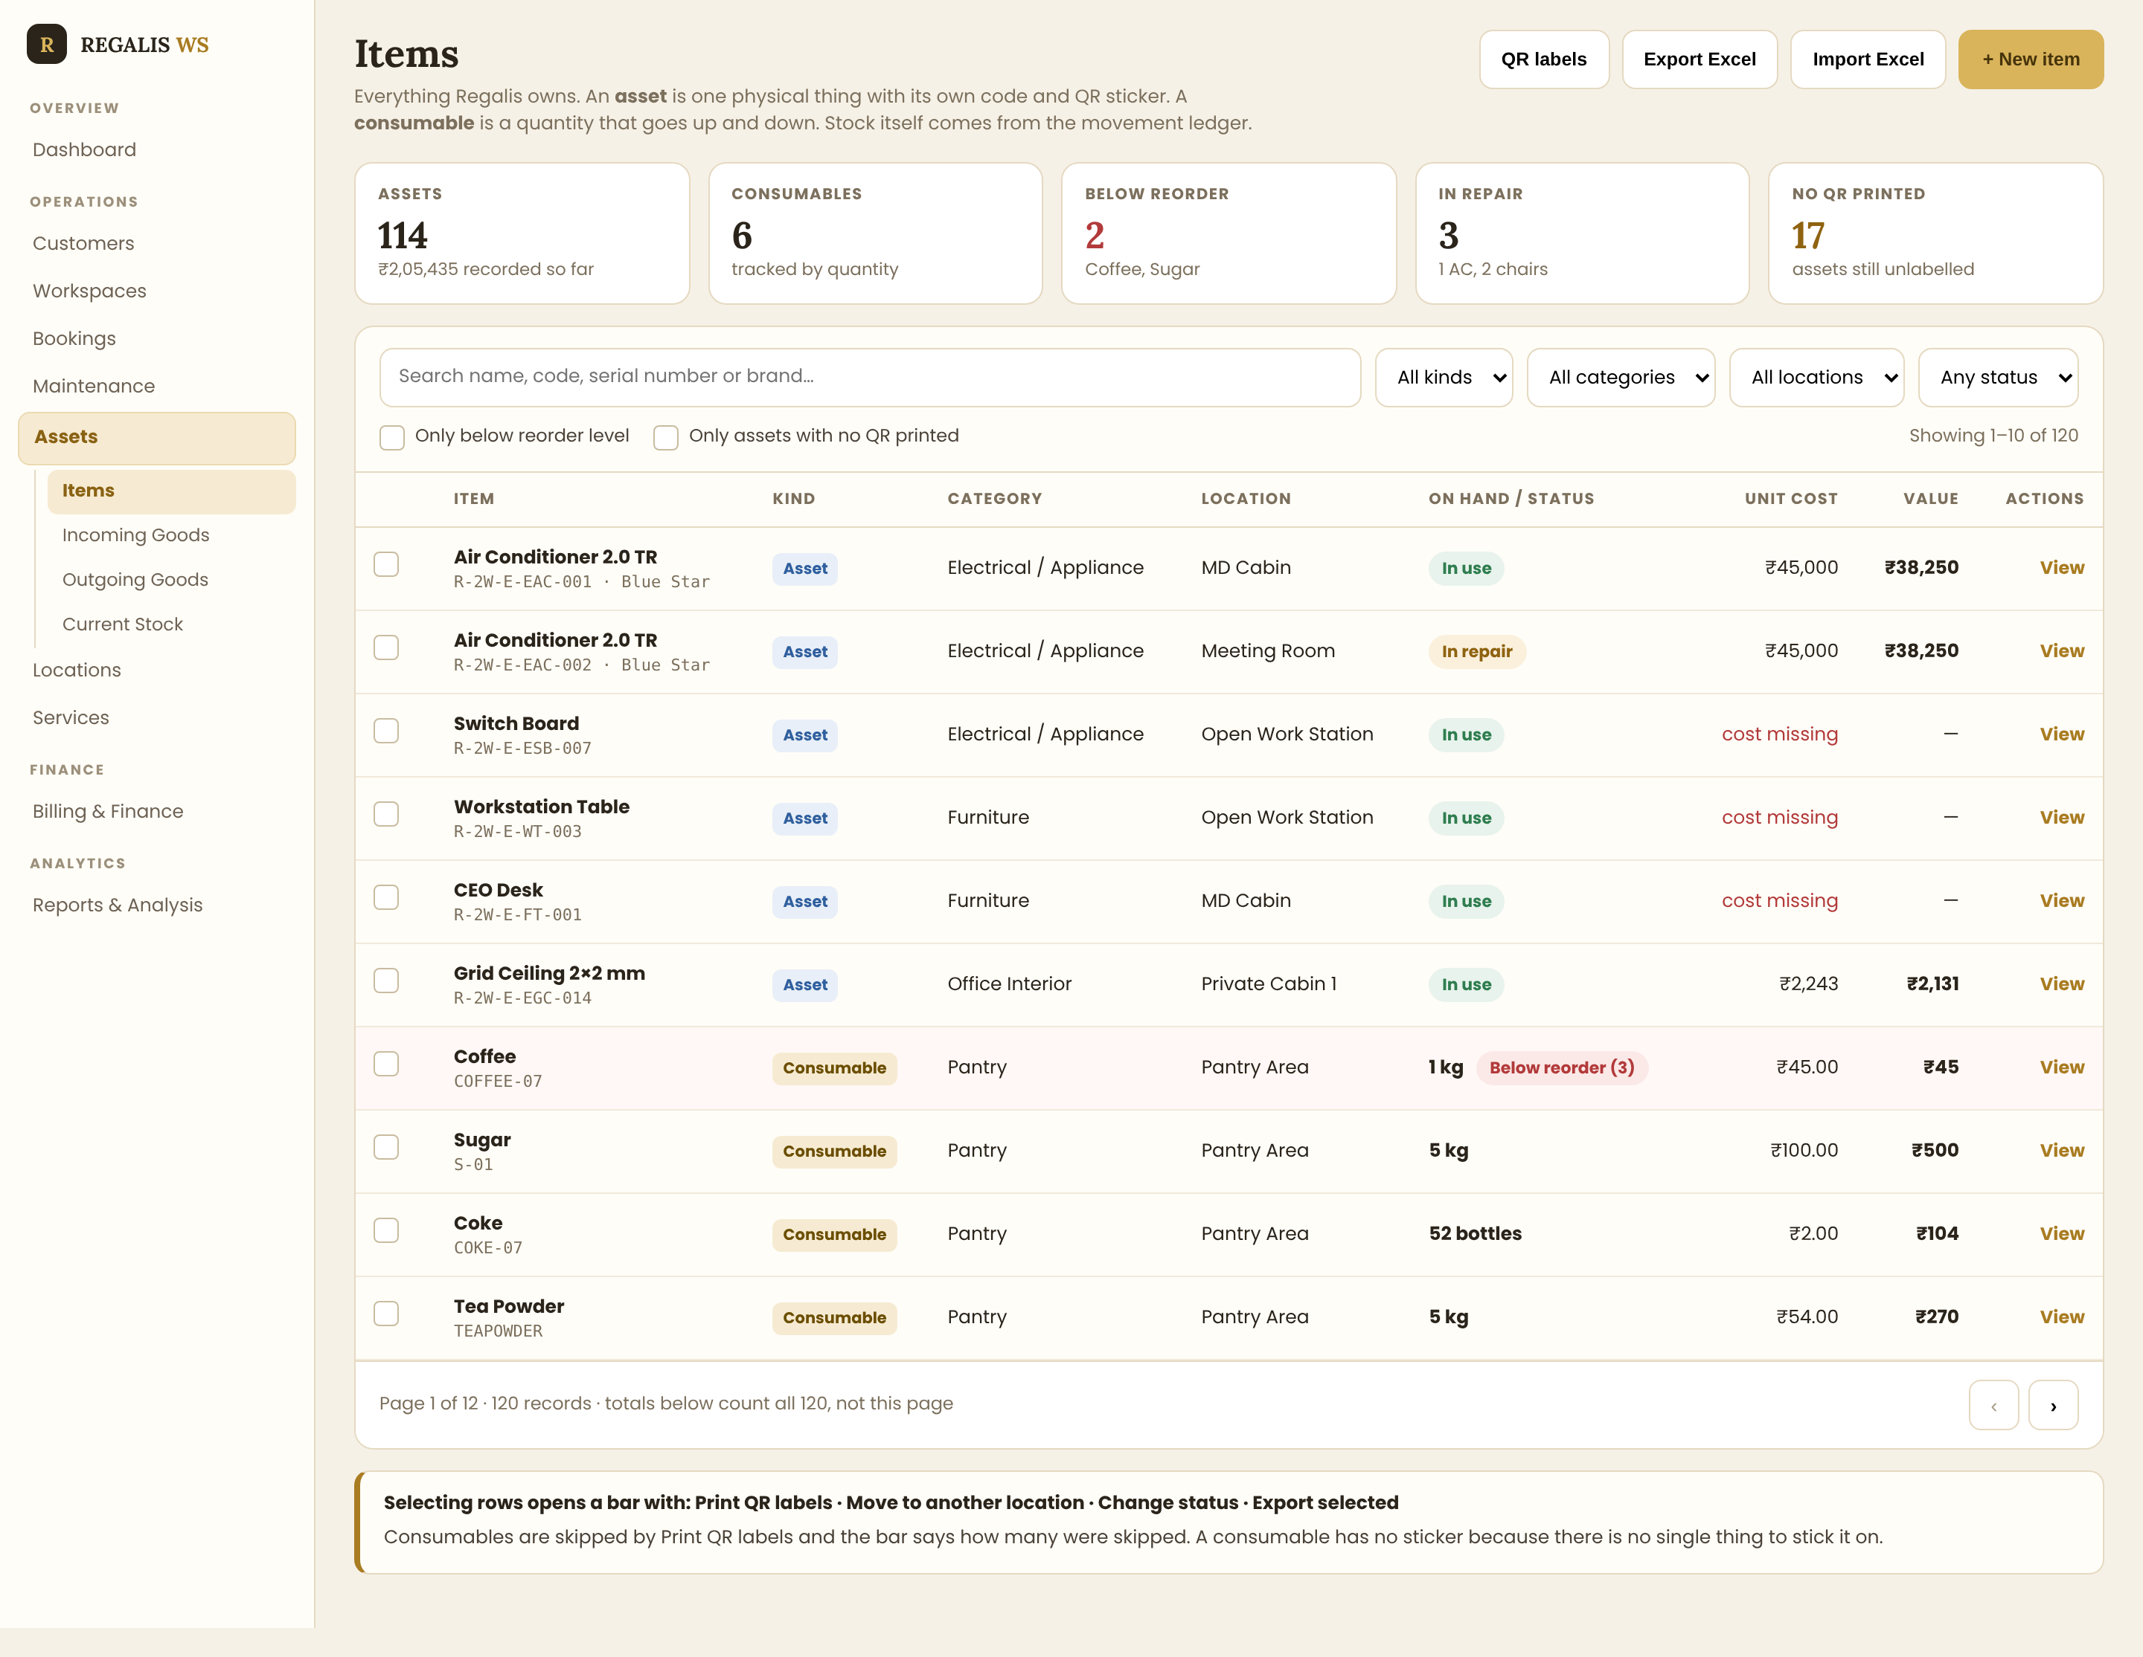
Page 1 — Items, the master list
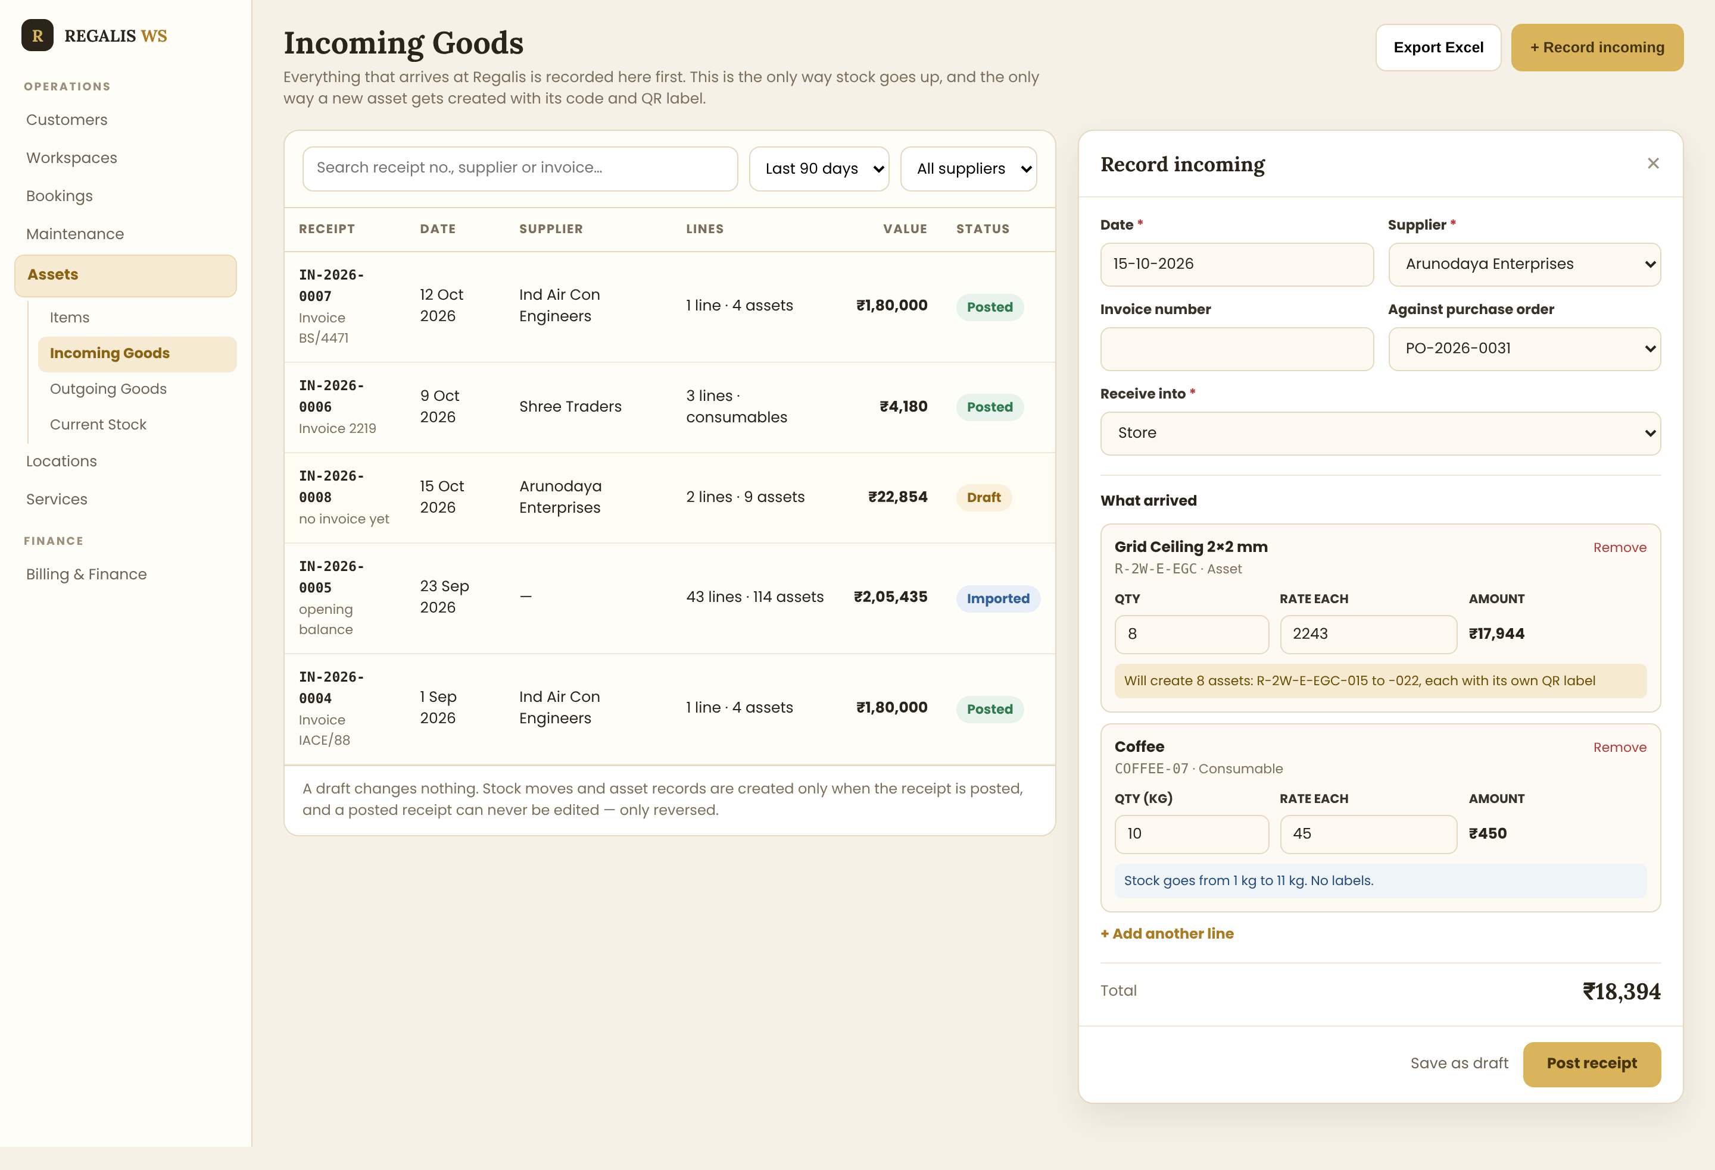
Page 2 — Incoming Goods
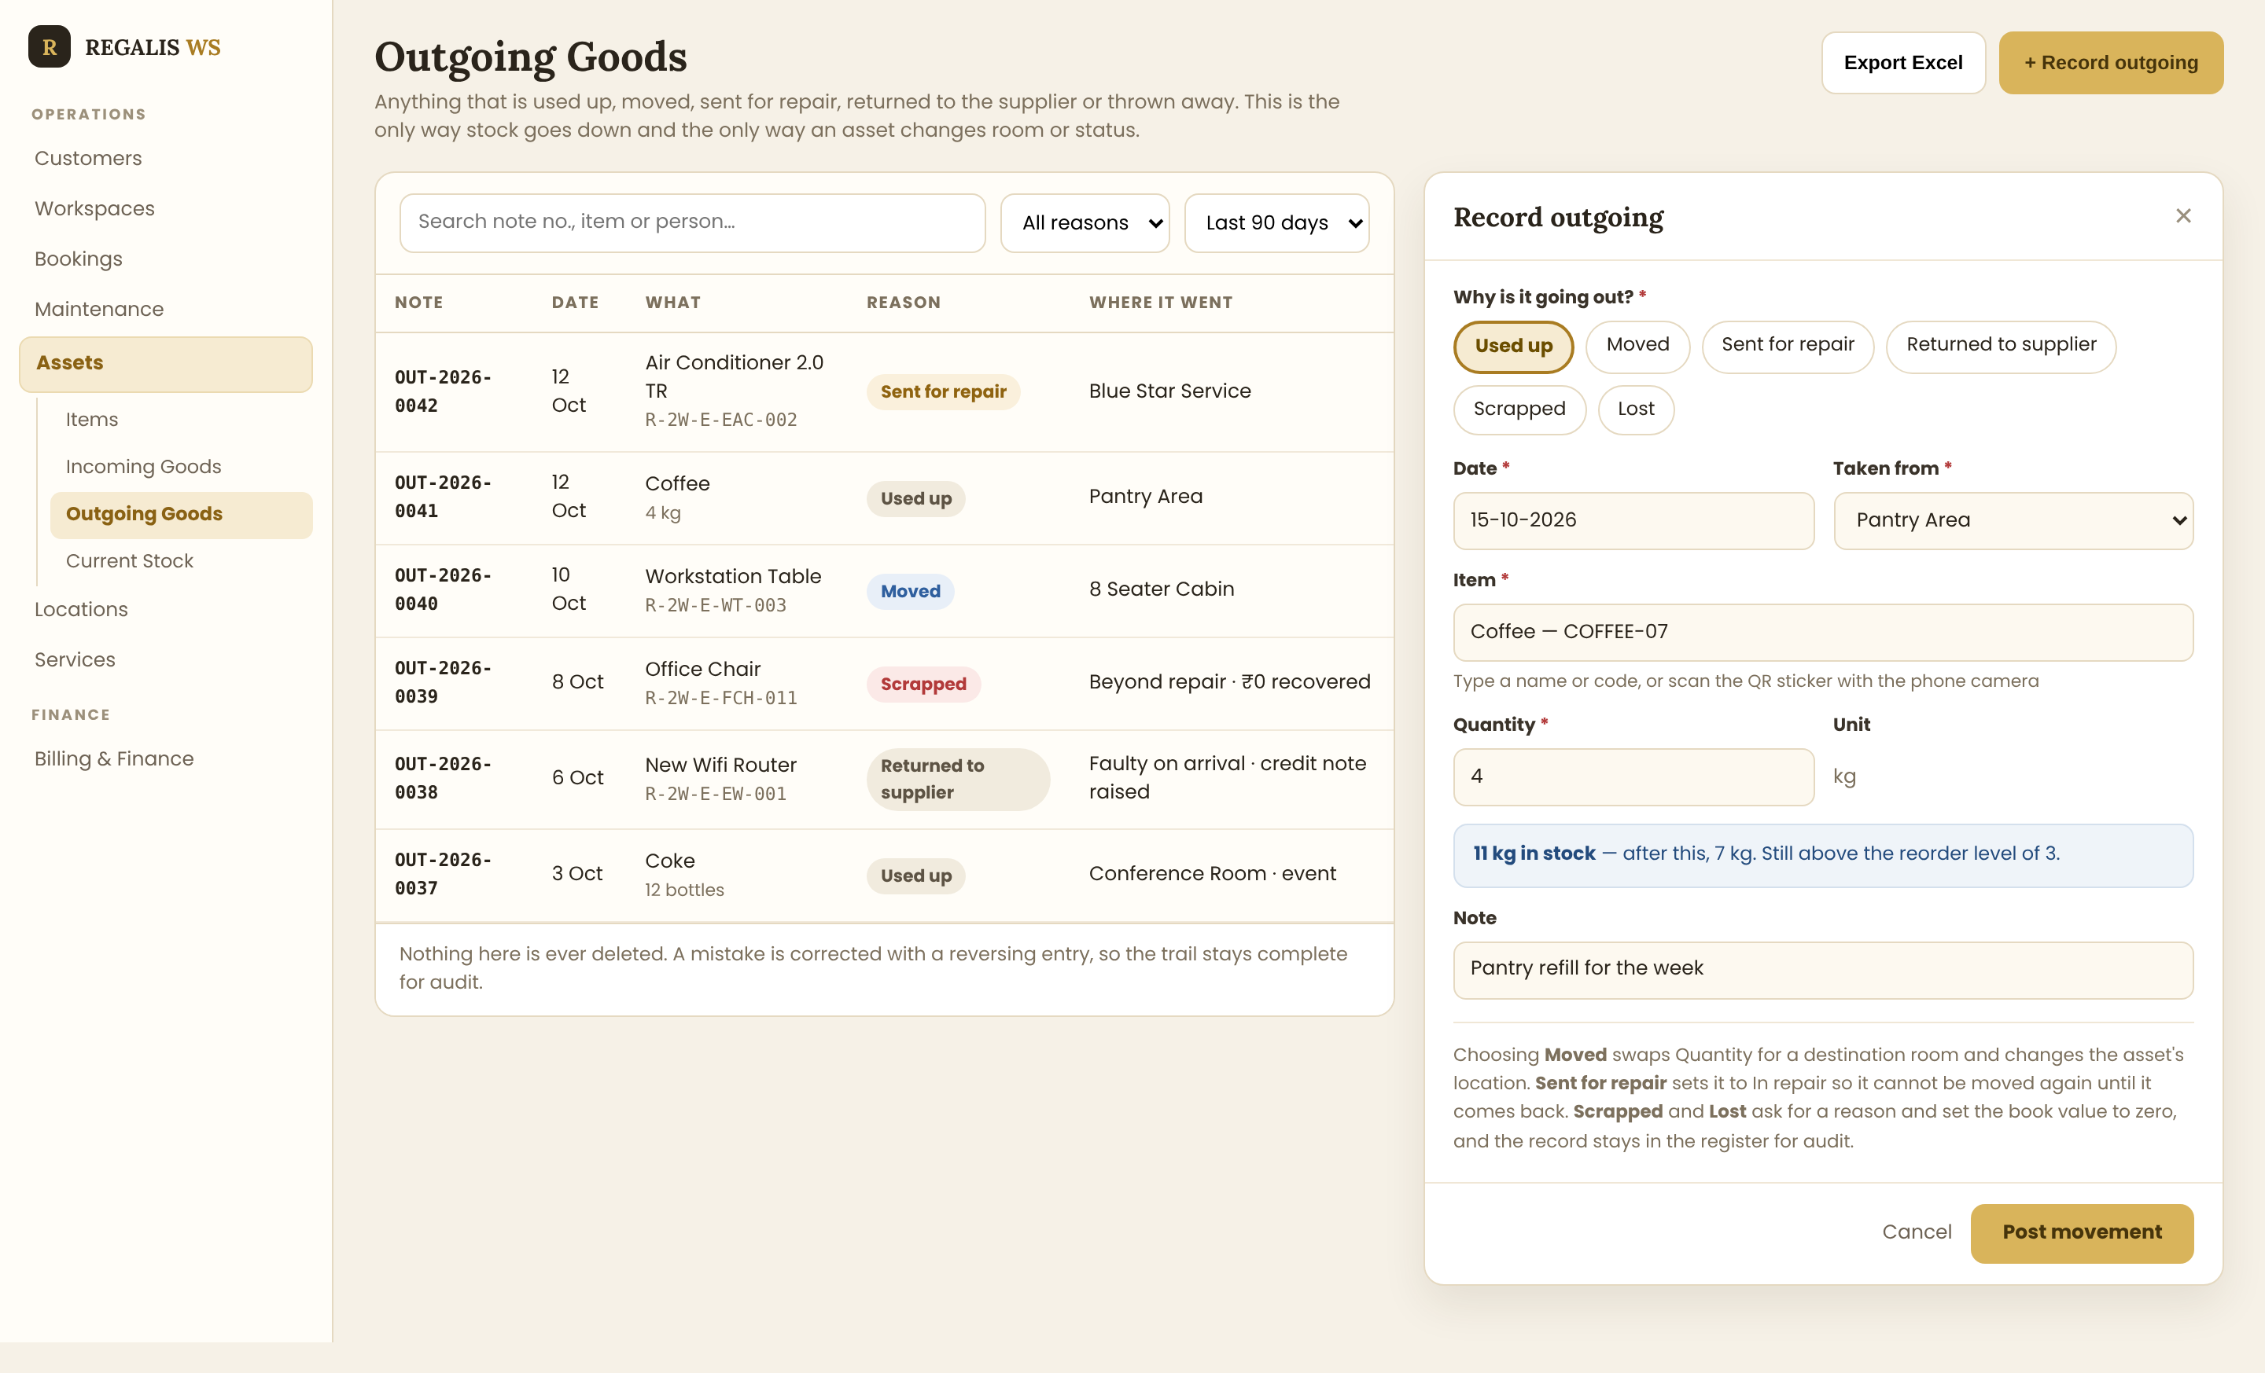
Page 3 — Outgoing Goods
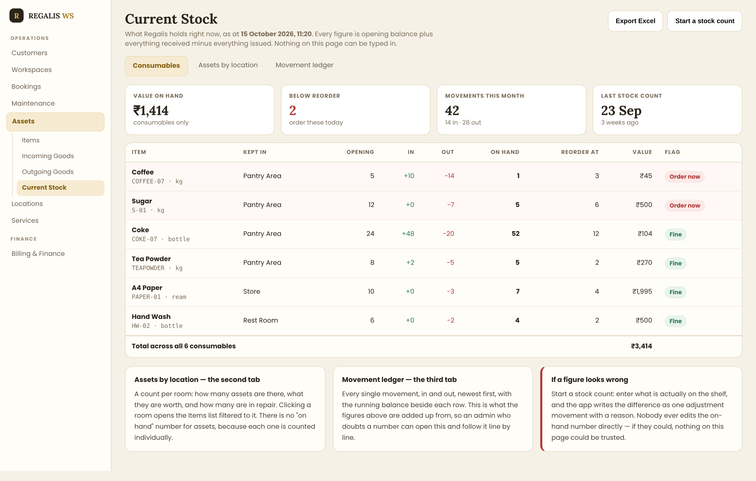
Page 4 — Current Stock

3. Every Field
These are the fields the Regalis team already keeps in its asset list, plus the few the app needs to work. The middle column says which of the two kinds uses it.

3.1 Shared By Both Kinds
Field | Required | Notes
Item name | Yes | What it is called: "Air Conditioner 2.0 TR", "Coffee"
Kind | Yes | Asset or Consumable. Asked first on the form and never changed afterwards
Code | Yes | Unique. For an asset the prefix plus a running number; for a consumable the code as it is
Category | Yes | From the list in 3.4, editable by an admin, never hard-coded
Description | No | The free-text detail the team already writes: "Blue star make 2.0 TR inverter, with copper piping"
Brand / model | No | Blue Star, Godrej, Featherlite. A separate field — not folded into the name
Unit cost | Yes | In rupees. For an asset, what one unit cost; for a consumable, the rate per unit
Vendor | No | Who it was bought from. Links to the Suppliers module where one exists
Remarks | No | Anything else
Photo | No | One picture. Useful for identifying furniture that all looks alike

3.2 Assets Only
Field | Required | Notes
Serial number | No | From the device label. Unique where present; warn on a duplicate rather than blocking
Location | Yes | Which room it is in: MD Cabin, Conference Room, Private Cabin 3, Server Room, Pantry Area. The list in 3.5
Condition | Yes | Good, Fair, Needs attention, Damaged. Defaults to Good
Status | Yes (auto) | In store, In use, In repair, Scrapped, Lost, Returned to supplier. Set by movements, never typed
Purchase date | Yes | Drives the book value. Cannot be in the future
Book value | Yes (auto) | Calculated, never typed. The formula is in 11.3
Label printed on | Auto | The date its QR label was last printed. Empty means no sticker on it yet
Warranty until | No | Drives the "Expiring soon" flag, 60 days by default

3.3 Consumables Only
Field | Required | Notes
Unit | Yes | kg, litre, piece, box, bottle, ream. Shown everywhere beside the quantity
Reorder level | Yes | Below this the item is flagged red on every page and the admin is notified
Kept in | Yes | Where it is stored: Pantry Area, Store, Rest Room
On hand | Auto | Never a field on any form. Always the sum of its movements
NOTE: There is no Quantity field on the item form. For an asset, quantity is how many records to create; for a consumable, quantity only ever arrives through a movement. An item record never stores a number that someone could edit by hand.

3.4 Categories
Category | Used for | Typical examples from the current list
Office Interior | Anything built into the building | Gypsum ceiling, grid ceiling, partitions
Electrical / Appliance | Anything powered | Air conditioners, LED lights, switch boards, speakers, fire alarm panel, Wi-Fi router
Furniture | Anything you sit at, on or in | CEO desk, reception table, cupboards, racks, workstation tables
IT Equipment | Computers and peripherals | Laptops, monitors, printers
Pantry | Consumables for the kitchen | Coffee, sugar, tea powder, coke
Housekeeping | Consumables for cleaning | Hand wash, cleaning supplies, bin liners
Stationery | Consumables for the office | A4 paper, pens, files
NOTE: Categories must be editable by an admin in a small settings screen, with a name, a default kind and a code prefix. Adding a category must never need a code change. The first four are asset categories, the last three consumable — but an admin can change that.

3.5 Locations
The locations in the current asset list are rooms inside the building, not cities: MD Cabin, Meeting Room, Conference Room, Private Cabin 1, 2 and 3, Private Workstation, Open Work Station, Work Station, 8 Seater Cabin, Reception Area, Server Room, Pantry Area, Rest Room, Rest Area, Walking Space, Walking Workspace, Custom Space, Amstag Area, Entrance.
NOTE: Several of these names are the same as rows in the Workspaces module. Where a location matches a workspace, link to it rather than storing the name twice — then "what is in Private Cabin 3" can be answered from either side. Where there is no matching workspace (Entrance, Server Room, Pantry Area), it is an ordinary location record. Confirm this before building: it is open item 4.

4. Page 1 — Items
The master list. Everything Regalis owns is here, asset and consumable together, told apart by a coloured tag and by what each row shows.

4.1 The Header
The title, the one-line explanation, and the four buttons
Control | Behaviour
The sub-line | Keep this sentence on the page. It is the only place a new admin is told the difference between an asset and a consumable, and it stops them guessing
QR labels | Opens the label sheet for every item matching the current filters, assets only
Export Excel | Downloads the full filtered list, every row, in the same column order as the team's own sheet
Import Excel | Download a template, fill it in, upload it, see a preview with errors marked, then confirm. Section 12 covers the first import
+ New item | Opens the form in 5

4.2 The Five Summary Cards
Five figures, each one clickable
Card | The figure | What clicking it does
Assets | How many asset records exist, and their total purchase value | Filters the list to assets
Consumables | How many consumable items are tracked | Filters to consumables
Below reorder | How many consumables are at or under their reorder level, named underneath | Filters to those, so they can be ordered
In repair | Assets currently away being fixed | Filters to them
No QR printed | Assets whose label has never been printed | Filters to them, ready for the label sheet
NOTE: The last card is the one that keeps the system honest. An asset with no sticker cannot be found by scanning, so the number must be visible on the page until it reaches zero. Every figure here is counted on the server across all rows, never from the page on screen.

4.3 Search And Filters
One search box, four dropdowns and two checkboxes
- Search matches item name, code, serial number and brand, so "blue star", "ESB" and "R-2W-E-EAC-001" all find something.
- All kinds — Assets, Consumables, or both.
- All categories, All locations, Any status — each from the lists in Section 3.
- Only below reorder level — the pantry check, in one click.
- Only assets with no QR printed — the labelling check.
- Every filter that is not at its default appears as a removable chip, and the row count on the right updates as they change.

4.4 The Table
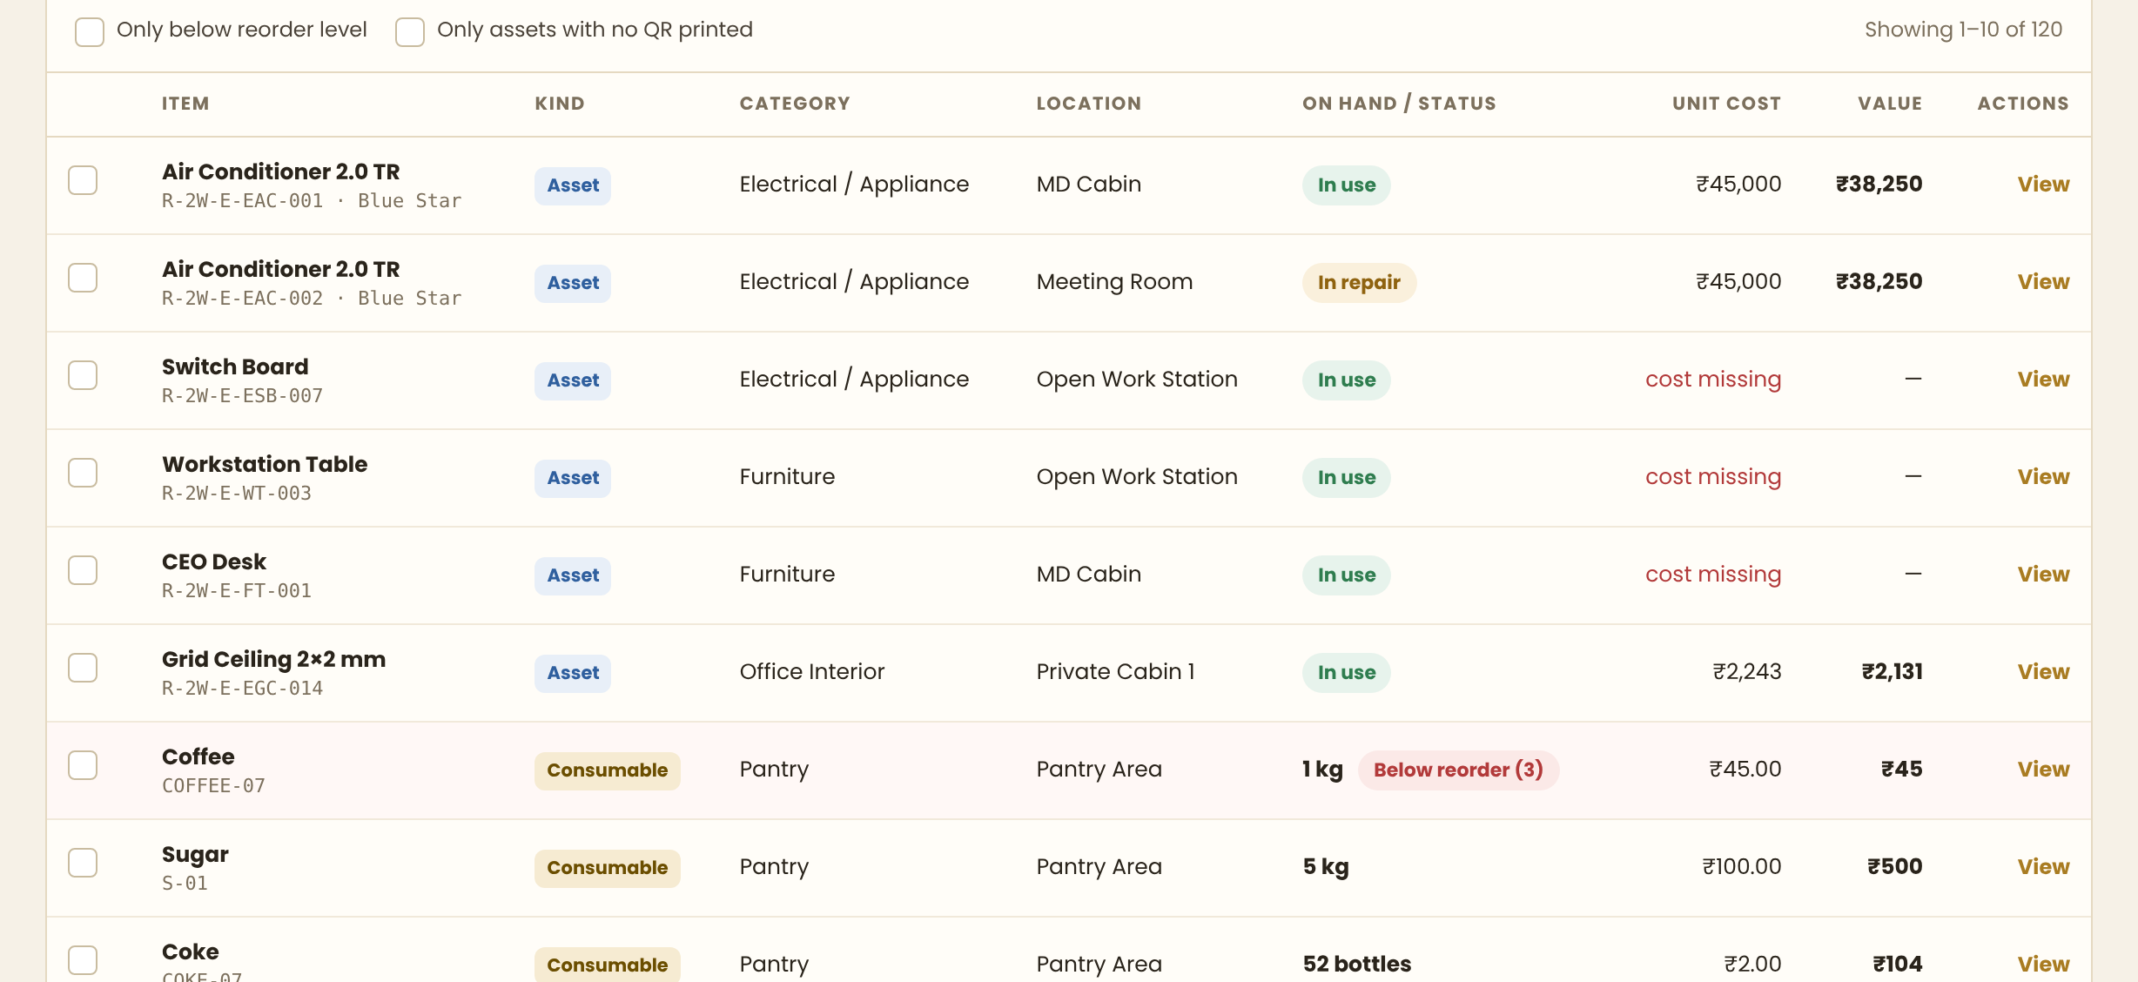
Assets and consumables in one table, told apart by the Kind tag and the On hand column
Column | Asset row | Consumable row
Item | Name, then its code and brand underneath | Name, then its code underneath
Kind | Blue "Asset" tag | Gold "Consumable" tag
Category | Its category | Its category
Location | The room it is in | Where it is kept
On hand / Status | A status pill: In use, In store, In repair | The quantity with its unit, and a red flag if at or below the reorder level
Unit cost | What that unit cost. Shown in red as "cost missing" when there is none | The rate per unit
Value | Its book value today | Quantity times unit cost
Actions | View, which opens the drawer in Section 4.6 | The same
NOTE: "Cost missing" in red is deliberate. Thirty-six of the forty-three rows in the current list have no purchase amount, and a blank cell lets that be ignored forever. The red text and the Value dash make it visible until someone fills it in.

4.5 Selecting Rows
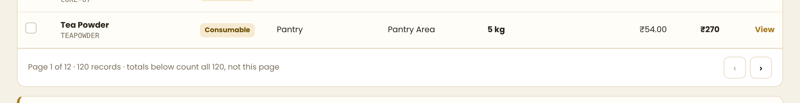
The page count, and what selecting rows offers
- Selecting rows shows a bar with: Print QR labels, Move to another location, Change status, Export selected.
- Bulk actions that make no sense for consumables skip them, and the message says how many were skipped — never a silent partial action.
- The page footer states that the totals count all records, not the page on screen.
- Fifty rows a page, with the page size set by the server.

4.6 Opening One Item
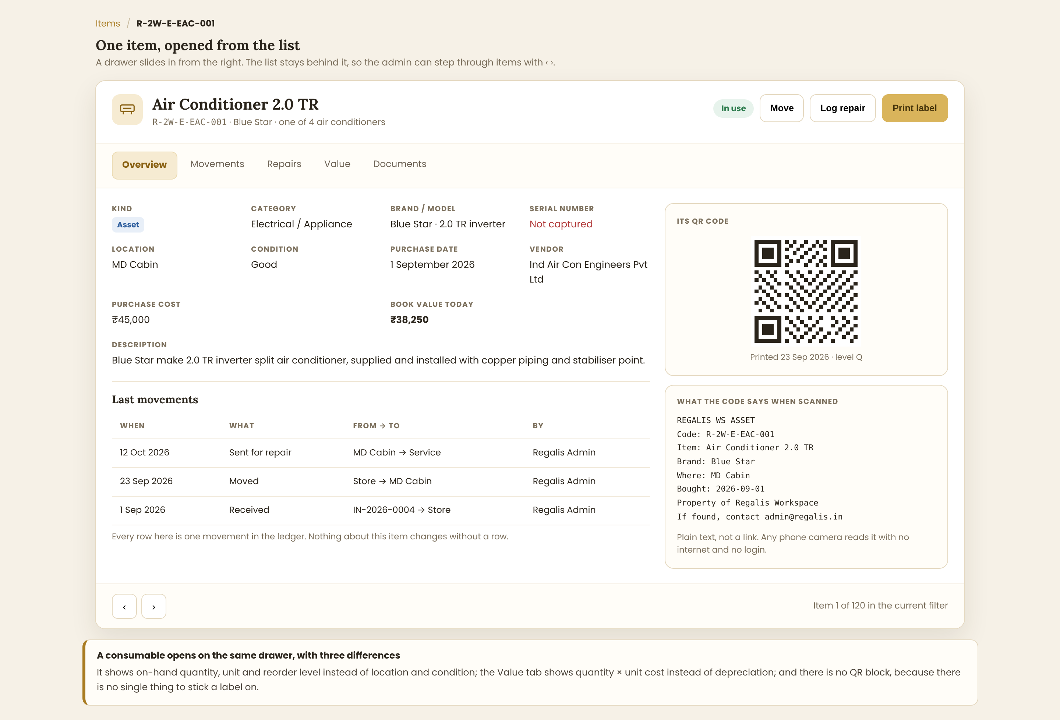
The item drawer, with the overview tab and the QR code

The header
- Icon, item name, code, brand, and a line placing it among its siblings: "one of 4 air conditioners".
- The status pill, then Move, Log repair and Print label.

The five tabs
Tab | What it holds
Overview | Every field from Section 3, the description, the last few movements, and the QR block
Movements | Every movement of this item, newest first: received, moved, sent for repair, returned, scrapped
Repairs | Each repair with its date, what was done, the cost and whether it is still open
Value | Purchase cost, book value today, the depreciation method, age, how much of its life is used, and total repair spend
Documents | Purchase invoice, warranty card, photos
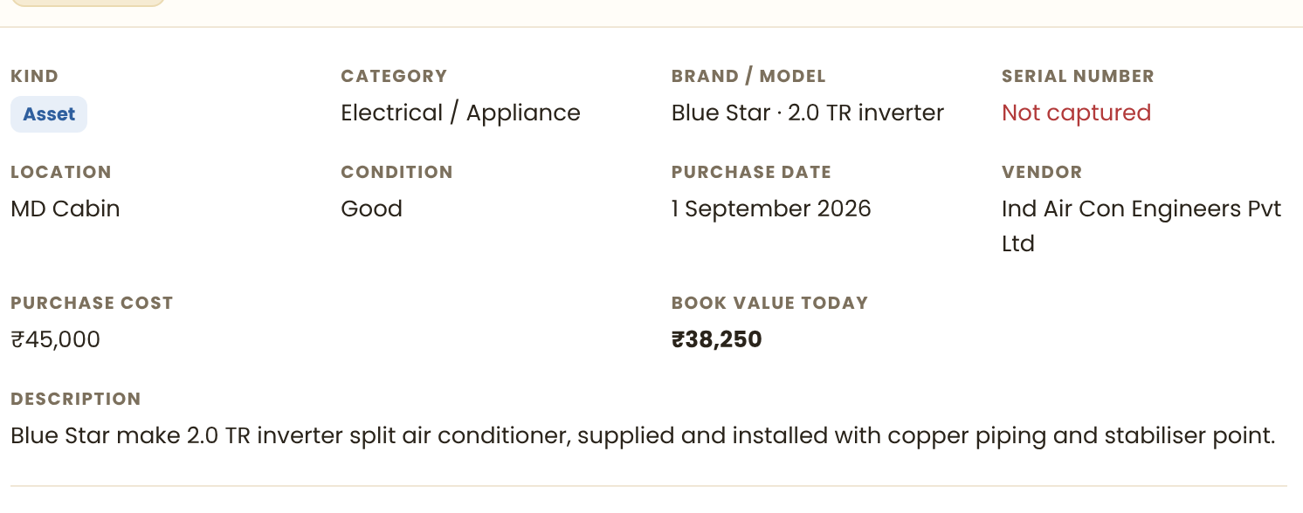
The fields, with anything missing called out rather than left blank
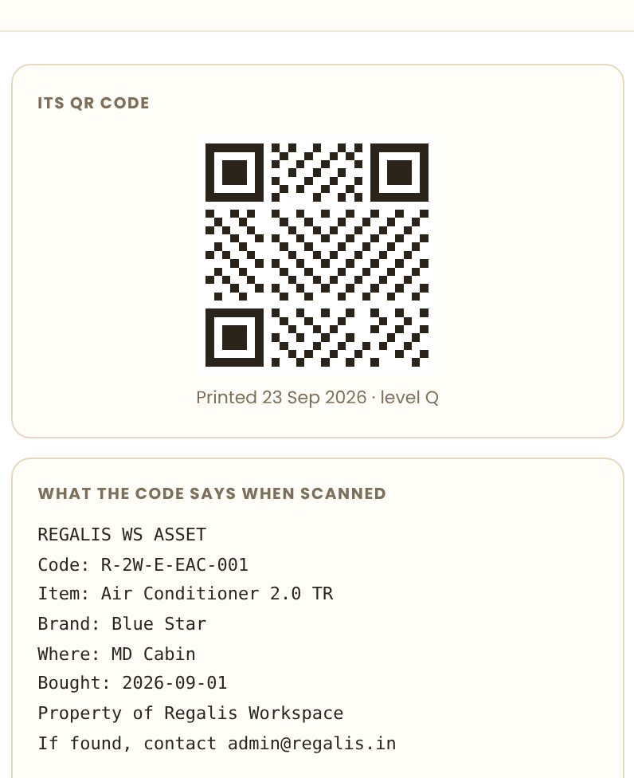
The QR block: the code itself, and the exact text it carries
- The QR block shows the code, when its label was last printed, and the exact text a scan returns — so an admin can see what they are putting on the wall.
- The ‹ › buttons at the bottom step to the previous and next item in the current filter, without closing the drawer.
- A consumable opens the same drawer with three differences: on-hand quantity, unit and reorder level instead of location and condition; the Value tab shows quantity times unit cost instead of depreciation; and there is no QR block.

5. Adding An Item
One form, and the first question changes the rest of it.
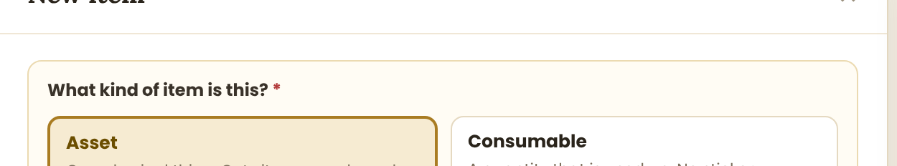
The first question. It is asked once and never changed afterwards
NOTE: Kind cannot be edited after the item is created. Changing coffee into an asset, or a cupboard into a quantity, would make every movement already recorded against it meaningless. If it was set wrongly, the item is made inactive and a new one created.

5.1 Adding Assets
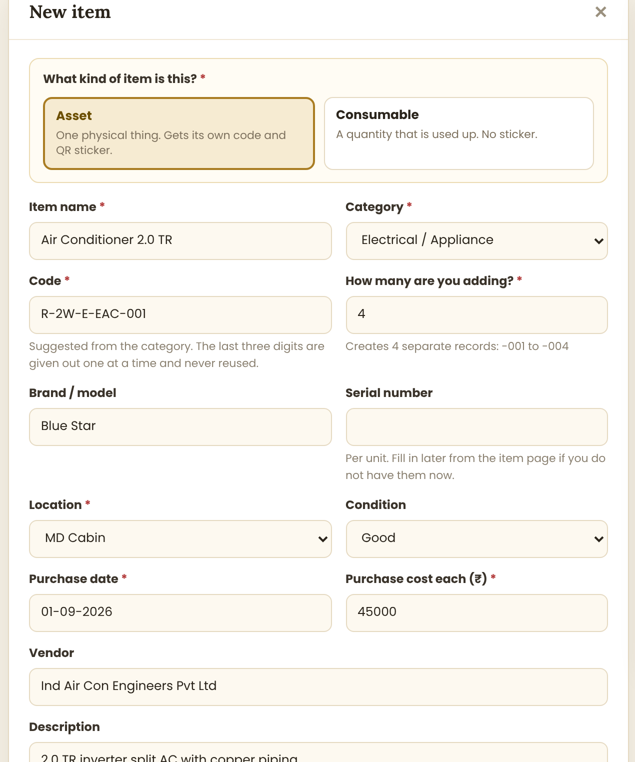
The asset form. Note "How many are you adding?"
Field | Behaviour
Code | Suggested from the category as prefix plus the next free number. The admin can change the prefix but not reuse a number
How many are you adding? | The important one. Typing 4 creates FOUR separate records, -001 to -004, not one record with a quantity of four. The hint under the box says exactly that
Brand / model | Applies to all of them
Serial number | Per unit, so it is left empty when several are added at once and filled in later from each item page
Location, Condition | Applied to all of them; any one can be moved afterwards
Purchase cost each | Per unit, not the total. The confirmation says "4 assets, ₹1,80,000 in total"
Print QR labels straight away | Ticked by default. Unticking it leaves them on the "No QR printed" list

5.2 Adding A Consumable
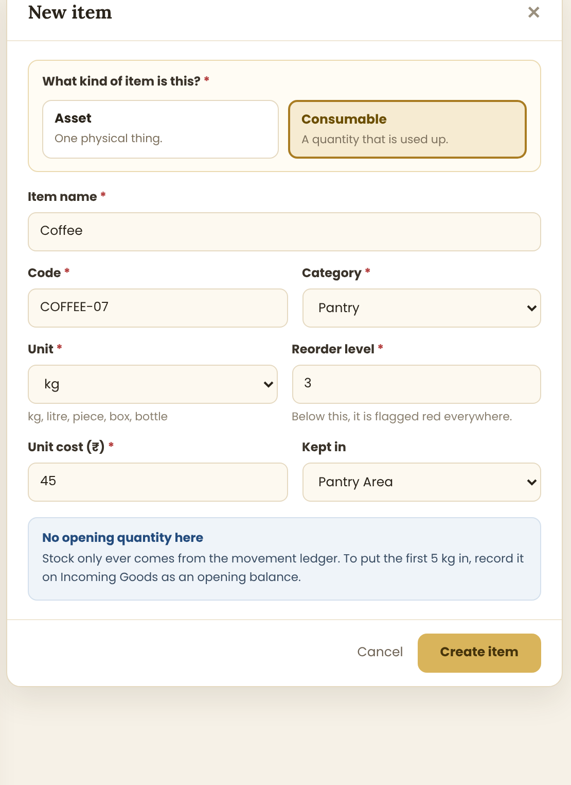
The consumable form — shorter, and with no opening quantity
- Unit and Reorder level appear in place of location, condition and dates.
- There is deliberately no opening quantity box. The first stock comes in as an Incoming Goods receipt marked "opening balance", so that even the very first number has a movement behind it.
- The blue panel on the form says this in plain words, so nobody looks for the missing field.
NOTE: This is the rule the whole module rests on: there is no way, anywhere in the app, to type a stock figure. If one existed, every figure on Current Stock would be a matter of opinion.

6. Page 2 — Incoming Goods
Everything that arrives at Regalis is recorded here first. This is the only way stock goes up, and the only way a new asset record comes into being.
The page header and its two buttons

6.1 The List Of Receipts
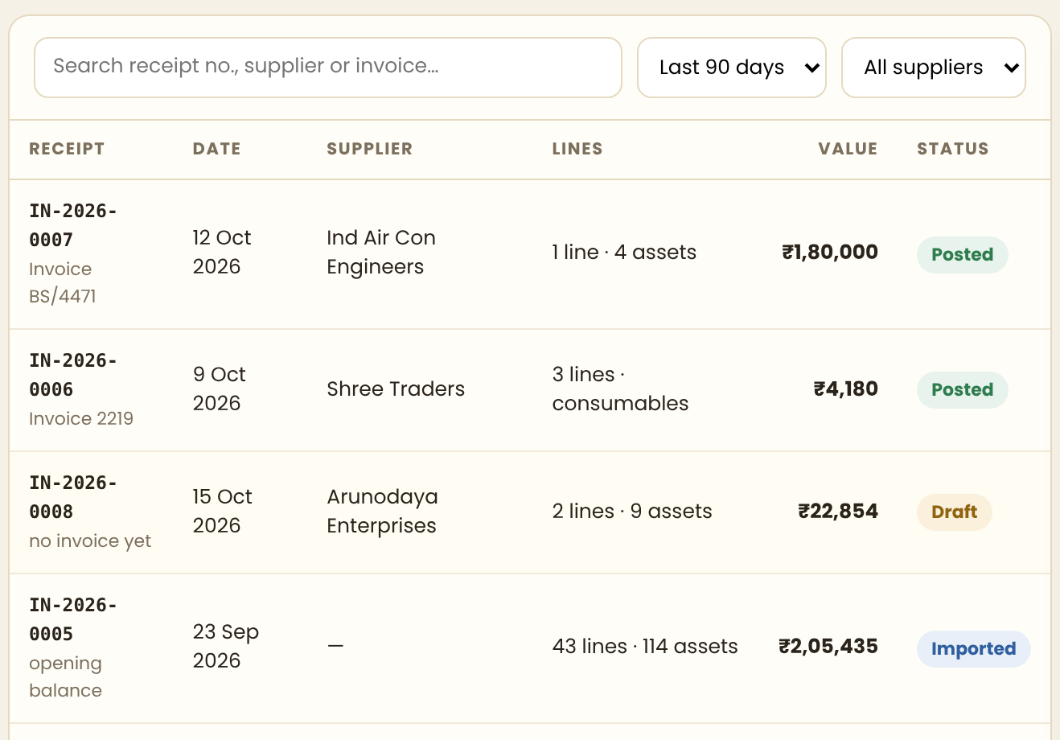
Every receipt, newest first
Column | Content
Receipt | The receipt number, IN-2026-0007, generated by the app, plus the supplier invoice number underneath
Date | The date the goods arrived, not the date it was typed in
Supplier | From the Suppliers module. Blank for an opening balance
Lines | How many lines and what they created: "1 line · 4 assets", "3 lines · consumables"
Value | The total of the receipt
Status | Draft, Posted, or Imported
Status | What it means
Draft | Typed in but not yet applied. Nothing has changed: no stock has moved and no asset exists. It can be edited or deleted freely
Posted | Applied. Stock has moved, asset records and QR codes have been created. It can never be edited — only reversed, which writes an opposite receipt and leaves both in the record
Imported | Created by the first Excel import, described in Section 12. Behaves exactly like Posted

6.2 Recording Something New
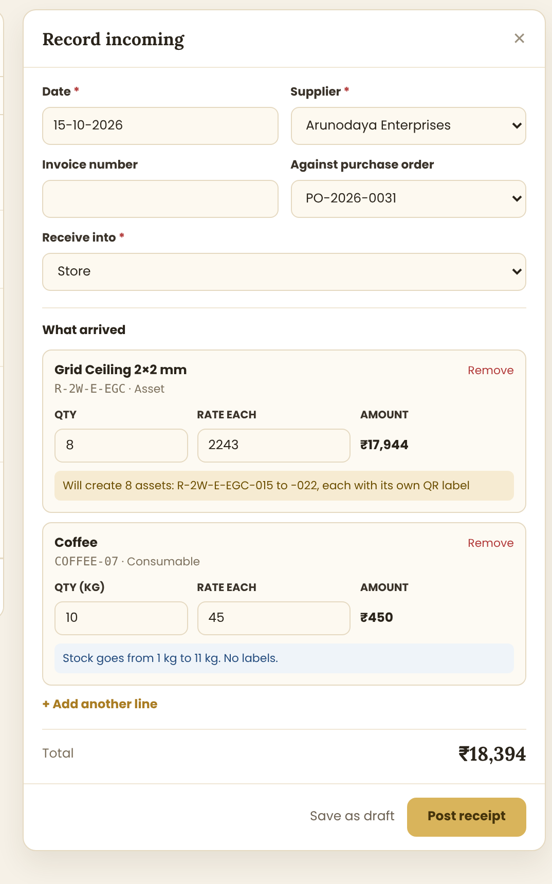
The receipt form, with one line per thing that arrived
Field | Behaviour
Date | Required. Cannot be in the future
Supplier | Required, from the Suppliers list. "Opening balance" is a reserved option with no supplier
Invoice number | Optional — goods often arrive before the invoice does
Against purchase order | Optional. Choosing a PO fills the lines from it, so a receipt against a PO is three clicks
Receive into | Required. Where it physically went: Store, Pantry Area, or a room
Each line | The item, how many, and the rate each. The amount is calculated and cannot be typed
Total | The sum of the lines, calculated
Save as draft | Changes nothing
Post receipt | Applies everything. This is the irreversible step

6.3 What Each Line Says It Will Do
Under every line the form states, in plain words, exactly what posting will cause. This is the most useful part of the screen and must not be left out.
- An asset line: "Will create 8 assets: R-2W-E-EGC-015 to -022, each with its own QR label" — the actual codes, worked out before posting.
- A consumable line: "Stock goes from 1 kg to 11 kg. No labels."
- If a line would create assets with no purchase cost, it says so in amber and asks the admin to confirm.
NOTE: Posting a receipt is the moment the 114 asset records and their QR codes are born. Everything in Section 9 about labels follows from this one action, so it has to be right: the codes are allocated inside a database transaction, one at a time per prefix, so two admins posting at once can never be given the same number.

7. Page 3 — Outgoing Goods
Anything used up, moved, sent for repair, returned to the supplier, scrapped or lost. This is the only way stock goes down and the only way an asset changes room or status.

7.1 The List Of Movements
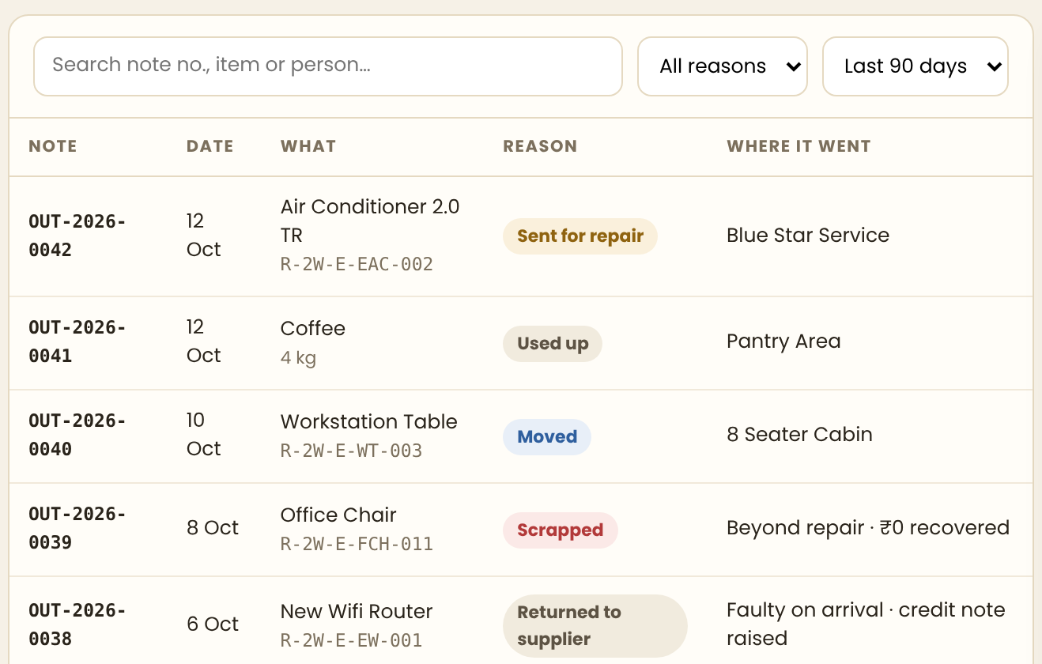
Every movement out, newest first
Column | Content
Note | The note number, OUT-2026-0042
Date | When it happened
What | The item, with its code underneath, or the quantity for a consumable
Reason | A coloured pill: Used up, Moved, Sent for repair, Returned to supplier, Scrapped, Lost
Where it went | The destination room, the service company, or the reason it was written off
NOTE: Nothing on this page is ever deleted. A mistake is corrected by posting a reversing entry, so the trail stays complete. An admin who deletes a line can hide a missing laptop; an admin who reverses one cannot.

7.2 Recording A Movement
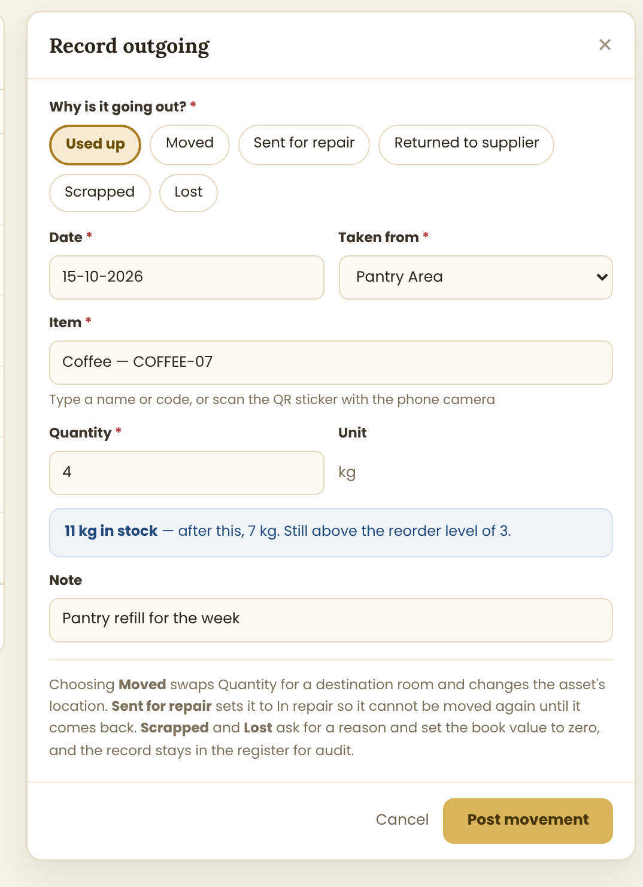
The form. The reason chosen at the top changes the fields below it
Reason | What the form then asks | What it does
Used up | A quantity | Consumables only. Reduces stock. Blocked if it would go below zero
Moved | The destination room | Assets only. Changes the location and writes the move to history
Sent for repair | Who it went to, and the expected cost | Sets the status to In repair, so it cannot be moved or issued until it is back
Returned to supplier | The reason, and whether a credit note was raised | Takes it out of the register but keeps the record
Scrapped | The reason and any amount recovered | Sets book value to zero. The record stays for audit
Lost | A note and who reported it | Same as scrapped, flagged differently in reports
- The item is found by typing its name or code, or by scanning its QR sticker with the phone camera — which is the whole point of the stickers.
- For a consumable the form shows the live balance: "11 kg in stock — after this, 7 kg. Still above the reorder level of 3."
- If the movement takes it below the reorder level, the panel turns red and says so before the admin posts it.
- A repair that is finished is closed from the item page, which writes a matching movement back in.

8. Page 4 — Current Stock
What Regalis holds right now. Every figure on this page is worked out from the movements; none of it is stored.
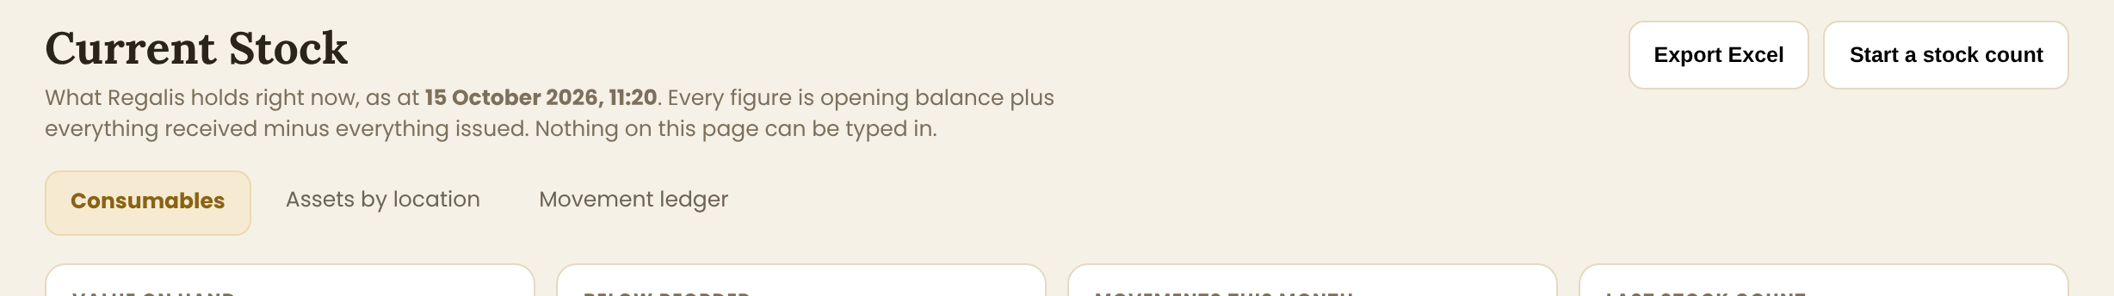
The header, the as-at time, and the three tabs
- The header carries the exact time the figures were worked out: "as at 15 October 2026, 11:20". A stock page with no timestamp is not a stock page.
- Three tabs: Consumables, Assets by location, Movement ledger.

8.1 The Four Figures
Value on hand, items below reorder, movements this month, last stock count
"Last stock count" is there to shame a space that has not counted in three months. If it has never been done, it says "Never".

8.2 The Consumables Tab
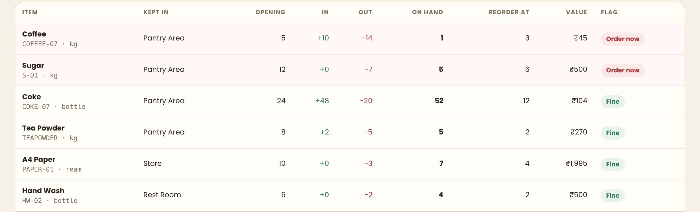
Opening, in, out, on hand — the arithmetic shown on every row
Column | What it is
Opening | The balance at the start of the chosen period
In | Everything received in the period, in green
Out | Everything issued in the period, in red
On hand | Opening plus In minus Out. This is the figure, and the three columns beside it show the working
Reorder at | The level below which it is flagged
Value | On hand times unit cost
Flag | Order now in red, or Fine in green
NOTE: Showing opening, in, out and on hand side by side is deliberate. An admin who doubts the figure can see the arithmetic without opening anything, and an admin who trusts it reads only the one column. A single "quantity" column invites exactly the argument this page exists to prevent.

8.3 The Other Two Tabs
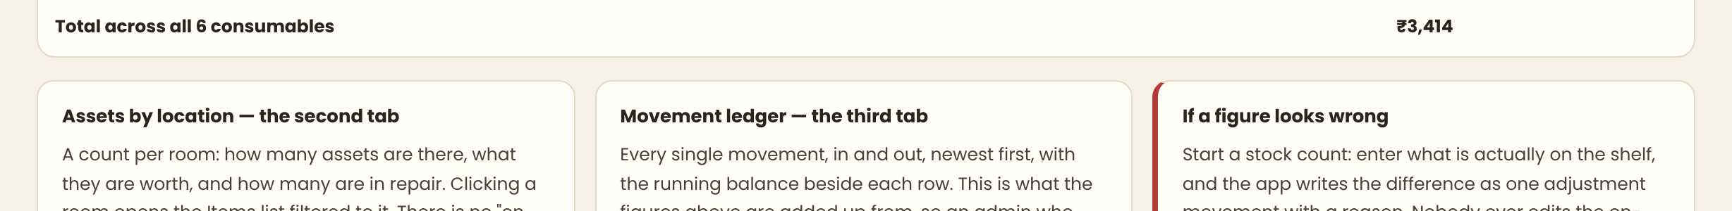
What the other two tabs do, and what to do when a figure looks wrong
Tab | What it shows
Assets by location | One row per room: how many assets are there, what they are worth, how many are in repair. Clicking a room opens Items filtered to it. There is no "on hand" number for assets, because each one is counted individually
Movement ledger | Every movement, in and out, newest first, with the running balance beside each row. This is what everything above is added from, so an admin who doubts a number can follow it line by line

8.4 Stock Counts
Physical stock drifts from recorded stock. The fix is a count, not an edit.
- Start a stock count opens a sheet of every consumable with its recorded quantity hidden, so the counter writes what is actually on the shelf.
- Submitting it shows the differences: "Coffee — recorded 7, counted 5, short 2".
- Confirming writes one adjustment movement per difference, with the reason "stock count", the date and who counted.
- The recorded figure is never overwritten. It is corrected by a movement, like everything else.
NOTE: Nobody can edit an on-hand number anywhere in the app. There is no such field. This is worth repeating to the developer because it is the one rule that is tempting to break — a "quick fix" edit box is a five-minute change that makes every figure on this page untrustworthy forever.

9. QR Codes And Labels
Every asset gets its own QR code the moment it is created, and a sticker printed for it. This is the part the Regalis team asked for, and it only works because each physical unit is now its own record.

9.1 What The Code Contains
Plain text, one field per line, exactly as below. Not a URL.
Line | Example
Title | REGALIS WS ASSET
Code | Code: R-2W-E-EAC-001
Item | Item: Air Conditioner 2.0 TR
Brand (skipped when there is none) | Brand: Blue Star
Where | Where: MD Cabin
Bought | Bought: 2026-09-01
Ownership | Property of Regalis Workspace
Contact | If found, contact admin@regalis.in
NOTE: Plain text, not a link, is a deliberate choice. A security guard, an electrician or an auditor can point any phone camera at it and read who owns the thing and where it belongs — with no app, no internet and no login. A URL would show a sign-in page to exactly the people who need it most. Open item 6 if Regalis wants a link as well.
- ASCII only. Replace long dashes, the rupee sign and any accented characters before encoding, or some scanners show the wrong text.
- Error correction level Q, so a scratched or partly painted-over label still scans.
- The code is generated as SVG in the browser, so it stays sharp at any size and needs no server round-trip.
- An admin scanning the same sticker inside the app is taken straight to that item's page. The sticker does not change; the app simply recognises its own code.

9.2 The Label
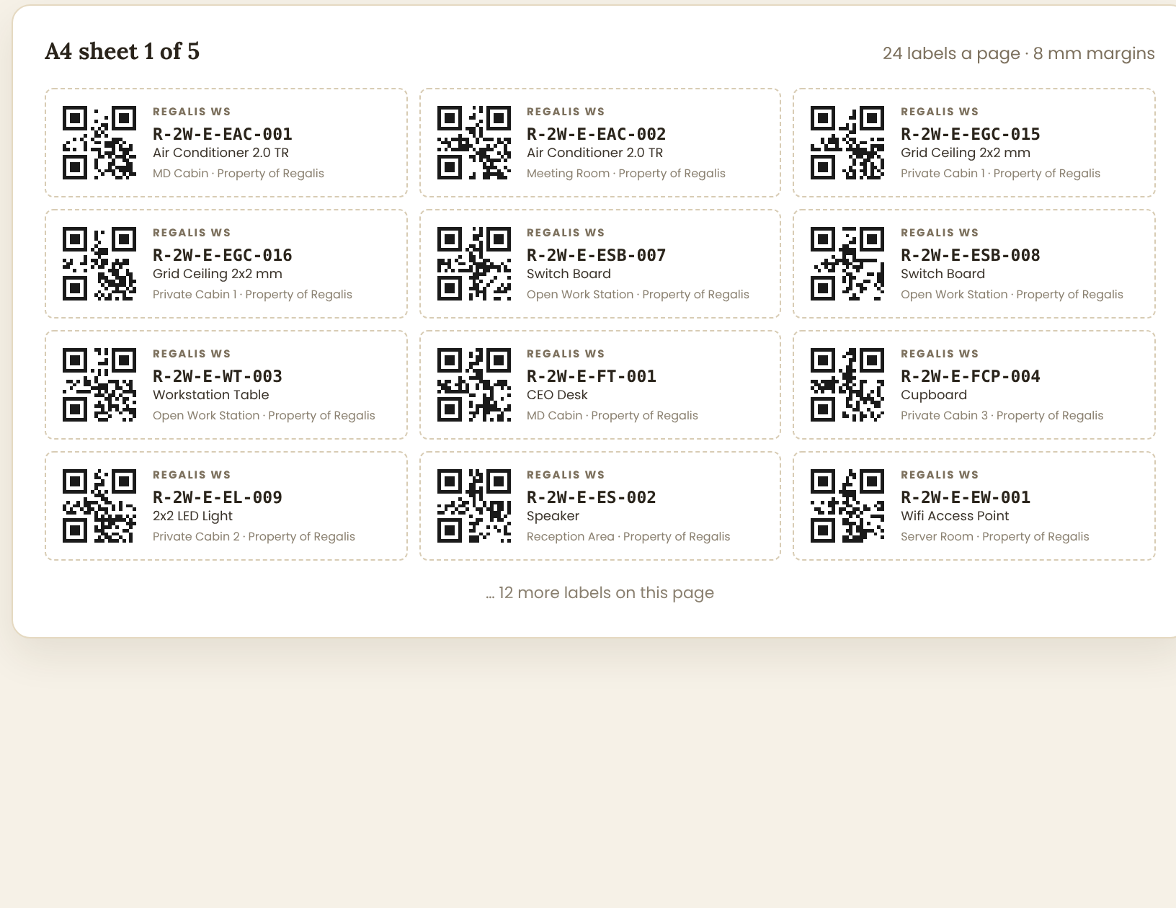
An A4 sheet of labels, 24 to a page
- Each label carries the QR code, REGALIS WS, the code in large monospace, the item name, where it belongs, and Property of Regalis.
- Large: 3 columns × 8 rows = 24 per A4 sheet, QR about 26 mm.
- Small: 4 columns × 10 rows = 40 per A4 sheet, QR about 20 mm.
- A4 with 8 mm margins. Only the sheet prints — none of the panel beside it, no sidebar, no browser furniture.

9.3 Printing
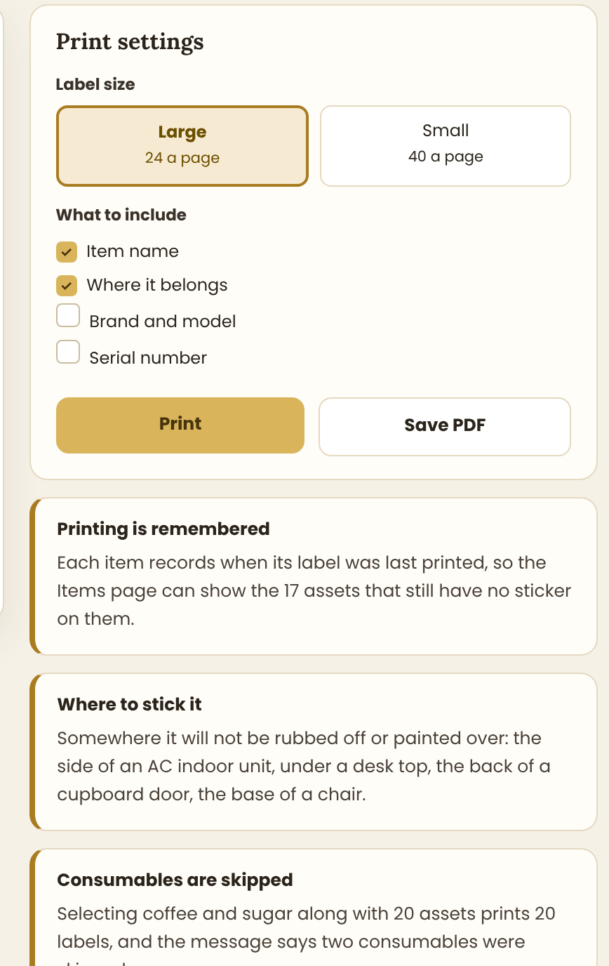
The print panel beside the sheet
Control | Behaviour
Opened by | The QR labels button (every filtered item), Print labels on selected rows, or Print label on one item
Label size | Large or Small
What to include | Item name and Where it belongs are ticked by default; Brand and Serial number are optional, since a crowded label is harder to read
Print | The browser print dialogue, pre-set to A4
Save PDF | The same sheet as a file, for printing somewhere else
- Each item records when its label was last printed, which is what feeds the "No QR printed" card on the Items page.
- Consumables in a selection are skipped and the message says how many.
- Reprinting is always allowed — stickers get damaged. The code never changes, so a reprint is identical to the original.
NOTE: Stick the label where it will not be rubbed off or painted over: the side of an air conditioner indoor unit, under a desk top, the back of a cupboard door, the base of a chair. A label on a false ceiling tile goes on the frame, not the tile, so it survives the tile being lifted.

10. Flow Charts
Five flows. Read the shapes this way: a black oval starts the flow, a cream box is something a person does, a diamond is a decision, a blue box is something the system does on its own, a green box is a successful end, and a red box is a failure or a blocked path.

10.1 Something Arrives
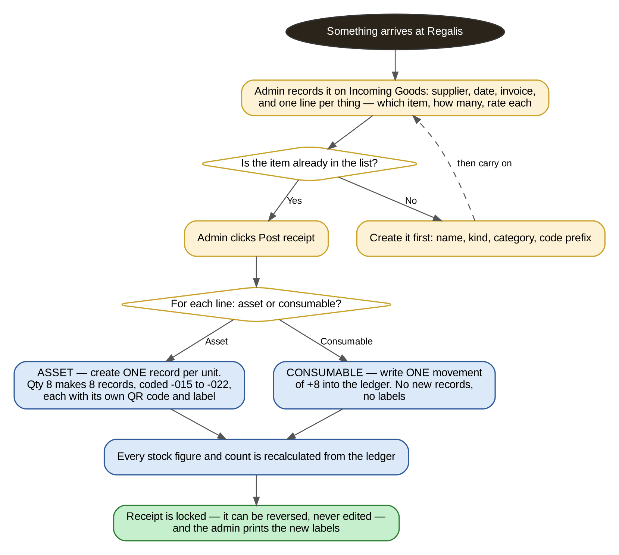
Flow 1 — from a delivery at the door to a printed sticker
- The split at the bottom is the whole module in one picture: an asset line creates records, a consumable line creates a movement.
- A receipt in draft changes nothing at all, which is what lets an admin type it in while the delivery is still being unloaded.
- Posting is irreversible by design. A mistake is reversed, which leaves both entries in the record.

10.2 Something Leaves
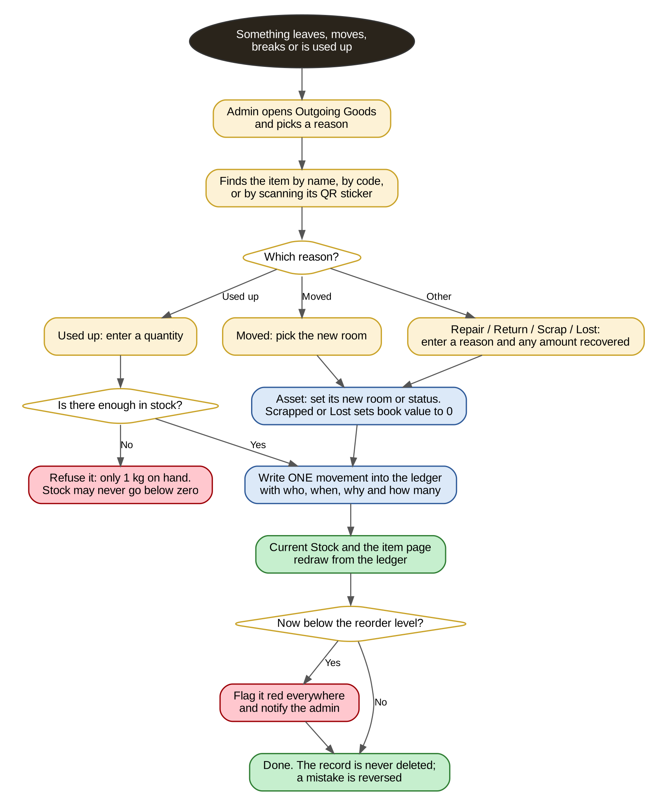
Flow 2 — using up, moving, repairing, scrapping
- The reason chosen at the top decides everything after it.
- Stock may never go below zero. If an admin tries to issue 4 kg when 1 kg is recorded, the app refuses — because the recorded figure being wrong is itself the thing to fix, through a stock count.
- Every path ends with one row in the ledger. Nothing changes an item without one.

10.3 How A Stock Figure Is Worked Out
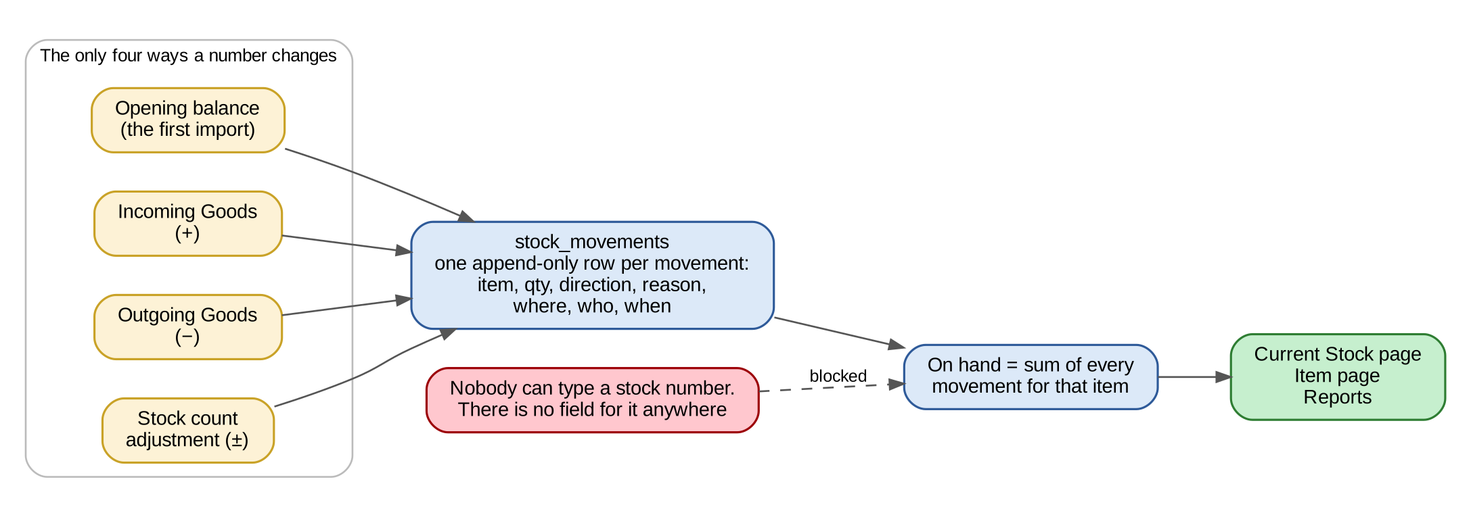
Flow 3 — the four ways a number can change, and the one place it is read from
- There are exactly four ways a quantity changes, and all four write to the same table.
- On hand is the sum of that table for that item. It is computed on read, never stored.
- The red box is in the picture on purpose: there is no screen, form or API that accepts a stock figure.

10.4 The Life Of An Asset
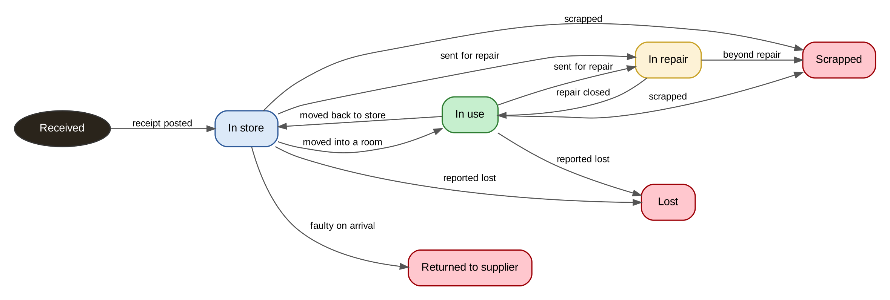
Flow 4 — every status an asset can be in, and every way it moves between them
- These are the only statuses, and the only transitions. Anything else is a bug.
- An asset in repair cannot be moved or issued until the repair is closed.
- Scrapped, Lost and Returned to supplier are ends, but the record stays in the register with its full history. An asset is never deleted.

10.5 The QR Code, From Creation To Scan
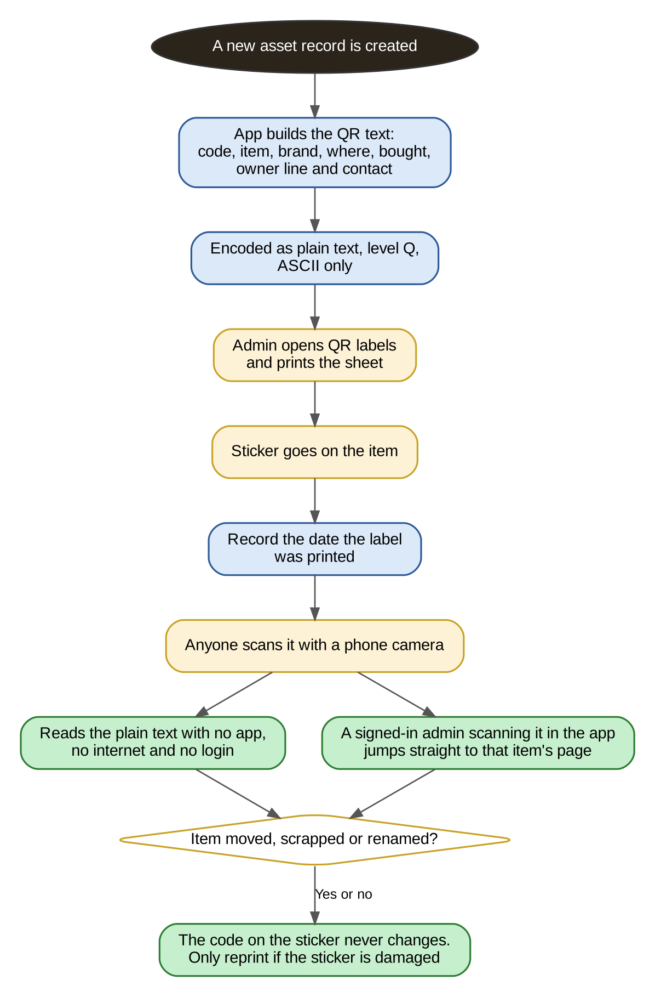
Flow 5 — how a code is made, printed, stuck on and read
- The code is built when the asset record is created, not when the label is printed.
- The printed date is recorded so unlabelled assets can be found.
- The code on a sticker never changes, however many times the item moves or is renamed. Only a damaged sticker is reprinted.

11. Data Model, Rules And The API

11.1 The Tables
Table | Key fields
item | id, code (unique), name, kind (asset or consumable), category_id, description, brand_model, unit_cost_paise, vendor_id, photo, remarks, is_active, created_by, timestamps
item_asset | item_id, serial_no, location_id, condition, status, purchase_date, warranty_until, book_value (computed), label_printed_at, retired_reason, retired_value, retired_at
item_consumable | item_id, unit, reorder_level, default_location_id
item_category | id, name, default_kind, code_prefix, is_active
location | id, name, workspace_id (nullable), is_active
goods_receipt | id, receipt_no, date, supplier_id, invoice_no, purchase_order_id, into_location_id, status (draft/posted), total_paise, posted_by, posted_at
goods_receipt_line | id, receipt_id, item_id, qty, rate_paise, amount_paise
goods_issue | id, note_no, date, reason, from_location_id, to_location_id, note, posted_by, posted_at
goods_issue_line | id, issue_id, item_id, qty, amount_paise
stock_movement | id, item_id, direction (in/out), qty, reason, source_type, source_id, location_id, moved_at, created_by — append only, never updated or deleted
item_repair | id, item_id, sent_on, vendor, description, cost_paise, is_open, closed_on
item_event | id, item_id, event, actor_id, meta (JSON), created_at
code_sequence | prefix, last_number — the row is locked while a number is issued
stock_count | id, date, location_id, counted_by, status; and stock_count_line: item_id, counted_qty, recorded_qty, difference

11.2 The Rules That Must Not Be Broken
- On hand is never stored. It is always SUM(in) − SUM(out) from stock_movement for that item. No column, no cache that can drift, no form field.
- Stock may never go below zero. The check happens inside the same transaction as the write, not before it.
- A posted receipt or issue is immutable. Correct it with a reversing entry.
- Nothing is deleted. Items are made inactive; assets are scrapped or marked lost; movements stay forever.
- Codes are never reused, even when an asset is scrapped or a record was created in error.
- Kind can never change after creation.
- Every figure is calculated on the server across all matching rows, never from the page loaded in the browser.
- Money is stored in paise as an integer and shown in the Indian grouping: ₹2,05,435, not ₹205,435.
- Dates and times are Indian Standard Time. Store UTC, convert at the edge.
- Every action writes to item_event with who did it and when.

11.3 Book Value
Straight-line depreciation over the category's useful life:
- age in years = (today − purchase date) ÷ 365
- book value = purchase cost × (1 − age ÷ useful life), never below 5% of cost while the asset is in use
- A scrapped or lost asset has a book value of 0
- Example: a ₹45,000 air conditioner on a 7-year life, bought 6 weeks ago, is worth ₹44,505
- Useful life is a property of the category, editable, not hard-coded. Suggested: Office Interior 10 years, Electrical / Appliance 7, Furniture 10, IT Equipment 4
- Book value is computed on read. An asset with no purchase cost shows a dash, not a zero
NOTE: Confirm the depreciation method with whoever does the accounts before building — the Companies Act rates may differ from a flat straight line. This is open item 2.

11.4 The API
Endpoint | What it does
GET /api/admin/items | The master list. Takes search, kind, category, location, status, below_reorder, no_label, page, sort. Returns the page of rows, the total count and the five summary figures in one response
GET /api/admin/items/:id | One item with its fields, its recent movements and its QR text
POST /api/admin/items | Creates one consumable, or N asset records from one form
GET/POST /api/admin/goods-receipts | List and create. POST creates a draft
POST /api/admin/goods-receipts/:id/post | Applies it: creates asset records, allocates codes, writes movements. The one transaction that matters
POST /api/admin/goods-receipts/:id/reverse | Writes the opposite receipt
GET/POST /api/admin/goods-issues | List and create a movement out
GET /api/admin/stock | Current Stock: per item, opening, in, out, on hand, value, flag
GET /api/admin/stock/ledger | The movement ledger with running balances
POST /api/admin/stock-counts | Start, submit and confirm a count
GET /api/admin/items/labels | The label sheet data for a set of items
GET /api/admin/items/by-code/:code | Used when a QR code is scanned inside the app

12. Bringing In The List Regalis Already Has
The Regalis team keeps its asset list in an Excel sheet. It has 43 rows, but those rows describe 114 physical things, and the same code is used on many rows. Turning that sheet into the register this document describes is a one-off job, and it must be done carefully because everything afterwards depends on it.

12.1 What The Sheet Looks Like Today
Column | State of the data | What to do with it
Sr. No. | Filled on all 43 | Ignore. The code replaces it
Asset ID | Filled on all 43, but only 12 distinct values across them | Becomes the prefix. The running number is added by the import
Item Name | Filled on all 43 | Item name
Category | Filled on all 43 — three values | Map to the categories in 3.4
Description | Filled on all 43 | Description
Brand / Model | Filled on 21 | Brand / model
Serial No. | Filled on 1 | Serial number. Leave the rest empty, to be filled in by scanning later
Purchase Date | Filled on 7 | Purchase date. Three rows read 01-09-2206 — a typo for 2026
Vendor | Filled on 7 | Vendor
Quantity | Filled on all 43 — 114 units in total | How many records to create. Not stored on the item
Purchase Amount | Filled on 7, ₹2,05,435 in total | Unit cost. The rest need filling in
Location | Filled on 41 | Location. Two rows are blank and need a room
Assigned To | Filled on 0 | Skip for now
Status | Filled on 0 | Everything starts as In use, since it is all installed
Condition | Filled on 3 | Default to Good where empty
Remarks | Filled on 1 | Remarks

12.2 How The Import Runs
- 1. The team fixes the three things the app cannot guess: the 2206 dates, the two blank locations, and the trailing space in the code `R-2W-E-ES `, which otherwise reads as a different prefix from `R-2W-E-ES`.
- 2. The sheet is uploaded as one Incoming Goods receipt marked opening balance, dated the day Regalis started counting.
- 3. The preview shows what will be created before anything is written: 114 asset records, their codes listed by prefix, and every row with a missing cost flagged.
- 4. The admin confirms. The app allocates the running numbers, creates the records, writes 114 movements and generates 114 QR codes.
- 5. The admin prints 5 sheets of labels and someone walks the building sticking them on.
NOTE: After the import, the Items page will show a large number on the "cost missing" and "No QR printed" cards. That is the point: the gaps become visible work rather than staying invisible in a spreadsheet. The two numbers should reach zero within a few weeks.

12.3 What The Codes Become
Prefix today | Rows | Units | Codes after import
R-2W-E-EAC | 4 | 4 | R-2W-E-EAC-001 to -004
R-2W-E-ESB | 12 | 41 | R-2W-E-ESB-001 to -041
R-2W-E-EGC | 5 | 26 | R-2W-E-EGC-001 to -026
R-2W-E-EL | 5 | 10 | R-2W-E-EL-001 to -010
R-2W-E-FT | 4 | 5 | R-2W-E-FT-001 to -005
R-2W-E-FCP | 4 | 6 | R-2W-E-FCP-001 to -006
R-2W-E-WT | 2 | 13 | R-2W-E-WT-001 to -013
R-2W-E-ES | 3 | 4 | R-2W-E-ES-001 to -004
The rest | 4 | 5 | One each
Forty-three rows become one hundred and fourteen records. Every one has a code nobody else has, and a sticker that says which one it is.

13. Who Can Do What
This module holds what the company owns and what it is worth, so it needs its own permissions rather than riding on the general admin role.
Permission | What it allows
assets.view | Open all four pages, search, filter and read any item
assets.receive | Record and post Incoming Goods
assets.issue | Record and post Outgoing Goods, including moves and repairs
assets.manage | Create and edit items and categories, and run the Excel import
assets.labels | Print QR labels
assets.count | Start and confirm a stock count
assets.reverse | Reverse a posted receipt or issue — the most powerful one, since it changes history
- Front desk staff would get view and issue, so they can take coffee out of the pantry but cannot create items or reverse anything.
- The office manager would get everything except reverse.
- Every permission is checked again on the server for every request. Hiding a button is presentation, not security.
- Confirm the mapping with the client before building — this is open item 7.

14. Empty, Loading And Error States
Situation | What the admin sees
A page is loading | Skeleton cards and rows the same size as the content coming, never a spinner replaced by content of a different height
No items at all yet | "Nothing is in the register yet." with two buttons: Import from Excel, and Add the first item
No rows match the filters | "No items match these filters." with a Clear filters button
Trying to issue more than is on hand | The field turns red: "Only 1 kg on hand. Record a stock count if the figure is wrong." The post button is disabled
Posting a receipt with a missing cost | An amber confirmation: "3 of these 8 assets have no purchase cost. They will show a dash for book value. Post anyway?"
A duplicate serial number | An amber warning, not a block: "This serial number is already on R-2W-E-EAC-002." Cheap items sometimes repeat
A duplicate code | A hard block: "This code already exists." Codes are the one thing that must be unique
Printing labels for a selection with consumables | "20 labels ready. 2 consumables were skipped — they have no sticker."
An asset in repair being moved | Blocked: "This item is away for repair. Close the repair first."
The whole request fails | One message at the top: "Could not load. Retry." Never a blank page, never a raw error
No permission | The page is not listed, and a direct URL shows "You do not have access to this page"

15. Open Items — Confirm Before Or While Building
# | Assumption made in this document | Needs confirmation
1 | Every physical unit becomes its own record with its own code and QR sticker | The most important item. It is what makes QR work at all, and it turns 43 rows into 114. Confirm before the import is built
2 | Straight-line depreciation over the category's useful life, with a 5% floor | Confirm with the accountant; the Companies Act rates may differ
3 | Useful life: Office Interior 10 years, Electrical / Appliance 7, Furniture 10, IT Equipment 4 | The real figures Regalis depreciates on
4 | Locations link to Workspaces where the names match | Whether rooms should be one list shared with Workspaces or a separate list
5 | Items that are built into the building (ceilings, partitions) are still assets | Whether the accountant treats these as fixed assets or as building improvements
6 | QR codes hold plain text, not a link into the app | Whether a link is also wanted. A link allows a live lookup but shows a sign-in page to anyone not logged in
7 | Seven permissions, with front desk getting view and issue only | The exact role mapping Regalis wants
8 | Assets are never assigned to a named person, only to a room | Whether laptops and phones issued to staff need an Assigned To field as well
9 | Purchase costs exclude GST | Confirm, and whether the GST on an asset purchase needs recording separately
10 | The existing Inventory Items page is replaced by this Items page | Confirm nothing else links to the old page

16. Summary For The Developer
If you only read one paragraph of this document, read this one:
NOTE: Build four pages under Assets. Every item is either an ASSET — one physical thing with its own code, its own QR sticker, a room and a condition — or a CONSUMABLE, a quantity with a unit and a reorder level; the kind is asked first on the form and can never be changed. ITEMS is the master list of both, with five clickable summary cards, a search box with five filters and a table that shows a status pill for assets and a quantity for consumables, opening into a drawer with the item's fields, its movements, its repairs, its value and its own QR code. INCOMING GOODS is the only way stock goes up and the only way an asset record is born: a receipt with one line per thing, and posting a line of quantity 8 creates eight separate asset records, R-2W-E-EGC-015 to -022, each with its own QR code and label. OUTGOING GOODS is the only way stock goes down and the only way an asset changes room or status, with a reason — used up, moved, sent for repair, returned, scrapped, lost — that decides the rest of the form. CURRENT STOCK holds no figures of its own: on hand is always opening plus everything in minus everything out, read from an append-only movement ledger, and there is no field anywhere in the app that accepts a stock number — a wrong figure is corrected by a stock count that writes an adjustment movement. Codes keep the prefixes Regalis already uses and add a running number that is never reused; money is stored in paise and shown as ₹2,05,435; dates are IST; a posted receipt is reversed, never edited; and nothing is ever deleted. The existing 43-row spreadsheet comes in as one opening-balance receipt and becomes 114 tagged assets with 114 QR codes.
Everything else in this document is detail in support of that paragraph.

