REGALIS WORKSPACE
Quotation — Complete Feature Specification
Single-feature build document for the development team — Zoho Books-style layout, Regalis theme
Module: Quotations (Admin Portal + Customer Portal)
Menu: Billing & Finance → Quotations
Project Manager: Kausika
Design reference: Zoho Books "New Quote" screen (layout only)
Document Version: 1.0 — September 2026

How To Use This Document
This document is self-contained. It describes ONE feature (Quotations) end to end: what it does, what it looks like, every field and option it needs, and the exact flows a developer should build. It can be handed to Claude on its own to build the Quotation feature, together with the existing Regalis codebase.
- Section 1 explains the feature in plain terms: what a quotation is, where it lives in the app, and what changes from today.
- Section 2 is the master list of options and fields: services, form fields, tax options and statuses.
- Section 3 shows every screen with a design reference image, described field by field.
- Section 4 has the 4 flow charts: create and send, customer approval, status lifecycle, and convert to invoice.
- Section 5 lists the data model, calculation rules and business rules needed to build this correctly.
- Section 6 lists open questions: assumptions made here that should be confirmed with the Project Manager.
- Section 7 is a one-paragraph summary for the developer.
NOTE: Build this in the existing app. Reuse the current Admin layout, sidebar, top bar, table component, form inputs, buttons and colour variables. Do not create a new design system. The quotation list page already exists; this document upgrades it and replaces the create form.

1. What Is a Quotation? (Overview)
A quotation is a priced offer that Regalis sends to a customer before any booking or invoice is made. The Admin prepares it, sends it by WhatsApp and/or Email, and the customer approves or rejects it inside the Customer Portal. When the customer approves, the Admin converts it into an invoice in one click, without typing anything again.
A single quotation can include different workspace services together. For example, one customer may ask for:
- 1 private cabin for 3 months
- 5 dedicated desks for 1 month
- A meeting room for 4 hours
All three go into the same quotation as separate lines, each with its own quantity, duration, rate and GST.
NOTE: Once a quotation is SENT it is frozen and can never be edited. If the price or terms must change, the Admin uses "Revise", which creates a new version (for example REG/QTN/2026-27/00004-R1) and marks the old one as Revised. This is the most important rule in this feature: the customer must always approve exactly what they were sent.
NOTE: Regalis currently operates from a SINGLE office. There is no location or branch picker anywhere in this feature. Zoho's "Project Name" field is NOT used. If a second location opens in future, a Location field can be added as a separate phase; do not build it now.

1.1 Where It Lives in the App
- Admin Portal: sidebar → FINANCE → Billing & Finance → Quotations (between Wallet and Expenses). This menu item already exists.
- Customer Portal: hamburger menu → Billing → Quotations.
- Customers only ever see their own quotations, and never see Drafts.

1.2 What Exists Today vs. What This Document Adds
Area | Today | After this build
Quotation list | Status dropdown + table (Quotation, Customer, Lines, Total, Valid until, Status, Invoice, Open) | Keep all columns. Add summary cards, status tabs, search, filters, row ⋯ menu, export
Create form | Basic form | Full Zoho Books-style page: customer band, quote details, item table, totals box, notes, terms, attachments, sticky action bar
Numbering | REG/QTN/2026-27/00001 | Keep exactly. Add -R1, -R2 for revisions
Details page | Open button only | PDF preview + activity timeline + actions by status
Sending | — | Send popup: Email and/or WhatsApp with PDF and portal link
Customer Portal | — | List, details, Approve / Reject with confirmation
Invoice | — | Convert approved quotation to invoice, prefilled

2. Quotation Options & Fields (What This Feature Must Offer)
These tables are the master list of what the Quotation feature must support. Every row must exist as a real, working option in the UI, not just as text.

2.1 Services That Can Be Quoted
Service type | Default duration unit | Rate comes from | Example line
Cabin | Month | Cabin price set in Workspaces → Cabins | Cabin C-001 · 1 × 3 Month × ₹25,000
Desk (hot / dedicated) | Month (or Day) | Desk price set in Workspaces → Desks | Dedicated desk · 5 × 1 Month × ₹6,000
Meeting Room | Hour | Hourly price set in Workspaces → Meeting Rooms | Meeting Room A · 1 × 4 Hour × ₹800
Day Pass / Monthly Pass | One-time | Pass price set in Passes | 10-Day Pack · 1 × One-time × ₹6,800
Custom line | Any | Typed by Admin | Setup / branding charges · 1 × One-time × ₹5,000
NOTE: Rates are auto-filled from the prices already configured in the app, but the Admin can change the rate on any line. Nothing is hard-coded.

2.2 Form Fields (Master List)
Field | Required | Default | Notes
Customer name | Yes | — | Searchable dropdown (name, company, mobile, email). Last option "+ New customer" opens a side drawer. 🔍 button opens advanced search
Place of supply | Yes (auto) | Customer's state | Decides CGST+SGST (Karnataka) or IGST (other states)
Quotation # | Yes (auto) | Next number | Format REG/QTN/{FY}/{5 digits}. Read-only with a 🔒 icon. Final number is given by the server on first save
Reference # | No | Empty | Customer PO or enquiry number, max 50 characters
Quote date | Yes | Today | Date picker, dd MMM yyyy
Valid until | Yes | Quote date + 15 days | Must be on or after quote date. Zoho calls this "Expiry Date" and makes it optional; here it is required
Salesperson | No | Logged-in Admin | Used in reports
Subject | No | Empty | Max 250 characters. Shown on the PDF and in the email subject
Service lines | Yes (min 1) | One empty row | See Section 3.3
Discount | No | 0 % | % or ₹, applied to the whole quotation before GST
TDS | No | None | Optional deduction, see Section 2.3
Adjustment | No | 0 | Editable label + positive or negative amount
Customer notes | No | From Settings | Printed on the PDF
Terms & conditions | No | From Settings | Editable per quotation
Attachments | No | — | Max 5 files, 10 MB each (PDF, JPG, PNG, DOCX, XLSX)
Advance invoice | No | Off | Zoho's "retainer invoice", used here for the security deposit

2.3 Tax & Totals Options
Option | Values | Rule
GST rate per line | 0%, 5%, 12%, 18%, 28%, Exempt, Non-GST | Default 18% (coworking services). Rates come from Settings
Intra-state (Karnataka, code 29) | CGST + SGST | Each is half of the GST rate, e.g. 9% + 9%
Inter-state (any other state) | IGST | Full GST rate, e.g. 18%
TDS | None / 194-I Rent 10% / 194-J Professional 10% (from Settings) | Calculated on the value before GST and shown as a minus. Only for corporate customers who deduct TDS
Round off | Automatic | Total rounded to the nearest rupee (can be switched off in Settings)

2.4 Quotation Statuses
Status | Set by | When | Editable? | Customer sees it?
Draft | Admin | Saved with "Save as draft" | Yes | No
Sent | System | First successful WhatsApp / Email send | No | Yes
Viewed | System | Customer first opens it in the portal | No | Yes
Approved | Customer | Clicks Approve and confirms | No | Yes
Rejected | Customer | Clicks Reject and gives a reason | No | Yes
Expired | System (daily at 00:05 IST) | Valid-until date has passed with no decision | No | Yes, buttons hidden
Revised | System | Admin revised it; replaced by a new version | No | Yes, as "Replaced"

3. Screens — What It Should Look Like
Theme: warm cream background, gold/amber accent, white cards with soft rounded corners, a serif font for page titles and a clean sans-serif for body text, consistent with the rest of the Regalis WorkSpace app. Colors: background #FBF6EC, card #FFFFFF, border #EEE4D2, gold accent #CC9A3D, gold-deep #B8842B, ink/text #241F19, muted grey #8C8272. Required fields show a red asterisk (*) only; the label itself stays dark (in Zoho the whole label is red, do not copy that).
Status pill | Background | Text colour
Draft | #EEEAE3 | #5B554C
Sent | #F5EBD0 | #9A7A1C
Viewed | #E4ECF7 | #2E5A99
Approved | #E3F3EA | #1E7B4F
Rejected | #FBE7E5 | #B42318
Expired | #F1E9DF | #8A6A4A
Revised | #ECE7F5 | #5B4A91

3.1 Quotation List (Admin)
Entry point: sidebar → Billing & Finance → Quotations. Keep the existing page, breadcrumb, title, description, "New quotation" button, columns and pagination. Add the items below.
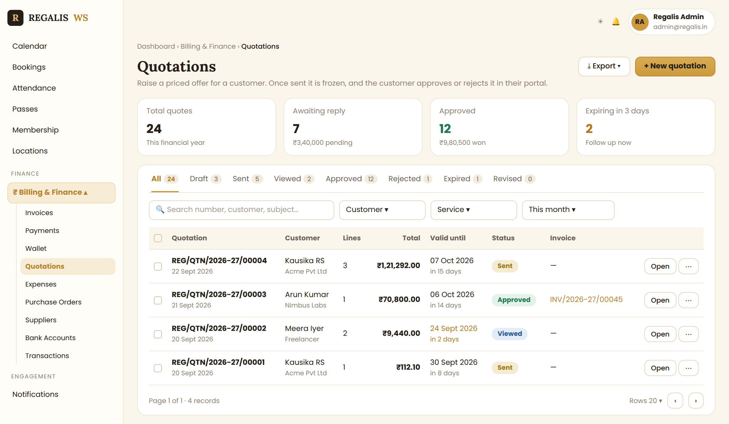
Reference: Quotation list with sidebar placement, summary cards, status tabs, filters and row actions
- Summary cards (4): Total quotes (this financial year) · Awaiting reply (Sent + Viewed, count and ₹ value) · Approved (count and ₹ value) · Expiring in 3 days. Clicking a card filters the table.
- Status tabs replace the current Status dropdown: All · Draft · Sent · Viewed · Approved · Rejected · Expired · Revised, each with a count. Active tab = gold text with a gold underline. Keep the tab in the URL (?status=sent).
- Search by quotation number, reference, customer name, company, mobile or subject. Filters: Customer, Service (Cabin / Desk / Meeting Room / Pass / Other), Date (Today / This week / This month / This FY / Custom).
- Columns: checkbox · Quotation (number + date) · Customer (name + company) · Lines · Total · Valid until (+ "in 8 days", amber when 3 days or less) · Status pill · Invoice (link or —) · Open + ⋯.
- Row ⋯ menu shows only actions allowed for that status: View, Edit (Draft), Send, Download PDF, Clone, Revise, Convert to invoice (Approved), Delete (Draft, red, with confirm).
- Clicking anywhere on the row opens the details page. Export downloads the filtered list as Excel or PDF.
- Empty state: "No quotations yet — create your first quotation for a cabin, desk or meeting room" with a gold New quotation button. Loading: 5 skeleton rows.
- Mobile: each row becomes a card (number + pill, customer, total, valid until, ⋯).

3.2 New Quotation — Customer & Quote Details (Admin)
Clicking "New quotation" opens a full page (not a popup) inside the admin layout, at /admin/billing/quotations/new. The layout copies the Zoho Books "New Quote" screen from top to bottom: labels on the left (200 px), fields on the right, sections separated by thin lines.
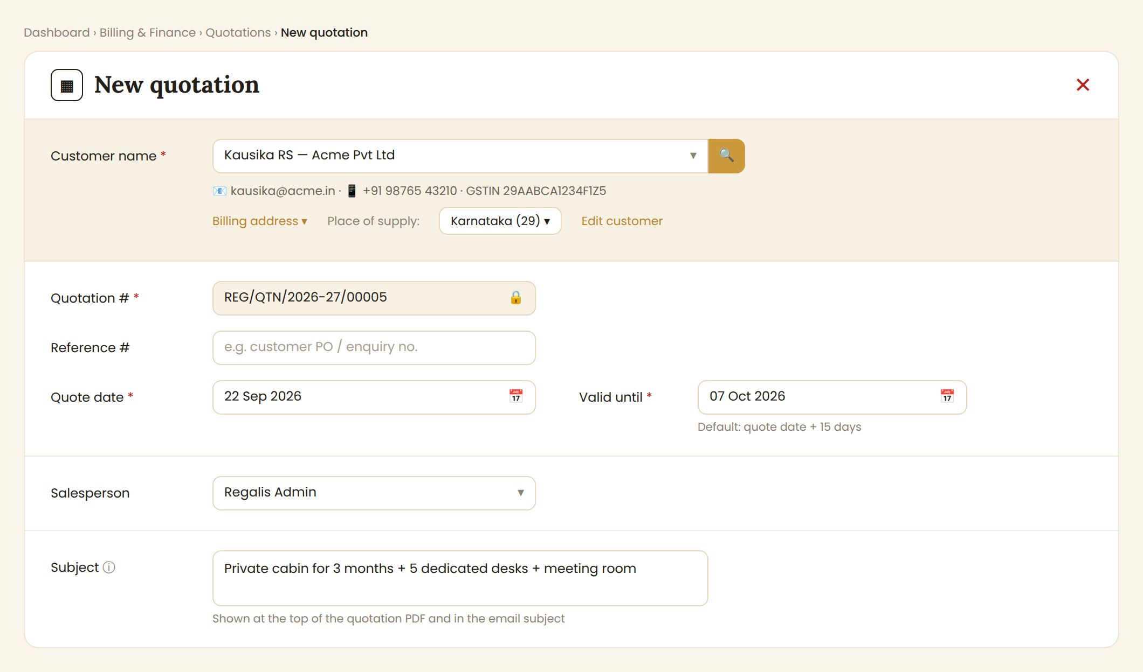
Reference: Header, customer band and quote details (Zoho layout, Regalis colours)
- Header: document icon + serif title "New quotation" (or "Edit quotation …" / "Revise …"). Red ✕ at top right. If there are unsaved changes, ask "Discard changes?" with Keep editing / Discard.
- Customer band (full-width, light gold background): searchable customer dropdown + gold 🔍 button. After selection, show email · mobile · GSTIN underneath, a "Billing address ▾" link, a Place of supply dropdown and an "Edit customer" link.
- Quotation #: read-only, grey background, 🔒 icon, shows the next number as a preview.
- Reference #, Quote date and Valid until on the same row as in Zoho (Quote date left, Valid until right).
- Salesperson dropdown, then Subject textarea with an ⓘ tooltip: "Shown at the top of the quotation PDF and in the email subject".
- Changing the customer after adding lines keeps the lines and recalculates GST, with a small toast "Tax recalculated for the new place of supply".

3.3 New Quotation — Item Table & Totals (Admin)
This is the heart of the form. It works like Zoho's "Item Table", except each line is a workspace service with a duration. The browser shows totals live; the server recalculates and stores the final numbers.
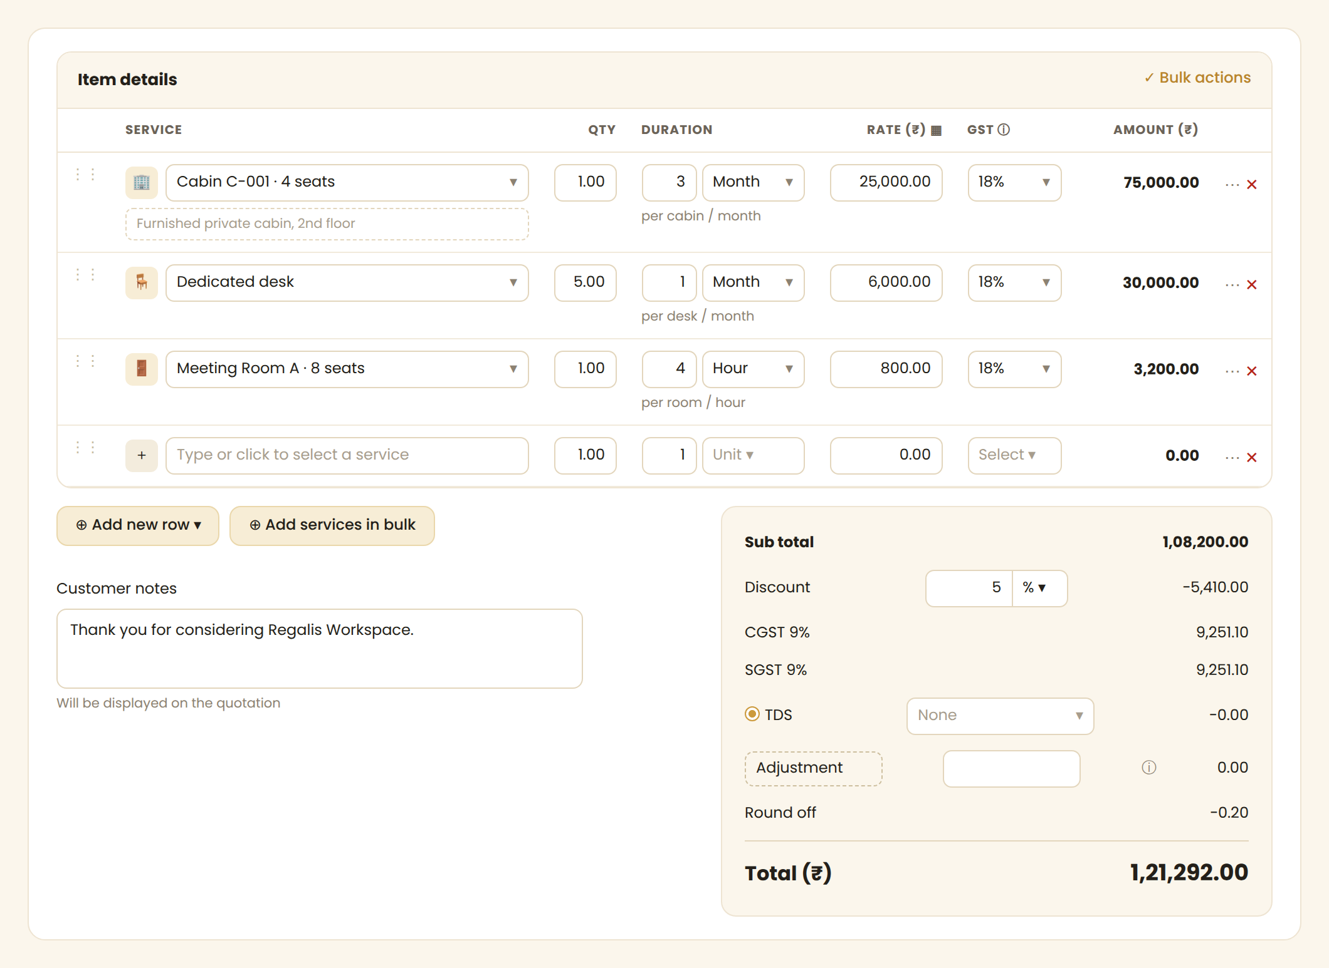
Reference: Item table with Cabin, Desk and Meeting Room lines, plus the totals box
Column | What it does
⋮⋮ (drag) | Drag to reorder lines. Appears on hover
Service | Searchable dropdown grouped by Cabins / Desks / Meeting Rooms / Passes / Other, showing name · seats. Typing an unknown name offers "+ Add as custom line". Optional description box below
Qty | Default 1.00. Locked to 1 for a specific cabin or meeting room (add another line for a second one)
Duration | Number + unit (Hour / Day / Month / One-time). Unit defaults from the service. Hint below: "per cabin / month"
Rate (₹) | Auto-filled from the service price for that unit; editable. If changed, show a small dot with tooltip "Changed from ₹27,000 (standard price)". The ▦ icon applies standard prices to all rows
GST | Dropdown, default 18%. Tooltip: "CGST+SGST inside Karnataka, IGST for other states"
Amount | Read-only, bold: Qty × Duration × Rate
⋯ / ✕ | ⋯ = Duplicate row, Insert above/below, Clear. ✕ = remove row (last row can only be cleared)

- Add new row ▾ adds an empty row; the ▾ offers Add Cabin / Add Desk / Add Meeting Room / Add Header (a bold text-only grouping row).
- Add services in bulk opens a popup with a checklist of all services, search, and a Qty box for each ticked item.
- Bulk actions shows row checkboxes to Delete, Set GST, or Set duration for many rows at once.
- Totals box (right side, light gold background): Sub total · Discount (number + %/₹ toggle) · CGST and SGST rows (or IGST) · TDS radio + rate dropdown · Adjustment (editable dashed label + amount + ⓘ) · Round off · Total (₹) in large bold.
- Customer notes sits on the left, beside the totals box, exactly as in Zoho.
- Maximum 100 lines. At least one line with amount above 0 is required to send.
- Mobile: each line becomes a stacked card; the totals box moves below the lines.

3.4 New Quotation — Terms, Attachments & Action Bar (Admin)
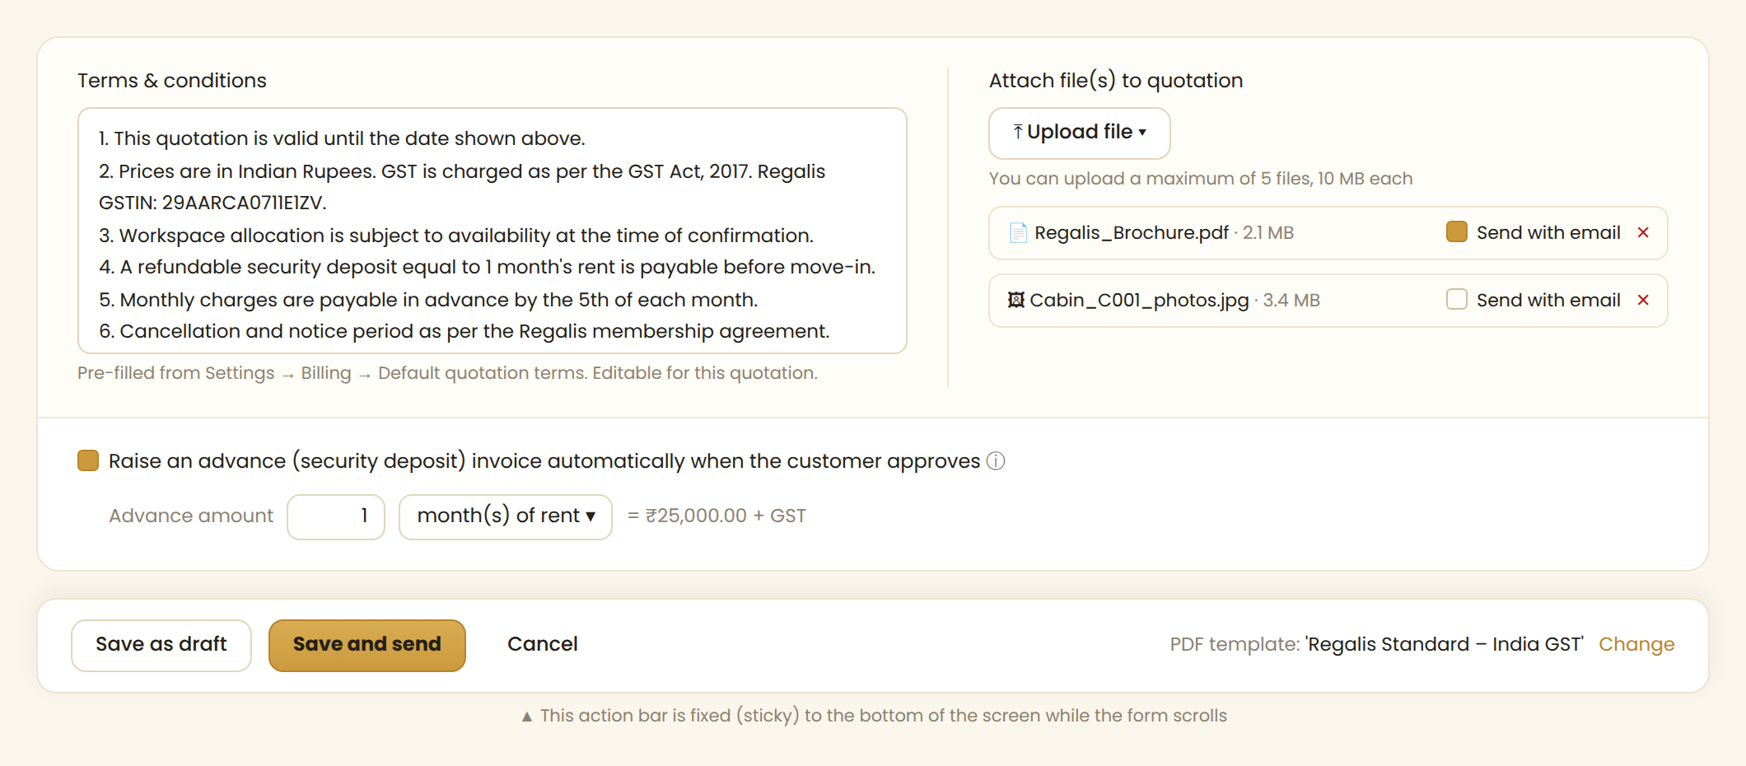
Reference: Terms & conditions, attachments, advance invoice option and the sticky action bar
- Terms & conditions (left, about 55% width): pre-filled from Settings → Billing → Default quotation terms, editable for this quotation. Scrolls inside the box.
- Attach file(s) (right): Upload file button, "maximum of 5 files, 10 MB each". Each file shows as a chip with name, size, a "Send with email" checkbox and ✕.
- Advance invoice checkbox: "Raise an advance (security deposit) invoice automatically when the customer approves". When ticked, show "Advance amount [1] month(s) of rent / fixed ₹". Off by default.
- Sticky action bar fixed to the bottom of the screen: Save as draft (secondary) · Save and send (gold) · Cancel. On the right: "PDF template: 'Regalis Standard – India GST' Change".
- Save as draft only needs a customer. Save and send runs full validation, saves, then opens the Send popup (Section 3.5).
- While saving, show a spinner on the clicked button and disable all three buttons (no double submit). Ctrl/Cmd + S = Save as draft.
- Errors: red border and red message under the field, red banner at the top ("Please fix 2 errors before saving"), and scroll to the first error.

3.5 Send Quotation Popup (Admin)
Opened by "Save and send", or by "Send" on a Draft. One popup handles both channels. Every send also publishes the quotation to the Customer Portal.
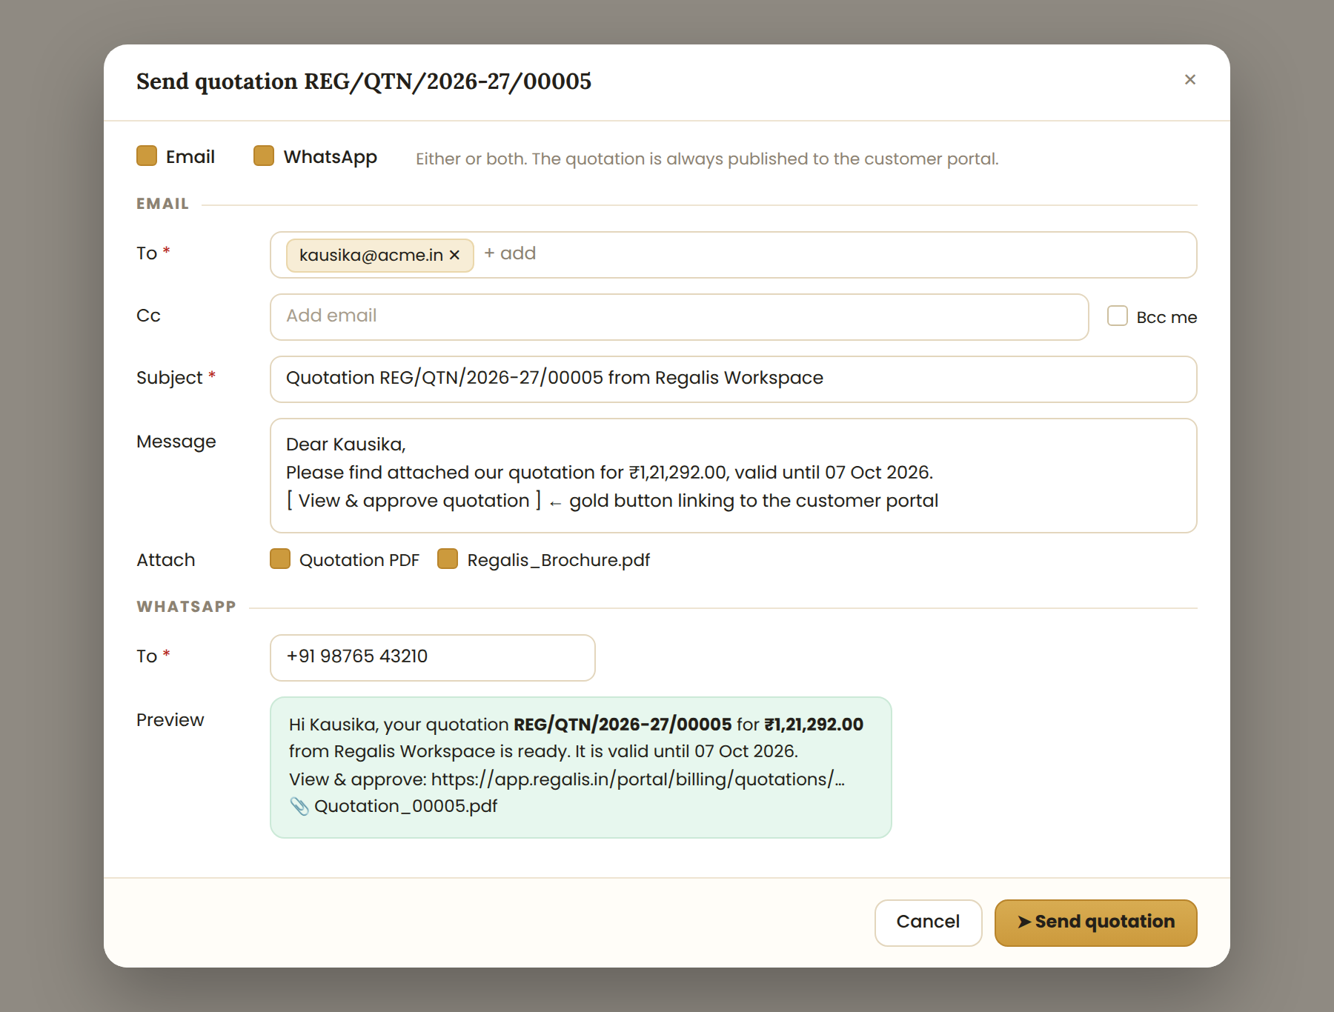
Reference: Send popup with Email and WhatsApp sections
- Channel checkboxes: Email, WhatsApp, or both.
- Email: To (prefilled with the customer email), Cc, Bcc me, Subject and Message (from Settings templates with {customer_name}, {quote_number}, {total}, {valid_until}, {portal_link}), and attachments (quotation PDF + any file marked "Send with email"). The email contains a gold "View & approve quotation" button.
- WhatsApp: To (prefilled mobile, +91 format) and a message preview with the PDF attached. Use the WhatsApp Business API with a pre-approved template named quotation_sent. If no API is set up, fall back to opening a wa.me link with the message and log it as "Shared via WhatsApp (manual)".
- If at least one channel succeeds: status becomes Sent, the PDF is frozen, and a toast confirms "Quotation sent by Email and WhatsApp". If a channel fails, show the error inside the popup with a Retry option.

3.6 Quotation Details (Admin)
Clicking "Open" shows a read-only page: the quotation (as it will look on the PDF) on the left and an Activity timeline on the right, with the allowed actions in a toolbar on top.
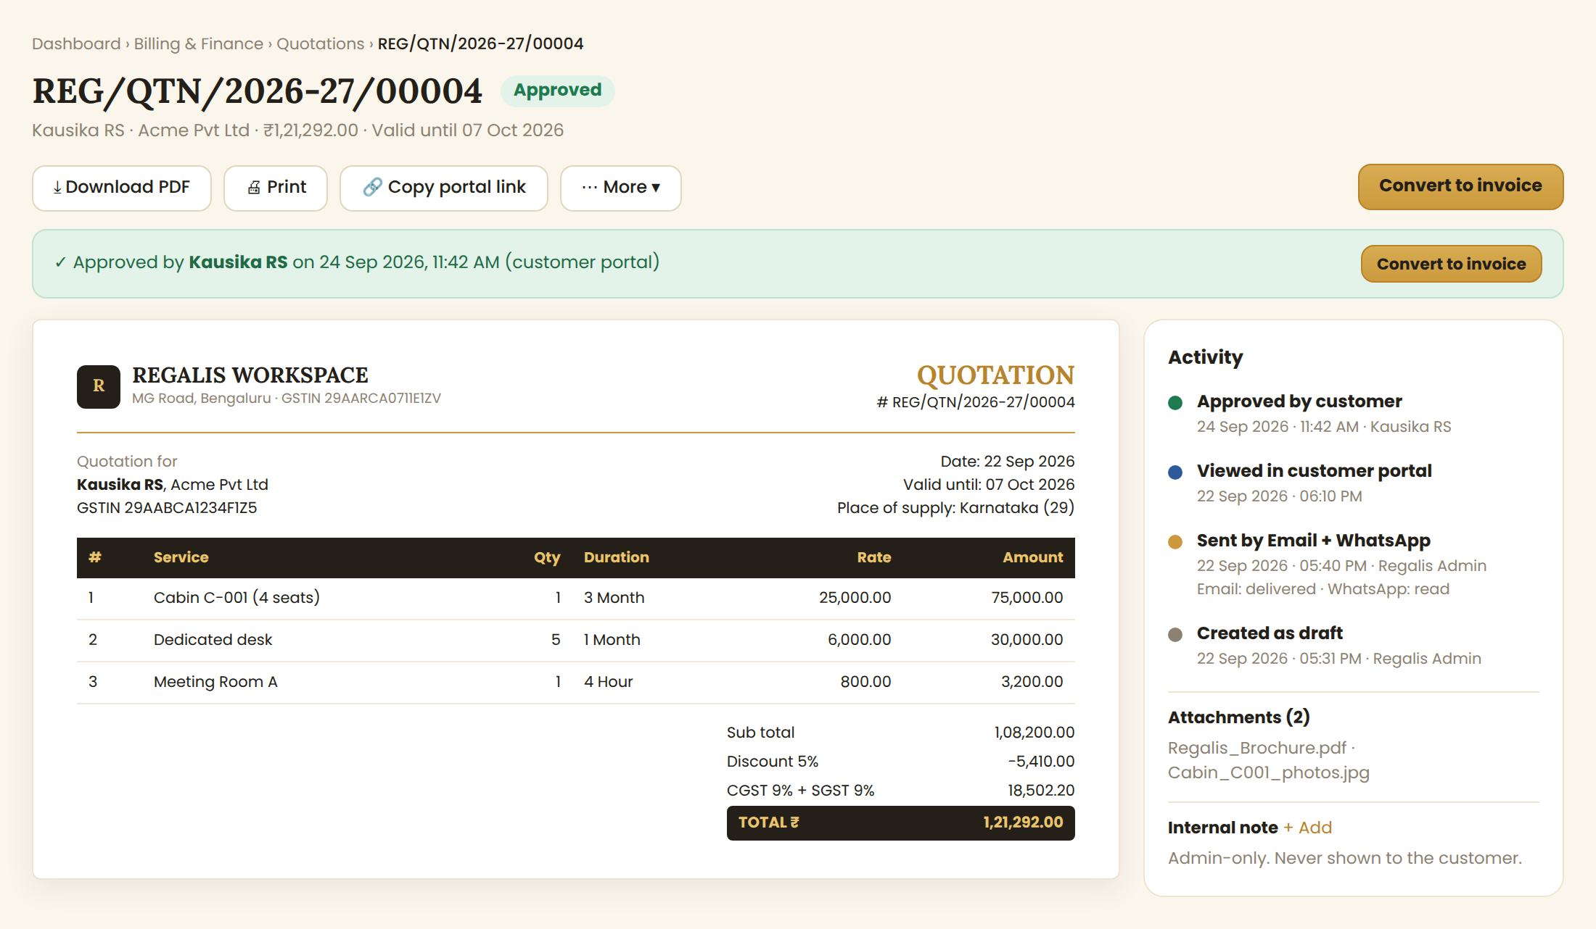
Reference: Quotation details with approval banner, PDF preview and activity timeline
Action | Draft | Sent | Viewed | Approved | Rejected | Expired | Revised
Edit | ✓
Send / Resend | ✓ | ✓ | ✓
Download PDF / Print | ✓ | ✓ | ✓ | ✓ | ✓ | ✓ | ✓
Copy portal link |  | ✓ | ✓ | ✓ | ✓ | ✓
Revise |  | ✓ | ✓ |  |  | ✓
Clone | ✓ | ✓ | ✓ | ✓ | ✓ | ✓ | ✓
Mark approved / rejected on behalf |  | ✓ | ✓
Convert to invoice |  |  |  | ✓
Delete | ✓

- Banner under the toolbar explains the current state: Approved (with Convert to invoice button), Rejected (with reason and Revise button), Expired (Revise / Clone), Revised ("Replaced by …-R1"), Draft ("The customer cannot see it yet").
- Activity timeline: every event with date/time (IST), who did it, and delivery status for Email/WhatsApp (Sent / Delivered / Read / Failed + Retry).
- Mark approved/rejected on behalf of the customer: for phone or in-person confirmation. Ask "Confirmed by", "Mode" (Phone / In person / Email / WhatsApp), note and optional proof file.
- Internal note: admin-only, never shown to the customer or printed.

3.7 Customer Portal — Quotations, Approve / Reject (Customer)
Most customers will arrive from the WhatsApp link on a phone, so this screen is designed mobile-first. The customer must be logged in; the link opens the login page first if needed and then returns to the quotation.
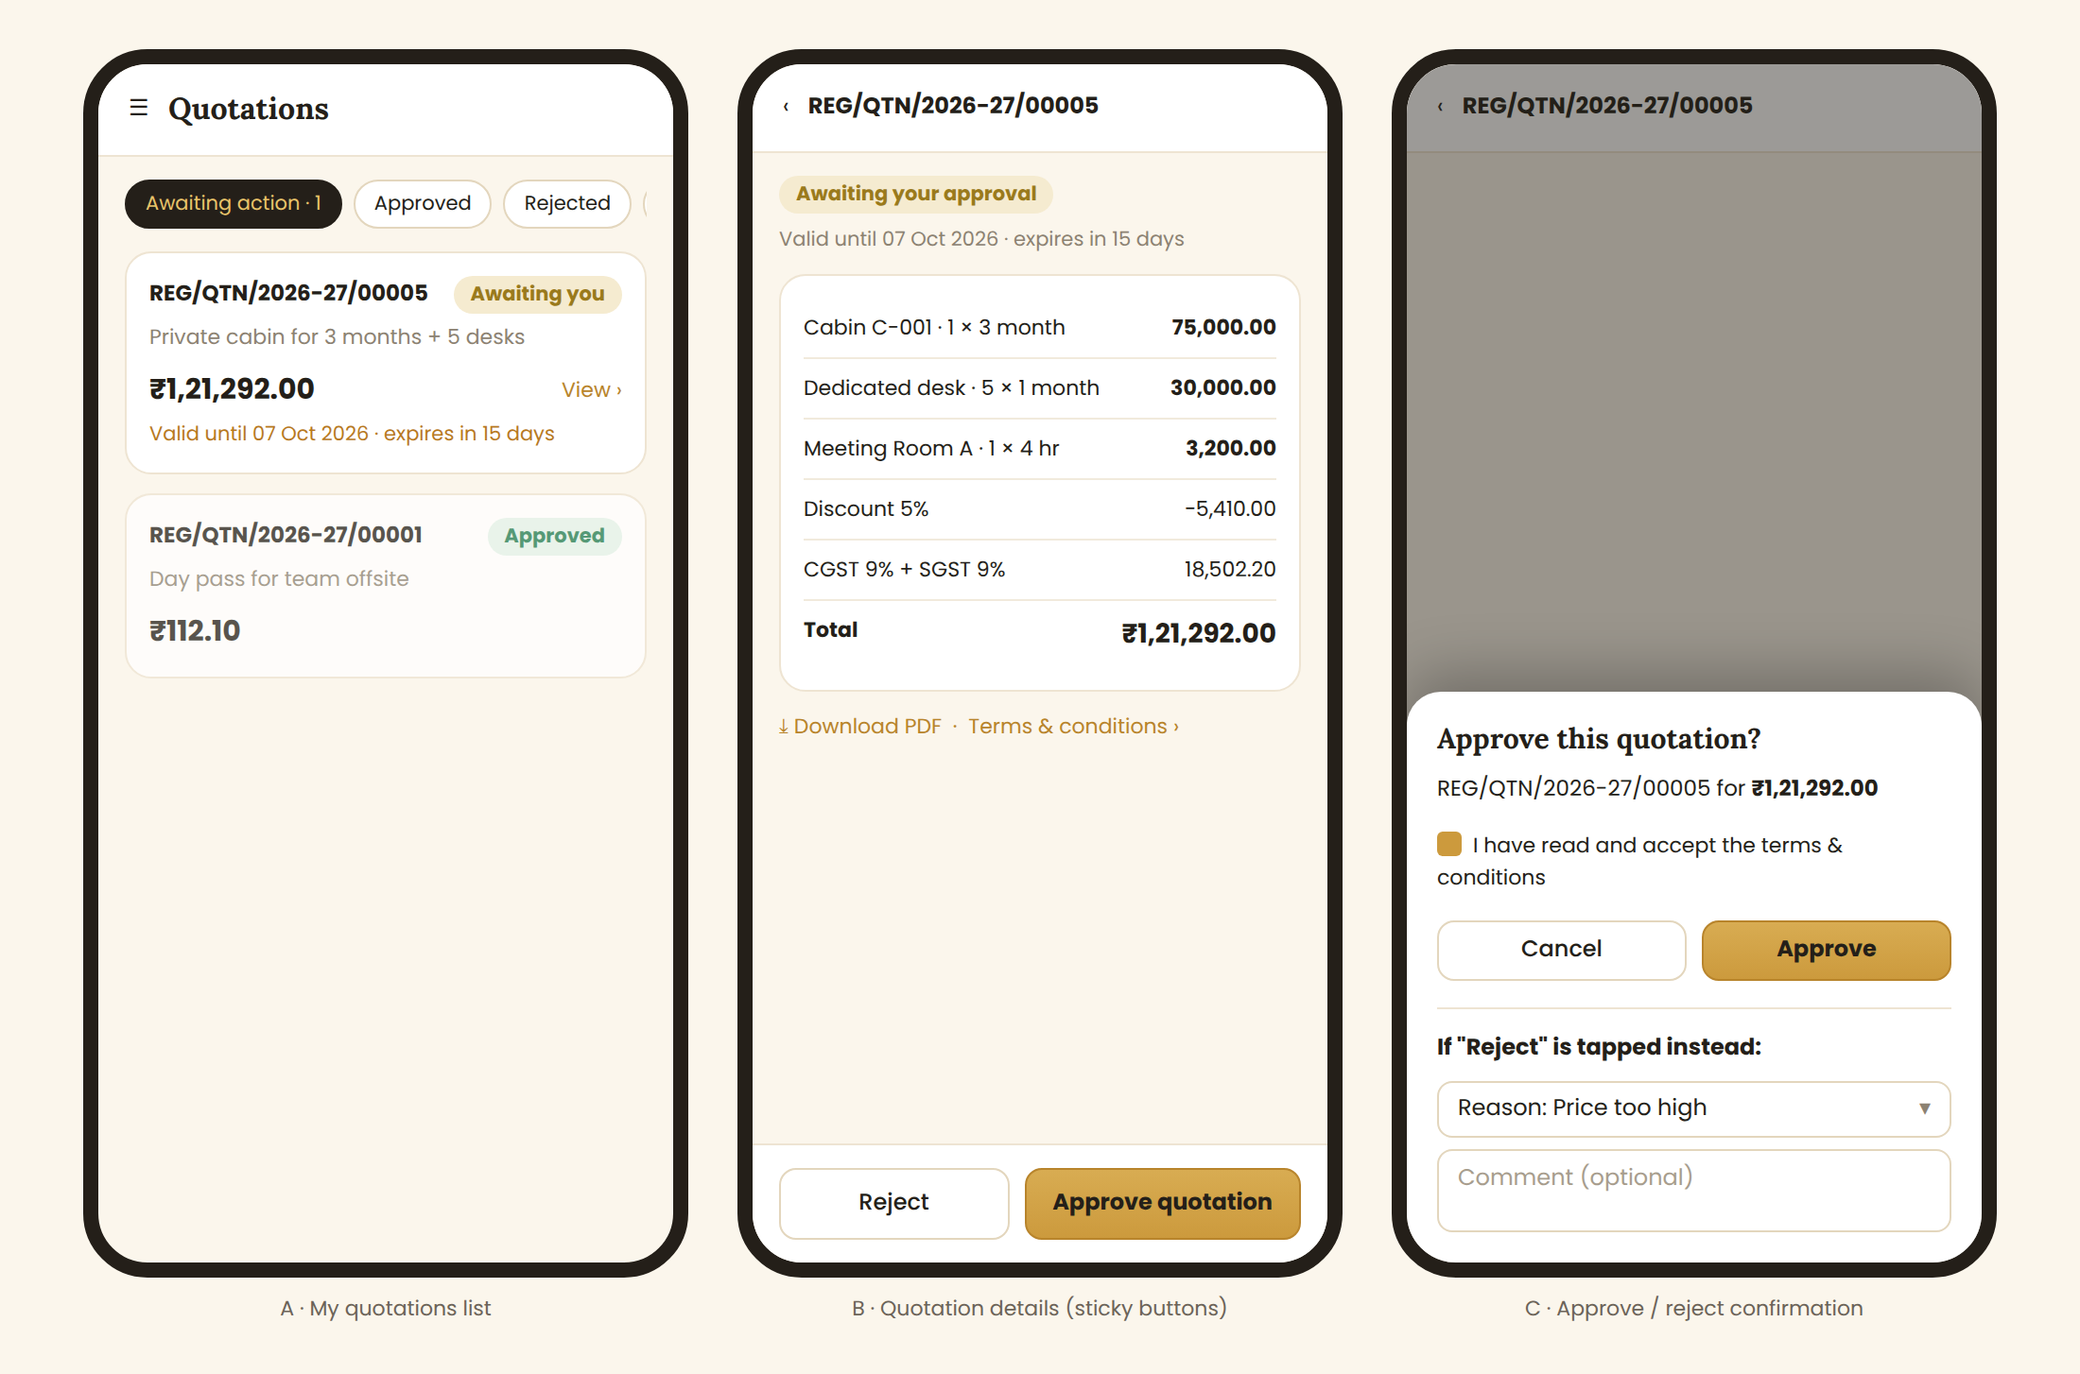
Reference: (A) My quotations list, (B) details with sticky Approve/Reject buttons, (C) confirmation popup
- List tabs: Awaiting action (Sent + Viewed) · Approved · Rejected · Expired. Customer-facing pill wording: "Awaiting your approval" instead of Sent/Viewed, and "Replaced" instead of Revised.
- Details: status pill, valid-until countdown, service lines, discount, GST, total, Download PDF, terms. Approve and Reject buttons are fixed at the bottom of the screen.
- First open of a Sent quotation changes the status to Viewed and notifies the Admin. Opens by the Admin never count.
- Approve popup: "Approve this quotation?" with the amount and a required checkbox "I have read and accept the terms & conditions". Success screen: "Thank you! Your quotation has been approved. Our team will share the invoice shortly."
- Reject popup: reason dropdown (Price too high / Found another space / Requirement changed / Timing not right / Other) and an optional comment (required when "Other").
- No buttons when Approved, Rejected, Expired or Replaced; show a banner instead. Expired shows a "Contact Regalis" button that opens Support/Ticket with the quote number filled in.

3.8 Quotation PDF (Template "Regalis Standard – India GST")
The same PDF is used for the admin preview, download, email attachment and customer portal. Generate it on the server from one HTML template (A4 portrait). All company details come from Settings.
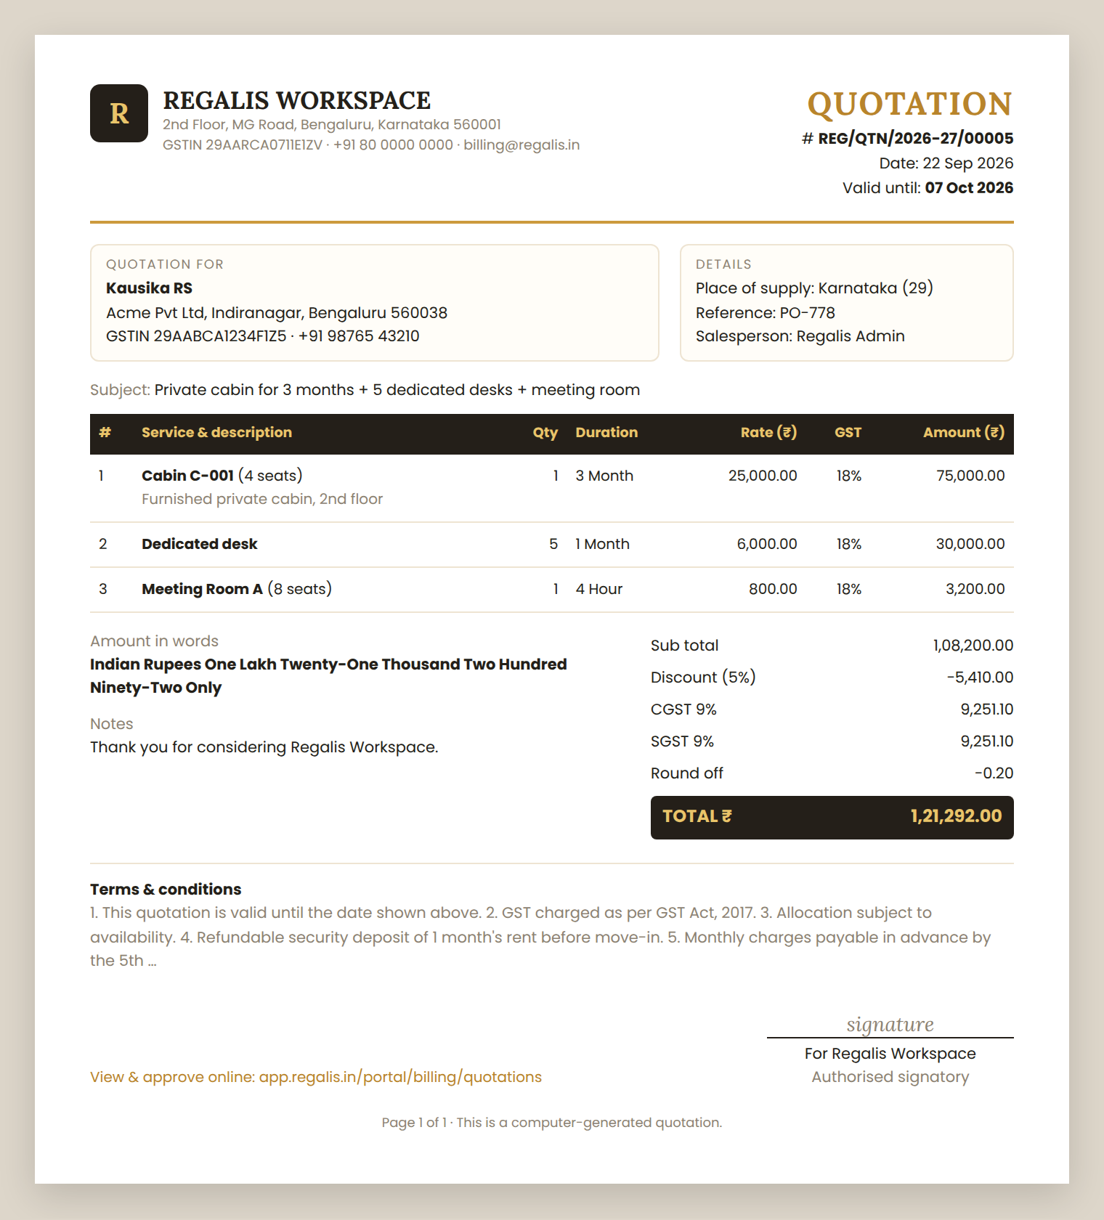
Reference: Quotation PDF layout
- Top: Regalis logo and name, address, GSTIN, phone, email; "QUOTATION" in gold with number, date and valid-until on the right.
- Two boxes: "Quotation for" (customer name, company, address, GSTIN, mobile) and "Details" (place of supply, reference, salesperson).
- Subject line, then the service table with a black header row and gold text.
- Totals on the right: Sub total, Discount, CGST + SGST (or IGST), TDS if any, Adjustment, Round off, and TOTAL ₹ in a black band. Amount in words on the left (Indian system: lakh, crore).
- Notes, Terms & conditions, "View & approve online" link, authorised signatory, and "Page 1 of N · This is a computer-generated quotation".
- Once sent, the PDF file is saved and never regenerated, so the customer's copy never changes.

4. Complete Flow Charts

4.1 Create & Send Flow (Admin)
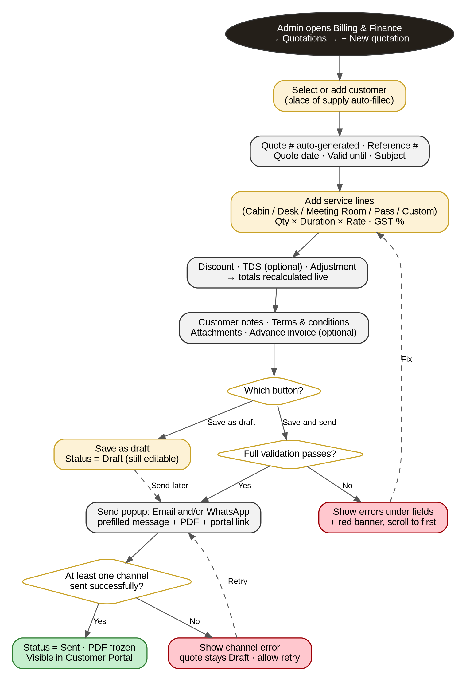
Figure 1 — Creating a quotation, saving it as draft or sending it

4.2 Customer Approval Flow (Customer Portal)
This is how the customer responds to a quotation they received.
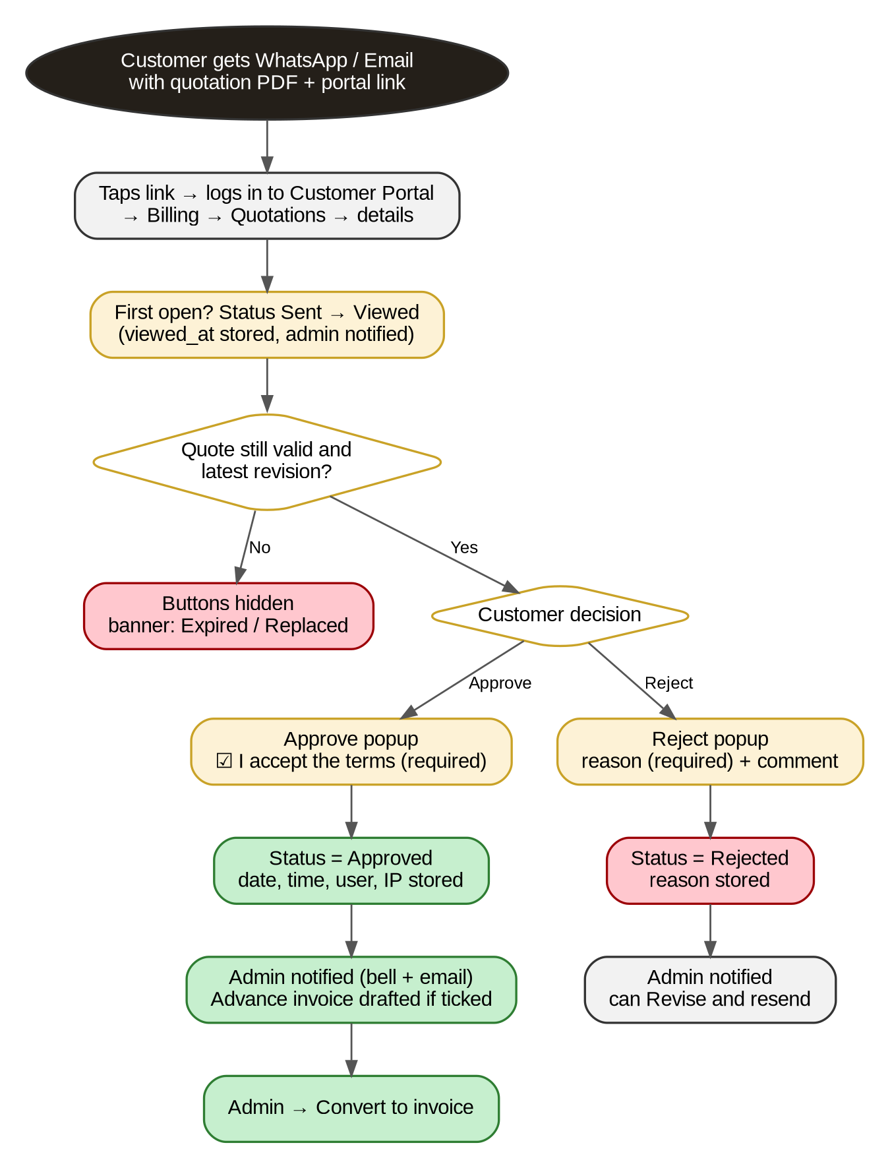
Figure 2 — Customer views, approves or rejects the quotation

4.3 Quotation Status Lifecycle
How a quotation's status changes over time. This drives the status pill in the admin list, the customer portal and the reports. Dashed arrows are Admin actions.
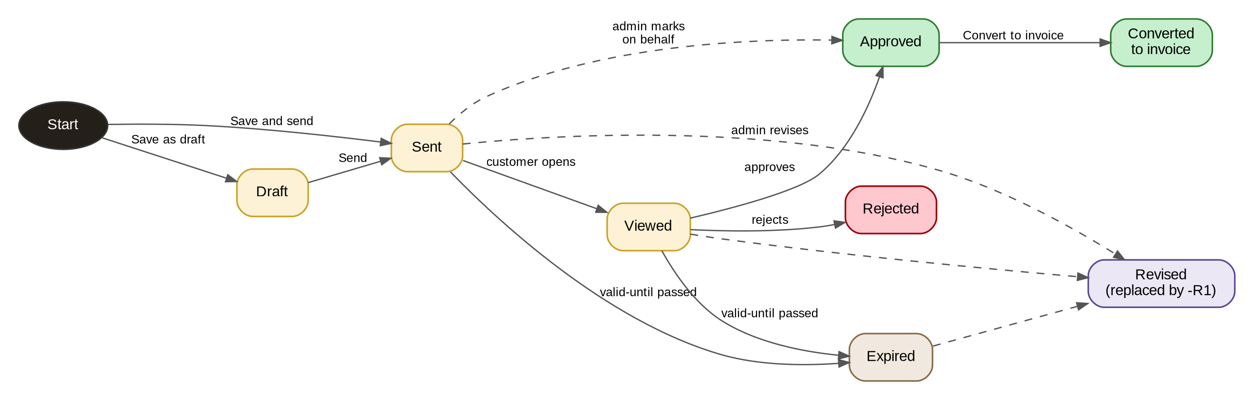
Figure 3 — Status states a quotation moves through
NOTE: Approved, Rejected, Expired and Revised are final states. To offer new prices or terms, the Admin uses Revise (creates -R1) or Clone (new number). Only the newest revision can be approved.

4.4 Convert to Invoice Flow
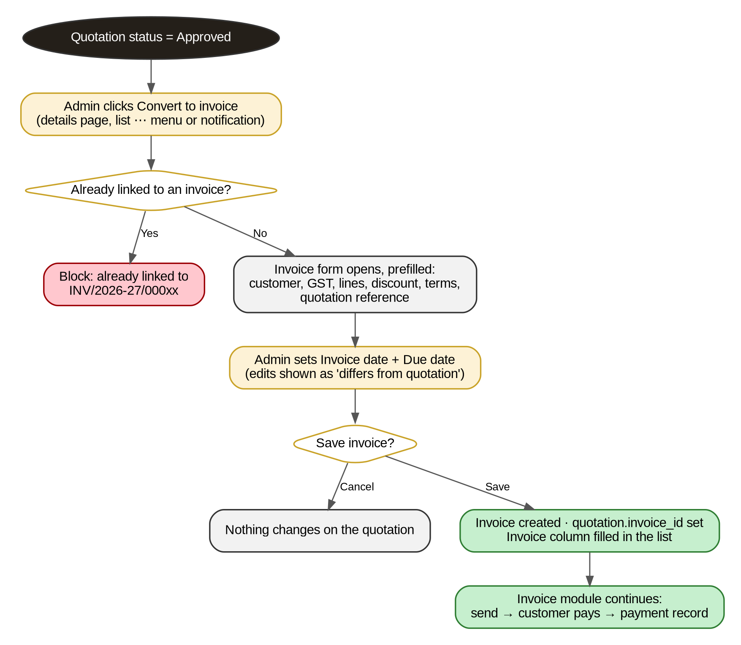
Figure 4 — Turning an approved quotation into an invoice

5. Data Model & Business Rules

5.1 Suggested Data Model
If quotation tables already exist in the codebase, extend them rather than creating duplicates.
Entity | Key Fields
Quotation | id, quote_number (unique), financial_year, revision_of_id, revision_no, customer_id, salesperson_id, reference_no, subject, quote_date, valid_until, status, place_of_supply_state_code, customer_gstin, billing_address (snapshot), tax_mode (intra/inter), discount_type, discount_value, tds_rate_id, adjustment_label, adjustment_amount, sub_total, discount_total, taxable_total, cgst_total, sgst_total, igst_total, tds_amount, round_off, grand_total, customer_notes, terms, internal_note, advance_invoice_enabled, advance_type, advance_value, pdf_file_path, sent_at, viewed_at, approved_at, rejected_at, expired_at, decision_by_user_id, decision_ip, decision_on_behalf, reject_reason, reject_comment, invoice_id, created_by, updated_by, timestamps
QuotationItem | id, quotation_id, sort_order, line_type (service/custom/header), service_type (cabin/desk/meeting_room/pass/other), workspace_id, name, description, qty, duration, duration_unit (hour/day/month/one_time), rate, standard_rate, gst_rate, amount, discount_share, taxable, cgst, sgst, igst, start_at, end_at (optional booking dates)
QuotationAttachment | id, quotation_id, file_name, file_path, mime, size_bytes, send_with_email, uploaded_by
QuotationEvent (audit log) | id, quotation_id, event (created, updated, sent_email, sent_whatsapp, viewed, approved, rejected, expired, revised, cloned, converted, note_added, deleted), actor_type (admin/customer/system), actor_id, meta (JSON), created_at
DocumentSequence | doc_type (QTN), financial_year, last_number. Lock the row (SELECT … FOR UPDATE) when issuing a number

5.2 Calculation Rules
- Line amount = Qty × Duration × Rate. Sub total = sum of line amounts.
- Discount is applied before GST and split across lines in proportion to their amount (the last line takes any paisa difference).
- Taxable per line = line amount − its discount share. GST per line = taxable × GST rate, rounded to 2 decimals.
- Karnataka (code 29): CGST = SGST = GST ÷ 2. Other states: IGST = GST.
- TDS = total taxable × TDS rate (shown as minus). Total = taxable + GST − TDS + adjustment + round off.
- Store money as DECIMAL(14,2), never float. The server always recalculates; totals sent from the browser are ignored.
Worked example (customer in Karnataka, 5% discount, 18% GST, no TDS). Use this as a unit test:
Line | Qty × Duration × Rate | Amount | Discount 5% | Taxable | GST 18%
Cabin C-001 | 1 × 3 Month × ₹25,000 | ₹75,000.00 | ₹3,750.00 | ₹71,250.00 | ₹12,825.00
Dedicated desk | 5 × 1 Month × ₹6,000 | ₹30,000.00 | ₹1,500.00 | ₹28,500.00 | ₹5,130.00
Meeting Room A | 1 × 4 Hour × ₹800 | ₹3,200.00 | ₹160.00 | ₹3,040.00 | ₹547.20
Totals |  | ₹1,08,200.00 | ₹5,410.00 | ₹1,02,790.00 | ₹18,502.20
CGST 9% = ₹9,251.10 and SGST 9% = ₹9,251.10. Total before rounding = ₹1,21,292.20, round off −₹0.20, so Total = ₹1,21,292.00. The existing quotation REG/QTN/2026-27/00001 also checks out: ₹95.00 + 18% GST = ₹112.10.

5.3 Business Rules
- Quotation numbers are unique and continuous per financial year (April–March): REG/QTN/2026-27/00001, 00002 … They restart at 00001 on 1 April. Deleted draft numbers are not reused.
- Only Drafts can be edited or deleted. Sent quotations are frozen in the UI and the API (return 409 if someone tries).
- Customer details (address, GSTIN, state) and prices are saved as a snapshot when sent. Later changes to the customer or the price list do not change a sent quotation.
- A quotation can be approved until 23:59:59 IST on its valid-until date. The daily job marks it Expired at 00:05 IST the next day. The Approve API also checks the date itself.
- Only the latest revision can be approved. If the customer and Admin act at the same moment, whichever is saved first wins.
- Approve and Reject store date, time, customer user ID, IP address and (for reject) the reason.
- A rejected or expired quotation never creates an invoice automatically.
- Convert to invoice works only for Approved quotations, only once, and copies every value. The invoice stores the quotation reference.
- Customers see only their own non-draft quotations. Another customer's quotation returns 404 (not 403).
- Every action is written to the QuotationEvent audit log with who, when and what changed.
- Notifications: Admin is notified on Viewed, Approved, Rejected and Expired. Customer and salesperson get a reminder 2 days before expiry.

5.4 Validation Messages
Field | Rule | Message
Customer | Required | Select a customer.
Valid until | On or after quote date | Valid-until date must be on or after the quote date.
Service lines | At least one line with amount > 0 | Add at least one service.
Service | Required on every filled row | Select a service or remove this row.
Qty / Duration | Greater than 0 | Must be greater than 0.
Rate | 0 or more | Rate cannot be negative.
Discount | Not more than sub total | Discount cannot be more than the sub total.
Total | 0 or more | Total cannot be negative. Check the discount and adjustment.
Email / WhatsApp | Valid when channel ticked | Enter a valid email address. / Enter a valid WhatsApp number.
Attachments | Max 5 files, 10 MB each | Maximum 5 files of 10 MB each.

6. Open Items — Confirm Before / While Building
This document makes reasonable assumptions so it can be built immediately. Flag these to the Project Manager rather than guessing silently.
# | Assumption Made Here | Needs Confirmation
1 | Default validity = 15 days from quote date | Exact number of days Regalis wants
2 | Default GST = 18% for all workspace services | Confirm with the accountant
3 | TDS is an optional row (default None); TCS from Zoho is not included, as it applies to goods | Whether TDS should appear at all on quotations
4 | Advance (security deposit) invoice option = 1 month's rent, off by default | Deposit amount and whether it should be automatic
5 | WhatsApp uses the Business API with a pre-approved template; wa.me link as fallback | Which WhatsApp provider/account Regalis uses
6 | Single office, so no Location field (Zoho "Project Name" dropped) | Same as the Day Pass decision
7 | Customer must log in to approve (no login-free approval link) | Confirm this is acceptable for customers

7. Summary For The Developer
If you only read one paragraph of this document, read this one:
NOTE: Rebuild the Quotation page as a full-page, Zoho Books-style form in the Regalis cream-and-gold theme, for a SINGLE office. The Admin picks a customer, adds service lines (Cabin / Desk / Meeting Room / Pass / Custom) with Qty × Duration × Rate and GST, applies discount, and clicks Save and send. The quotation goes out by WhatsApp and/or Email with a PDF and a portal link, and is frozen from that moment. The customer approves or rejects it in the Customer Portal, the Admin is notified, and an approved quotation converts to an invoice in one click without re-typing. Numbering (REG/QTN/2026-27/00001), GST split (CGST+SGST in Karnataka, IGST elsewhere), statuses and all totals are handled by the server. Everything else in this document exists to support that one flow correctly.

