REGALIS WORKSPACE
Purchase Order — Complete Feature Specification
Single-feature build document for the development team — Zoho Books-style layout, Regalis theme
Module: Purchase Orders (Admin Portal)
Menu: Billing & Finance → Purchase orders
Project Manager: Kausika
Design reference: Zoho Books "New Purchase Order" screen (layout only)
Document Version: 1.0 — September 2026

How To Use This Document
This document is self-contained. It describes ONE feature (Purchase Orders) end to end: what it does, what it looks like, every field it needs, and the exact flows a developer should build. It can be handed to Claude on its own, together with the existing Regalis codebase.
- Section 1 explains the feature in plain terms and what changes from the current popup.
- Section 2 is the master list of fields, tax options and statuses.
- Section 3 shows every screen with a design reference image, described field by field.
- Section 4 has the 3 flow charts: create and send, receive and bill, and the status lifecycle.
- Section 5 lists the data model, calculation rules and business rules.
- Section 6 lists open questions to confirm with the Project Manager.
- Section 7 is a one-paragraph summary for the developer.
NOTE: Build this inside the existing app. Reuse the current admin layout, sidebar, table component, form inputs, buttons and colour variables. The Purchase orders menu item and list page already exist; this document replaces the create popup with a full page and upgrades the list, details and receiving flow.
NOTE: The live UI design for these screens is on the Regalis Purchase Order design canvas. The images in Section 3 are taken from it; open the canvas to inspect exact spacing, colours and text.

1. What Is a Purchase Order? (Overview)
A purchase order (PO) is an order Regalis sends to a supplier for goods or services: pantry stock, furniture, stationery, housekeeping supplies, AMC work and so on. The admin creates it, sends it to the supplier, receives the goods when they arrive, and finally records the supplier bill against it. It is the buying side of the app, the mirror image of a quotation.
One purchase order can contain many items. For example a single PO to a furniture supplier may hold 6 mesh chairs and 4 work desks, each with its own quantity, rate and GST rate.
NOTE: Once a PO is SENT to the supplier it is frozen and can no longer be edited. From that point it can only be received, cancelled, or closed. This prevents a PO from being changed after the supplier has already acted on it.
NOTE: Regalis operates from a SINGLE office, so there is no location picker. The office address is used as the delivery address, and a "Change delivery address" link covers the rare case of a delivery going elsewhere.

1.1 What Is Wrong With the Current Screen
The current "New purchase order" is a small centred popup. These problems must be fixed by the redesign:
Problem today | Fix in this document
The popup scrolls inside its own scrolling box | A full page inside the admin layout, with a sticky action bar
Only one item can be entered | A real item table with many rows, drag to reorder, add and remove rows
No totals at all | Totals box: sub total, discount, TDS, CGST/SGST or IGST, adjustment, grand total
No PO number shown | Auto number REG/PO/2026-27/00001, same pattern as quotations
No supplier details after selection | Supplier band showing email, phone, GSTIN, state and the supplier address
Overlapping label under "Item name" | Rebuilt form layout, labels above fields on a clean grid
No statuses, no receiving, no bill link | Status flow Draft → Sent → Partially received → Received → Billed, with a Receive items screen

1.2 Where It Lives
- Sidebar → FINANCE → Billing & Finance → Purchase orders (the item already exists).
- List page: `/admin/billing/purchase-orders`. New PO: `/purchase-orders/new`. Edit draft: `/purchase-orders/:id/edit`. Details: `/purchase-orders/:id`.
- Purchase orders are admin-only. They never appear in the Customer Portal.

2. Fields, Options and Statuses
Every row below must exist as a real, working control in the UI.

2.1 Header Fields
Field | Required | Default | Notes
Supplier name | Yes | — | Searchable dropdown with a gold search button. Last option "+ New supplier" opens a drawer (name, company, mobile, email, address, GSTIN, state). After selection, show email, phone, GSTIN and state
Supplier address | Yes (auto) | From the supplier record | Read-only block under the supplier details. Shown on the PO PDF as the "To" address
Deliver to | Yes (auto) | Regalis Workspace office address | Shown under the supplier address. A "Change delivery address" link allows a one-off address for this PO
Purchase order # | Yes (auto) | Next number | REG/PO/{FY}/{5 digits}, read-only, assigned by the server on first save
Reference # | No | Empty | Supplier quotation or internal indent number, max 50 characters
Date | Yes | Today | Date picker, dd MMM yyyy
Expected delivery | No | Empty | Drives the Overdue flag and the delivery reminder
Shipment preference | No | Supplier delivery | Supplier delivery / Courier / Pickup by Regalis
Reverse charge | No | Off | Checkbox: "This purchase is applicable for reverse charge". For unregistered suppliers
Notes | No | Empty | Printed on the PO PDF for the supplier
Terms & conditions | No | From Settings | Editable for this PO
Attachments | No | — | Maximum 10 files, 10 MB each (PDF, JPG, PNG, DOCX, XLSX)
NOTE: Payment terms has been REMOVED from this form by the Project Manager. Payment timing is handled on the supplier bill, not on the purchase order. Do not add a Payment terms field.

2.2 Item Line Fields
Column | Rules
Item details | Searchable dropdown of stock and non-stock items, with an optional description line. Typing an unknown name offers "+ Add as new item"
Account | Expense or asset account this item is booked to: Pantry & supplies, Office supplies, Furniture & fixtures, Repairs & maintenance, Housekeeping, Other. Comes from the item, and is editable
Quantity | Number, 2 decimals, greater than 0
Rate (₹) | Auto-filled from the item's last purchase price; editable
GST | 0%, 5%, 12%, 18%, 28%, Exempt, Non-GST. Default from the item
Amount | Read-only: Quantity × Rate
Row actions | ⋯ menu (duplicate, insert above/below, clear) and ✕ to remove. Drag handle to reorder. Maximum 100 rows

2.3 Tax and Totals
Option | Rule
GST split | Supplier in Karnataka (state code 29): CGST + SGST, half each. Supplier in another state: one IGST row
Reverse charge ticked | GST is shown for information but not added to the payable total; the PDF prints "Tax payable under reverse charge"
Discount | % or ₹ on the whole PO, applied before GST and split across lines in proportion to their amount
TDS | Optional deduction on the value before GST: None / 194C Contractor 2% / 194J Professional 10%, from Settings
Adjustment | Editable label (default "Rounded") and a positive or negative amount
Total | Taxable + GST − TDS + adjustment

2.4 Statuses
Status | Set by | When | Editable?
Draft | Admin | Saved with "Save as draft" | Yes
Sent | System | Sent to the supplier, or marked as sent | No
Partially received | System | Some but not all ordered quantity received | No
Received | System | All ordered quantity received | No
Billed | System | A supplier bill is recorded against the PO | No
Cancelled | Admin | Cancelled before or during delivery, with a reason | No
Closed | Admin | Short delivery accepted; remaining quantity written off | No

3. Screens — What It Should Look Like
Theme: warm cream background, gold/amber accent, white cards with soft rounded corners, a serif font for page titles and a clean sans-serif for body text. Colors: background #FBF6EC, card #FFFFFF, border #E6DAC2, gold accent #CC9A3D, gold-deep #A8761B, ink/text #241F19, muted grey #6E6559. Required fields show a red asterisk only. Status pills: Draft #EEEAE3/#5B554C, Sent #F5EBD0/#8A6A14, Partially received #E4ECF7/#2E5A99, Received #E3F3EA/#1A6B45, Billed #ECE7F5/#51418A, Cancelled #FBE7E5/#9E2016.

3.1 New Purchase Order (full page)
This replaces the current popup. It is a full page inside the admin layout at /admin/billing/purchase-orders/new, laid out top to bottom exactly as shown.
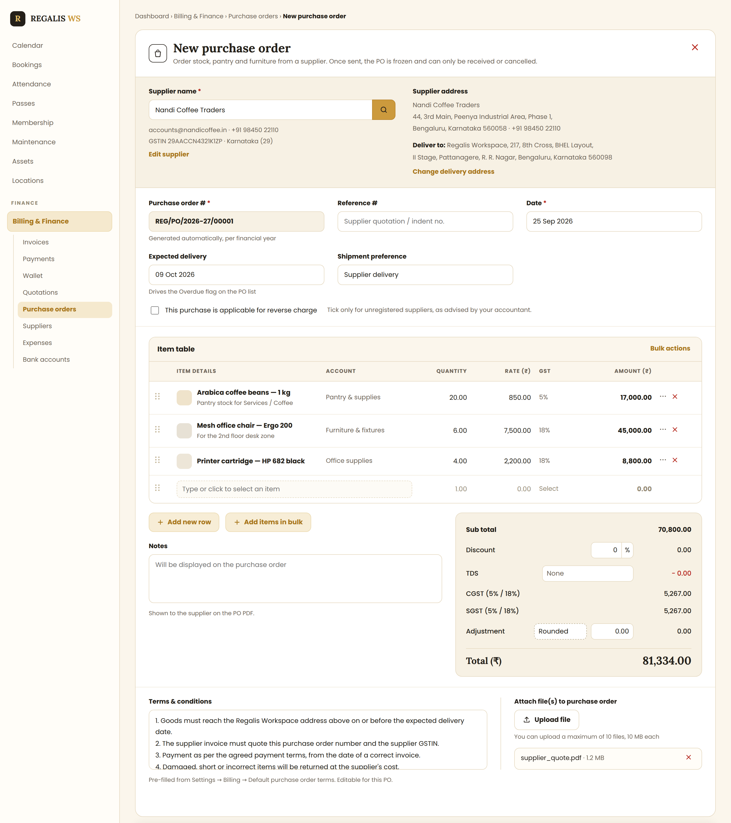
Reference: New purchase order — supplier band, header fields, item table, totals, terms and sticky action bar
- Header: bag icon, serif title "New purchase order", one line of help text, and a red ✕ that asks "Discard changes?" when the form is dirty.
- Supplier band (light gold): supplier dropdown with the gold search button, supplier email, phone, GSTIN and state below it, an "Edit supplier" link; on the right, Supplier address, then the Deliver to address and a "Change delivery address" link.
- Header fields on a three-column grid: Purchase order # (read-only, grey), Reference #, Date, Expected delivery, Shipment preference; then the reverse-charge checkbox with its help text.
- Item table: columns Item details, Account, Quantity, Rate, GST, Amount, with a drag handle, a ⋯ menu and a ✕ per row, plus one always-empty row at the bottom. "Add new row" and "Add items in bulk" sit under the table.
- Totals box on the right: Sub total, Discount (value + % or ₹), TDS, CGST and SGST (or IGST), Adjustment (editable label, default "Rounded") and the grand total in large serif type.
- Notes on the left beside the totals; Terms & conditions and Attach file(s) in a 60/40 split below.
- Sticky action bar: Save as draft · Save and send to supplier (gold) · Cancel, with the PDF template name and a Change link on the right.
- Mobile: fields go one per row and each item line becomes a stacked card; the action bar stays fixed at the bottom.

3.2 Purchase Orders List
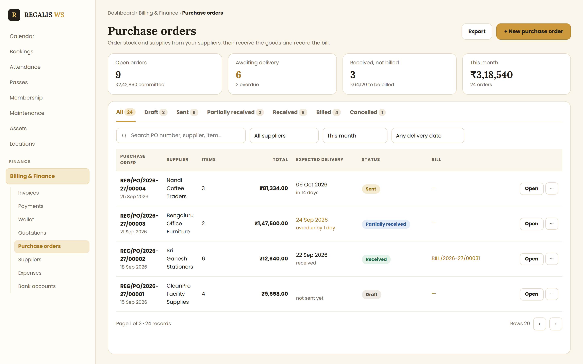
Reference: Purchase orders list with summary cards, status tabs, filters and row actions
- Summary cards: Open orders (count and committed value) · Awaiting delivery (with overdue count in amber) · Received, not billed · This month.
- Status tabs with counts: All, Draft, Sent, Partially received, Received, Billed, Cancelled.
- Filters: search (PO number, supplier, item), supplier, date range, and delivery ("Any delivery date" / "Overdue only").
- Columns: Purchase order (number + date), Supplier, Items, Total, Expected delivery (with "in 14 days" or "overdue by 1 day" in amber), Status pill, Bill (bill number or —), Open + ⋯.
- Row ⋯ menu by status: View, Edit (Draft), Send, Download PDF, Receive items, Convert to bill, Clone, Cancel, Delete (Draft only).
- Empty state: "No purchase orders yet — raise your first order for pantry, furniture or supplies."

3.3 Purchase Order Details
Read-only page showing the PO as it will print, with an activity timeline on the right and the actions allowed for the current status on top.
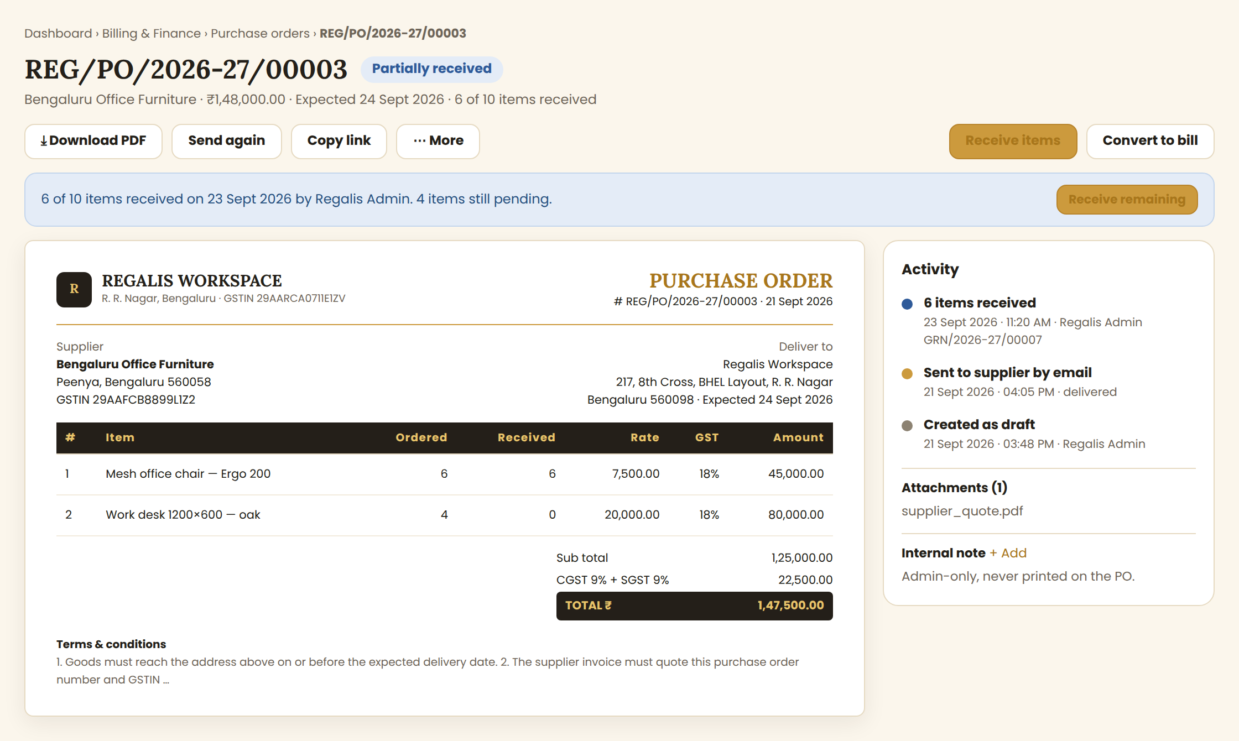
Reference: Purchase order details with receiving banner, PO preview and activity timeline
- Header: PO number, status pill, supplier, total, expected delivery and "6 of 10 items received".
- Toolbar: Download PDF, Send again, Copy link, ⋯ More; on the right the gold Receive items and Convert to bill buttons.
- Banner explains the current state, for example part-received with a "Receive remaining" button, or cancelled with the reason.
- The preview shows the PO PDF layout: Regalis header and GSTIN, supplier block, deliver-to block, item table with Ordered and Received columns, totals, terms, and an authorised signatory line.
- Activity timeline: created, sent (with delivery status), each receipt with its GRN number, bill created, cancelled. Attachments and an admin-only internal note sit below it.

3.4 Receive Items
Opened from the details page or the list ⋯ menu. This is the screen that turns a PO into stock.
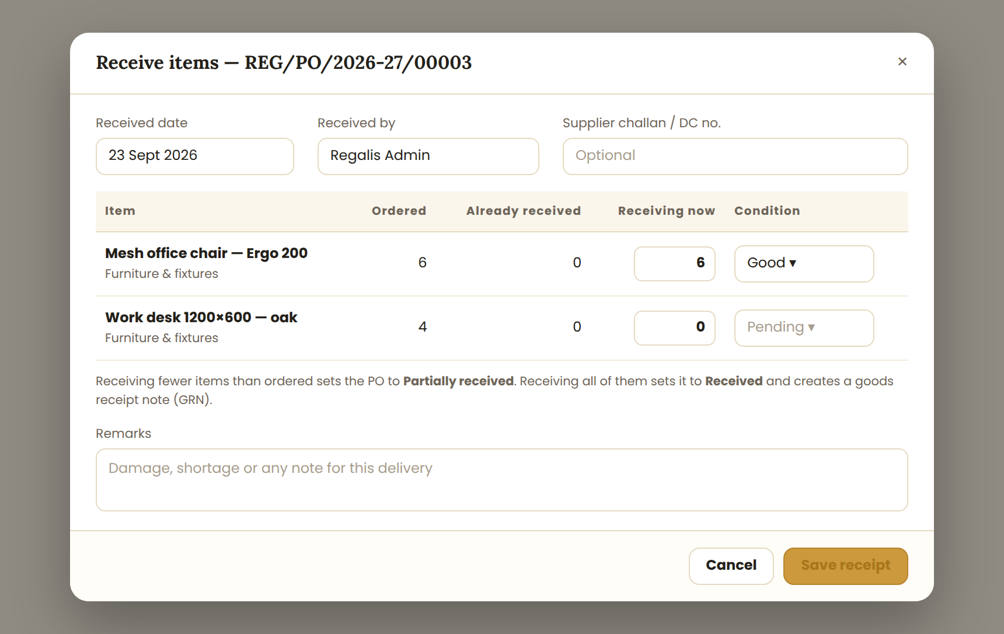
Reference: Receive items popup with per-item received quantity
- Fields: Received date, Received by, supplier challan / DC number (optional), and Remarks.
- One row per item: Ordered, Already received, Receiving now (editable), and Condition (Good / Damaged / Pending).
- Receiving part of the order sets Partially received; receiving everything sets Received and creates a goods receipt note (GRN) number.
- Over-receiving is blocked: "Receiving now cannot be more than the pending quantity."
- Stock items update the Assets / Inventory module with the received quantity and the rate from the PO.

4. Complete Flow Charts

4.1 Create and Send Flow
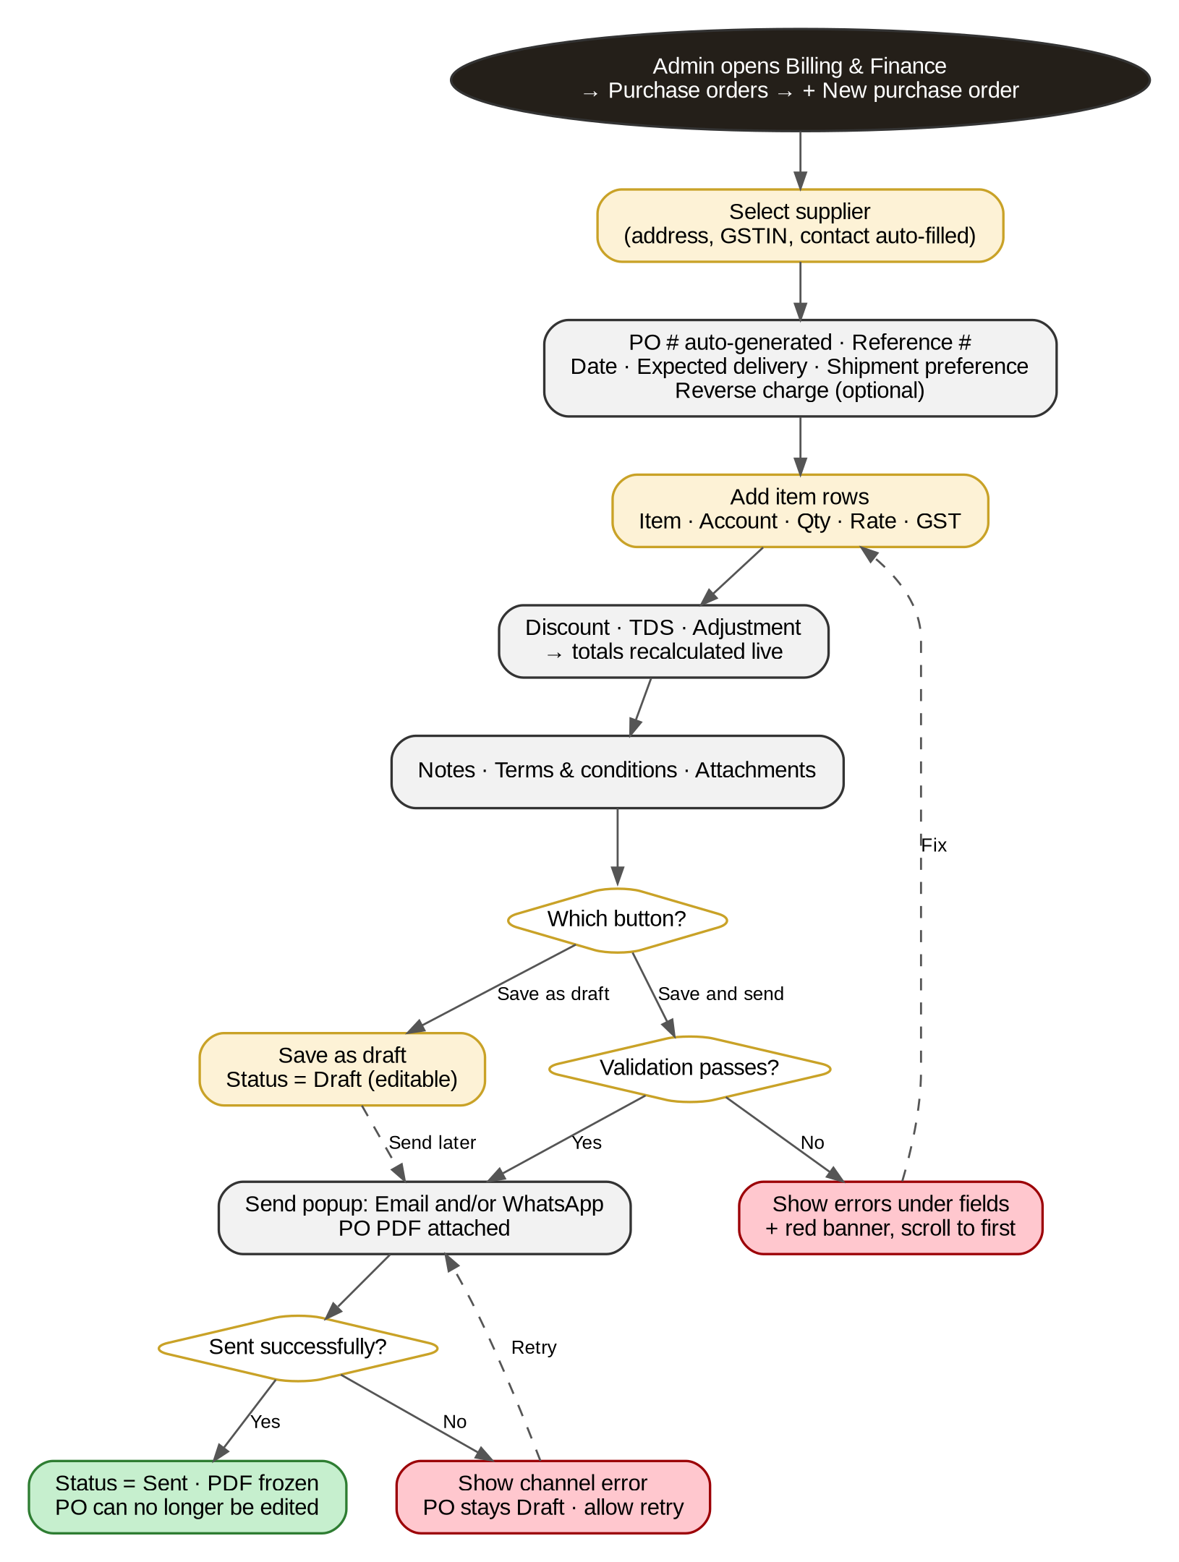
Figure 1 — Creating a purchase order and sending it to the supplier

4.2 Receive and Bill Flow
What happens after the supplier delivers.
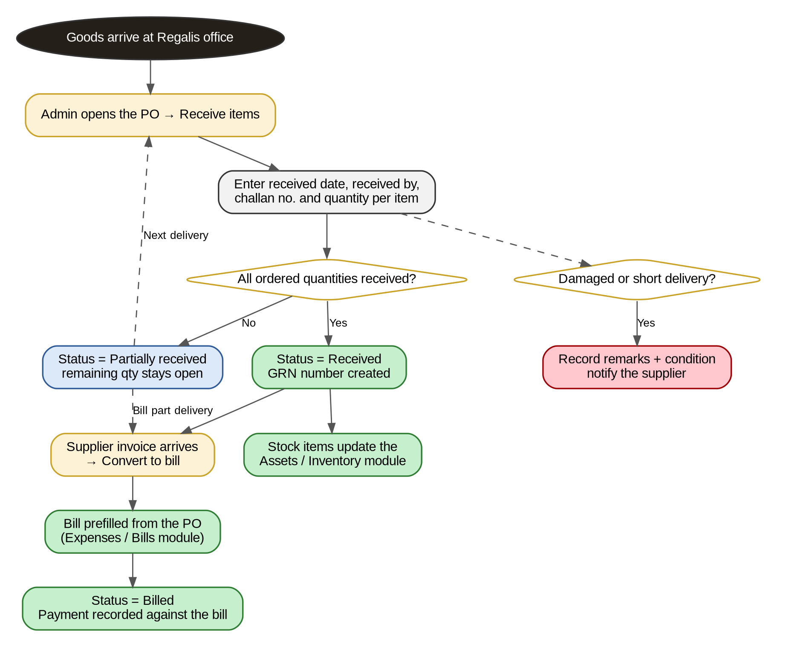
Figure 2 — Receiving goods, handling short delivery, and converting to a supplier bill

4.3 Purchase Order Status Lifecycle
How a PO moves between statuses. Dashed arrows are optional admin actions.
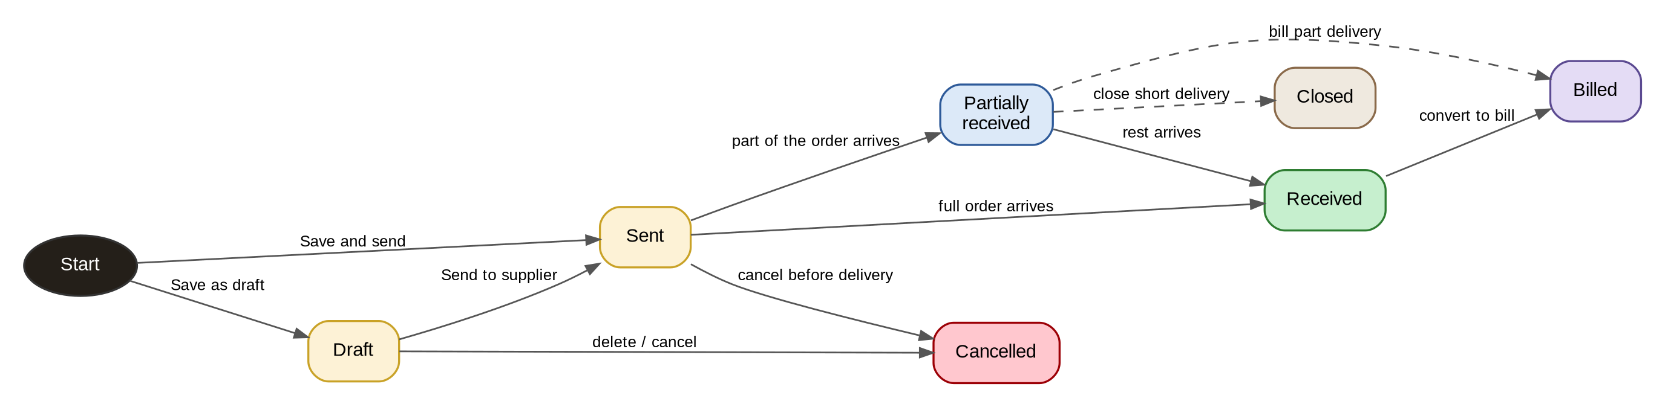
Figure 3 — Status states a purchase order moves through
NOTE: A PO can only be edited while it is a Draft. After it is sent, a mistake is fixed by cancelling the PO and raising a new one, so that the supplier and Regalis always hold the same document.

5. Data Model & Business Rules

5.1 Suggested Data Model
Entity | Key Fields
PurchaseOrder | id, po_number (unique), financial_year, supplier_id, reference_no, po_date, expected_delivery_date, shipment_preference, status, supplier_address (snapshot), supplier_gstin, place_of_supply_state_code, tax_mode (intra/inter), reverse_charge, delivery_address (snapshot), discount_type, discount_value, tds_rate_id, adjustment_label, adjustment_amount, sub_total, discount_total, taxable_total, cgst_total, sgst_total, igst_total, tds_amount, grand_total, notes, terms, internal_note, pdf_file_path, sent_at, received_at, cancelled_at, cancel_reason, bill_id, created_by, updated_by, timestamps
PurchaseOrderItem | id, purchase_order_id, sort_order, item_id (nullable for custom lines), name, description, account_id, qty_ordered, qty_received, rate, gst_rate, amount, discount_share, taxable, cgst, sgst, igst
GoodsReceipt (GRN) | id, purchase_order_id, grn_number, received_date, received_by, challan_no, remarks, created_at
GoodsReceiptItem | id, goods_receipt_id, purchase_order_item_id, qty_received, condition (good/damaged), remarks
PurchaseOrderAttachment | id, purchase_order_id, file_name, file_path, mime, size_bytes, uploaded_by
PurchaseOrderEvent (audit log) | id, purchase_order_id, event (created, updated, sent, received, partially_received, cancelled, closed, billed, note_added, deleted), actor_id, meta (JSON), created_at
DocumentSequence | doc_type (PO, GRN), financial_year, last_number — lock the row when issuing a number

5.2 Calculation Rules
- Line amount = Quantity × Rate. Sub total = sum of line amounts.
- Discount applies before GST and is split across lines in proportion to their amount.
- GST per line = (line amount − its discount share) × GST rate, rounded to 2 decimals. Karnataka: CGST = SGST = half. Other states: IGST = full.
- TDS = total taxable × TDS rate, shown as a deduction.
- Total = taxable + GST − TDS + adjustment. Store money as DECIMAL(14,2), never float. The server always recalculates.
Worked example (supplier in Karnataka, no discount, no TDS). Use this as a unit test:
Item | Qty × Rate | Amount | GST rate | GST
Arabica coffee beans — 1 kg | 20 × ₹850 | ₹17,000.00 | 5% | ₹850.00
Mesh office chair — Ergo 200 | 6 × ₹7,500 | ₹45,000.00 | 18% | ₹8,100.00
Printer cartridge — HP 682 | 4 × ₹2,200 | ₹8,800.00 | 18% | ₹1,584.00
Totals |  | ₹70,800.00 |  | ₹10,534.00
CGST = ₹5,267.00 and SGST = ₹5,267.00, so the Total is ₹81,334.00.

5.3 Business Rules
- PO numbers are unique per financial year (April–March): REG/PO/2026-27/00001. They restart at 00001 on 1 April and deleted draft numbers are not reused.
- Only a Draft can be edited or deleted. A sent PO is frozen in the UI and the API (409 on edit).
- Supplier details, addresses and rates are stored as a snapshot when the PO is sent.
- Received quantity can never exceed ordered quantity. Receiving is cumulative across several deliveries.
- A PO becomes Received only when every line is fully received; otherwise it stays Partially received until closed.
- Every goods receipt creates a GRN number and updates stock for stock-tracked items.
- Convert to bill copies supplier, items, quantities received, rates and GST into the supplier bill, and links both ways. A PO can be billed only once unless part deliveries are billed separately.
- Cancelling requires a reason and is blocked once any quantity has been received; use Close instead.
- Every action is written to the audit log with who, when and what changed.
- Notifications: a reminder to the admin 1 day before the expected delivery date, and an overdue alert the day after.

5.4 Validation Messages
Field | Rule | Message
Supplier | Required | Select a supplier.
Date | Required | Enter the purchase order date.
Expected delivery | On or after PO date | Expected delivery cannot be before the purchase order date.
Item lines | At least one line with amount > 0 | Add at least one item.
Quantity | Greater than 0 | Quantity must be greater than 0.
Rate | 0 or more | Rate cannot be negative.
Account | Required on every item line | Select an account for this item.
Receiving now | Not more than pending quantity | Receiving now cannot be more than the pending quantity.
Attachments | Max 10 files, 10 MB each | Maximum 10 files of 10 MB each.

6. Open Items — Confirm Before / While Building
# | Assumption Made Here | Needs Confirmation
1 | Payment terms is removed from the PO form; payment timing lives on the supplier bill | Confirmed by the Project Manager on 25 Sep 2026
2 | The delivery address defaults to the single Regalis office, with a one-off override link | Correct for now, since Regalis has one office
3 | Approval is not required: any admin with the permission can send a PO | Whether POs above a value (for example ₹50,000) need approval first
4 | TDS is an optional row; TCS is not included | Confirm with the accountant
5 | Accounts list: Pantry & supplies, Office supplies, Furniture & fixtures, Repairs & maintenance, Housekeeping, Other | Final chart of accounts
6 | Stock-tracked items update the Assets / Inventory module on receipt | Which module holds stock, and whether all items are tracked
7 | PO is sent by email, with WhatsApp as an option | Whether suppliers should get WhatsApp messages at all

7. Summary For The Developer
If you only read one paragraph of this document, read this one:
NOTE: Replace the New purchase order popup with a full page in the Regalis cream-and-gold theme, laid out like Zoho Books: supplier band with supplier address and delivery address, header fields (no payment terms), a multi-row item table with Account, Quantity, Rate and GST, a totals box, notes, terms, attachments and a sticky action bar. Numbering is REG/PO/2026-27/00001. Sending freezes the PO; goods are then received through the Receive items screen, which supports part deliveries and creates a GRN; a received PO converts into a supplier bill in one click. Totals, GST split and statuses are calculated by the server, never trusted from the browser.

