**Difference between HTTP1.1 vs HTTP2**

**Introduction:**

A web browser is a software application for accessing information on the World Wide Web.

The World Wide Web has come a long way since its inception, and with it, the protocols that govern the way we communicate over the internet have evolved as well. One significant leap in this evolution was the transition from HTTP/1.1 to HTTP/2. In this blog post, we will delve into the key differences between these two protocols and explore how HTTP/2 has improved upon its predecessor.

**HTTP/1.1 Overview:**

The widely adopted protocol that has been the backbone of the web for over a decade, operates on a request-response model. It allows a single request to be processed at a time, leading to a phenomenon known as head-of-line blocking. This means that if one element of a webpage is slow to load, it can delay the loading of other elements, thereby affecting the overall page load time.

**Characteristics of HTTP/1.1:**

* HTTP/1.1 introduced the concept of persistent connections, allowing multiple requests and responses to be sent over a single TCP connection. However, each request had to wait for the previous one to complete, contributing to latency issues.
* To reduce the number of requests, developers often used techniques like resource inlining or spriting. While these methods decreased the number of requests, they could result in larger initial downloads and increased complexity.

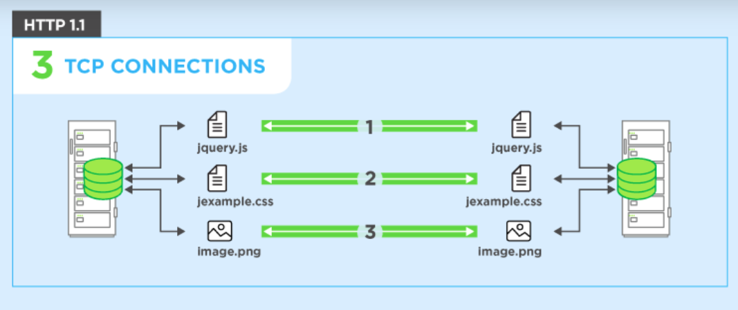

**HTTP/2 Overview:**

* **Recognizing the limitations of HTTP/1.1, the Internet Engineering Task Force (IETF) introduced HTTP/2 in 2015 as an effort to address performance bottlenecks and improve the efficiency of web communication.**
* **This overview will delve into the key features and advantages that make HTTP/2 a game-changer in the world of web protocols.**

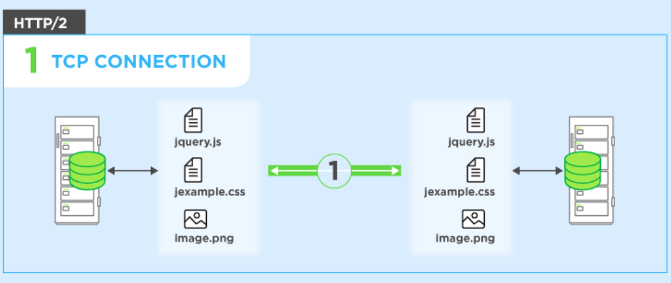

**Difference:**

**HTTP/1.1:**

* **It works on the textual format.**
* **There is head of line blocking that blocks all the requests behind it until it doesn’t get its all resources.**
* **It uses requests resource Inlining for use getting multiple pages**
* **It compresses data by itself.**

**HTTP/2:**

* **It works on the binary protocol.**
* **It allows multiplexing so one TCP connection is required for multiple requests.**
* **It uses PUSH frame by server that collects all multiple pages**
* **It uses HPACK for data compression.**

**Key Improvements in HTTP/2:**

* **Multiplexing: One of the most significant enhancements in HTTP/2 is the introduction of multiplexing. Unlike HTTP/1.1, which processed one request at a time, HTTP/2 allows multiple requests and responses to be sent concurrently over a single connection. This eliminates head-of-line blocking and significantly improves page load times.**
* **Header Compression: HTTP/2 utilizes header compression to reduce overhead. While headers in HTTP/1.1 were sent with each request, HTTP/2 employs a header compression algorithm called HPACK, which reduces redundant header information, resulting in more efficient data transfer.**
* **Server Push: HTTP/2 introduces server push, a feature that enables the server to push additional resources to the client before they are explicitly requested. This can further optimize page load times by anticipating the client's needs and reducing the number of required requests.**
* **Binary Protocol: Unlike the text-based format of HTTP/1.1, HTTP/2 uses a binary protocol, which is more efficient to parse and requires fewer bytes to transmit information. This contributes to a reduction in latency and an overall improvement in performance.**

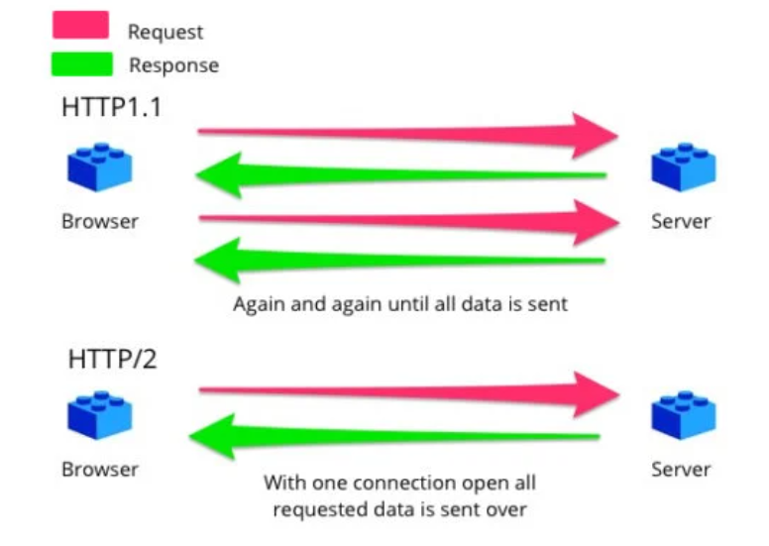

**Conclusion:**

* **In conclusion, the transition from HTTP/1.1 to HTTP/2 represents a significant leap forward in the world of web protocols.**
* **HTTP/2 addresses the limitations of its predecessor by introducing multiplexing, header compression, server push, and a binary protocol.**
* **These improvements collectively result in faster page load times, reduced latency, and a more efficient web experience for users.**
* **As web technologies continue to evolve, staying informed about these advancements is crucial for developers and businesses alike to provide a seamless and optimized online experience.**