# Assignment 4

|  |  |
| --- | --- |
| Title | Connectivity of Raspberry Pi /Beagle board circuit with InfraRed (IR) sensor. |
| Problem statement / definition | Understanding the connectivity of Raspberry-Pi /Beagle board circuit with IR sensor. Write an application to detect obstacle and notify user using LEDs. |
| Learning objective | Understanding the connectivity of Raspberry Pi /Beagle board circuit with IR sensor. |
| Learning outcome | The students will be able to   * To interface IR sensor to Raspberry Pi * Detect the obstacle with IR sensor * Can perform actuation |
| S/w packages & hardware apparatus used | Raspberry Pi/Beagle board Development Boards, PC/Monitor/Keyboard, IR Sensor, 1 LED, 1 Resistor (330 Ω), Few jumper cables, 1 Breadboard, Raspbian OS, Debian Linux and Python |

**Theory: -**

**Raspberry Pi:**

The Raspberry Pi is a series of credit card-sized single-board computers developed in the United Kingdom by the Raspberry Pi Foundation to promote the teaching of basic computer science in schools and in developing countries. It is a capable little computer which can be used in electronics projects, and for many of the things that your desktop PC does, like spreadsheets, word processing, browsing the internet, and playing games. It also plays high-definition video.

The Raspberry Pi is open hardware, with the exception of the primary chip on the Raspberry Pi, the Broadcom SoC (System on a Chip), which runs many of the main components of the board–CPU, graphics, memory, the USB controller, etc. Many of the projects made with a Raspberry Pi are open and well-documented as well and are things you can build and modify yourself.

One powerful feature of the Raspberry Pi is the row of GPIO (general purpose input/output) pins along the top edge of the board. These pins are a physical interface between the Pi and the outside world. At the simplest level, you can think of them as switches that you can turn on or off (input) or that the Pi can turn on or off (output). Of the 40 pins, 26 are GPIO pins and the others are power or ground pins.

**Raspberry Pi Board with GPIO:**

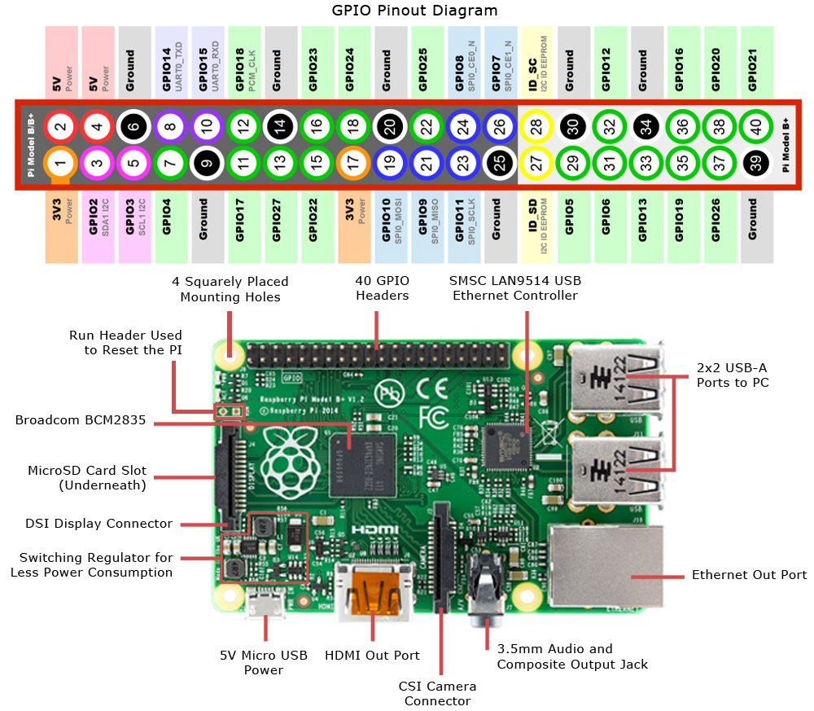

**Infrared (IR) sensor: -**

IR (Infrared) Sensor works by emitting infrared signal/radiation and receiving of the signal when the signal bounces back from any obstacle. In other words, the IR Sensor works by continuously sending signal (in a direction) and continuously receive signal, if comes back by bouncing on any obstacle in the way.

**Components of IR Sensor:**

1. Emitter: This component continuously emits the infrared signal
2. Receiver: It waits for the signal which is bounced back by obstacle
3. Indicator: On board LED to signal if obstacle is deducted by the sensor
4. Output: Could be used as Input for further processing of the signal
5. Ground: Ground/Negative point of the circuit
6. Voltage: Input 3.3V

IR Sensor has 3 pins, viz VCC, GND and OUT. We will use GPIO 23 for receiving input from the sensor.

**Connecting IR Sensor:**

1. Connect GPIO 23 from the Raspberry Pi to Breadboard
2. Connect OUT pin of the sensor with the Breadboard. This will send input received from sensor to GPIO 23, which will be processed further.
3. Connect GND (any pin from board will work) with negative line on left side of the breadboard.
4. Connect GND of the IR Sensor to Breadboard
5. Connect GND from Step 3 to Breadboard
6. Connect VCC of the IR Sensor to Breadboard
7. Connect 3v3 (Pin #1) to positive line on left side of the breadboard
8. Connect 3v3 (connected in Step 7) to the Breadboard

**Connecting LED:**

Objective is to turn on the LED when obstacle is detected.

1. Connect GPIO 4 from the board to the Breadboard
2. Connect positive point of the LED (longer pin of the LED) to the Breadboard
3. Connect negative point of the LED (smaller pin of the LED) to the Breadboard
4. Use resistor (330 Ω) to connect negative to the negative point of the LED



**Python code to detect obstacle: -**

from gpiozero import LED

from signal import pause

import RPi.GPIO as GPIO

import time

GPIO.setmode(GPIO.BCM)

LED_PIN = 27

IR_PIN = 23

indicator = LED(LED_PIN)

GPIO.setup(IR_PIN, GPIO.IN)

count = 1

while True:

got_something = GPIO.input(IR_PIN)

if got_something:

indicator.on()

print ("Object detected".format(count))

else:

indicator.off()

print ("Nothing detected".format(count))

count += 1

time.sleep(0.2)

**Conclusion**

Thus, we successfully studied the IR sensor and used it with Raspberry Pi to detect objects.