# Assignment 5

|  |  |
| --- | --- |
| Title | Write an application to capture and store the image. |
| Problem statement / definition | Understanding and connectivity of Raspberry-Pi /Beagle board with camera. Write an application to capture and store the image. |
| Learning objective | * To capture and store Image using Raspberry Pi. * To understand configuration of Raspberry-pi/Beagle board circuit with basic peripherals and its use in the program. |
| Learning outcome | Students will be able to capture an image using Raspberry Pi and store it. |
| S/w packages & hardware apparatus used | * Pi Camera Package * Raspberry Pi * Camera Module |

**Theory: -**

**Pi Camera Module Interface with Raspberry Pi using Python:**

Pi Camera module is a camera which can be used to take pictures and high definition video. Raspberry Pi Board has CSI (Camera Serial Interface) interface to which we can attach PiCamera module directly. This Pi Camera module can attach to the Raspberry Pi’s CSI port using 15-pin ribbon cable.

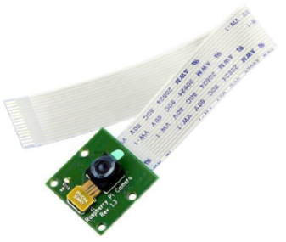

**How to attach Pi Camera to Raspberry Pi?**

Connect Pi Camera to CSI interface of Raspberry Pi board as shown below:

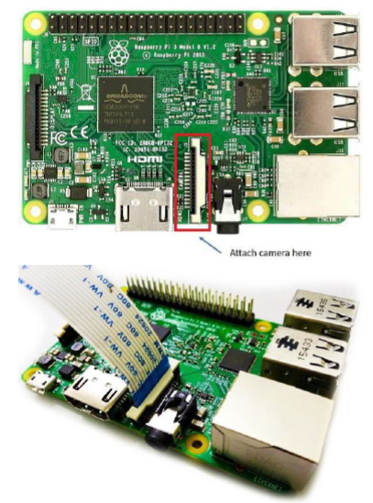

Now, we can use Pi Camera for capturing images and videos using Raspberry Pi.

**Python Code:**

import picamera

from time import sleep

#create object for PiCamera class

camera = picamera.PiCamera()

#set resolution

camera.resolution = (1024, 768)

camera.brightness = 60

camera.start_preview()

#add text on image

camera.annotate_text = 'Hi Pi User'

sleep (5)

#store image

camera.capture('image1.jpeg')

camera.stop_preview()

**Conclusion**

Students have successfully connected the camera module to the Raspberry Pi device and have captured and stored an image.