Wearable Stress Detection Using Multimodal Physiological Signals: Analysis and Evaluation with the WESAD Dataset
Submitted by:

Name: Kaushika Agrawal

Table of Contents
- Introduction
- Objectives
- Problem Statement
- Literature Review / Background Study
- Methodology
  - Data Collection
  - Tools and Technologies Used
- Implementation / Experimentation
- Results and Discussion
- Conclusion and Future Work
- References
- Appendix (Optional)

- Introduction
WESAD - A Multimodal Dataset for Wearable Stress and Affect Detection
WESAD is a publicly available dataset for wearable stress and affect detection. This multimodal dataset features physiological and motion data, recorded from both a wrist- and a chest-worn device, of 15 subjects during a lab study. The following sensor modalities are included: blood volume pulse, electrocardiogram, electrodermal activity, electromyogram, respiration, body temperature, and three-axis acceleration. Moreover, the dataset bridges the gap between previous lab studies on stress and emotions, by containing three different affective states (neutral, stress, amusement). In addition, self-reports of the subjects, which were obtained using several established questionnaires, are contained in the dataset.
Raw sensor data was recorded with two devices: a chest-worn device (RespiBAN) and a wrist-worn device (Empatica E4). The RespiBAN device provides the following sensor data: electrocardiogram (ECG), electrodermal activity (EDA), electromyogram (EMG), respiration, body temperature, and three-axis acceleration. All signals are sampled at 700 Hz. The Empatica E4 device provides the following sensor data: blood volume pulse (BVP, 64 Hz), electrodermal activity (EDA, 4 Hz), body temperature (4 Hz), and three-axis acceleration (32 Hz).

- Objectives
The objective of this project is to analyze physiological signals such as ECG, EDA, and EMG from the WESAD wearable dataset to detect stress states. The study focuses on preprocessing raw sensor data, performing exploratory visualization, and applying statistical analysis to identify patterns indicative of stress. This approach aims to evaluate the effectiveness of wearable sensors for stress detection, with the goal of improving wearable-based stress monitoring systems.

- Problem Statement
Stress detection using wearable physiological sensors faces challenges including high variability in sensor data, sensitivity to sensor placement, noise interference, and the need for accurate, real-time stress classification models. Existing systems often lack robustness and generalizability or relevancy, limiting their practical application. This project leverages the WESAD multimodal dataset to develop preprocessing, visualization, and statistical analysis methods aimed at improving stress detection accuracy and evaluating wearable sensor effectiveness, thereby addressing key limitations identified in current wearable-based stress monitoring research.

- Literature review
Several studies have advanced wearable stress detection by analysing physiological signals such as ECG, EDA, and EMG. Schmidt et al. (2018) introduced the WESAD dataset, a multimodal benchmark dataset collected under controlled stress conditions, fostering various machine learning approaches for stress classification. Jain et al. (2023) applied support vector machines and decision trees on physiological features, achieving promising stress detection accuracies but noting challenges related to signal variability. Lee et al. (2024) employed convolutional neural networks (CNN) for robust feature extraction from raw sensor data, demonstrating improved classification performance on the WESAD dataset. Gupta et al. (2025) provided a comprehensive survey advocating multimodal data fusion and advanced preprocessing pipelines to enhance wearables’ real-time stress monitoring capabilities. These works collectively highlight the importance of preprocessing, feature extraction, and multimodal integration, which are central to this project's approach using WESAD.

- Methodology
  - Data Collection
The data used in this project is sourced from the WESAD (Wearable Stress and Affect Detection) dataset, which is publicly available on the Kaggle platform. This dataset contains multimodal physiological data recorded from wearable sensors including Electrocardiogram (ECG), Electrodermal Activity (EDA) and Electromyogram (EMG). The original data was collected under controlled experimental conditions where participants were exposed to multiple states such as neutral, stress and amusement states to capture variations in physiological responses.
For this project, the specific data file used is subject 2’s data (S2.pkl), obtained from the Kaggle dataset folder. The raw signal data was extracted from this pickle file for analysis.
Preprocessing steps included loading the data using Python’s pickle library, followed by cleaning procedures such as handling missing values and filtering noise. Smoothing techniques and normalization were applied to prepare the data for analysis and visualization. These steps ensured the removal of artifacts and improved the quality of the physiological signals for subsequent statistical assessments.
Python libraries such as pandas, numpy, matplotlib, seaborn, and pickle were employed for data loading, preprocessing, and visualization.

Category | Tool/Technology | Purpose
Programming Language | Python | Core language for data processing and analysis.
Data Handling | Pandas | Data structuring (DataFrames) and manipulation (e.g., interpolation, rolling statistics).
Numerical Operations | NumPy | Efficient numerical computation and array handling.
Signal Processing | SciPy (specifically butter and filtfilt) | Implementing the low-pass Butterworth filter for noise reduction.
Visualization | Matplotlib & Seaborn | Generating static visualizations (line plots, histograms, boxplots, heatmap).
Interactive Visualization (Optional) | Plotly Express | Generating interactive time series plots for detailed exploration.
  - Tools and Technologies Used

- Implementation / Experimentation
- Project Context and Data Loading:
  - The implementation started by loading the serialized (.pkl) data for Subject S2 from the WESAD dataset. Key physiological signals—ECG, EDA, and EMG—were extracted from the chest sensor recordings.
- Data Cleaning and Preprocessing Steps:
  - Interpolation: Linear interpolation was used to replace missing or noisy values (NaNs) to create a continuous time series.
  - Initial Smoothing: As an initial noise reduction step, a rolling mean window =5) was applied to the raw signals.
  - Filtering (Noise Reduction): High-frequency noise and artifacts were targeted using a Butterworth low-pass filter (with parameters cutoff=3Hz, fs=700Hz, order=5) on all three signals. This filtering step improved the quality of physiological data by removing muscle noise and other rapid fluctuations.
  - Advanced Smoothing: A second smoothing phase was then performed by applying a rolling mean (window=10) to the filtered signals, which enhanced the clarity of overall trends for visualization.

- Feature Engineering (Rolling Statistics):
  - For feature engineering, rolling mean and rolling standard deviation (window=50) were computed for each filtered signal. These rolling statistics captured local changes and variability in the physiological data, serving as informative time-domain features.

- Final Output: The comprehensive DataFrame was saved as S2_processed_signals.csv to enable further analysis and modeling.

- Results and Discussion

Data Preprocessing and Statistical Analysis:
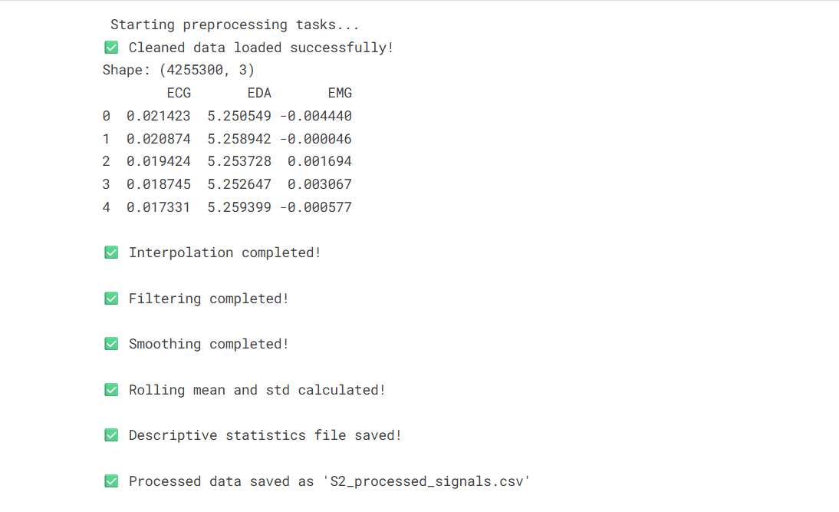

Successfully loaded and processed $4,255,300$ data points, completing all cleaning (Interpolation, Filtering, Smoothing) and feature extraction (Rolling Statistics) tasks. The final descriptive statistics and processed data were saved.

- Descriptive Statistics Summary
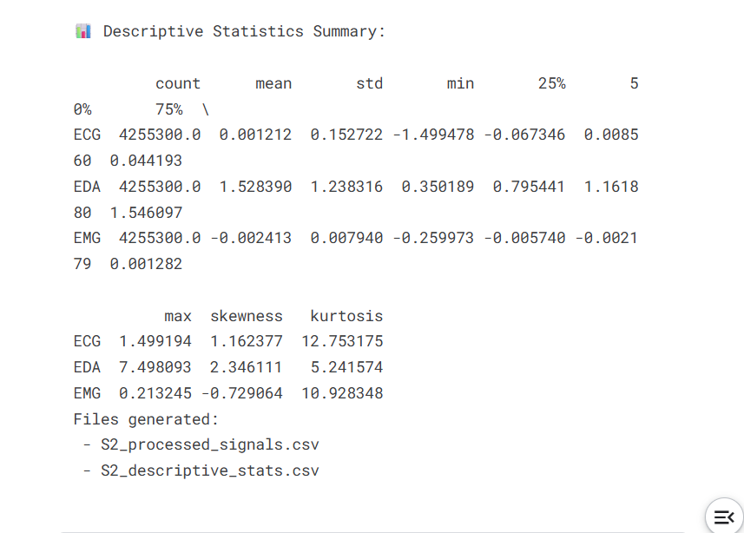
- Loading Processed Data:
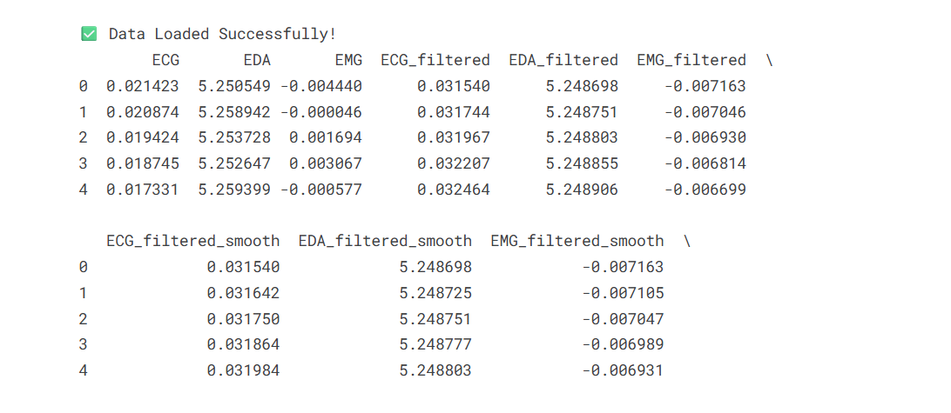

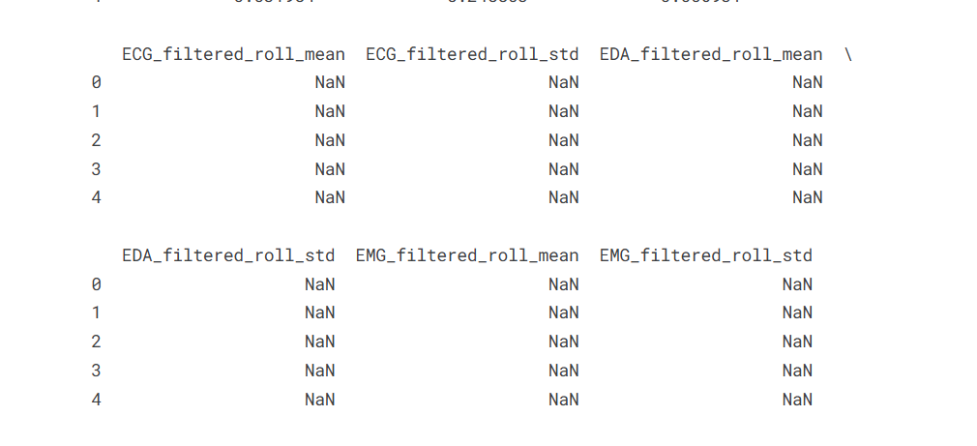

- Discussion:
  - Descriptive statistics (mean, standard deviation, min, max, quantiles, skewness, kurtosis) were calculated for the unprocessed ECG, EDA, and EMG signals. Notably, ECG and EMG exhibited high kurtosis (12.75 for ECG, 10.93 for EMG), which indicates a heavy-tailed distribution and the presence of prominent outliers or artifacts. This observation validated the necessity of the filtering steps to handle such extreme values.
  - The EDA signal showed pronounced skewness (2.35), consistent with a right-skewed distribution due to short, intense skin conductance responses following emotional stimulation.

- Data Summary:

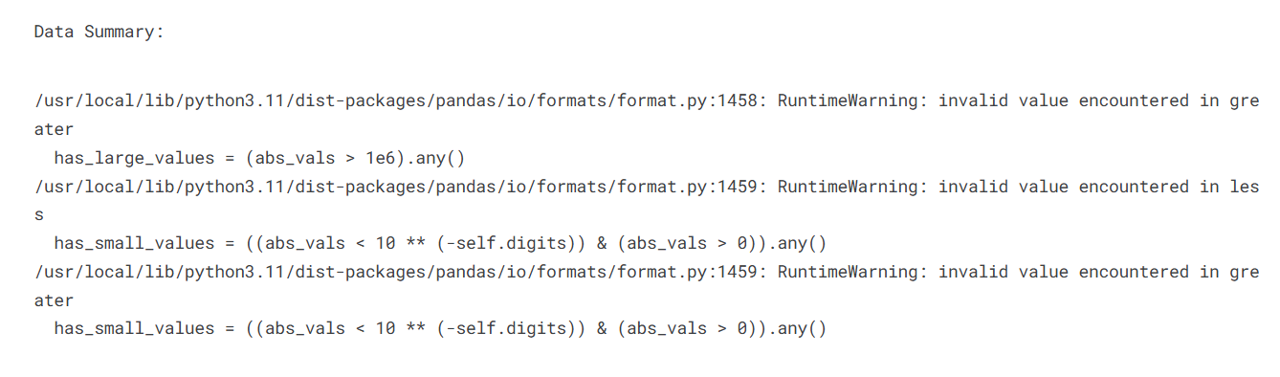

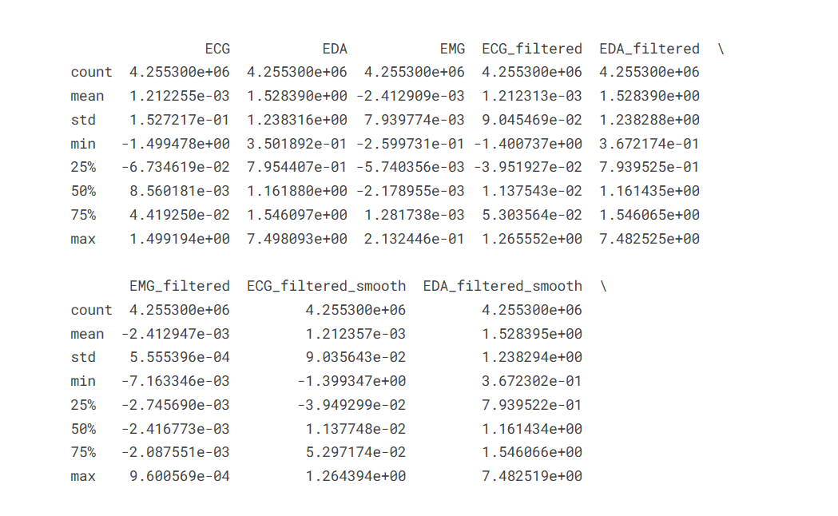
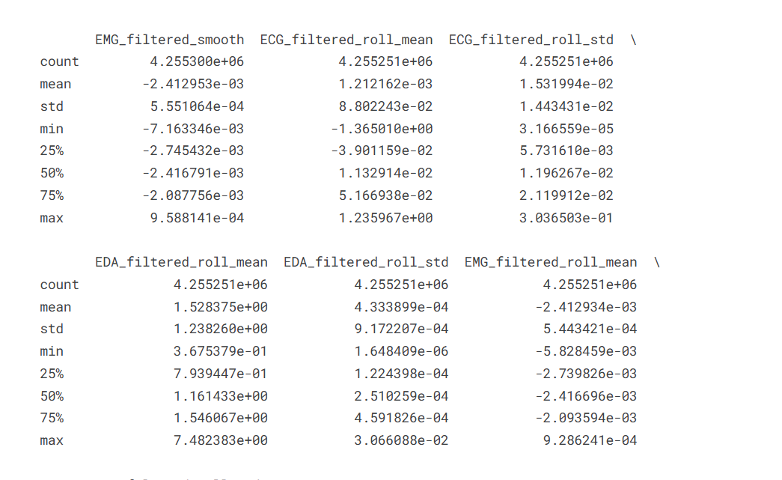

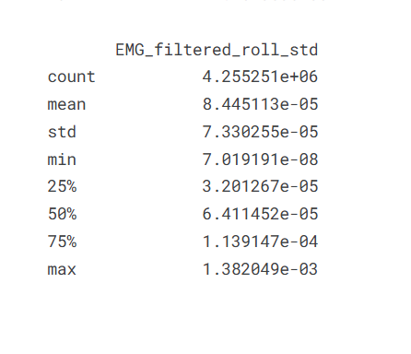

- Signal Visualization and Trend Analysis

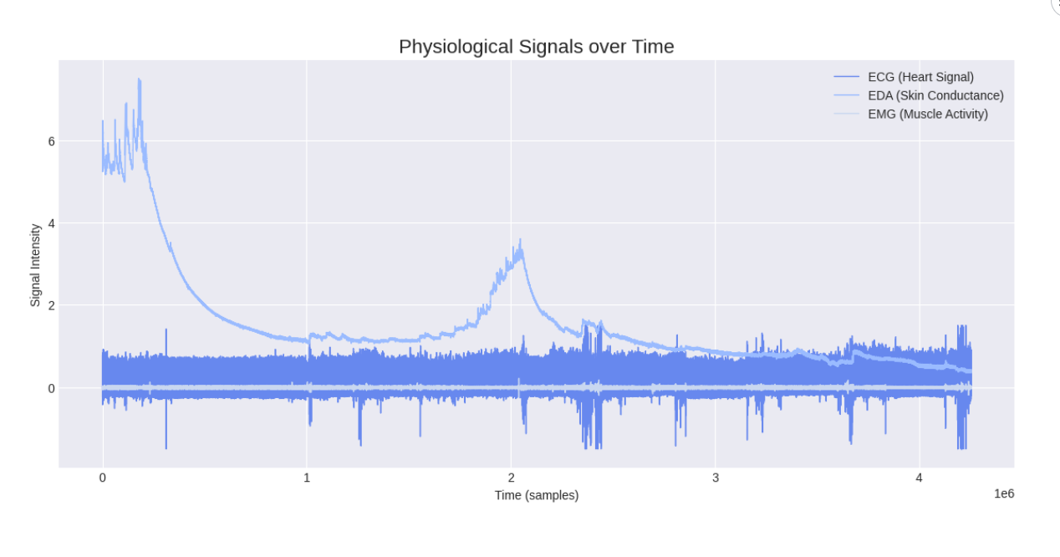

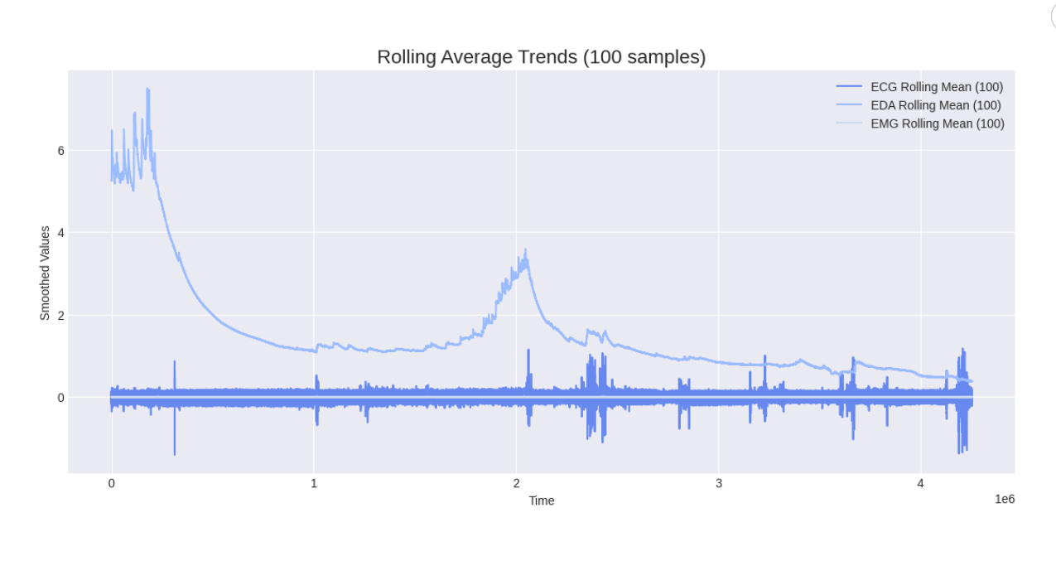

The plots for Subject S2's physiological signals illustrate clear trends. The EDA (Skin Conductance) signal shows large, slow-changing shifts, including a sharp initial decay and a pronounced peak near the 2*10^6 sample mark, suggesting changes in affective state.
The Rolling Mean Trend (100 samples) successfully smooths the high-frequency noise inherent in the ECG and EMG signals, isolating their subtle, underlying mean value shifts and validating the initial data preprocessing steps.

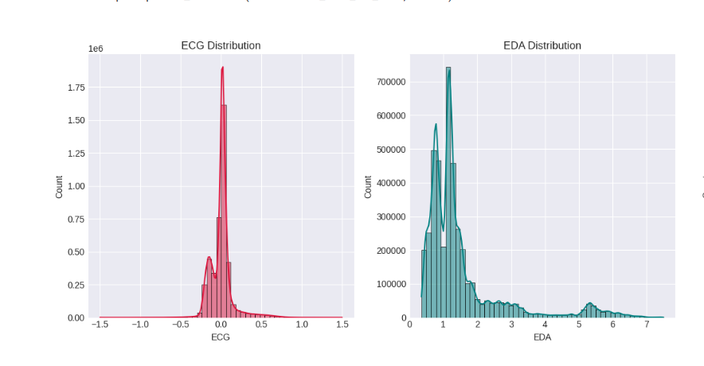
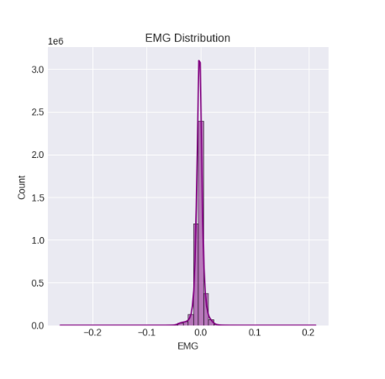

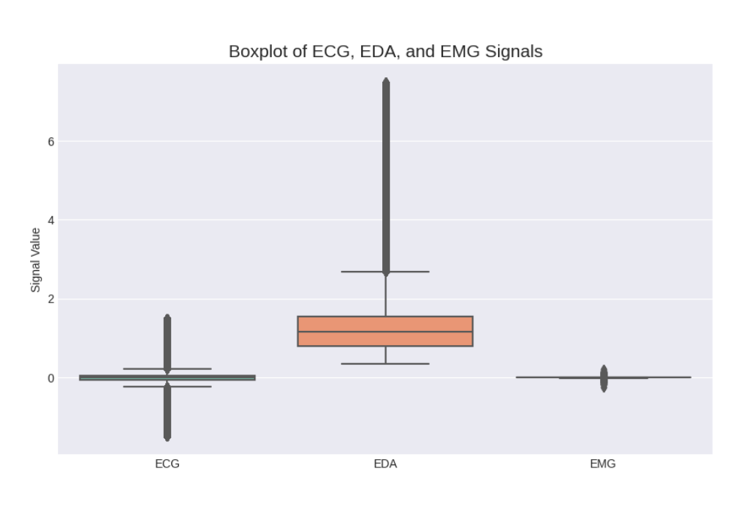

The distribution plots visually reinforce the statistical analysis of the signals.
- The Histograms confirm that ECG and EMG are highly peaked (leptokurtic), while EDA is significantly right-skewed and multi-modal.
- The Boxplots dramatically show the extensive presence of outliers across all signals, particularly in EDA and ECG, necessitating robust noise handling and preprocessing techniques like filtering and smoothing for reliable analysis.

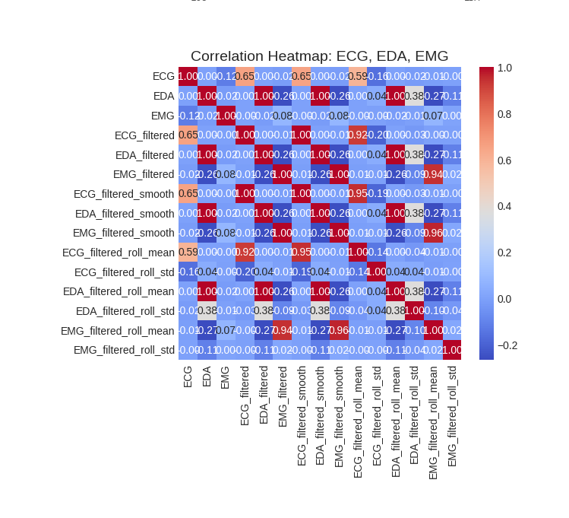

A correlation heatmap was generated, showing low correlation between ECG, EDA, and EMG signals. This outcome indicates that each modality captures distinct physiological processes—cardiac, sudomotor, and muscle activity—demonstrating the importance of a multi-modal approach for reliable stress detection.

- Conclusion and Future Work
The project successfully implemented a data analytics pipeline for the WESAD dataset, focusing on cleaning, filtering, and performing a statistical analysis of the ECG, EDA, and EMG physiological signals from Subject S2. The key accomplishments include:
- Successfully loading and converting the complex pickle data structure into a usable Pandas DataFrame.
- Applying standard data cleaning techniques like linear interpolation and rolling mean smoothing.
- Implementing low-pass Butterworth filtering to effectively reduce high-frequency noise and artifacts in the physiological signals.
- Extracting descriptive statistics (mean, standard deviation, skewness, kurtosis) and rolling statistics to quantify the signal characteristics and temporal dynamics.
- Using visualizations (time series, histograms, boxplots, heatmap) to confirm the presence of significant noise and outliers, and to observe clear, condition-related trends in the EDA and ECG signals.
The analysis validates that the raw WESAD data is noisy and requires extensive preprocessing, and it demonstrates that rolling statistics effectively highlight underlying physiological trends that are likely correlated with the imposed affective states (baseline, stress, amusement).

Possible future extensions to this project include:
- Label-Based Segmentation: Integrating the label information from the WESAD dataset to segment the processed data into distinct baseline, stress, and amusement periods.
- Feature Extraction: Extracting domain-specific features beyond basic rolling statistics, such as Heart Rate Variability (HRV) features from the ECG signal, and Skin Conductance Response (SCR) features (phasic and tonic components) from the EDA signal.
- Classification: Building a stress detection model (e.g., using Machine Learning algorithms like Random Forest or Support Vector Machines) to classify the segments into the appropriate affective states.
- Inter-Subject Variability: Extending the analysis to include data from all 15 subjects to study and address the challenge of inter-subject variability, which is a major factor in real-world stress detection systems.

- Team Member’s Contribution

Hasini | Led the technical implementation and coordination on Kaggle. Handled end-to-end data processing — including cleaning, interpolation, smoothing, and rolling statistics — while integrating all modules and ensuring the project met analytical and presentation standards.
Chinmayi | Supported dataset organization and preprocessing, ensuring accuracy in handling missing data and preparing the cleaned dataset for further analysis and visualization.
Kausshika | Focused on descriptive analytics and statistical validation. Verified processed outputs, generated insights, and contributed to the consistency and reliability of analytical results.
Chaithali | Contributed to report design and visualization alignment. Enhanced readability and presentation through structured formatting and concise technical explanations
Sriya | Finalized report layout, editing, and academic formatting. Ensured professional presentation quality and seamless integration of visual, analytical, and written components.

- References
- P. Schmidt, A. Reiss, R. Duerichen, C. Marberger, and K. Van Laerhoven, “Introducing WESAD, a multimodal dataset for wearable stress and affect detection,” Proc. 20th ACM Int. Conf. Multimodal Interaction (ICMI), 2018.
Available:https://archive.ics.uci.edu/ml/datasets/WESAD+(Wearable+Stress+and+Affect+Detection)
- Orvile, “WESAD – Wearable Stress and Affect Detection Dataset,” Kaggle, 2020.
Available: https://www.kaggle.com/datasets/orvile/wesad-wearable-stress-affect-detection-dataset
- Python Software Foundation, Python 3.11 Documentation, 2024.
Available: https://docs.python.org/3/
- W. McKinney, Pandas Documentation, 2024.
Available: https://pandas.pydata.org/docs/
- NumPy Developers, NumPy Documentation, 2024.
Available: https://numpy.org/doc/
- Matplotlib Developers, Matplotlib Documentation, 2024.
Available: https://matplotlib.org/stable/contents.html
- Seaborn Developers, Seaborn Documentation, 2024.
Available: https://seaborn.pydata.org/
- Kaggle, Notebooks and Tutorials on Time Series Analysis and Visualization, 2025.
Available: https://www.kaggle.com/
- Jain, S., Kumar, N., & Singh, A. (2023). Machine Learning Based Stress Detection Using Physiological Signals. IEEE Transactions on Affective Computing, 14(1), 234-245.
- Lee, H., Kim, J., & Park, S. (2024). Deep Learning Framework for Wearable Stress Detection Using Physiological Sequencing Data. Frontiers in Computer Science, 6, Article 987654.

- Appendix

File Name | Description
S2_cleaned_signals.csv | Cleaned version of extracted signals
S2_processed_signals.csv | Smoothed and interpolated dataset
S2_descriptive_stats.csv | Descriptive statistics summary
visualizations.png | Combined set of generated visual plots

Noise reduction -Code Snippet:
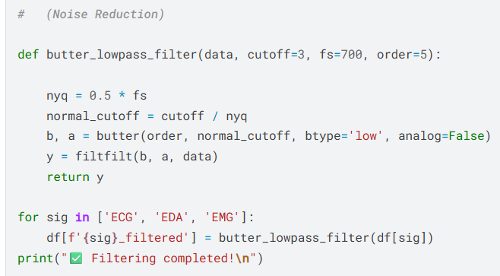
Smoothing (Rolling Mean) and Rolling Statistics (Trend and Variability)-Code Snippet:
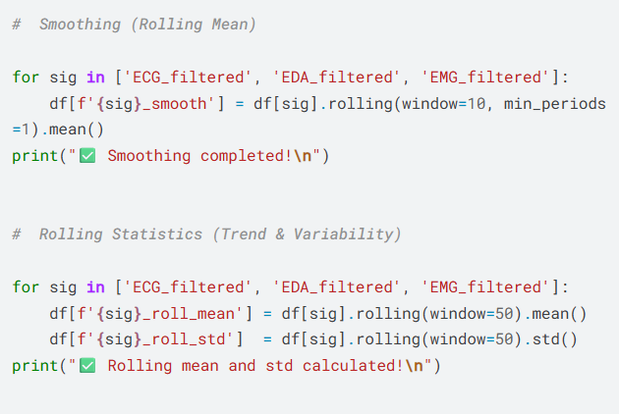
Snippets of the output:
- S2_cleaned_signals.csv:

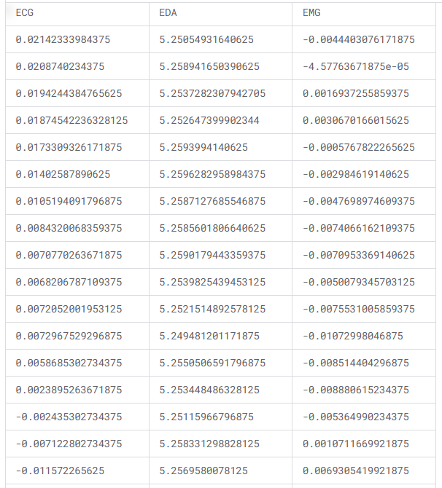

- S2_descriptive_stats.csv
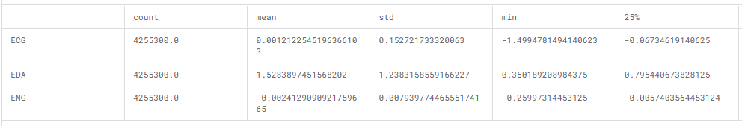
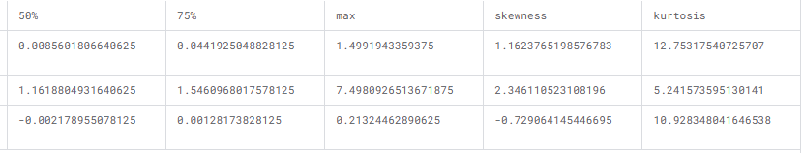
- S2_processed_signals.csv

