**KitaabShop User Journey Documentation**

Table of Contents

1. Introduction
2. Homepage
3. User Registration
4. Login
5. OTP Verification
6. Forgot Password
7. Browse Books by Category
8. View Book Details
9. Add to Cart
10. Checkout
11. Order Confirmation
12. View Order History
13. Profile Management
14. Admin Functionality: Add Books
15. Admin Functionality: Remove Books
16. Conclusion

**1. Introduction**

* **KitaabShop** is an e-commerce platform designed for book lovers, providing users with an easy and intuitive way to browse, purchase, and manage orders for a variety of books. The application offers a seamless user experience with features like book categorization, search functionality, and a user-friendly interface for both customers and administrators.
* The user journey starts with the homepage, which allows users to search for books, navigate categories, view detailed product descriptions, and add items to their cart. From there, users can register an account, log in, and manage their profiles. A key security feature of the platform is OTP-based login verification, adding an additional layer of security to user accounts. Additionally, the platform includes a "forgot password" functionality for users to reset their credentials.
* For administrators, **KitaabShop** offers easy-to-use interfaces to add new books, manage inventory, and remove books from the store. This functionality ensures the platform stays updated with new content while maintaining its inventory.
* The purpose of this document is to guide the reader through the **KitaabShop** user journey, providing visual references for each major feature and interaction, from browsing books to managing accounts, and from logging in to completing a purchase. The document includes screenshots of each feature with explanations of their respective functionalities.

**2. Homepage**  
URL: /  
Description: This is the landing page where users can browse books, use the search bar, and access account or cart features.

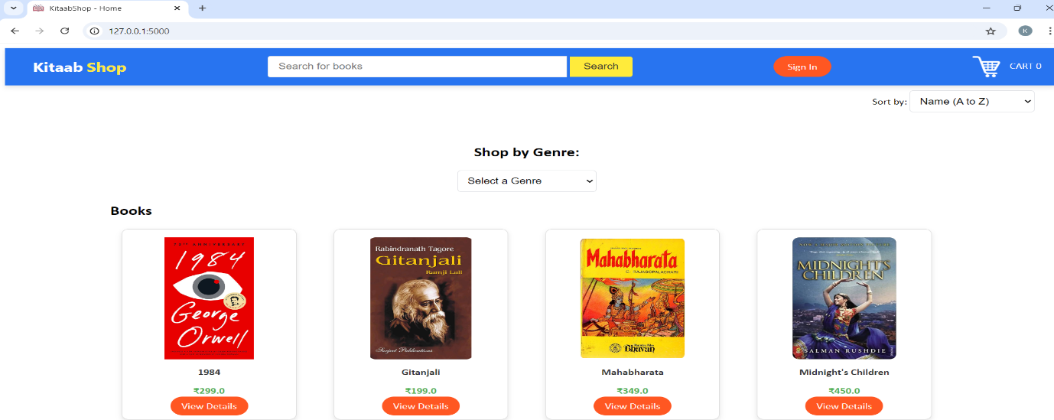

Key Features:

* Search Bar: Allows users to search for books by title, author, or genre.
* Account/Login Button: If a user is not logged in, they will see the “Sign In” button.
* Cart: Displays the number of items in the user’s cart.

**3. User Registration**  
URL: /registrationForm  
Description: This page allows new users to create an account by filling out their personal details.

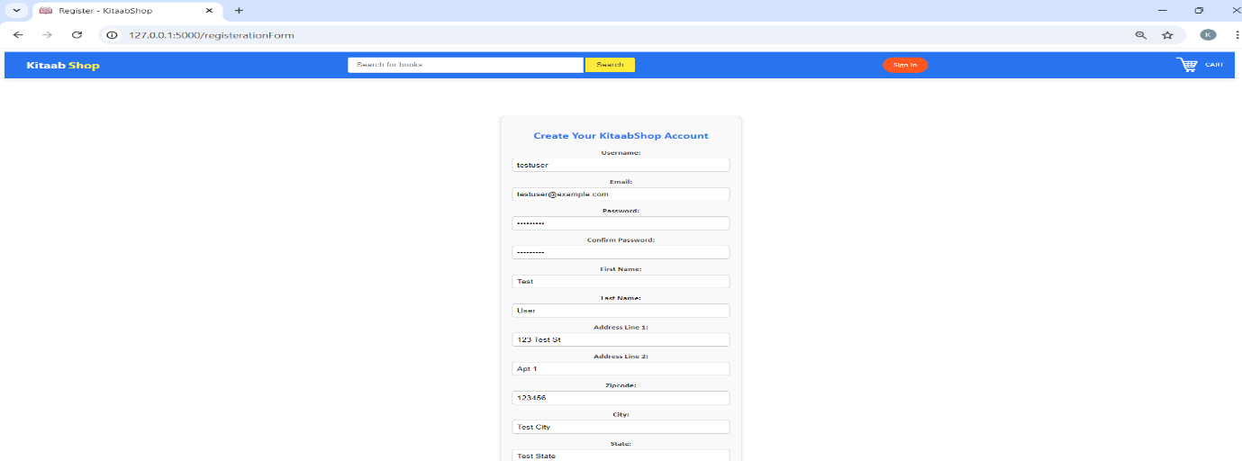

Key Features:

* Registration Form: Users can input their email, password, and other personal details to create an account.
* Submit Button: After submitting, users will receive confirmation of successful registration.

**4. Login**  
URL: /loginForm  
Description: Users can log in to their account using their email and password.

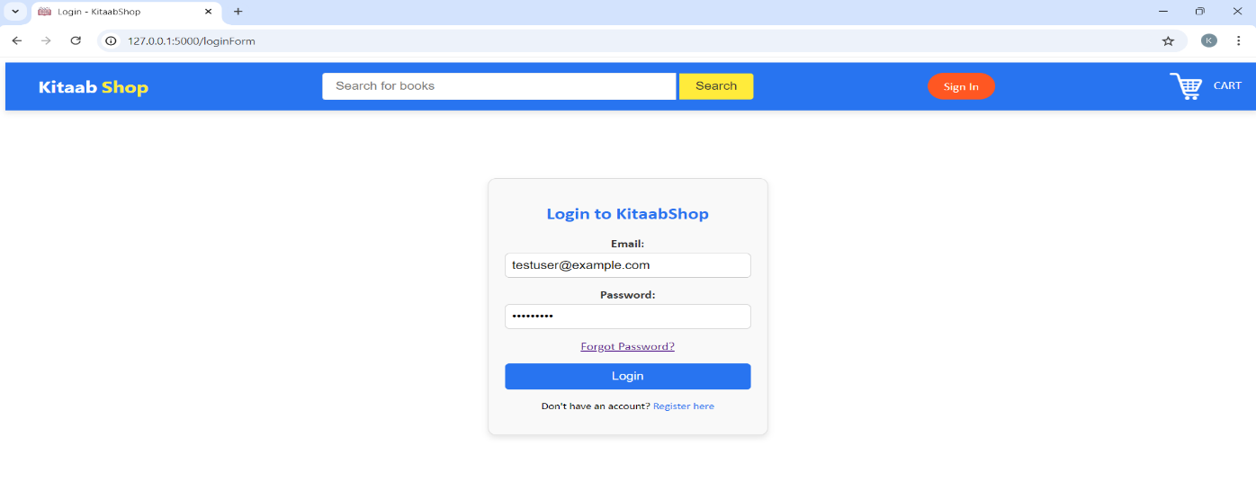

Key Features:

* Login Form: Input fields for email and password.
* Forgot Password: A link is available for users who forgot their password to reset it.
* Login Button: Submits the form for login.

**5. OTP Verification**  
URL: /otp  
Description: After entering valid login credentials, users must verify their identity via OTP.

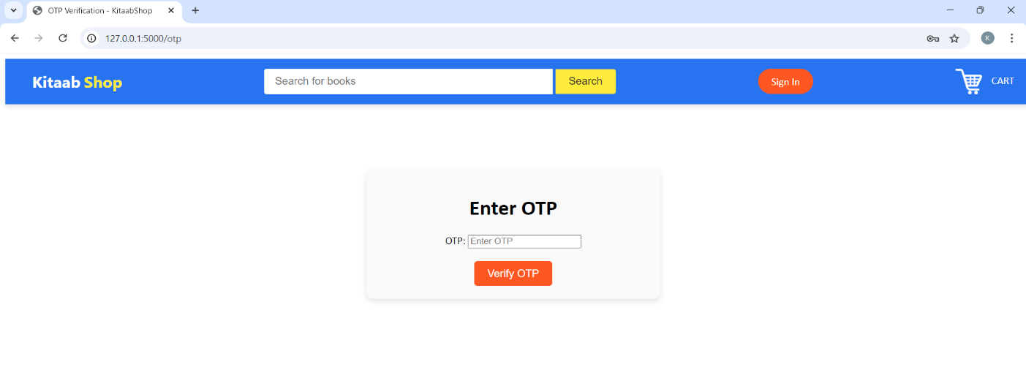

Key Features:

* OTP Form: Input field for entering the one-time password.
* Verify OTP Button: Validates the OTP entered by the user.

**6. Forgot Password**  
URL: /forgot_password  
Description: Users can request a password reset link by entering their email.

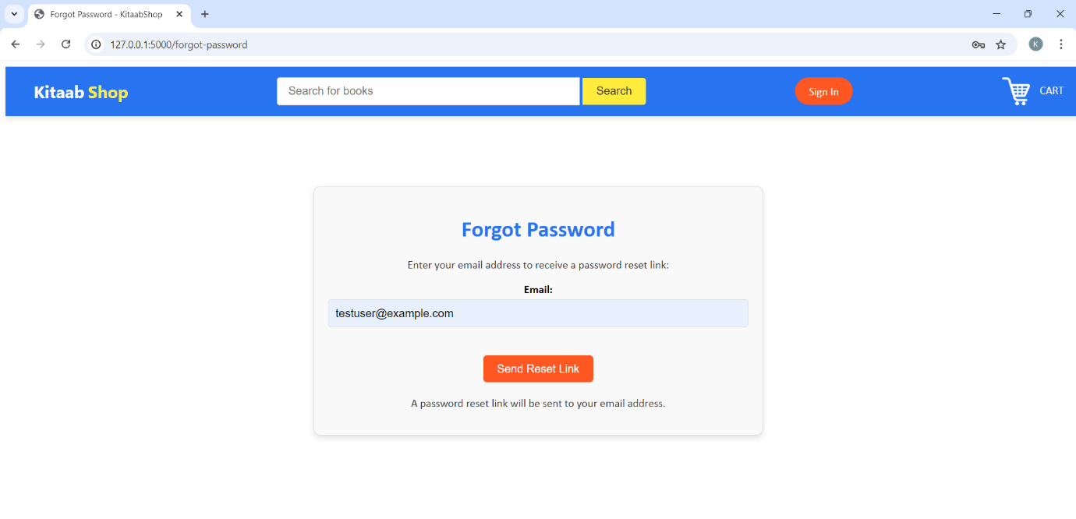

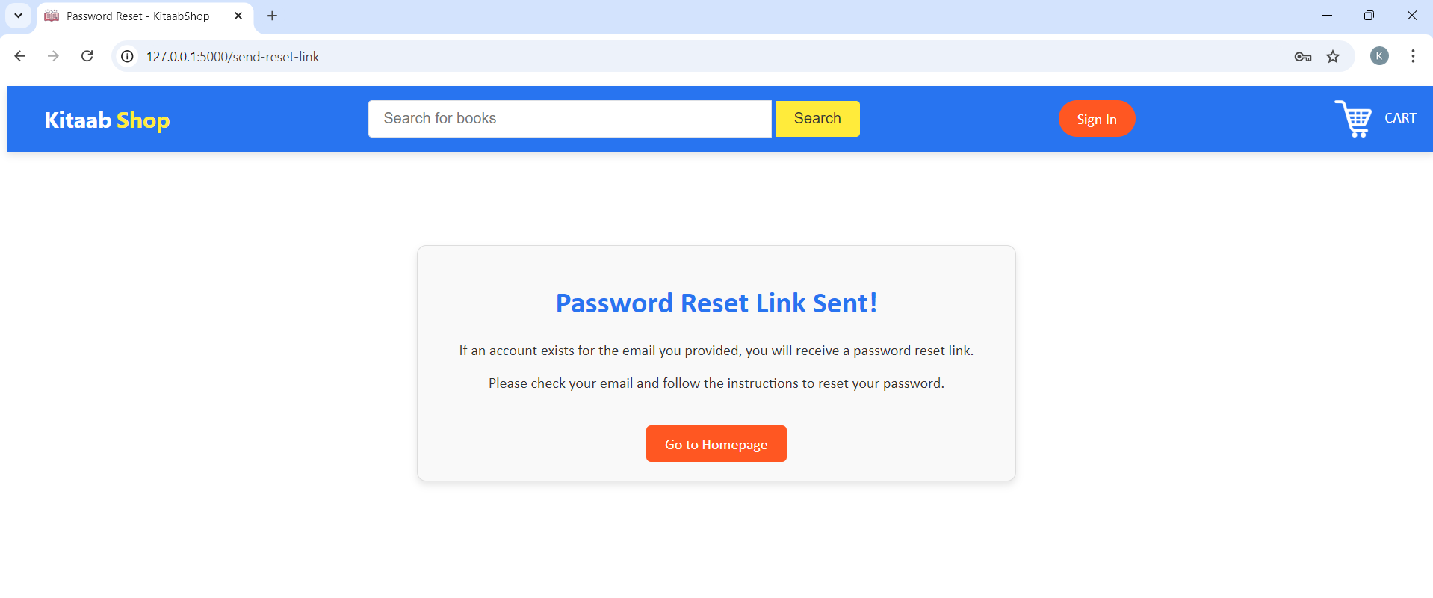

Key Features:

* Email Input: Users enter the email associated with their account.
* Send Reset Link Button: Sends the password reset email.

**7. Browse Books by Category**  
URL: /displayCategory  
Description: Users can browse books based on categories such as Fiction, Non-Fiction, etc.

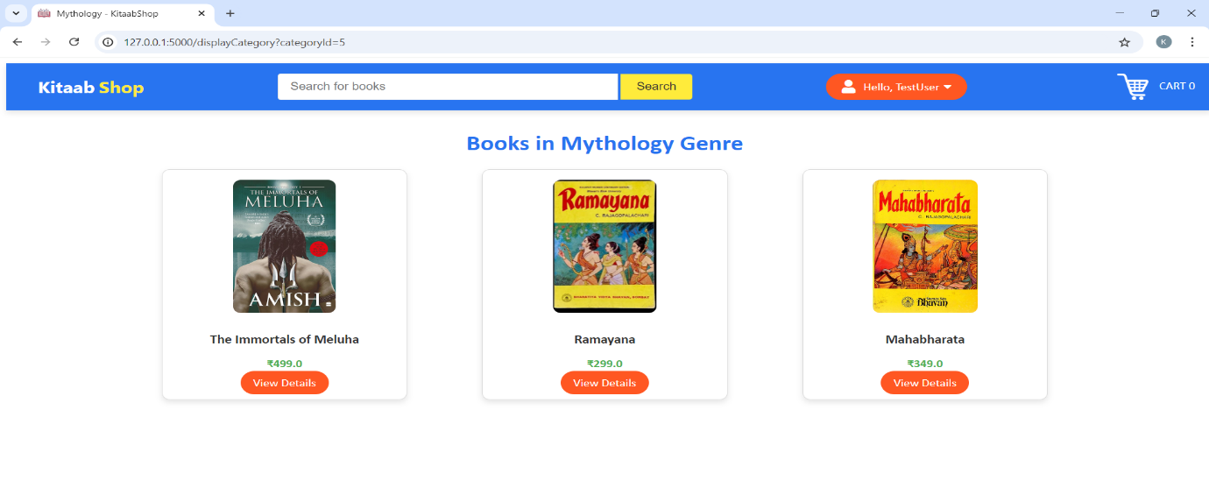

Key Features:

* Category Dropdown: A dropdown allows users to select a specific category.
* Books Grid: Displays books in the selected category.

**8. View Book Details**  
URL: /productDescription  
Description: Displays detailed information about a specific book, including price, description, and stock.  
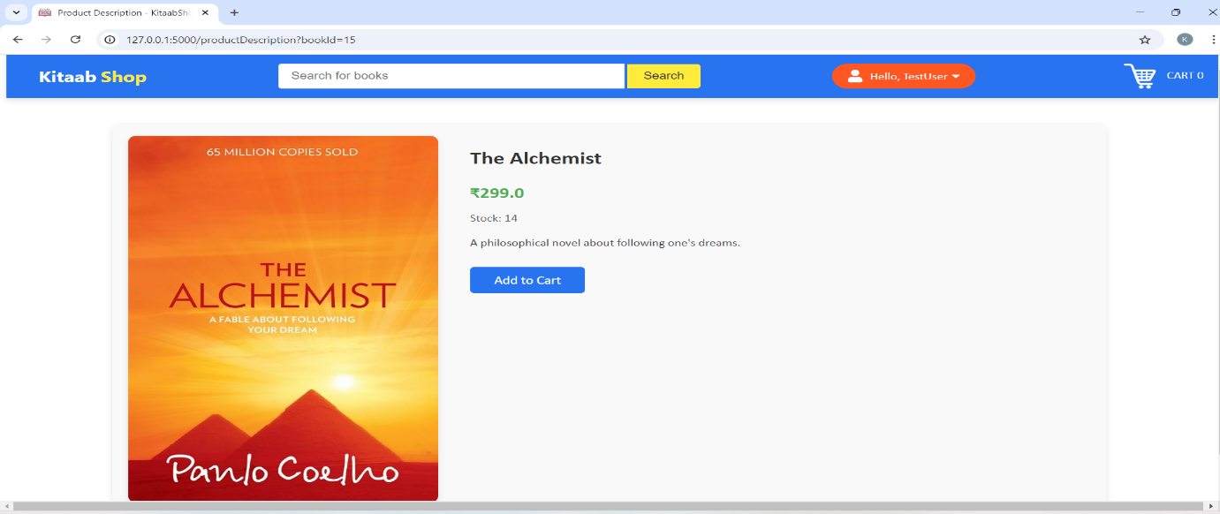

Key Features:

* Book Image and Description: Displays cover image, author, price, and book details.
* Add to Cart: Button to add the book to the user’s cart.

**9. Checkout**

URL: /checkout  
Description: Users enter shipping and payment information to complete their order.

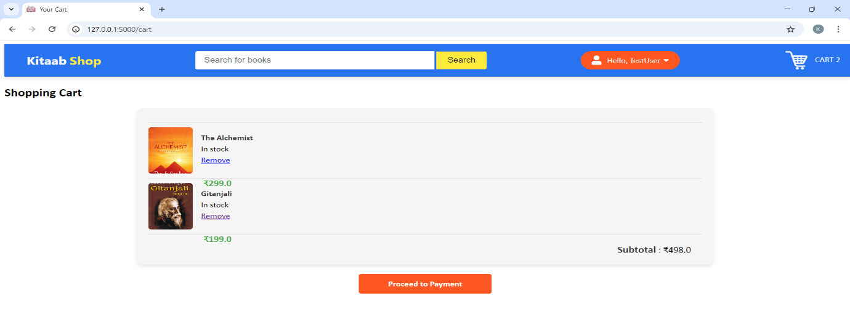

Key Features:

* Order Summary: Lists the books being purchased and the total price.
* Shipping Information: Form for entering the shipping address.
* Payment Method: Options for payment.

**10. Payment**  
URL: /payment  
Description: user can payment details i.e card details.

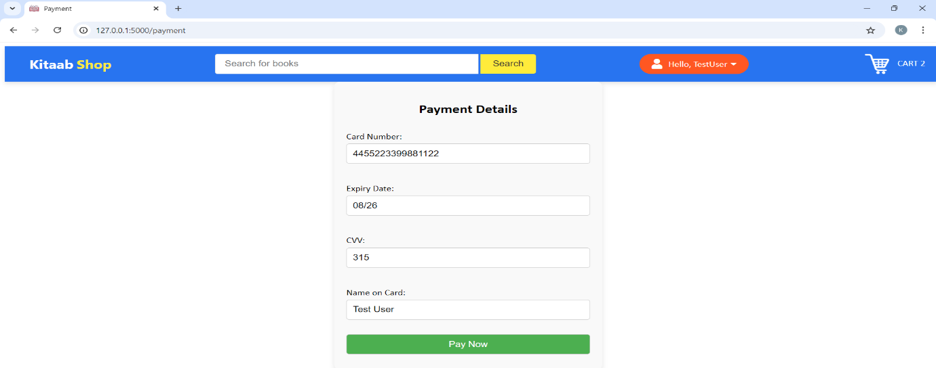

Key Features:

* Card verification – verifies card number length.
* Verify CVV length.

**11. Order Confirmation**  
URL: /orderConfirmation  
Description: Confirms the successful order placement and provides order details.

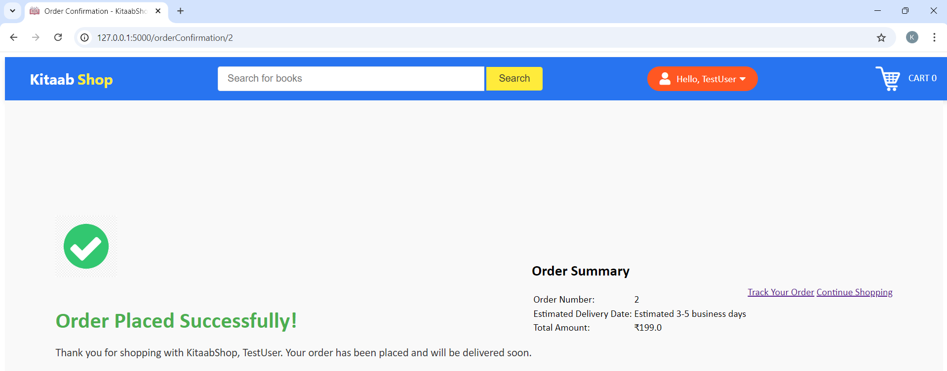

Key Features:

* Order Details: Displays order ID, books purchased, and total cost.
* Go to Homepage: A link to return to the homepage.

**12. View Order History**  
URL: /account/orders  
Description: Users can view a list of their previous orders.

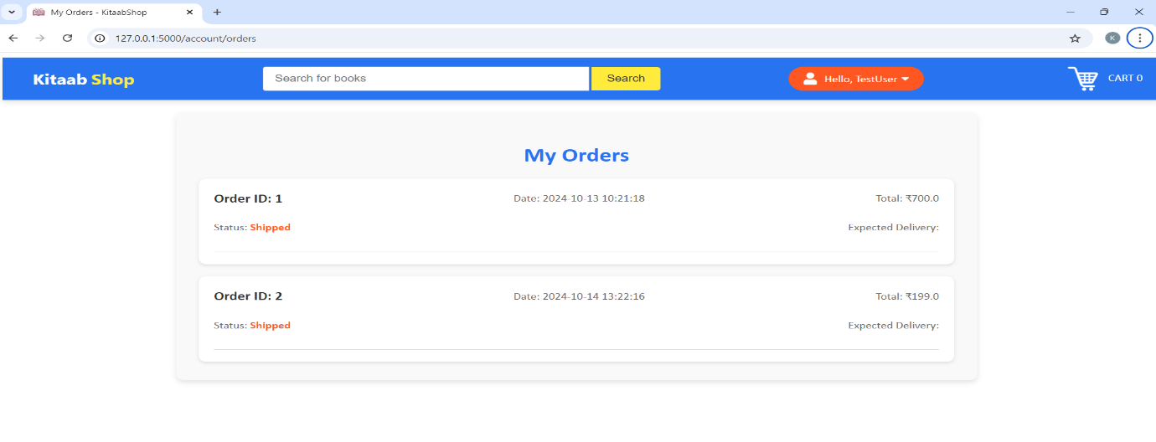

Key Features:

* Order List: Displays all previous orders with order IDs and purchase dates.

**13. Profile Management**

Page Name: User Profile  
URL: /account/profile  
Description: Users can view and edit their profile information here. User can change password as well.

Account profile

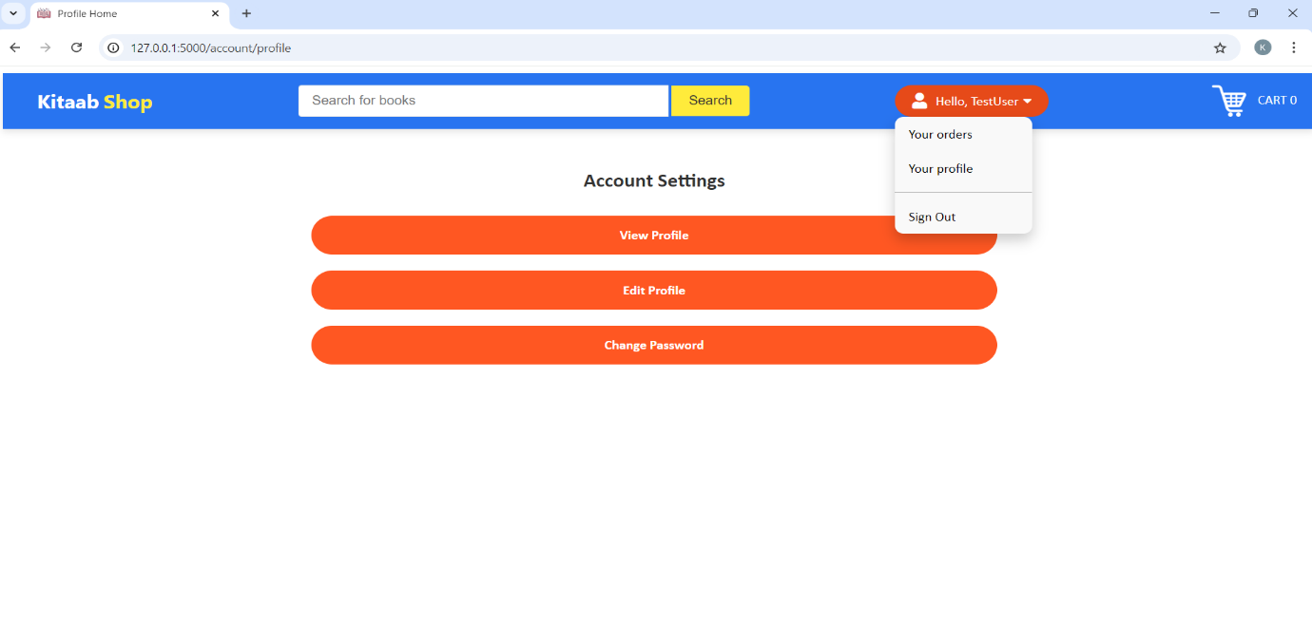

Edit profile

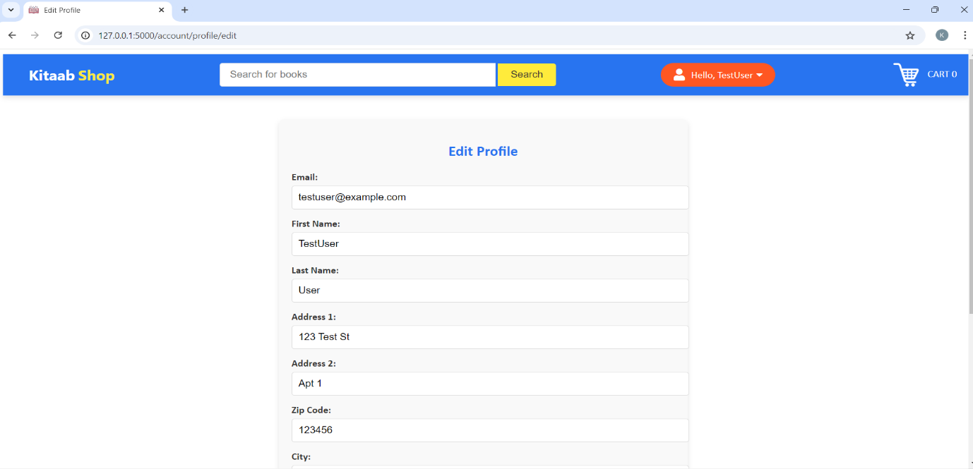

Change Password

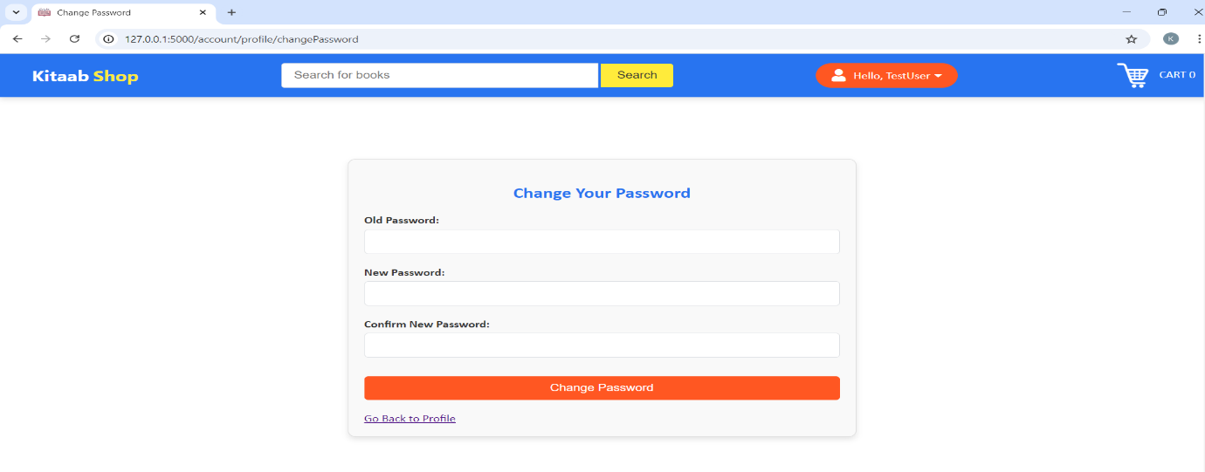

Key Features:

* Edit Profile: Option to update personal information like name, address, and phone number.
* Change Password: Option to reset the user’s password.