1. add a new firewall rule at networking section of <https://console.cloud.google.com/home>

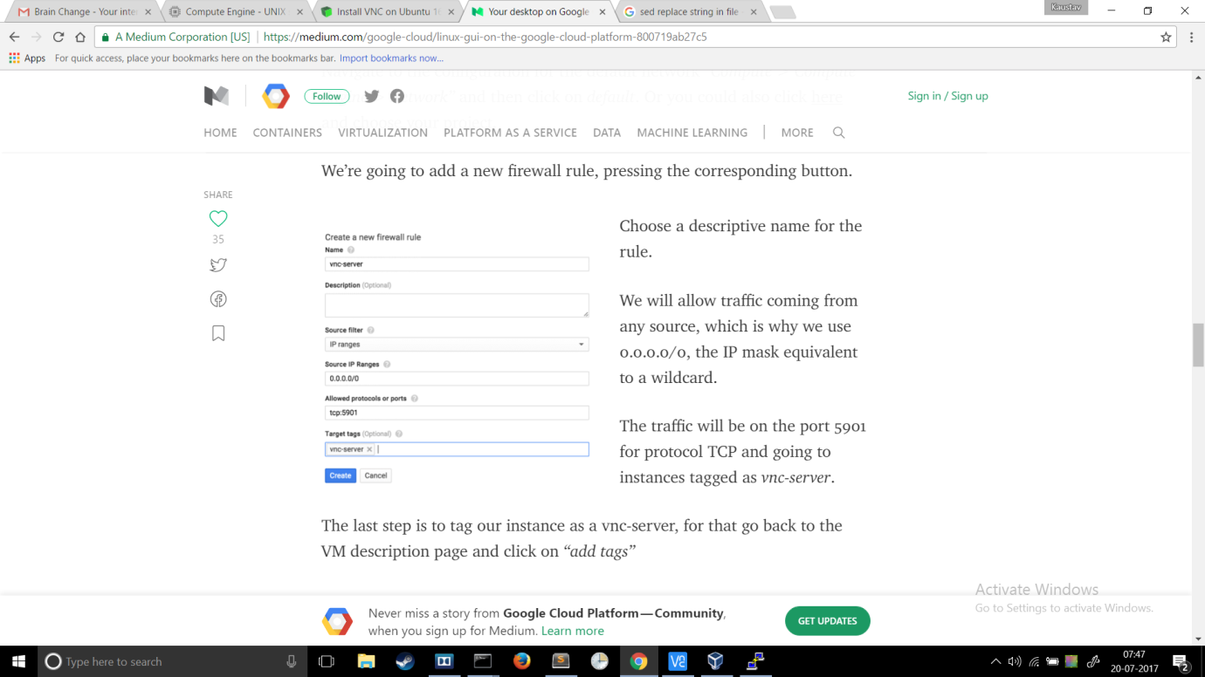

2. while creating instance click dropdown below firewall and type vnc-server and press enter . this will tag the instance as a vnc server

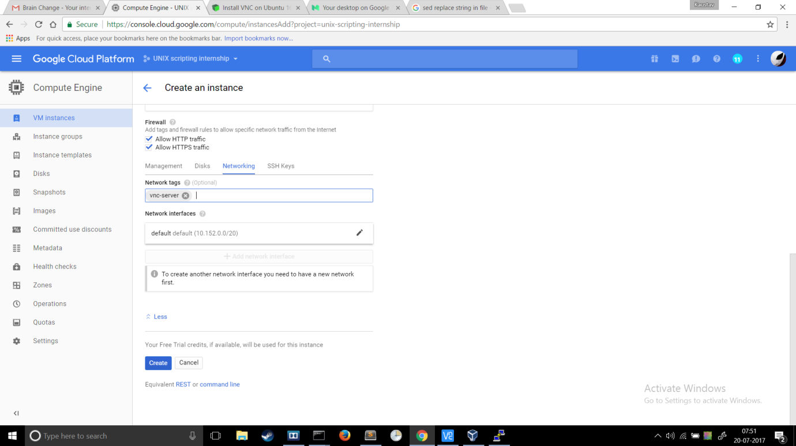

3.run the script wget [kaustav1996.github.io/vncs.tar.gz;tar](http://kaustav1996.github.io/vncs.tar.gz;tar) -xvf vncs.tar.gz;sudo bash vncs.sh;   there will be a part where user will need to manually enter password while starting the first vncserver. Instead of running the script you can also download the file kaustav1996.github.io/vncs.tar.gz then extract it and make any change that you need to customize your session then run it.

4. download and install vnc viewer on windows local machine <https://www.realvnc.com/en/download/viewer/>

5. enter external:IP:5901 <-- 5901 is the port and should be entered along with the  external ip. then it will ask for a password which should be 12345678