ID: 98398  
Date: 2024-06-10 16:24:00

# Spirometry Results

Temperature: 25 Humidity: 50.0 Pressure:1013.47498

The following graph visualizes the flowrate and cumulative volume over time.

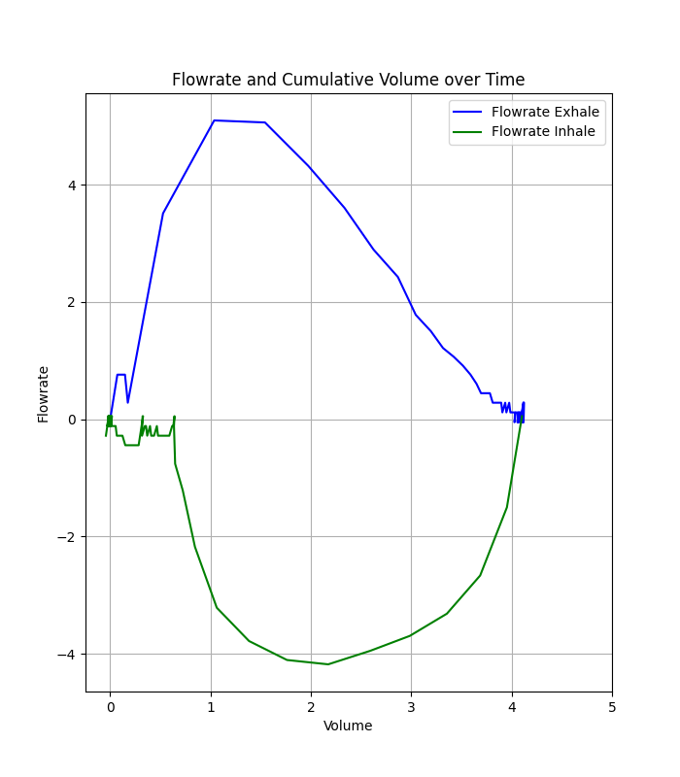

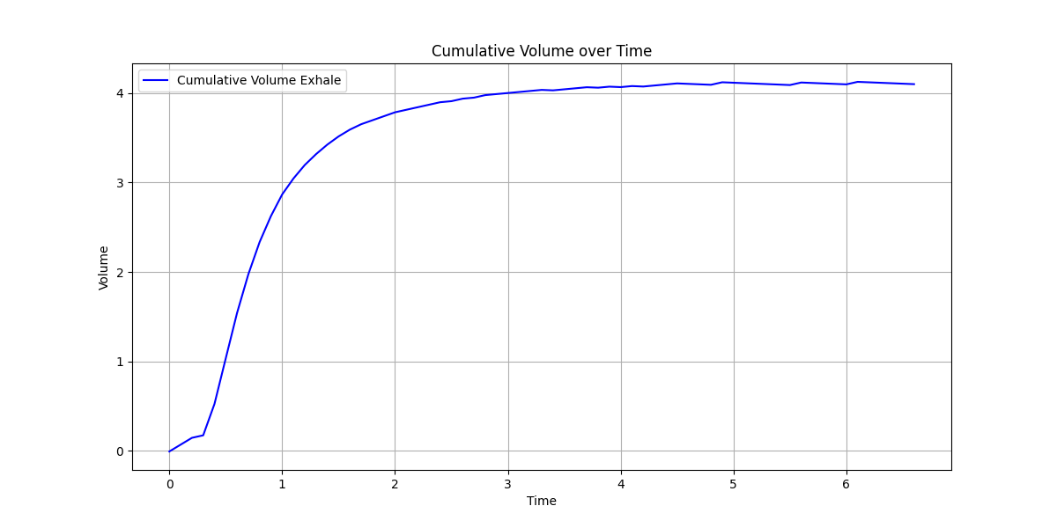

The following table lists the calculated spirometry parameters.

|  |  |  |  |  |
| --- | --- | --- | --- | --- |
| Parameter | Value | Predicted Value | Pred_Percentage | Z_Score |
| FEV1 (L) | 2.87 | 4.19 | 68.41 | -2.26 |
| FVC (L) | 4.10 | 4.82 | 85.09 | -1.37 |
| PEF (L/sec) | 5.10 | 6.50 | 78.39 | - |
| FIVC (L) | 4.14 | 4.14 | - | - |
| FEV1/FVC | 0.70 | 0.87 | 80.40 | -0.34 |
| FEV.5 (L) | 1.04 | 1.04 | - | - |
| FEV3 (L) | 4.00 | 4.00 | - | - |
| FEV6 (L) | 4.10 | 4.10 | - | - |
| FEF 25% (L/sec) | 5.10 | 5.10 | - | - |
| FEF 50% (L/sec) | 3.60 | 3.60 | - | - |
| FEF 75% (L/sec) | 1.50 | 1.50 | - | - |
| FEV.5/FVC | 0.25 | 0.25 | - | - |
| FEF 25%-75% (L/sec) | 3.60 | 3.60 | - | - |
| FEF 0.2-1.2 (L/sec) | 4.30 | 4.30 | - | - |
| FIF 25% (L/sec) | 3.21 | 3.21 | - | - |
| FIF 50% (L/sec) | 4.18 | 4.18 | - | - |
| FIF 75% (L/sec) | 3.32 | 3.32 | - | - |
| PIFR (L/sec) | 4.18 | 4.18 | - | - |