1. Wizoona  
     
   Foruppo

First of what is foruppo?  
Foruppo is an autonomous startup ecosystem and collaborative workspace where young and passionate entrepreneurs co-create and co-own innovative startups.  
  
They have three startups and initiated five entrepreneurial projects. Notable ventures include:

* **Ukisho**: A meritocratic social learning community built by cross-discipline intellectuals to study life.
* **Sheefro**: India's first digital intrapreneurship initiative aimed at instilling innovation in large-scale conventional businesses.
* **Startup Party**: An event where founders, aspiring entrepreneurs, startup enthusiasts, and investors play offline startup games together to connect and collaborate while having fun.

They have an internship programme which starts of with developing different innovative mini-SaaS products which are launched on Product Hunt if its worth it.  
  
Luckily, I was selected to lead one of the group (a team of 8), where in I had the first experience of leading an unknown group of people from different parts of india, I had experience of building something before, our dance production  
although I could find a many things, this was different in a fun manner, i learnt a lot in those 2 weeks. We had numerous meets, starting from brainstorming a tangible idea to concretizing it, splitting roles, iterating, fixing and dodging the barriers as we went along.  
  
I was lucky enough to be part of wonderful team, I was as much part of the team as other, in the sense that during meetings, I just tried to act as a regulator and not boss, but sometimes it was necessary to make the final call.  
  
We decided to built a fashion recommendation website, where in people with fair bit of wardrobe can come in and get inspired for new outfit ideas.  
We curated a five dimensional filter to choose your weather, occasion, which will give you diverse options.  
The dataset was exploited and labelled by our team members only.  
The websites was built on WordPress by me and one of the other team members.  
  
**FUNDAMENTAL PRINCIPLES OF OPTIMUS MAXIMUS :**

1. ACTION FIRST APPROACH
2. AVOID ENGAGING IN MONOTONOUS LEADERSHIP ROLE
3. GIVE PEOPLE AUTONOMY TO DO THEIR JOBS
4. DO REGULARS SYNC-UPS AND REMOVE BLOCKERS QUICKLY
5. AVOID BUILDING THE PYRAMID TEAM HIERARCHY
6. BEST METHOD FOR BUILDING A PROTOTYPES

Next, I was fortunate to be part of one of their flagship projects.  
Wizoona - 1st community-led holistic education startup to empower young adults with comprehensive life education.  
  
Wizoona, it’s a platform, aimed at fixing flaws in the Indian education system. Wizoona focuses on mental well-being, upskilling, and empowering youth through practical life skills.  
  
Equips users with the tools to care for their mental well-being and essential life skills, such as **sex education**, **managing accounts**, **investing**, and **collaboration-building**.  
  
 The platform is community-driven, offering sub-communities called tribes like   
**Meraki** (for mental wellness) and  
**Zenshin (for professional growth).** It’s designed to improve critical and creative thinking, helping young people to live life in a better way.  
  
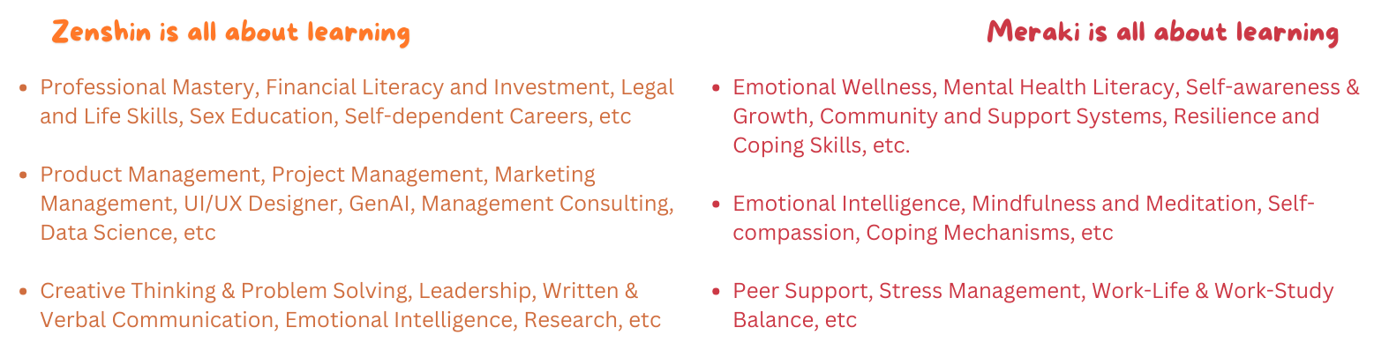

they have built a proper filtering mechanism, where the eco-system is such that, which starts with sessions and product building. Where great ideas can pop-up, genuine members get filtered up, they collaborate and eventually some ideas get concretized with current team, which goes into full blown production.   
  
Few ideas suggested by me.  
  
Self Help Book.  
Daily Feelings Survey.  
  
**Value Proposition**  
• Wizoona is not just a platform; it's a movement where passion meets collaboration.

• Users can join or create **Tribes**—interest-based groups fostering deep exploration, creativity, and skill-building.  
Had many collaborative brainstorming sessions.  
Idea is you will have this groups based on interest.  
And there will be some hierarchy, few would be part of wizoona, excelling in that domain.  
Rest others would collaborate, have fun meetings, sessions, discussion etc.  
  
  
  
**Customer Segmentation**  
Primarily we planned to focus on college going students.  
College Students (18–24 years):

* Ideal demographic for cultivating active, vibrant Tribes.
* Students who seek a mix of skill-building, career guidance, and interest-based learning in an engaging ecosystem.

**GTM Strategy.**We had many discussion on this  
Obviously we have our accounts in all fronts.  
We decided to grow through WhatsApp, tho its old school, but it has its merits  
  
**WhatsApp-Centric Growth (The Old School Advantage):**

* **Broadcast Networks:** Build interest-specific WhatsApp groups to create early Tribes.
* Share interactive polls, quizzes, and event links to generate buzz.
* Enable Tribe leaders to grow micro-communities on WhatsApp, creating a sense of exclusivity.

**3. Ambassador Program:**

* Appoint college student ambassadors to promote Wizoona on their campuses.
* Ambassadors can host **offline meet-ups** to strengthen community ties and onboard new members.

**4. Gamification:**

* Tribe performance metrics: e.g., “Most active Tribe,” “Top Collaborator,” or “Event of the Month.”
* Give rewards like badges, exclusive resources, or even scholarships for excelling Tribes or individuals.

**5. Leader Showcases:**

* Spotlight Wizoona Leaders in specific domains through webinars or Tribe meet-ups.
* Turn them into micro-influencers for Wizoona’s vision.