**Scenario 2**

**Create application load balancer and classic load balancer to load balance between two EC2 instances placed under two separate AZs. Ensure the servers are HA, fault tolerant and can be access over internet ONLY through HTTP & HTTPS ports.**

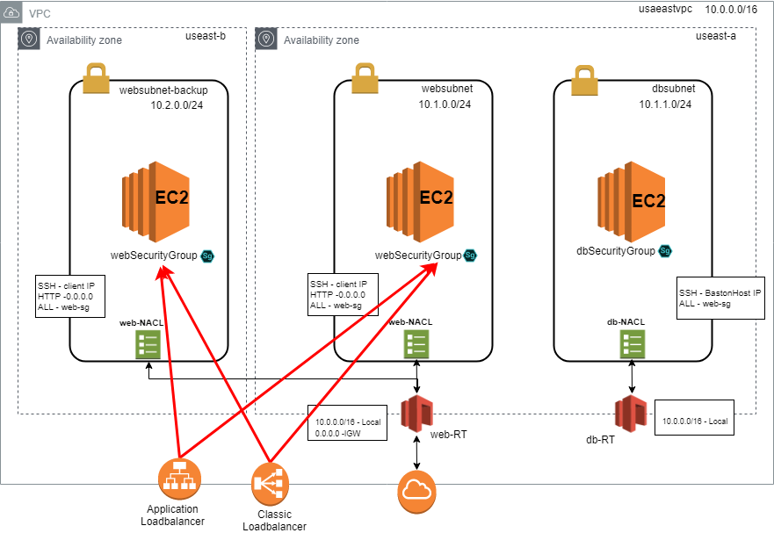

1. Create two subnet – **websubnet** and **websubnet-backup**, place each subnet in different AZs.
2. Create a new NACL web-NACL and open all inbound and outbound connections.
3. Create a new security group with following rules

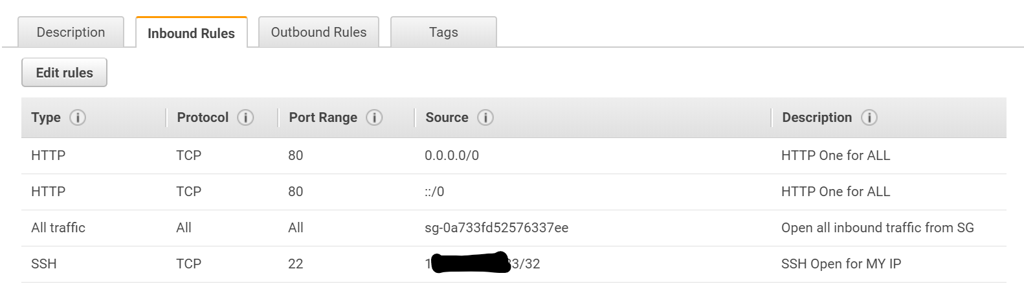

1. Create two webservers in each subnets (**websubnet** and **websubnet-backup**) with following bootstrap scripts.

|  |
| --- |
| #!/bin/bash  sudo su  yum update -y  yum install httpd -y  service httpd start  chkconfig httpd on  cd /var/www/html  securitygroup=$(curl http://169.254.169.254/latest/meta-data/security-groups/)  instanceid=$(curl http://169.254.169.254/latest/meta-data/instance-id/)  availabilityzone=$(curl http://169.254.169.254/latest/meta-data/placement/availability-zone)  echo '<html><center><h1>HOSTED FROM AMAZON EC2 INSTANCE</h1><center><body><iframe src="http://www.youtube.com/embed/_Yn7QAS5Wpw" width="560" height="315" frameborder="0" allowfullscreen></iframe></br><p1> This page is hosted using AWS EC2 instance </p1> <h3>EC2 Instance Info</h3><center><body><table><tr><td><b>instance-id</b></td><td>'$instanceid'</td><td><b>availability-zone</b></td><td>'$availabilityzone'</td></td><tr><td><b>security-group</b></td><td>'$securitygroup'</td></tr></table></body></html>' >index.html |

1. Once bootup – login to each induvial webservers public IPs.

 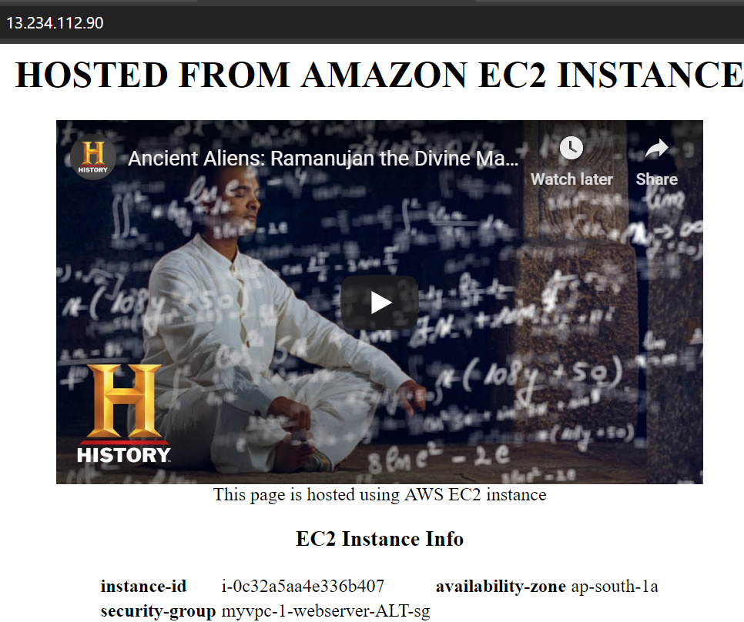

1. Ensure that both private IPs can be pinged from one another.
2. Create a Classic Load Balancer, add **websubnet** and **websubnet-backup** subnet **–** Add running webserver and webserver backup instance to the load balancer group. Configure health check as shown below.

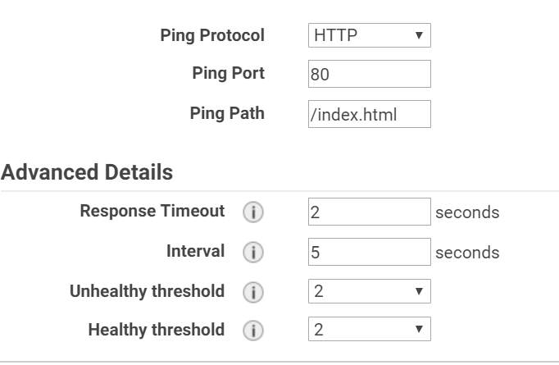

1. Open loadbalancer URL to ensure its working as expected.

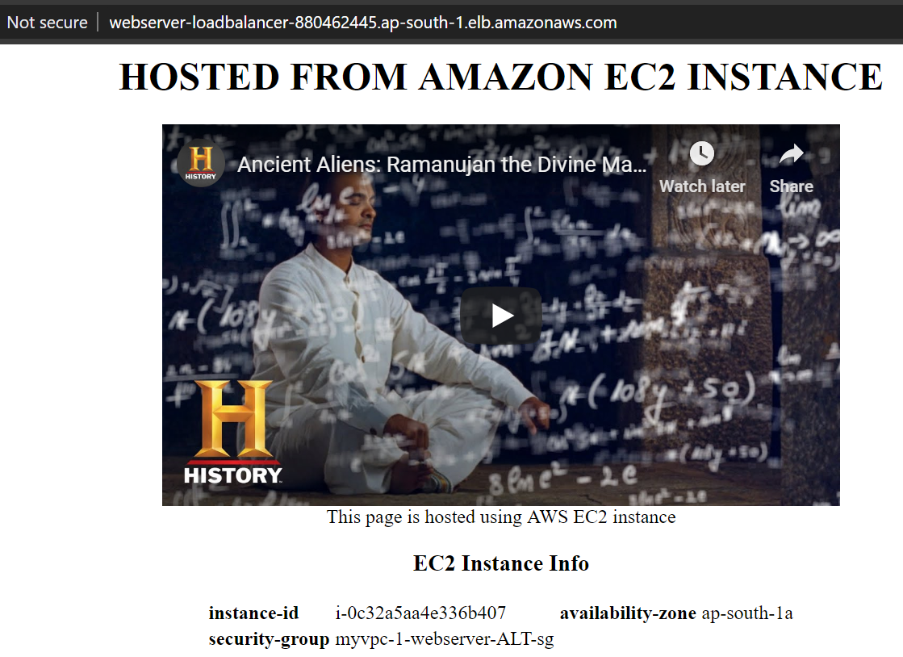

1. Create a new internet facing application loadbalancer, with similar configuration as that of the classic load balancer.

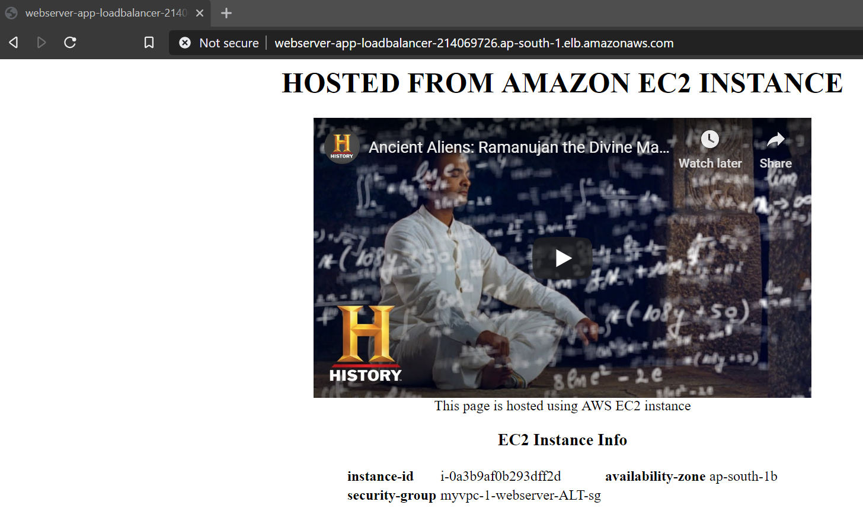

Note: Ensure that instances are added to the target group. Once added, make sure the instances are showing as healthy.

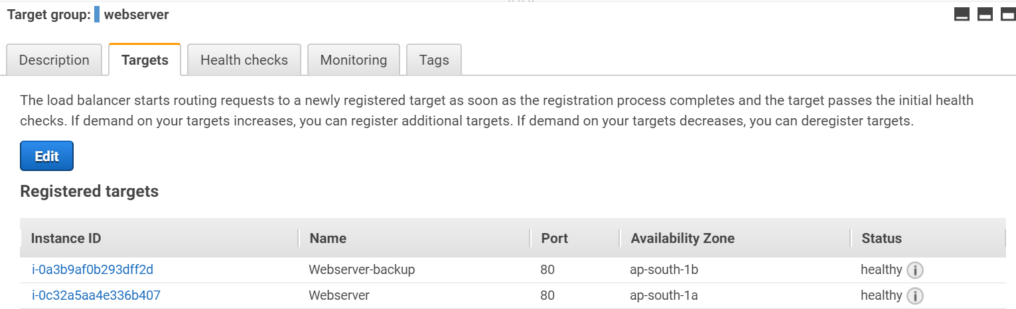

1. Delete all created resources to avoid charging.
   1. Autoscaling group
   2. Launch Configuration
   3. Delete Classic Load Balancer
   4. Delete Application Load Balancer
   5. Delete Target group
   6. Terminate Running instances

**Knowledge Points**

|  |
| --- |
| What is the difference between Launch Configuration and Launch Template?  A launch template is similar to a [launch configuration](https://docs.aws.amazon.com/autoscaling/ec2/userguide/LaunchConfiguration.html), in that it specifies instance configuration information. Included are the ID of the Amazon Machine Image (AMI), the instance type, a key pair, security groups, and the other parameters that you use to launch EC2 instances. However, defining a launch template instead of a launch configuration allows you to have multiple versions of a template. With versioning, you can create a subset of the full set of parameters and then reuse it to create other templates or template versions. For example, you can create a default template that defines common configuration parameters such as tags or network configurations, and allow the other parameters to be specified as part of another version of the same template. |

|  |
| --- |
| NO public IP will be assigned to the instances launched by autoscaling group    In the "Create Launch Configuration", select "Advanced Details" and look for the "IP Address Type" Section, you'll see:  IP Address Type   * Only assign a public IP address to instances launched in the default VPC and subnet. (default) * Assign a public IP address to every instance. * Do not assign a public IP address to any instances. Note: this option only affects instances launched into an Amazon VPC |