**Okta Security Configuration**

1. Login to : <https://developer.okta.com/signup/>
2. Select

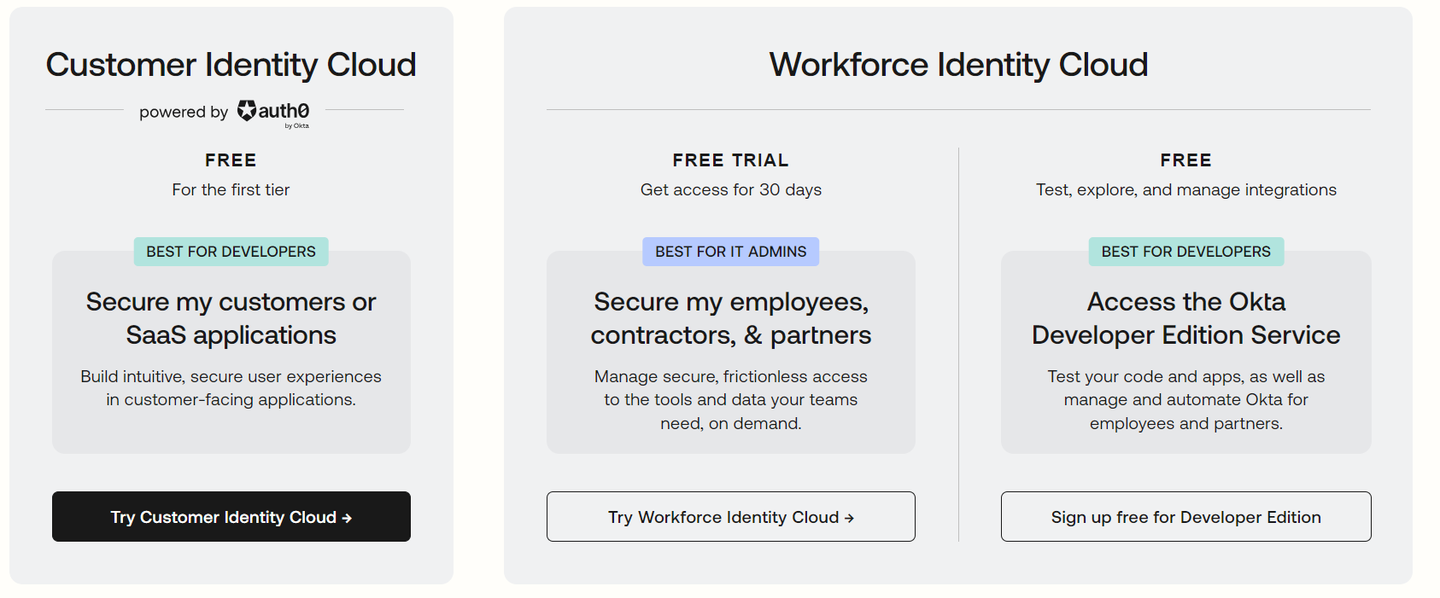

1. Sign up with Google Account

|  |  |
| --- | --- |
| UserName | ****** |
| Password | ****** |

1. Domain : dev-11896815-admin.okta.com
2. Create App Integration

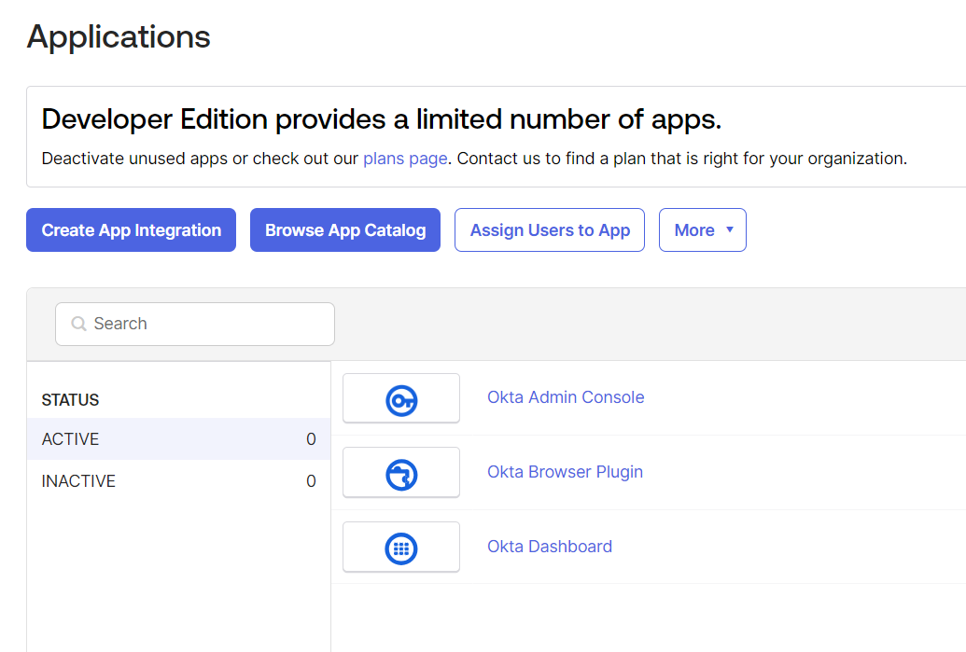

1. Select OIDC – OpenID Connect/ Web Application
2. 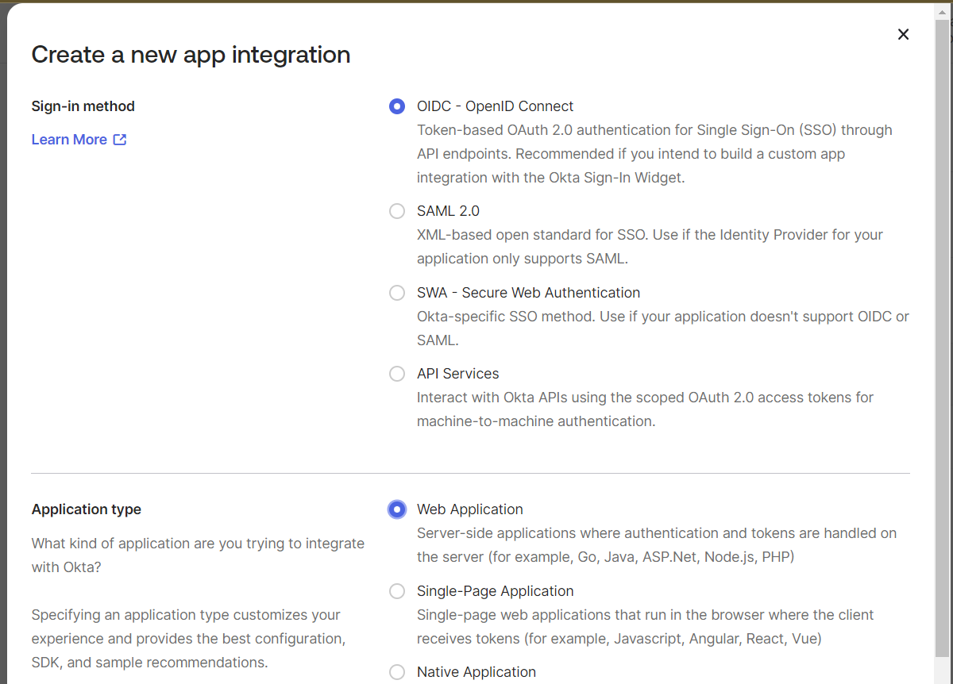
3. Give Application Name & logo (optional)
4. Select Grant Type

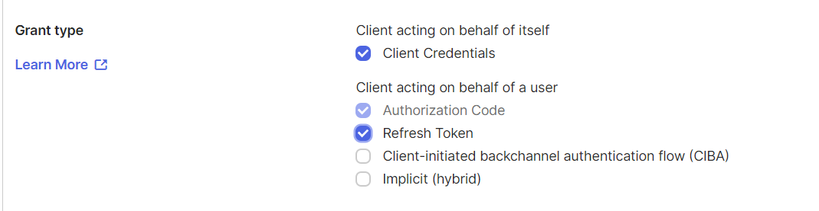

1. Sign-In redirect URL

Note: as the API gateway (application entry point is running on localhost:9090 login URL needs to be changed accordingly)

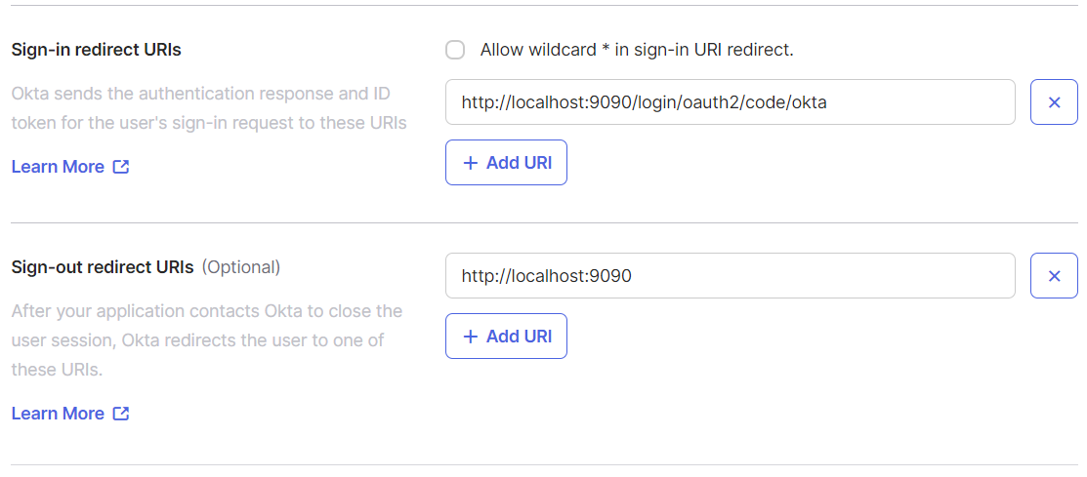

1. Click on Security > API > default

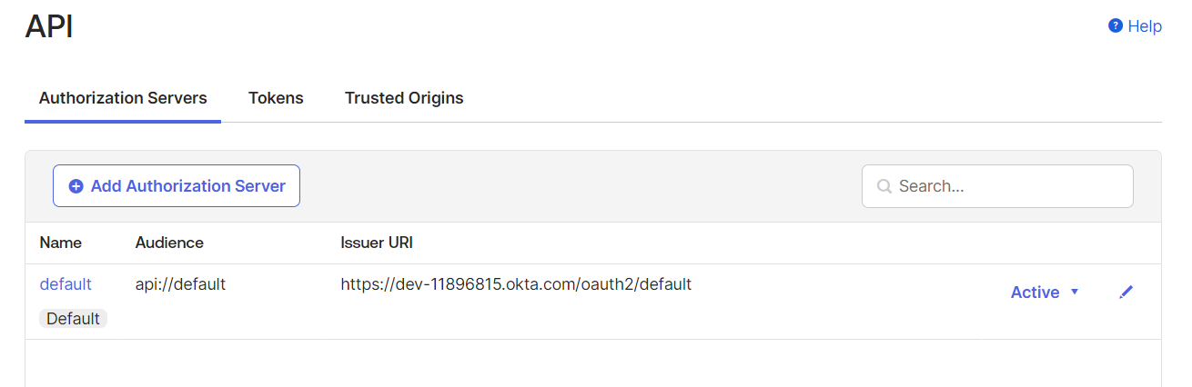

1. Add new Scope

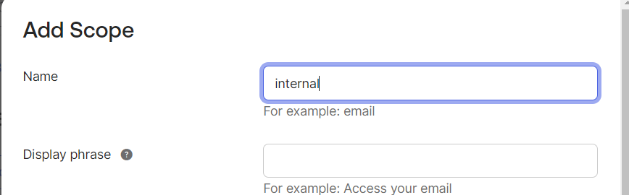

1. Under Directory > Group Create two new Groups
2. Admin
3. Customer

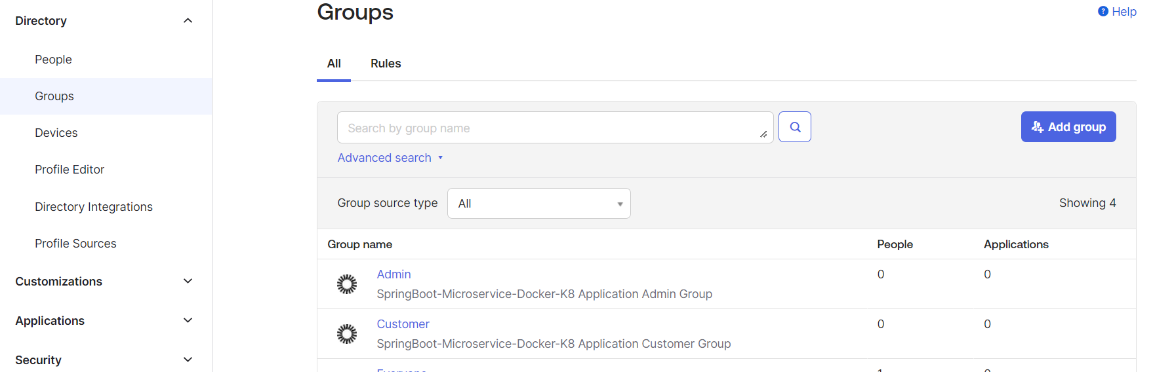

1. Add new Users

|  |  |
| --- | --- |
| User Name | Password |
| Customer@SpringBootApplication.com | PassW0rd@1234 |
| Admin@SpringBootApplication.com | PassW0rd@1234 |
| Customer_2@SpringBootApplication.com | PassW0rd@1234 |
| kaustavdassoa@gmail.com | Sample001@1234 |