

**Basic Linux Commands Assignments**

**Full Screen Assignment:** 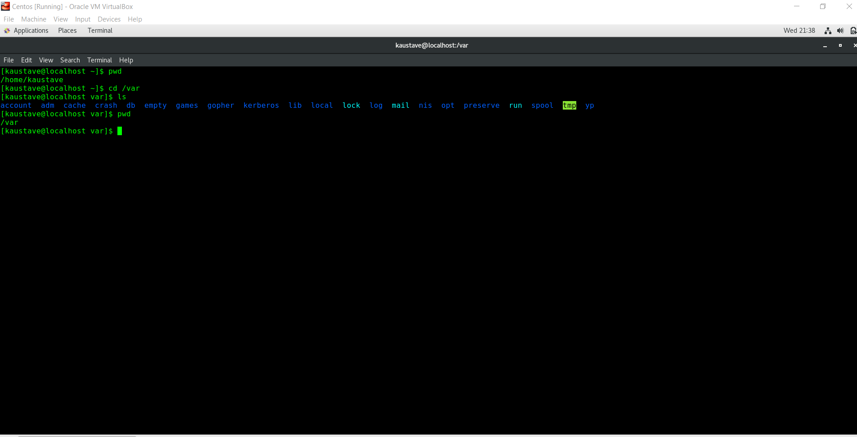

**Yum update –y assignment:**

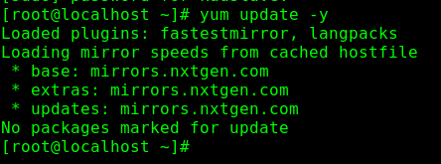

Assignment-1

Connect and disconnect with login Access

* What happens when you login a non-existent users or username?
  + Provide Screenshot and What you understand, explain in short brief?

When I tried to login with non –existent user, it didn’t allowed to login, may be because the distro doesn’t know about the user credentials. We need to add to user list to make it known to the OS for the user to login.

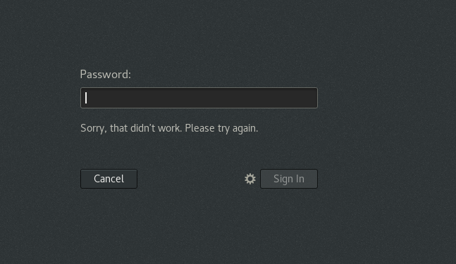

Assignment-2

Password changing

I tried changing the password, but it doesnot took effect.

* Login into your account and then change password?
  + Change your password into **IneuR0n#42** and hit the **Enter** key
    - Explain what happen and give screenshot?
  + Try again to change password but use like password ***1234*** or ***abcd***
    - Explain what happen and give screenshot?
  + Try again to change password but now don’t use any password just hit **Enter** key
    - Explain what happen and give screenshot?

Assignment-3

Working with Directories

* Enter the command **cd /** and then **ls** and then hit **Enter** key
  + Take screenshot and explain what output we got?
  + From the below screenshot its validated that cd / takes us to the root directory

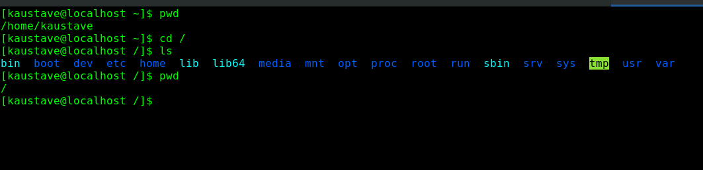

* Enter the command now **cd /home** and then hit **Enter** key
  + Do **ls,** provide screenshot and explain what is **/home** directory used for?
  + Cd /home takes to the home directory

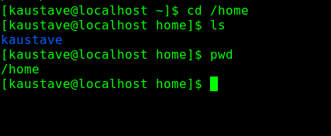

* Enter **cd ..** and hit **Enter** key [ *Note: here we have space after cd then use double dot*]
  + Check what happen and give screenshot?
  + It moves back one directory

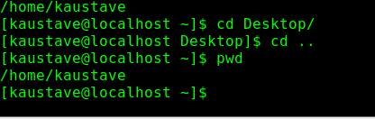

* Now enter **cd /var/www/html** and then type **cd** and hit **Enter** key
  + Explain what happen and give screenshot?
  + There was no www directory under var, so couldnot complete this.
* Now type **cd /root** and then hit **Enter** key
  + Do **ls,** check any output we have on screen if yes then take screenshot?
  + Permission got denied

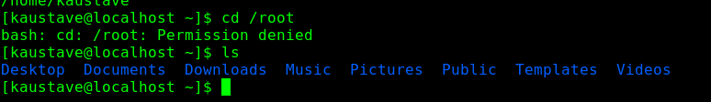

Assignment-4

Working with File Listing

* Go to **cd /etc** and type **ls**
  + Take screenshot and explain what files you have seeing?
  + Take screenshot and explain what different output you found compare to previous command you used?

These are centos config files, these files will be common to all users.

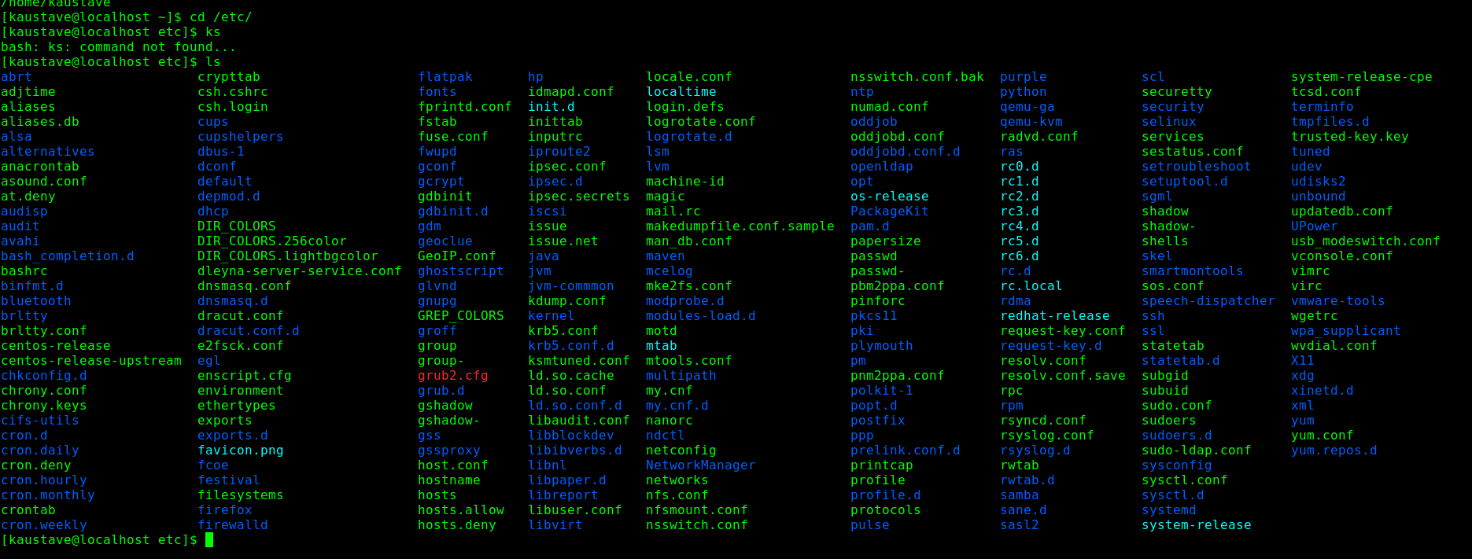

* Then type **ls -al** and hit **Enter** key
  + Take screenshot and explain what new file or directory you found?
  + Here a lot of hidden files can be seen as listed.

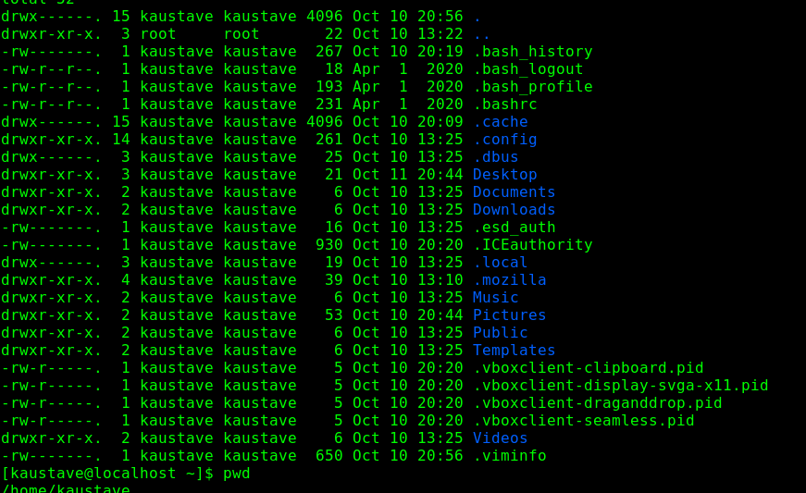

* Then use **ls -i** and hit **Enter** key
  + Now see what different output its shows and take screenshot?
  + It gives us the output of size and its concurrent directory name
  + 
* Then use **ls –help** and see other options about **ls** command
  + Explore it and try with other attribute we can use with **ls** command

Assignment-5

Know where you are and where you working

*Here we use* ***pwd, cd and ls*** *as combine task to understand where you working on terminal and how you can switch from one directory to another one.*

* Open terminal after restart the linux
  + Check which location you working, type **pwd** and take screenshot

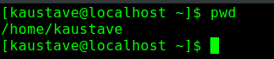

* Now use **cd /var** and hit **Enter** key
  + Do **ls,** and see what output comes, give screenshot?



* Do explore other help options of each command to learn more other things we can do with these commands