Internship Report
Of
AI-Powered Network Defense System (AMCDS)
Submitted
To
School of Computer Science and Engineering
IILM University, Greater Noida, U.P.
In partial fulfilment of the requirement of degree of
B.Tech CSE

By
Roll Number of Student: CS-023411064
Name of Student: KAUSTUBH PANDEY
Batch: 2026-27

INTERNSHIP COMPLETION CERTIFICATE
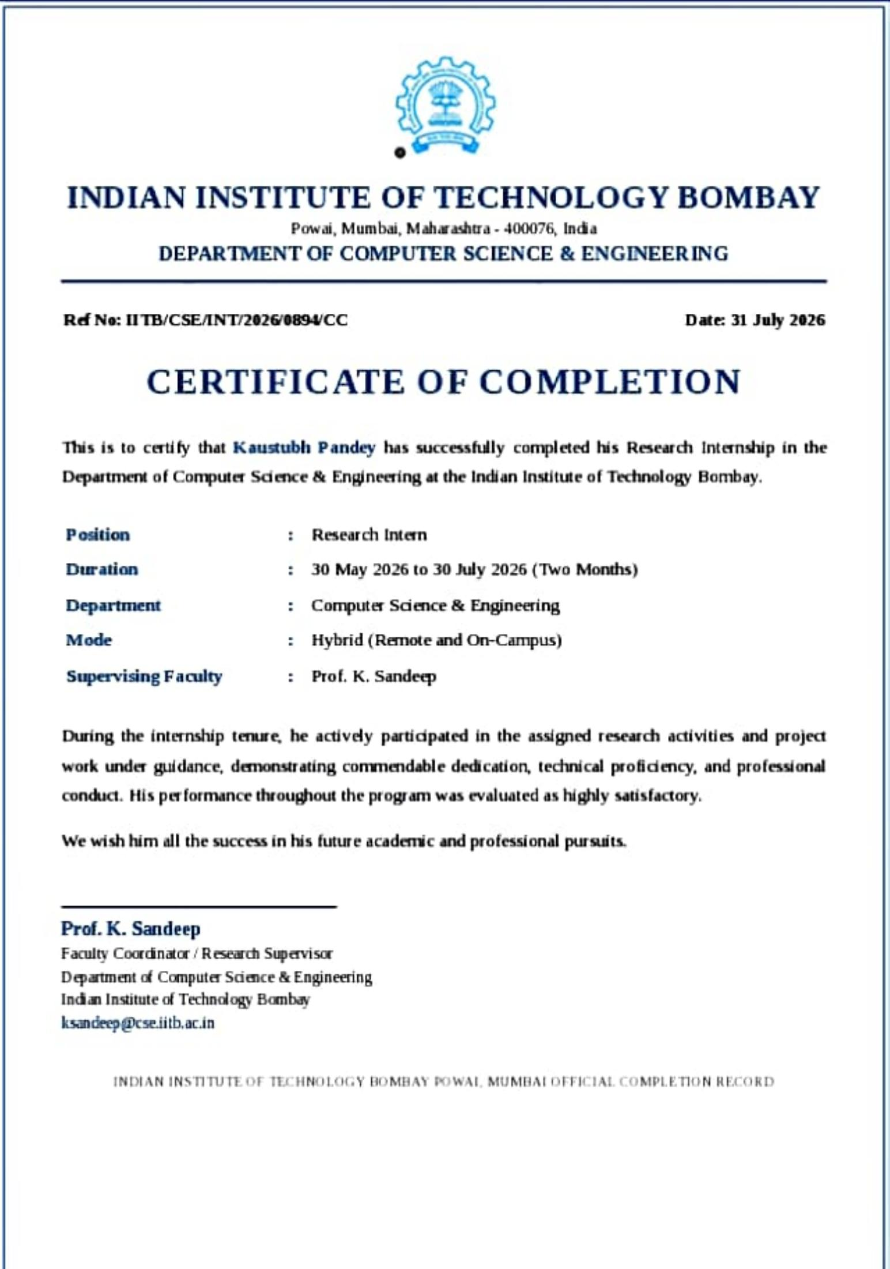

CANDIDATE'S DECLARATION
I, Kaustubh Pandey, Roll No. CS-023411064, do hereby declare that the internship report titled “AI-Powered Network Defense System (AMCDS)” has been completed by me during my research internship at the Indian Institute of Technology Bombay (IIT Bombay), Department of Computer Science and Engineering, to fulfil the requirement for the award of the degree of Bachelor of Technology in CSE. All the references have been quoted and I have not taken as such any material from any other source. I affirm that this report is my own work and has not been submitted to any other institute for any degree/diploma requirement, and I shall be solely responsible for any kind of copyright violation in this regard.
Signature: Kaustubh Pandey
Student Name: Kaustubh Pandey
Roll No.: CS-023411064

ACKNOWLEDGEMENT
I would like to express my sincere gratitude to the Indian Institute of Technology Bombay (IIT Bombay) for providing me the opportunity to undertake my research internship in the Department of Computer Science and Engineering. This experience has been immensely valuable in strengthening my technical knowledge and research aptitude in the field of AI-driven cyber defense systems.
I am deeply thankful to my faculty guide, Prof. K. Sandeep, for his invaluable guidance, continuous encouragement, and constructive feedback throughout the course of this internship. His mentorship played a pivotal role in shaping the direction and outcome of this project.
I am using this opportunity to express my gratitude to everyone at IIT Bombay who supported me throughout the internship program. I am thankful for their aspiring guidance, invaluably constructive criticism, and friendly advice during this work. I am sincerely grateful to them for sharing their truthful and illuminating views on a number of issues related to this work.
I also express my gratitude to my parents for their constant blessings and support.
Signature: Kaustubh Pandey
Student Name: Kaustubh Pandey
Roll No.: CS-023411064

TABLE OF CONTENTS

Chapter No. | Chapter Name | Page Nos.
 | Cover Page | ---
1. | Candidate's Declaration | i
2. | Acknowledgement | ii
3. | Internship Completion Certificate | iii
4. | Project Description  4.1 Introduction  4.2 Organization Profile  4.3 Problem Statement  4.4 Project Objectives  4.5 Scope of the Project  4.6 Technologies and Tools Used  4.7 System Architecture  4.8 Methodology  4.9 Expected Outcomes  4.10 Certificate of completion and other communication mail proof | 1
5. | Bibliography/References

4. Project Description

4.1 Introduction
Cybersecurity threats have grown increasingly sophisticated in recent years, with attackers leveraging automation and adaptive strategies to breach network defenses. Traditional rule-based and signature-based security systems often struggle to keep pace with rapidly evolving attack patterns. This project, undertaken as a research internship at the Indian Institute of Technology Bombay (IIT Bombay), Department of Computer Science and Engineering, focuses on the design and development of an Autonomous Multi-Agent Cyber Defense System (AMCDS) — an AI-driven framework capable of simulating, detecting, analyzing, and autonomously responding to cyber threats in real-time network environments.
The internship was carried out under the guidance of Prof. K. Sandeep, Faculty Coordinator / Research Supervisor, Department of Computer Science and Engineering, from 30 May 2026 to 30 July 2026 (a duration of two months), in Hybrid mode (Remote and On-Campus). The internship provided extensive exposure to research methodologies, multi-agent system design, and the practical application of machine learning and reinforcement learning techniques in the domain of network security.

4.2 Organization Profile
The Indian Institute of Technology Bombay (IIT Bombay), established in 1958, is one of India's premier institutions for engineering education and research. Located in Powai, Mumbai, IIT Bombay is renowned for its contributions to cutting-edge research across disciplines such as computer science, artificial intelligence, cybersecurity, and data engineering. The Department of Computer Science and Engineering at IIT Bombay is home to numerous research groups working on advanced topics including machine learning, distributed systems, and network security, providing a highly stimulating environment for research interns to engage in impactful, industry-relevant work.

4.3 Problem Statement
Modern networked systems face a constant barrage of sophisticated cyberattacks that exploit vulnerabilities faster than they can be manually identified and mitigated. Security Operations Centers (SOCs) often rely heavily on manual analysis and static rule sets, resulting in delayed detection, high false-positive rates, and insufficient scalability against dynamic, multi-stage attacks. There is a pressing need for an intelligent, autonomous system capable of simulating realistic attack-defense scenarios, continuously learning from network behavior, and responding to threats in real time with minimal human intervention.

4.4 Project Objectives
- To design and develop a multi-agent simulation environment comprising autonomous attacker, defender, and SOC agents.
- To implement realistic cyberattack scenarios based on the MITRE ATT&CK framework, including reconnaissance, exploitation, and lateral movement.
- To build AI-powered defense agents capable of continuous network monitoring, threat analysis, and risk scoring using Graph Neural Networks (GNNs).
- To apply Reinforcement Learning (RL) for optimizing autonomous defensive decision-making.
- To integrate Large Language Models (LLMs) for threat interpretation and incident analysis.
- To evaluate the system's effectiveness in improving incident response speed and overall network resilience.

4.5 Scope of the Project
The scope of the AMCDS project encompasses the design of a virtual network environment for simulating cyberattacks and defenses, the development of autonomous agent behaviors, and the integration of AI/ML models for real-time threat detection and response. The system is intended as a research prototype demonstrating the feasibility of autonomous, multi-agent cyber defense, and can be extended in future work to larger-scale, production network environments and a wider range of attack techniques.

4.6 Technologies and Tools Used
- Programming Language: Python
- Backend Framework: FastAPI
- Frontend Framework: React
- Database: PostgreSQL
- AI/ML Techniques: Graph Neural Networks (GNNs), Reinforcement Learning (RL)
- Large Language Models (LLMs) for threat interpretation and incident analysis
- Framework Reference: MITRE ATT&CK

4.7 System Architecture
The AMCDS architecture is composed of three primary categories of autonomous agents operating within a simulated virtual network environment:
- Attacker Agents: Execute MITRE ATT&CK-based tactics such as reconnaissance, exploitation, and lateral movement to simulate realistic adversarial behavior.
- Defender Agents: Continuously monitor network activity, perform threat analysis using GNN-based risk scoring, and deploy automated containment actions.
- SOC Agents: Oversee the overall security posture, coordinate defensive responses, and utilize LLM-based analysis for incident interpretation and reporting.
The FastAPI backend orchestrates communication between agents and the PostgreSQL database, while the React-based frontend provides a real-time dashboard for visualizing network activity, threat scores, and agent actions.

4.8 Methodology
The development methodology involved first constructing a virtual network environment capable of hosting simulated hosts, services, and traffic. Attack agents were programmed to execute staged attack sequences based on MITRE ATT&CK tactics, progressing through reconnaissance, exploitation, and lateral movement phases. In parallel, AI-powered defense agents continuously monitored network activity logs, extracted relevant features, and used Graph Neural Network models to calculate dynamic risk scores for hosts and connections within the network graph.
Reinforcement Learning was employed to train the defender agents to select optimal containment and mitigation actions based on the evolving state of the network, with reward signals designed to balance threat neutralization against operational disruption. Large Language Models were integrated to assist SOC agents in interpreting detected threats, summarizing incidents, and generating human-readable analysis reports. The complete pipeline was tested iteratively across multiple simulated attack scenarios to evaluate detection accuracy, response time, and overall system resilience.

4.9 Expected Outcomes
The AMCDS system successfully demonstrated automated threat detection, dynamic risk assessment, attack-path analysis, and intelligent, autonomous response generation. Results from the simulation trials showed improved incident response speed compared to manual analysis, a reduction in the need for manual intervention, and enhanced overall network resilience against simulated multi-stage cyberattacks. These outcomes validate the feasibility of using coordinated multi-agent AI systems, combining GNNs, Reinforcement Learning, and LLMs, for next-generation autonomous cyber defense.

4.10 Certificate of Completion and Other Communication Mail Proof
The scanned copy of the official Internship Completion Certificate (Ref No. IITB/CSE/INT/2026/0894/CC, dated 31 July 2026), issued by Prof. K. Sandeep, Faculty Coordinator / Research Supervisor, Department of Computer Science and Engineering, Indian Institute of Technology Bombay, is attached on the Internship Completion Certificate page included earlier in this report. The certificate confirms successful completion of the Research Internship in Hybrid mode (Remote and On-Campus) over the period 30 May 2026 to 30 July 2026.

5. Bibliography/References
1. MITRE ATT&CK Framework. MITRE Corporation. https://attack.mitre.org/
2. Kipf, T. N., & Welling, M. (2017). Semi-Supervised Classification with Graph Convolutional Networks. International Conference on Learning Representations (ICLR).
3. Sutton, R. S., & Barto, A. G. (2018). Reinforcement Learning: An Introduction (2nd ed.). MIT Press.
4. FastAPI Documentation. https://fastapi.tiangolo.com/
5. React Documentation. https://react.dev/
6. PostgreSQL Documentation. https://www.postgresql.org/docs/
7. Relevant internal project documentation and reports, IIT Bombay, Department of Computer Science and Engineering.

