TT Cell Vocational Training System

Database Schema & ER Diagram
Below is the visual Entity-Relationship diagram representing the latest backend schema (including the roll_number primary key change for Trainees):
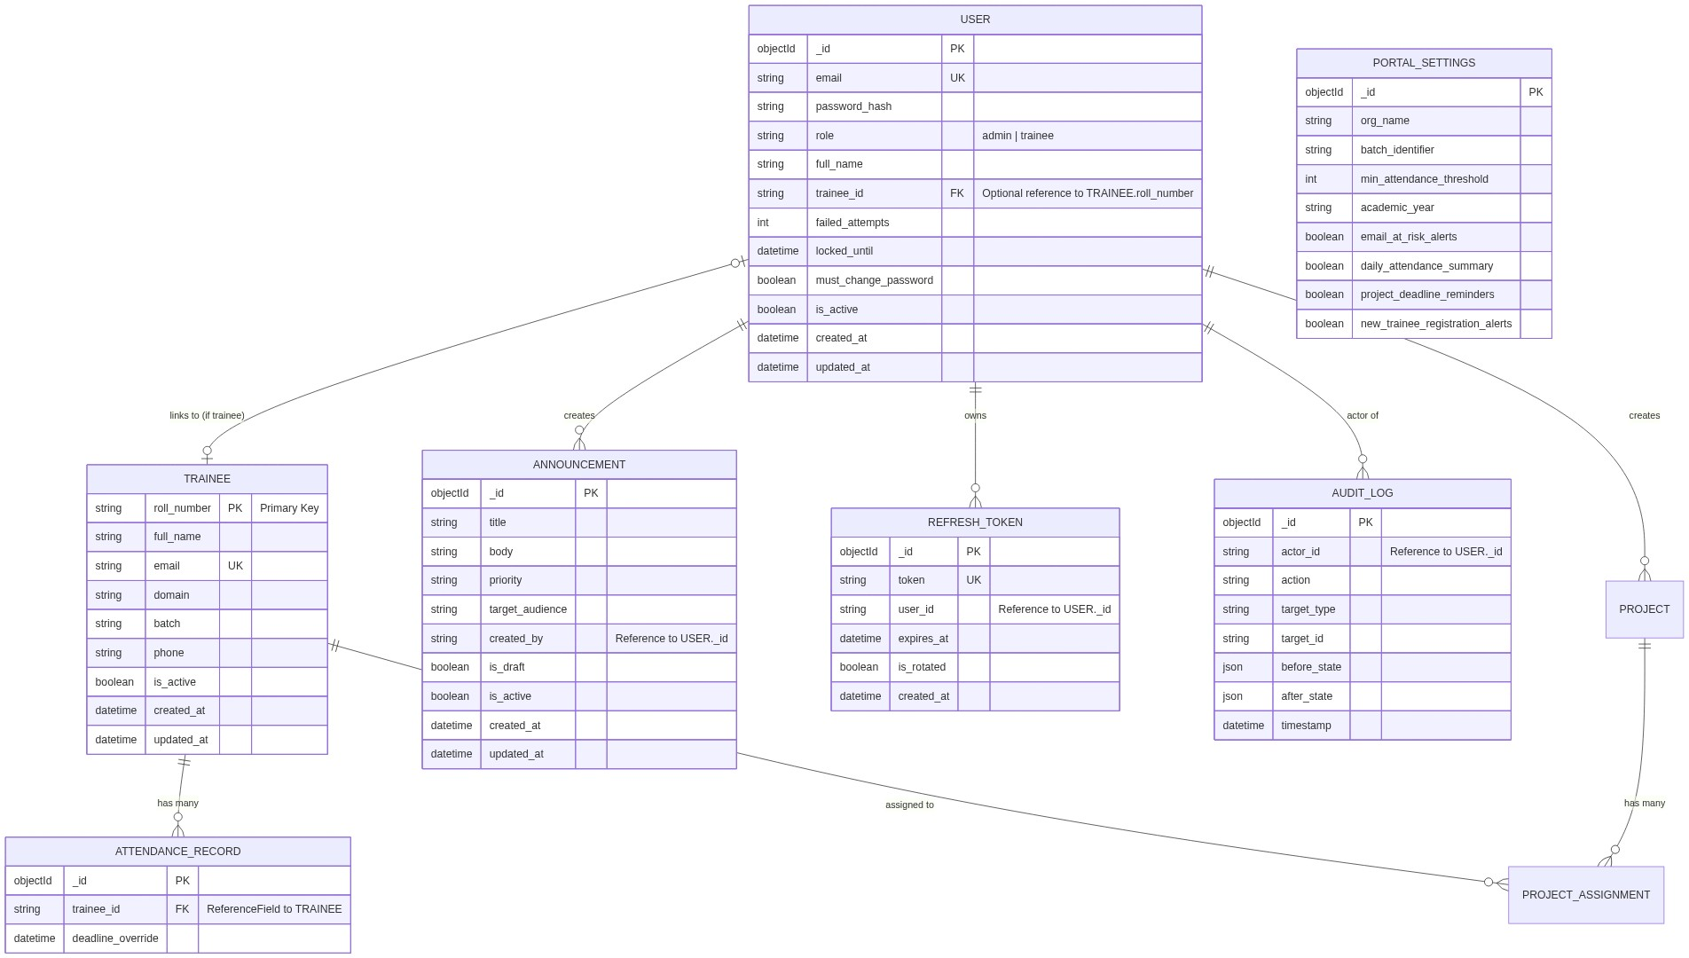

Collection Details

1. trainees
Stores all student profiles.
- Primary Key: roll_number (updated from auto-generated ObjectId)
- Indexes: email, full_name (Text Search), Compound: (is_active, domain), (is_active, batch)
- Behavior: Uses Soft Deletes (is_active = False) instead of hard deletion.

2. users
System credentials for logging in (both Administrators and Trainees).
- Relationships: A User with role="trainee" will have a populated trainee_id field mapping to a Trainee.roll_number.
- Security: Tracks failed_attempts and locks accounts automatically to prevent brute-force attacks.

3. attendance_records
Daily logs of trainee attendance.
- Relationships: Maintains a direct ReferenceField to the Trainee collection.
- Deletion Rule: CASCADE (If a trainee is completely removed from DB, their attendance records are purged).

4. projects & project_assignments
Manages vocational training projects.
- projects stores the definitions, domain requirements, and overall status.
- project_assignments connects a Trainee to a Project through an associative entity using ReferenceField. It supports overriding deadlines per trainee.

5. announcements
Broadcast messages and alerts for specific batches or domains.
- Maintains created_by to track which administrator published the announcement.

6. refresh_tokens
Stores JWT refresh tokens for secure authentication.
- Auto-Cleanup: Uses MongoDBs Time-To-Live (TTL) index expireAfterSeconds: 0 on the expires_at field to automatically delete expired tokens.

7. audit_logs
Tracks sensitive actions across the entire platform.
- Records the actor_id (admin/user) and the complete before_state and after_state (JSON) of the modified entity.

