$route['employee'] ="Frontend/EmployeeController/index";

{ main page : <http://localhost:8000/employee> }

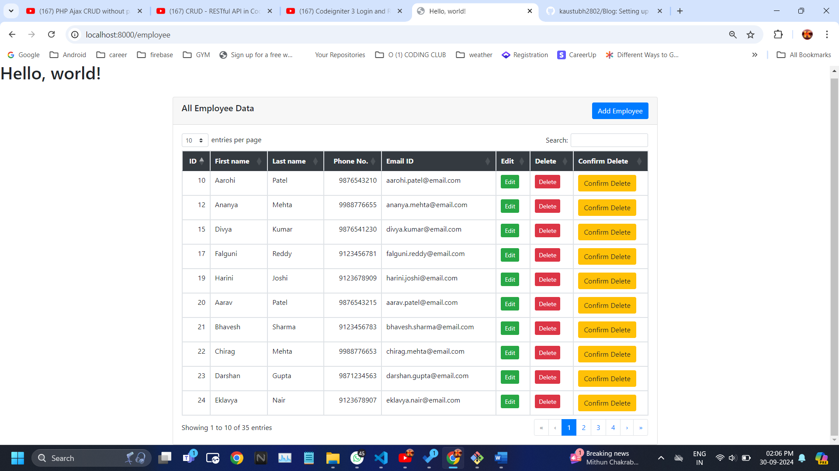

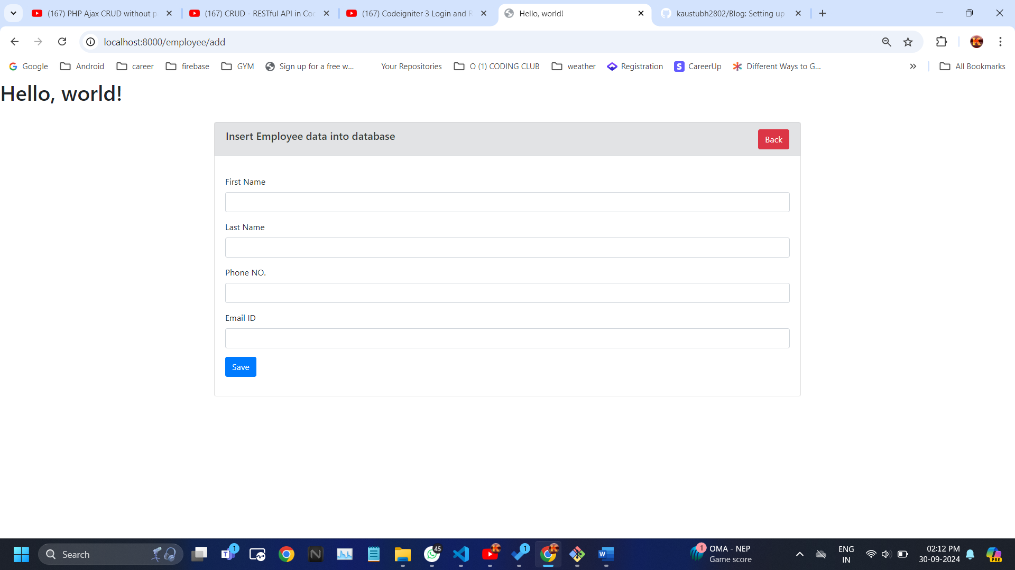

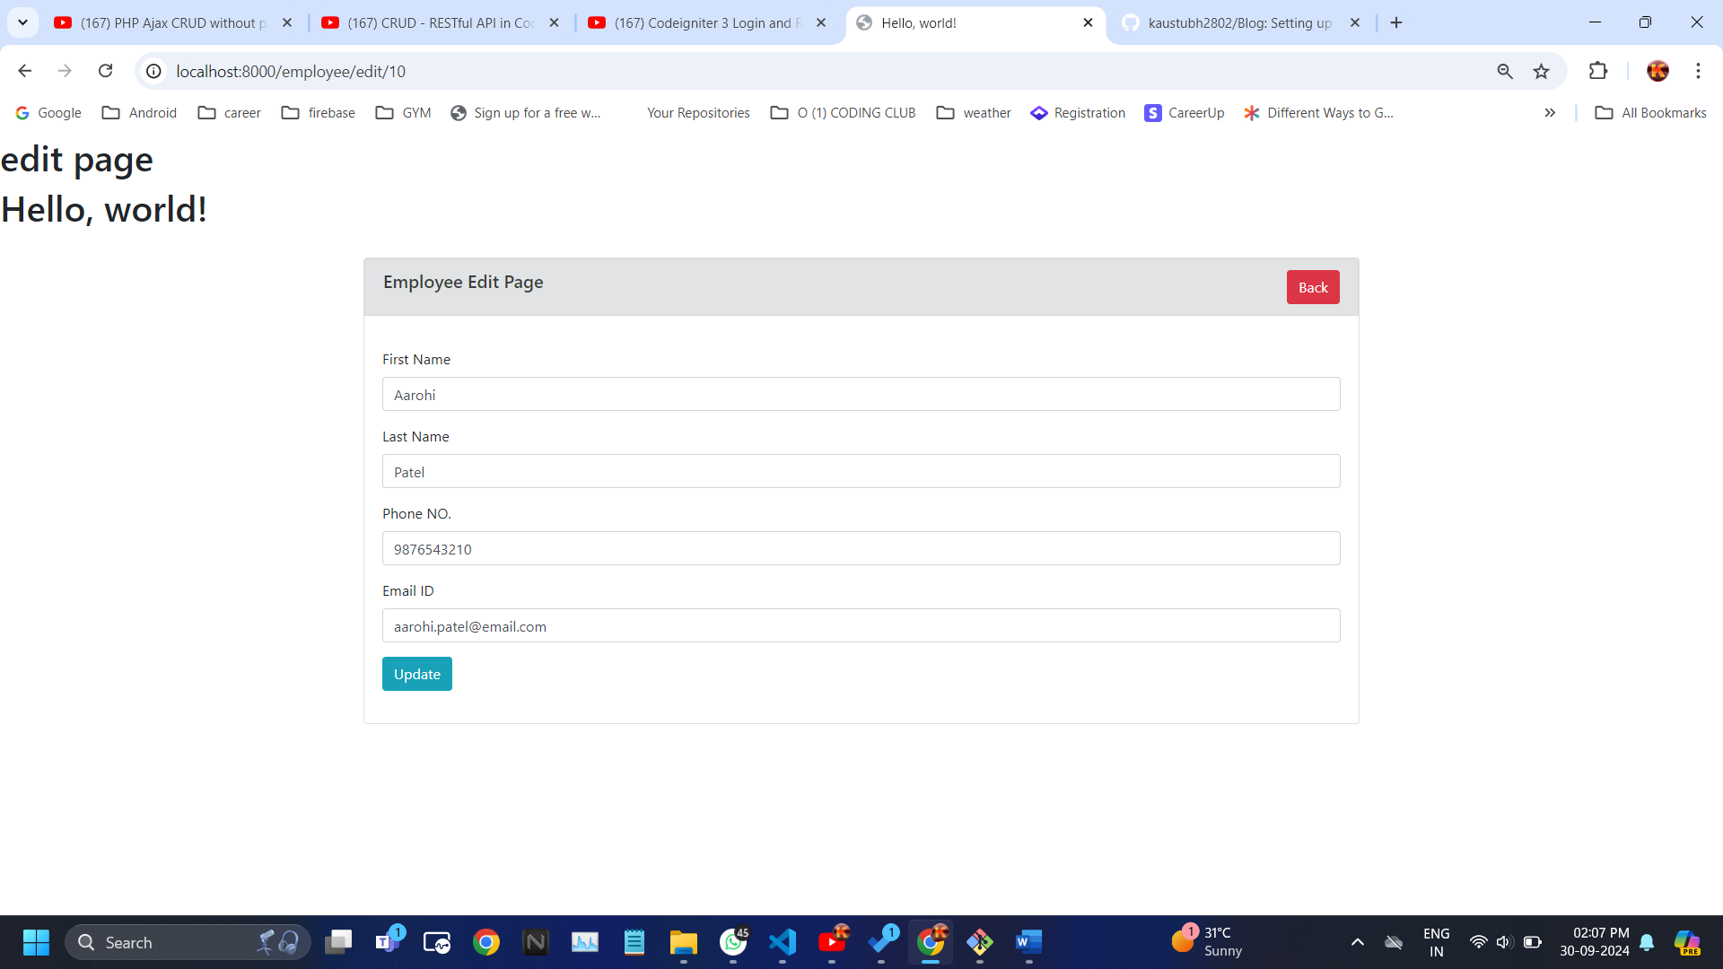

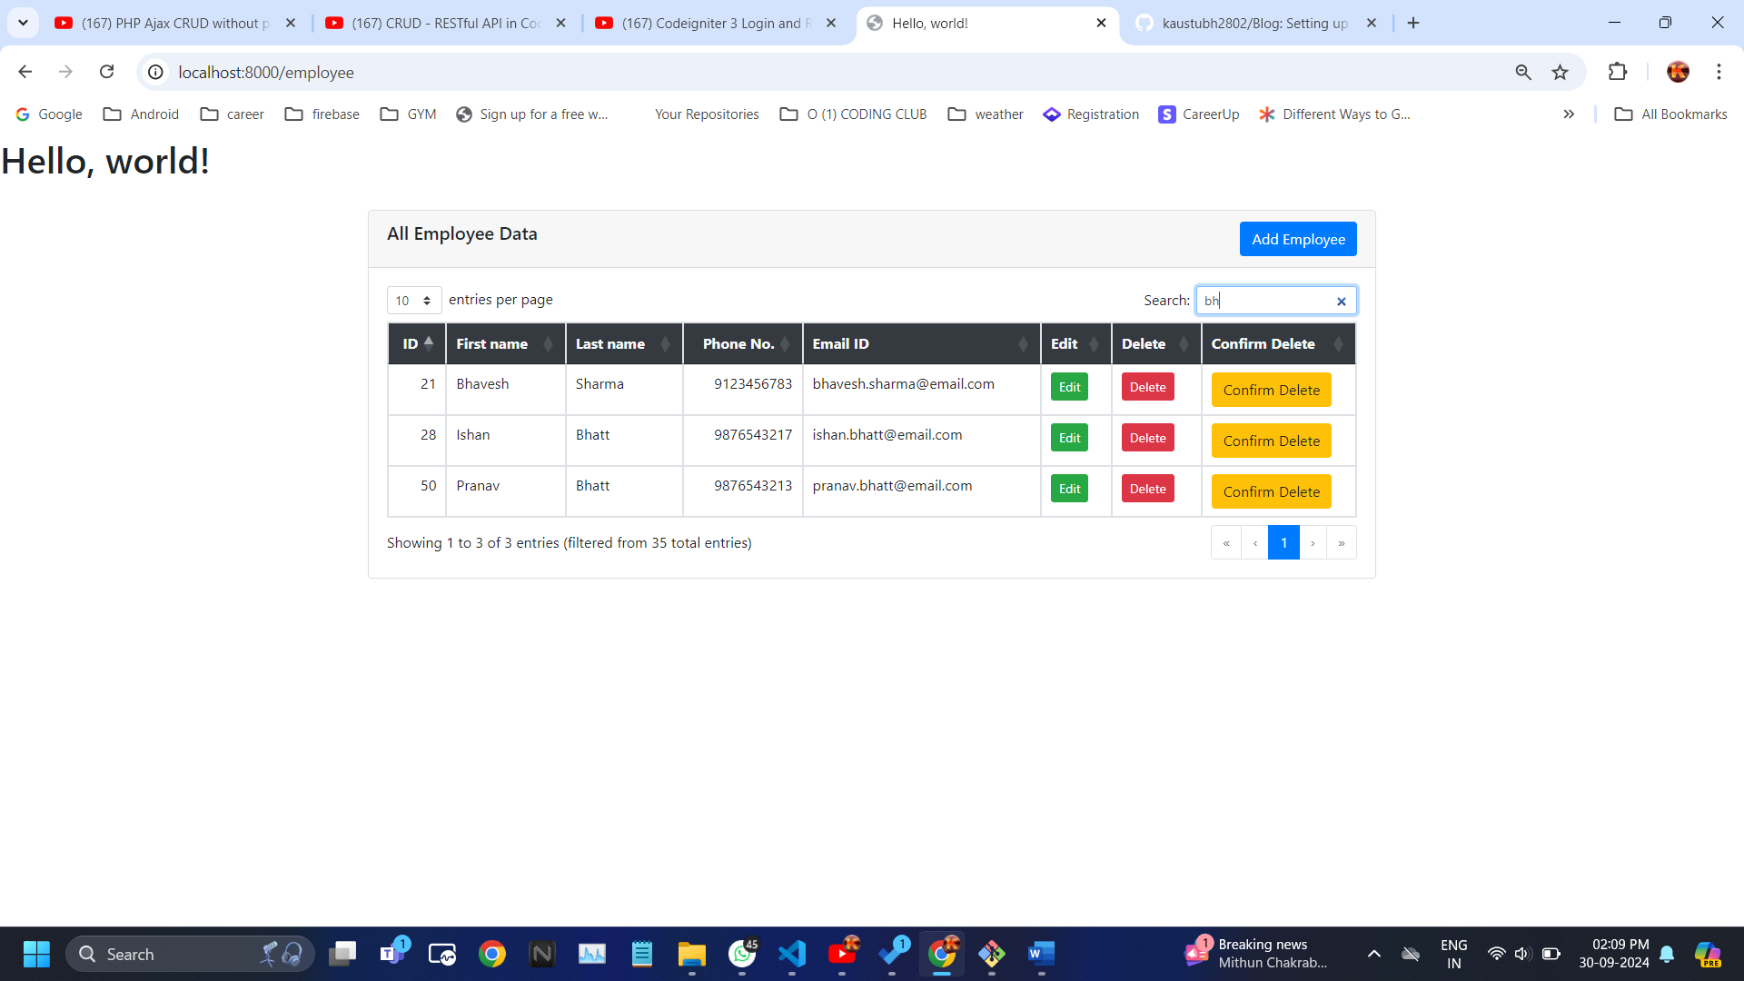

// for practicing

$route['abouts'] = 'welcome/demo'; { <http://localhost:8000/abouts> }

$route['home'] = 'PageController/index'; { <http://localhost:8000/home> }

$route['about'] = 'PageController/aboutus'; { <http://localhost:8000/about> }

$route['blog/(:num)'] = 'PageController/blog/$1'; { <http://localhost:8000/blog/5478> }

$route['studentcontroller'] = 'StudentController/index'; { <http://localhost:8000/StudentController> }

// employee routes

$route['employee'] ="Frontend/EmployeeController/index"; { main page : <http://localhost:8000/employee> }

$route['employee/add'] = "Frontend/EmployeeController/create";

//below routes called in a base_url() to jumping the functions

$route['employee/store'] = "Frontend/EmployeeController/store";

$route['employee/edit/(:any)'] = "Frontend/EmployeeController/edit/$1";

$route['employee/update/(:any)'] = "Frontend/EmployeeController/update/$1";

$route['employee/delete/(:any)'] = "Frontend/EmployeeController/delete/$1";

$route['employee/confirmdelete/(:any)']['DELETE'] = "Frontend/EmployeeController/delete/$1";