**PRN No : 230945920070**

**Module name: MS .NET**

**SET - 2**

‘

**Table in Database:**

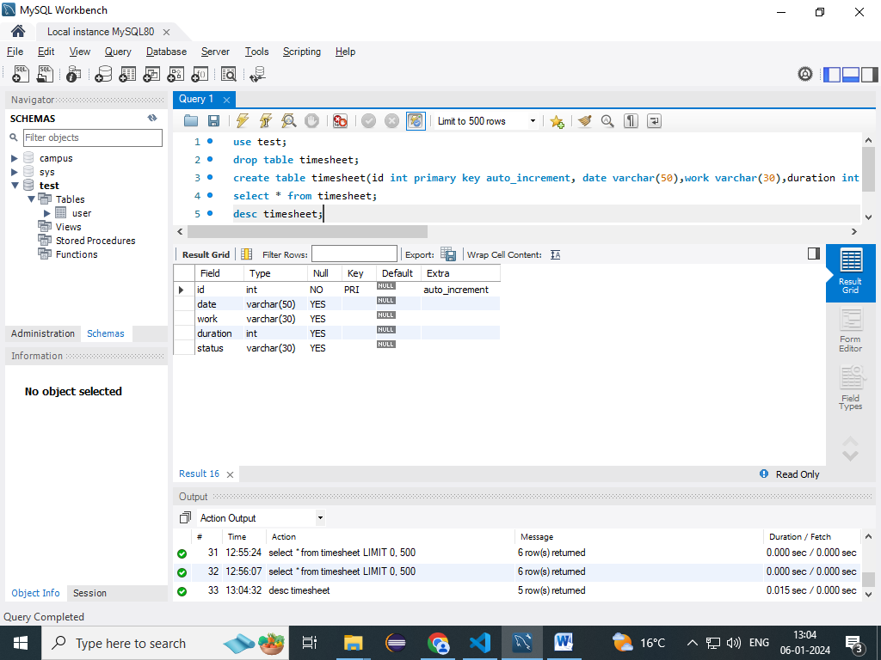

**Front End**

1. **Home Page**

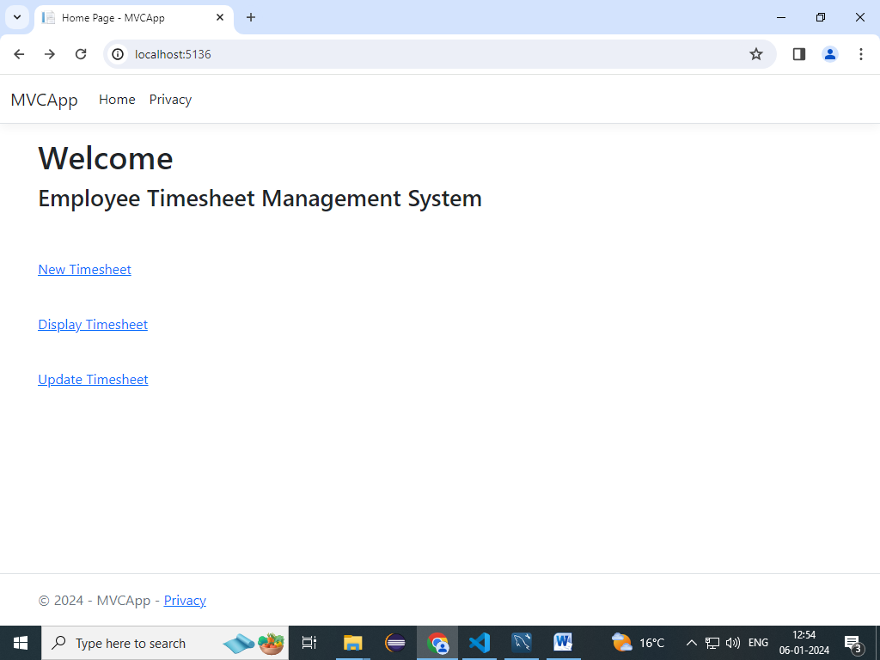

1. **Insert Page**

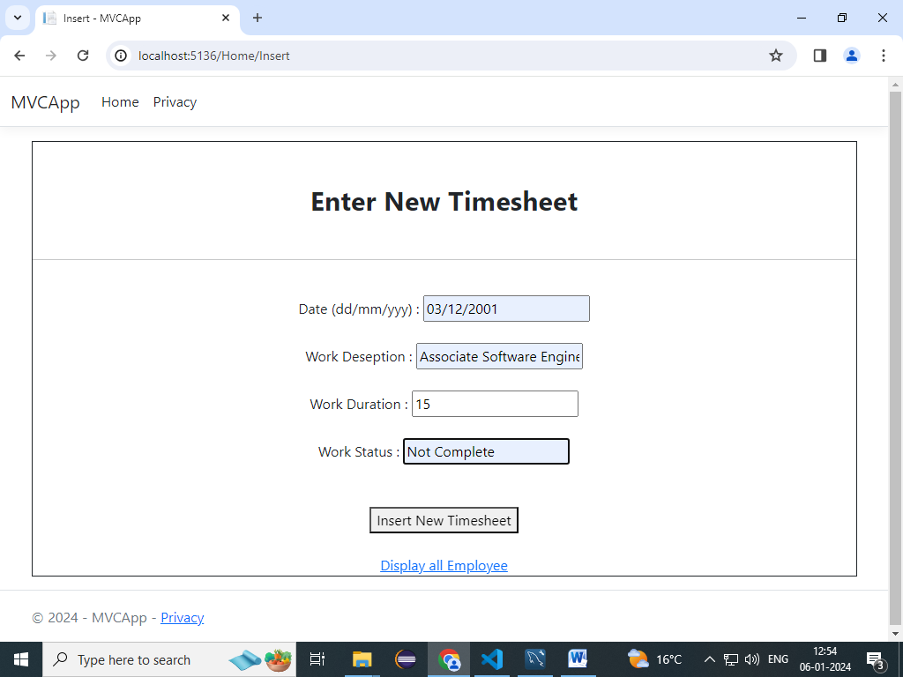

1. **Display Page**

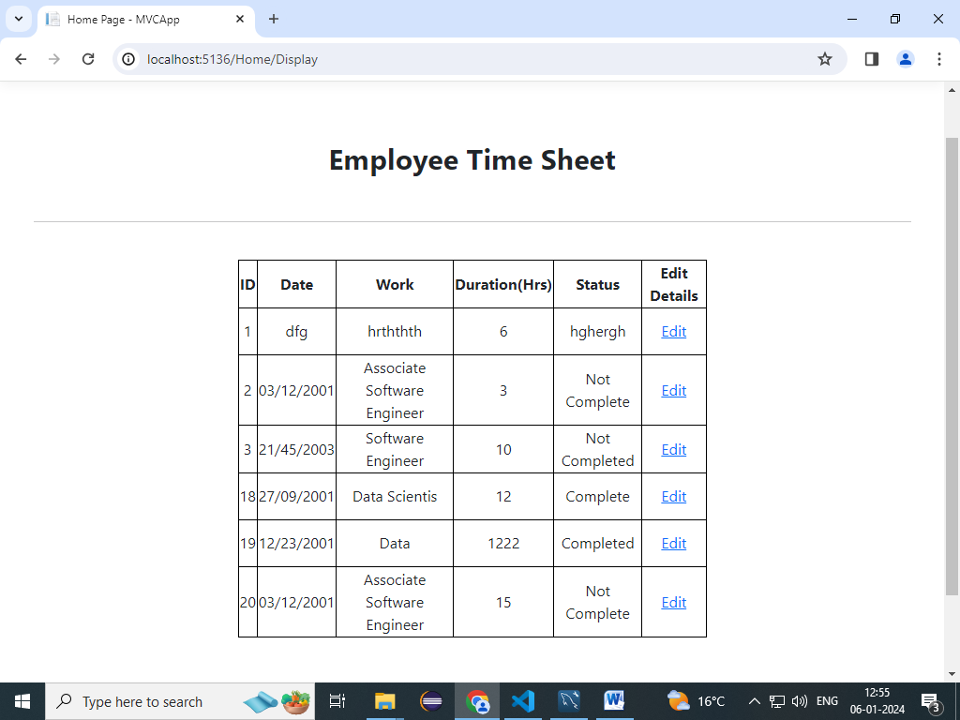

1. **Update Page**

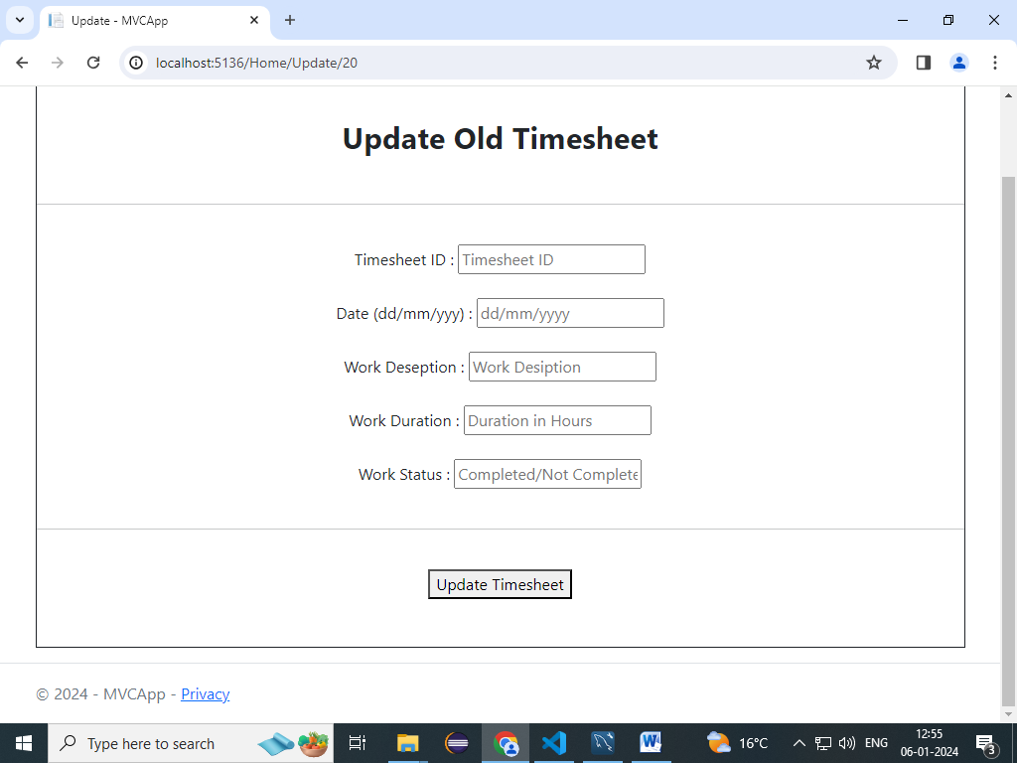

1. **Display In Database**

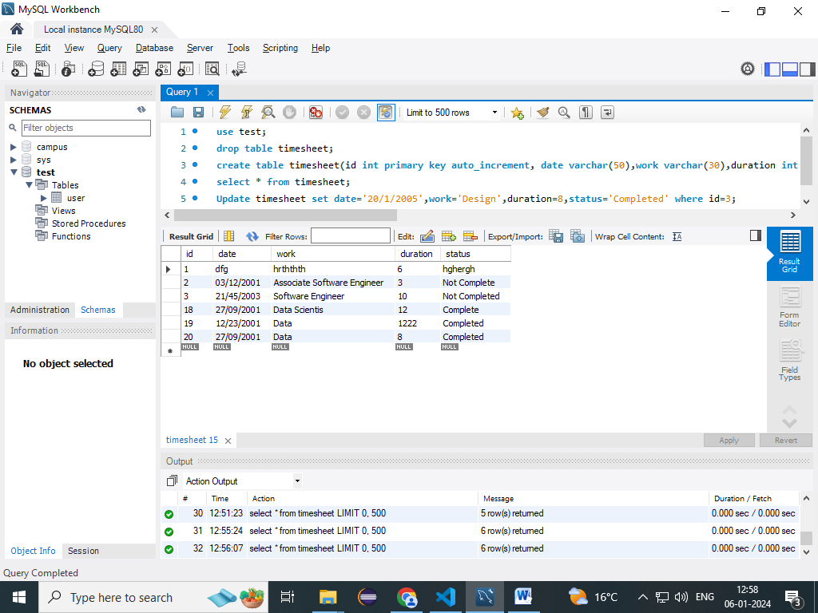

**Code**

1. **View (.cshtml Pages)**

**Home Page**

@{

    ViewData["Title"] = "Home Page";

}

<h1>Welcome</h1>

<h3>Employee Timesheet Management System</h3><br><br>

<p><a href="Home/Insert">New Timesheet</a></p><br>

<p><a href="Home/Display">Display Timesheet</a></p><br>

<p><a href="Home/Update">Update Timesheet</a></p><br>

**Insert Page**

@{

    ViewData["Title"] = "Insert";

}

<div class="text-center">

    <fieldset class="text-center" style="border:0.5px solid;background-color:rgb(30, 151, 91)30, 179)" ;><br><br>

        <form method="post">

            <h2><b>Enter New Timesheet</b></h2><br>

            <hr><br>

            Date (dd/mm/yyy) : <input type="text" name="Date" placeholder="dd/mm/yyyy"></input><br><br>

            Work Deseption : <input type="text" name="Work" placeholder="Work Desiption"></input><br><br>

            Work Duration : <input type="number" name="Duration" placeholder="Duration in Hours"></input><br><br>

            Work Status : <input type="text" name="Status"

                placeholder="Completed/Not Completed/In Progress"></input><br><br><br>

            <button type="submit">Insert New Timesheet</button><br><br>

            <a href="/Home/Display">Display all Employee</a>

        </form>

    </fieldset>

</div>

**Display Page**

@using BOL;

@{

    ViewData["Title"] = "Home Page";

}

@{

    List<Timesheet>? ls = this.ViewData["display"] as List<Timesheet>;

}

<style>

    table,

    th,

    td {

        border: 1px solid black;

        border-collapse: collapse;

    }

    .center {

        margin-left: auto;

        margin-right: auto;

    }

</style>

<div class="text-center" style="background-color:rgb(30, 151, 91)30, 179)"><br><br>

    <h2><b>Employee Time Sheet</b></h2><br>

    <hr><br>

    <table class="center" border="1" width="500">

        <thead>

            <tr>

                <td height="50"><b>ID</b></td>

                <td height="50"><b>Date</b></td>

                <td height="50"><b>Work</b></td>

                <td height="50"><b>Duration(Hrs)</b></td>

                <td height="50"><b>Status</b></td>

                <td height="50"><b>Edit Details</b></td>

            </tr>

        </thead>

        <tbody>

            @foreach (Timesheet ts in ls)

            {

                <tr>

                    <td height="50">@ts.id</td>

                    <td height="50">@ts.Date</td>

                    <td height="50">@ts.Work</td>

                    <td height="50">@ts.Duration</td>

                    <td height="50">@ts.Status</td>

                    <td height="50"><a href="/Home/Update/@ts.id">Edit</a></td>

                </tr>

            }

        </tbody>

    </table><br><br><br>

</div>

**Update Page**

@{

    ViewData["Title"] = "Update";

}

<div class="text-center">

    <fieldset class="text-center" style="border:0.5px solid;background-color:rgb(30, 151, 91)30, 179)" ;><br><br>

        <form method="post">

            <h2><b>Update Old Timesheet</b></h2><br>

            <hr><br>

            Timesheet ID : <input type="number" name="id" placeholder="Timesheet ID"></input><br><br>

            Date (dd/mm/yyy) : <input type="text" name="Date" placeholder="dd/mm/yyyy"></input><br><br>

            Work Deseption : <input type="text" name="Work" placeholder="Work Desiption"></input><br><br>

            Work Duration : <input type="number" name="Duration" placeholder="Duration in Hours"></input><br><br>

            Work Status : <input type="text" name="Status"

                placeholder="Completed/Not Completed/In Progress"></input><br><br>

            <hr><br>

            <button type="submit">Update Timesheet</button><br><br><br>

        </form>

    </fieldset>

</div>

1. **Home Controler ( in Controller)**

using System.Diagnostics;

using Microsoft.AspNetCore.Mvc;

using MVCApp.Models;

using BOL;

using DAL;

namespace MVCApp.Controllers;

public class HomeController : Controller

{

    private readonly ILogger<HomeController> _logger;

    public HomeController(ILogger<HomeController> logger)

    {

        _logger = logger;

    }

    public IActionResult Index()

    {

        return View();

    }

    public IActionResult Privacy()

    {

        return View();

    }

    [HttpGet]

    public IActionResult Display()

    {

        List<Timesheet> ls = DBManager.Display();

        this.ViewData["display"] = ls;

        return View();

    }

    [HttpGet]

    public IActionResult Insert()

    {

        return View();

    }

    [HttpPost]

    public IActionResult Insert(string Date, string Work, int Duration, string Status)

    {

        Timesheet ts = new Timesheet(Date, Work, Duration, Status);

        DBManager.Insert(ts);

        return View();

    }

    [HttpGet]

    public IActionResult Update()

    {

        return View();

    }

    [HttpPost]

    public IActionResult Update(int id, string Date, string Work, int Duration, string Status)

    {

        Timesheet ts = new Timesheet(id, Date, Work, Duration, Status);

        DBManager.Update(ts);

        return RedirectToAction("Display");

    }

    [ResponseCache(Duration = 0, Location = ResponseCacheLocation.None, NoStore = true)]

    public IActionResult Error()

    {

        return View(new ErrorViewModel { RequestId = Activity.Current?.Id ?? HttpContext.TraceIdentifier });

    }

}

1. **DB Manager (in DAL)**

using BOL;

using MySql.Data.MySqlClient;

using ZstdSharp.Unsafe;

namespace DAL;

public static class DBManager

{

    public static void Insert(Timesheet ts)

    {

        MySqlConnection conn = new MySqlConnection();

        conn.ConnectionString = "server=127.0.0.1;port=3306;user=root;password=root;database=test";

        string query = "Insert into timesheet(date,work,duration,status)values('" + ts.Date + "','" + ts.Work + "'," + ts.Duration + ",'" + ts.Status + "')";

        MySqlCommand cmd = new MySqlCommand(query, conn);

        try

        {

            conn.Open();

            cmd.ExecuteNonQuery();

        }

        catch (Exception e)

        {

            Console.WriteLine(e.Message);

        }

        finally

        {

            conn.Close();

        }

    }

    public static List<Timesheet> Display()

    {

        MySqlConnection conn = new MySqlConnection();

        conn.ConnectionString = "server=127.0.0.1;port=3306;user=root;password=root;database=test";

        string query = "Table Timesheet";

        MySqlCommand cmd = new MySqlCommand(query, conn);

        List<Timesheet> ls = new List<Timesheet>();

        try

        {

            conn.Open();

            MySqlDataReader reader = cmd.ExecuteReader();

            while (reader.Read())

            {

                Timesheet ts = new Timesheet();

                ts.id = int.Parse(reader["id"].ToString());

                ts.Date = reader["Date"].ToString();

                ts.Work = reader["Work"].ToString();

                ts.Duration = int.Parse(reader["Duration"].ToString());

                ts.Status = reader["Status"].ToString();

                ls.Add(ts);

            }

            return ls;

        }

        catch (Exception e)

        {

            Console.WriteLine(e.Message);

            return null;

        }

        finally

        {

            conn.Close();

        }

    }

    public static void Update(Timesheet ts)

    {

        MySqlConnection conn = new MySqlConnection();

        conn.ConnectionString = "server=127.0.0.1;port=3306;user=root;password=root;database=test";

        string query = "Update timesheet set date='" + ts.Date + "',work='" + ts.Work + "',duration=" + ts.Duration + ",status='" + ts.Status + "' where id=" + ts.id;

        MySqlCommand cmd = new MySqlCommand(query, conn);

        try

        {

            conn.Open();

            cmd.ExecuteNonQuery();

        }

        catch (Exception e)

        {

            Console.WriteLine(e.Message);

        }

        finally

        {

            conn.Close();

        }

    }

}

1. **Class File (in BOL)**

namespace BOL;

public class Timesheet

{

    public int id;

    public string? Date;

    public string? Work;

    public int Duration;

    public string? Status;

    public Timesheet()

    {

    }

     public Timesheet(int id, string Date, string Work, int Duration, string Status)

    {

        this.id=id;

        this.Date=Date;

        this.Work=Work;

        this.Duration=Duration;

        this.Status=Status;

    }

     public Timesheet(string Date, string Work, int Duration, string Status)

    {

        this.Date=Date;

        this.Work=Work;

        this.Duration=Duration;

        this.Status=Status;

    }

    public override string ToString(){

        return this.Date+" "+this.Work+" "+this.Duration+" "+this.Status;

    }

}