Weekly OEE Insight Report - Fillpac 1 & 2 (Packer 1 + Packer 2)
Weekly executive summary with quantified insights, loss drivers and action priorities
Report Week: Week 36
Start Date: 31st August 2026 End Date: 7th September 2026

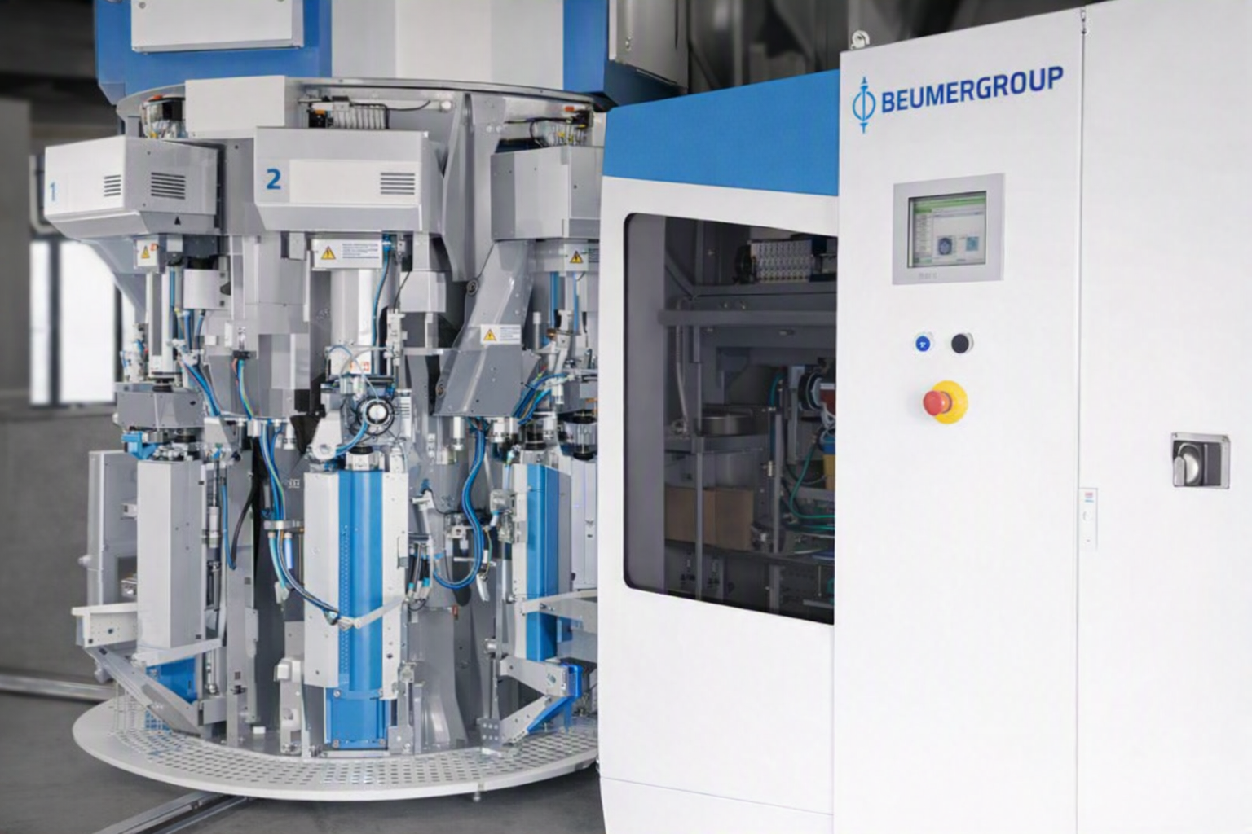

Contents

Section | Main heading | Page
1 | Executive Insight Dashboard | 3
2 | Why OEE Is Going Down | 4
3 | Quality, Fault Risk and Improvement Opportunity | 5
4 | Action Plan: What to Do Next Week | 6

1. Executive Insight Dashboard
This page explains the verified OEE results in plain language for operations, maintenance and management users.
Summary
The current OEE is 28.77%, below the target of 85.00%. The weakest KPI is Performance at 29.95%. The strongest KPI is Quality at 98.28%.
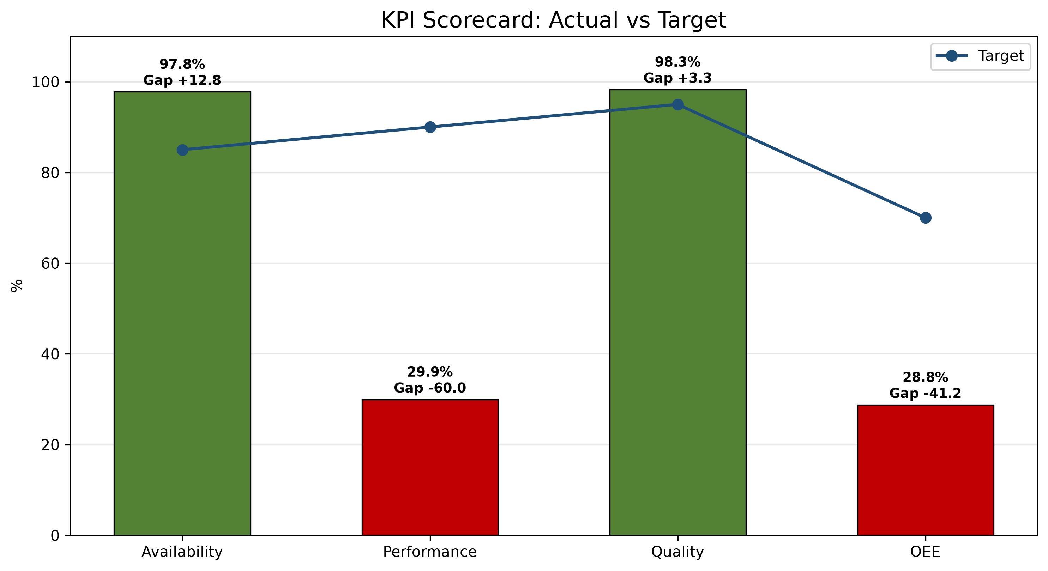
1. Main loss driver  Fillpac 2 Main Drive Stop accounts for 54.35% of classified downtime, contributing 4933.48 minutes. | 2. Performance concern  The actual performance value of 29.95% is significantly lower than the expected value of 1584.829 bags. The production gap is 1,110,240 bags. | 3. Strongest KPI  Quality at 98.28%.
KPI Scorecard vs Industry Standard
KPI | Current | Industry standard | Status
OEE | 28.77% | 85% world-class | Critical
Availability | 97.78% | 90%+ | On Target
Performance | 29.95% | 95%+ | Critical
Quality | 98.28% | 99.9% | Below Target
Week 35 vs Week 36 Comparison
KPI / Parameter | Week 35 | Week 36 | Change | Management insight
OEE | - | 28.77% | - | No prior week's verified data exists for comparison.
Availability | - | 97.78% | - | No verified previous-week value for Availability to compare against; currently 7.78 points above the 90.00% target.
Performance | - | 29.95% | - | No verified previous-week value for Performance to compare against; currently 65.05 points below the 95.00% target.
Quality | - | 98.28% | - | No verified previous-week value for Quality to compare against; currently 1.62 points below the 99.90% target.
pp = percentage points, the straight difference between two percentages (e.g. 45% to 50% is +5 pp), not a percent change.
pp = percentage points, the straight difference between two percentages (e.g. 45% to 50% is +5 pp), not a percent change.

2. Why OEE Is Going Down

Rank | Fault code / parameter | Loss | Insight from data | Immediate action
1 | Fillpac 2 Main Drive Stop | 4933.48 min | Fillpac 2 Main Drive Stop accounts for 4933.48 minutes of recorded downtime. | Prioritize investigation of Fillpac 2 Main Drive Stop using available production and equipment records.
2 | Fillpac 1 Main Drive Stop | 3739.90 min | Fillpac 1 Main Drive Stop accounts for 3739.90 minutes of recorded downtime. | Prioritize investigation of Fillpac 1 Main Drive Stop using available production and equipment records.
3 | Fillpac 2 Belt Not Running | 404.24 min | Fillpac 2 Belt Not Running accounts for 404.24 minutes of recorded downtime. | Prioritize investigation of Fillpac 2 Belt Not Running using available production and equipment records.
Decision point
Prioritize investigating the Fillpac 2 Main Drive Stop to reduce downtime and improve overall OEE.

Fillpac 2 Main Drive Stop accounts for 54.35% of classified downtime, contributing 4933.48 minutes.
Shift changeover delay is a controllable availability loss. Week 36 data show delay time during handover and start-up stabilization.
Shift changeover | Delay time
Shift A Changeover Delay | 1977.86 min
Shift B Changeover Delay | 82.14 min
Shift C Changeover Delay | 160.36 min
Total Week 36 delay | 2220.36 min

2.2 Spout Downtime by Machine - Week 36
Spout-level downtime highlights which individual spouts are driving each machine's Spout Fault minutes, so maintenance can target the specific spouts responsible rather than the machine as a whole.
Fillpac 1 (PLC_01)
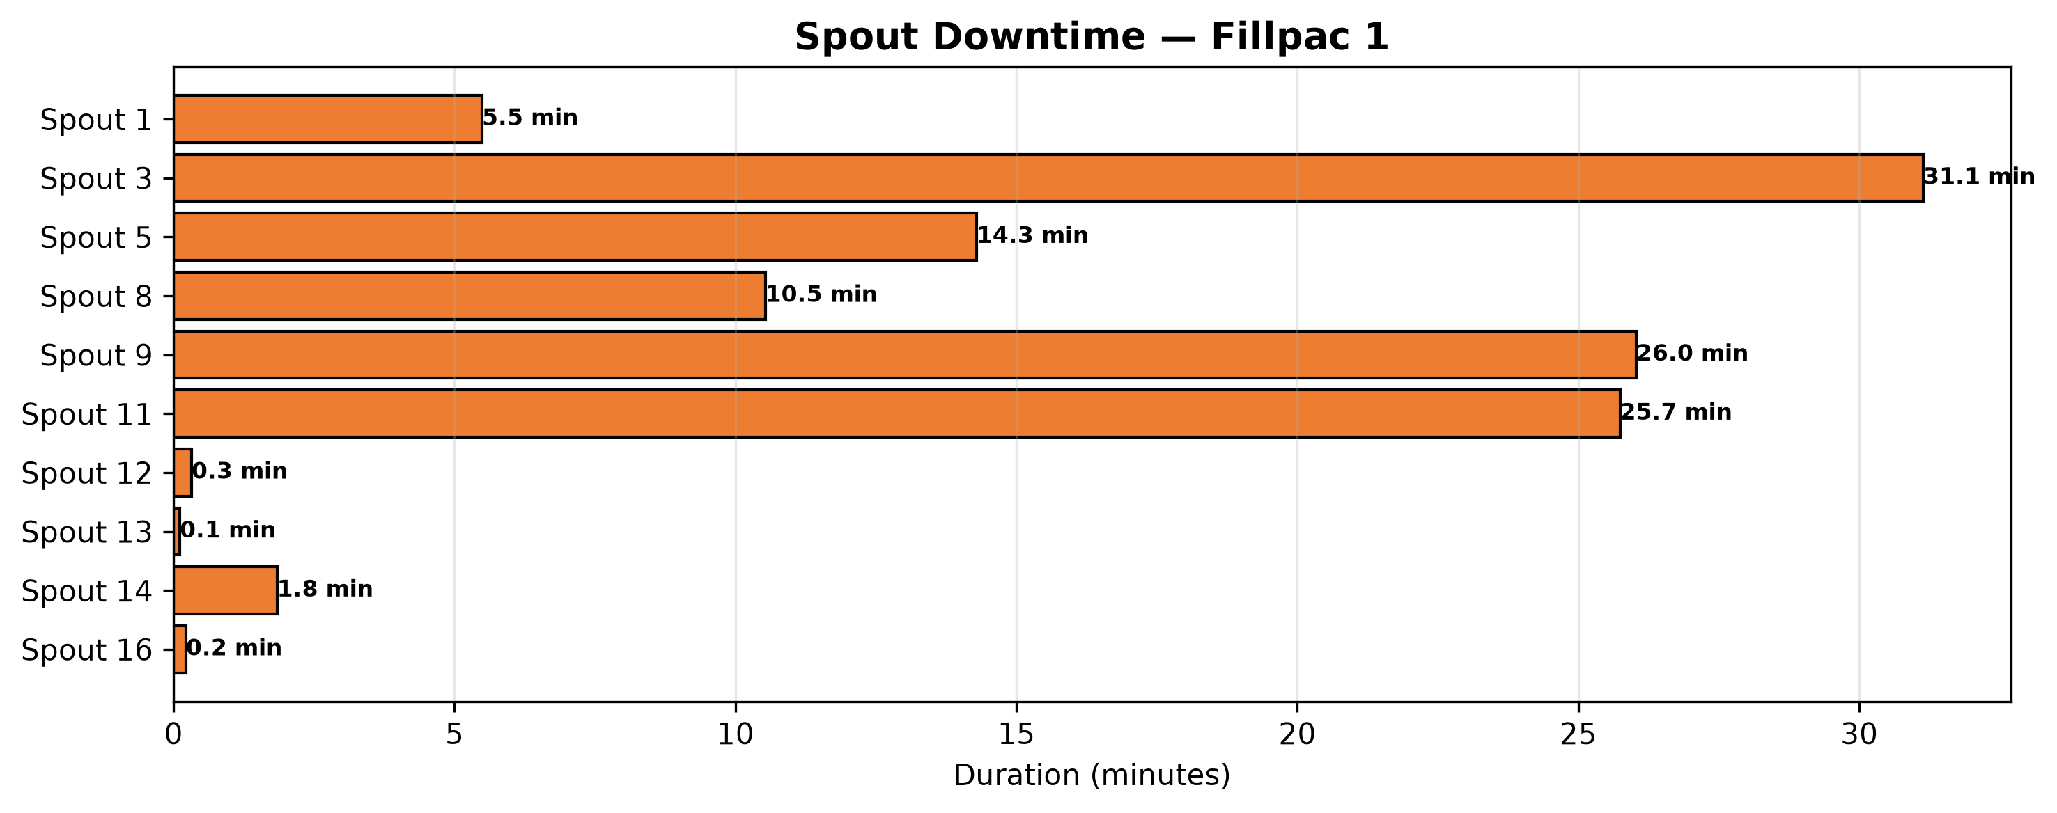
Fillpac 2 (PLC_02)
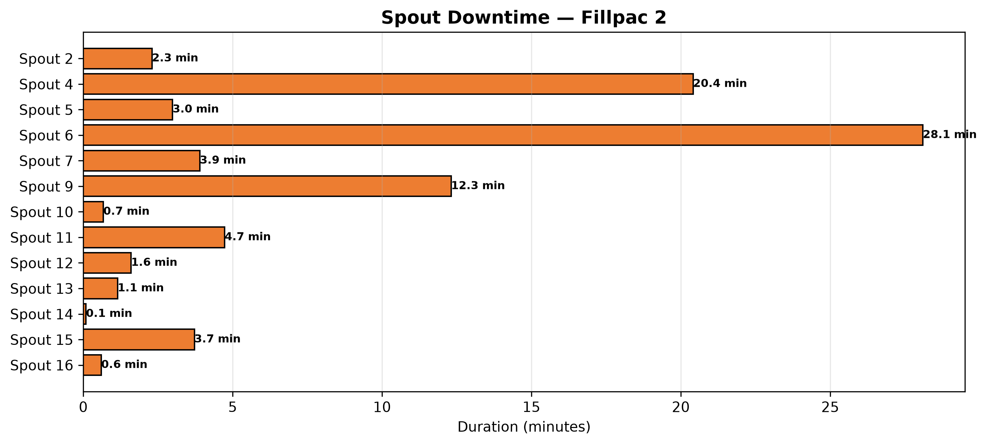

3. Quality, Fault Risk and Improvement Opportunity
The quality loss is 1.72% with Out of Limit Bags accounting for 65.77% of the recorded quality loss and Burst Bags contributing 34.23%.
Quality Loss Mix
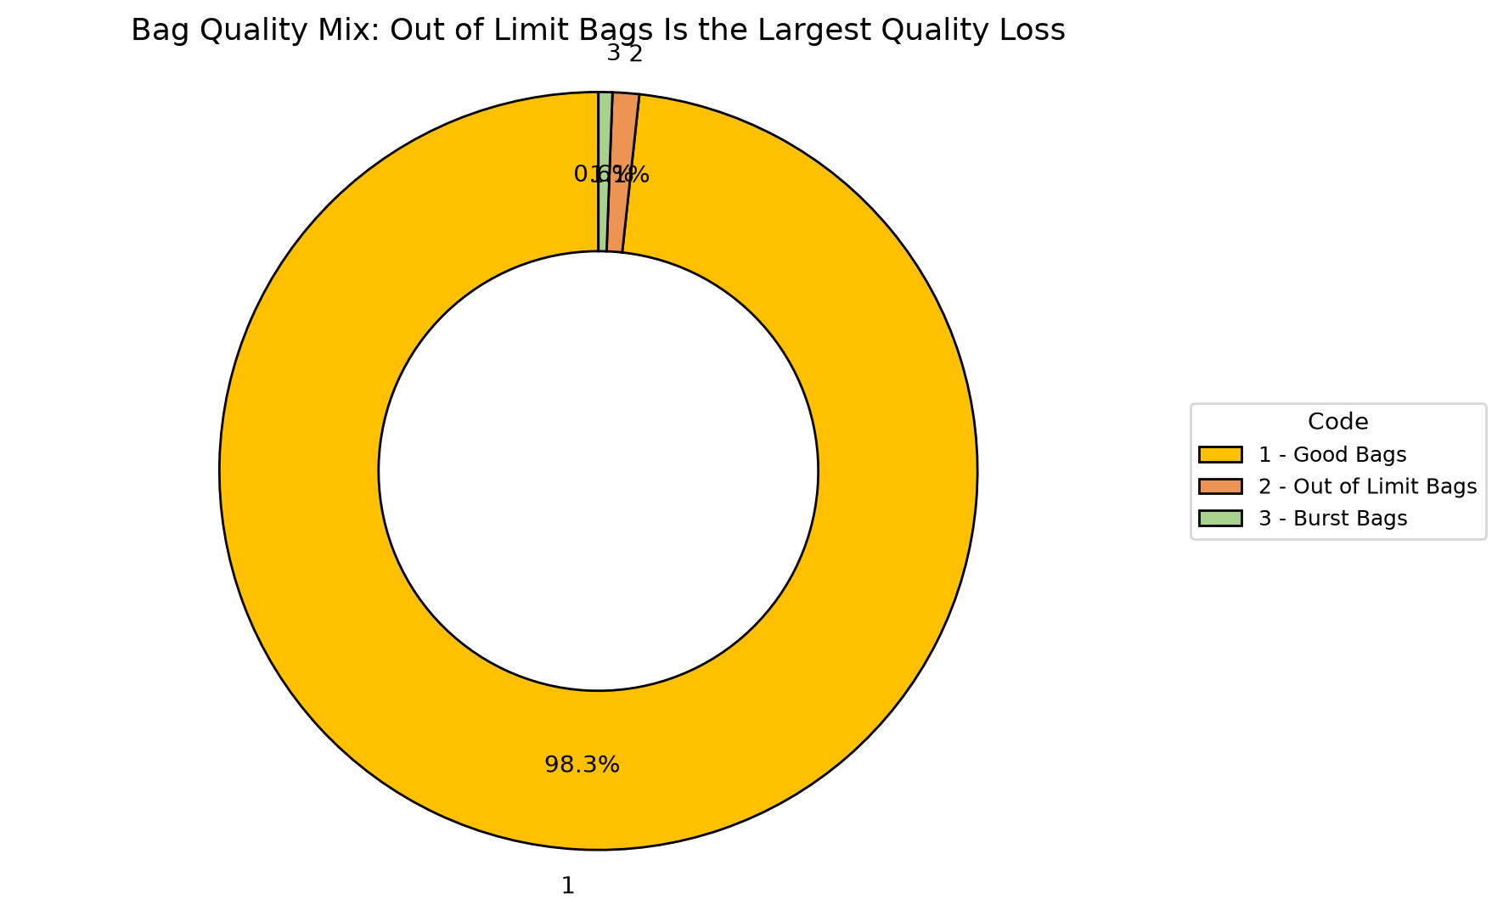
Code | Parameter | Quantity |  | What it means | Control action
1 | Good Bags | 474589 bags |  | Good Bags represents 98.28% of total bags produced this week. | Baseline reference — no corrective action required.
2 | Out of Limit Bags | 5475 bags |  | Out of Limit Bags represents 1.13% of total bags produced this week. | Review process records associated with Out of Limit Bags and prioritize corrective action.
3 | Burst Bags | 2849 bags |  | Burst Bags represents 0.59% of total bags produced this week. | Review process records associated with Burst Bags and prioritize corrective action.
Quality insight
Out of Limit Bags account for 65.77% of the recorded quality loss, totaling 5,475 bags.

4. Action Plan: What to Do Next Week
Actions are prioritized from the verified OEE losses and AI-generated recommendations.
Priority | Owner |  | Fault code | Action | Success measure |  | Review frequency
P1 | Maintenance + Production |  | Maintenance + Production | Fillpac 2 Main Drive Stop | Reduce Fillpac 2 Main Drive Stop downtime (currently 4933.48 minutes this week) to recover Availability. |  | Cut Fillpac 2 Main Drive Stop downtime versus this week's 4933.48 minutes.
P1 | Maintenance + Production |  | Maintenance + Production | Fillpac 1 Main Drive Stop | Reduce Fillpac 1 Main Drive Stop downtime (currently 3739.90 minutes this week) to recover Availability. |  | Cut Fillpac 1 Main Drive Stop downtime versus this week's 3739.90 minutes.
P1 | Maintenance + Production |  | Maintenance + Production | Fillpac 2 Belt Not Running | Reduce Fillpac 2 Belt Not Running downtime (currently 404.24 minutes this week) to recover Availability. |  | Cut Fillpac 2 Belt Not Running downtime versus this week's 404.24 minutes.
P2 | Production |  | Production | Out of Limit Bags | Reduce Out of Limit Bags (currently 5475 bags this week) to recover Quality yield. |  | Cut Out of Limit Bags bags versus this week's 5475 bags.
If action is completed |  | Expected change |  | Approx. OEE result |  | Management decision
Fillpac 2 Main Drive Stop reduced |  | Availability improves first |  | ~54.07% |  | Continue the countermeasure until stable
Fillpac 2 Main Drive Stop plus Fillpac 1 Main Drive Stop addressed |  | Near-target recovery |  | ~70.94% |  | Shift focus to Out of Limit Bags, the next-largest quality contributor
Availability stable + Out of Limit Bags reduced |  | Target recovery |  | ~85.00% |  | Standardize the new checks into SOP

