Weekly OEE Insight Report - Fillpac 1 & 2 (Packer 1 + Packer 2)
Weekly executive summary with quantified insights, loss drivers and action priorities
Report Week: Week 36
Start Date: 31st August 2026 End Date: 7th September 2026

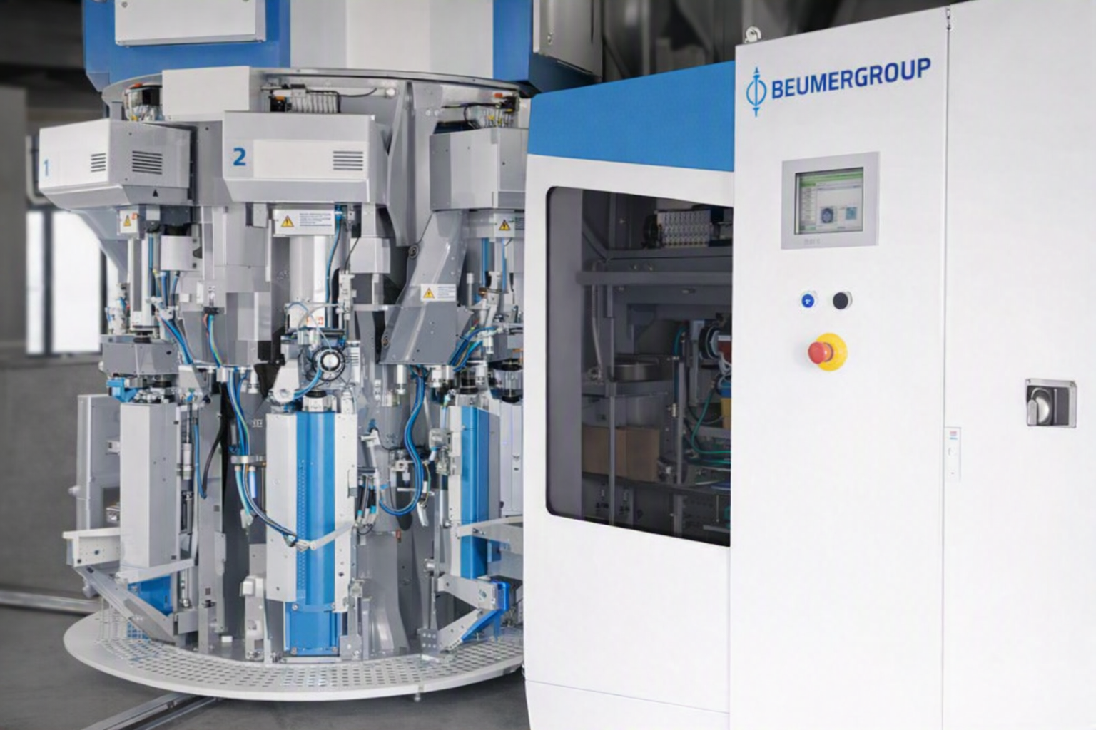

Contents

Section | Main heading | Page
1 | Executive Insight Dashboard | 3
2 | Why OEE Is Going Down | 4
3 | Quality, Fault Risk and Improvement Opportunity | 5
4 | Action Plan: What to Do Next Week | 6

1. Executive Insight Dashboard
This page explains the verified OEE results in plain language for operations, maintenance and management users.
Summary
The current OEE is 38.34%, below the target of 85.00%. Performance is the weakest KPI at 39.14% and Quality is the strongest KPI at 99.07%.
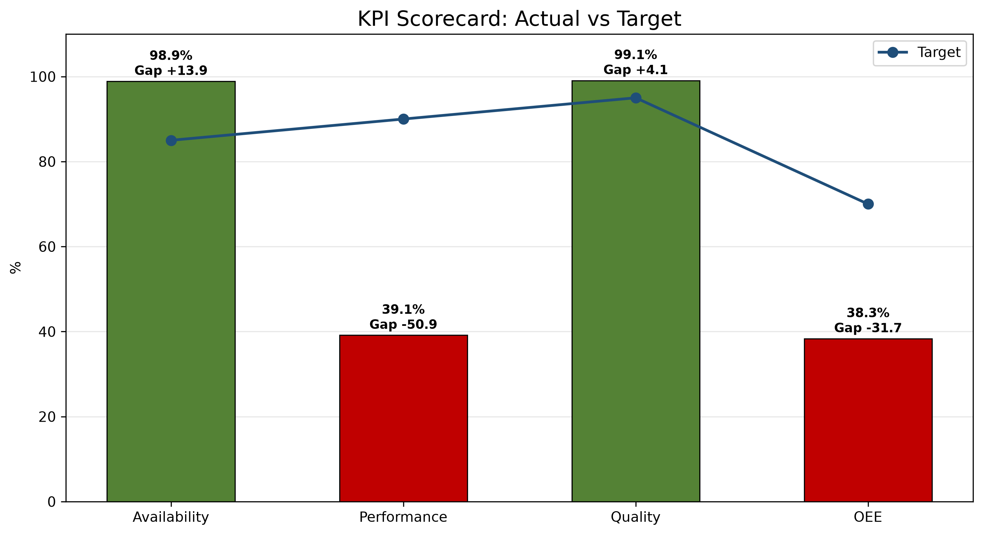
1. Main loss driver  Fillpac 1 Main Drive Stop accounts for 52.05% of classified downtime. | 2. Performance concern  The actual good bags produced are 624,053 while the expected good bags were 1,594,403. This results in a production gap of 970,350 bags. | 3. Strongest KPI  Quality is the strongest KPI at 99.07%.
KPI Scorecard vs Industry Standard
KPI | Current | Industry standard | Status
OEE | 38.34% | 85% world-class | Critical
Availability | 98.88% | 90%+ | On Target
Performance | 39.14% | 95%+ | Critical
Quality | 99.07% | 99.9% | Below Target
Week 36 vs Week 37 Comparison
KPI / Parameter | Week 36 | Week 37 | Change | Management insight
OEE | 28.77% | 38.34% | +9.57 pp | Availability increased by 1.10 percentage points, Performance increased by 9.19 percentage points and Quality increased by 0.79 percentage points. OEE changed by 9.57 percentage points.
Availability | 97.78% | 98.88% | +1.10 pp | Availability improved by 1.10 pp week over week; currently 8.88 points above the 90.00% target.
Performance | 29.95% | 39.14% | +9.19 pp | Performance improved by 9.19 pp week over week; currently 55.86 points below the 95.00% target.
Quality | 98.28% | 99.07% | +0.79 pp | Quality improved by 0.79 pp week over week; currently 0.83 points below the 99.90% target.
pp = percentage points, the straight difference between two percentages (e.g. 45% to 50% is +5 pp), not a percent change.
pp = percentage points, the straight difference between two percentages (e.g. 45% to 50% is +5 pp), not a percent change.

2. Why OEE Is Going Down

Rank | Fault code / parameter | Loss | Insight from data | Immediate action
1 | Fillpac 1 Main Drive Stop | 2912.33 min | Fillpac 1 Main Drive Stop accounts for 2912.33 minutes of recorded downtime. | Prioritize investigation of Fillpac 1 Main Drive Stop using available production and equipment records.
2 | Fillpac 2 Belt Not Running | 1355.31 min | Fillpac 2 Belt Not Running accounts for 1355.31 minutes of recorded downtime. | Prioritize investigation of Fillpac 2 Belt Not Running using available production and equipment records.
3 | Fillpac 2 Main Drive Stop | 1327.64 min | Fillpac 2 Main Drive Stop accounts for 1327.64 minutes of recorded downtime. | Prioritize investigation of Fillpac 2 Main Drive Stop using available production and equipment records.
Decision point
Prioritize investigation of the largest recorded downtime driver, Fillpac 1 Main Drive Stop.

Fillpac 1 Main Drive Stop accounts for 52.05% of classified downtime.
Shift changeover delay is a controllable availability loss. Week 37 data show delay time during handover and start-up stabilization.
Shift changeover | Delay time
Shift A Changeover Delay | 1032.34 min
Shift B Changeover Delay | 90.83 min
Shift C Changeover Delay | 49.58 min
Total Week 37 delay | 1172.75 min

2.2 Spout Downtime by Machine - Week 37
Spout-level downtime highlights which individual spouts are driving each machine's Spout Fault minutes, so maintenance can target the specific spouts responsible rather than the machine as a whole.
Fillpac 1 (PLC_01)
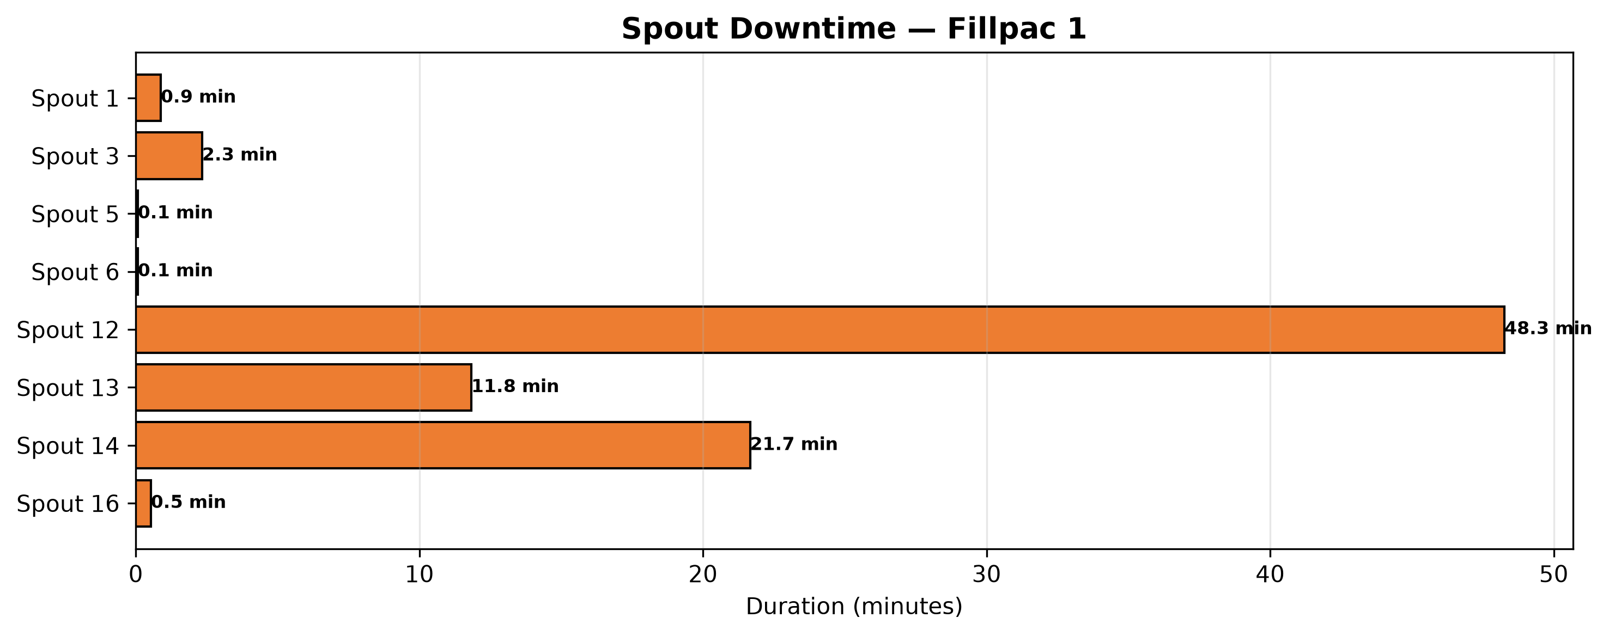
Fillpac 2 (PLC_02)
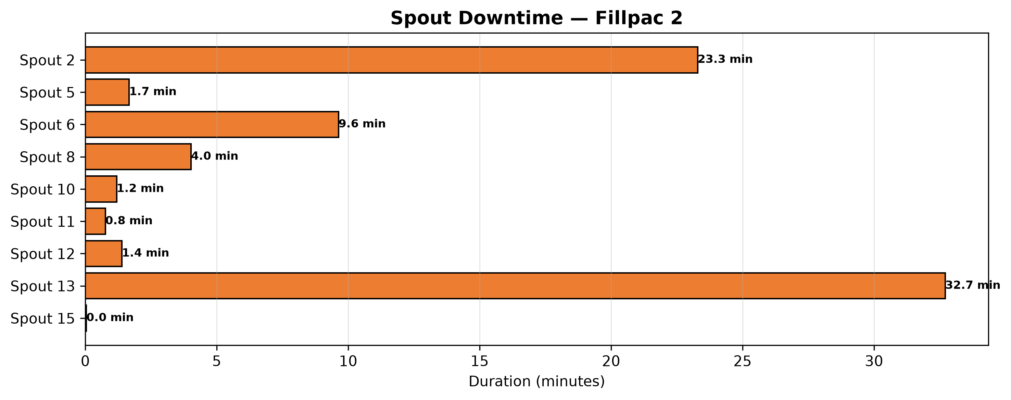

3. Quality, Fault Risk and Improvement Opportunity
Out of Limit Bags account for 59.17% of recorded quality loss while Burst Bags account for 40.83%.
Quality Loss Mix
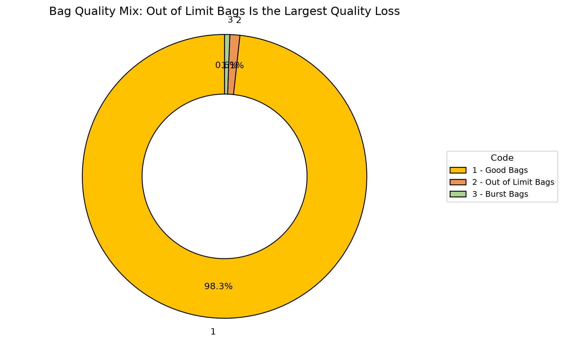
Code | Parameter | Quantity |  | What it means | Control action
1 | Good Bags | 624053 bags |  | Good Bags represents 99.07% of total bags produced this week. | Baseline reference — no corrective action required.
2 | Out of Limit Bags | 3453 bags |  | Out of Limit Bags represents 0.55% of total bags produced this week. | Review process records associated with Out of Limit Bags and prioritize corrective action.
3 | Burst Bags | 2383 bags |  | Burst Bags represents 0.38% of total bags produced this week. | Review process records associated with Burst Bags and prioritize corrective action.
Quality insight
Out of Limit Bags.

4. Action Plan: What to Do Next Week
Actions are prioritized from the verified OEE losses and AI-generated recommendations.
Priority | Owner |  | Fault code | Action | Success measure |  | Review frequency
P1 | Maintenance + Production |  | Maintenance + Production | Fillpac 1 Main Drive Stop | Reduce Fillpac 1 Main Drive Stop downtime (currently 2912.33 minutes this week) to recover Availability. |  | Cut Fillpac 1 Main Drive Stop downtime versus this week's 2912.33 minutes.
P1 | Maintenance + Production |  | Maintenance + Production | Fillpac 2 Belt Not Running | Reduce Fillpac 2 Belt Not Running downtime (currently 1355.31 minutes this week) to recover Availability. |  | Cut Fillpac 2 Belt Not Running downtime versus this week's 1355.31 minutes.
P1 | Maintenance + Production |  | Maintenance + Production | Fillpac 2 Main Drive Stop | Reduce Fillpac 2 Main Drive Stop downtime (currently 1327.64 minutes this week) to recover Availability. |  | Cut Fillpac 2 Main Drive Stop downtime versus this week's 1327.64 minutes.
P2 | Production |  | Production | Out of Limit Bags | Reduce Out of Limit Bags (currently 3453 bags this week) to recover Quality yield. |  | Cut Out of Limit Bags bags versus this week's 3453 bags.
If action is completed |  | Expected change |  | Approx. OEE result |  | Management decision
Fillpac 1 Main Drive Stop reduced |  | Availability improves first |  | ~59.34% |  | Continue the countermeasure until stable
Fillpac 1 Main Drive Stop plus Fillpac 2 Belt Not Running addressed |  | Near-target recovery |  | ~73.34% |  | Shift focus to Out of Limit Bags, the next-largest quality contributor
Availability stable + Out of Limit Bags reduced |  | Target recovery |  | ~85.00% |  | Standardize the new checks into SOP

